6303
Project2
Roshan Adhikari
02/17/2026

Nutritional Analysis of McDonalds Menu

Abstract:
This study analyzes the nutritional content of the McDonald's menu items using the dataset ‘menu.csv’. The objective is to understand the distribution of calories, identify features strongly correlated with calorie count, and handle outliers and missing data. We found that total fat and calories from fat are the strongest predictors of total calories. Data pre-processing involved removing outliers using the 1.5 IQR rule and imputing missing values with the mean, resulting in a significant reduction in the standard deviation of several nutritional metrics.
Literature Review:
Nutritional analysis of fast food often focuses on the high density of calories, fats, and sodium. Studies have shown that caloric content in fast food is frequently driven by fat and carbohydrate content. Correlation analysis is a standard statistical tool used to identify these drivers. Furthermore, real-world datasets often contain outliers—extreme values that can skew statistical analysis. Standard methods for handling these include the Interquartile Range (IQR) method for detection and mean/median imputation for replacement.
Methodology:
Using R programming language, EDA, visualization, outlier detection, imputation and comparison were done to get the following results.
Introduction:
The dataset of the given data consists of 260 observations of 24 variables. The observations are breakfast menu items of McDonalds and their nutritional measurements. An initial histogram was plotted on calories for all 260 observations which showed a normal-looking plot with most data points falling between 200 and 600 calories.
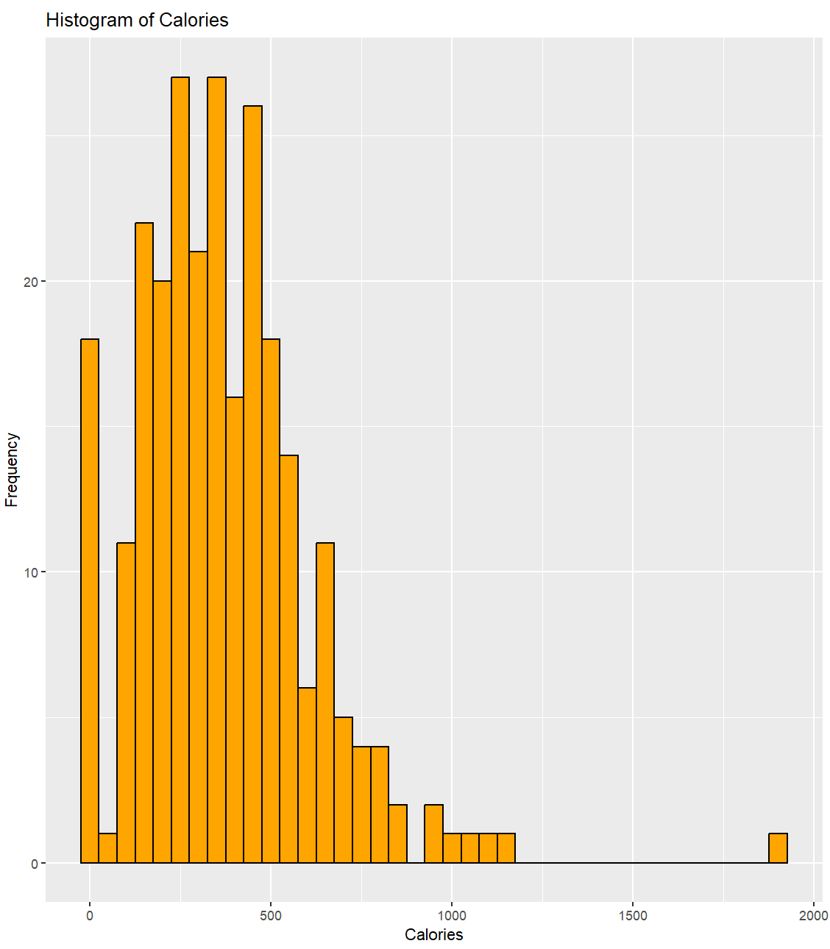
We have few outliers at the top end as well as at the bottom end of the calories spectrum.
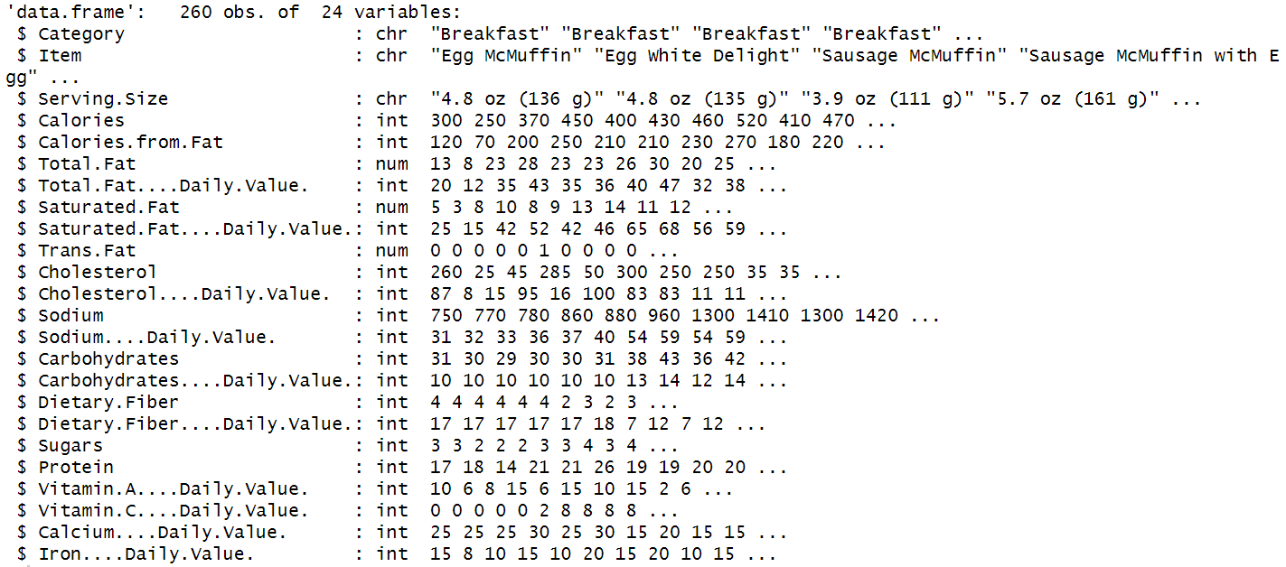
The dataset consists of character features as well as numeric features. Category, item and serving size are expected to be descriptive character datatype while all other features are numeric quantities.

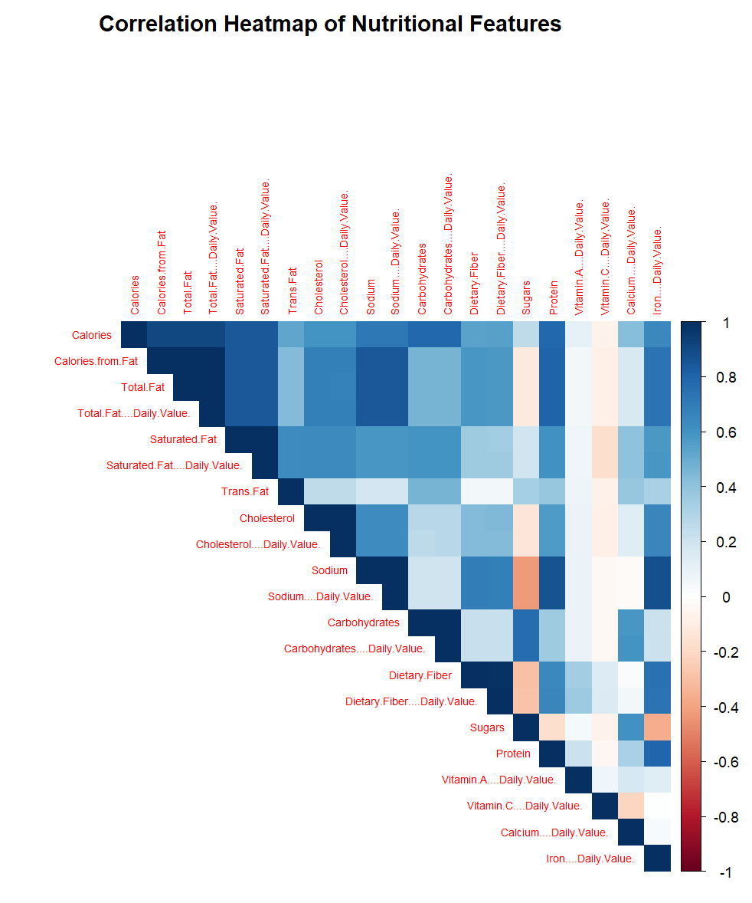
A correlation heatmap was plotted in order to find which numeric features had a relationship between them and could be discarded for introducing multicollinearity. The diagonal elements always show 1 correlation value as expected as each variable perfectly correlates with itself.
CORR(X,X) = 1
Identifying features with top correlations with calories helps us identify important features that move calories in a McDonalds meal, however, in the dataset, we have some features that explain the same information (e.g. total fat, calories from fat and total fat % daily value). For that reason, some features were dropped to get top 5 features with positive correlations and no repetitive effect.
So, top second and third features correlating with calories are ‘Saturated.Fat’ and ‘Protein’.
While looking for any features with negative correlation (decreasing calories with increasing feature value), only ‘Vitamin C % daily value’ showed negative correlation of -0.06874704. This actually makes sense since our dataset is a high caloric menu inferring low Vitamin C content. Also, most of our features increase calories with their respective increment.
Scatter plots and box plots were plotted to get the following results.
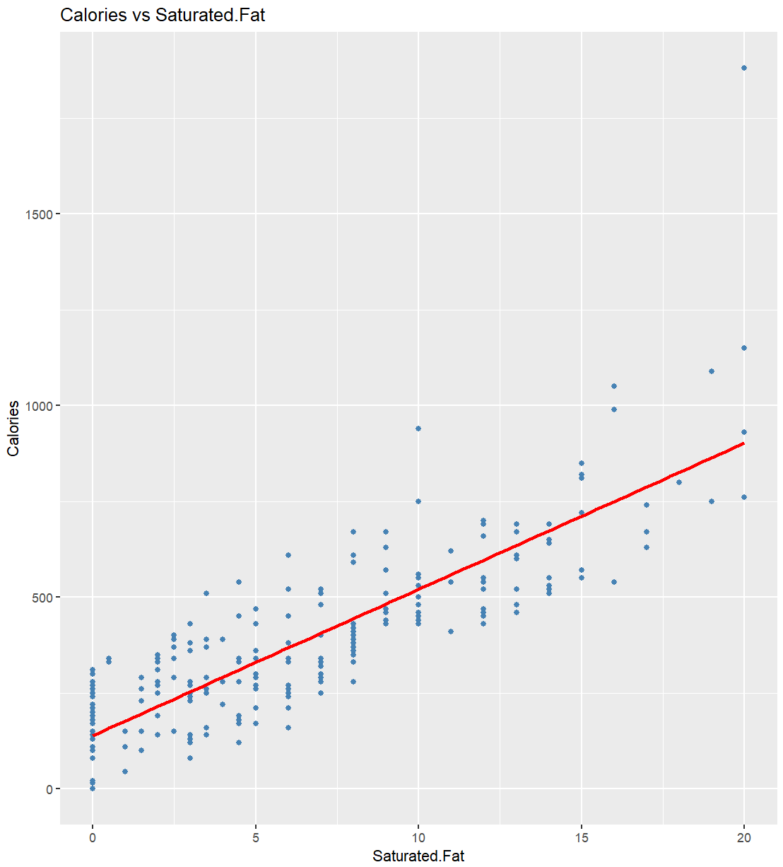
Saturated Fat vs Calories presents a strong and clear linear trend which makes sense since fat contributes a lot of calories inferring menu items with high fat relating to high calories.
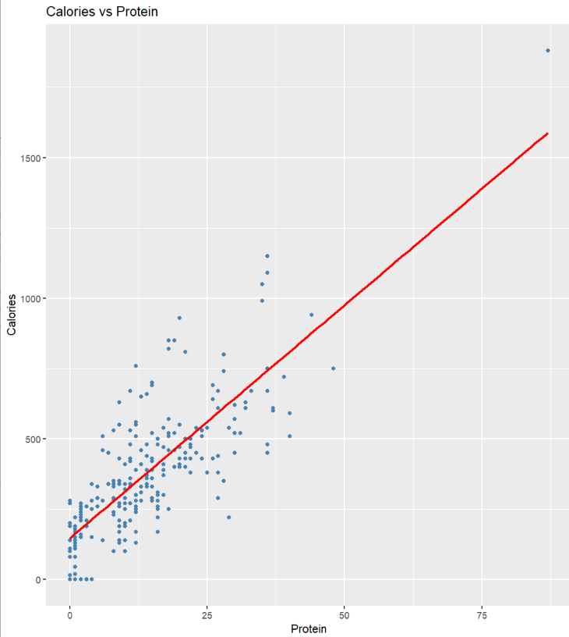
Similar upward trend is visible in Protein vs Calories as well, however with much spread between the data points.

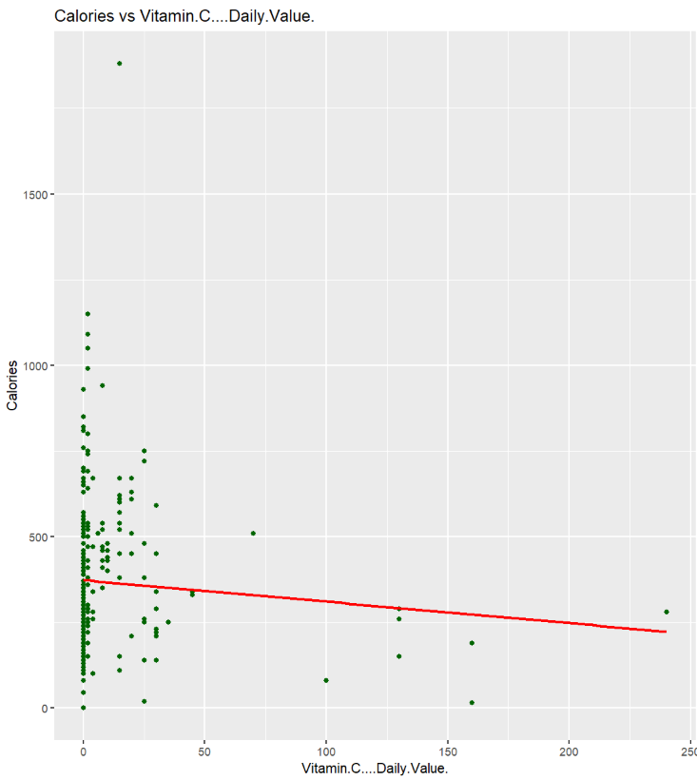
Vitamin C shows a negative relationship with calories among the McDonalds menu items. With most data points clustered at 0, it can be inferred that the menu items in McDonalds seriously lack Vitamin C content. The data points at the far end are most likely smoothies.

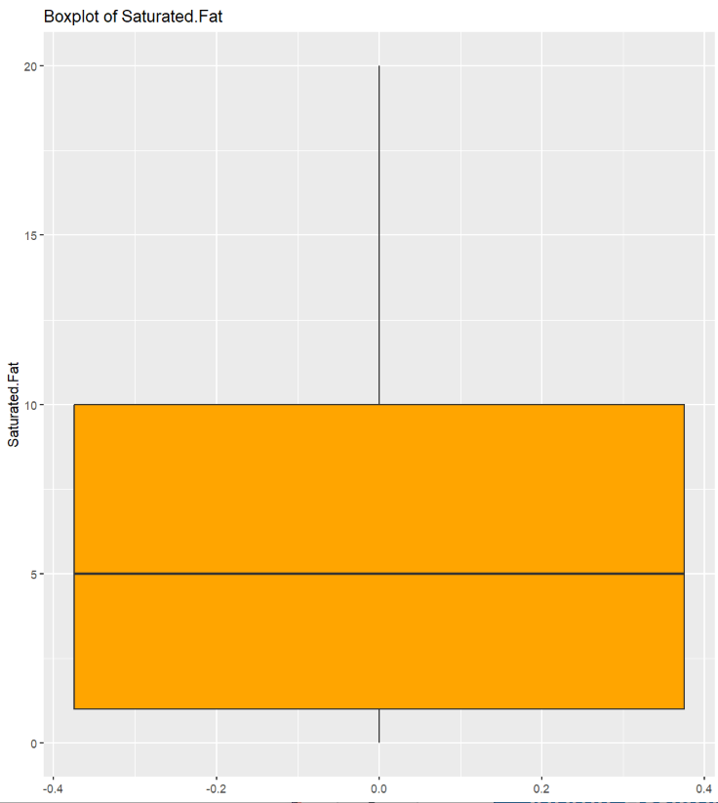
In the boxplot above, saturated fat content ranges from near 0 to upwards of 10 units inferring the distribution of beverages at the low end to smoothies and beer/pork items.

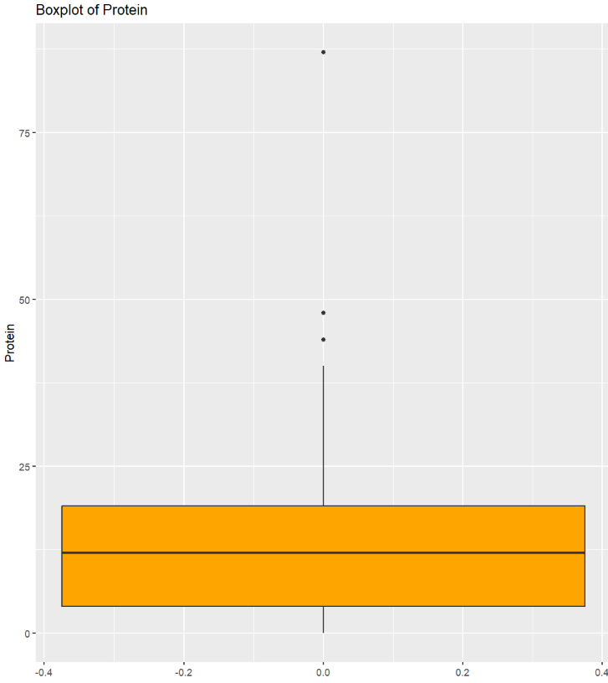
In the protein content, beverages again sit at the bottom of the plot while chicken and fish items are in the upper range with some lying in the outliers (most possibly combo meals).
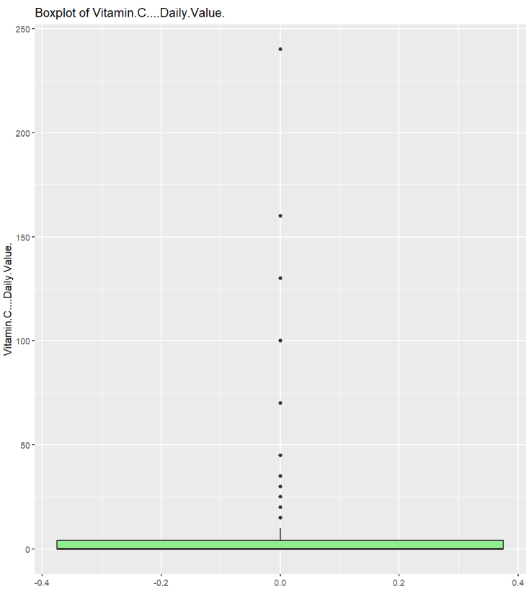
Vitamin C content is mostly clustered around 0 while some outliers like smoothies and shakes have very high Vitamin C content further explaining the lack of relationship between calorie count and Vitamin C content.

After calculating the median and standard deviation, following results were obtained:
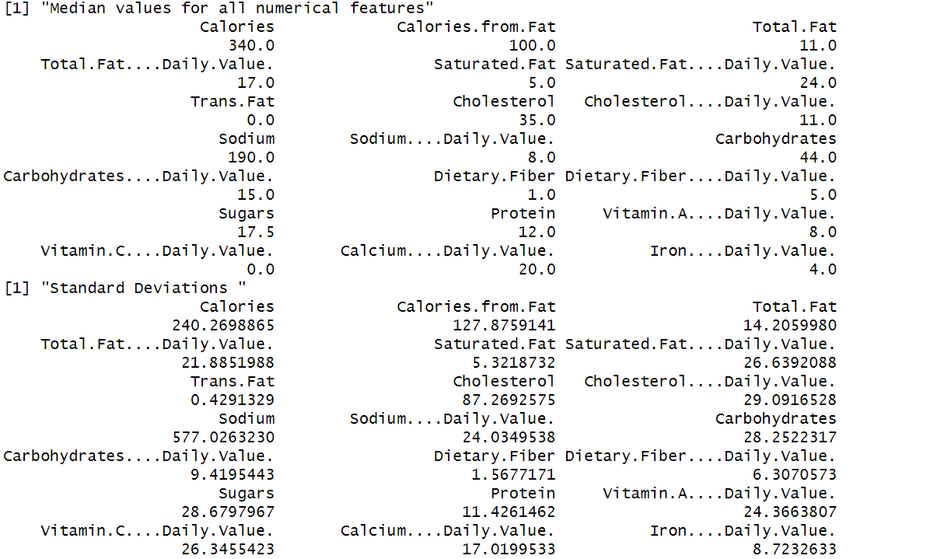
All the median values are the central values for each category, which gives us a rough estimate of where the features mostly lie.
Features like Calories, Total Fat, sodium and Carbohydrates have high standard deviation inferring that their values range widely for different menu items. Example: Apple slices to shakes.
In order to flag and remove any potential outliers in the features, 1.5*IQR rule was used and then replaced by NaN value. High calorie items like shakes had many outliers in Calories, Fat, Carbs and Sugars. Also, Vitamin and %Daily Value features had some in the lower ranger nearing 0.
Following are the counts of observations replaced by NaN in each column:
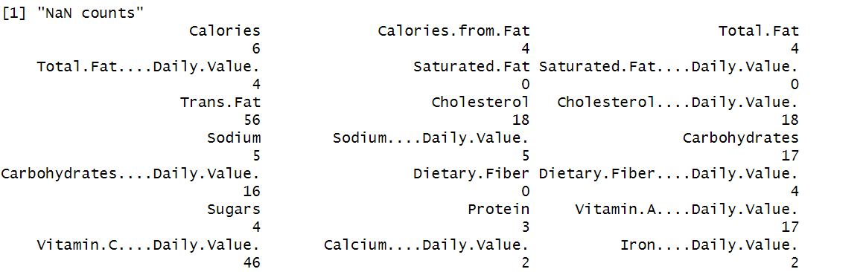
After imputing NaN fields with mean from each feature, we had the updated median and SD. Median did not change much because it was already robust to outliers, however SD show some improvement as the outliers are shrunk towards mean.
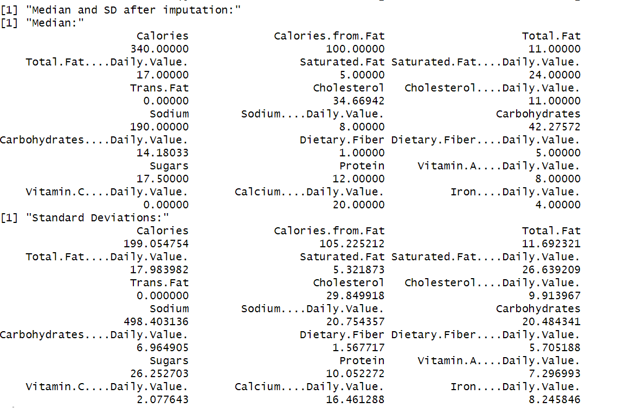
The central tendency of the dataset remained relatively stable while the variance dropped. This suggests that the "average" McDonald's item is consistent, but a few "mega" items skew the raw statistics significantly.

References:
Kaggle. (2017). Nutrition Facts for McDonald's Menu [Data set]. https://www.kaggle.com/datasets/mcdonalds/nutrition-facts
U.S. Department of Agriculture & U.S. Department of Health and Human Services. (n.d.). Dietary Guidelines for Americans. https://www.dietaryguidelines.gov/
U.S. Food and Drug Administration. (2022, February 25). Daily Value on the Nutrition and Supplement Facts Labels. https://www.fda.gov/food/nutrition-facts-label/daily-value-nutrition-and-supplement-facts-labels

