SAES Asset Register
Client Progress Report
Prepared for client review | 26 June 2026
This report summarises build progress for the Salvation Emergency Services Asset Register and provides a client-facing view of where the product stands today.
Executive Summary
The core application build is now 85.0% complete, covering login, assets, consumables, maintenance, deployments, attachments, dashboard, and offline foundations.
Across the broader implementation build, the project is 71.8% complete. Across the full end-to-end delivery checklist, which also includes documentation, deployment, training, and client rollout readiness, overall completion is 50.8%.
Testing readiness
The application is now strong enough for a guided preview and internal QA, but it is not yet at the point I would classify as formal client testing readiness. The remaining work is mainly around audit trail completion, reporting/export, deeper test coverage, and deployment/handoff polish.
Progress Snapshot
Measure | Progress | Status | Notes
Core application build | 85.0% | Preview-ready | Main operational modules are in place and usable for guided review.
Implementation build | 71.8% | In progress | Build work is well advanced, but testing and operational polish are still active.
Full project checklist | 50.8% | Mid-project | Includes deployment, handoff, documentation, training, and broader readiness work.
What Is Already Working
- Supabase-backed login with a working QA account for internal review.
- Asset management, including fleet/plant records and parent-child asset relationships.
- Consumable batch tracking, stock movement logic, and threshold alert foundations.
- Maintenance schedules, maintenance records, and approved vendor management.
- Deployment workflows linking assets and consumables to operational events.
- Attachments and document handling across operational records.
- Offline mutation queue and sync engine foundations.
- Operational dashboard with alert-oriented summary views.
Module Status
Module | Percent | Status | Checklist
Technical Foundation | 73.1% | In progress | 19/26
Supabase and Database Foundation | 73.9% | In progress | 17/23
Authentication and Roles | 81.2% | Advanced | 13/16
Locations | 73.7% | In progress | 14/19
Asset Management | 92.7% | Substantially complete | 38/41
Consumable Batches | 96.4% | Substantially complete | 27/28
Stock Movements | 89.3% | Advanced | 25/28
Planned Maintenance | 87.1% | Advanced | 27/31
Deployments | 95.2% | Substantially complete | 20/21
QR Codes and Scanning | 76.5% | Advanced | 13/17
Attachments, Photos, and Documents | 100.0% | Substantially complete | 17/17
Offline-First and Sync | 72.7% | In progress | 16/22
Dashboard | 85.7% | Advanced | 12/14
Testing | 31.8% | Early | 7/22
Before Formal Client Testing
- Finish the audit trail module and its related reporting surfaces.
- Complete reporting/export screens and validate the expected output set.
- Increase end-to-end and real-device QA, especially for scan and field workflows.
- Complete deployment and handoff readiness, including client-safe environment setup.
Preview Position
The product has moved well beyond specification and scaffold stage. It is now a functional working build with the major operational modules visible and connected. My recommendation is to use the current build for a guided preview, not yet as a formal client test release.

Dashboard
Operational overview with headline counts, alert surfaces, and links into the main workflows.
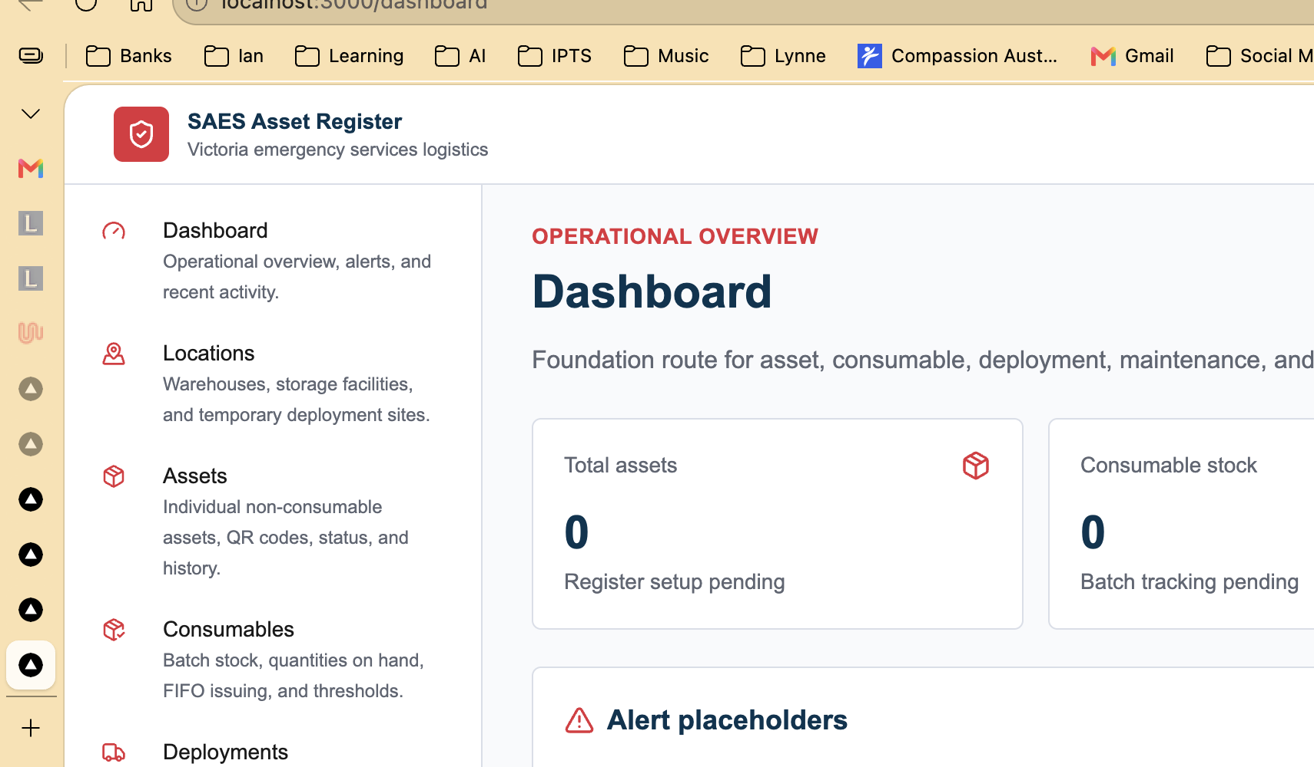
Captured from the working preview environment.

Assets
Asset register with filtering, status handling, detail views, and QR-ready records.
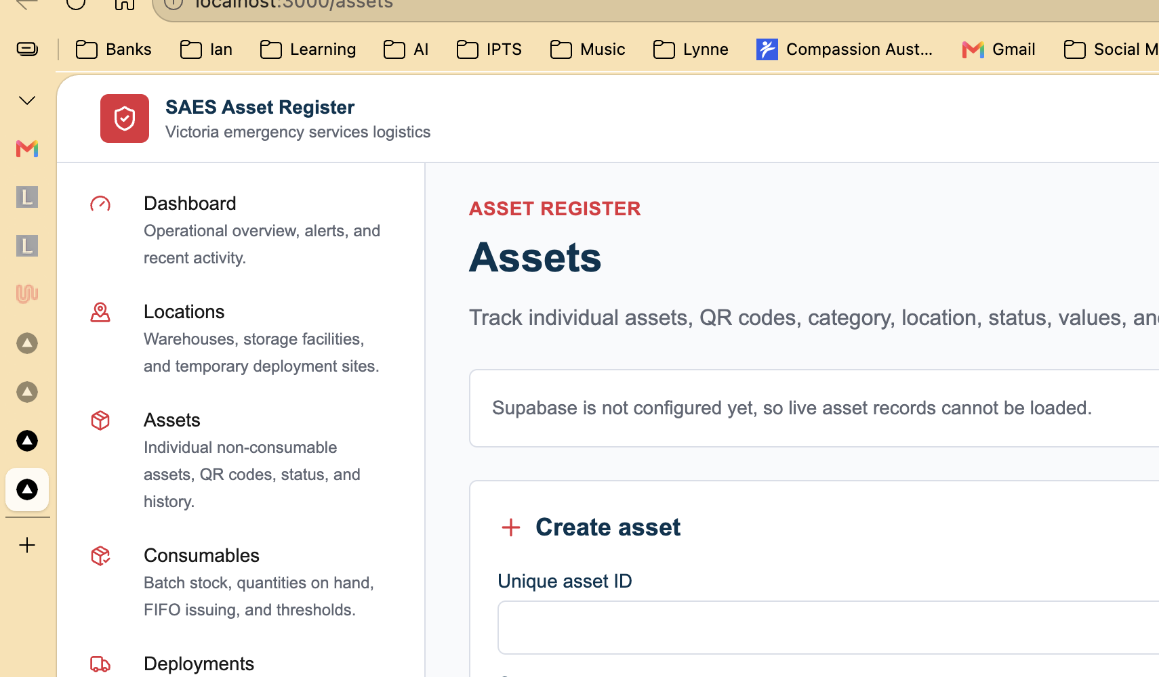
Captured from the working preview environment.

Consumables
Consumables and batch tracking screen for stock on hand, issue flows, and thresholds.
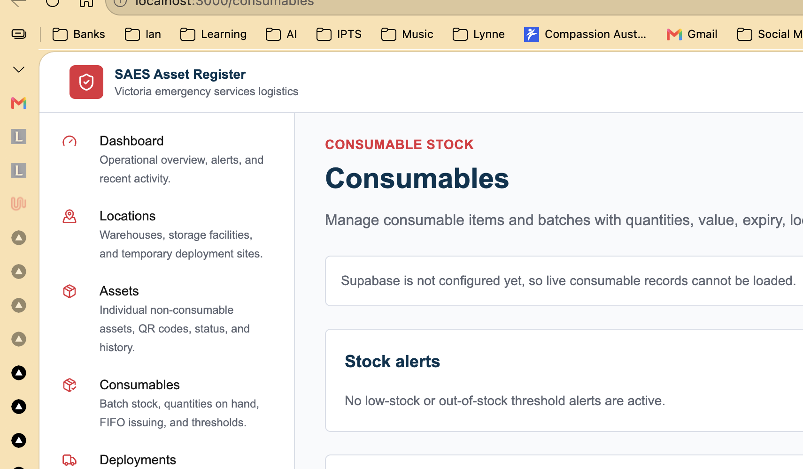
Captured from the working preview environment.

Maintenance
Maintenance schedules, service records, approved vendors, and due/overdue visibility.
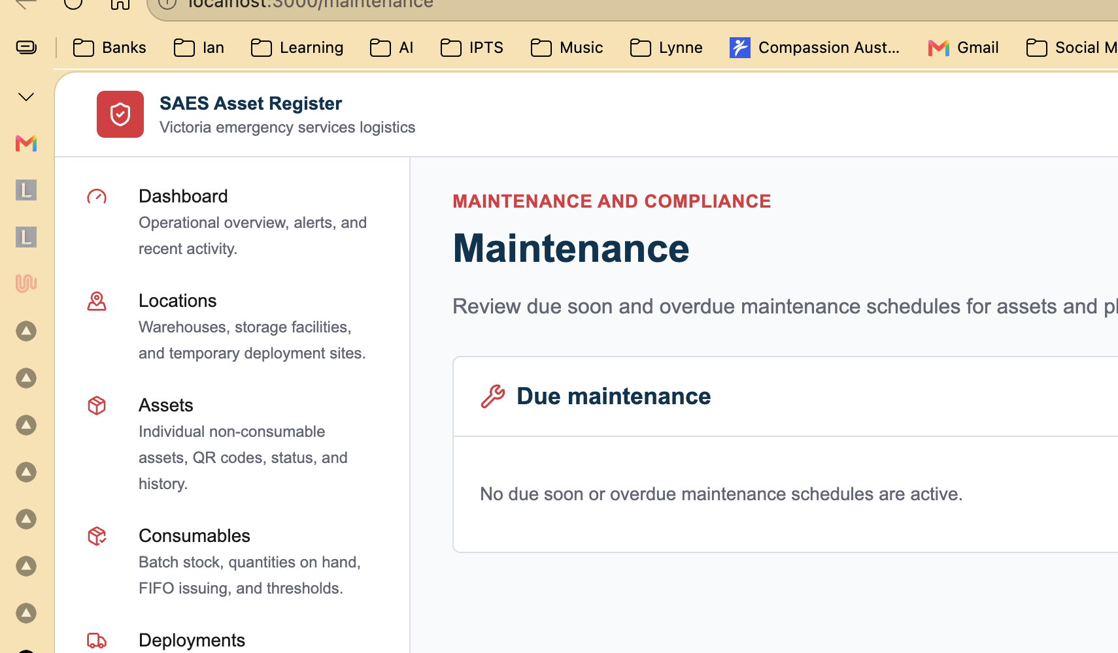
Captured from the working preview environment.

Deployments
Deployment planning and tracking with operational assignment flows for assets and consumables.
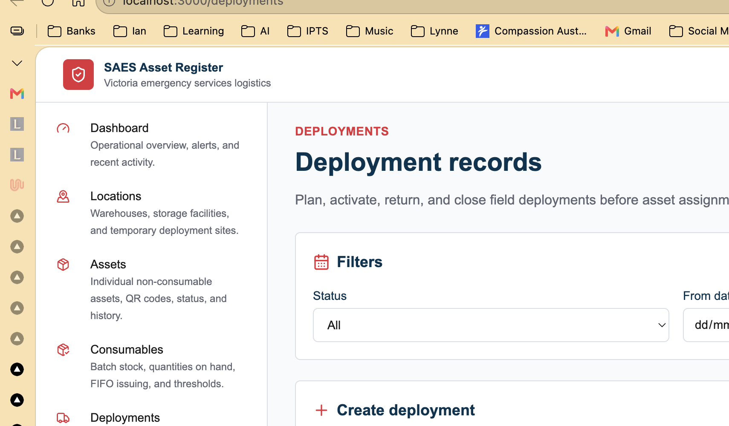
Captured from the working preview environment.

Login
Supabase-backed authentication screen now wired for real QA access.
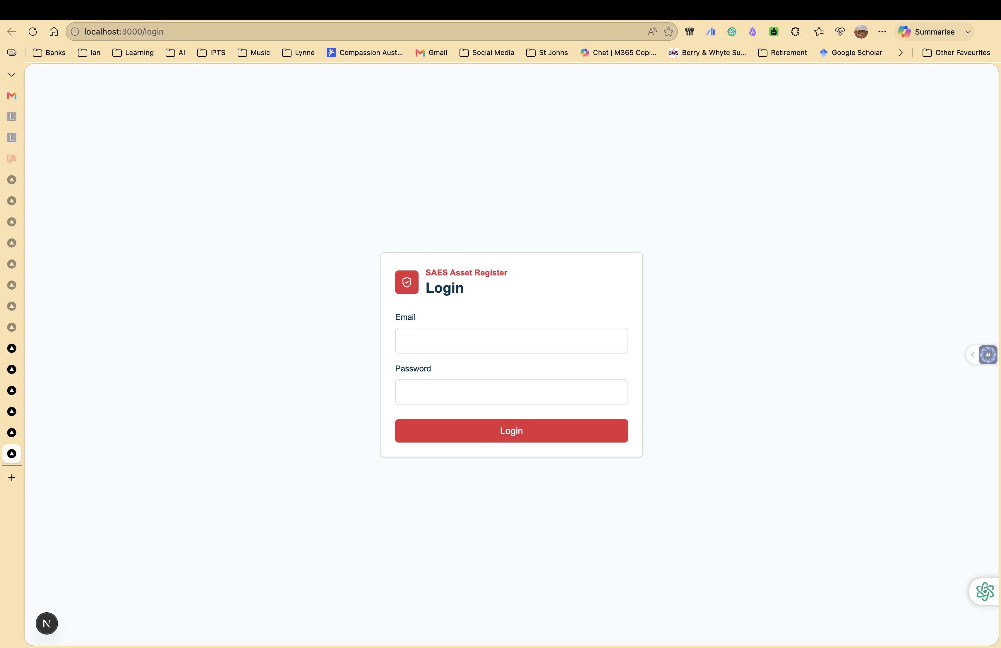
Captured from the working preview environment.

