SAES Asset Register
Client Progress Report
Prepared for client review | 19 June 2026
This report summarises the current build progress for the Salvation Emergency Services Asset Register and includes screenshot evidence of the client-facing screens completed so far.
Executive Summary
The core asset-register foundation is now in place. The project currently covers operational overview, location management, asset records, consumable stock control, maintenance scheduling, deployment tracking, and login flow preparation.
The application is running locally and the main workflows are wired into the interface. Because the live Supabase environment has not yet been configured in this development workspace, the screens currently show the structure, forms, and empty-state messaging rather than real operational data.
Completed In This Build
- Dashboard route with operational summary cards and alert space.
- Locations register with create and update workflow support.
- Asset register, forms, filters, and detail-page foundation.
- Consumable items, batches, issue handling, and stock movement rules.
- Maintenance schedules, service records, and due-maintenance review screen.
- Deployment records with asset assignment and consumable issue support.
- Login page prepared for authenticated access once environment setup is complete.
Current Build Status
Module | Status | Current scope
Dashboard | Built | Operational summary layout and alert scaffolding
Locations | Built | Location register and create/update flows
Assets | Built | Asset list, filtering, forms, and detail route
Consumables | Built | Items, batches, issue flows, and stock movement logic
Maintenance | Built | Schedules, records, audit logging, and due views
Deployments | Built | Deployments, asset assignment, and consumable issue flows
Authentication | Built | Login experience ready for Supabase configuration
Environment Note
These screenshots were taken from the local development build in Microsoft Edge on 19 June 2026. Live data loading is intentionally deferred until the Supabase public URL and anon key are configured for the environment.
Additional routes already exist in code for asset details, consumable batch details, consumable item details, deployment details, audit, reports, settings, and health checks. The pages shown in this report are the modules that are currently the clearest client-facing view of delivered progress.

Dashboard
Operational overview with headline counts, alert placeholders, and space for activity summaries.
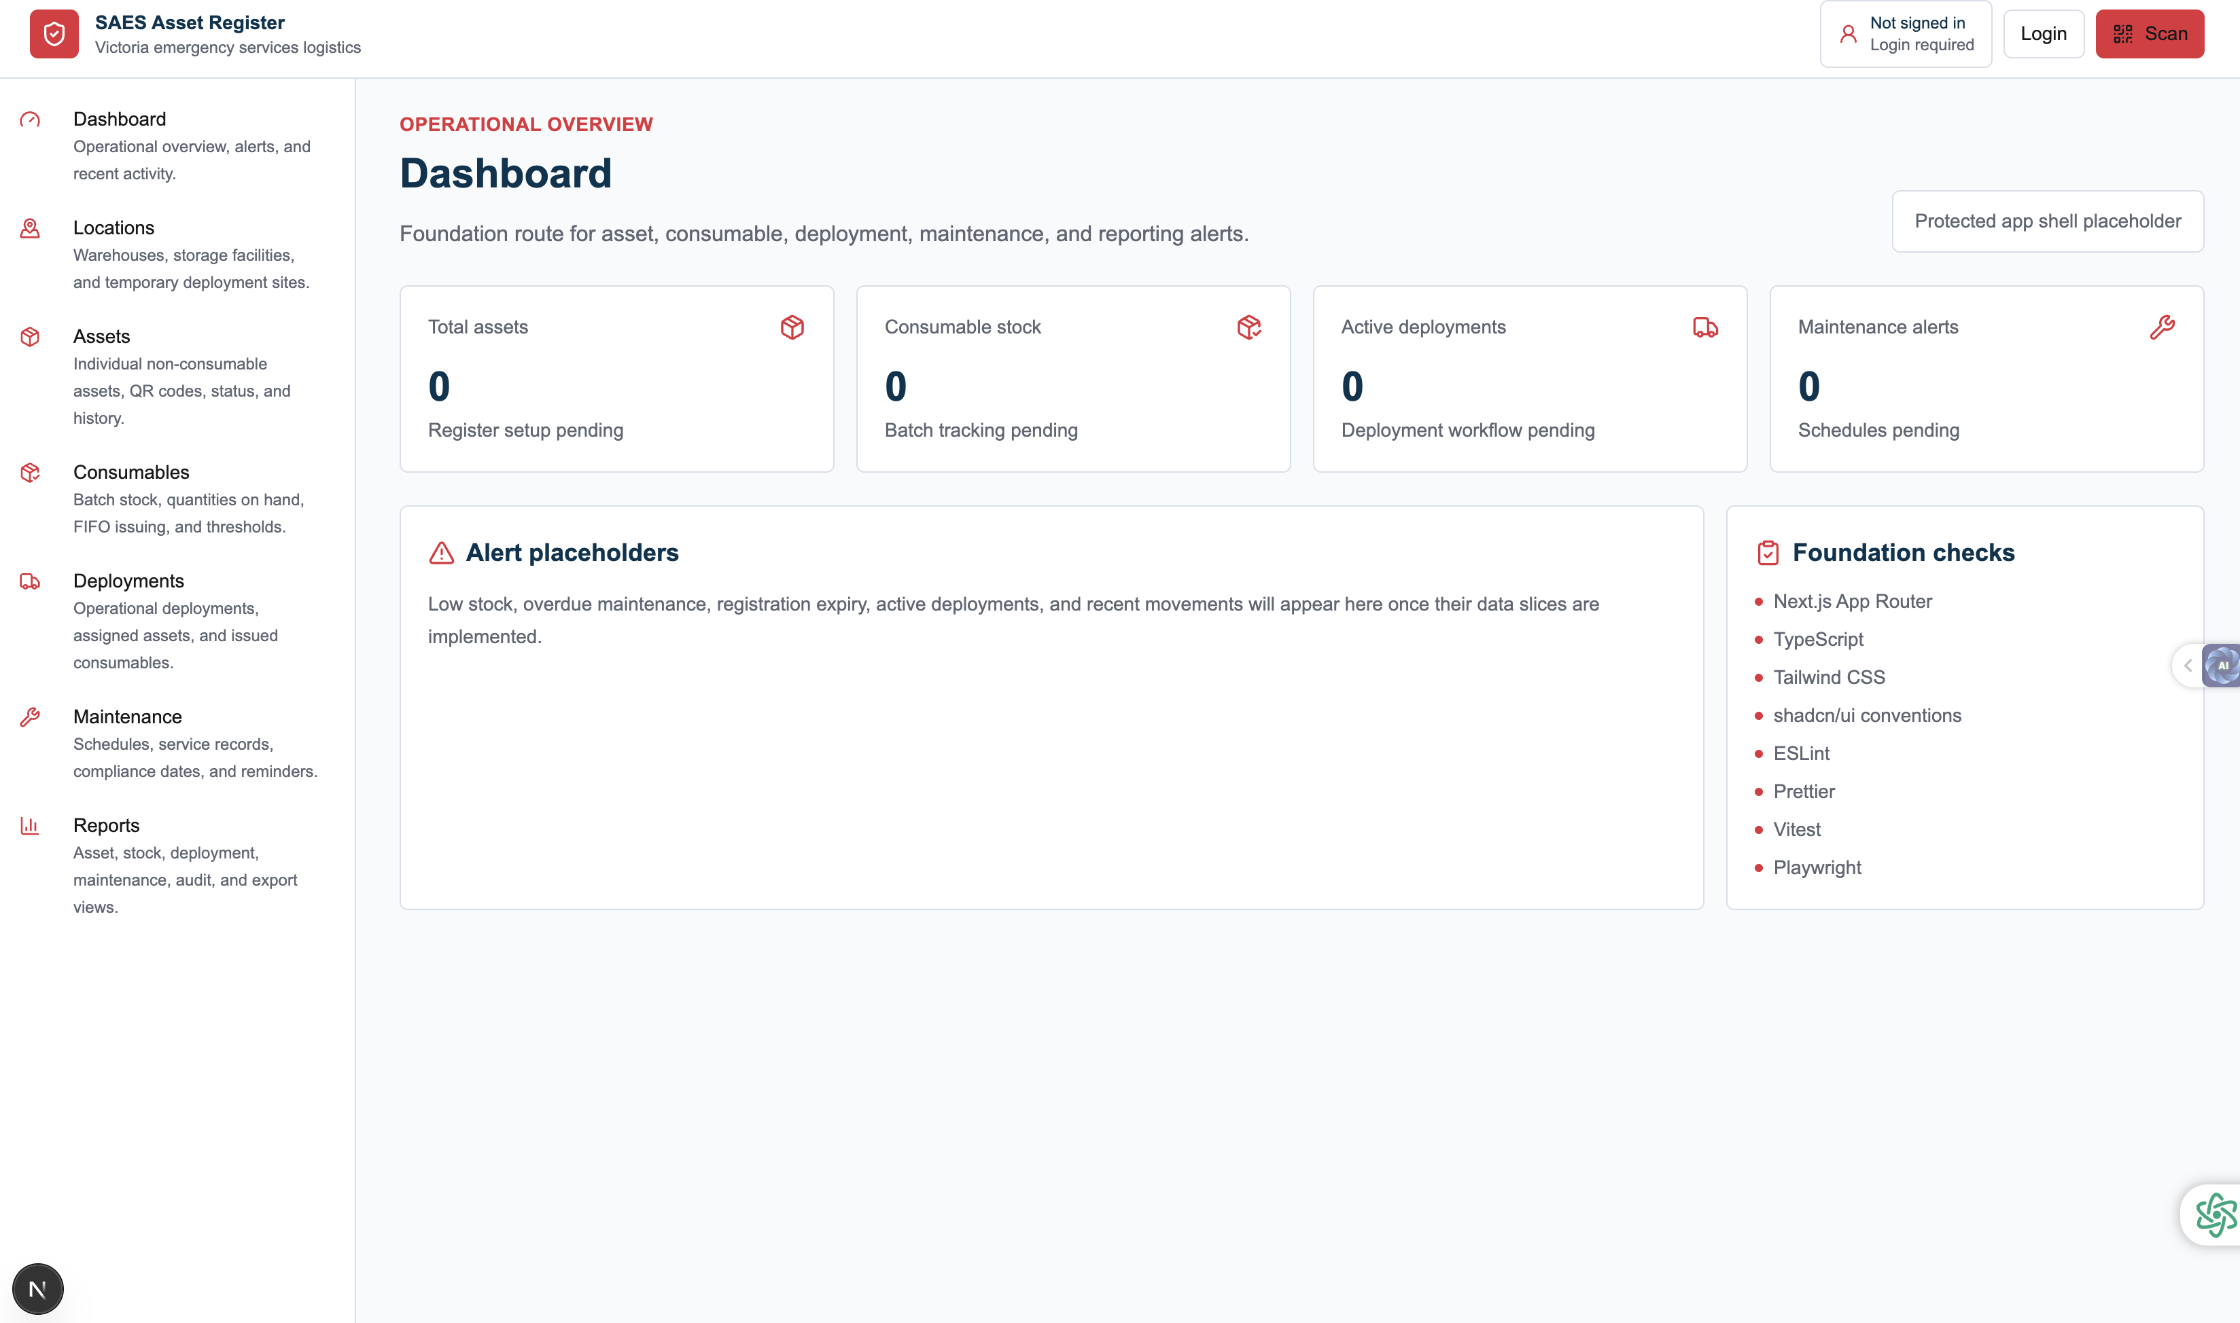
Captured in local Microsoft Edge review mode.

Locations
Location register for warehouses, storage points, and temporary deployment sites.
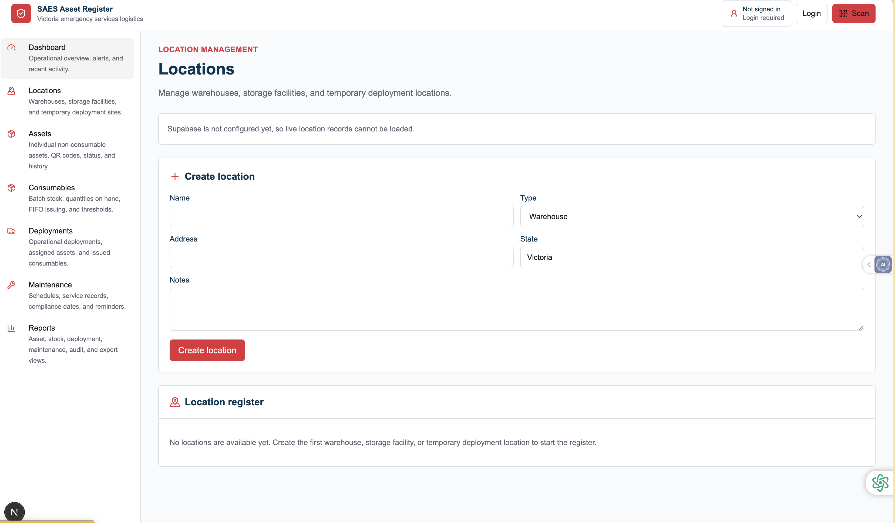
Captured in local Microsoft Edge review mode.

Assets
Asset register with filters, status handling, and create/edit flow entry points.
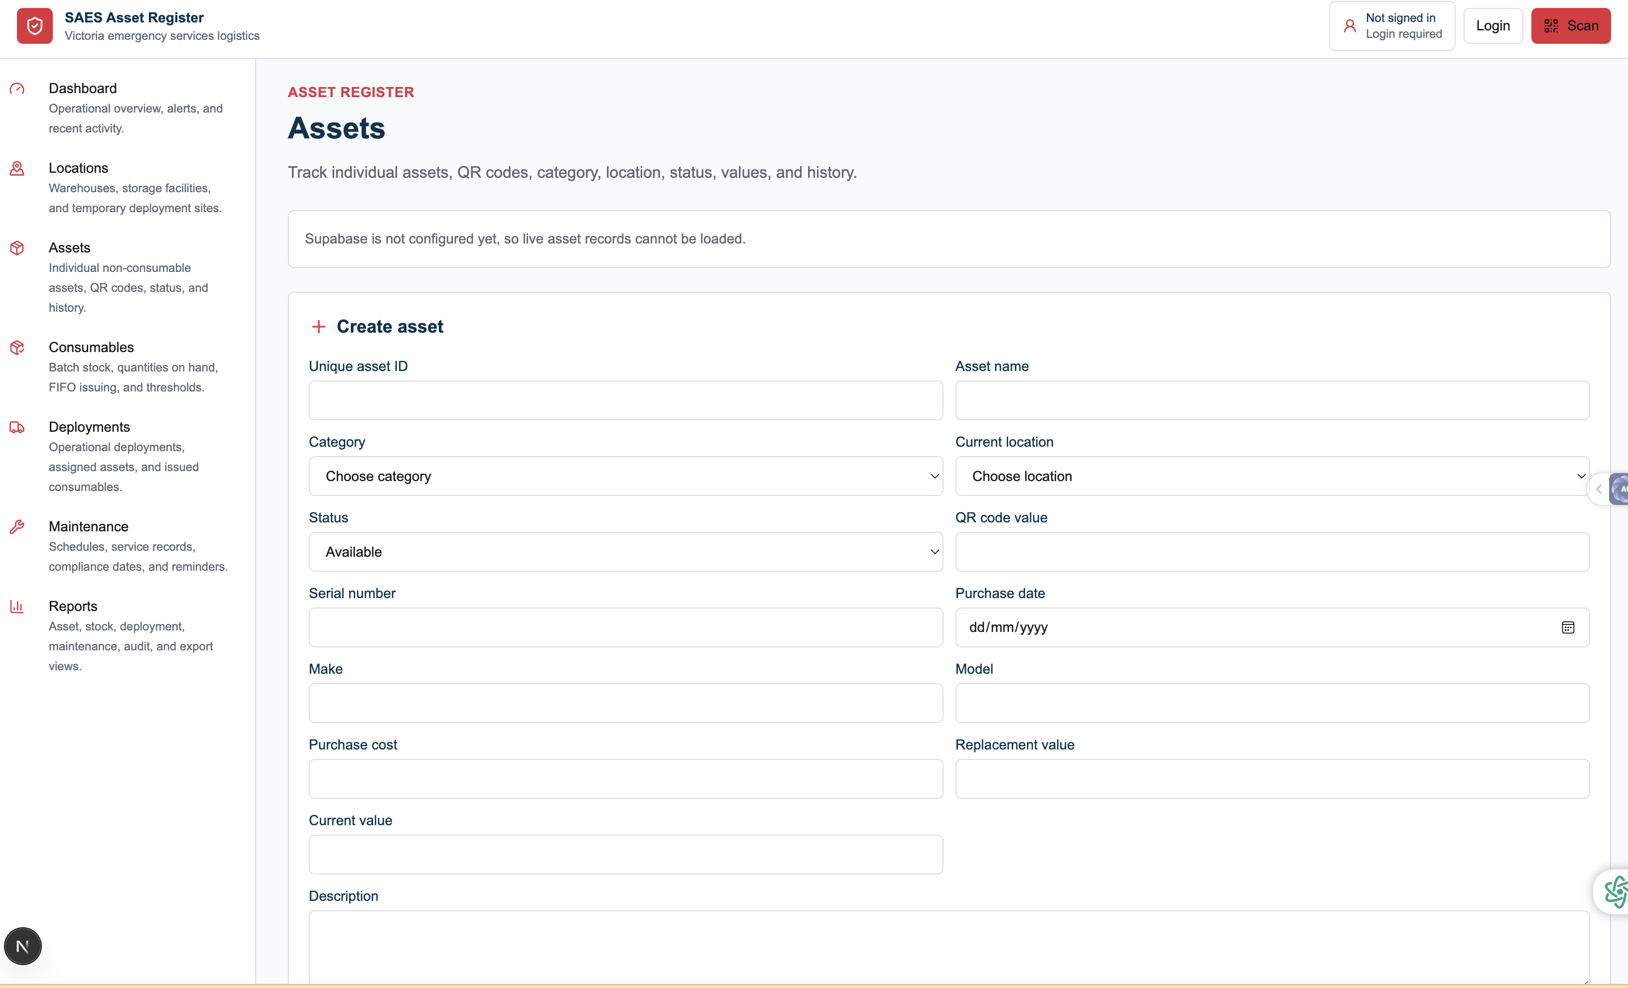
Captured in local Microsoft Edge review mode.

Consumables
Consumables and batch tracking screen for stock on hand, issue flows, and threshold management.
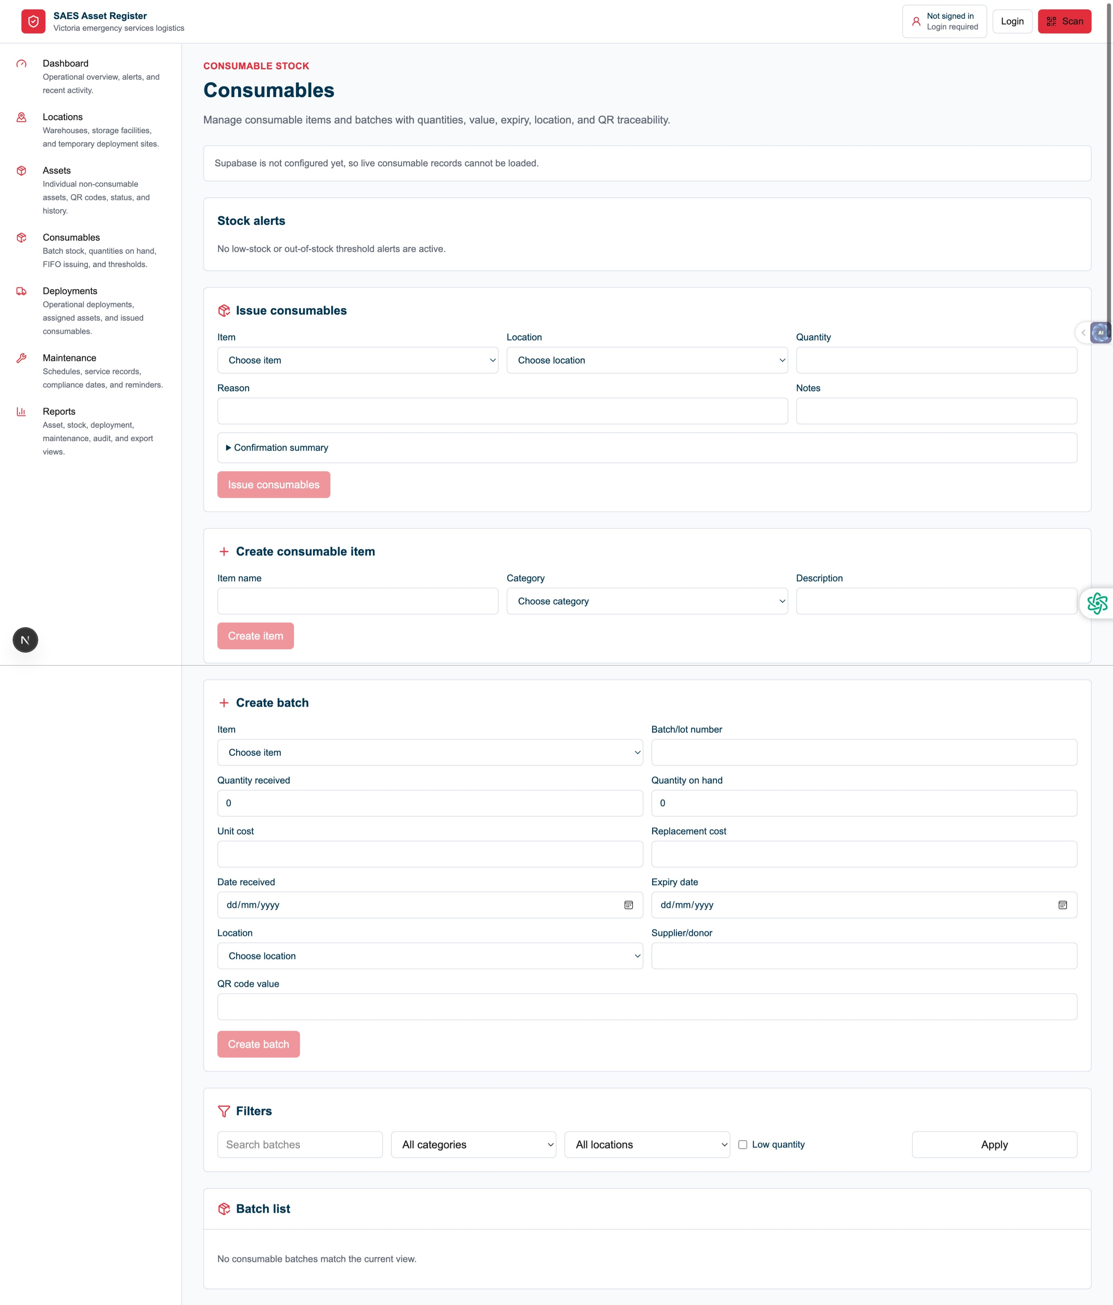
Captured in local Microsoft Edge review mode.

Maintenance
Maintenance and compliance view for upcoming schedules and overdue servicing work.
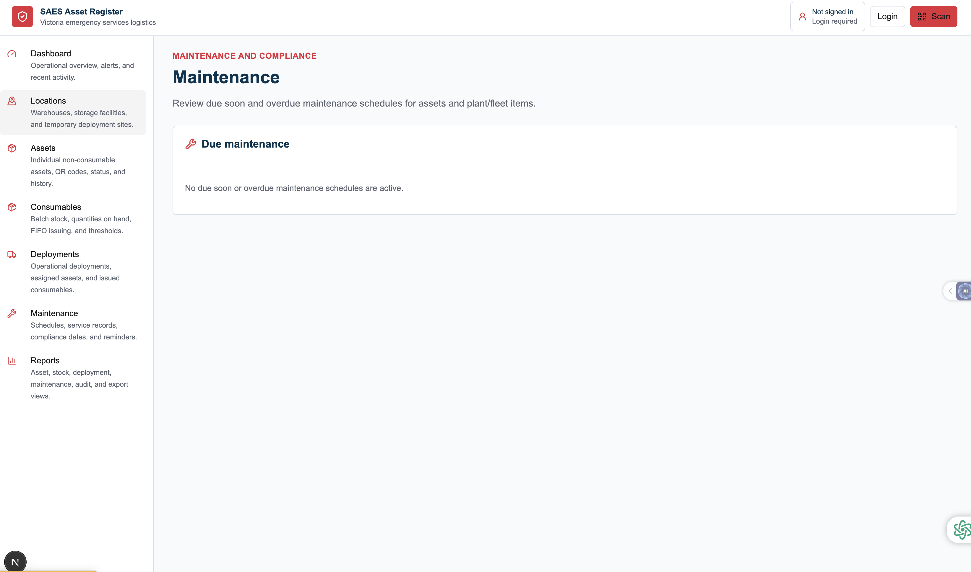
Captured in local Microsoft Edge review mode.

Deployments
Deployment planning screen with filtering, creation flow, and future field operation tracking.
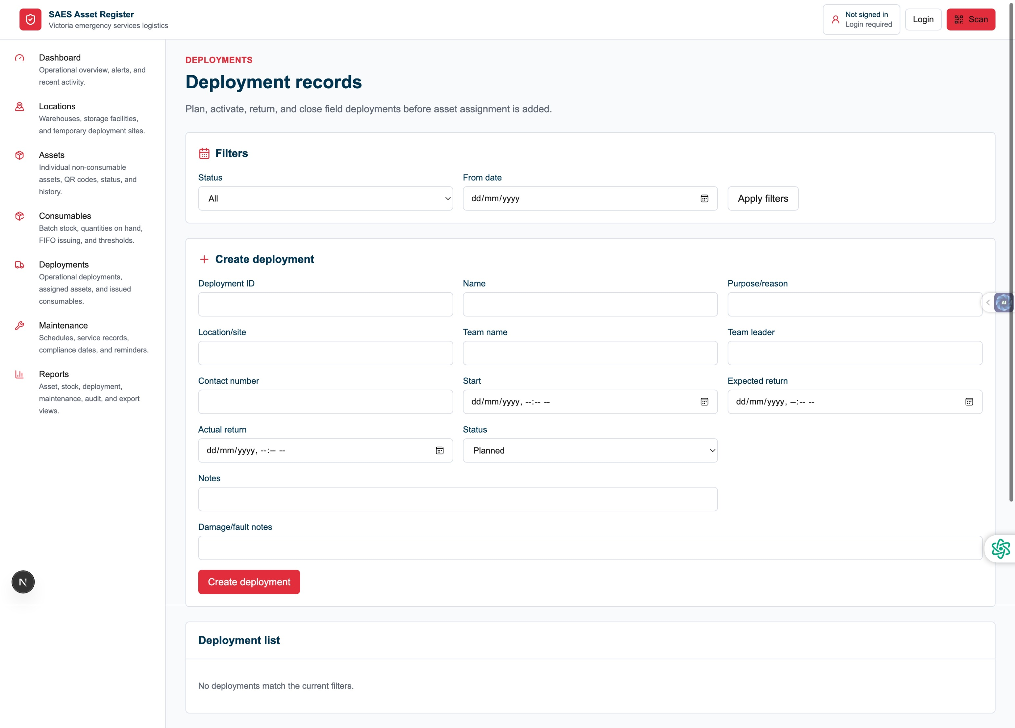
Captured in local Microsoft Edge review mode.

Login
Authentication screen wired for Supabase-backed sign-in once environment variables are configured.
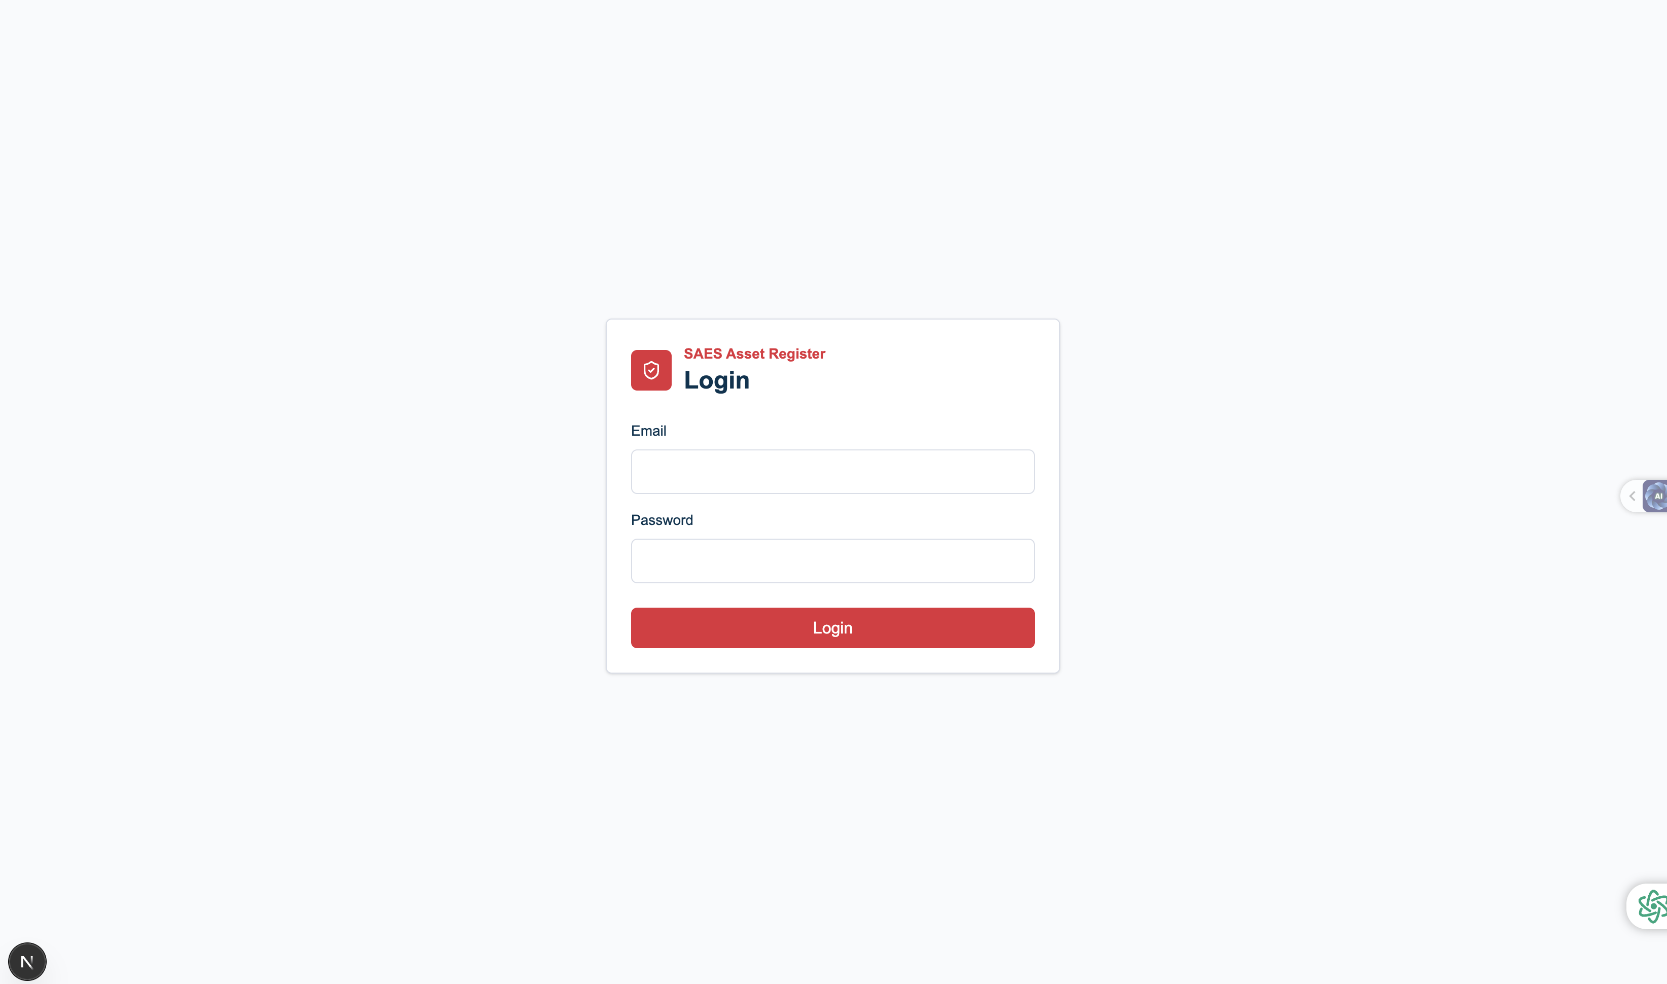
Captured in local Microsoft Edge review mode.

