**Index**

1- Introduction

2-phases on violent behavior

3-use of serotonin levels to detect violent behavior

4-upgrade of Nexcor to implement violence detection technology

**Introduction**

According to the Oxford Dictionary, Aggression is defined as the feeling of anger or antipathy resulting in hostile or violent behavior. In other words, it can be defined as the readiness to attack or confront.

Aggression can be Instrumental or Reactive. Instrumental aggression is used in order to accomplish a goal. For example: the football players use instrumental aggression in order to perform better during a match, but this type of aggression is not intended to cause any harm to the other players playing in the match.

Reactive Aggression may be Physical or Verbal. In the course of this research study, I will be focusing more on physical aggression, how to detect it before it can cause any harmful activity.

Before entering in detail about reactive aggression, let’s understand aggression properly.

For a person to reach to a violent behavior, 3 stages must be manifested.

The first is **Anger**. Anger is a normal emotion, it’s neither good nor bad and no judgment need to be attached to it.

A person can be angry and nobody would know it unless the person demonstrated some behavior associated to anger. Anger can even cause positive emotions like motivation. The issue is not to eliminate anger but to keep it at a level where it assists performance.

When anger increases, Cognitive processing speed goes down, fine motor coordination and sensitivity to pain decreases and muscle strength often increases. When such symptoms emerge, we enter to the second stage which is called **Aggression.**

Aggression is the intention to harm or injure others. This behavior is usually triggered by injustice, insult or wrongdoing. For example, a dog baring his teeth is showing aggression though it may not become violent towards another dog or person.

Uncontrolled aggressive behavior brings up the third stage which is **Violence.**

Violent behavior is usually linked with brain chemicals like serotonin and testosterone. Low levels of serotonin have been linked with violent behavior and high secretion of testosterone has been shown to be correlated with violent (though the role of testosterone in violent behavior has been constantly analyzed since many researches show that this theory is not consistent enough).

Knowing that low levels of serotonin have been linked with violent behavior, let’s look at how it can be used in order to predict when a person is prone to develop aggressive features way before it turns into a harmful situation.

Serotonin is a tiny molecule, bibelot built of 10 carbon atoms, a dozen of hydrogen, 2 nitrogen atoms and a single oxygen atom. It has various receptors, a transporter and a janitorial protein that removes the serotonin once the task is through.

Serotonin is also referred as 5-HTP (5-hydroxy-tryptophan) and is located at the midbrain and hindbrain. It’s one of the most important feel good neurotransmitters. It’s also called the “happy molecule” for the role it plays in positive mood. Serotonin regulates mood, social behavior, sleep, memory and learning.

Though serotonin is also found in the brain, 95% of it is manufactured in the intestines. That’s why experts consider it as a hormone as well as a neurotransmitter.

This molecule was first detected in 1948 in blood serum and it was shown to be a vascular toning agent that cause blood vessels to constrict.

This constriction of blood vessels caused by the serotonin levels is our main focus in order to understand the effects or significance of serotonin in causing violent behaviors in people.

Serotonin dysfunction will influence aggression differently depending on the individual’s impulse control, emotional regulation and social abilities.

The communications between the amygdala and the prefrontal cortex is weak following serotonin depletion.

Weak communication means that is more difficult for the prefrontal cortex to control the feelings of anger that are generated within the amygdala when the serotonin levels are low.

Between 2012 and 2013 in Brazil, the CORCAM Tecnologia SA with the help of Flextronics Institute of Technology (FIT) as well as many other companies, launched the Nexcor -Heart Monitoring Device-to help reduce the propagation of cardiac arrests in patients having heart conditions.

This device is wearable and is used to monitor all the heart activities of the person wearing it. If any abnormal activity is registered, the device sends a notification to the hospital and a doctor calls to assist the patient immediately.

My goal is to use the basic functionalities of the Nexcor to help in the detection of blood vessels constrictions and use it to detect aggression on people.

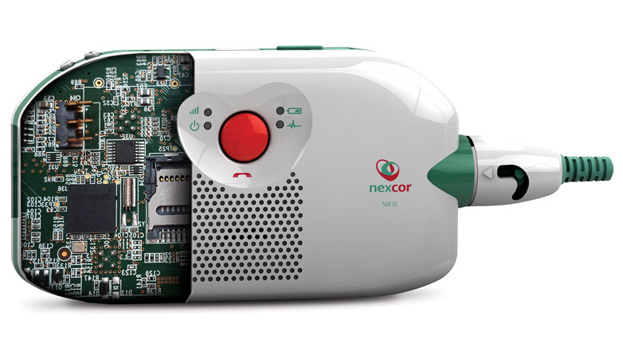

The components of Nexcor include:

Battery, Electrodes, Charger, SIM card, USB entry, ADC (Analog to Digital converter, 10 bits), Accelerometer, Audio Integrated Circuit (microphone and speaker), GPS( frequency LI-1575.42MHz), GSM/GPRS quad band-850,900,1800 and 1900MHz , monitor and many others.

Basically, by adding some additional features to the device so that it can detect the constriction of blood vessels, it will be possible to predict the violent behavior of a person.

Since, the Nexcor originally contains a feature that allows the doctor to get a notification when the patient is undergoing some abnormal activity in his body, this feature can also be used to alarm the doctor that the person is about to show some aggressive behavior.

With this technology, it’s possible to prevent patient on patient violence and patient on care giver violence.

**Bibliography**

1. The Oxford dictionary

2. [www.bebrainfit.com](http://www.bebrainfit.com)

3.www.researchgate.net

4. www.sciencedaily.com

5. www.natural.health-alternative.blogspots.com