**Term Project – Phase 5**

**Introduction to Database Management**

**COMP122 – 003**

**Ryunghi Kim – 300920995**

**Peter Iljung Yoon – 300982328 – Group Leader**

Table of Contents

Problem Description 2

Fact Finding 2

Business Rules 3

Identifying Users 4

User’s Data Requirements 4

E-R Diagram 6

Table Relationships 7

Meta Data 7

Normalization of Tables to 3NF 8

Users 8

SnsList 8

UserMonitorSns 8

UserSnsUseLog 8

SnsRestrictionRule 9

UserRewards 9

Create Script 10

Insert Data Script 11

Queries 13

Query1 13

Query2 14

Query3 15

Query4 16

Query5 17

Query6 18

References 19

# Problem Description

The emergence and prevalence of social media has taken the world by storm and it is one of the main forms of entertainment for many people. Teenagers and young adults are especially connected to these social media platforms such as Facebook, Instagram, and Youtube. Although social media allows family members and friends to connect whenever and wherever they want, the addiction to social media is far too real and it can be extremely difficult to cut one’s online presence. Instagram and Facebook allow users to endlessly scroll through their feed, and Youtube has recommended and related videos for users to indulge continuously. The time spent on social media has increased with advancing technologies, most notably the smartphones, and ironically is making users of social media more anxious. In addition, attention span has drastically lowered and studies show that those who spend less time on social media tend to focus on tasks better than those who indulge on those platforms. Furthermore, people are shifting their priorities to value virtual relationships more than real relationships that can cause problems such as developing bad social skills. It is recommended that a new system be developed and deployed so that users of social media applications are enabled to control themselves and be aware of the amount of time spent on these platforms. This system is to be deployed as an app that is accessible to all people with a smart phone.

# Fact Finding

With the convenience of smartphones and easy access to modern technology, social media is one of the most used applications on the mobile market with Facebook, Instagram, and Youtube all garnering over a billion downloads each. A study by the PEW Research Center indicates that about 88% of Americans from age 18 to 29 (Greenwood, 2018) use social media and the result of social media consumption can be addiction that is harder to resist than cigarettes and alcohol (Meikle, 2012). Social media can be difficult to cut off as there of many factors of satisfaction users get when using social media such as social validation, instant gratification, and general brain chemistry (Psychology of Social Networks, 2016). The addition is real and can result in disassociation with the real world, anxiety, distraction, lack of exercise, and fatigue (Sysomos, 2017).

It is futile to combat social media addiction with conventional means by trying to raise awareness with advertisements or campaigns. With many youth and young adults having access to smartphones, it is important to remain interactive with this user demographic and develop a software that will be accessible to reach and easy and rewarding to use.

The software system will allow users to connect their social media profiles to one application to track usage data and analyze daily, weekly, and monthly usage to reveal to users how much they actually use these platforms. In addition, users can set goals for themselves to limit their usage and allow for alerts to be sent when reaching the limit. Furthermore, a weekly incentive can be awarded to selected users which will create more appeal and awareness.

# Business Rules

1. Member Register

* New users enter basic information: name, phone number, email through client application.
* The servers receive the information and store it to database.

1. Register Social Network Service use monitoring

* Users choose Social Network Service that needs to be monitored through client application.
* The client application gets permission and then monitors the use of Social Network Service.

1. Restriction Social Network Service use

* The user sets the time target first. Daily, weekly or monthly.
* The client application gathers statistics for use of social network services then sends the data to the database.
* The monitor system judge if use time is less than the restriction rules, if it satisfies, the sponsor and marketing manager will reward users with a present.

1. Statistics and Analysis

* Application gathers statics then sends the data to the database.
* The monitoring system analyses and stores the data of which how long does the user use the social network services for a time, and How long it takes for people to use the duration of the social network services.

1. Reward Achievements

* Chosen users will be contacted that they have reached their goal and have won a prize
* Confirmation to be sent out to user to verify

# Identifying Users

Service users

* People using the application

Social Media Analyst/Marketing Manager

* Person responsible of collecting and analyzing statistics and data collected from users

Sponsors

* Person(s) responsible for providing prizes/donations for users

User’s Data Requirements

(※ SNS or Sns stands for Social Network Service)  
(※ PK : Primary Key FK: Foreign Key)

|  |  |  |  |
| --- | --- | --- | --- |
| Users | Table Name | Fields | Description |
| • Customer | Users | - User Index(PK)  - User Name  - Email ID - phone number  - Password | • Store User account information. |
| • Customer  • Marketing  Manager | UserMonitorSns | - Monitor Index(PK)  - User Index(FK)  - SNS ID | • Store User’s SNS which are supposed to be monitored.  • SNS ID refers to specific predefined numeric index. |
| • Customer  • Marketing  Manager | SnsRestrictionRule | - Restriction Index(PK)  - User Index(FK)  - Hour Per a day  - Hour Per a week  - Hour Per a month | • Store SNS restrictions rules which are requested by user. |
| • Customer  • Marketing  Manager  • Sponsor | UserSnsUseLog | - Log Index (PK)  - User Index (FK)  - SNS ID  - Start Datetime  - End Datetime | • The system saves User’s SNS activities(connected time and disconnected time) |
| • Customer  • Marketing  Manager  • Sponsor | UserReward | - Reward Index(PK)  - User Index(FK)  - Present ID  - Received | • If user achieved its goal, the sponsor gives small present.  • Present ID refers to specific predefined present numeric index. |

E-R Diagram

Table Relationships

|  |  |  |
| --- | --- | --- |
| Table | Relationship | Table |
| Users | 1:M | UserMonitorSns |
| 1:M | UserSnsUseLog |
|  | 1:M | SnsRestrictionRule |
|  | 1:M | UserReward |
| SnsList | 1:M | UserMonitorSns |
|  | 1:M | UserSnsUseLog |
|  | 1:M | SnsRestrictionRule |

Meta Data

|  |  |  |  |  |
| --- | --- | --- | --- | --- |
| **Table** | **Attribute** | **Key Type** | **Data Type** | **Required** |
| Users | UserIndex | Primary Key | Number(15) | Yes |
| Name |  | Varchar2(25) | Yes |
| Email |  | Varchar2(30) | Yes |
| PhoneNumber |  | Number(12) | No |
| Password |  | Char(64) | Yes |
| UserMonitorSns | MonitorIndex | Primary Key | Number(15) | Yes |
| UserIndex | Foreign Key | Number(15) | Yes |
| SnsID |  | Number(2) | Yes |
| UserSnsUseLog | LogIndex | Primary Key | Number(15) | Yes |
| UserIndex | Foreign Key | Number(15) | Yes |
| SnsID |  | Number(2) | Yes |
| StartDate |  | Date | Yes |
| EndDate |  | Date | No |
| SnsRestrictionRule | RestrictionIndex |  | Number(15) | Yes |
| UserIndex | Primary Key | Number(15) | Yes |
| HourPerDay | Foreign Key | Number(2) | Yes |
| HourPerWeek |  | Number(3) | Yes |
| HourPerMonth |  | Number(3) | Yes |
| UserReward | RewardIndex | Primary Key | Number(15) | Yes |
| UserIndex | Foreign Key | Number(15) | Yes |
| PresentID |  | Number(2) | Yes |
| Received |  | CHAR(1) | No |

# Normalization of Tables to 3NF

## Users



* To avoid any anomalies, the **Users** table will only contain the user information. This data can be edited by the database administrator or the user.
* The user will be assigned an index key (UserIndex) as a special identifier to uniquely identify the user and all of the user activities will be linked to their primary key.

## SnsList



* The SnsList table provides another unique identifier to keep track of all social mediums registered to the user. This will streamline any configurations the users wish to implement
* The SnsID (primary key) will be the identifier that connects all other tables related to social media usage.

## UserMonitorSns



* The **UserMonitorSns** table allows for the users to connect their social network applications. This is done so that the **Users** table is not jam-packed with data that may introduce anomalies.
* This table is linked with the UserIndex and SnsID identifier to keep the streamlining of data

## UserSnsUseLog



* The **UserSnsUseLog** table solves the issue of having all social network application usage and related activities in one table. Specifically, this table records the start and end time of each social media application by having the UserIndex and SnsID as identifiers (foreign key) to track usage data.

## SnsRestrictionRule



* The **SnsRestrictionRule** table allows users to set restrictions for themselves to reach certain goals whether it be restrictions set per day, per week, or per month.

## UserRewards



* The **UserRewards** table identifies users who have hit milestones and are rewarded with a prize for their achievements. Again, this is identified by the UserIndex key.

# Create Script

|  |
| --- |
| CREATE TABLE Usertable(  UserIndex NUMBER(15) PRIMARY KEY,  Name VARCHAR2(25) not null,  Email VARCHAR2(30) not null,  PhoneNumber NUMBER(12) not null,  Password CHAR(64) not null  );  CREATE TABLE UserMonitorSns (  MonitorIndex NUMBER(15) PRIMARY KEY,  UserIndex NUMBER(15) not null,  SnsID NUMBER(2) not null,  CONSTRAINT fk_userindex1 FOREIGN KEY(UserIndex) REFERENCE Usertable(UserIndex),  CONSTRAINT "FK_SNSINDEX" FOREIGN KEY ("SNSINDEX") REFERENCES SNSLIST ("SNSID")  );  CREATE TABLE UserSnsUseLog (  LogIndex NUMBER(15) PRIMARY KEY,  UserIndex NUMBER(15) NOT NULL,  SnsID NUMBER(2) NOT NULL,  StartDate TIMESTAMP NOT NULL,  EndDate TIMESTAMP,  Constraint fk_userindex2 FOREIGN KEY(UserIndex) REFERENCE Usertable(UserIndex),  CONSTRAINT "FK_SNSINDEX" FOREIGN KEY ("SNSINDEX") REFERENCES SNSLIST ("SNSID")  );  CREATE TABLE SNSLIST (  SnsID Number(2) PRIMARY KEY,  SnsName VARCHAR2(50) NOT NULL  );  CREATE TABLE SNSRESTRICTIONRULE (  RestrictionIndex NUMBER(15) PRIMARY KEY,  UserIndex NUMBER(15,0) NOT NULL,  SnsID Number(2) NOT NULL,  HourPerDay NUMBER(2) NOT NULL ,  HourPerWeek NUMBER(3) NOT NULL,  HourPerMonth NUMBER(3) NOT NULL,  CONSTRAINT "FK_USERINDEX" FOREIGN KEY ("USERINDEX") REFERENCES USERS ("USERINDEX"),  CONSTRAINT "FK_SNSINDEX" FOREIGN KEY ("SNSINDEX") REFERENCES SNSLIST ("SNSID")  );  CREATE TABLE REWARD (  REWARDINDEX NUMBER(15) PRIMARY KEY,  USERINDEX NUMBER(15) NOT NULL ,  PRESENTID NUMBER(2) NOT NULL ,  RECEIVED CHAR(1) ,  CONSTRAINT fk_RewardUserIndex FOREIGN KEY(UserIndex) REFERENCES Usertable(UserIndex)  ); |

Insert Data Script

|  |
| --- |
| INSERT INTO USERS (USERINDEX, NAME, EMAIL, PHONENUMBER, PASSWORD) VALUES ('1', 'Ryan','ryan89@gmail.com','9212223334', '553AE7DA92F5505A92BBB8C9D47BE76AB9F65BC2');  INSERT INTO USERS (USERINDEX, NAME, EMAIL, PHONENUMBER, PASSWORD) VALUES ('2', 'Francheska','ranches@hotmail.com','34422202466', '3BC4E3F25D4E3E52684EA662B78E85C7C0BFE969');  INSERT INTO USERS (USERINDEX, NAME, EMAIL, PHONENUMBER, PASSWORD) VALUES ('3', 'Leonardo','leo667@gmail.com','54333427632', 'CC1888AD2A45F636C497473DF38771D9535F654D');  INSERT INTO USERS (USERINDEX, NAME, EMAIL, PHONENUMBER, PASSWORD) VALUES ('4', 'Amalda sadia','sadia657@gmail.com','45234246643', '91B414E40040D9E32CC2EAA415CF8A8390D2C355');  INSERT INTO USERS (USERINDEX, NAME, EMAIL, PHONENUMBER, PASSWORD) VALUES ('5', 'Rouko ohsawa','ryouko32@gmail,com','45633426674', '912E78EA0F4E70C0E80BD7E6BB1E37DA6BC488FC');  INSERT INTO SNSLIST (SNSID, SNSNAME) VALUES ('1', 'Twitter');  INSERT INTO SNSLIST (SNSID, SNSNAME) VALUES ('2', 'Facebook');  INSERT INTO SNSLIST (SNSID, SNSNAME) VALUES ('3', 'Instagram');  INSERT INTO SNSLIST (SNSID, SNSNAME) VALUES ('4', 'WhatsApp');  INSERT INTO SNSLIST (SNSID, SNSNAME) VALUES ('5', 'Other');  INSERT INTO USERMONITORSNS (MONITORINDEX, USERINDEX, SNSID) VALUES ('1', '1', '2');  INSERT INTO USERMONITORSNS (MONITORINDEX, USERINDEX, SNSID) VALUES ('2', '1', '1');  INSERT INTO USERMONITORSNS (MONITORINDEX, USERINDEX, SNSID) VALUES ('3', '2', '3');  INSERT INTO USERMONITORSNS (MONITORINDEX, USERINDEX, SNSID) VALUES ('4', '3', '2');  INSERT INTO USERMONITORSNS (MONITORINDEX, USERINDEX, SNSID) VALUES ('5', '4', '1');  INSERT INTO SNSRESTRICTIONRULE ("RestrictionIndex", HOURPERDAY, HOURPERWEEK, HOURPERMONTH, USERINDEX, SNSID) VALUES ('1', '1', '20', '30', '1', '2');  INSERT INTO SNSRESTRICTIONRULE ("RestrictionIndex", HOURPERDAY, HOURPERWEEK, HOURPERMONTH, USERINDEX, SNSID) VALUES ('2', '2', '20', '0', '2', '1');  INSERT INTO SNSRESTRICTIONRULE ("RestrictionIndex", HOURPERDAY, HOURPERWEEK, HOURPERMONTH, USERINDEX, SNSID) VALUES ('3', '0', '0', '0', '5', '3');  INSERT INTO SNSRESTRICTIONRULE ("RestrictionIndex", HOURPERDAY, HOURPERWEEK, HOURPERMONTH, USERINDEX, SNSID) VALUES ('4', '3', '0', '0', '2', '2');  INSERT INTO USERSNSUSELOG (LOGINDEX, USERINDEX, SNSID, STARTDATE) VALUES ('1', '1', '2', TO_TIMESTAMP('2018-03-05 13:43:49.914000000', 'YYYY-MM-DD HH24:MI:SS.FF'));  INSERT INTO USERSNSUSELOG (LOGINDEX, USERINDEX, SNSID, STARTDATE, ENDDATE) VALUES ('2', '2', '1', TO_TIMESTAMP('2018-02-12 15:44:22.794000000', 'YYYY-MM-DD HH24:MI:SS.FF'), TO_TIMESTAMP('2018-02-15 20:44:37.352000000', 'YYYY-MM-DD HH24:MI:SS.FF'));  INSERT INTO USERSNSUSELOG (LOGINDEX, USERINDEX, SNSID, STARTDATE, ENDDATE) VALUES ('3', '3', '3', TO_TIMESTAMP('2018-04-02 14:45:47.554000000', 'YYYY-MM-DD HH24:MI:SS.FF'), TO_TIMESTAMP('2018-04-03 23:46:04.214000000', 'YYYY-MM-DD HH24:MI:SS.FF'));  INSERT INTO USERSNSUSELOG (LOGINDEX, USERINDEX, SNSID, STARTDATE, ENDDATE) VALUES ('4', '2', '4', TO_TIMESTAMP('2018-03-12 11:46:34.326000000', 'YYYY-MM-DD HH24:MI:SS.FF'), TO_TIMESTAMP('2018-03-12 12:46:48.611000000', 'YYYY-MM-DD HH24:MI:SS.FF'));  INSERT INTO USERSNSUSELOG (LOGINDEX, USERINDEX, SNSID, STARTDATE, ENDDATE) VALUES ('5', '4', '3', TO_TIMESTAMP('2018-03-19 14:47:29.254000000', 'YYYY-MM-DD HH24:MI:SS.FF'), TO_TIMESTAMP('2018-03-19 15:47:48.224000000', 'YYYY-MM-DD HH24:MI:SS.FF'));  INSERT INTO REWARD (REWARDINDEX, USERINDEX, PRESENTID) VALUES ('1', '1', '3');  INSERT INTO REWARD (REWARDINDEX, USERINDEX, PRESENTID, RECEIVED) VALUES ('2', '2', '1', '1');  INSERT INTO REWARD (REWARDINDEX, USERINDEX, PRESENTID) VALUES ('3', '4', '2'); |

# Queries

## Query1

***Select All Registered Users***

SELECT * FROM USERS;

Execution:

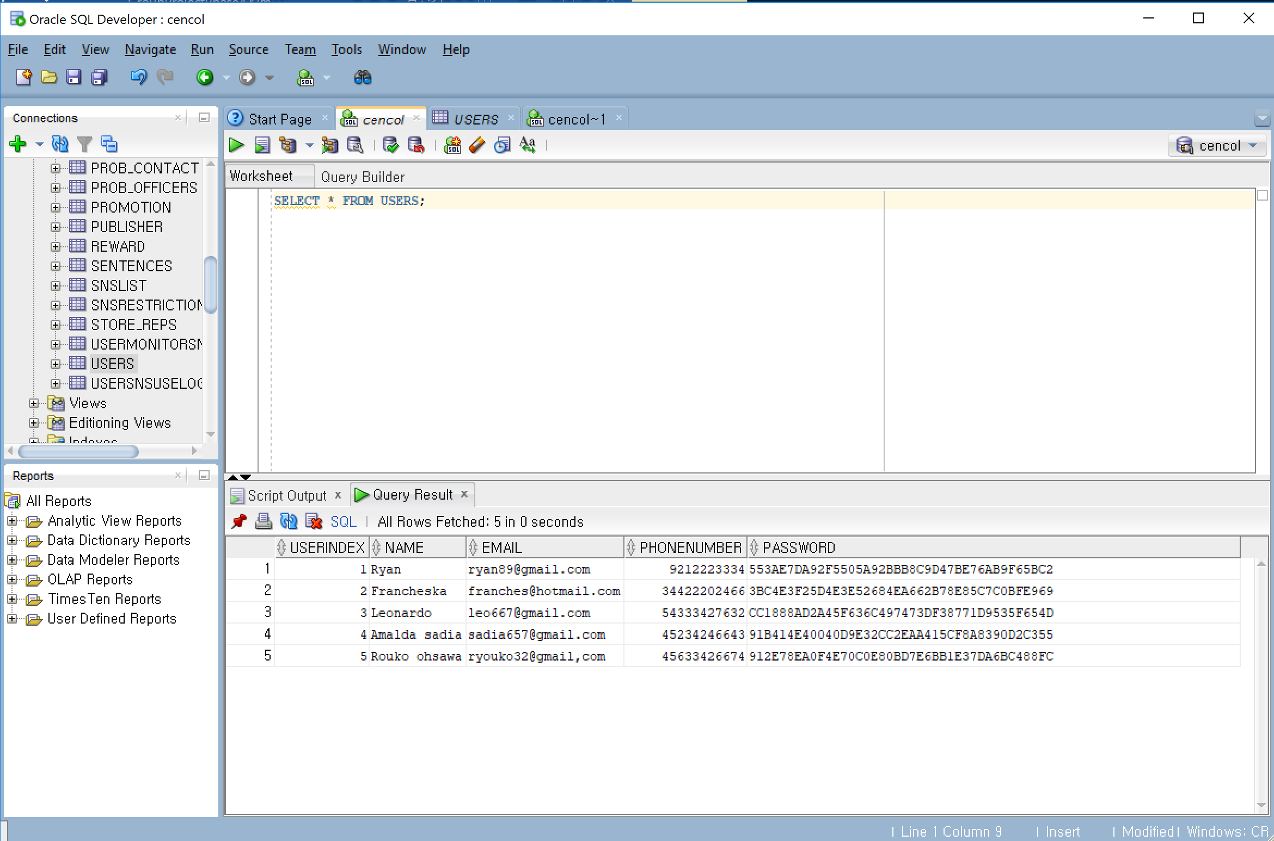

## Query2

***Select social network service monitor list which every user registered***

SELECT USERS.NAME, SNSLIST.SNSNAME FROM USERMONITORSNS

NATURAL JOIN USERS NATURAL JOIN SNSLIST;

Execution:

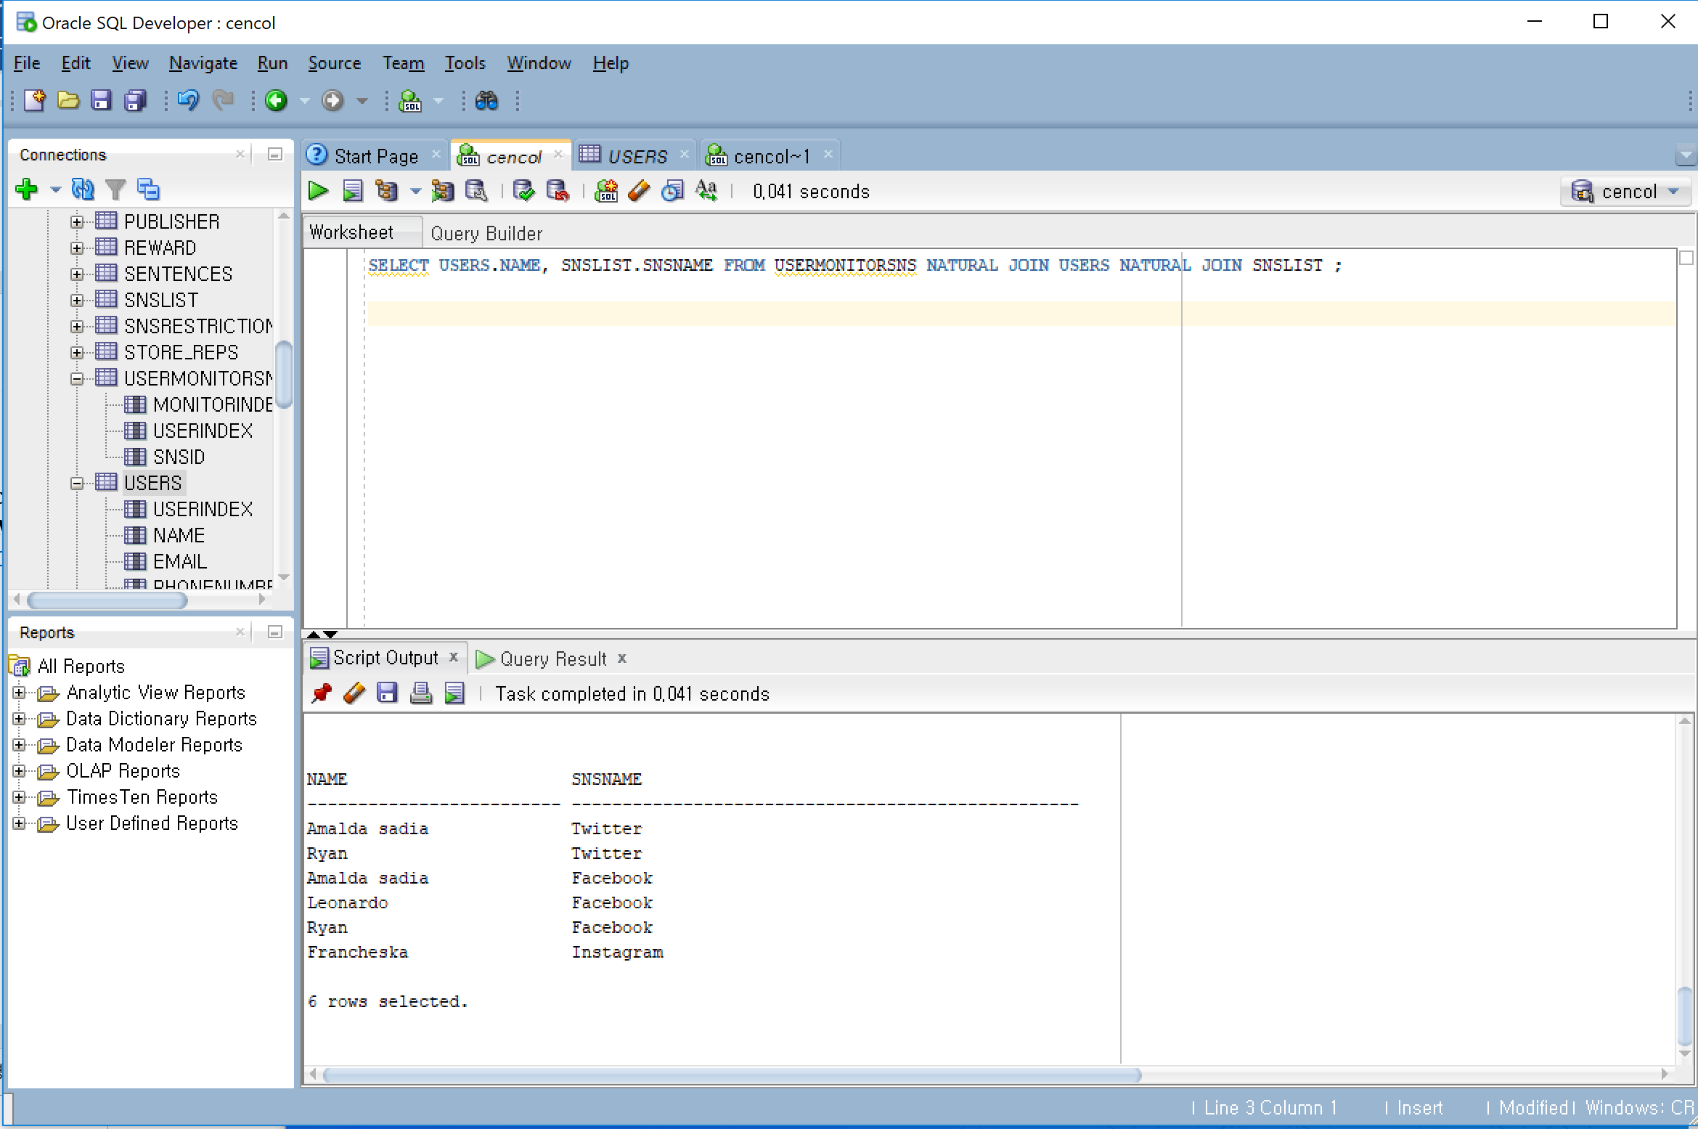

## Query3

***Select “Amalda Sadias” social network services use log***

SELECT USERS.NAME, SNSLIST.SNSNAME, STARTDATE, ENDDATE FROM USERSNSUSELOG NATURAL JOIN USERS NATURAL JOIN SNSLIST

WHERE USERS.NAME = 'Amalda sadia';

Execution:

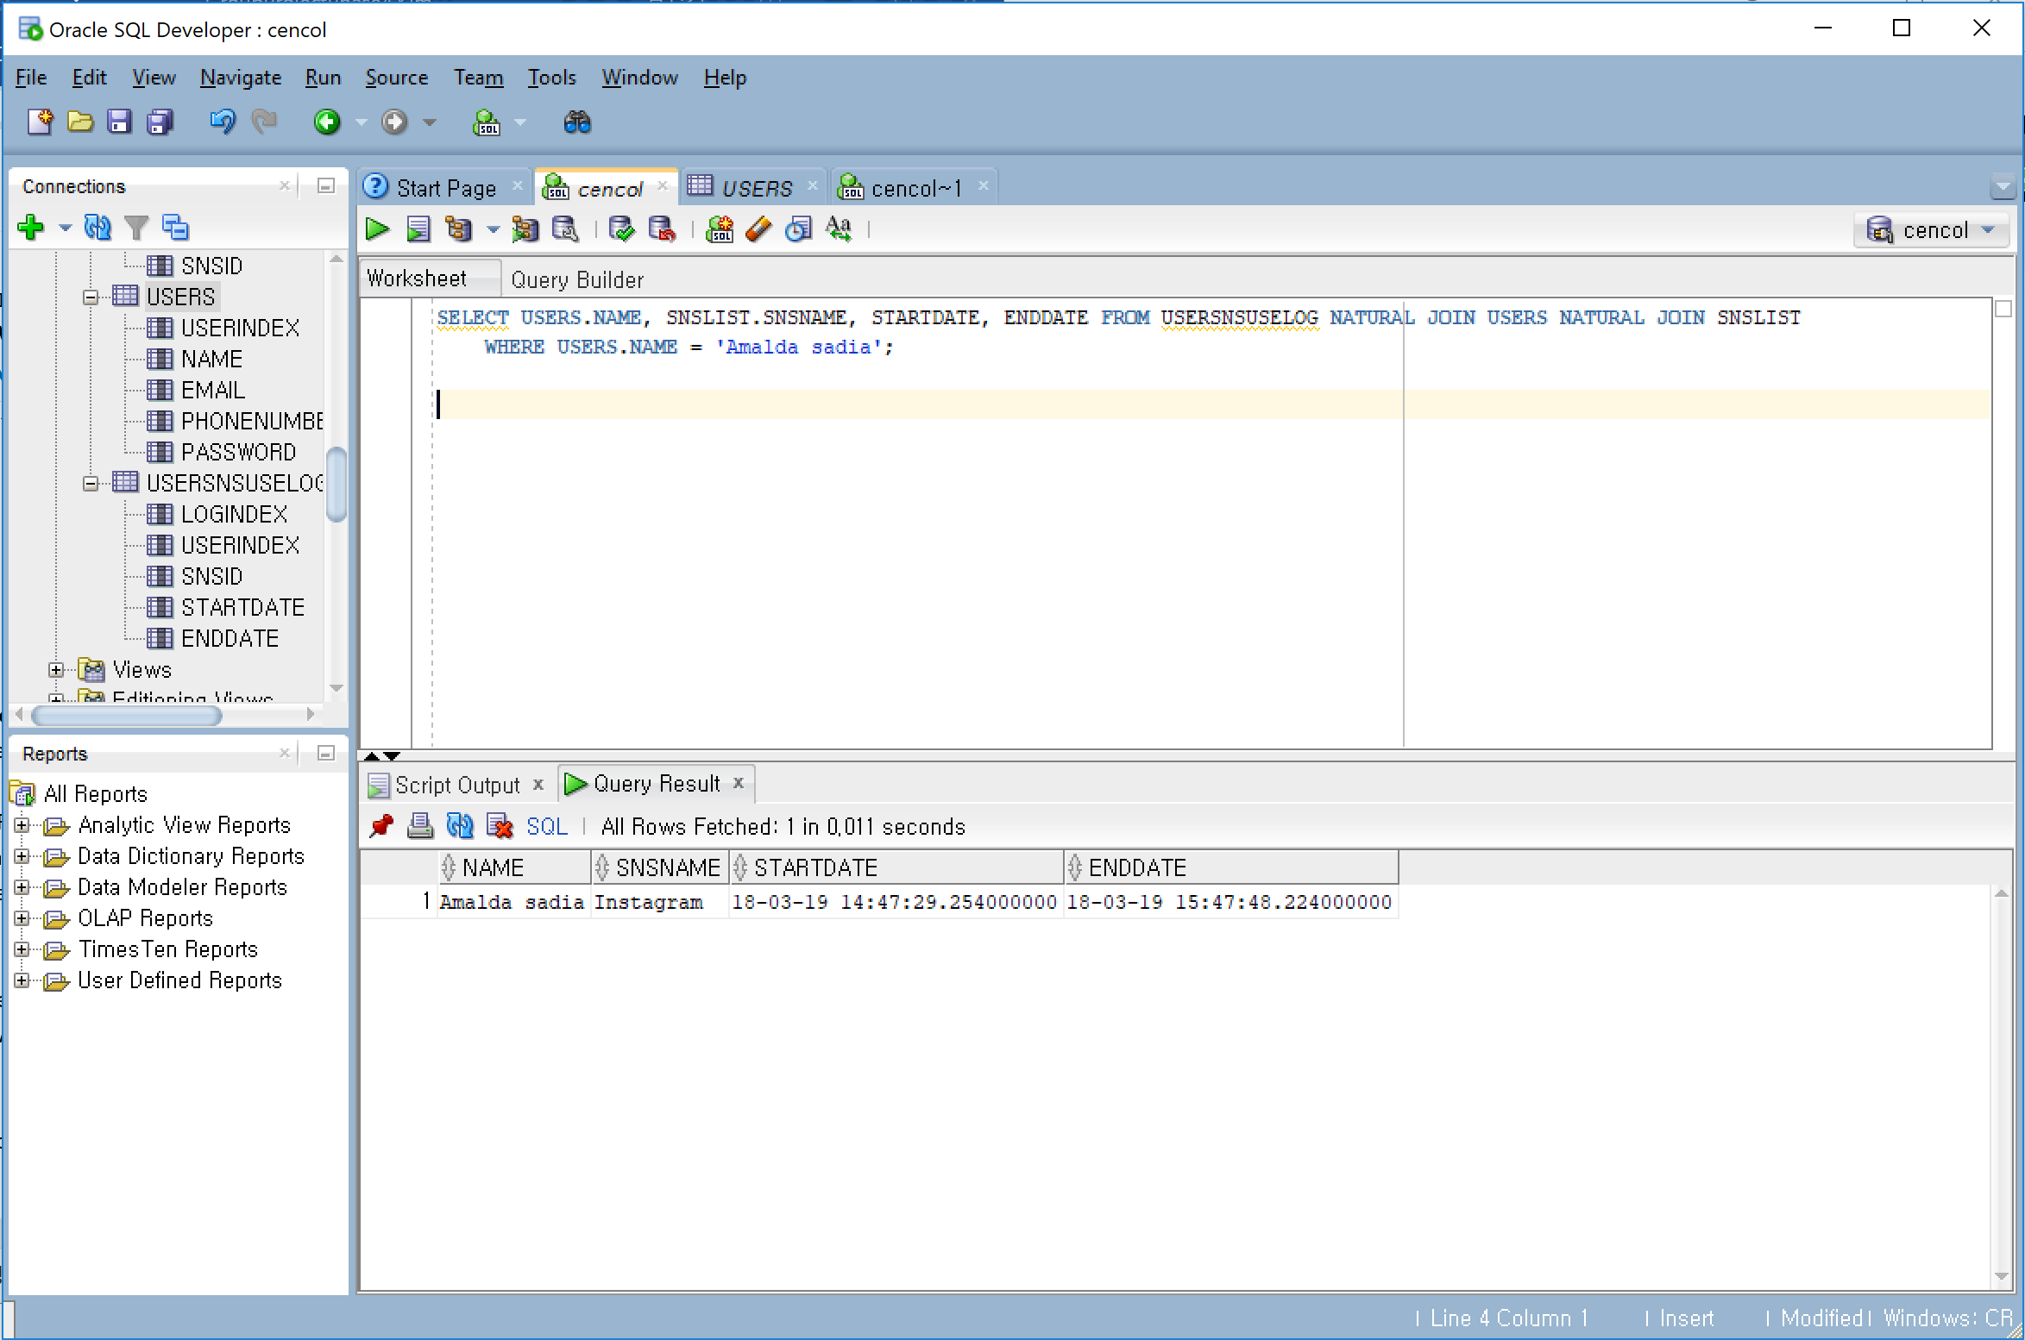

## Query4

***Select “Francheska’s” social network services restriction rules***

SELECT USERS.NAME, SNSLIST.SNSNAME, STARTDATE, ENDDATE FROM USERSNSUSELOG NATURAL JOIN USERS NATURAL JOIN SNSLIST

WHERE USERS.NAME = ‘Francheska’;

Execution:

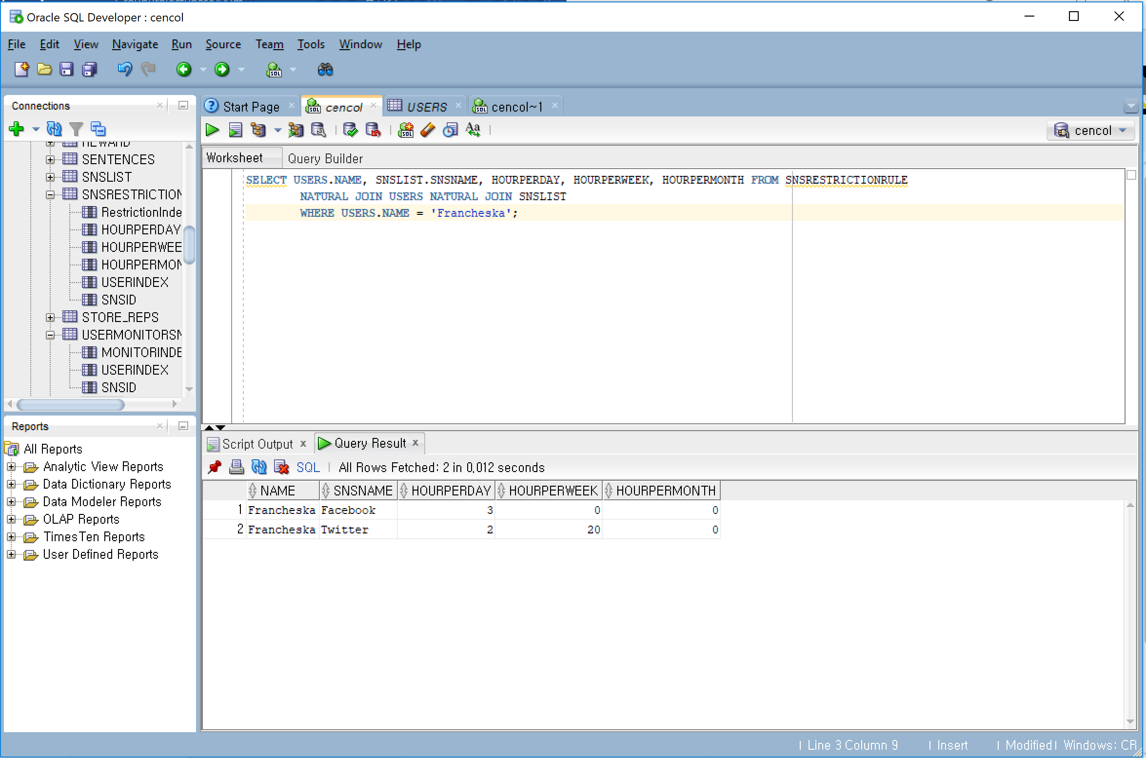

## Query5

Select who overused its restriction rules

SELECT LOGINDEX, USERINDEX, NAME, HOURPERWEEK, SNSNAME,

EXTRACT (day from (ENDDATE - STARTDATE))* 24 + EXTRACT (hour from

(ENDDATE - STARTDATE)) AS totalUseTime

FROM USERSNSUSELOG

NATURAL JOIN USERS

NATURAL JOIN SNSRESTRICTIONRULE

NATURAL JOIN SNSLIST

WHERE HOURPERWEEK < (EXTRACT (day from (ENDDATE - STARTDATE))*

24 + EXTRACT (hour from (ENDDATE - STARTDATE)));

Execution:

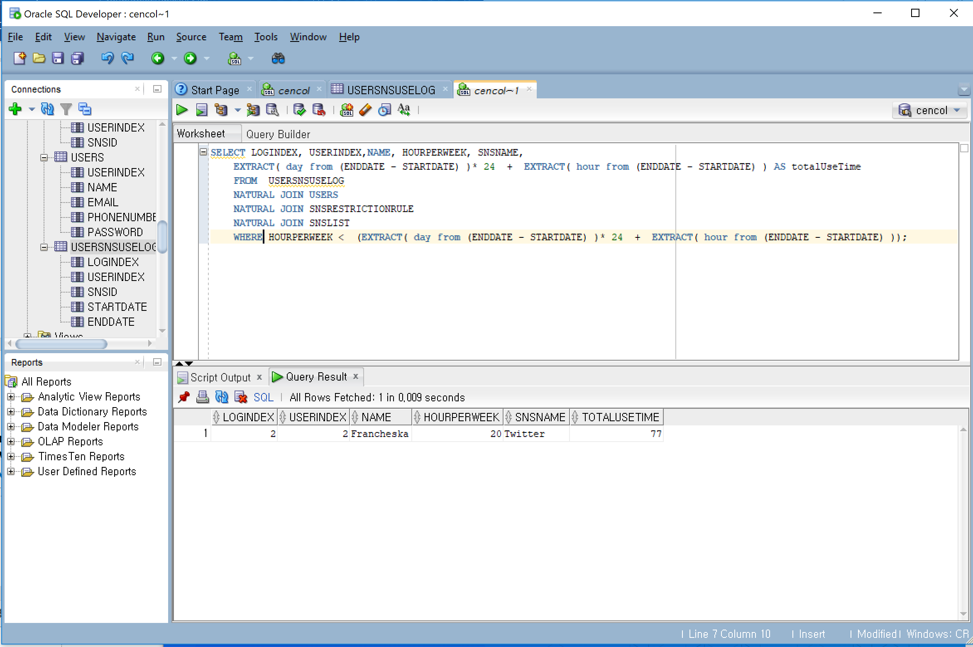

## Query6

***Select user name and reward item number, who didn’t received a present yet***

SELECT NAME, REWARDINDEX FROM REWARD

NATURAL JOIN USERS

WHERE RECEIVED IS NULL;

Execution:

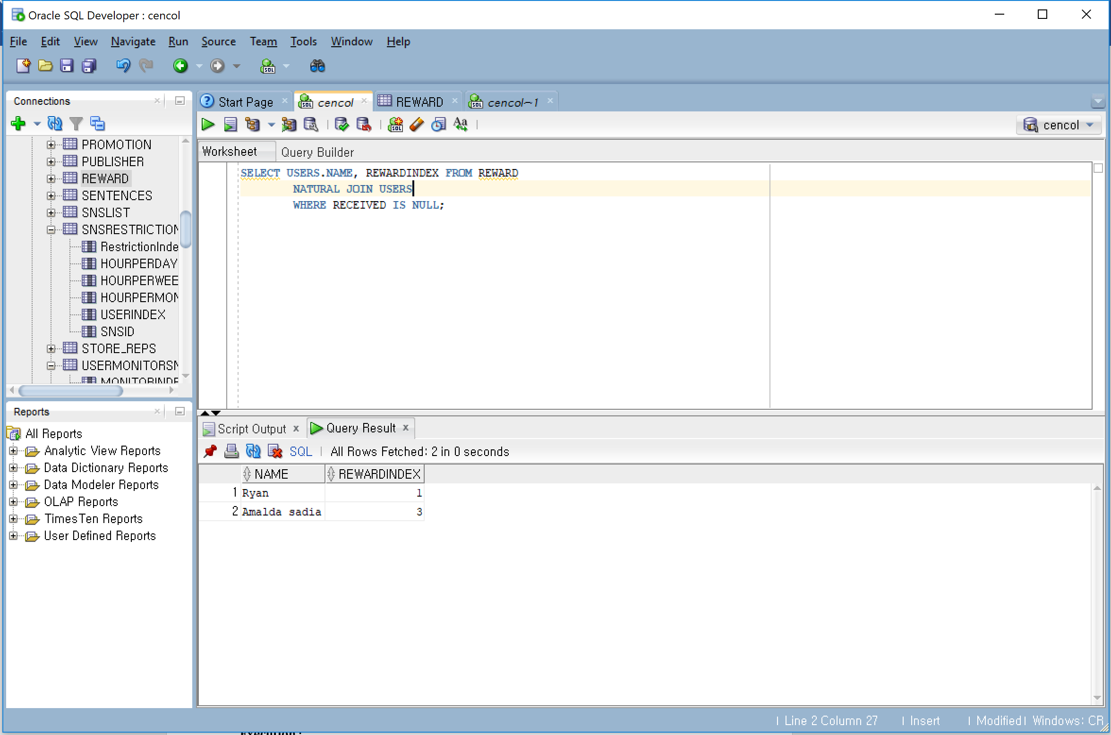

# References

Meikle, J. (2012, February 03). Twitter is harder to resist than cigarettes and alcohol, study finds.

Retrieved March 9, 2018, from https://www.theguardian.com/technology/2012/feb/03/twitter-resist-cigarettes-alcohol-study

Greenwood, S. (2018, February 27). Social platforms like Snapchat and Instagram are especially popular

among those ages 18 to 24. Retrieved March 9, 2018, from

http://www.pewinternet.org/2018/03/01/social-media-use-in-2018/pi_2018-03-01_social-media_0-02/

Psychology of Social Networks: What makes us addicted? (2016, January 21). Retrieved March 9, 2018,

from http://www.keepitusable.com/blog/?p=2568

How Can Social Media Affect Your Health? (2017, February 14). Retrieved March 10, 2018, from

https://sysomos.com/2016/10/27/can-social-media-affect-health/