# Introduction to Database Management – Assignment #1 – City Jail

**//Alias table creation**

Create Table Aliases

(Alias_ID Number (6),

Criminal_ID Number(6,0),

Alias varchar2(10));

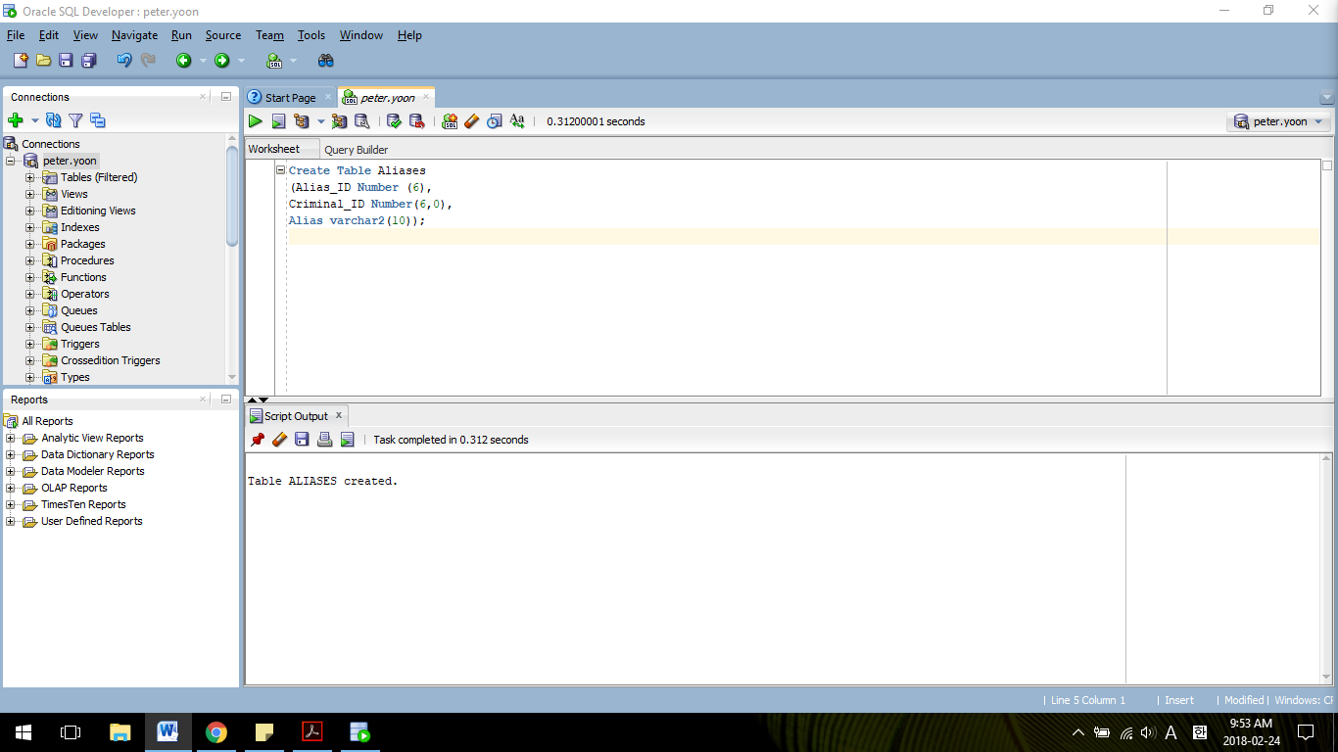

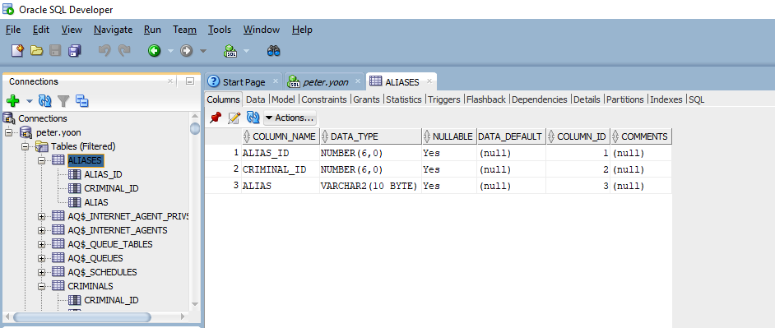

**//Criminals table creation**

Create Table Criminals

(Criminal_ID Number(6,0),

Last varchar2(15),

First varchar2(10),

Street varchar2(30),

City varchar2(20),

State char(2),

Zip char(5),

Phone char(10),

V_Status char(1) default ‘N’,

P_Status char(1) default ‘N’);

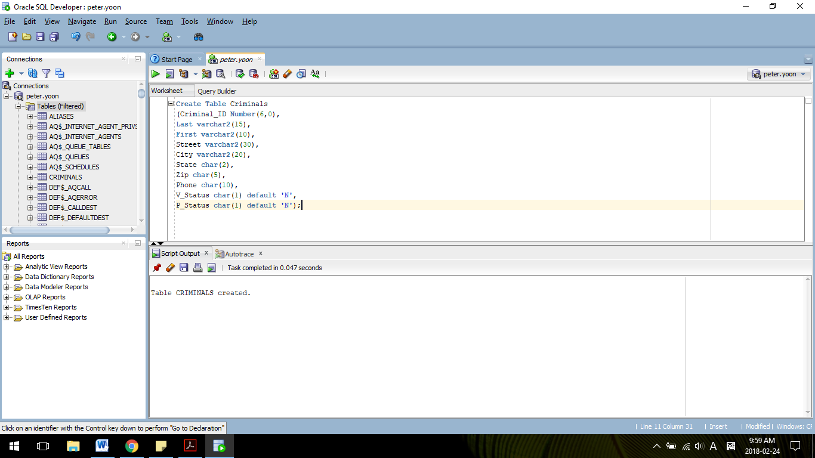

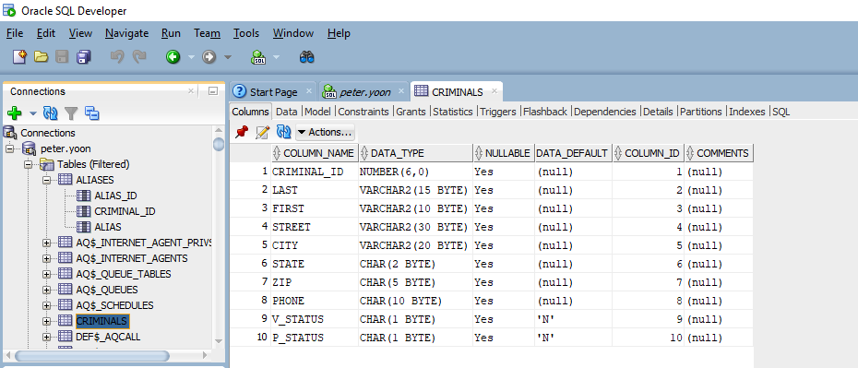

**//Crimes table creation**

Create Table Crimes

(Crime_ID Number(9,0),

Criminal_ID Number(6,0),

Classification char(1),

Date_Charged Date,

Status char(2),

Hearing_Date Date,

Appear_Cut_Date Date);

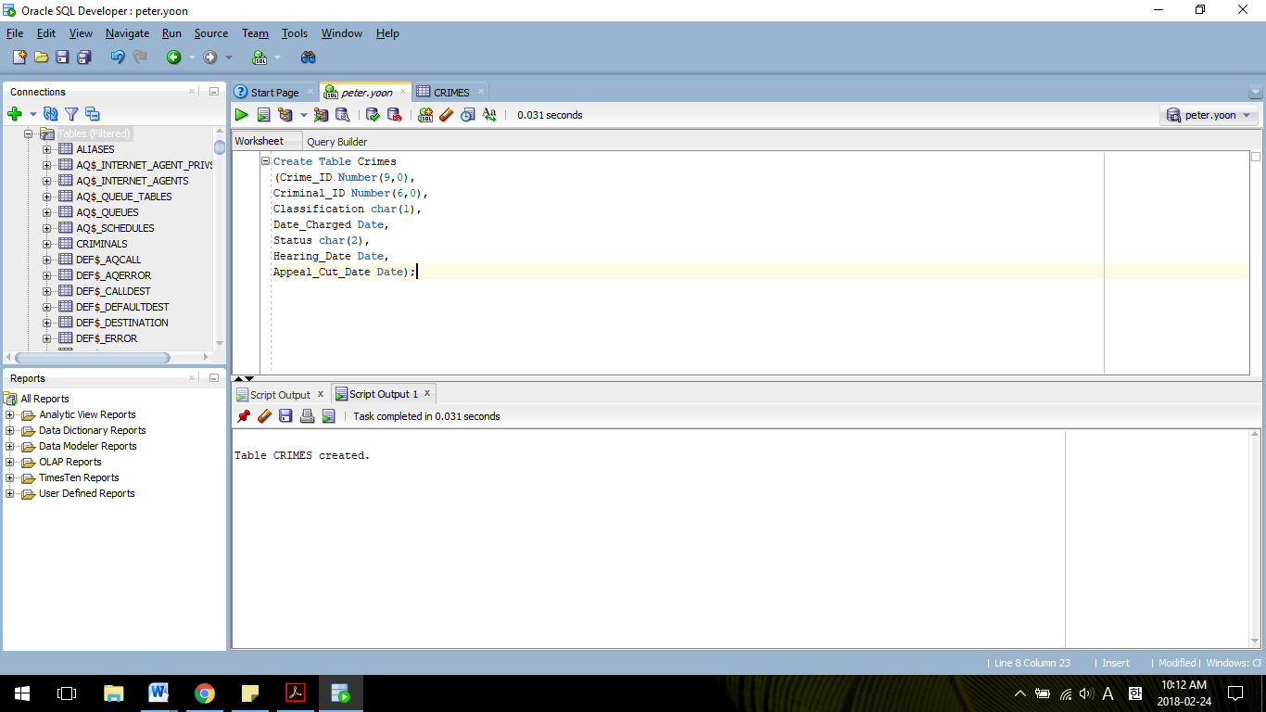

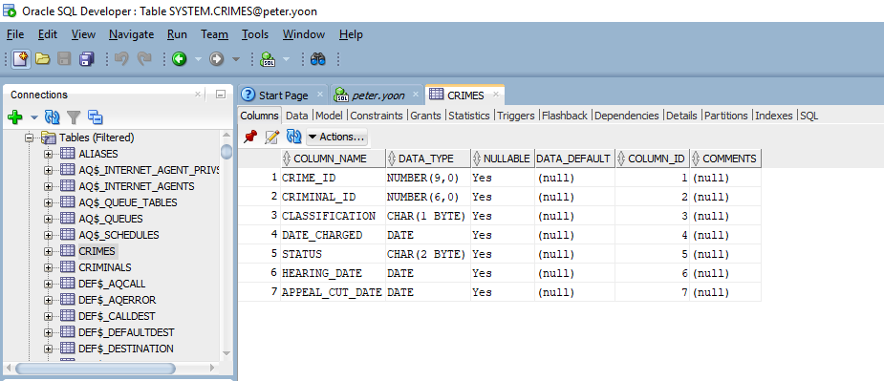

**//Sentences table creation**

Create Table Sentences

(Sentence_ID Number(6),

Criminal_ID Number(6),

Type char(1),

Prob_ID Number(5),

Start_Date Date,

End_Date Date,

Violations Number(3));

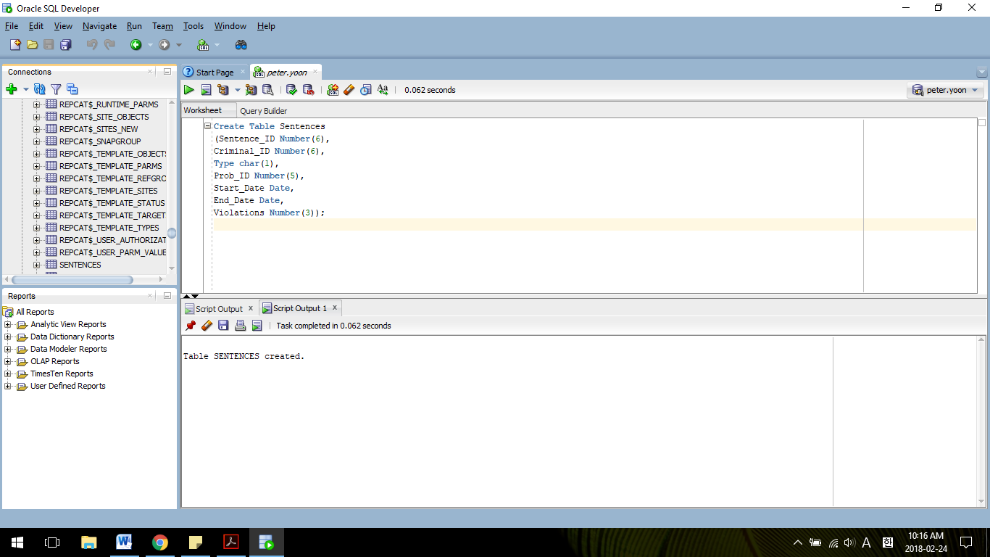

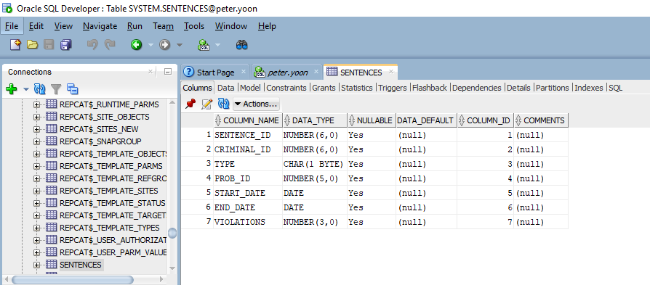

**//Probation Officers table creation**

Create Table Prob_Officers

(Prob_ID Number(5),

Last varchar2(15),

First varchar2(10),

Street varchar2(30),

City varchar2(20),

State char(2),

Zip char(5),

Phone char(10),

Email varchar2(30),

Status char(1) default ‘A’);

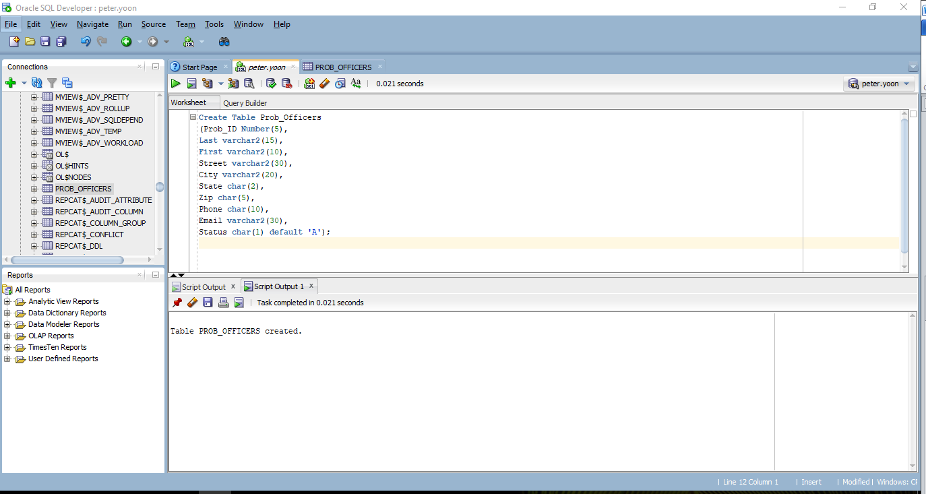

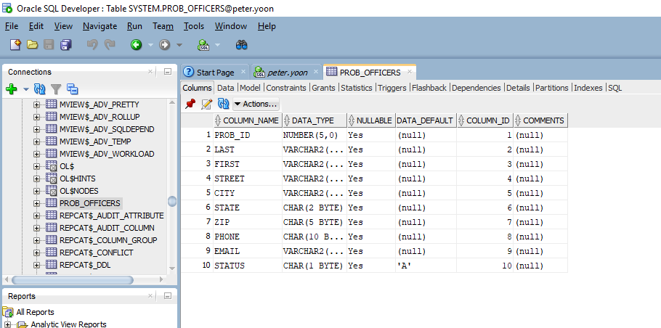

**//Crime charges table creation**

Create Table Crime_Charges

(Charge_ID Number(10,0),

Crime_ID Number(9,0),

Crime_Code Number(3,0),

Charge_Status char(2),

Fine_Amount Number(7,2),

Court_Fee Number(7,2),

Amount_Paid Number(7,2),

Pay_Due_Date Date);

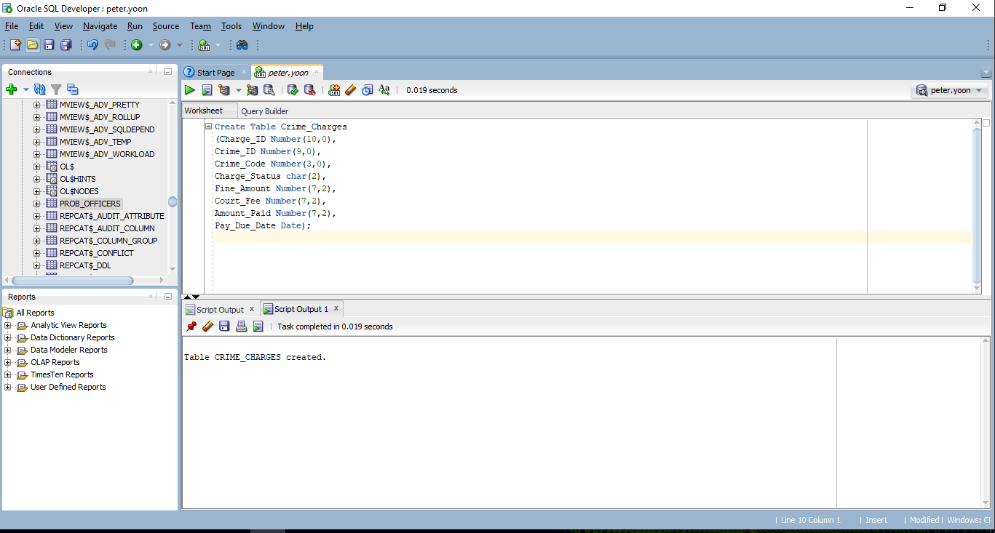

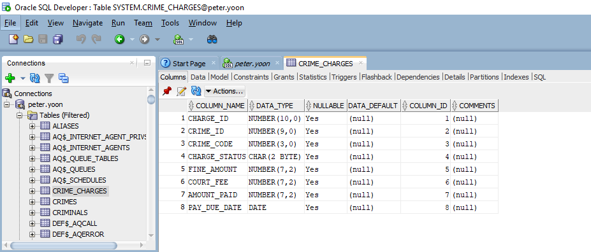

**//Crime Officers table creation**

Create Table Crime_Officers

(Crime_ID Number(9,0),

Officer_ID Number(8,0));

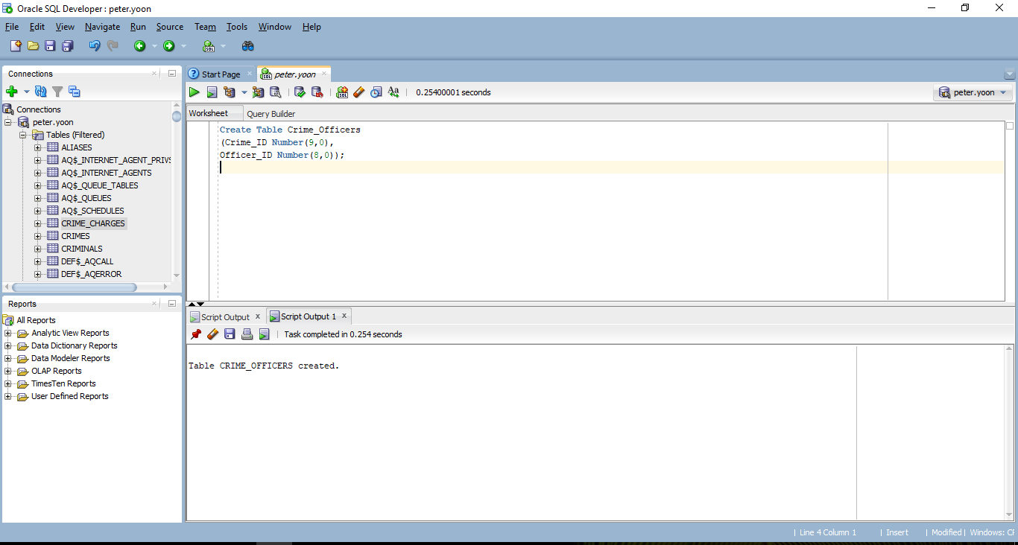

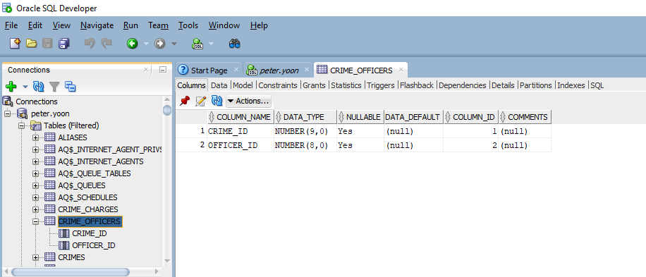

**//Officers table creation**

Create Table Officers

(Officer_ID Number(8,0),

Last varchar2(15),

First varchar2(10),

Precinct char(4),

Badge varchar2(14),

Phone char(10),

Status char(1) default ‘A’);

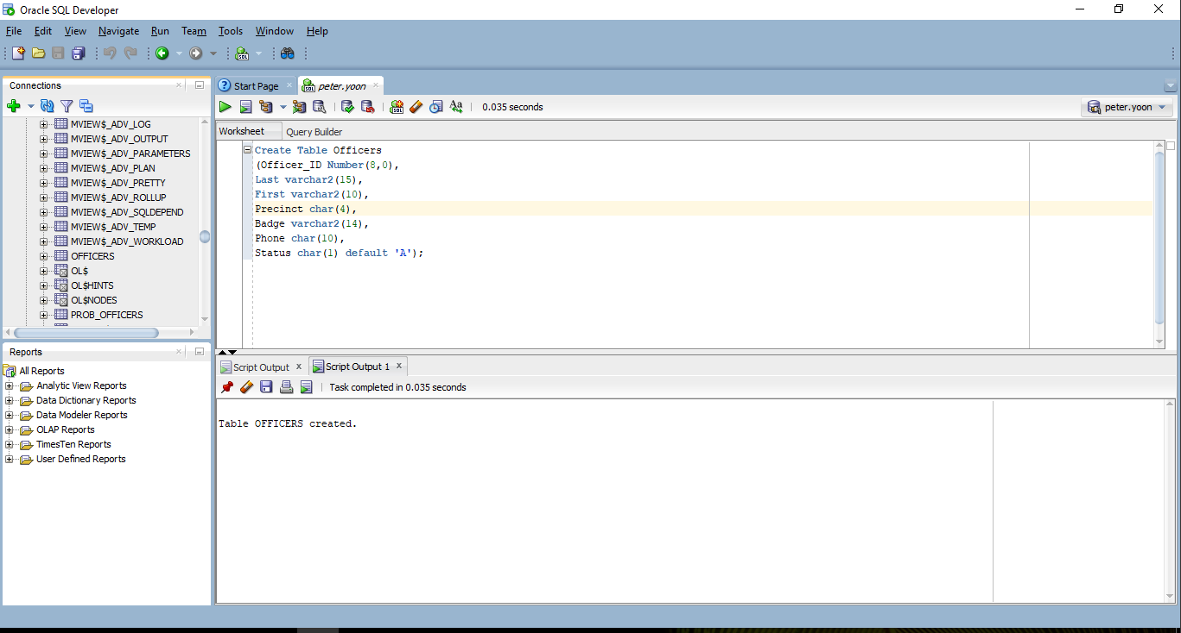

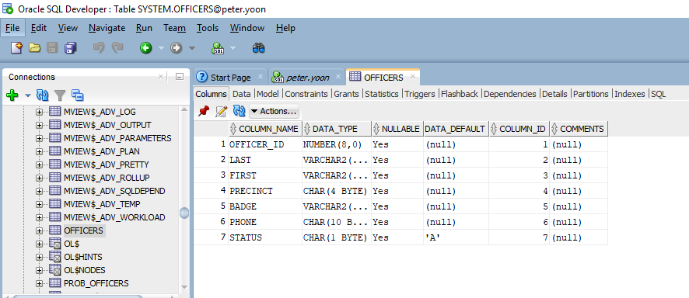

**//Appeals table creations**

Create Table Appeals

(Appeal_ID Number(5),

Crime_ID Number(9,0),

Filing_Date Date,

Hearing_Date Date,

Status char(1) default ‘P’);

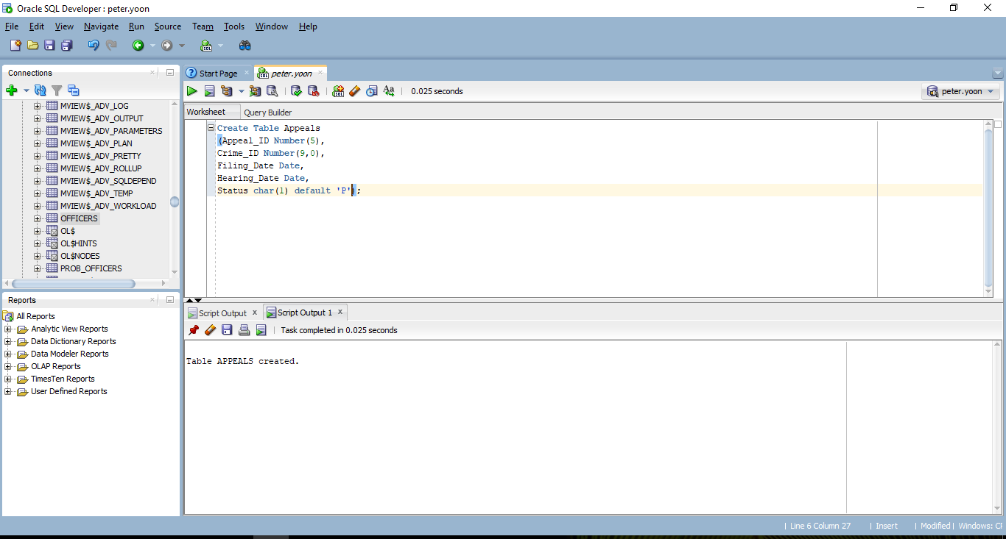

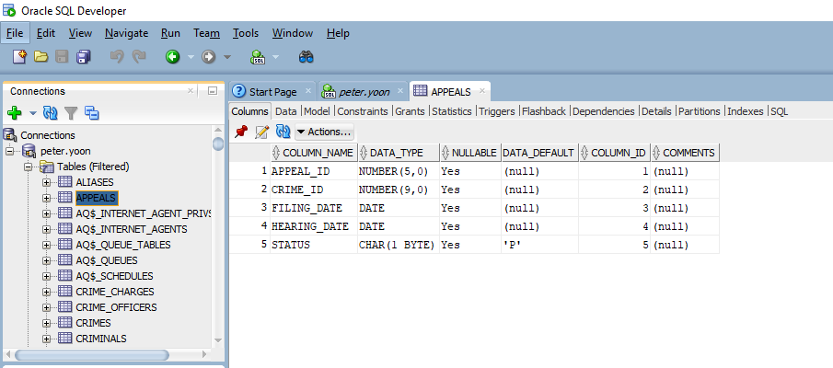

**//Crime codes table creation**

Create Table Crime_Codes

(Crime_Code number(3,0),

Code_Description varchar2(30));

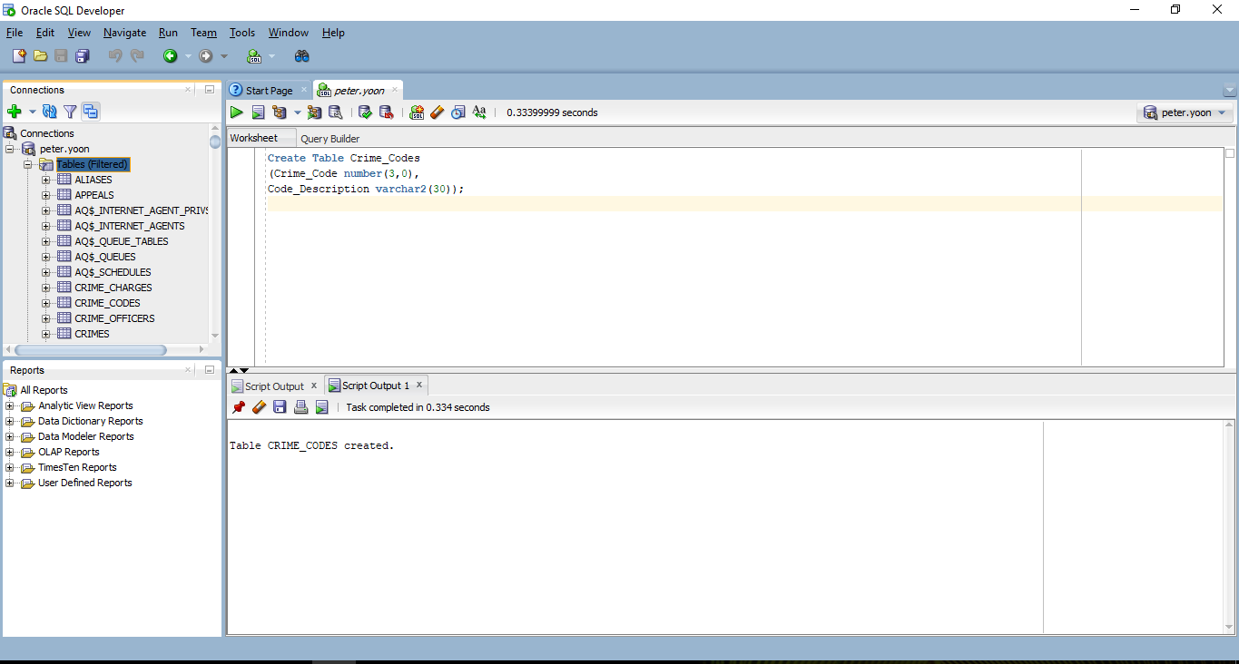

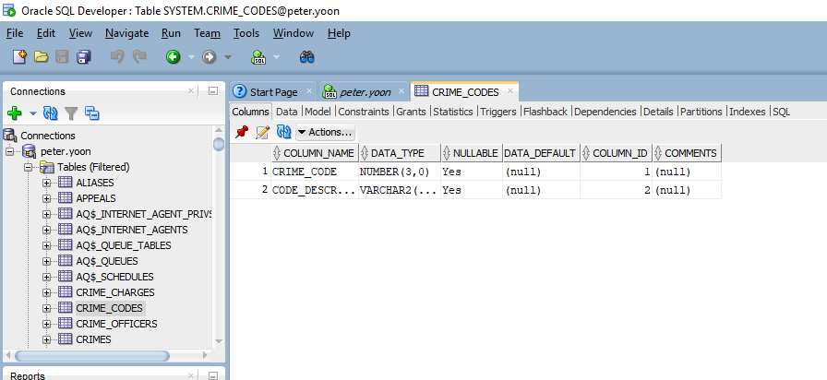

**//Add a default value of U for the Classification column of the Crimes table**

Alter Table Crimes

Modify (Classification default ‘u’);

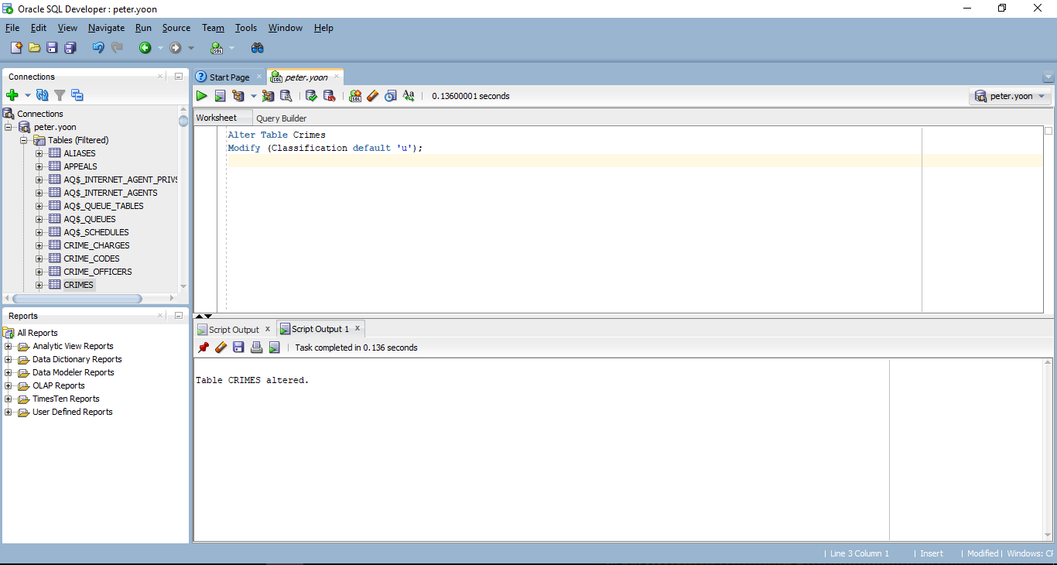

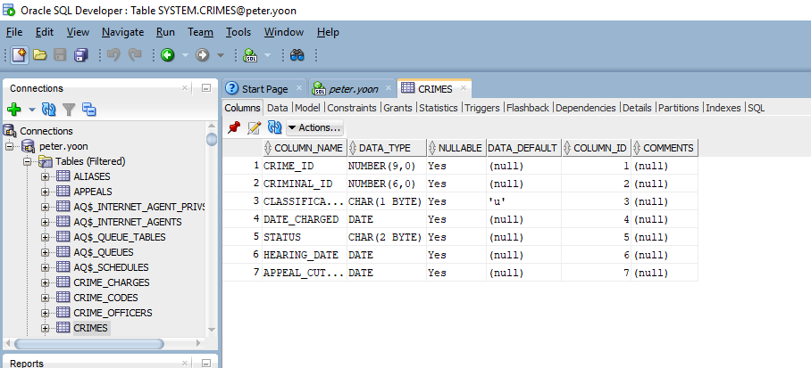

**//Add a column named Date_Recorded to the Crimes table. This column needs to hold date values and should be set to the current date by default**

Alter Table Crimes

Add (Date_Recorded Date default sysdate);

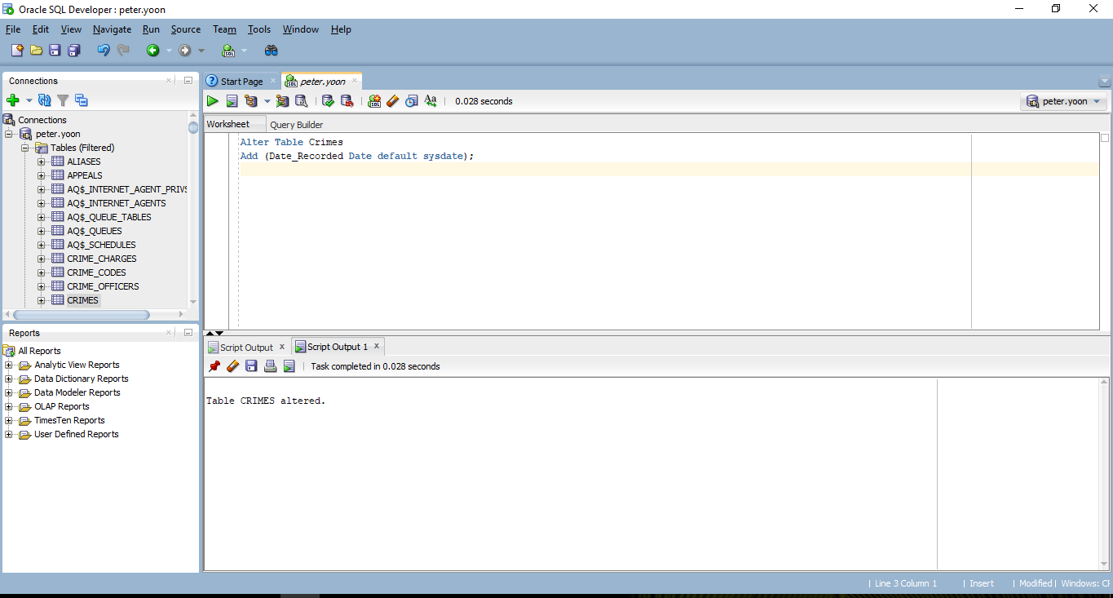

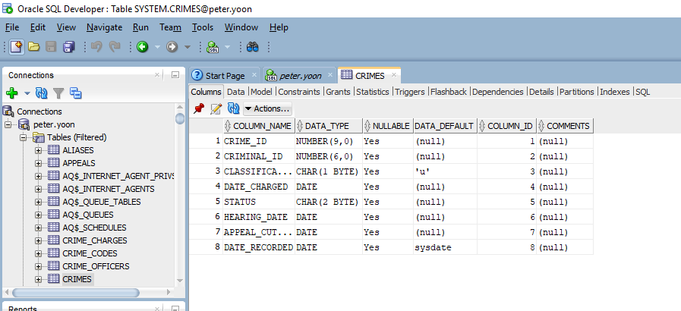

**//Add a column to the Prob_officers table to contain the pager number for each officer. The column needs to accommodate a phone number, including area code. Name the column Pager#**

Alter Table Prob_Officers

Add (Pager# char(10));

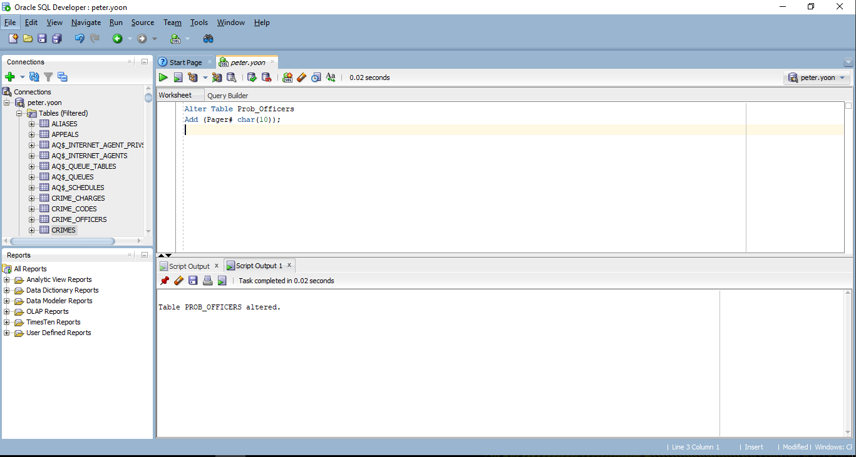

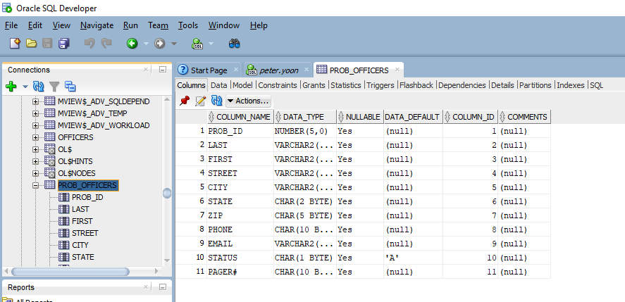

**//Change the Alias column in the Aliases table to accommodate up to 20 characters**

Alter Table Aliases

Modify (Alias varchar2(20));

