# Introduction to Database Management – Assignment #3 – City Jail

**Traditional//List all criminals along with the crime charges filed**

Select C.CRIMINAL_ID, C.LAST, C.FIRST, CC.CRIME_CODE, CC.FINE_AMOUNT

From CRIMINALS C, CRIMES CR, CRIME_CHARGES CC

Where CR.CRIME_ID = CC.CRIME_ID

And C.CRIMINAL_ID = CR.CRIMINAL_ID

;

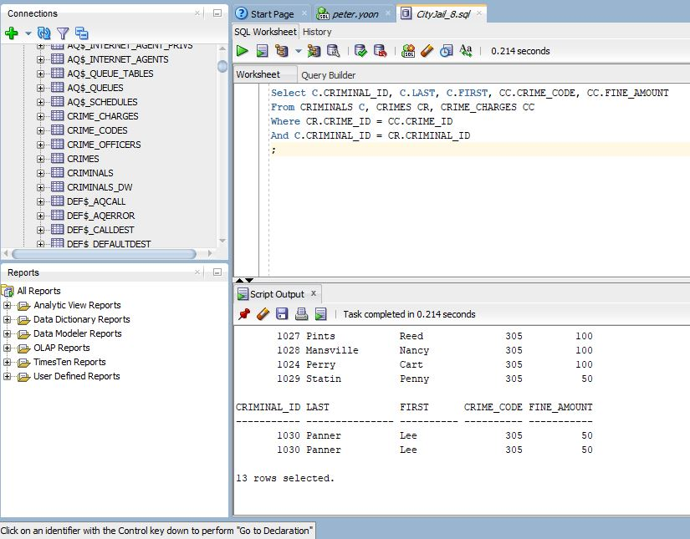

**ANSI JOIN//List all criminals along with the crime charges filed**

Select CRIMINAL_ID, LAST, FIRST, CRIME_CODE, FINE_AMOUNT

From CRIMINALS

Natural Join CRIMES

Natural Join CRIME_CHARGES

;

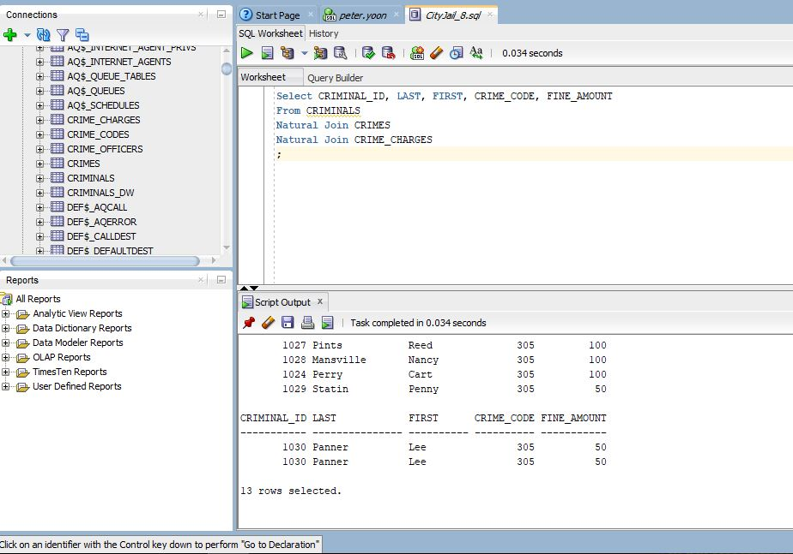

**Traditional//List all criminals along with crime status and appeal status**

Select C.CRIMINAL_ID, C.LAST, C.FIRST, CR.CLASSIFICATION, CR.DATE_CHARGED, CR.CRIME_ID, A.FILING_DATE, A.STATUS

From CRIMINALS C, CRIMES CR, APPEALS A

Where C.CRIMINAL_ID = CR.CRIMINAL_ID

And CR.CRIME_ID = A.CRIME_ID (+)

Order by C.LAST

;

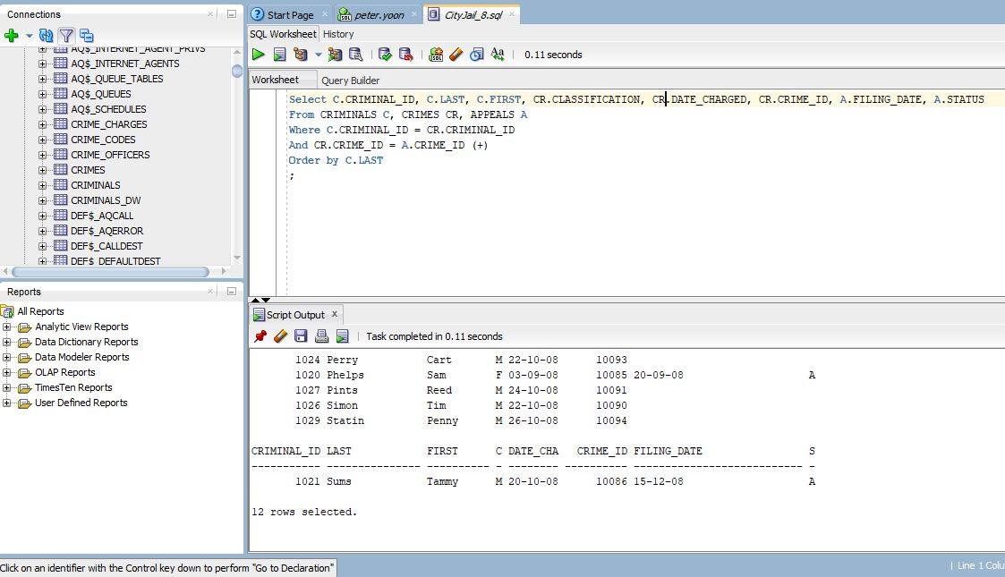

**ANSI JOIN//List all criminals along with crime status and appeal status**

Select CRIMINAL_ID, LAST, FIRST, CLASSIFICATION, DATE_CHARGED, CRIME_ID, FILING_DATE, A.STATUS

From CRIMINALS

Natural Join CRIMES

Left Outer Join APPEALS A

Using (CRIME_ID)

Order By Last

;

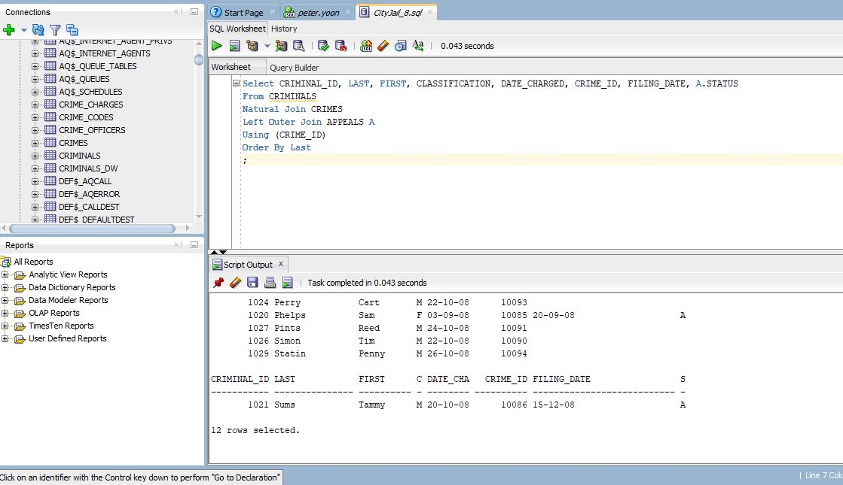

**Traditional//List all criminals along with crime information**

Select C.CRIMINAL_ID, C.LAST, C.FIRST, CR.CLASSIFICATION, CR.DATE_CHARGED, CC.CRIME_CODE, CC.FINE_AMOUNT

From CRIMINALS C, CRIMES CR, CRIME_CHARGES CC

Where CLASSIFICATION = 'O'

And CR.CRIME_ID = CC.CRIME_ID

And C.CRIMINAL_ID = CR.CRIMINAL_ID

Order By CRIMINAL_ID, DATE_CHARGED

;

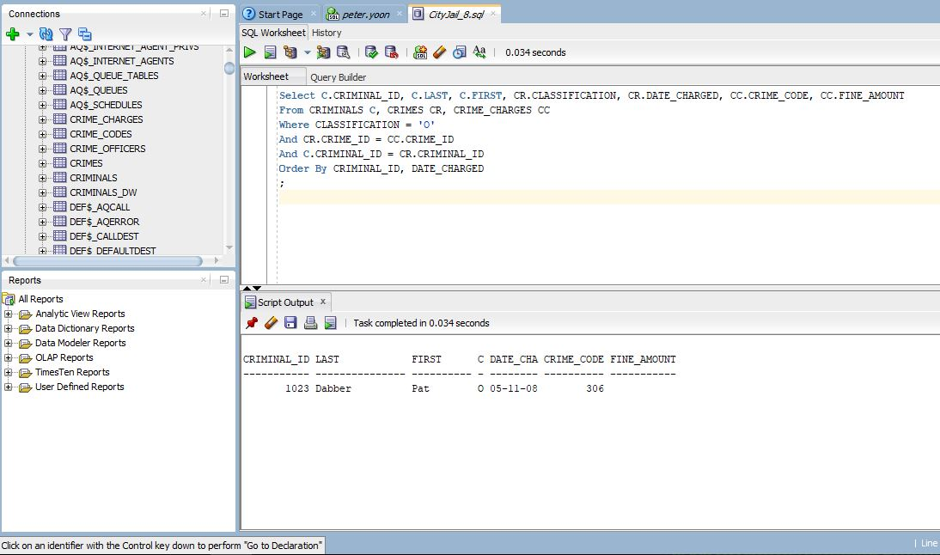

**ANSI JOIN//List all criminals along with crime information**

Select CRIMINAL_ID, LAST, FIRST, CLASSIFICATION, DATE_CHARGED, CRIME_CODE, FINE_AMOUNT

From CRIMINALS

Natural Join CRIMES

Natural Join CRIME_CHARGES

Where CLASSIFICATION = 'O'

;

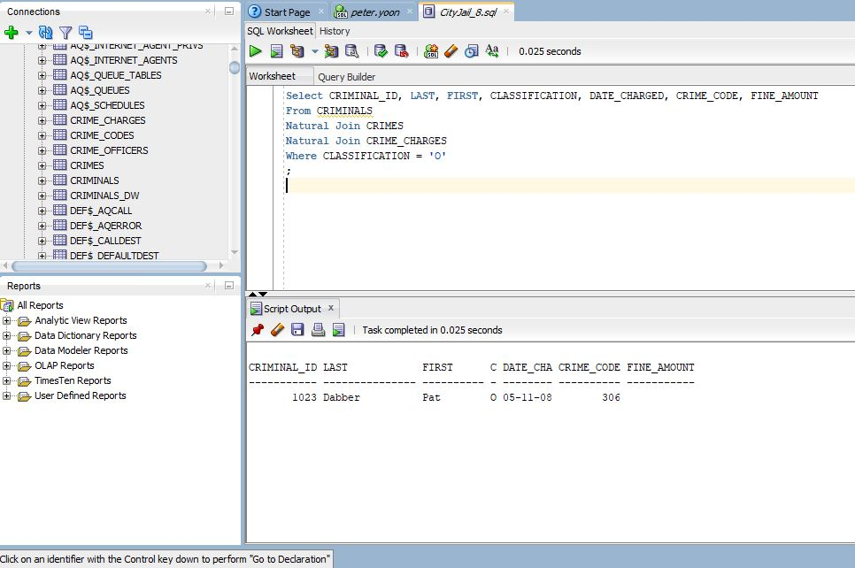

**Traditional//Create an alphabetical list of all criminals**

Select C.CRIMINAL_ID, C.LAST, C.FIRST, C.V_STATUS, C.P_STATUS, AL.ALIAS

From CRIMINALS C, ALIASES AL

Where C.CRIMINAL_ID = AL.CRIMINAL_ID (+)

Order by LAST

;

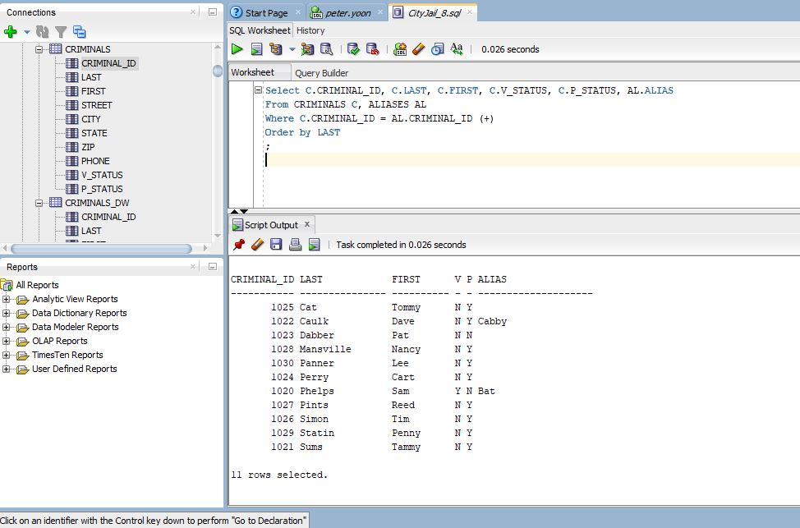

**ANSI JOIN// Create an alphabetical list of all criminals**

Select CRIMINAL_ID, LAST, FIRST, V_STATUS, P_STATUS, ALIAS

From CRIMINALS

Full Outer Join ALIASES

Using (CRIMINAL_ID)

Order by LAST

;

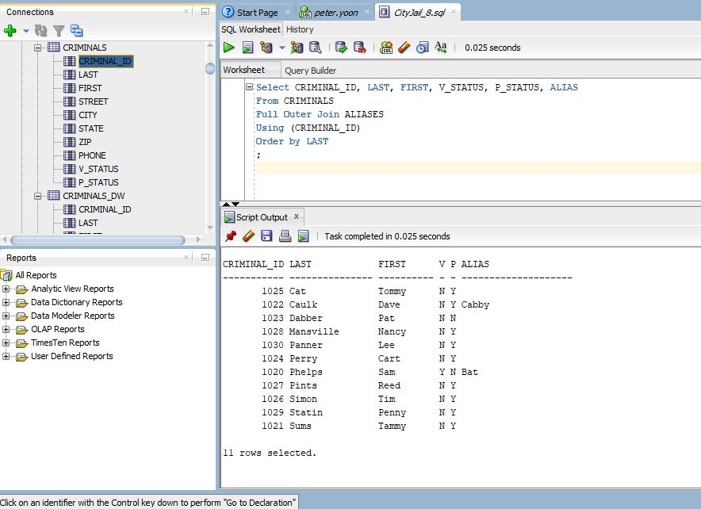

**Traditional//Create a list containing the name of each criminal who has been assigned a probation period**

SELECT C.LAST, C.FIRST, S.START_DATE, S.END_DATE, PR.CON_FREQ

FROM CRIMINALS C, PROB_CONTACT PR, SENTENCES S

WHERE C.CRIMINAL_ID = C.CRIMINAL_ID

AND TYPE='P'

AND (S.END_DATE - S.START_DATE) <= HIGH_AMT

AND (S.END_DATE - S.START_DATE) >= LOW_AMT

ORDER BY LAST, START_DATE

;

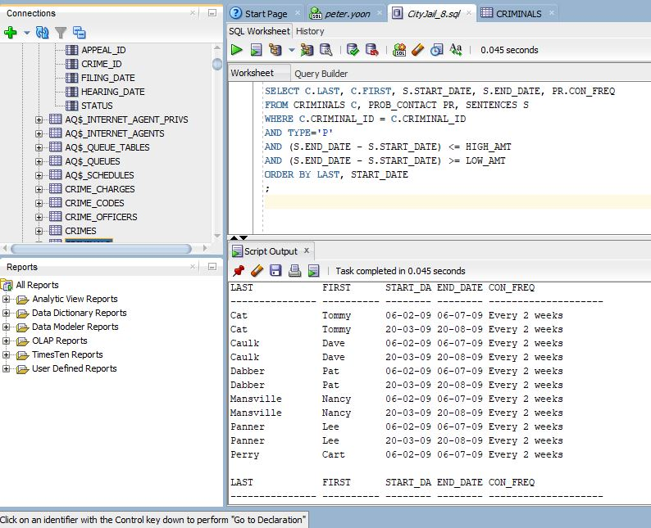

**ANSI JOIN//Create a list containing the name of each criminal who has been assigned a probation period**

Select LAST, FIRST, START_DATE, END_DATE, CON_FREQ

From CRIMINALS

Join SENTENCES S

On S.TYPE = 'P'

Join PROB_CONTACT P

On END_DATE - S.START_DATE >= LOW_AMT

And END_DATE - S.START_DATE <= HIGH_AMT

Order by LAST, FIRST, START_DATE

;

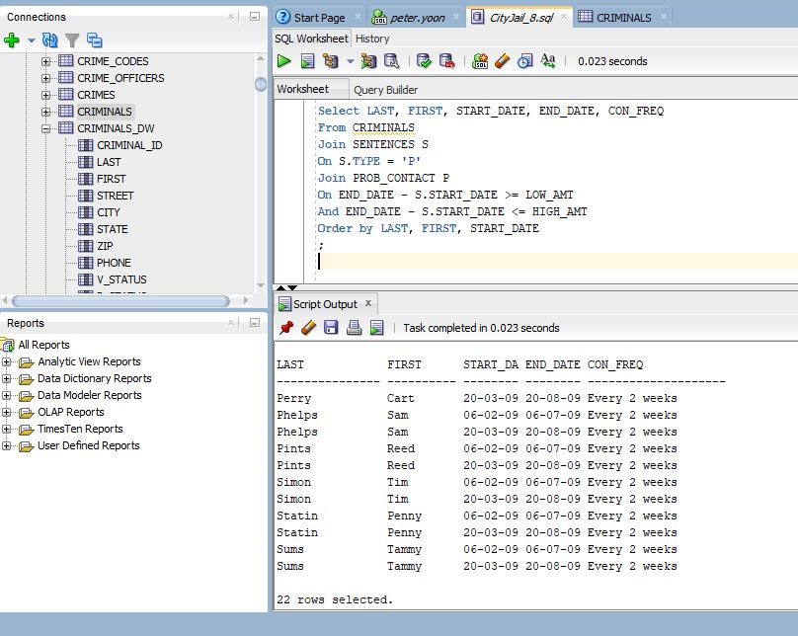

**Traditional//Produce a list showing each probation officer’s name and his or her supervisor’s name**

Select PRO.LAST, PRO.FIRST, MGR.LAST as "SUPERVISOR_LNAME", MGR.FIRST as "SUPERVISOR_FNAME"

From PROB_OFFICERS PRO, PROB_OFFICERS MGR

Where PRO.MGR_ID = MGR.PROB_ID (+)

Order by PRO.LAST, PRO.FIRST

;

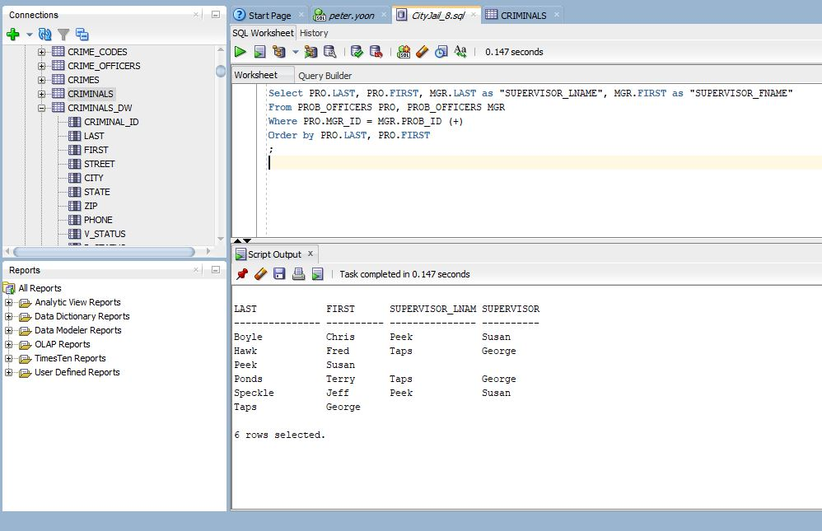

**ANSI JOIN//Produce a list showing each probation officer’s name and his or her supervisor’s name**

Select PRO.LAST, PRO.FIRST, MGR.LAST as "Supervisor_LNAME", MGR.FIRST as "Supervisor_FNAME"

From PROB_OFFICERS PRO

Left Outer Join PROB_OFFICERS MGR

On PRO.MGR_ID = MGR.PROB_ID

Order by LAST, FIRST

;

