OOP – Lab Task 13

Source Code & Output of LT1
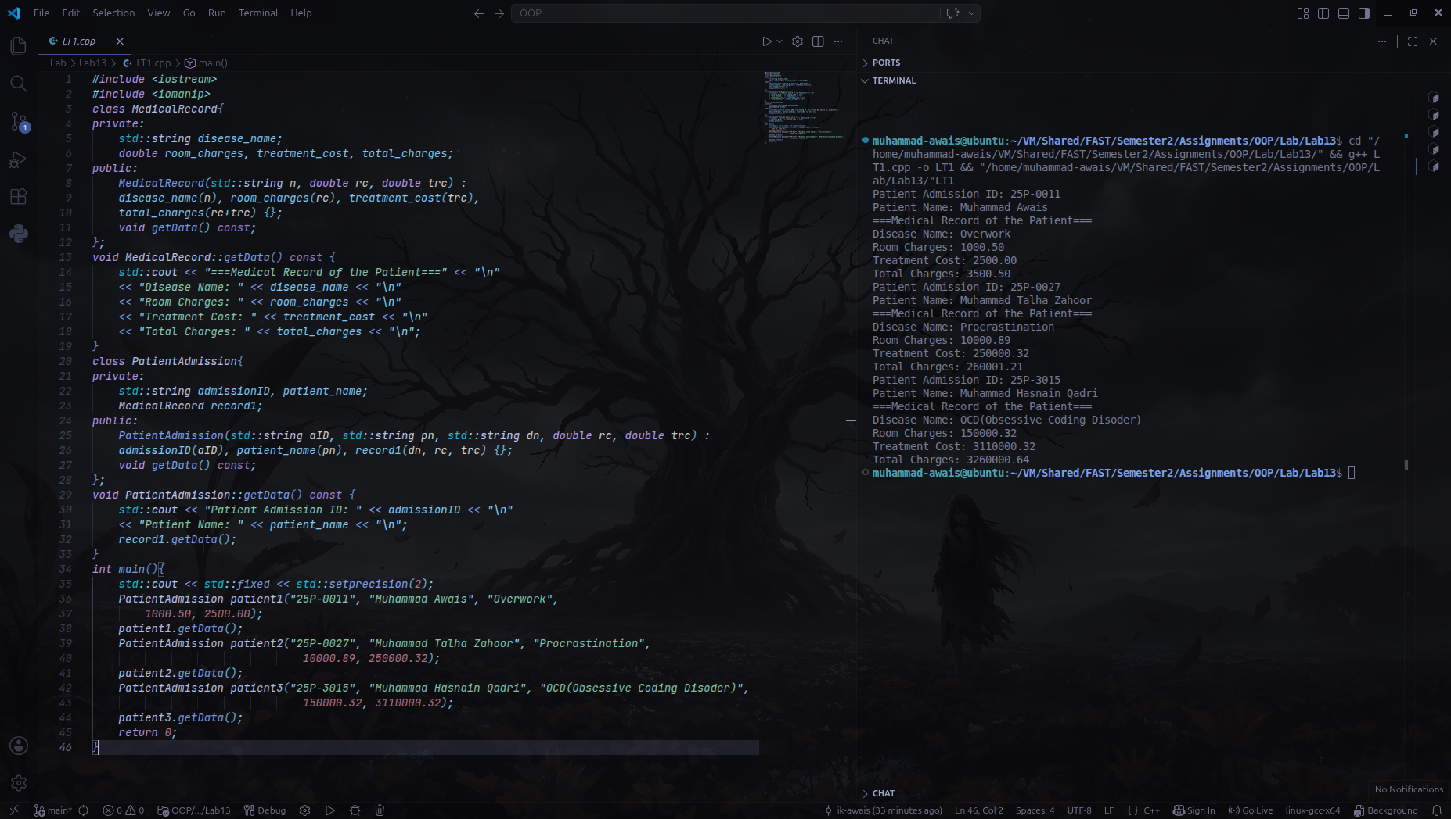
Source Code & Output of LT2