PF – LAB TASK 2

Create and Save a C file Correctly

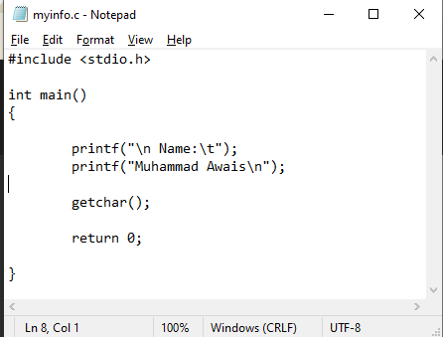

- I created a C file that prints my name as:
    - Name: Muhammad Awais
- I saved the file in a directory named as C. The file saved is shown in the following screenshot.

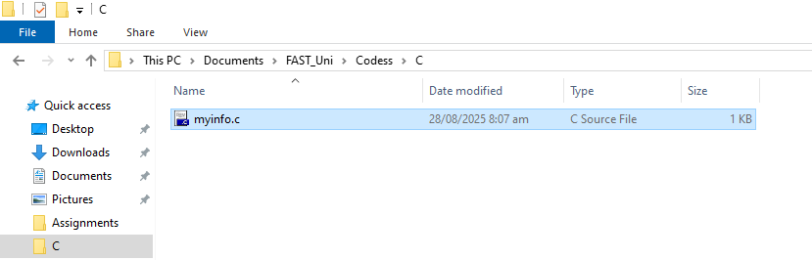

Navigate and Compile

I copied the file path and located it in the cmd using cd command.
    - cd C:\Users\p250011\Documents\FAST_Uni\Codess\C

Alternatively, I could also simply type cmd at the place of file location and it would have opened the cmd directly in the file directory.
    - cmd
- Another way can be used to locate our desired file using cmd by using cd command for moving from one directory to another one by one, however, it is less efficient and time taking.
    - cd Documents
    - cd FAST_Uni
    - cd Codess
    - cd C
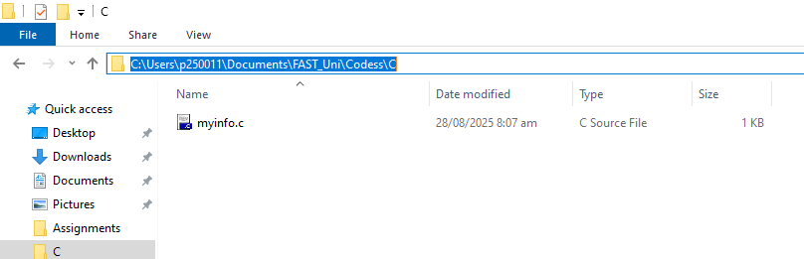

- In the following screenshot, I copied the path and pasted it in the cmd after cd function.

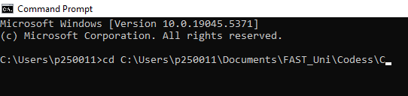

Compilation:

- In order to compile the C file, and set a customized name for the executable(.exe) file, we would run the following command in cmd:
    - gcc myinfo.c -o myinfo.exe

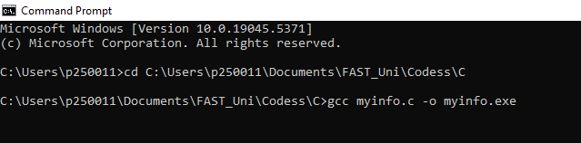

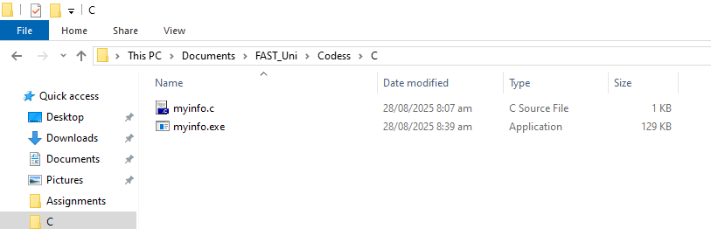

- After running the mentioned command, we can see that the myinfo.exe named executable file has been created successfully.

- We can now execute the C code either by running it in cmd by typing the file name, or by just double-clicking the file in the file directory.

Experiment with printf()

- After re-compiling and then executing the above C code, the output is shared as follows:

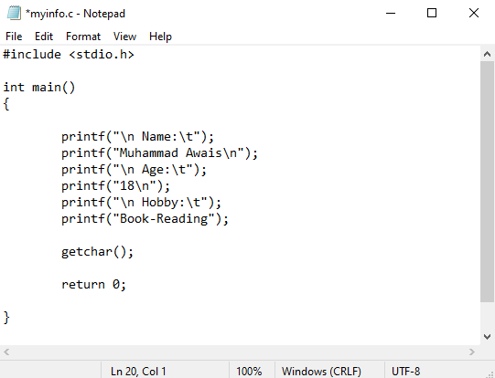

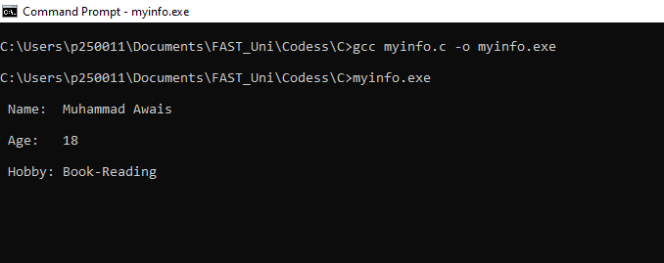

- The code was executed successfully and continued after pressing enter key due to getchar() function.

