PF LAB Task 3

Escape Sequence Puzzle

- Source Code:

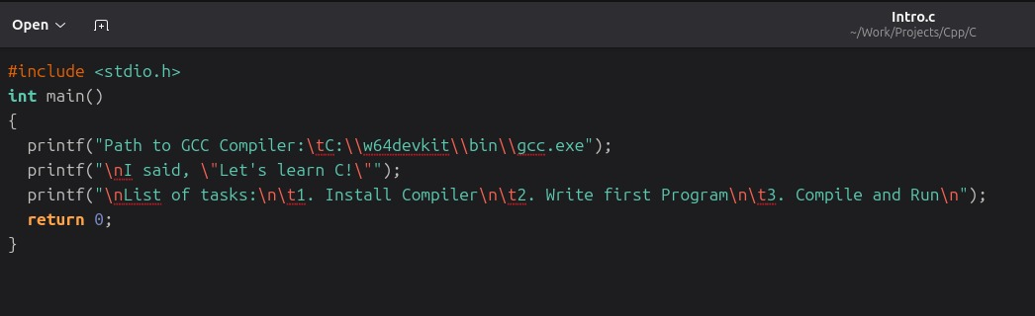

- Output:

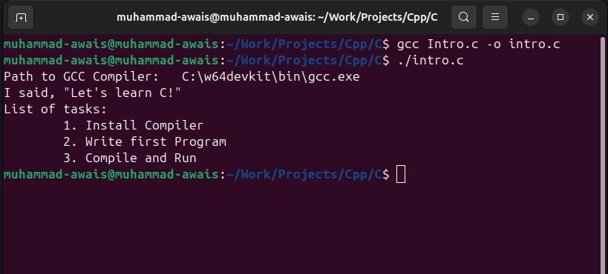

Mini Calendar

- Source Code:

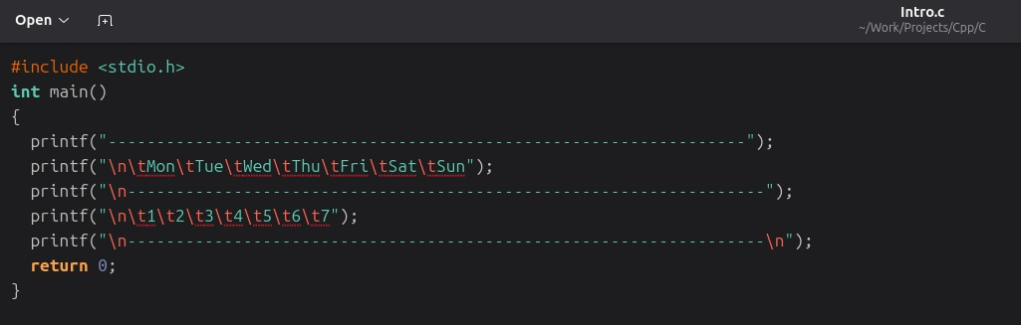

- Output:
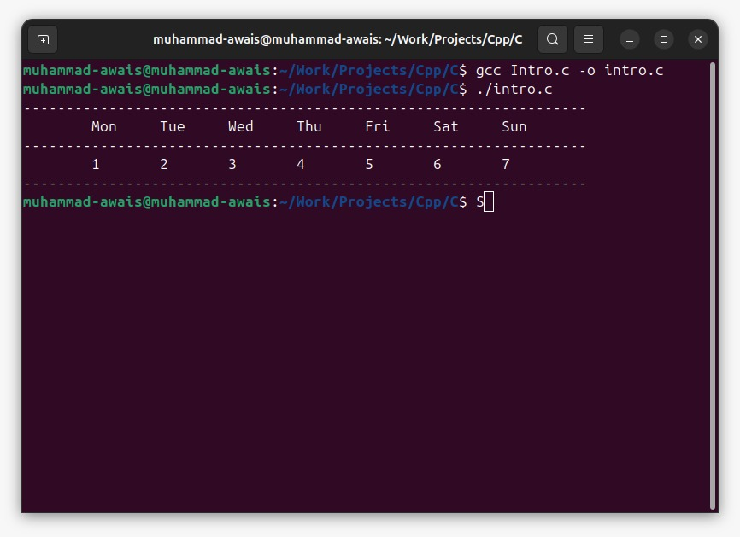

Roll Number Display
- Source Code:
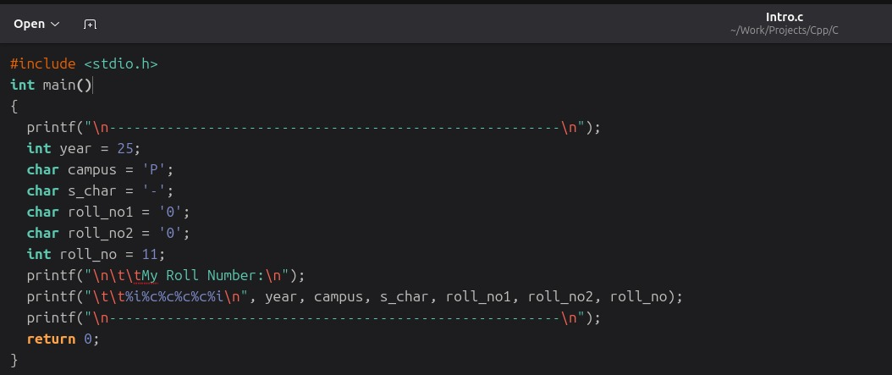
- Output:
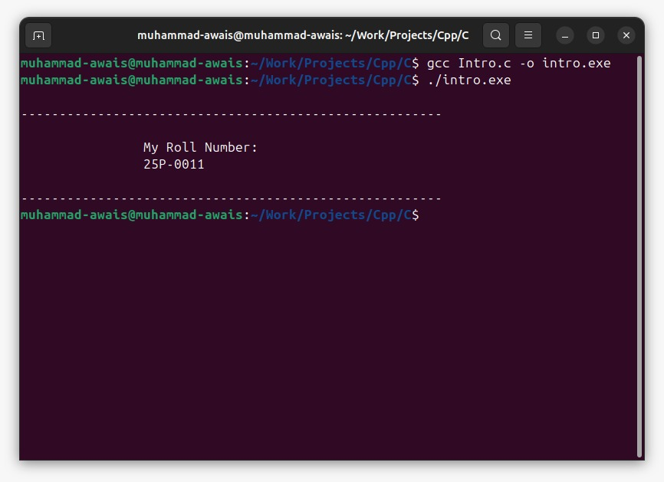

Student Grade Report

- Source Code:

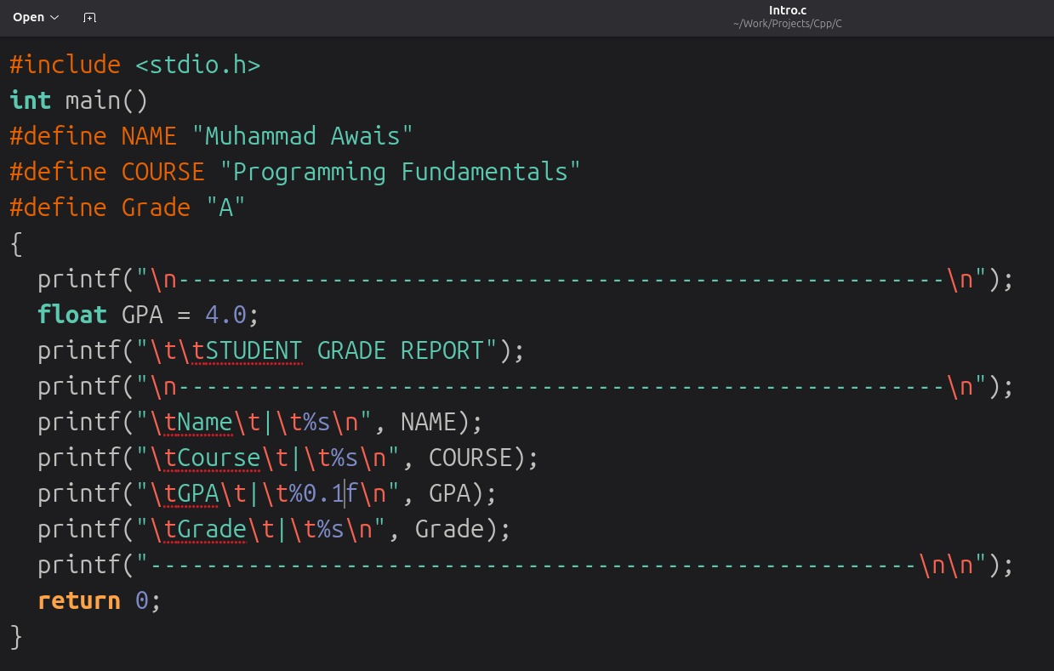

Output:

