PF Lab Task # 6

LCM Finder

Source Code:
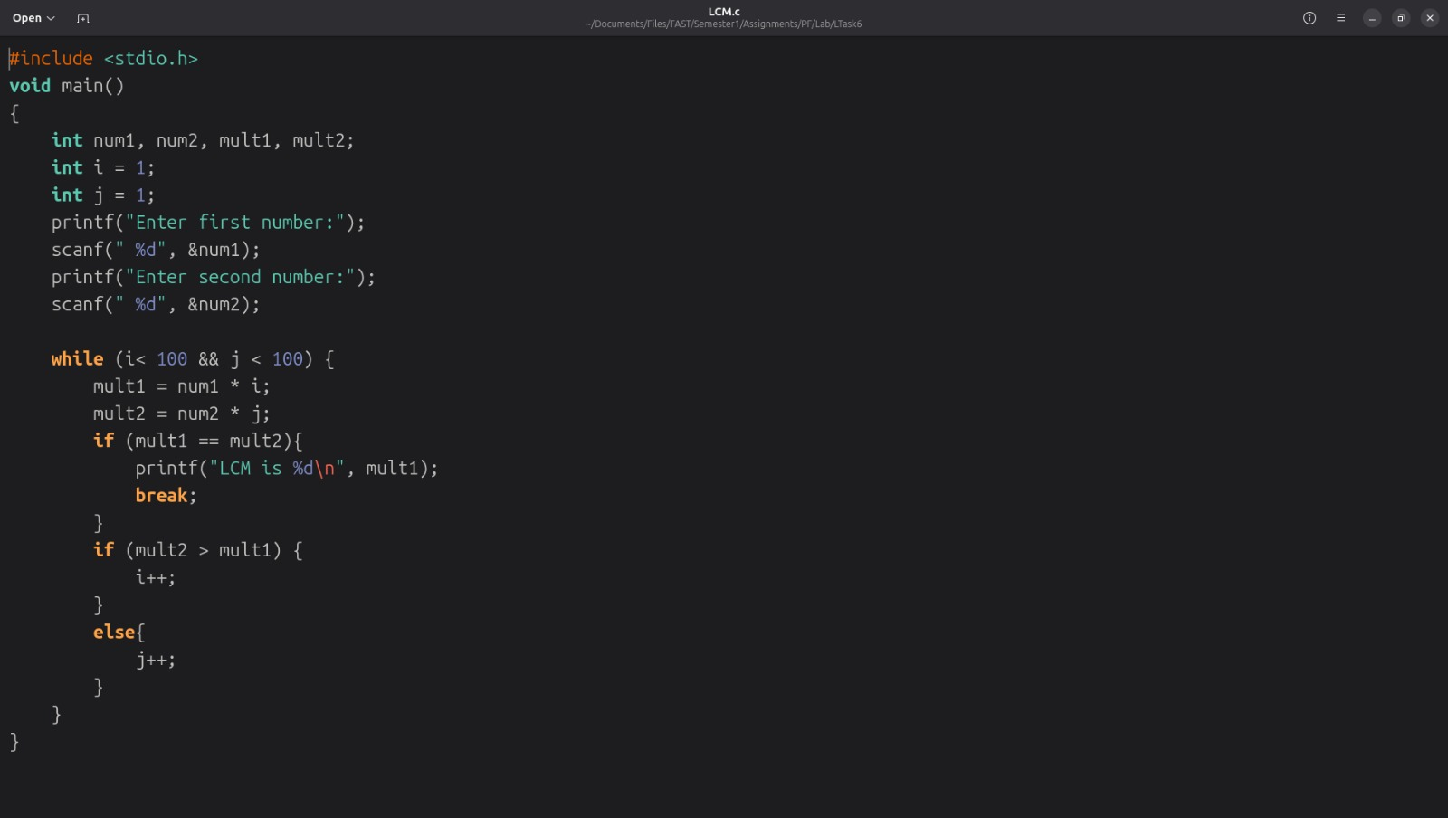

Output:
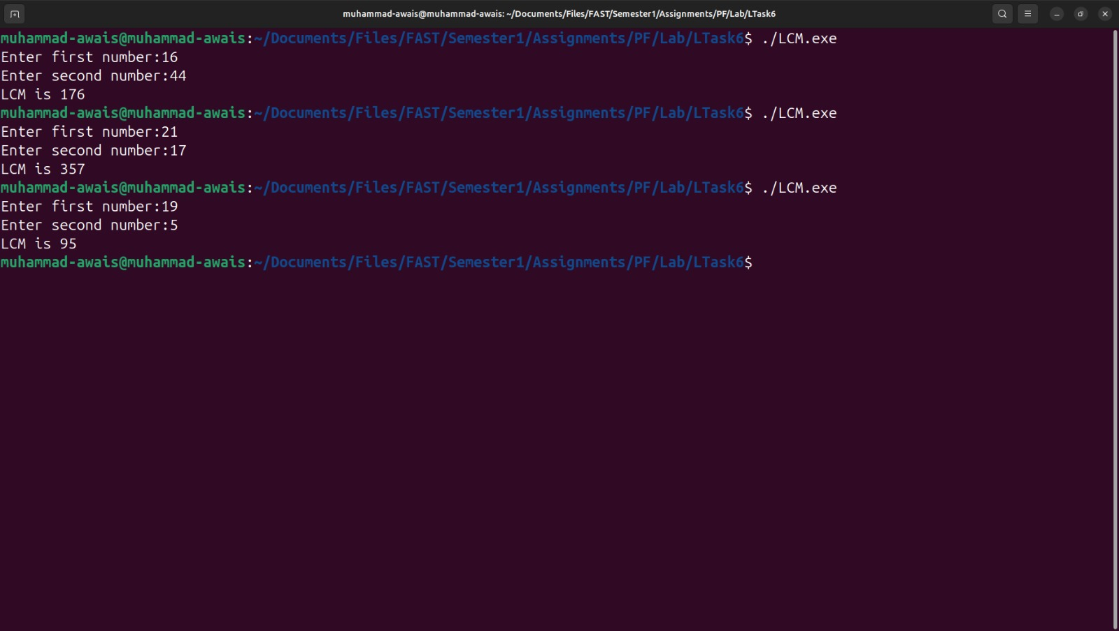

Calculator (Extended)

Source Code:
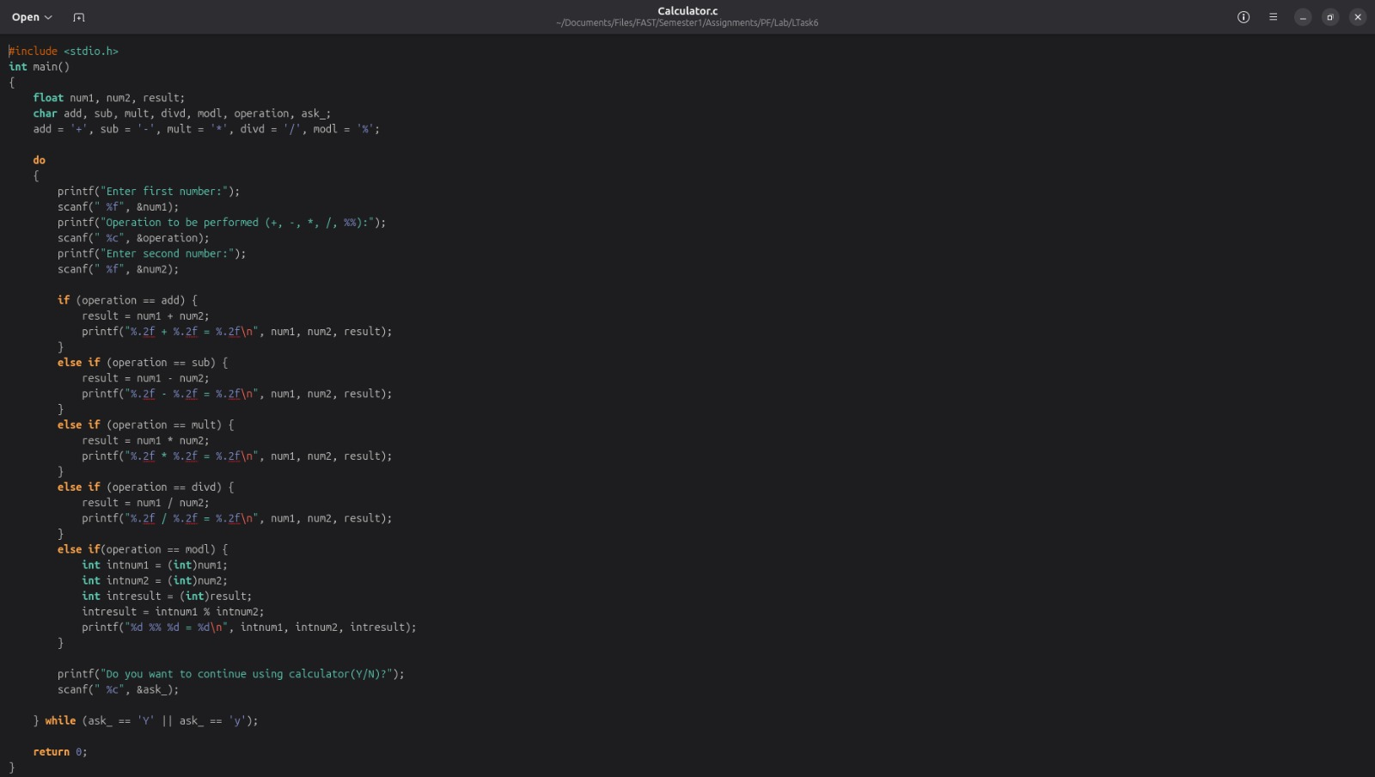

Output:
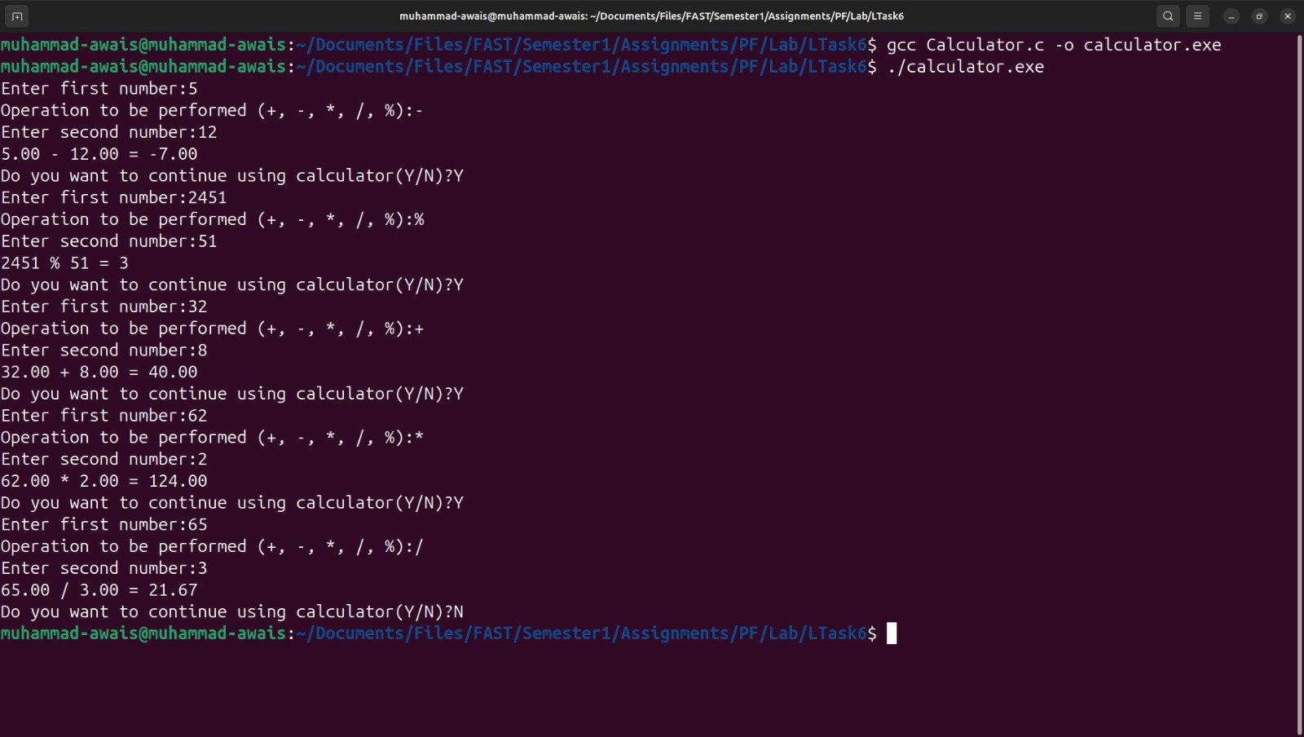

BRT Ticket Booking System

Source Code:
- You would find a commented statement in the source code. There’s not an issue with it, just a mild logical error was being displayed. Although every effort was made from my end to clear the issue out, I failed to tackle it out on my own. So instead of running to ChatGPT for short term relaxation, I preferred leaving it to my respected Lab Instructor to demonstrate the error and its solution using the very same concepts that are covered in our syllabus till now.
- I prefer conceptual logic to GPT’s broken logics. That’s another reason why I try to write most of my codes (for now at least) in a regular text editor instead of an IDE.

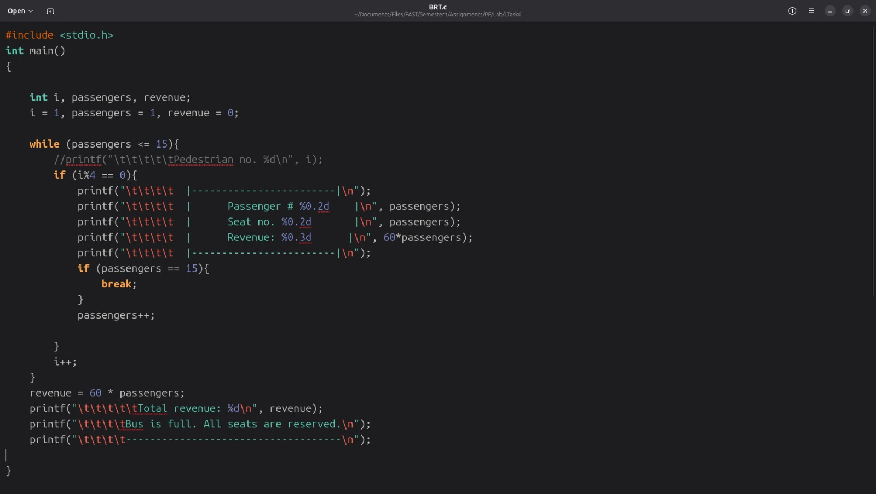

Output:
- This is my code that I’m running in VS code as the compiler doesn’t support %0.2d format for integers in raw terminal.
- Despite the warnings, as it worked in VS code, it was apt to display the output in this IDE.
