Lab 2 - COAL

Lab Task 1:

Step | Instruction | AX | AH | AL
1 | MOV ax, val1 | 4660 | 18 '\x12' | 52 '4'

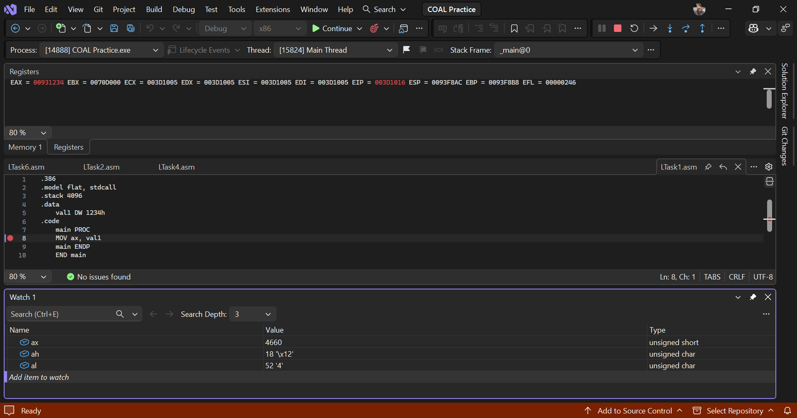

Lab Task 2:

Step | Instruction | AX | AL | BX | BL
1 | MOV bx, num1 | 65428 | 148 '”' | 37 | 37 ‘%’
2 | MOV al, bl | 65317 | 37 ‘%’ | 37 | 37 ‘%’

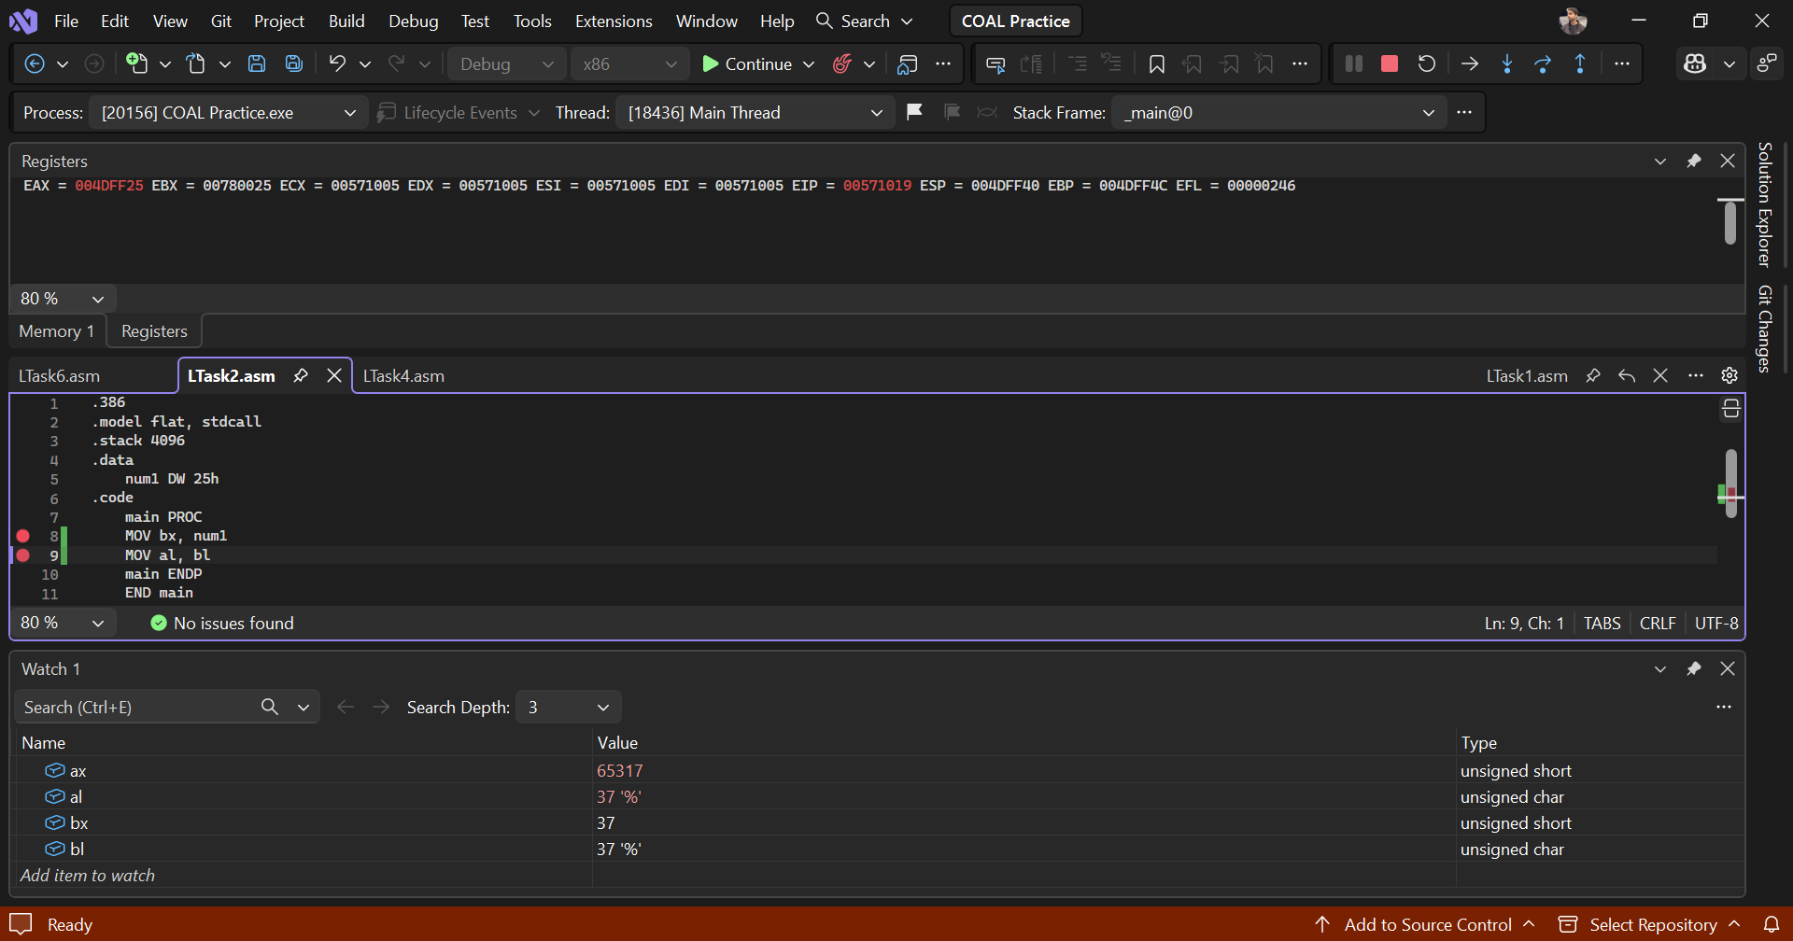

Lab Task 3:

Step | Instruction | CX
1 | MOV cx, counter | 0
2 | INC cx | 1
3 | INC cx | 2
4 | INC cx | 3
5 | DEC cx | 2

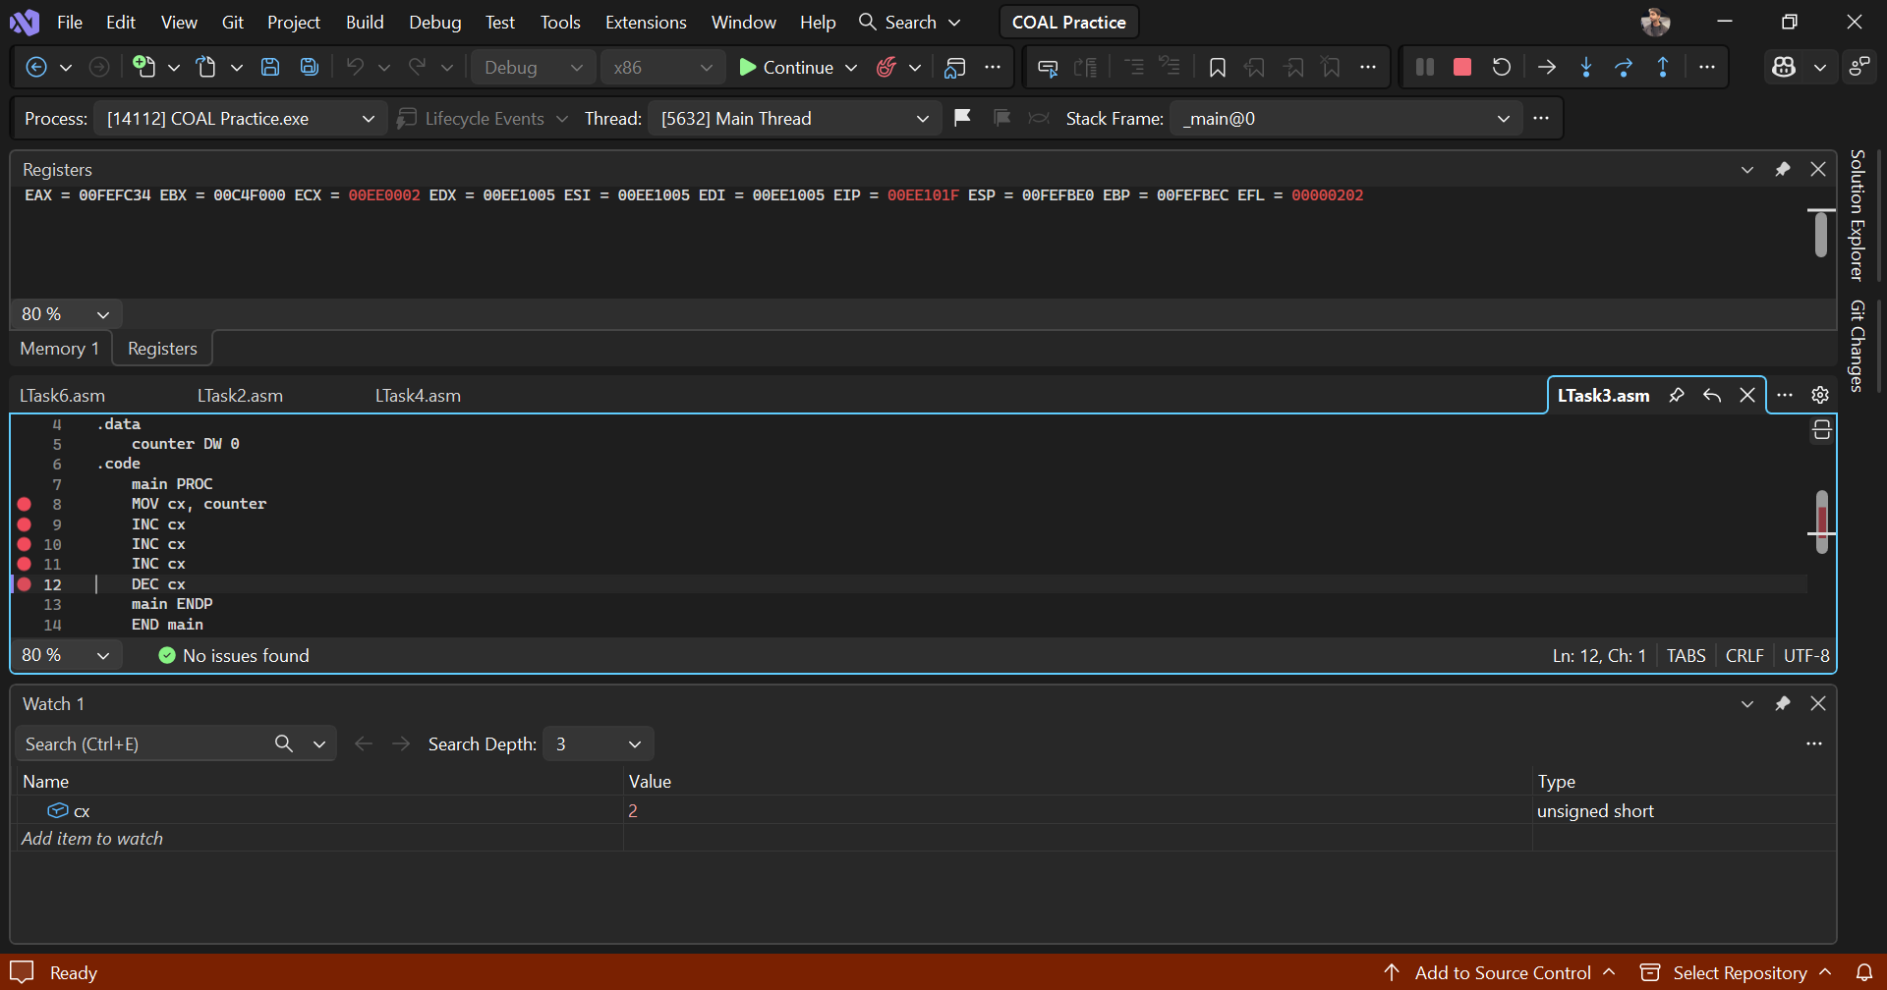

Lab Task 4:

Step | Instruction | DX | DH | DL
1 | MOV DL, 05h | 4101 | 16 '\x10' | 5 '\x5'
2 | MOV DH, 0Ah | 4101 | 16 '\x10' | 5 '\x5'
3 | INC DL | 2565 | 10 '\n' | 5 '\x5'
4 | INC DH | 2566 | 10 '\n' | 6 '\x6'
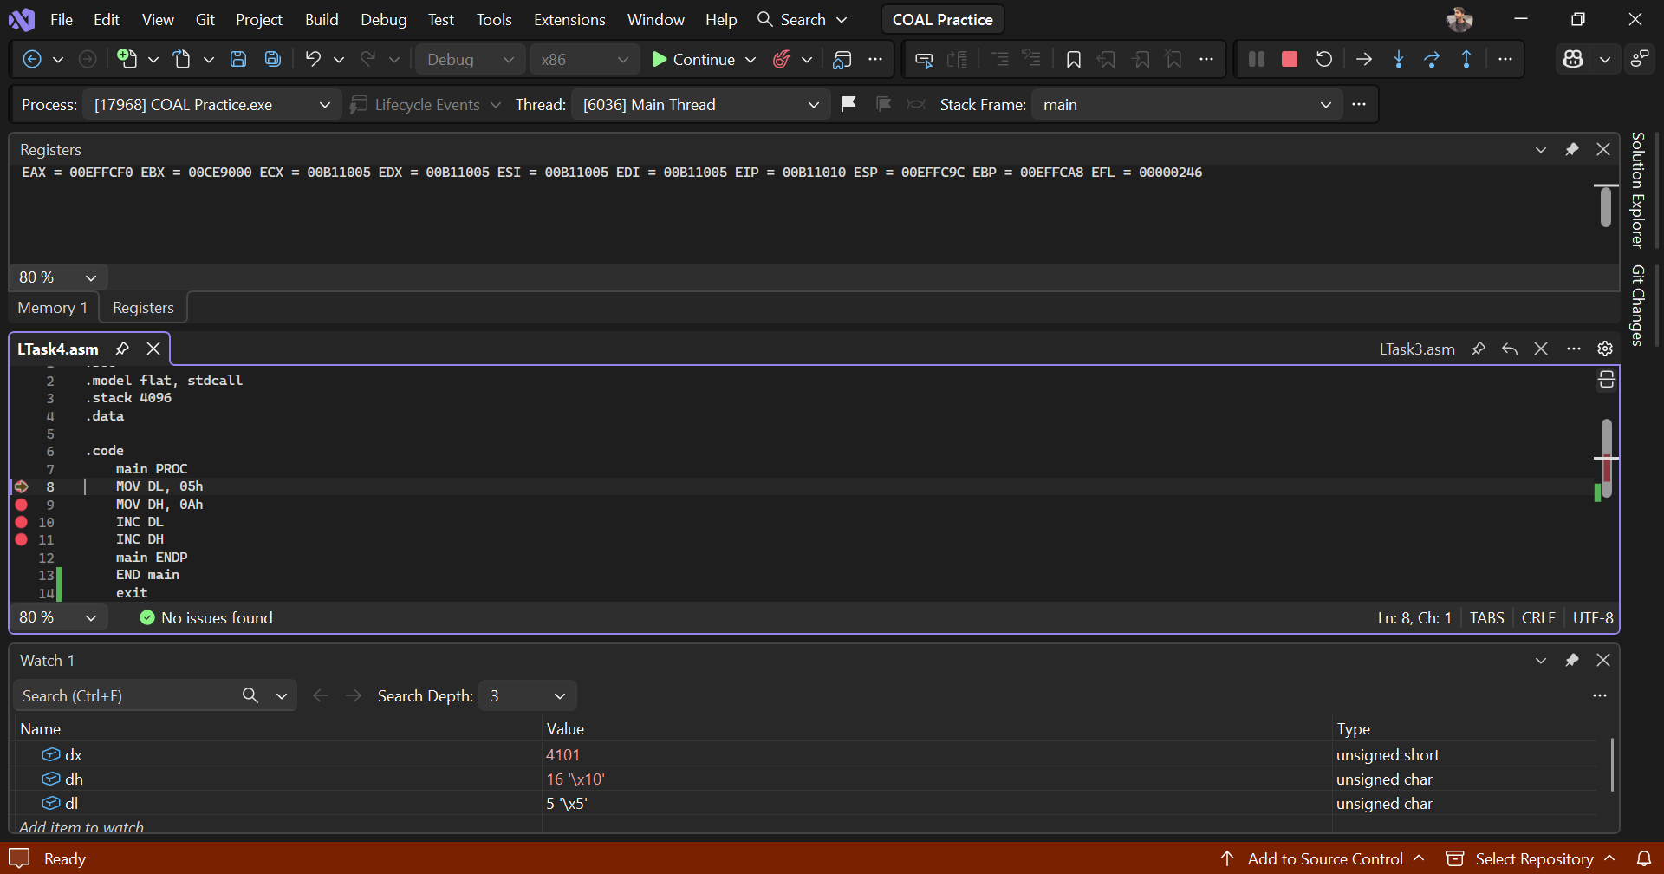
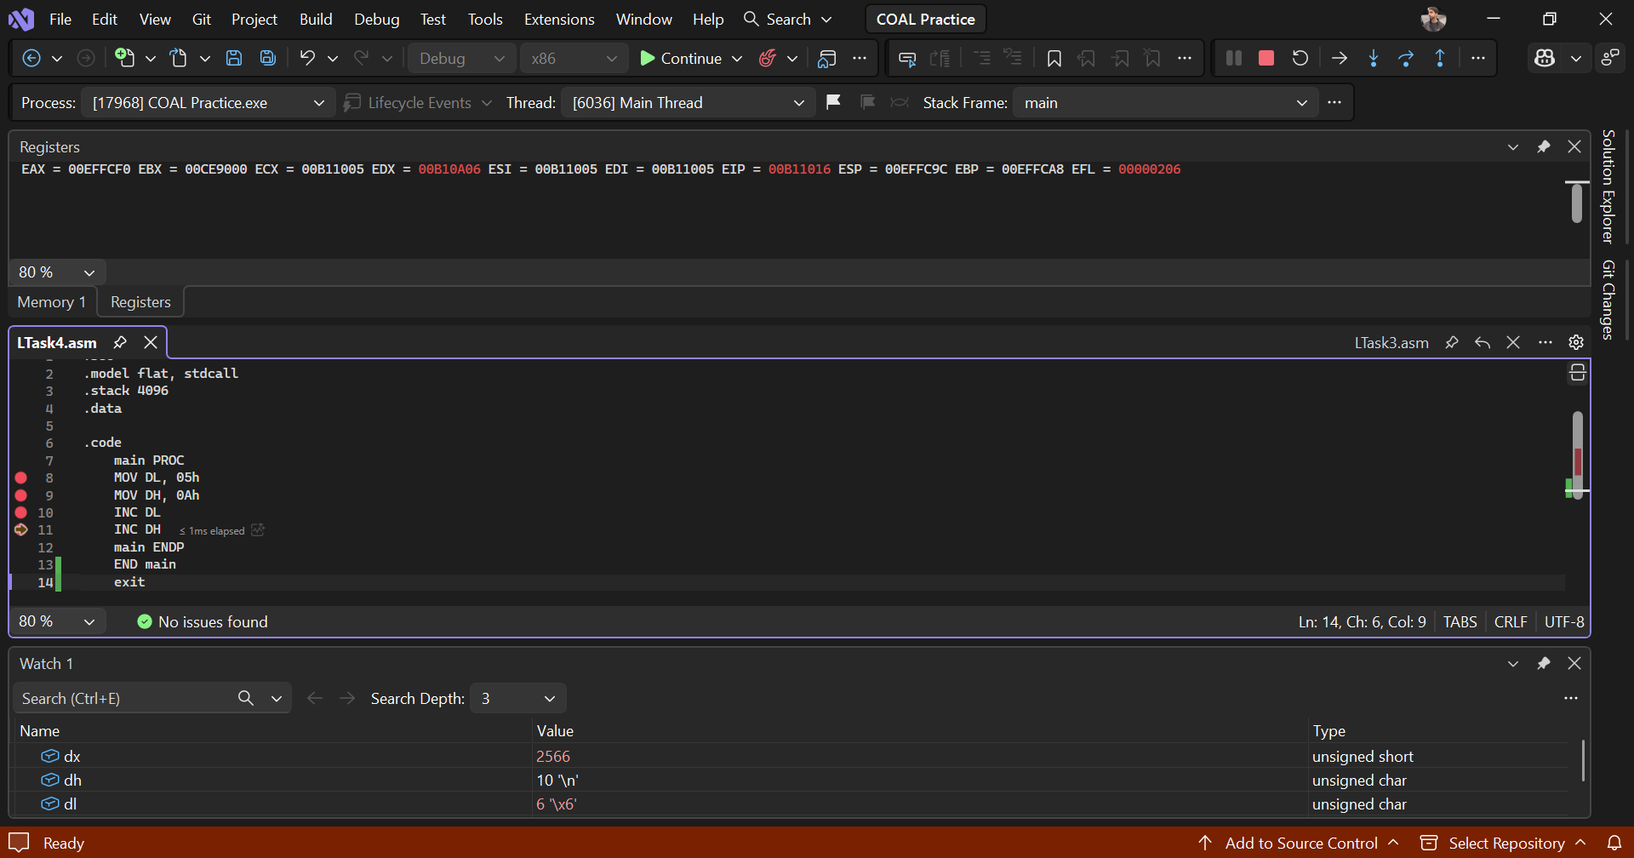

Lab Task 5:

Instr. | Valid / Invalid | Reason (if invalid) | Corrected version (if applicable)
a | Valid
b | Invalid | Can’t copy from one memory to other directly | Totally wrong, use a register to copy from one variable and then move to other
c | Invalid | Destination is data value | MOV ax, 5
d | Invalid | Size mismatch of registers | MOV AL, BL / MOV AX, BX

Lab Task 6:

Step | Instruction | AL | storeHere (mem)
1 | MOV al, storeHere | 127 '' | 0 '\0'
2 | INC al | 128 '€' | 0 '\0'
3 | MOV storeHere, al | 128 '€' | 128 '€'

