July 14, 2022

submitted by

imran khan (051-19-0010)

AFTAB AHMED (023-19-0049)

finger tips image capturing application (FTICA)

AI semester project report

Introduction:

Finger tips image capture application is a smart solution for image capturing applications which use signs of AI and ML to capture the image. This is enhancement in the hand sign image capturing feature which makes hand sign very easy and sophisticated to capture any image with your desired position and pose.

Problem statement:

This problem was detected by me which was found in my OPPO mobile having model A54. Problem was that when we try to capture the image by showing our hand to camera it detects the hand and starts timer for ten counts and then captures image directly. The main problem was that first of all we have to go to the settings and set timer for the capture image in exact counts like 5 or 10 seconds count. After that it does not wait if the count ends it immediately captures the image as soon as the timer reaches the required count. So overcome this problem I have developed an Artificial intelligence and machine learning based program and named it (FTICA) Finger tips image capturing application. Which is very useful to resolve that problem in every device.

Literature Review:

This problem is not only the matter of my mobile phone only but this problem is found in every mobile phone even biggest companies like Apple and Huawei mobile phones are suffering from the same problem. They just receive a sign of hand and capture directly. In other situation we have to hold the capturing of image by setting timer manually that looks too awkward. Through our program this problem can be resolved very easily. Because our program doesn’t need to set any timer to capture image but our fingers work like a timer if we show one finger it will count 1, if we show two fingers It will count 2 likewise till four. When we show the full hand or five fingers it will open a new window for capturing the image. It will wait for your hand until and unless you take away your hand it will not capture image but remains in wait state until your hand is in front of camera. As soon as you move away your hand from camera it will capture your image and saves it.

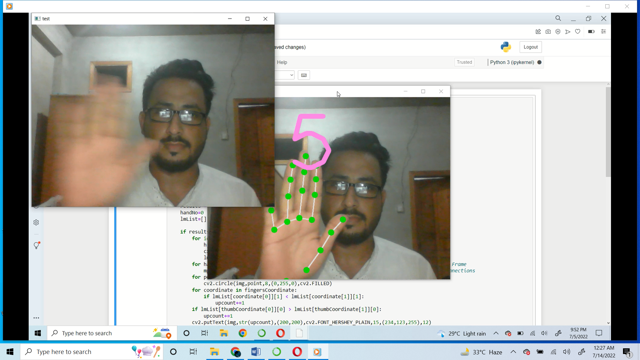

Methodology:

We have used artificial intelligence and machine learning based algorithms to develop this application. The programming language that we have used is python and the version of python is python 3. We have used different libraries to accomplish different tasks in application. The main two libraries that we have used are openCV and mediaPipe. For image processing and computer vision jobs, OpenCV is a fantastic tool. It is an open-source library that may be used for a variety of operations, including face identification, object tracking, landmark detection, and many more. Python, Java, and C++ are just a few of the languages it supports. There is more to developing an application that handles perceptual inputs than simply running an ML model. In order to conduct many processes simultaneously and with pipelining, developers must balance resource utilization and result quality. They also need to make sure that time-series data is properly synced. These difficulties are addressed with the MediaPipe architecture. Using MediaPipe, a developer may quickly and simply mix new and current perceptual components to create prototypes that can then be improved into polished cross-platform apps. The developer may set up a MediaPipe-based application to manage resources effectively for low latency performance, handle time-series data synchronization for audio and video frames, and monitor performance and resource usage. We demonstrate how these characteristics allow developers to concentrate on the algorithm or model development while using MediaPipe as an environment for iteratively developing their application, with consistent results across many platforms and devices. We have used openCV to process the image and capture image and set frames for image windows. Whereas mediaPipe is used to detect hand and figures to capture the image.

How it works:

First of all open the python 3 file in Jupyter note book click the run button it will open the camera window for you. In that window show your hand to camera by closing your fingers and open it one by one till four. As soon as you open the fifth finger it will open a new window for capturing the image. Just take away your hand in front of camera it will capture your image and saves it where your file is located.

Conclusion:

Finger tips image capturing application can be very useful for every kind of devices which use selfie camera to capture picture. It resolve the problem of setting timer for capturing images and also you can use your fingers as timer. It will wait for you until and unless you move your hand in front of the camera. Through using this feature in your device you can capture one of the best images in your desired position and pose. We will suggest all smart devices companies and image capturing software developers to use this feature program and make image capturing very easy and user friendly by only at your fingertips.

Link for demo video:

<https://youtu.be/pSCdRZ1yrW4>