|  |  |  |
| --- | --- | --- |
| **Kingdom of Saudi Arabia**  **Ministry of Education**  **University of Hail**  **College of Computer Science and Engineering**  **Department of Computer Engineering** |  | **المملكة العربية السعودية**  **وزارة التعليم**  **جامعة حائل**  **كلية علوم وهندسة الحاسب الآلي**  **قسم هندسة الحاسب الألي** |

**Electronics - 203**

Experiment #3: Applications of Semiconductor Diodes

**Name :** Khaled Mofdi Alshammri

**Couse :** EE-203

Introduction :

In this experiment I will study the diode and see what’s happen with two parallel voltage source for choose what is a best logic gate to relationship representation and What is the diode that is turned on.

The circuit used is :

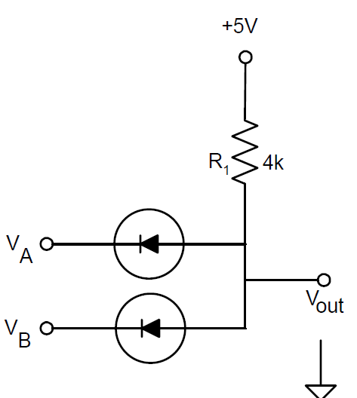

|  |  |  |  |
| --- | --- | --- | --- |
| VA | VB | Vout | Picture PSpice |
| 0 | 0 | 542.86 mV |  |
| 0 | 5 | 578.03 mV |  |
| 5 | 0 | 578.03 mV |  |
| 5 | 5 | 5V |  |

1 ) What logic function does the circuit perform?

Answer : In the circuit use AND logic gate when you see truth table in AND gate

1.1=1 then 5.5=5v

0.1 = 0 then 0.5 = 578.03mV It is a very small value very close to zero

Conclusion :

I concluded from the electrical circuit that a parallel voltage source is disabled one and the other source is turned on and this corresponds to the truth table of the logic AND gate. And in table When VA = 0 & VB =5 Same value when VA = 5 & VB =0