|  |  |  |
| --- | --- | --- |
| **Kingdom of Saudi Arabia**  **Ministry of Education**  **University of Hail**  **College of Computer Science and Engineering**  **Department of Computer Engineering** |  | **المملكة العربية السعودية**  **وزارة التعليم**  **جامعة حائل**  **كلية علوم وهندسة الحاسب الآلي**  **قسم هندسة الحاسب الألي** |

**Electronics - 203**

Experiment #5: Diode applications : Limiters, Clampers &Voltage Doubler

**Name :** Khaled Mofdi Alshammri

**Couse :** EE-203

Introduction :

in this experiment i will study applications of diode

( clampers , limiters and voltage doubler ) then see how its work and trace sin wave in oscilloscope

Lets get started :

Experimental Work:

1. **Fixed biased Diode Limiter:** Assemble the underneath biased diode positive and

negative limiter circuit; Use function generator as input signal (set for: sinusoidal,

triangle, and square waveforms with 2 KHz, 10 Volts peak one waveform at a time); Use

oscilloscope for tracing the output voltages for each of the waveform types; Use two DC

adjustable power supplies as bias voltage sources. Use X-Y mode of oscilloscope to plot

the transfer function for sinusoidal case.

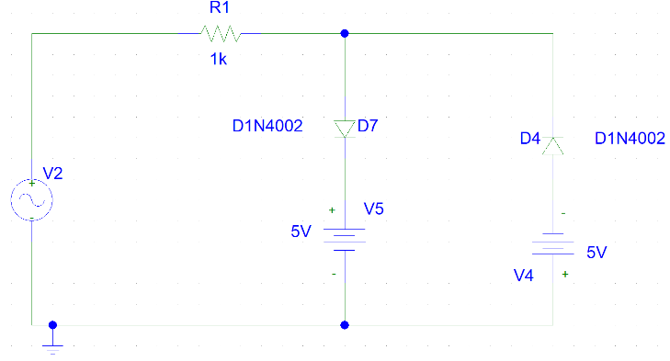

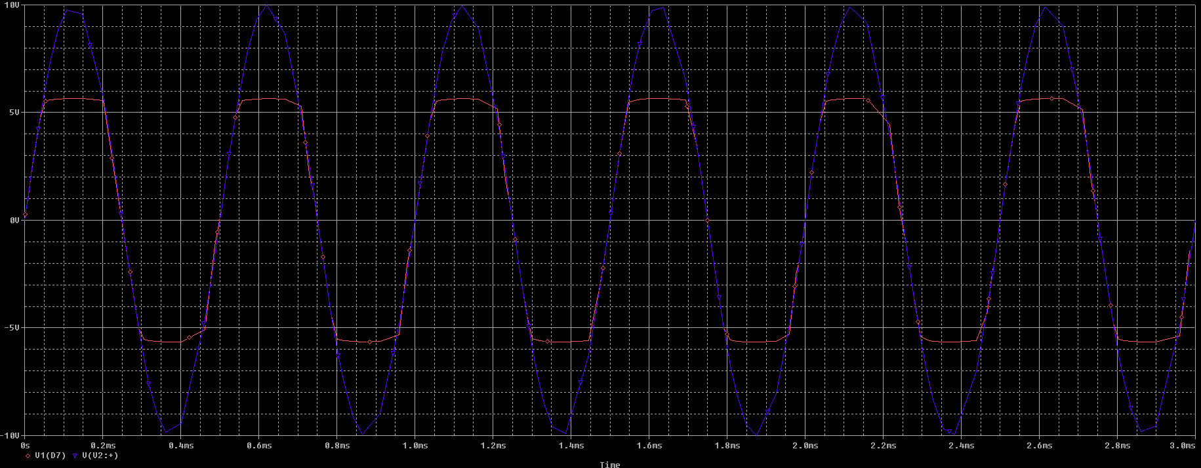

2. Observe the output for sinusoidal input for the case when one diode is removed

(alternately). And for the case when both biasing supplies are removed. Use the X-Y

mode to plot the transfer function.

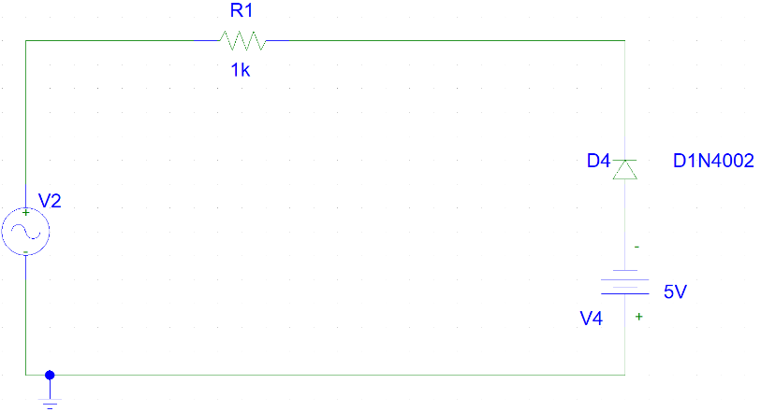

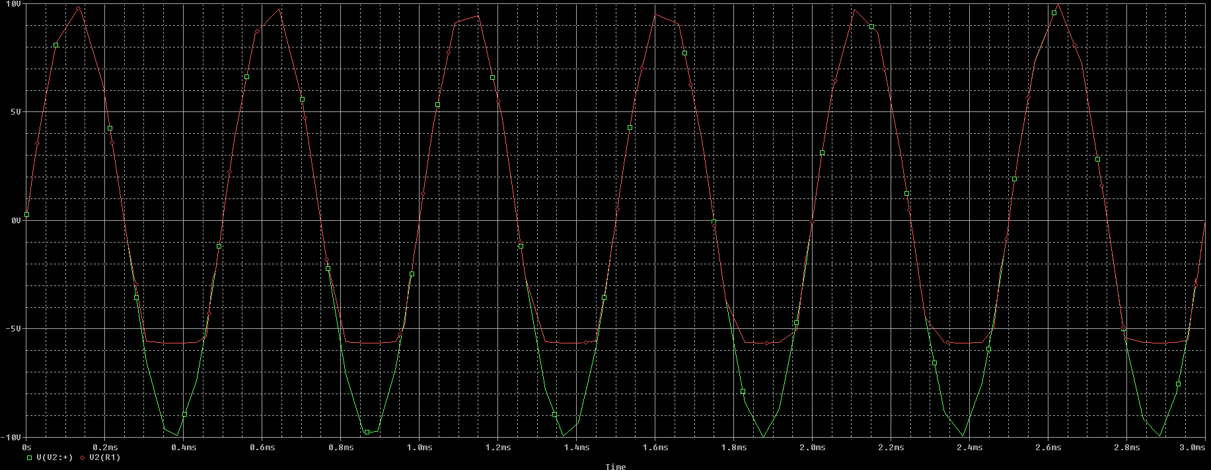

3. **Clamping Circuit:** 5 KHz 10V . Check also what happens when

capacitor polarity is reversed.

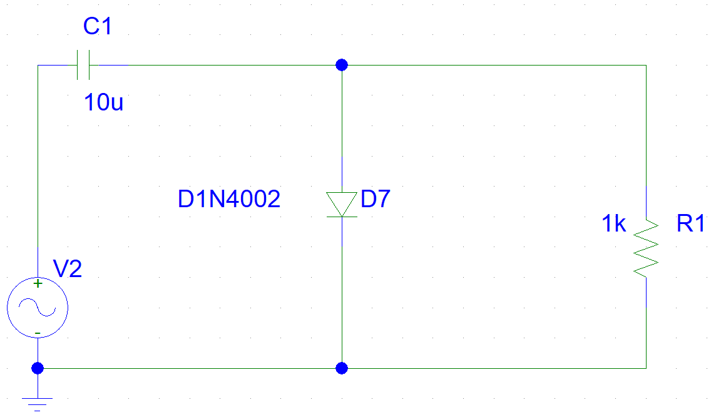

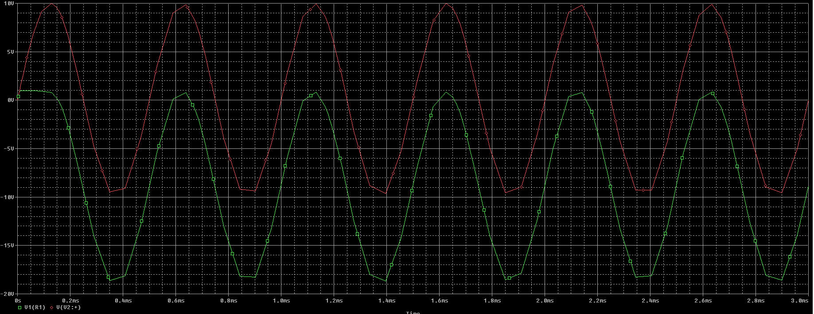

After reverse Fig2 :

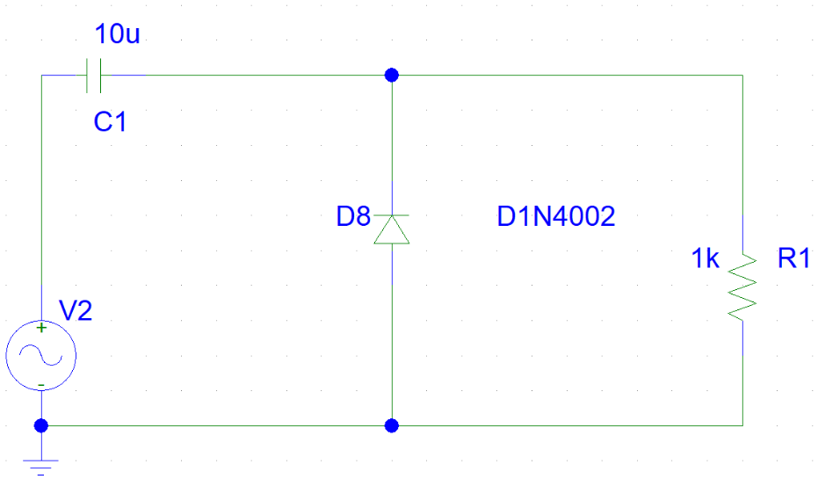

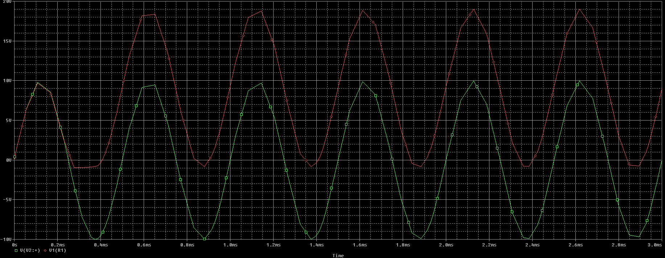

4. Lastly add a dc supply of 2 volt to the diode as shown in Figure 3. Sketch the output

waveform. Show the dc level on your sketch. Also check output for square wave input.

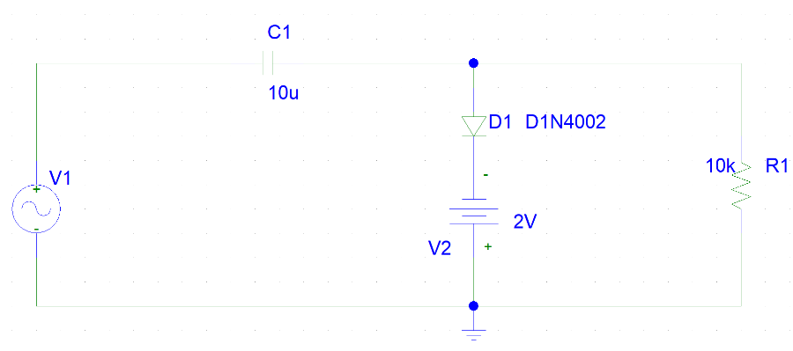

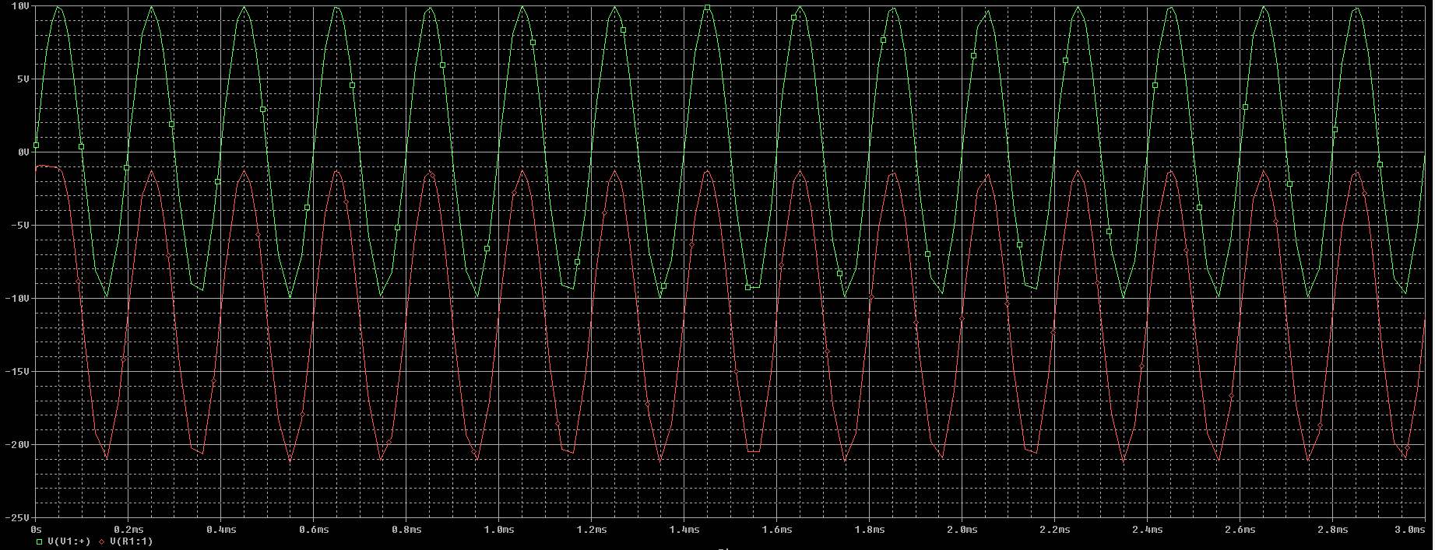

5. Keep the clamped capacitor circuit shown in Figure 2 as it is. Build a circuit by

exchanging the position of capacitor and diode as shown Figure 4, sketch the output. Next

use output of the clamped capacitor as an input to the present circuit as shown in Figure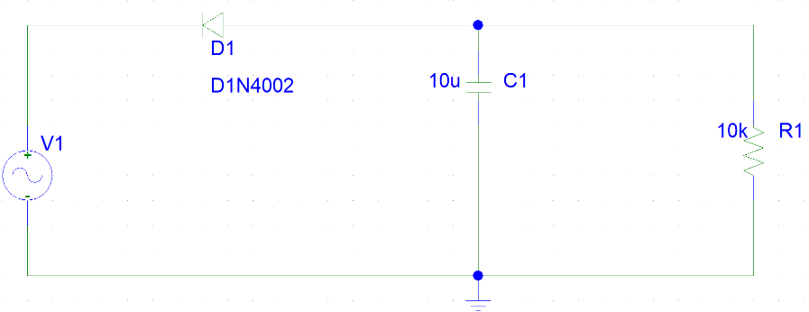

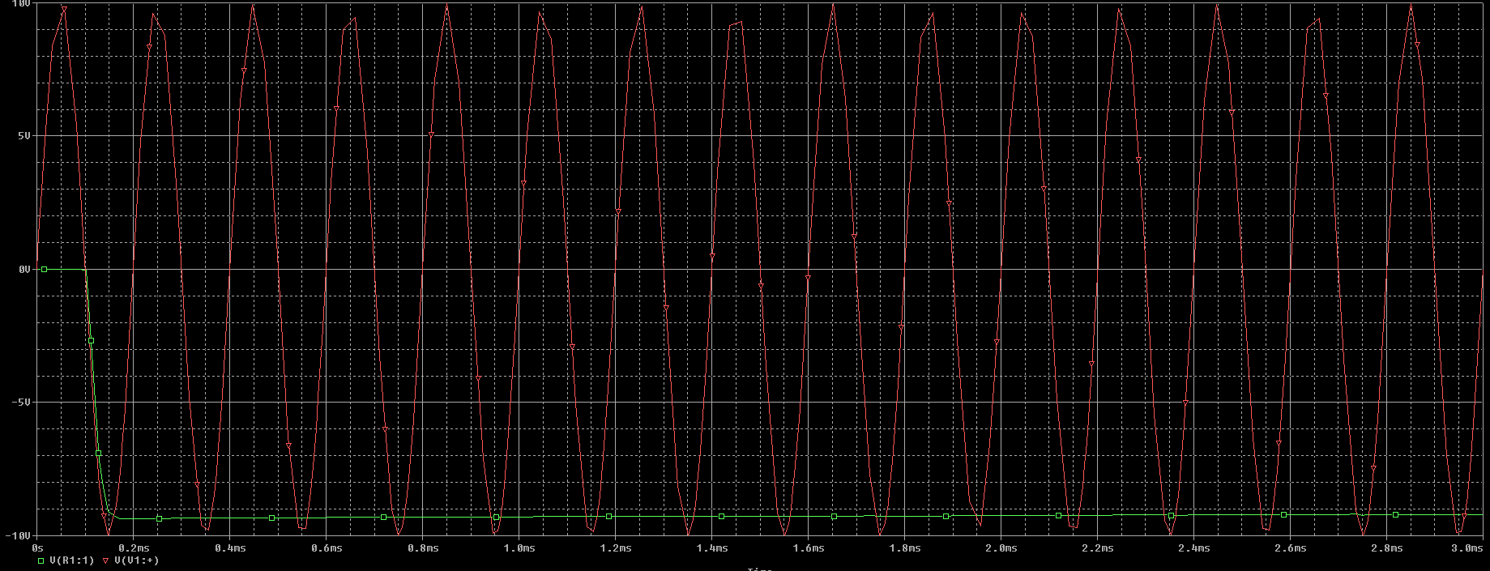

5,. Measure and explain the output. What would you call this circuit?

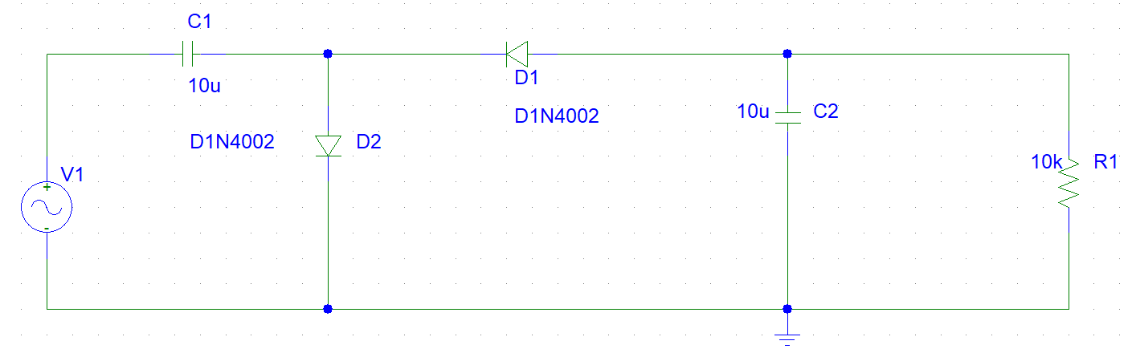

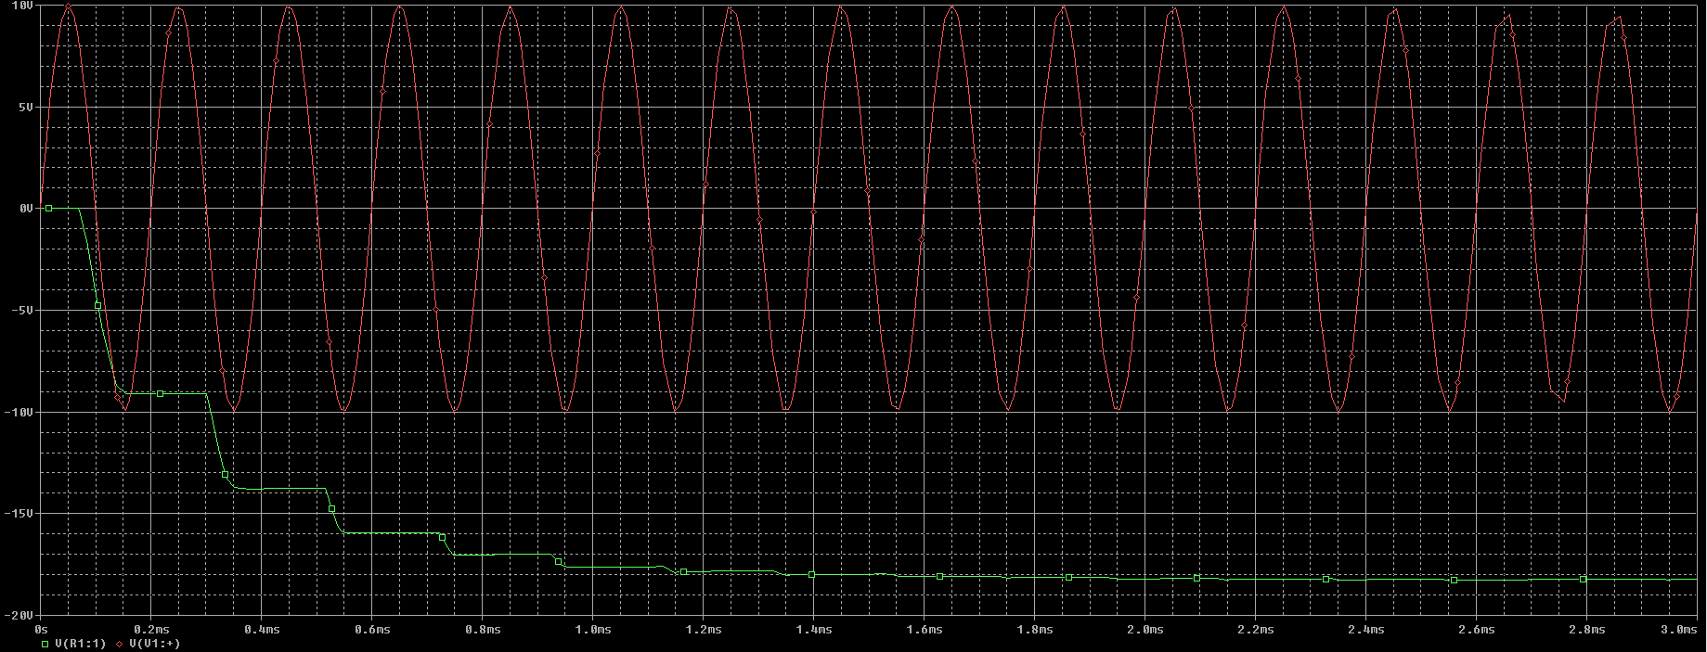

This circuit called voltage doubler

A circle gives the shape of levels

Conclusion :

In fig 1 : the voltage output range between +5v & -5v its circuit The circuit set limits to the output voltage

And after remove the output voltage limit just in -5v and in positive same input voltage .

In fig 2 the output voltage start from zero to -20v and the limit range is 0 to -20v

In fig 3 the voltage source 2v help to voltage keep under zero to -20v

In fig5 the output voltage start from 0 and drop to -10v keep same value along time

In fig 5, when sin wave -10v the voltage in output drop and in +10v its constant in same level