|  |  |  |
| --- | --- | --- |
| **Kingdom of Saudi Arabia**  **Ministry of Education**  **University of Hail**  **College of Computer Science and Engineering**  **Department of Computer Engineering** |  | **المملكة العربية السعودية**  **وزارة التعليم**  **جامعة حائل**  **كلية علوم وهندسة الحاسب الآلي**  **قسم هندسة الحاسب الألي** |

**Electronics - 203**

Experiment #6: Bipolar Junction Transistor Characteristics

Part#1

**Name :** Khaled Mofdi Alshammri

**Couse :** EE-203

Introduction :

in this experiment i will study transistor BJT type PNP ( PNP mean positive negative positive ) and will analysis current with software PSpice, then find beta value and alpha value with use some law to find it

Lets get started :

**A ) Determine α and β from the curves for the following values of IB and VCE: IB =**

**0.1mA, 0.3mA and 0.5mA at VCE = 2.5V and VCE = 5V.** Compare with experimental

result.

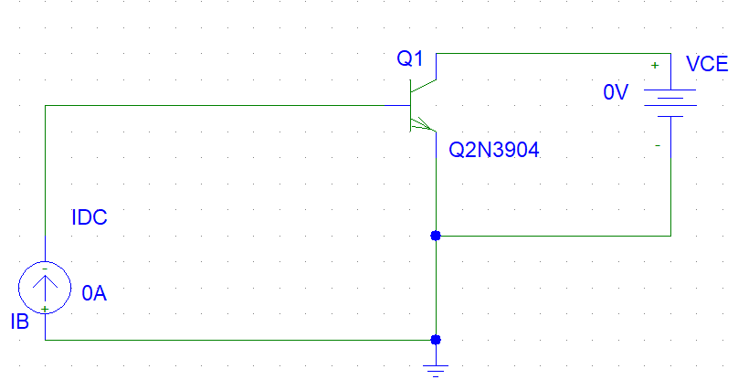

***Trace Circuit ( IC ) Current :***

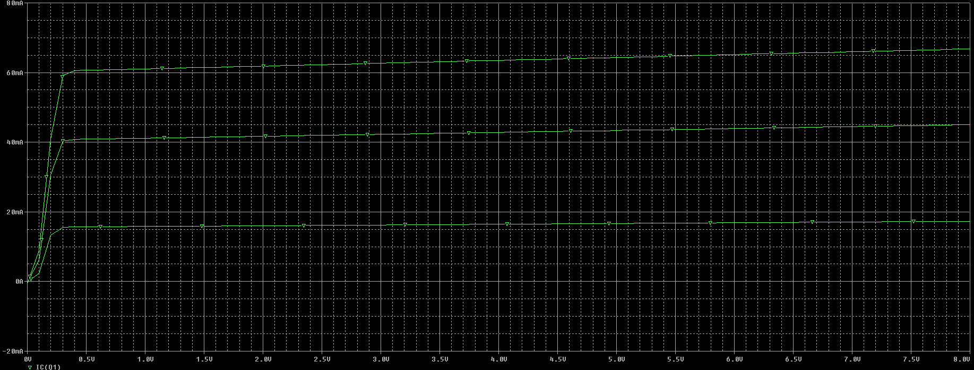

Result Cursor at **VCE** = 2.5v :

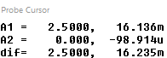

Ic = 16.136mA at 2.5v

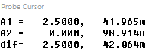

Ic = 41.965mA at 2.5v

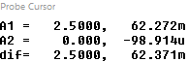

Ic = 62.272mA at 2.5v

***1 ) Find $β$ $$β= \frac{Ic}{Ib}=\frac{16.136mA}{0.1mA}=161.36$$***

$$β= \frac{Ic}{Ib}=\frac{41.965mA}{0.1mA}=419.65$$

$$β= \frac{Ic}{Ib}=\frac{62.272mA}{0.1mA}=622.72$$

***2 ) Find $α$***

$α=\frac{β}{β+1}=\frac{161.36}{161.36+1}=0.99$**3**

$$α=\frac{β}{β+1}=\frac{419.65}{419.65+1}=0.997$$

$$α=\frac{β}{β+1}=\frac{622.72}{622.72+1}=0.998$$

Result Cursor at **VCE** = 5v :



Ic = 16.673mA at 5v



Ic = 43.376mA at 5v

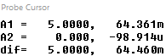

Ic = 64.361mA at 5v

***1 ) Find $β$ $$β= \frac{Ic}{Ib}=\frac{16.673mA}{0.1mA}=166.73$$***

$$β= \frac{Ic}{Ib}=\frac{43.376mA}{0.1mA}=433.76$$

$$β= \frac{Ic}{Ib}=\frac{64.361mA}{0.1mA}=643.61$$

***2 ) Find $α$***

$$α=\frac{β}{β+1}=\frac{166.73}{166.73+1}=0.994$$

$$α=\frac{β}{β+1}=\frac{433.76}{433.76+1}=0.997$$

$$α=\frac{β}{β+1}=\frac{643.61}{643.61+1}=0.998$$

Conclusion :

At voltage 2.5v $β$ small and in voltage 5v the $β$ increasing value but $α$ is almost same .

And if I have IC ,IB and ($β, α$) I cant find IE

IE = ( +1 ) IB  or IE = I*C* /