Univerzitet u Sarajevu
Elektrotehnički fakultet Sarajevo
Odsjek za računarstvo i informatiku
Praktikum - Napredne web tehnologije

Quotebook
Dokumentacija

Irma Kapetanović

Sarajevo, juni 2015. god.

Sadržaj

Sadržaj 1
Analiza 2
Opis i upotreba 2
Za šta se koristi? 2
Ko koristi? 3
Postojeća rješenja 4
Quotebookapp 4
Pullquote 7
Quotabl.es 8
Brainyquote 9
Zahtjevi 10
Korisnici 10
Moduli i funkcionalnosti 11
Static pages 11
Modul 1: Autentifikacija 11
Modul 2: Administracija 11
Modul 3: Korisnici 11
Modul 4: Autori 11
Modul 5: Citati 12
Modul 6: Tagovi 12
Dizajn 13
Tehnološki stek 13
ERD 14
REST servisi 15
Implementacija 17
Razvojni alati i tehnologije 17
Literatura 18

Analiza

Opis i upotreba

Za šta se koristi?
It’s a place to store and share your favorite quotes.
Collect quotes that inspire YOU.
Keep your quote collection organized.

Quotebook je lična kolekcija citata.
Svaki korisnik odabire u koje svrhe i koje citate želi sačuvati, organizovati, a po želji i podijeliti sa drugima.

Za ljubitelje citata više nema potrebe za slanjem emailova samom sebi, izgubljenih i razasutih stikera, te nepreglednih dokumenata.
Quotebook ima za cilj da olakša sakupljanje (dodavanje), centralizovanje, pretragu i pregled citata bilo koje vrste: izreke poznatih ličnosti, dirljivi izrazi djece, citati iz stručne literature, podvučene rečenice iz omiljene knjige...

Odlika ove aplikacije jeste da ne dolazi popunjena citatima, već omogućava korisniku da pravi vlastitu kolekciju ideja koje se njega tiču.

Ko koristi?

- Roditelji

Kako bi zabilježili emotivne, smiješne i posebne izreke svoje djece ili druge značajne porodične trenutke.

- Studenti

Prilikom pretraživanja i rada na studentskim esejima, seminarskim radovima, stručnim i naučnim radovima, člancima...

- Pisci

U trenucima inspiracije za bilješke ideja za svoja djela.

- Govornici

Za pripremu predavanja/debata, referencirajući se na ranije spašene citate iz relevantnih izvora (knjiga, predavanja...) kao vid argumentacije.

- Svi

Kao izvor inspirativnih i motivacionih izreka značajnih upravo njihovoj ličnosti.

Postojeća rješenja

Quotebookapp

URL: http://quotebookapp.com/

Quotebook is where you collect quotes that matter. Curate, organize, and share the quotes
from your library in an app designed for readability. Build your collection over time, and
your favorite quotes will always be with you on all your devices.

- Add quotes seamlessly from life, books, and friends
- Discover more about the people and places that inspire you
- Share quotes with the people who matter, no matter where they are
- Tag and search quotes to find the perfect one when you need it most
- Collect quotes on your phone and they’ll be waiting at home on your iPad
- Information about your authors and sources is automatically downloaded from Wikipedia

The app goes one step further and makes it super-simple to import quotes found in your iPhone’s clipboard, and plays nicely with @author names, automatically opening a Twitter profile within a web view. Quotes can be searched and filtered, shared on Twitter, Facebook and Tumblr, or browsed by author and tag using the buttons in the bottom toolbar.

NEDOSTATAK: App samo za iPhone/iPad.
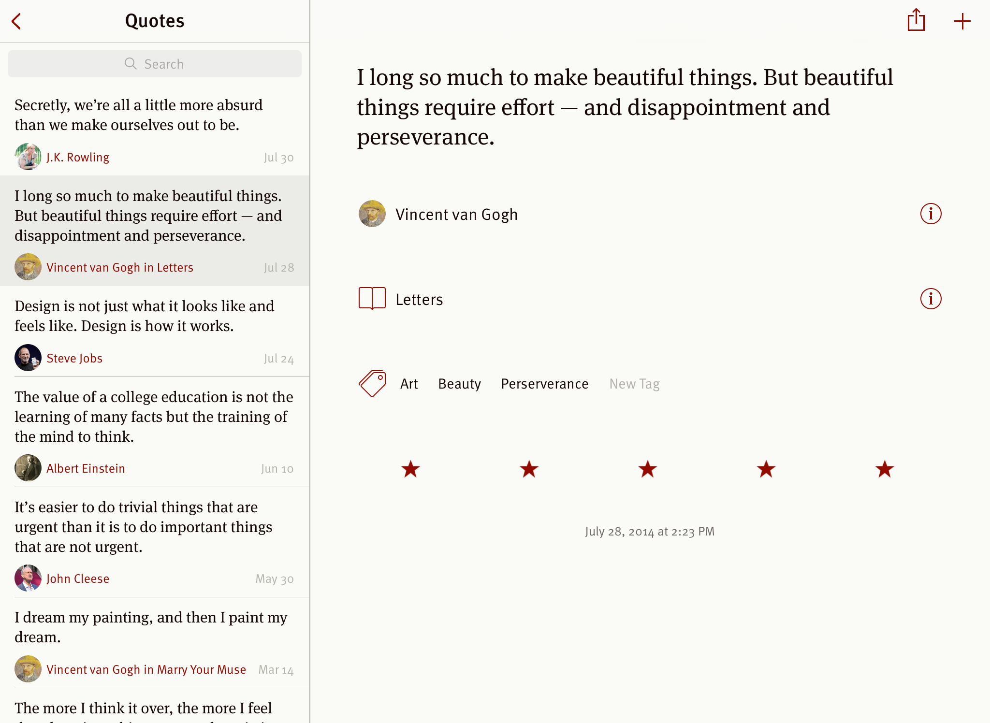

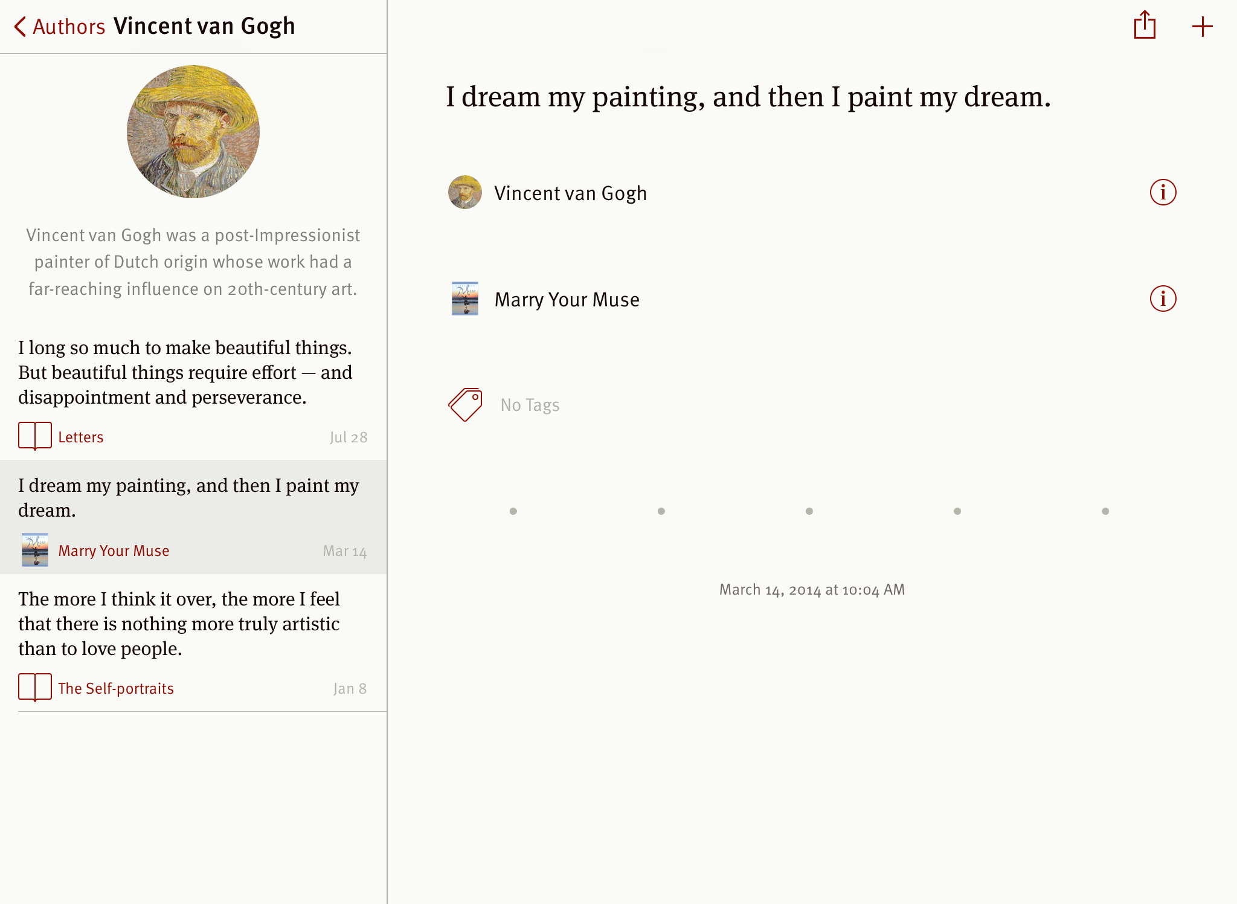

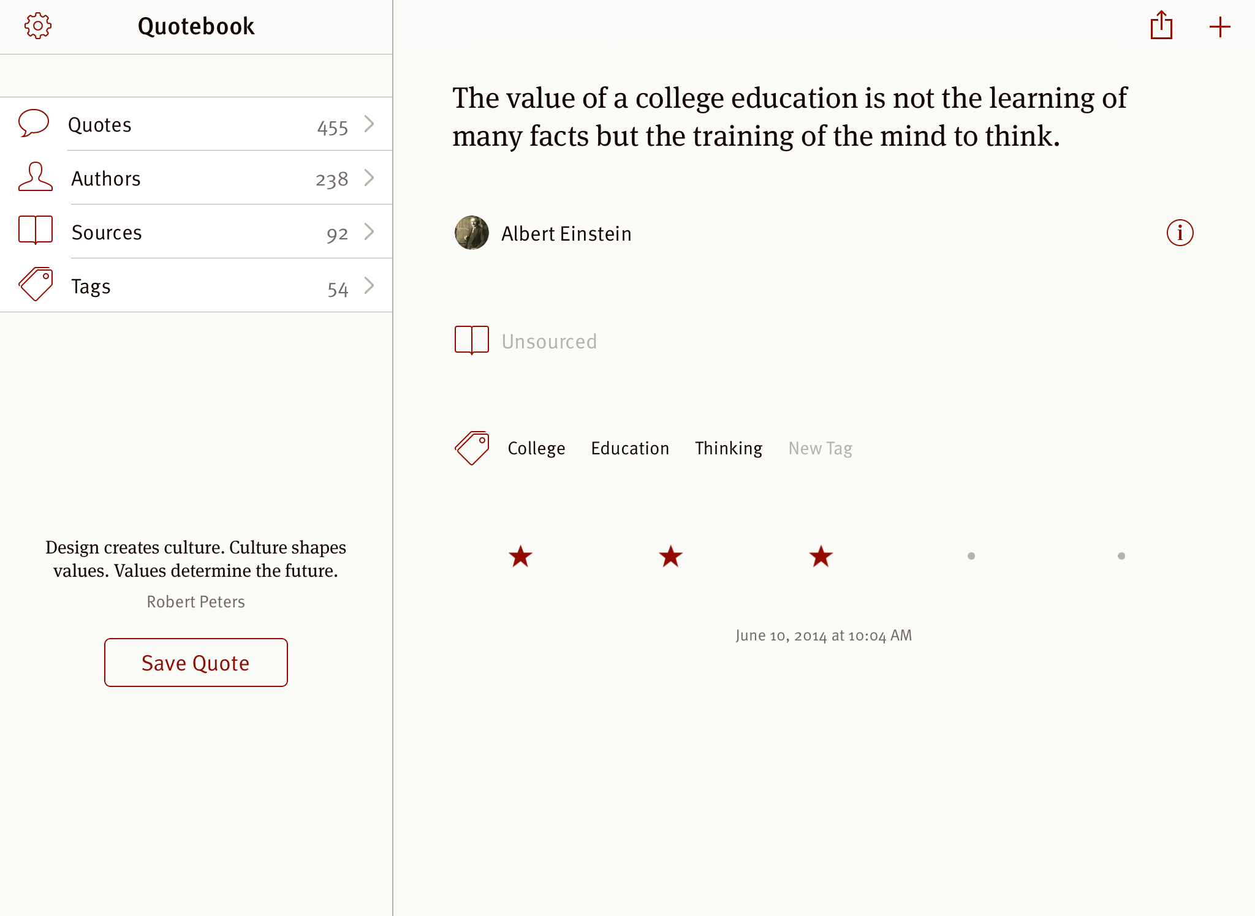

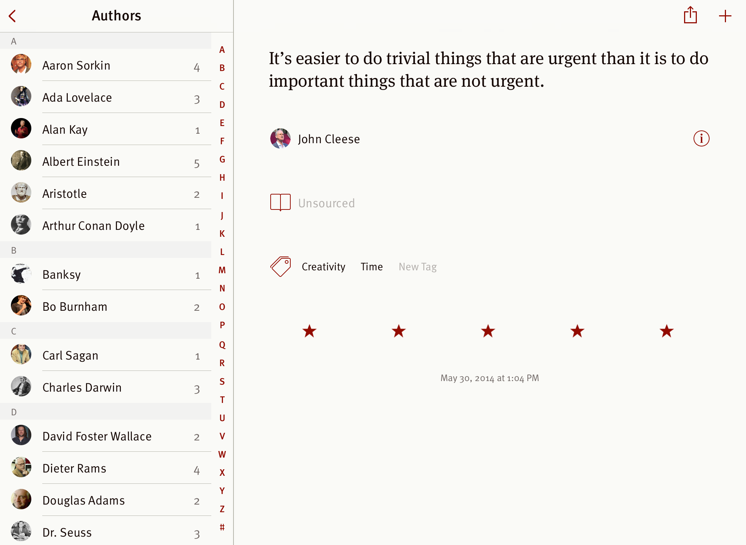

Pullquote

URL: http://pullquote.com/

Once you've installed the app and set it all up, just browse as you would usually. When you find a quote you like, highlight it and you'll see a menu with some options pop up. Simply select Tweet, make whatever modifications you like, and post. You can even save your favorite quotes with tags for easy access later. Pullquote also makes it easy to tweet an image. When you find an image you like, click the Quote It button in the corner of the image, crop as needed, and tweet it.

NEDOSTATAK: Ne može se organizovati po autorima; samo Chrome ekstenzija.

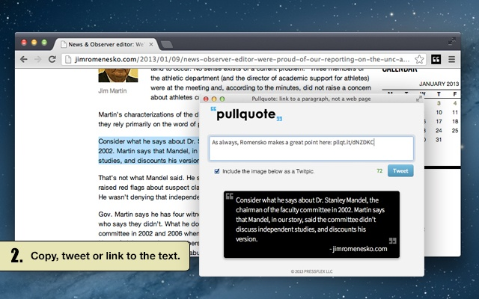

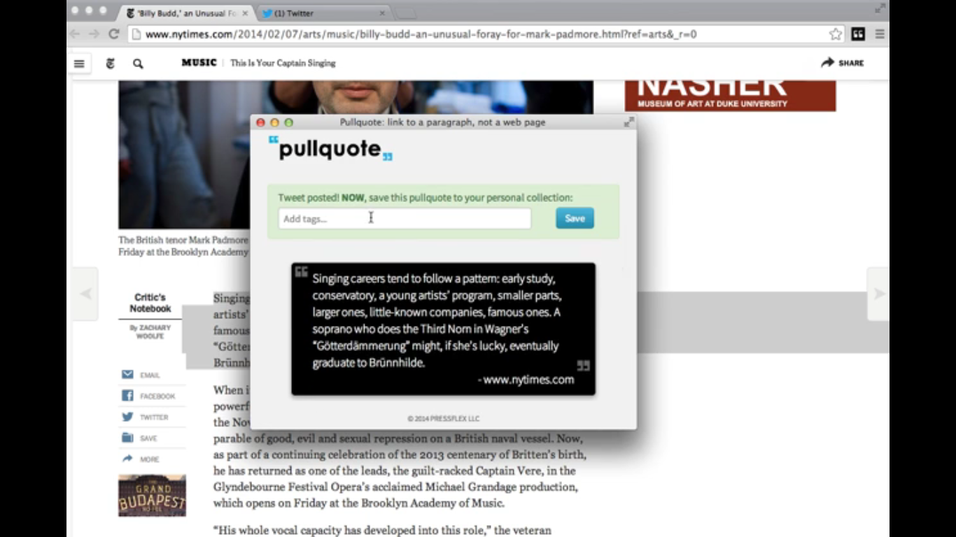

Quotabl.es

URL: http://quotabl.es/

Quotabl.es is a simple elegant way to create a collection of your favorite quotes.

Like Flickr for photos, Quotabl.es homepage shows recently activity on quotes you’ve submitted, along with recently added and popular quotes from across the site. Quotes are organised by tags.

Sharing quotes into the site is a breeze thanks to wonderfully minimalist bookmarklet. Each quote you share or discover on the site can be favorited, shared (into Twitter and Facebook), edited to correct/add further details, or added to a specific list of quotes you maybe working on.

NEDOSTATAK: Nema mogućnost spašavanja privatnih citata.

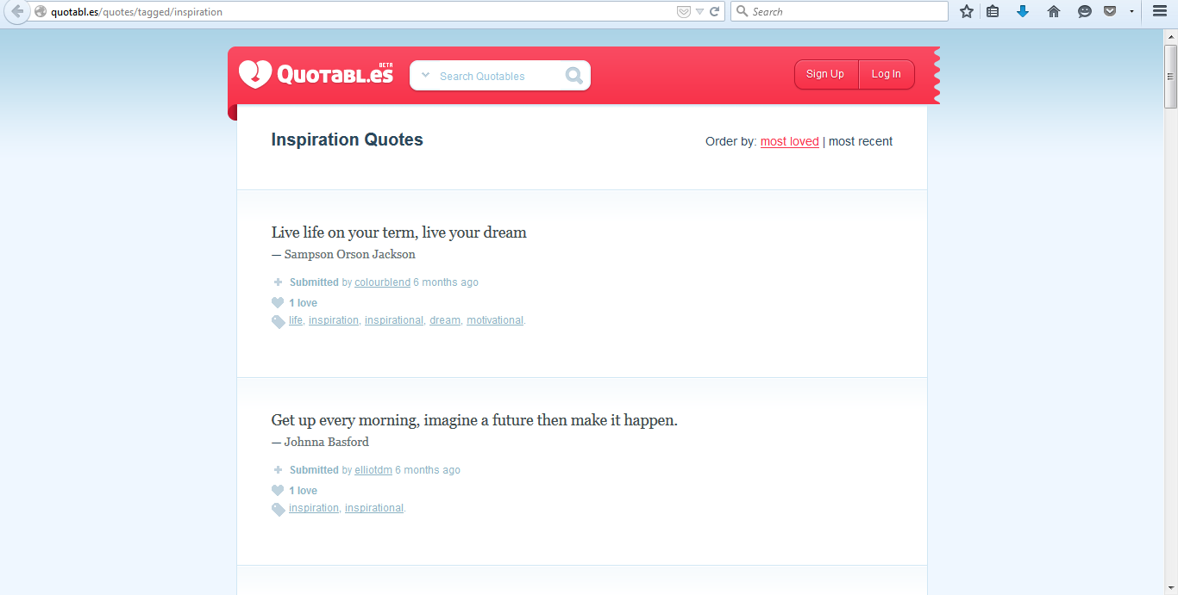

Brainyquote

URL: http://www.brainyquote.com/

BrainyQuote is the largest, most user-friendly quotation site on the web. We are a quality educational resource and provide free access to our extensive database of prominent historical figures and today's newsmakers - famous celebrities, athletes, politicians, authors and other public figures.

Create and share more than 225,000 unique quote pictures and wallpapers with our beautiful gallery of high-resolution photographs. Email, text and share your creations with friends, family and social networks. Get Today's Quote - our inspiring quote of the day - in Notifications. You can share it, or save the image to create a stunning wallpaper for your iPhone or iPad.

NEDOSTATAK: Nema mogućnost dodavanja citata od strane korisnika.

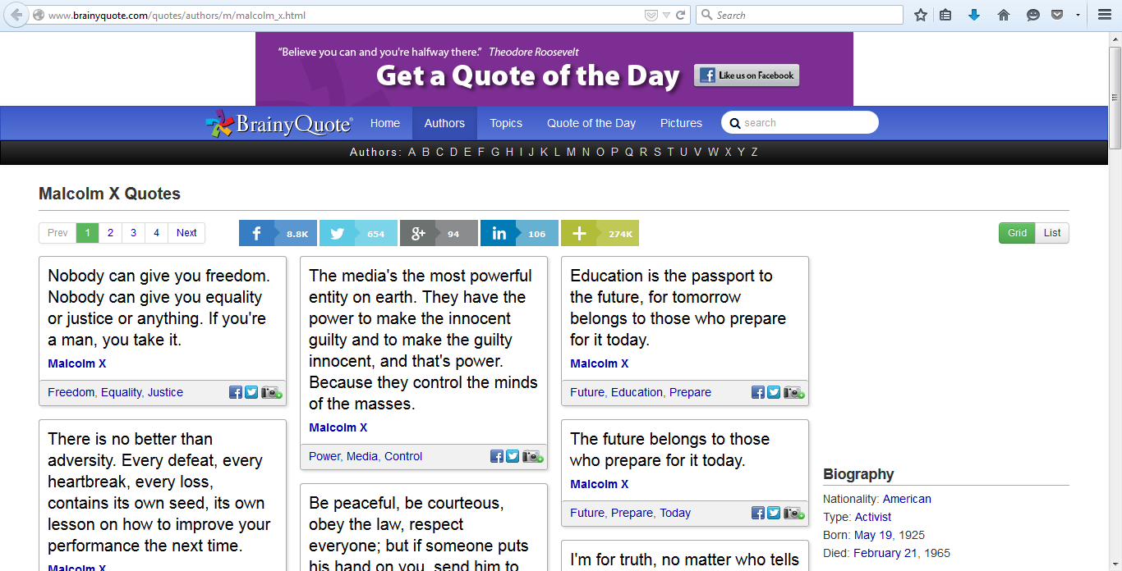

Zahtjevi

Korisnici
Tipovi korisnika u sistemu:
- Gost korisnik
- Registrovani korisnik

Privilegije registrovanih korisnika u sistemu su:
- Standardni korisnik
- Administrator

Baza podataka dolazi sa osnovnim administratorskim računom.

Gost korisnik:
- Autentifikacija (samo registracija)

Standardni korisnik:
- Autentifikacija (sve osim registracije)
- Korisnici
- Autori
- Citati
- Tagovi

Administrator:
- Autentifikacija (sve osim registracije)
- Administracija
- Korisnici
- Autori
- Citati
- Tagovi

Moduli i funkcionalnosti

Static pages

- Home
- About
- Contact
- Help

Modul 1: Autentifikacija

- Registracija
- Potvrda registracije emailom
- Settings
- Log out
- Log in
- Reset lozinke

Modul 2: Administracija

- Grafički pregled top usera i top autora
- Eksport usera u tekstualnu datoteku (CSV)
- Pregled liste korisnika
- Brisanje korisnika

Modul 3: Korisnici

- Pregled liste korisnika
- Pregled profila
- Follow

Modul 4: Autori

- Dodavanje
- Pregled liste autora
- Brisanje
- Pregled odabranog
- Uređivanje

Modul 5: Citati

- Dodavanje
- Feed
- Uređivanje
- Brisanje
- Eksport u tekstualnu datoteku (CSV)

Modul 6: Tagovi

- Dodavanje
- Pregled citata za odabrani tag
- Tags cloud

Dizajn

Tehnološki stek
Frontend FW: Bootstrap
JavaScript FW: AngularJS
Web FW: Ruby on Rails
ORM: ActiveRecord
Baza: PostgreSQL

ERD
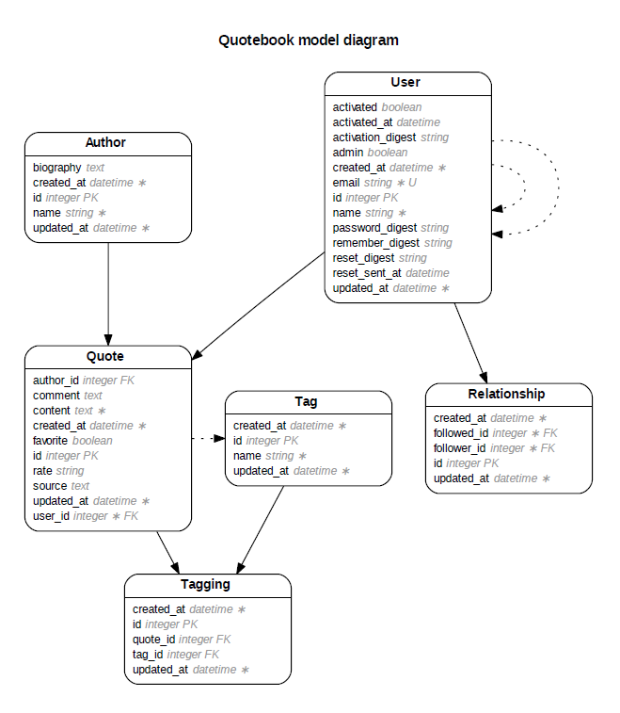

REST servisi
Tip | Path | Akcija | Parametri | Rezultat
GET | /users | index | - | Lista svih usera
POST | /users | create | name, email, password | Kreiranje zapisa o useru
GET | /users/new | new | - | Forma za novog usera
GET | /users/[user_id]/edit | edit | - | Forma za editovanje usera
GET | /users/[user_id] | show | user_id | Jedan user sa ID-em
PUT | /users/[user_id] | update | name, email, password | Ažuriranje zapisa o useru
DELETE | /users/[user_id] | destroy | user_id | Brisanje zapisa o useru

Tip | Path | Akcija | Parametri | Rezultat
GET | /authors | index | - | Lista svih autora
POST | /authors | create | name, biography | Kreiranje zapisa o autoru
GET | /authors/new | new | - | Forma za novog autora
GET | /authors/[author_id]/edit | edit | - | Forma za editovanje autora
GET | /authors/[author_id] | show | author_id | Jedan autor sa ID-em
PUT | /authors/[author_id] | update | name, biography | Ažuriranje zapisa o autoru
DELETE | /authors/[author_id] | destroy | author_id | Brisanje zapisa o autoru

Tip | Path | Akcija | Parametri | Rezultat
POST | /quotes | create | content, author_id, source, comment, user_id | Kreiranje zapisa o citatu
GET | /quotes/[quote_id]/edit | edit | - | Forma za editovanje citata
PUT | /quotes/[quote_id] | update | content, author_id, source, comment, user_id | Ažuriranje zapisa o citatu
DELETE | /quotes/[quote_id] | destroy | quote_id | Brisanje zapisa o citatu

Tip | Path | Akcija | Parametri | Rezultat
POST | /relationships | create |  | Kreiranje zapisa o vezi
DELETE | /relationships/[relationship_id] | destroy |  | Brisanje zapisa o vezi

Tip | Path | Akcija | Parametri | Rezultat
POST | /password_resets | create |  | Kreiranje zapisa o resetu
GET | /password_resets/new | new | - | Forma za novi reset
GET | /password_resets/[user_id]/edit | edit | - | Forma za editovanje reseta
PUT | /password_resets/[user_id] | update |  | Ažuriranje zapisa o resetu

Tip | Path | Akcija | Parametri | Rezultat
PUT | /account_activations/[user_id] | update |  | Ažuriranje zapisa o aktivaciji

Tip | Path | Akcija | Parametri | Rezultat
POST | /login | create |  | Kreiranje zapisa o loginu
GET | /login | new | - | Forma za novi login
DELETE | /login | destroy |  | Brisanje zapisa o loginu

Implementacija

Razvojni alati i tehnologije
Operativni sistem: Windows 7 x64

Revision control software: GitHub
https://github.com/

GitHub Client for Windows: Verzija 2.0.0
https://windows.github.com/

RailsInstaller for Windows x64: Verzija 3.0.0
http://railsinstaller.org/en
https://s3.amazonaws.com/railsinstaller/Windows/railsinstaller-3.0.0.exe

Rails: Verzija 4.2.1
Ruby: Verzija 2.0.0p598 (2014-11-13) [i386-mingw32]
RubyGems: Verzija: 2.4.6
Web server: WEBrick

IDE: Aptana for Windows, verzija 3.6.1
http://www.aptana.com/products/studio3/download.html

Git for Windows: Verzija 1.9.5
http://git-scm.com/

Baza podataka: PostgreSQL for Windows x64, verzija 9.4.1
http://www.postgresql.org/download/windows/

Literatura

[1] Android apps
https://play.google.com/store/search?q=quotes&c=apps

[2] Quotebook - a simple app that lets you enter quotes
https://play.google.com/store/apps/details?id=app.statzapps.quotebook

[3] Inspirational Quotes
https://play.google.com/store/apps/details?id=com.azwstudios.galaxyinspirationalquotes

[4] iPhone/iPad apps
https://itunes.apple.com/us/genre/ios-reference/id6006?mt=8&letter=Q&page=3#page

[5] Quotebookapp
http://quotebookapp.com/
https://itunes.apple.com/us/app/quotebook-notebook-for-quotes/id423726272?mt=8
http://minimalmac.com/post/24114361750/quotebook-2-0-is-out-and-it-is-a-huge-update-to
http://www.macstories.net/links/quotebook-2-0/
http://gizmodo.com/5792630/quotebook-for-iphone
http://www.theverge.com/2012/5/31/3052484/quotebook-for-ipad

[6] Quotenote
http://www.topleftsoft.com/quotenote
http://appadvice.com/appnn/2011/08/quickadvice-quotenote

[7] Organizing Quotes On A Mac
http://www.brianstucki.com/blog/organizing-quotes-on-a-mac/

[8] Pullquote
http://lifehacker.com/pullquote-makes-sharing-quotes-and-images-on-twitter-qu-1677183452
http://pullquote.com/

[9] Quotabl.es
http://quotabl.es/
http://thenextweb.com/lifehacks/2010/11/02/quotabl-es-probably-the-coolest-way-to-collect-quotes-you-can-quote-me-on-that/

[10] Quotes.ly
http://quotes.ly/

[11] MyQuoteBox
http://www.myquotebox.com/

[12] Findings
http://findings.com/
http://www.borthwick.com/weblog/2011/10/25/findings_launch/
http://www.stevenberlinjohnson.com/2011/10/introducing-findings.html
http://web.appstorm.net/reviews/save-your-favorite-quotes-with-findings/
http://www.economistgroup.com/leanback/the-next-big-thing/want-to-collect-quotes-from-your-kindle-or-the-web-findings-can-help/

[13] Instapaper
https://www.instapaper.com/
https://itunes.apple.com/us/app/instapaper/id288545208?mt=8%3FpartnerId%3D30
http://blog.instapaper.com/

[14] Quotica
http://www.quoti.ca/
http://www.businessinsider.com/collect-your-favorite-quotes-online-with-quotica-2011-6

[15] Quoty
http://quoty.co/

[16] Spoken.ly
https://www.spoken.ly/?in=welcome

[17] Wordpress plugins

Prefect quotes: https://wordpress.org/plugins/perfect-quotes/
Quotes Collection: https://wordpress.org/plugins/quotes-collection/
VR-Frases (collect & share quotes): https://wordpress.org/plugins/vr-frases/

[18] Brainyquote
http://www.brainyquote.com/

[19] Quotesabout
http://quotesabout.us/

[20] Install Ruby on Rails, Postgresql, and Aptana on Windows
https://youtu.be/qd6WF32-fm0

[21] Revision control software: GitHub
https://github.com/

[22] GitHub Client for Windows (v2.0.0):
https://windows.github.com/

[23] RailsInstaller for Windows x64 (v3.0.0):
http://railsinstaller.org/en
https://s3.amazonaws.com/railsinstaller/Windows/railsinstaller-3.0.0.exe

[24] IDE: Aptana for Windows (v3.6.1)
http://www.aptana.com/products/studio3/download.html

[25] Git for Windows (v1.9.5):
http://git-scm.com/

[26] Baza podataka: PostgreSQL for Windows x64 (v9.4.1)
http://www.postgresql.org/download/windows/

[27] Entity-Relationship Diagrams for Ruby on Rails
http://rails-erd.rubyforge.org/

