

* [Tutorial - 1](https://youtu.be/N1vOgolbjSc)

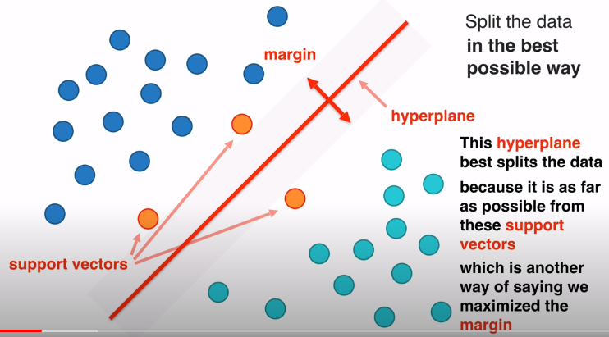

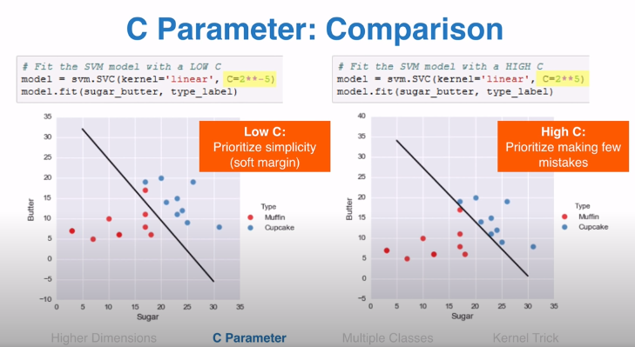

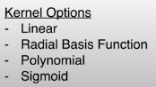

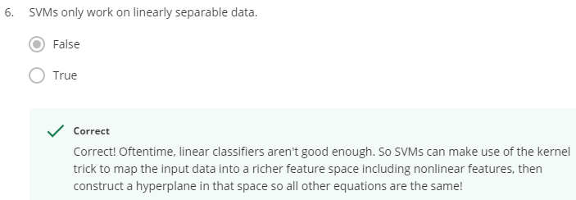

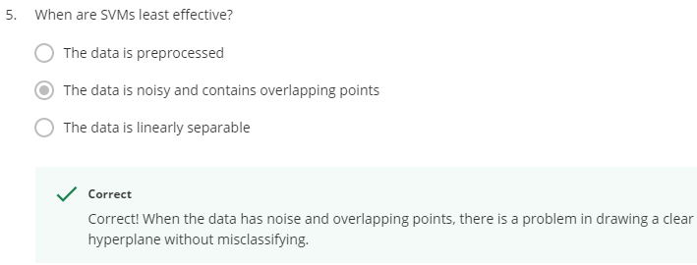

* #1

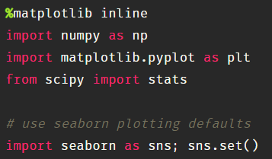

*  This will show the graph or image inside notebook, if we don’t use this line, the image may show in different pop up window.
* 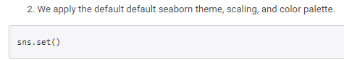



* 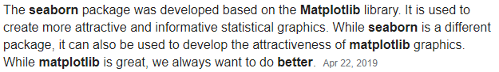

* #2

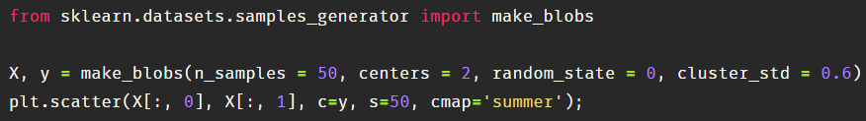

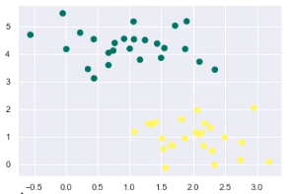

**y**

**x**

* Green = active volcanoes
* Yellow = dormant volcanoes

make_blobs is some random Gaussian blobs





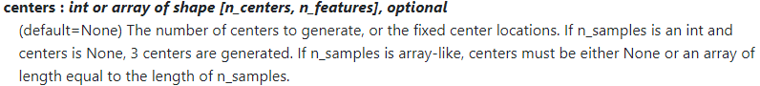

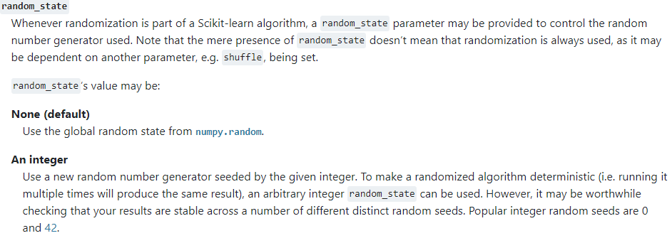

* #3

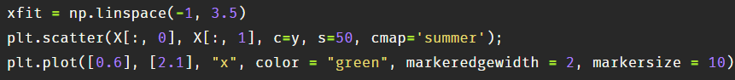

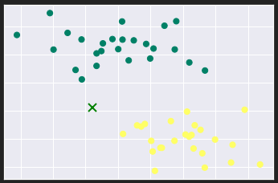

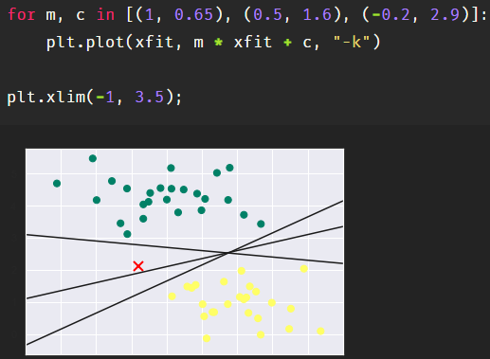

We know, y = mx + c where

* m = slope
* c = y-intercept

 3 tuples

[(m1, c1), (m2, c2), (m3, c3)]

* “-k” is color code for black

**\*\*** For dark background in the jupyter notebook, I couldn’t see the axis details. Solution

* 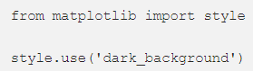

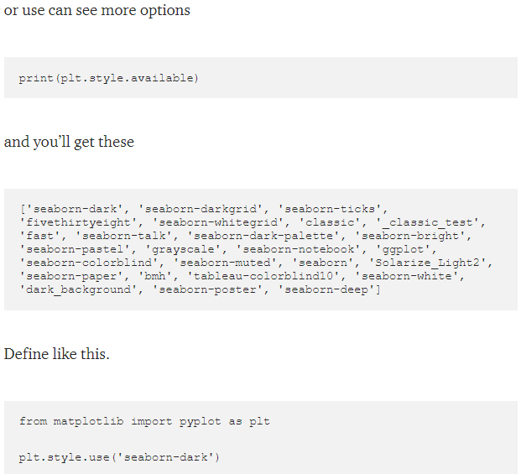

** Now the problem is – there are infinite number of decision boundaries. How to select the best one from them?

* SVM use a concept named – margin
* #4

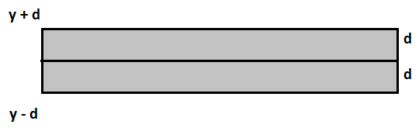

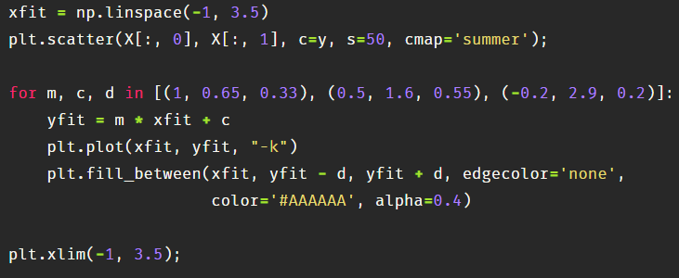

* alpha = optaity
* #5

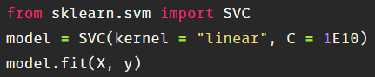

* #6

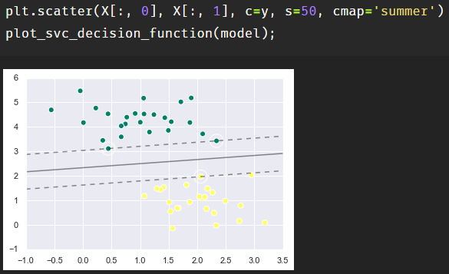

Here, there are 3 support vectors



* Co-ordinates of the support vectors: 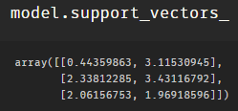



* For face recognition, we need dataset
* #1

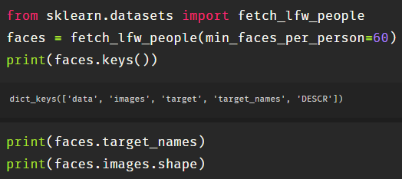

* #2

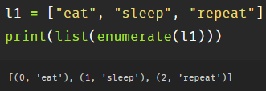

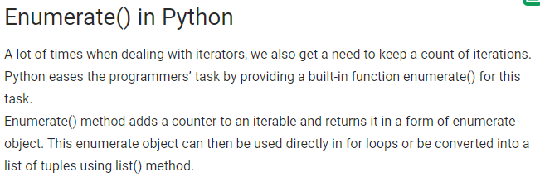

* #3

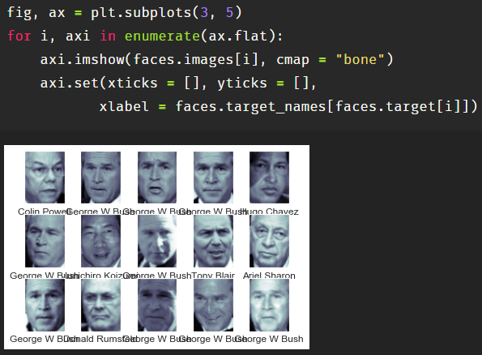

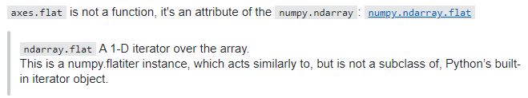

Steps:

* plotting 3 * 5 grid
* enumerating ax.flat which iterates every cell in the grid from left to right
* every grid will contain an image which is defined by using imshow()
* every grid will contain name of the person in the image, which is set by xlabel



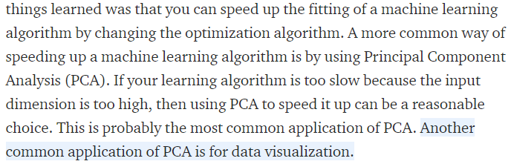

* #1

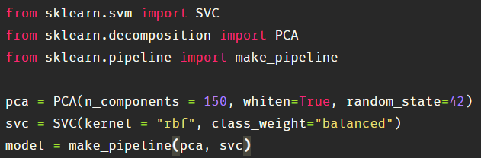

** previous version of PCA is RandomizedPCA which is deprecated now

* #2

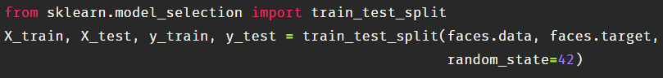

** deprecated 

* #Grid-search model selection

c = margin hardness

gamma = size of rbf

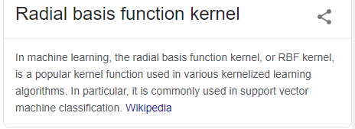

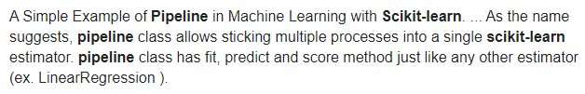

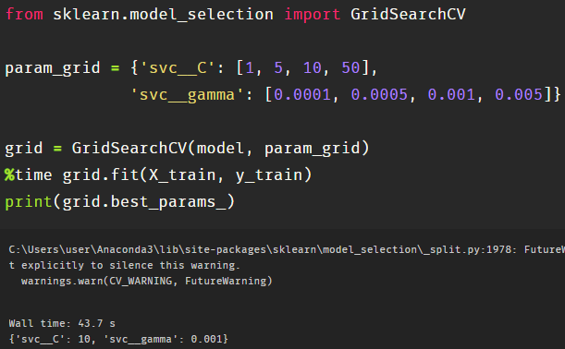

Now with this cross-validated model, we can now predict the labels of our test data





* Now again draw a 4 * 6 subplot



* Let’s plot image iterator

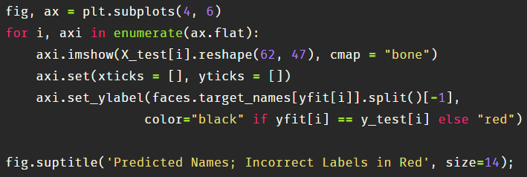



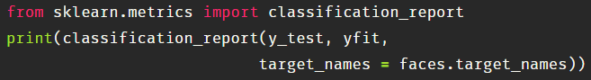

* Drawing a heatmap to see where it tends to do misclassification

