28 May, 2020

Confusion?? MUI **Box** and **CssBaseline**

29 May, 2020

**\*\*** Trying to find – how can I use hover in MUI ***makeStyle***

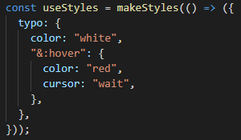

cursor properties:

1. auto
2. default
3. copy
4. crosshair
5. grab/grabbing
6. help
7. move
8. no-drop
9. pointer
10. progress/wait
11. zoom-in/zoom-out
12. text

It’s simple! :p

**\*\*** Now break down this

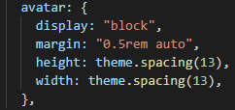



[rem & em (Traversy media)](https://www.youtube.com/watch?v=H4UtKu11yXg)

|  |  |
| --- | --- |
| rem | em |
| Relative em, so it’s size will be similar to root element |  |
| 0.5rem = 0.5 * 16px = 8px |  |
|  |  |

**Drawer**

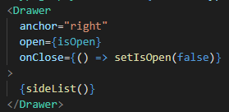 Not so difficult

**React-typed:**

Let’s learn another react npm package **“react-typed”**

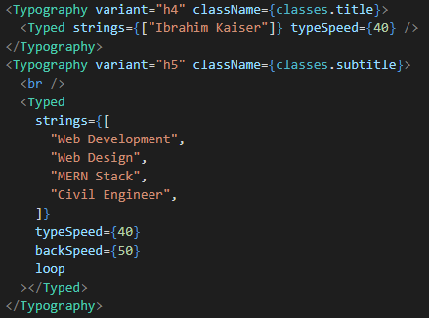

**React-particle-js:**

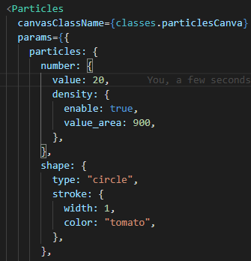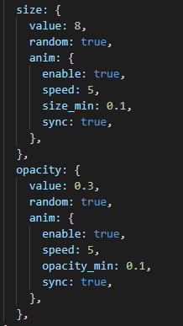

It’s little bit tricky

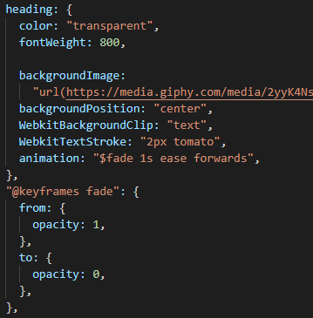

This is the way to use keyframe in Materia UI.

**\*\*\*** “$” should be added in the animation