**PIZZA SALES SQL QUERIES**

1. **KPIs**
2. **Total Revenue:**

**select sum(total_price) as Total_Revenue**

**from pizza_data;**



1. **Average Order Value**

**select sum(total_price) / count(distinct order_id) as Avg_Order_Value**

**from pizza_data;**



1. **Total Pizzas Sold**

**select sum(quantity) as Total_Pizzas_Sold**

**from pizza_data;**



1. **Total Orders**

**select count(distinct order_id) Total_Orders**

**from pizza_data;**



1. **Average Pizzas Per Order**

**select round(round(sum(quantity), 2) / round(count(distinct order_id), 2), 2) as Avg_Pizzas_per_order**

**from pizza_data;**



**B. Charts**

**1. % of Sales by Pizza Category**

**select pizza_category, sum(total_price) Total_sales, round(sum(total_price)*100 / (select(sum(total_price)) from pizza_data), 2) as Total_Sales_Percent**

**from pizza_data**

**group by pizza_category;**

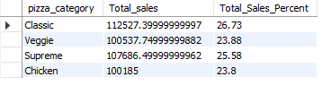

**2. % of Sales by Pizza Size**

**select pizza_size, sum(total_price) Total_sales,**

**round(sum(total_price)*100 / (select(sum(total_price)) from pizza_data),2)Total_Sales_Percent**

**from pizza_data**

**group by pizza_size;**

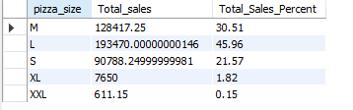

**3. Total Pizzas Sold by Pizza Category**

**select pizza_category, sum(quantity) Total_Pizzas_Sold**

**from pizza_data**

**group by pizza_category;**

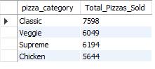

**4. Top 5 Best Seller by Total Pizzas Sold**

**select pizza_name, sum(quantity) Total_Pizzas_Sold**

**from pizza_data**

**group by pizza_name**

**order by Total_Pizzas_Sold desc**

**limit 5;**

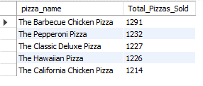

**5. Bottom 5 by Total Pizzas Sold**

**select pizza_name, sum(quantity) Total_Pizzas_Sold**

**from pizza_data**

**group by pizza_name**

**order by Total_Pizzas_Sold**

**limit 5;**

