Y: An Introduction to Realtime Digital Signal Processing through Parallelism

Sherwyn Sen
Computer Science Department
San Jose State University
San Jose, CA 95192
408-924-1000
sherwyn.sen@gmail.com
https://github.com/ika-musuko

ABSTRACT
Digital Signal Processing is an ubiquitous field that can be boiled down to taking a signal, such as an audio wave, an image, or motion, applying some operation to it, and outputting the result. In software, signals are usually represented in vector-like data structures, and the operations on signals are done across the entire vector. Additionally, sometimes signal data gets inputted in real time and the current data must be analyzed at once without slowing the system down. This paper will discuss an approach to reading and processing realtime signal data using parallelism to ensure the system processes the data as it arrives.

1. WHAT IS DIGITAL SIGNAL PROCESSING?
Since the targeted audience of this paper is software engineers and computer programmers as opposed to electrical engineers, what digital signal processing is and some of its applications will be discussed before diving into its parallelization. As mentioned in the abstract, digital signal processing at its most basic form is taking a stream of data, modifying it in some way, and outputting the modified stream.
1.1 Signals
But what exactly is a signal? A signal in theoretical terms is a function which conveys information about a system. Signals exist all around us in nature. Commonly known signals are motion, sound, and images, however more specialized signals could be biological membrane potentials, seismograph data, or medical signals. This paper will use audio signals as a reference point since they are the easiest to conceptualize according to the author.
1.2 Digital Signal Processing
A digital signal processor takes a digitized signal and performs various mathematical operations on the signal to modify it in some way. Signals can be digitized using an "ADC unit", an analog to digital converting unit. Output of a DSP-processed signal is done via a "DAC unit", a digital to analog converting unit.
2. WHY PARALLELIZE DIGITAL SIGNAL PROCESSING?
At its heart, DSP is essentially mathematical operations, which makes it an ideal candidate to think about how many DSP operations can be parallelized. Many common DSP operations are suited for task partitioning so they are relatively easy to parallelize in both hardware and software. A system running DSP operations in parallel can do so with a reduced clock speed, or run more DSP operations at the same clock speed as it would sequentially, resulting in increased data throughput. These days, parallel programming paradigms have been well established so it is much easier to experiment with ways to parallelize common DSP operations.

3. DISCLAIMER
The code samples in the paper itself are pseudocode-Python or psuedocode-C, to ease explaining the actual concepts at hand. The real source code for the programs discussed are attached with the paper (also available at https://github.com/ika-musuko/parallelizing-dsp). The programming languages used are Python 3.5 and C, with additional libraries.

4. REPRESENTING TIME-BASED SIGNALS IN THE FREQUENCY DOMAIN
4.1 The Fourier Transform
One of the fundamental DSP operations is the Fourier transform, invented by Joseph Fourier. The goal of the Fourier transform is to take a signal represented in as a waveform in the time domain and translate it into the frequency domain. It does this through the following equation:
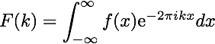
Fig 4-1: The Fourier Transform. http://devonbryant.github.io/blog/2013/03/02/fourier-transforms/
For those not familiar with the mathematics, this equation can be intuited in the following way: take a signal, wrap it around a circle, and figure out how far the wrapped shape's center is from the center of the circle. This distance is how much "energy" the waveform has at a particular frequency k. You can go around the circle's circumference k times per second.
4.2 Discrete Fourier Transform
Now obviously, integrals cannot be easily evaluated by a computer; they are not discrete! This problem was first solved using the cleverly named “Discrete Fourier Transform, shown below.
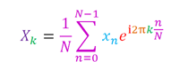

Figure 4-2: Discrete Fourier Transform[Better Explained Creds]
The difference between the Discrete Fourier Transform and the regular Fouier Transform is that the discrete version divides a pre-specified frequency range up into N pieces and calculates the inner Fourier expression for each piece individually and then sums it up normally.
4.3 Fast Fourier Transform

5. MAKING A REALTIME WAVE FILE SPECTRUM ANALYZER VIA PARALLEL PROCESSING
5.1 Basic Principles
If we want to analyze signals, we can use an oscilloscope and a spectrum analyzer. This demonstration is done in software although similar principles could be applied in hardware. An oscillosocope shows the waveform data of a signal with respect to time. We can use the Fast Fourier Transform discussed in the previous section for the spectrum analysis.
What if we want to analyze an audio signal stored in a wave file using a computer? One approach is to simply run the entire wave file data through an FFT algorithm and output the result
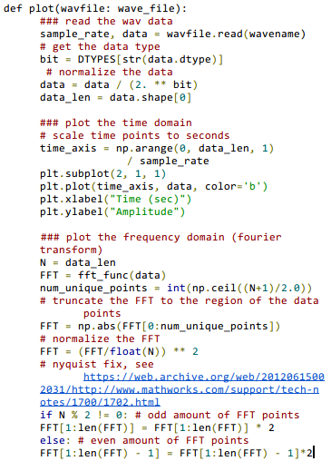

Code 5-1: Reading a WAVE file and plotting the data onto a graph.
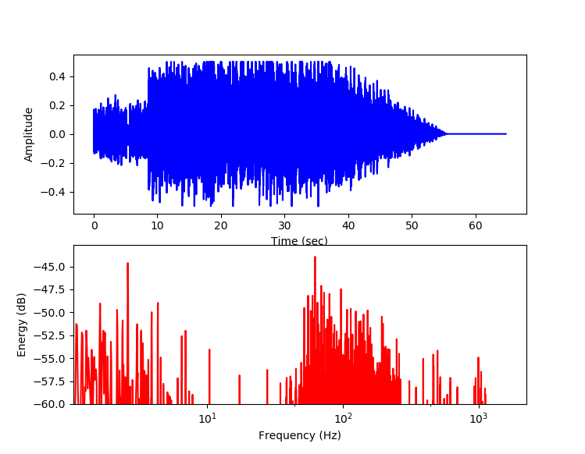

Fig 5-2: The resulting output graph of the above code on a sample audio file.
5.2 Sequential Signal Analysis
However, for many applications a more "real time" result is desired. That is, we would like to look at the current state of the signal while it is being outputted. For example, it is quite useful to look at the state of a signal before any signal processing is done to it, in addition to looking at the result after it is processed. With audio processing, seeing what a wave looks like "right now" rather than over its entire duration is often leveraged for making processing decisions. In order to accomplish this, we must change our strategy for analysis.
Before talking about how parallel processing can be utilized, it is vital to discuss the sequential flow for accomplishing this task. The following diagram shows this approach.
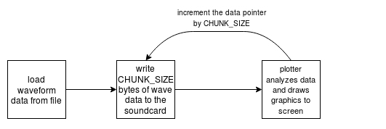

Fig 5-3: The algorithm for the sequential analyzer.
To simulate the "real-time" effect, 1024 bytes at a time of the wave data are read, played, and then subsequentially analyzed. "Playing" really means writing those 1024 bits to the machine's sound card and having the machine deal with actually playing the audio back. This typically consists of using a DAC, as mentioned in the Introduction, to convert the digital audio data into analog signal data that can be played on speakers or headphones.
Here is a pseudocode implementation of the above algorithm.

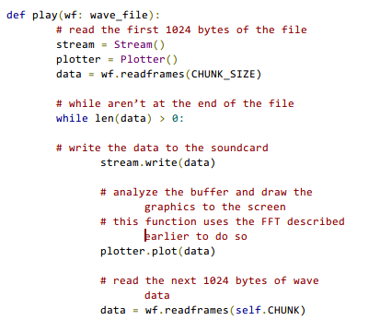

Code 5-4: Playing and plotting audio in a sequential manner.
However, the problem with this approach is that analyzing and displaying the wave data is a bottleneck. Since the write() and plot() functions are both blocking, each function must be thoroughly completed before the program can advance to the next instruction. In our case, the audio playback must wait for the slow plot() function to finish before continuing playback of the next chunk, causing playback to "stutter". This sounds very bad!

<< screenshots of stutter >>
Fig 5-6: This loop rapidly switches between the two views, which sounds like stutters in the audio. Unfortunately this cannot be expressed in the paper itself.
5.3 Basic Parallel Signal Analysis Strategy
We can avoid destroying the audio playback by playing and analyzing the audio in a "pipeline" fashion. That is, while analyzing the current 1024-byte buffer, have the player write the next 1024 bytes of data to the soundcard. This is illustrated in the flowchart below.
<< parallel_analyzer_flow >>
Fig 5-7: The algorithm for the parallel analyzer.
The green arrows are the steps that are done in parallel. This way, we can uncouple the audio playback and the audio analysis which should result in the audio playing smoothly. We start by dispatching the plotter function into a new process and then calling the player.
<< high level process code >>
Code 5-8: High-level code for splitting the player and plotter into their own processes. start_plotter is a function that initializes the plotter.
There are still some problems with our existing code that prevent us from smoothly parallelizing the playback and plotter. First, we must deal with removing the blocking functions and replacing them with non-blocking equivalents. Second, there has to be a way for the audio player and the plotter to share the wave data.
5.4 Asynchronous Callback Functions
The audio and graphics libraries used (PyAudio and matplotlib) fortunately provide facilities for non-blocking I/O through asynchronous callback functions. Callback functions are passed to another function or object and is assumed to be called whenever some sort of event happens. An asynchronous callback function is done in a separate thread in parallel, which makes it non-blocking.
If a callback function is supplied to an audio stream, the play loop changes to roughly the following:
<< audio player callback code >>
Code 5-9: Non-blocking wave playback using an asynchronous callback function
Inside the start_stream() function, there is some loop that repeatedly calls the get_wave_data function. In the get_wave_data callback function, we first get thewave data and then write it to a shared data queue. This shared data queue can be thought of as a "global object" (although in practice, it is recommended to contain these functions in a structure or object so data collisions with multiple wave analyzers do not happen).
Following a similar convention as the audio playback above, here's what the code calling the plot roughly turns into:

<< plotter callback code >>

Code 5-10: Non-blocking wave data analysis and plotting
Like the aformentioned start_stream function, the start_plotting method will repeatedly call the plot_callback function to retrieve the current wave data. Note that the callback function this time reads data off of the SHARED_DATA_QUEUE rather than putting it on the queue. In this manner, the audio player and the audio plotter have a simple producer-consumer relationship.The player is producing wave data for the analyzer to consume.
5.5 The Inner Workings of an Asynchronous Callback Function
- DISCUSS HOW THE CALLBACK FUNCTION ACTUALLY WORKS
5.6 Results of the Basic Parallel Analysis Method
- DISCUSS THE RESULTS OF THIS METHOD AND HOW THE AUDIO ANALYSIS LAGS BEHIND THE AUDIO PLAYBACK
5.7 Ensuring the Audio Playback and the Audio Analysis are Singing The Same Tune
-DISCUSS HAVING THE ANALYZER EAT UP ALL OF THE SHARED QUEUE ITEMS TO GET THE LATEST DATA
-DISCUSS HOW THIS APPROACH IS SUCCESSFUL IN CREATING A REAL TIME SPECTRUM ANALYZER

6. CONCLUSION
- DISCUSS HOW WE STARTED FROM A SEQUENTIAL IDEA AND TURNED IT PARALLEL BY SPLITTING THE MAIN TASKS INTO PROCESSES AND REMOVING ALL OF THE BLOCKING FUNCTIONS TO ACHEIVE THE REAL TIME ANALYZER

7. WHERE TO GO FROM HERE
- TALK ABOUT HOW THE AUDIO COULD BE FILTERED AND PRE-PROCESSED BEFORE WRITING TO THE SOUND CARD
- TALK ABOUT DEPLOYING MULTIPLE WAVE ANALYZERS AT ONCE AND SUMMING THEIR OUTPUTS INTO A “MASTER TRACK” CREATES A SIMPLE MIXER
- TALK ABOUT HOW PARALLELISM IN DSP IS NOT ONLY USED IN PERFORMANCE BUT ALSO IN MAKING DIFFERENT KINDS OF EFFECTS
- LARGE FIELD, POSSIBILITIES ARE ENDLESS

8. SOURCES

