Travaux communs a tpus les 4 groupes
Exercice 1
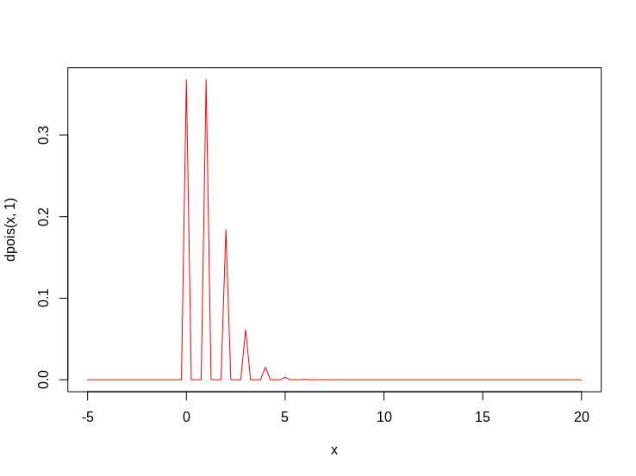

Exercice 2
1)
P(X<=4)=0.92224

2)

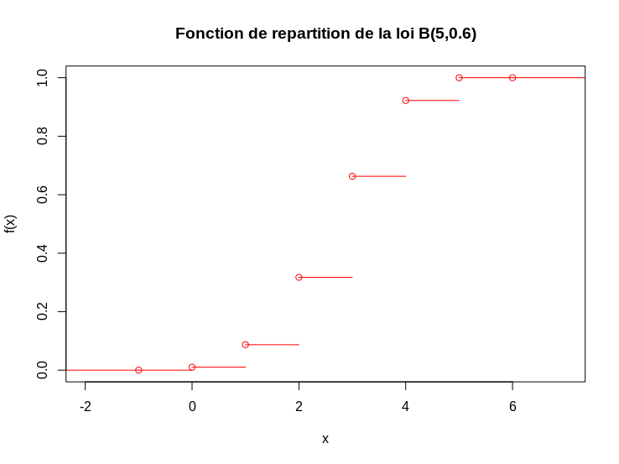

3)
k=2
4)

sim_X<-rbinom(20,5,0.6)
table(sim_X)

1 2 3 4
1 9 4 6

Exercice 3

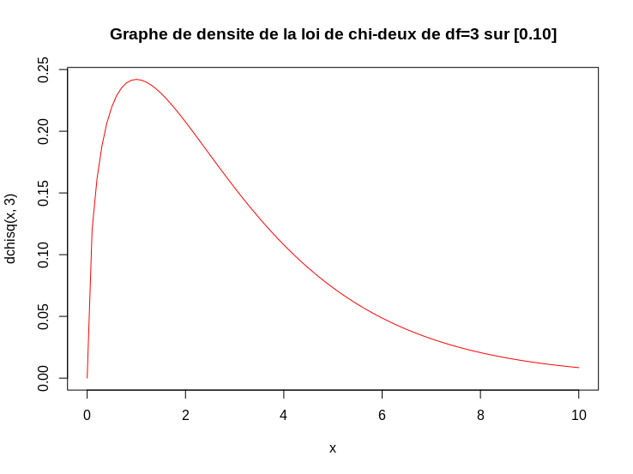

Exercice 4

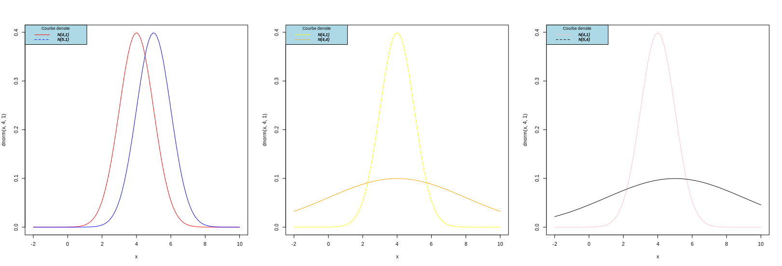

Exercice 5

P(Z<=-0.5)=0.3085375

P(Z>1.5)=1-P(Z<=1.5)=0.0668072
P(Z>-1)=1-P(Z<=-1)= 0.8413447

Exercice 6
1)
P(16 ≤ X ≤ 20)=0.2073777

P(X > 18)=1-p(X<=18)=0.3694413

P(X < 6)=P(X<=5)= 0.1332603

2)
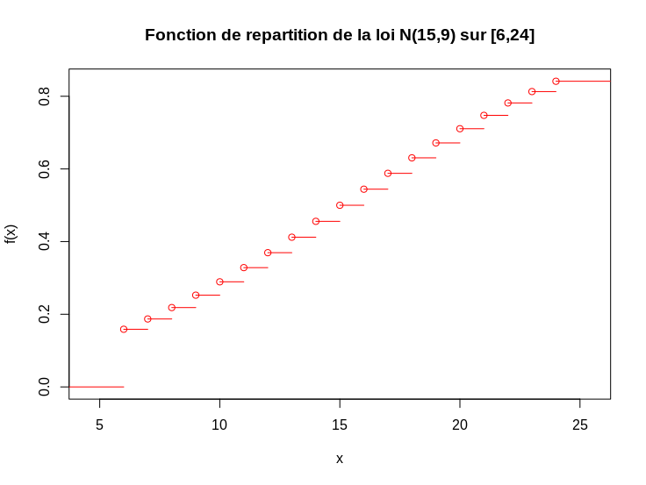

Exercice 7

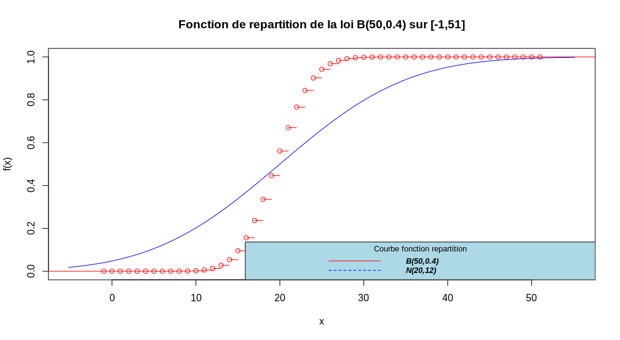

Exerccie 8

Exercice 10

