**Evaluation of advertisement**

By: Bahar Khajavi

Advisor: Irakli Javakhishvili

European School of Tbilisi

11 AHS

Junior Project

2017

**Table of Contents**

**Introduction**

**Thesis**

**Methodology**

**History of Advertisement**

**Types of Advertisement**

**Advertisement as Art**

**Conclusion**

**Bibliography**

**Introduction**

Advertisements are very important part of everyday life. If we consider ancient culture, then also Egyptian art can be considered as the first examples advertisements (Egyptians used to depict the most important personalities in wider forms and their figure were the biggest ), therefore if we consider advertisement as showing someone’s priority , the Egyptian art can also contain the examples of advertisement. However if we think that advertisement is only connected to the digital world, then the priority of industry would be 20th century. That is why I thought this controversy was interesting for me and decided to make a research paper about evaluation of advertising business. In my research I will be focusing on advertisement types, the history of advertisement and advertisement as art.

I though starting from Egypt would be too long and time consuming, also I understand that the history of advertisement can be connected to invention of printing press in 1440s, so I decided to focus on the advertisements of 20th and 21 century.

**Thesis**

I believe that even though advertisement is seen as necessarily related to the product, it can be art itself. In pervious century companies and the society did not differentiate product and advertisement. The aim of my research is to see whether advertisement can be seen as art not related to the product.

**Methodology**

For my research thesis I have chosen the method of content analysis -> content analysis means that I will see the resources and will analyze the narrative. Also I am to use visual analysis of the advertisement and after the content analysis I will establish the criteria to see whether advertisement can be art or no.

For my thesis firstly I’m going to establish 3 chapters. 1st chapter will be dedicated to history of advertisement and their development.2nd chapter will be focused on the types of advertisement. Those two chapters will be majorly based on the resources. On the 3rd chapter called “Advertisement as Arts” I will choose 10 advertisements and give explanations why can they be considered as art masterpieces. Finally paper will be finished will conclusion.

**The History of Advertisement**

The first advertisement appeared in United States in 1941during a football game, spectators had a chance to watch the first television advertisement of Bulova watches. 10 seconds advertisement showed USA with the icon of Bulova watch and the voice announced watch time and America runs on Bulova time. Bulova paid four dollars for air fees plus 5 dollars for station fees. It was played on NBC owned station called WNBT. The first advertisement came in USA for a reason, Europe was at the World War 2 at that time so it is not surprising that the advertising industry started to grow in USA. Bulova advertisement paid the foundation to the future of advertisement industry. In 1950s USA entered the period of cold war but in spite of that television and radio were actively used in promotion of certain products.

The characters for advertisement were especially built around the product. One particular actor might be used in several advertisements of the same brand, for example Marlboro cigarette advertisement included famous actors. As a result certain actors became associated with certain products for example Marlboro man who became cultural icon from 90s to 99s. The aim of Marlboro was to show their product as masculine. This could be achieved by using the elements of American history such as cowboys and moody looking men. This icon made the brand very successful and their advertisement campaign the best advertisement of all time.

After the cigarette, the food advertisements became very popular, here as well certain characters became associated with certain products for example cereal and its character Tony Tiger, you can still buy Tony Tiger cereal even now a days. Advertisements in 1950s had one major function: The product should be sold even though characters created cultural icons, the main was the product. After invention of internet the product stopped to be central mile store of the commercials instead commercials were used for raising brand awareness. Example of new type of advertisement was Cadbury chocolate commercial with dairy milk Gorilla. The advertisement did not even mention Cadbury, Gorilla was playing on drams and it was strategic move to draw attention to the brand itself. According to this advertisement Cadbury was cool and must have product. The simple commercial gained popularity for the brand and other companies started to make spoofs of the advertisement, approximately 300 even the music was especially selected. Famous musician Phil Collins finally agreed to perform one of his prominent songs. This advertisement proves how tiring and time consuming can advertisement be. The author of the idea, Juan Cabral needed 3 months negotiations with different institutions to shot the advertisement in London. According to the interviews neither Cabral nor the company heads expected the advertisement to be so successful. They attribute huge success to good agency high quality product and gorilla. This commercial won 3 award: Black and Yellow pencils, TV and Cinema advertising, D and AD awards 2008. According to the awards Chris Willingham “Gorilla broke the world in many respects and is still getting hits on YouTube a year later so its lived way beyond the conventional television advertising campaign”.

As soon as internet became more widespread in society was applications started to appeal: for Example Company “fixed in 6” home improvement advertisement took only 6 sec and they were available to watch only from Vine app. The humor was crucial for those commercials, the crucial foundry atmosphere and took away the advertiser from the product, plus it was not vary connected to the company. The idea 6sec advertisement was to respond to the consumers problems and not to advertise the particular brand. That is why it does not say anything about the brand. That means that the internet brought new challenges to the companies, brands have to work twice as hard to gain the trust for consumers in internet world.

Advertising started to have two steps: 1) every commercial should be helpful for the viewer. 2) It should contain the information about the reliability of the brand. This tendency can be seen in establishment of strewing platform for example Pinterest app.

**Types of Advertisement**

There are several types of advertisement: 1) posters are the printed advertisement commercial for the product or brand d. the main idea under using the posters was that it does not need specific location, posters can be placed on the walls of the buildings in the street so they are cheaper. 2) radio advertisements became very popular in the beginning of 20th century . After the first world war, advertisements in radio started to more people due to the variety of product and segments of society. The target audience could be anyone because radio was in every American family : news about war were spreading through radio.that is why in post war period radios were used to transfer advertisements . It was inexpensive in In comparison to the poster because it didn't need painting and design , therefore companies paid for actor ,music and time.

3)Television advertisement which uses certain channels for advertising particular products or brand. It became popular after the industrial revolution due to the creation of different types of products. TV advertisement was the successor of radio advertisements and combined in itself voice and picture. TV advertisements were especially popular from 1970s to early 200s until new types of advertisement appeared. 4) Internet advertisement which can be streamed only in internet and you need specific apps to see them, examples could be app such as Vimeo, Vine and Pinterest. This advertisement is more expensive however it brings more popularity to the producer because everyone uses internet. More over such website as Facebook offers advertisement packages to the companies in order to advertise particular products and services.

5)DIY Advertisements or do it yourself advertisements which become increasingly popular brunch of internet advertisement. It includes 6seconds advertisements made by ordinary people in order to advertise whatever they like. DIY Advertisements are the most popular now a days because they are the cheapest and the most affective in terms of time cost: 6 seconds are not expensive plus they are wide spread through internet. Some of the people believe this is the future of advertisement.

**Advertisement as Art**

In this chapter I will discuss 10 advertisements and talk about why I think they are piece of art.

1. “ALIEN radio adverts, London release, September 1979.” YouTube, 16 June 2012, youtu.be/a23l_RMrJd0.

The advertisement was made in 1979 .Voice over describes basic set up for the plot and does so in a clam manner to sway the audience. Title of the film, location and certificate given. Calm music in contrast to the nature of the advertisement. Voice over is taken from the actual film also tone of the voice and the story which was performed by voice made it a piece of art. The advertisement used voice over, music and content to the further their image their services and product to the listener.

2. Coca Cola has been part of popular culture for over 100 years and has been called a “Vision Brand“. Its marketing and communication is purposeful and connects with its audience in a way that makes it stand out from its competitors. Its mission is not about selling products but to create significant positive change in the world that makes the world a better place.

Coca Cola’s mission statement, To refresh the world

To inspire moments of optimism and happiness, To create value and make a difference

Recently they have realized that their marketing strategy that has worked well for them for decades needed to evolve and as such they are moving from “Creative Excellence” to “Content Excellence”

Creative excellence has always been at the heart of Coca Cola’s advertising and they have decided that content is now the key to marketing in the 21st century on a social web. Content for Coca Cola is now the “Matter” and “Substance” of “Brand Engagement”.

The Golden Age of Coca-Cola probably happened in the 1950's because of the times. At that point, TV was emerging, and TV shows depicting American life were playing roles in the home as well. Coke began playing ads depicting leisure, relaxation and comfort on TV, and these images helped spread Coke's appeal not only in America, but all over the world. Coke's appeal became so broad that an article in Time magazine stated that, "It is simpler, sharper evidence than the Marshall Plan, or a voice of American broadcast that the U.S. has gone out into the world to stay."

“Coca - Cola 1950.” YouTube, 7 Nov. 2011, youtu.be/NCGixzi1foo. Throughout the years, the slogans used in advertising for Coca-Cola have reflected not only the brand, but the times. Slogans provide a simple, direct way to communicate about Coca-Cola. Some slogans for Coca-Cola have concentrated on the quality of the product, It’s refreshing taste, or even its role in entertaining, as in 1950’s “Refresh Yourself” , “Enjoy Thirst” , “The Cold”, “Crisp Taste of Coke” , “Be Really Refreshed” , “Pure as Sunlight” and “Delicious and Refreshing”. These were exactly the slogans which were used in the commercial which caught my attention as a piece of art. Advertisement opens up with music, then the actresses in the video start dancing and singing also their acting contained emotions. The advertisement shows Coca-Cola as inseparable element of American life. They are shown as housewives which advertise the fizzy drink. Costume had an important affect too, in my opinion author showed the feeling of happiness by using white color as the color of the women’s dresses, Therefore, I consider this commercial as an art piece.

3. “Marlboro Cigarettes Commercial (1966).” YouTube, 3 Aug. 2009, youtu.be/yQmpqvoEpws. A 1966 commercial for Marlboro cigarettes featuring the iconic Marlboro men, originally created in 1954 by Leo Burnett. "Come to where the flavor is. Come to Marlboro Country." One of the first things which may attract the audience is that how the filmmaker (cameraman) works with shadows, light and close up (basically how he records the video)which transfers the vibe and kind of the massage that author wants to say. Also music which is obviously considers as art had a big impact on creating the vibe for the audience which mainly is because it was chosen according to the environment of the video, massage and the idea of the author. The author associated power and strangeness with Marlboro cigarette and by using music and art of filming he showed his idea in the commercial.

4. To continue the line of Marlboro Advertisements, I will continue with the poster of the same concept. Marlboro Man ads, which began running as early as 1955, represented the power of a brand when it creates a lifestyle around its product. Want to be free? Want to be a man? Want to be on the open range? That was the very definition of a Marlboro Man. The ads were effective because they captured an ideal lifestyle to which many men aspired at the time.

« The Marlboro Man », one of the most successful advert ever made. Back in the 1920’s, filtered cigarettes were considered feminine, with the famous advert « Mild as May », showing beautiful women smoking with the slogan « Ivory Tips Protect the Lips ». Then in 1954, Philip Morris decided to expand their sells by targeting a new important population into their market: men. And it worked brilliantly. The original feminine campaign changed to a totally masculine one within months. Sales were originally at $5 billion, and ended up at $20 billion (a 300% increase), by 1957.

Persuasion, Influence, and identification. The cowboy, most masculine figure in America in the 50’s, was not chosen accidently. He depicts archetypal masculine traits. Marlboro’s target consumers (mid-age men) associate the cowboy with an independent, strong, rough, muscly and manly guy, who at that time almost every men wanted to be. He is living in the wild, does not seem to obey to any rules, relies on no one, invulnerable, and in a way symbolizes freedom.

The technique used here is called “similarity alter casting”, (Weinstein, 1963). This technique basically projects an identity, by targeting the social role and the ego (in this case being a « real » man). Alter casting has great effects on behavior change, by making the audience identifying to the ad and hence wanting to model the behavior depicted in this ad. In this example, the cowboy, the « Marlboro Man » depicts all of what « masculinity » apparently is for men, and what they all wish to be. It is a tactic to persuade people by forcing them into a social role (manhood), so that they then behave according to that role (smoking).

Which is impressive especially in this case considering that cigarettes are unhealthy, addictive, and smoking kills.

The « Marlboro Man » is a perfect example of a successful persuasion and influence technique, however the campaign stopped. A few models incorporating this Marlboro Man died from tobacco related issues, and tobacco companies have seen themselves put a lot of pressure on concerning tobacco advertising by health groups (especially when the fact of smoking is glorified). This advertisement was done as a poster which at first is a photo therefore, it concludes photography also Photoshop and graphic design (as we see there are some words on the poster) plus the model which this piece has makes it more like a piece of art.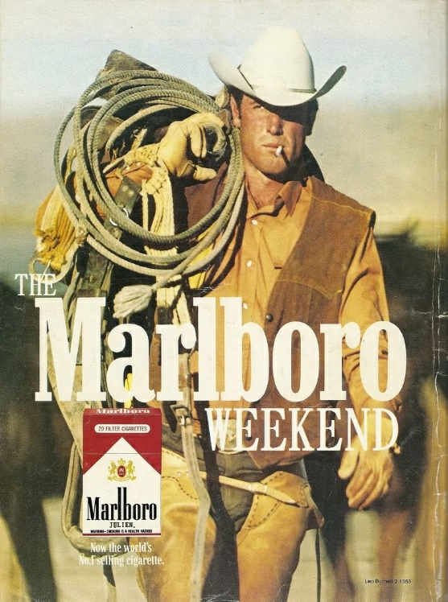

5.TV3: Law And Order

Title: Interrogation, Company: Colenso Bbdo, NEW ZEALAND, Auckland , Executive Creative Director: Nick Worthington , Creative Director: Steve Cochran , Deputy Creative Director: Karl Fleet , Art Director/Copywriter: Lisa Fedyszyn , Copywriter/Art Director: Jonathan McMahon , Account Director: Karla Fisher , Account Executive: Virginia Frankovich , Producer: Paul Courtney,Retoucher: Kevin Hyde Contract: , Photographer: Troy Goodall

The Print Ad titled LAW & ORDER was done by Colenso BBDO Auckland advertising agency for product: Law & Order Tv Show (brand: Tv3) in New Zealand. It was released in the Apr 2009. By using dark colors author points out to regret, punishment and sadness which are the results of committing crime. As dark color is associated with sadness, audience can understand and get the feeling which author wanted to show by using dark colors.in this art piece author shows all the emotions related to concept in the drawing. This piece was done as graphic design art and being 3d makes it more visible and helps to attract and get the attention of a lot of people. This advertisement is the combination of concept, arts and modern technology.

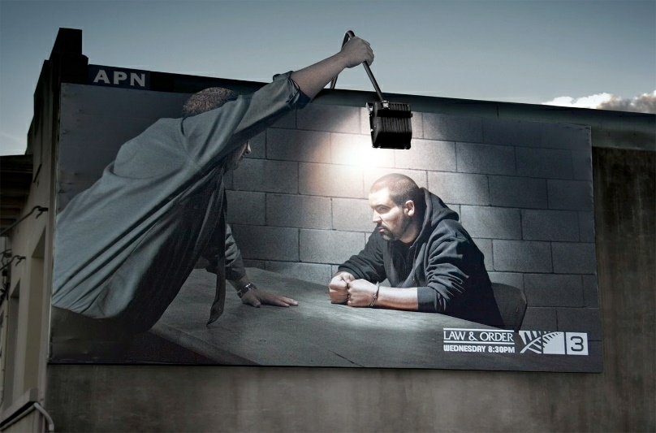

6. “Sunday Times the most creative ad 'Icons'.” YouTube, 11 Sept. 2015, youtu.be/LcIlHSm8r34.

Director - Us ,Production Company - Academy Films ,Executive Producer - Lizie Gower ,Producer - Juliette Harris ,DOP - Ben Fordesman ,A&R Operator - Simon Wood , Grade - Aubrey Woodiwiss , Agency – Grey , Executive Creative Director - Nils Leonard , Creative Director - Dave Monk , Creatives - Jonathan Rands & Johan Leandersson ,Agency Producer - Debbie Impett

This commercial had several art forms United such as painting, scenes from movies. The background was decorated and designed and would change with each different part of the video. The art of makeup was involved in this video, also costumes played a big role which was differently designed for each part. Music and art of filmmaking were involved as well and that made it a stronger art piece. Commercial showed the concept by presenting different types of art because the commercial was about finding your talent in the field of art.

7. Koleston Naturals: Change (Koleston Naturals is a hair colorant from natural ingredients. (Advertising Agency: Leo Burnett, Beirut, Libanon))

This piece is not complete without environment and it involves environment in it which in my opinion is creative and can be affective. To create this advertisement author involves graphic design and installation.



8. “THE FRAGRANCE GABRIELLE CHANEL – THE FILM.” YouTube, 30 Aug. 2017, youtu.be/X_y38L1RINU.

Director: Ringan Ledwidge Star: Kristen Stewart, 30 August 2017 (France) it has concept( before she was the designer Coco Chanel, she was Gabrielle. A rebel at heart, passionate and self-ruling, she freed herself to become the woman she wanted to be.) One of the first things to point out is Stewart performing in this commercial, she is an actress and that is one of the reasons that this video is considered as art. Commercial has a designed decoration and also the costume, which defiantly helped to transfer the concept of the advertisement. This video involves dancing, acting, music, lighting, creative filming and those are all connected to each other to give audience the idea of the author.

9. The slogan of this advertisement is “There’s always room for more. Adopt.”

Client: World For All , Art Director: Pranav Bhide , Writer: Pranav Bhide ,Photographer: Amol Jadhav

Retoucher: Pranav Bhid ,Product: Animal Protection ,Media: Print, Optical Illusion , Advertising Agency: McCann , Location: Mumbai, India

Photography is very well involved in this advertisement, as we see photography shows the important idea of commercial: making a world better place by adopting the animals. The idea is very kind, and wants to give the audience the feeling of responsibility towards animals. Author shows his idea by the pose of the models and also lighting, he wants to reflect a warm and kind environment with animals involved which tries to tell the audience to adopt animals and that is very well shown in the advertisement.



10. The 12th Annual Women's Golf Classic: Priceless

Advertising Agency: MacLaren McCann, Canada

Creative Director: Sean Davison

Art Director / Group Creative Director: Robert Kingston

Copywriter: Ron MacDonald

Print Producer: Steve Ferreira

Photographer: Paul Weeks

Print advertisement created by McCann, Canada for MasterCard, within the category: Finance.

There are two things about this ad you should take notice of

1. Visual story telling:

Visual (rear of a white shoe with brown pencil heels placed in a Golf course) is enough to tell the viewers that it is Women’s Golf Tournament.

2. What’s most important is: “Attention value”

The appealing shape of the rear of the shoe Grabs viewers’ attention. In advertising this rule is called “first 5 sec”

If you don’t grab your audience’s attention is first 5 seconds then it’s rare that they will even look notice you ad in that magazine or newspaper. This is where this ad scores a point. It holds your attention for the first few minutes (Of course it looks like rear of a woman)

Then just one line says it all: “The 12th Annual Women’s Golf Classic: Priceless”

The author says his idea and shows the concept within a simple and powerful idea. Art of photography and graphic design created this piece therefore it is considered as art.



**Conclusion**

My research allowed me to see the tendency of advertisements, I have seen how advertisements changed according to era and interests of the audience. It is true that firstly commercials were designed to male particular products popular but with the time tendency changed and advertisement became independent piece of art. My thesis was confirmed because the research I conducted showed that commercials can be valuable contribution to modern art industry. Therefor I believe my research was successful and with my paper I will be able to persuade the reader in meaning of advertisement per second.

**Bibliography**

Pincas, Stephane, and Marc Loiseau. A History of Advertising. Taschen, 2008.

{"isAjaxInProgress_B001HCXEJO":"0","isAjaxComplete_B001HCXEJO":"0"} Charles A. Goodrum (Author) › Visit Amazon's Charles A. Goodrum Page Find all the books. “Advertising in America: The First Two Hundred Years Hardcover – September 1, 1990.” Advertising in America: The First Two Hundred Years: Charles A. Goodrum, Helen Dalrymple: 9780810911871: Amazon.com: Books, [www.amazon.com/Advertising-America-First-Hundred-Years/dp/0810911876](http://www.amazon.com/Advertising-America-First-Hundred-Years/dp/0810911876).

[www.bing.com/cr?IG=77AFB571D16342ADB493F84501B03F8A&CID=1F2D4C0A58B362FF3578474759B56312&rd=1&h=-6YZk16I_loyaWGb-hHYKzhyFrRUa10tcNkddmYWvOE&v=1&r=https%3a%2f%2fwww.amazon.com%2fAdland-History-Advertising-Mark-Tungate%2fdp%2f0749464313&p=DevEx,5080.1](http://www.bing.com/cr?IG=77AFB571D16342ADB493F84501B03F8A&CID=1F2D4C0A58B362FF3578474759B56312&rd=1&h=-6YZk16I_loyaWGb-hHYKzhyFrRUa10tcNkddmYWvOE&v=1&r=https%3a%2f%2fwww.amazon.com%2fAdland-History-Advertising-Mark-Tungate%2fdp%2f0749464313&p=DevEx,5080.1).

Sobieszek, Robert A. “The Art of Persuasion: A History of Advertising Photography.” Barnes & Noble, [www.barnesandnoble.com/w/the-art-of-persuasion-robert-a-sobieszek/1114540974](http://www.barnesandnoble.com/w/the-art-of-persuasion-robert-a-sobieszek/1114540974).

““American Advertising: A Brief History.” HISTORY MATTERS - The U.S. Survey Course on the Web, historymatters.gmu.edu/mse/ads/amadv.html.Ad Age Homepage - AdAge.” Ad Age, [www.adage.com/](http://www.adage.com/).

“Advertising Educational Foundation - Educational Advertising Resources - AEF.” Webdoct.com, [www.webdoct.net/www.aef.com](http://www.webdoct.net/www.aef.com).

“Art & Copy (2009).” IMDb, IMDb.com, [www.imdb.com/title/tt1333631/](http://www.imdb.com/title/tt1333631/).

“Advertising.” Duke Digital Collections, Duke University Libraries, library.duke.edu/digitalcollections/advertising/.

“1950's: The Golden Age of Coca-Cola.” The History of Coca-Cola: 1950's, iml.jou.ufl.edu/projects/spring08/Cantwell/20thcent/50.html.

<http://www.coca-colacompany.com/stories/coke-lore-slogans>

Stref, Audrey. “Behaviour Change.” Persuasion and Influence, 1 Jan. 1970, persuasion-and-influence.blogspot.com/2016/02/the-marlboro-man-marlboroman-one-of.html.