**NAME : Shantanu Bagde**

**ID NO : VU4F2223003 , SE/IT/A**

**Experiment NO : 15**

**Aim:** Write a python program to implement File Handling operations in Python.

**Program:**

import os

def create_file(filename):

try:

with open(filename, "w") as f :

f.write("My Name Is Night\n")

print("File " + filename + " Created Successfully")

except IOError:

print("Error : Could Not Create File" + filename)

def read_file(filename):

try:

with open(filename, "r") as f:

f_content = f.read()

print(f_content)

except IOError:

print("Error : Could Not Read File" + filename)

def append_file(filename, text):

try:

with open(filename, "a") as f:

f.write(text)

print("Text Appended To File " + filename + " Successfully")

except IOError:

print("Error : Could Not Append Text To File" + filename)

def rename_file(filename, new_filename):

try:

os.rename(filename, new_filename)

print("File " + filename + " Renamed To" + new_filename + " Successfully")

except IOError:

print("Error : Could Not Rename File" + filename)

def delete_file(filename):

try:

os.remove(filename)

print("File " + filename + "Deleted Successfully")

except IOError:

print("Error : Could Not Delete File" + filename)

if __name__ == '__main__':

filename = "exp15.txt"

new_filename = "night.txt"

create_file(filename)

read_file(filename)

append_file(filename, "This is Append test!\n")

read_file(filename)

rename_file(filename, new_filename)

read_file(new_filename)

delete_file(new_filename)

**OUTPUT:**

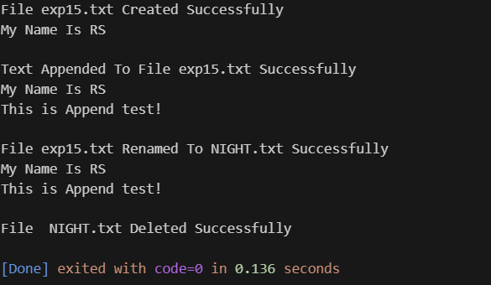

**CONCLUSION:**Hence, we successfully implemented File Handling operations in Python.