**EXPERIMENT NO:17**

**Aim:** Write a python program to implement different types of plots using Numpy and Matplotlob.

**Program:**

**Line.py**

import matplotlib.pyplot as plt

# Define the coordinates for the letter R

letter_r = [(0, 0), (0, 3), (2, 3), (2, 1.5), (0, 1.5), (2, 0)]

# Extract x and y coordinates

x_r, y_r = zip(*letter_r)

# Plot the letter R

plt.plot(x_r, y_r, marker='o')

# Set axis limits

plt.xlim(-1, 3)

plt.ylim(-1, 4)

# Set aspect ratio to be equal

plt.gca().set_aspect('equal', adjustable='box')

# Show the plot

plt.show()

**OUTPUT:**

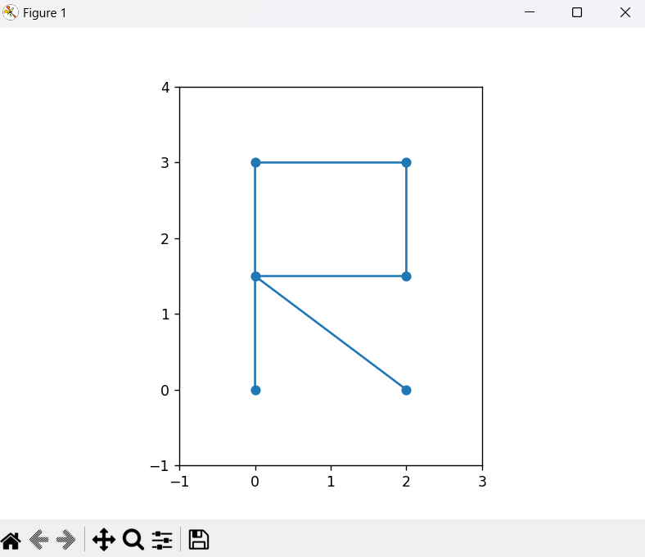

**Histogram.py**

import matplotlib.pyplot as plt

import numpy as np

# Data for India's population growth rate (from 1950 to 2024)

years = list(range(1950, 2025))

growth_rate = [2.21, 2.21, 2.21, 2.23, 2.27, 2.28, 2.28, 2.25, 2.25, 2.31, 2.33, 2.34,

2.34, 2.33, 2.26, 2.18, 2.15, 2.19, 2.23, 2.23, 2.24, 2.25, 2.28, 2.28,

2.26, 2.23, 2.23, 2.24, 2.25, 2.29, 2.3, 2.29, 2.28, 2.29, 2.27, 2.26,

2.24, 2.21, 2.19, 2.16, 2.12, 2.1, 2.07, 2.04, 2.01, 1.97, 1.94, 1.91,

1.87, 1.84, 1.82, 1.79, 1.74, 1.69, 1.62, 1.54, 1.48, 1.43, 1.4, 1.39,

1.37, 1.34, 1.31, 1.25, 1.19, 1.19, 1.16, 1.09, 1.03, 0.96, 0.8, 0.68, 0.81, 0.92]

# Calculate mean and standard deviation using numpy

mean_growth_rate = np.mean(growth_rate)

std_dev_growth_rate = np.std(growth_rate)

# Create the histogram

plt.figure(figsize=(10, 6))

plt.hist(growth_rate, bins=20, color='skyblue', edgecolor='black')

plt.xlabel('Population Growth Rate (%)')

plt.ylabel('Frequency')

plt.title('India Population Growth Rate (1950-2024)')

plt.grid(axis='y')

# Display mean and standard deviation

plt.text(1.4, 18, f'Mean: {mean_growth_rate:.2f}\nStd Dev: {std_dev_growth_rate:.2f}', bbox=dict(facecolor='white', alpha=0.5), fontsize=10)

# Show the plot

plt.show()

**OUTPUT:**

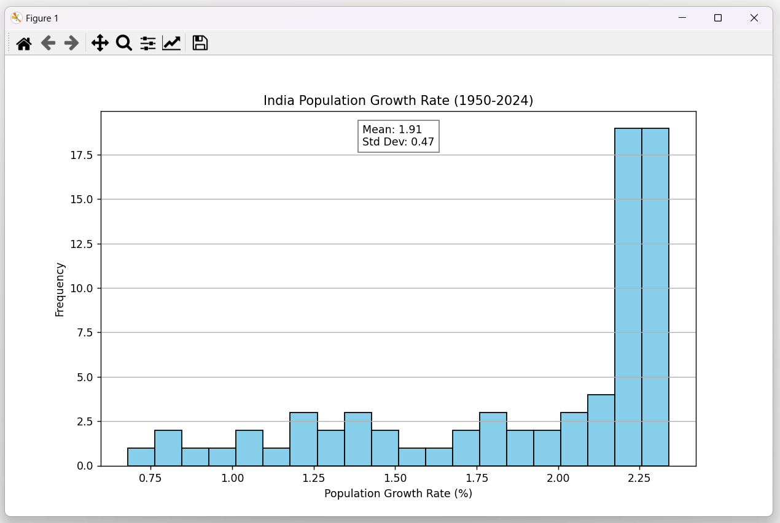

**Pie.py**

import matplotlib.pyplot as plt

budget_data = [25, 20, 18, 15, 12, 10] # Placeholder data

sector_labels = ["Defense", "Social Welfare", "Infrastructure", "Education", "Healthcare", "Other"]

# Find the index of "Education" sector

education_index = sector_labels.index("Education")

# Create an explode list with 0 for all slices except Education

explode = [0 for _ in range(len(budget_data))]

explode[education_index] = 0.1 # Adjust explosion factor as needed

# Create the pie chart

plt.pie(budget_data, labels=sector_labels, autopct="%1.1f%%", startangle=140, explode=explode)

plt.title("Indian Budget Allocation 2024-2025")

# Display the pie chart

plt.axis("equal") # Equal aspect ratio ensures a circular pie chart

plt.show()

**OUTPUT:**

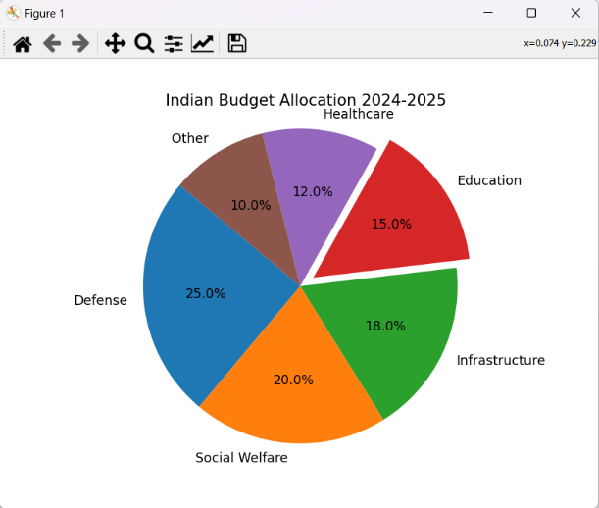

**Conclusion:** Hence, we successfully implemented different types of plots using Numpy and Matplotlob.