Experiment - 3

**Aim:** Write python programs to implement Looping in Python (while loop, for loop, nested loop)

**Theory:**

1. While loop

Syntax: while (*condition*):

c*ode statements*

1. For loop

Syntax: for (*iteration_variable*) in [*range function | list*]:

*code statements*

1. Nested loop

Syntax: for (*iteration_variable*) in [*range function | list*]:

for (*iteration_variable*) in [*range function | list*]:

*code statements*

**Program:**

def fibonacci():

n = int(input("Enter the number of terms to print for Fibonacci series: "))

a = 0

b = 1

sum = a + b

count = 1

print("Fibonacci series is: ", end=" ")

while (count <= n):

count += 1

print(a, end=" ")

a = b

b = sum

sum = a + b

def printFruits():

fruits = ["apple", "banana", "cherry", "mango"]

for x in fruits:

print(x)

start = 25

end = 50

print("Prime numbers between", start, "and", end, "are:")

def printPrimeNum():

start = int(input("Enter start of the range of prime numbers: "))

end = int(input("Enter end of the range of prime numbers: "))

for num in range(start, end + 1):

if num > 1:

for i in range(2, num):

# check for factors

if (num % i) == 0:

break

else:

print(num)

print("Using while loop to print fibonacci series")

fibonacci()

print()

print("Using for loop to print list of Fruits")

printFruits()

print()

print("Using nested loop to print range of prime numbers")

printPrimeNum()

print()

**Output:**

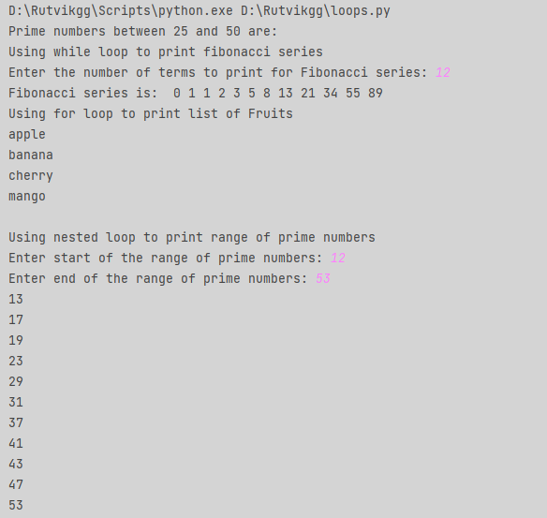

**Conclusion:** We have successfully implemented programs to execute loops (while, for and nested) in Python.