**Experiment 4**

Aim – Write python programs to implement Different List and List Operations.

Theory:

Lists are used to store multiple items in a single variable.

Lists are one of 4 built-in data types in Python used to store collections of data, the other 3 are [Tuple](https://www.w3schools.com/python/python_tuples.asp), [Set](https://www.w3schools.com/python/python_sets.asp), and [Dictionary](https://www.w3schools.com/python/python_dictionaries.asp), all with different qualities and usage.

Lists are created using square brackets:

Syntax: *list_name* = [*item 1, item 2, item 3, …*]

Different list operations are as follows:

append() Adds an element at the end of the list

clear() Removes all the elements from the list

copy() Returns a copy of the list

count() Returns the number of elements with the specified value

extend() Add the elements of a list (or any iterable), to the end of the current list

index() Returns the index of the first element with the specified value

insert() Adds an element at the specified position

pop() Removes the element at the specified position

remove() Removes the item with the specified value

reverse() Reverses the order of the list

sort() Sorts the list

Program:

def createList():

list = []

n = int(input("Enter the length of List to be created: "))

for _ in range(n):

item = input("Enter item: ")

list.append(item)

return list

def appendItem(list):

item = input("Enter item to add: ")

list.append(item)

def removeItem(list):

item = input("Enter item to remove: ")

if item in list:

list.remove(item)

else:

print("The item does not exits")

def reverseList(list):

list.reverse()

def printList(list):

if not list:

print("List is empty")

else:

for item in list:

print(item, end=", ")

def clearList(list):

list.clear()

def main():

mylist = []

while True:

print("List operations")

print("1. Create List")

print("2. Print List")

print("3. Add item to List")

print("4. Remove item from List")

print("5. Reverse the list")

print("6. Clear the list")

print("7. Exit program")

choice = int(input("Enter your choice: "))

if choice == 1:

mylist = createList()

elif choice == 2:

printList(mylist)

elif choice == 3:

appendItem(mylist)

elif choice == 4:

removeItem(mylist)

elif choice == 5:

reverseList(mylist)

elif choice == 6:

clearList(mylist)

elif choice == 7:

break

else:

print("Invalid choice choose correctly")

if __name__ == "__main__":

main()

Output:

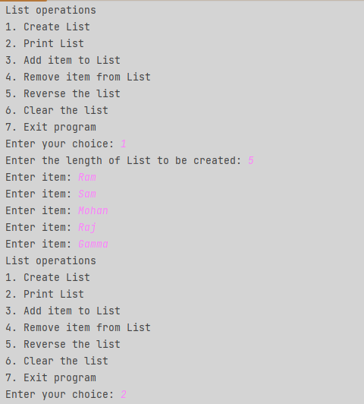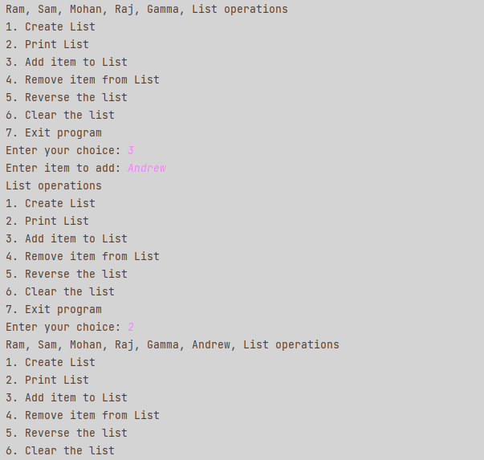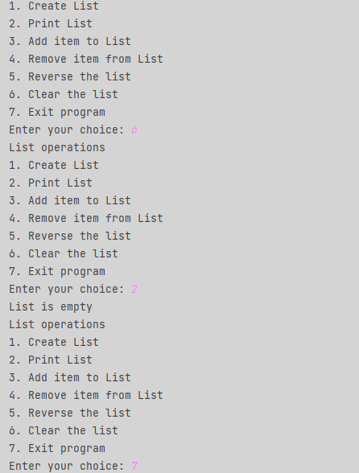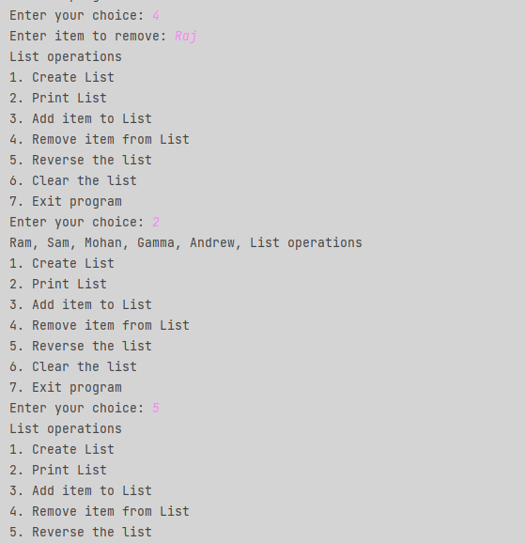

**Conclusion**: We have successfully implemented List and its Operations in python