Experiment 5

Aim-Write python programs to implement Different Tuple operations using Built-in functions.

Theory:

In Python, a tuple is an ordered and im ble collection of elements. Its similar to a list, but once created, you cannot modify its elements - you can't add, remove, or change them

Tuples are created using round parentheses:

Syntax:

*tuple_name* = (*item 1, item 2, item 3, ...*)

Different tuple operations are as follows:

len() - This function in used to get number of elements

+ - This operator is use to concatenate two tuples

in - This membership operator is used to check if element exist in the tuple

index() - This function is use to find index of element in tuple

count() - This function is use to count the number of occurrences of the element in tuple

Program:

rpgTuple = (1, "Rutvik", 88.3, False)

print("First Element of tuple:", rpgTuple[0]) print("Second Element of tuple:", rpgTuple[1])

print()

print("All elements of the tuple are")

for item in rpgTuple:

print(item)

print("Length of tuple", len(rpg Tuple))

print()

another Tuple = ("Sandwich", 45)

print("Tuple A", rpgTuple)

print("Tuple B", another Tuple) print("Concatenated Tuples", rpgTuple + another Tuple)

print()

print("Checking the element is in tuple")

element = input("Enter the element: ")

print(element in rpgTuple)

print()

print("Repeating the tuple", another_tuple * 3)

print()

index = rpgTuple.index(88.3)

print("Index of 88.3 is", index)

print()

print("Sliced tuple is", rpgTuple[1:3])

Output:

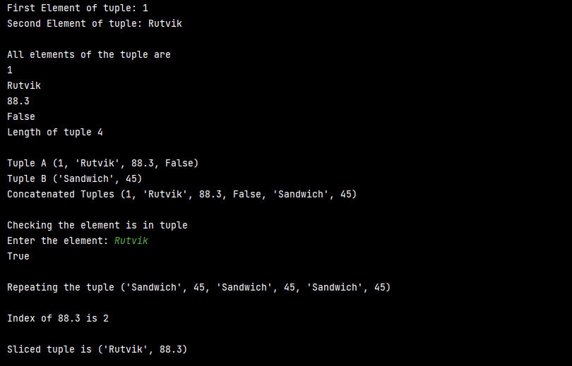

Conclusion: Different Tuples and its Operations are executed successfully in Python