Experiment 6

Aim-Write python programs to implement Built-In Set and String functions

Theory:

SET - A set is an unordered collection of unique elements. It is defined by enclosing a comma-separated sequence of elements within curly braces {}. Sets are commonly used for tasks where the uniqueness of elements is essential, such as eliminating duplicate values from a list or checking membership of an element in constant time.

Syntax:

*set_name* = {*item1, item2, item3, …*}

OR

*set_name* = set(*values/list*)

Following are different built-in methods for set

add() - Adds an element to the set

clear() - Removes all the elements from the set

copy() - Returns a copy of the set

difference() - Returns a set containing the difference between two or more sets

difference_update() - Removes the items in this set that are also included in another, specified set -

discard() - Remove the specified item

intersection() - Returns a set, that is the intersection of two or more sets

intersection_update() - Removes the items in this set that are not present in other, specified set

isdisjoint() - Returns whether two sets have a intersection or not

issubset() - Returns whether another set contains this set or not

issuperset() - Returns whether this set contains another set or not

pop() - Removes an element from the set

remove() - Removes the specified element

symmetric_difference() - Returns a set with the symmetric differences of two sets

symmetric_difference_update()

- inserts the symmetric differences from this set and another

union() - Return a set containing the union of sets

update() - Update the set with another set, or any other iterable

STRING - A string is a sequence of characters. It is one of the built-in data types and is commonly used to represent textual data. Strings are defined by enclosing a sequence of characters within single (') or double (") quotation marks.

Syntax:

*string_name* = ‘*your_string*’ OR “*your_string*”

capitalize() - Converts the first character to upper case

count() - Returns the number of times a specified value occurs in a string

endswith() - Returns true if the string ends with the specified value

expandtabs() - Sets the tab size of the string

find() - Searches the string for a specified value and returns the position of it

format() - Formats specified values in a string

index() - Searches the string for a specified value and returns the position of it

isalnum() - Returns True if all characters in the string are alphanumeric

isalpha() - Returns True if all characters in the string are in the alphabet

isdecimal() - Returns True if all characters in the string are decimals

isdigit() - Returns True if all characters in the string are digits

islower() - Returns True if all characters in the string are lower case

isnumeric() - Returns True if all characters in the string are numeric

isupper() - Returns True if all characters in the string are upper case

join() - Converts the elements of an iterable into a string

lower() - Converts a string into lower case

replace() - Returns a string where a specified value is replaced with a specified value

split() - Splits the string at the specified separator, and returns a list

splitlines() - Splits the string at line breaks and returns a list

startswith() - Returns true if the string starts with the specified value

strip() - Returns a trimmed version of the string

title() - Converts the first character of each word to upper case

upper() - Converts a string into upper case

Program:

SET FUNCTIONS

def main():

print("Creating a numeric Sets")

n1 = int(input("Enter the number of elements to enter in Set 1: "))

n2 = int(input("Enter the number of elements to enter in Set 2: "))

numbers1 = set()

numbers2 = set()

for n in range(n1):

ele = int(input(f"Enter element {n+1} of Set 1: "))

numbers1.add(ele)

for n in range(n2):

ele = int(input(f"Enter element {n+1} of Set 2: "))

numbers2.add(ele)

while True:

print("Set 1:", numbers1)

print("Set 2:", numbers2)

print("SET Operations")

print("1. Add no to Set \t 2. Remove no from Set \t 3. Clear Set \t 4. Union \t 5. Intersection \t 6. "

"Difference \t 7. Is Disjoint \t 8. Is Subset \t 9. Quit Program")

choice = int(input("Enter you choice: "))

if choice == 9:

break

elif choice == 1:

n = int(input("Enter the no of the Set: "))

element = int(input("Enter the element to add: "))

if n == 1:

numbers1.add(element)

elif n == 2:

numbers2.add(element)

else:

print("There are only two sets | Enter 1 0r 2")

elif choice == 2:

n = int(input("Enter the no of the Set: "))

element = int(input("Enter the element to remove "))

if n == 1:

numbers1.remove(element)

elif n == 2:

numbers2.remove(element)

else:

print("There are only two sets | Enter 1 0r 2")

elif choice == 3:

n = int(input("Enter the no of the Set: "))

if n == 1:

numbers1.clear()

elif n == 2:

numbers2.clear()

else:

print("There are only two sets | Enter 1 0r 2")

elif choice == 4:

print(numbers1.union(numbers2))

elif choice == 5:

print(numbers1.intersection(numbers2))

elif choice == 6:

n = int(input("Enter the no of the Set from which to get difference: "))

if n == 1:

print(numbers1.difference(numbers2))

elif n == 2:

print(numbers2.difference(numbers1))

else:

print("There are only two sets | Enter 1 0r 2")

elif choice == 7:

if numbers1.isdisjoint(numbers2):

print("The sets are disjoint")

else:

print("The set are NOT disjoint")

elif choice == 8:

n = int(input("Enter the no of the Set which is subset to verify: "))

if n == 1:

print(numbers1.issubset(numbers2))

elif n == 2:

print(numbers2.issubset(numbers1))

else:

print("There are only two sets | Enter 1 0r 2")

else:

print("Enter a valid choice")

main()

Output:

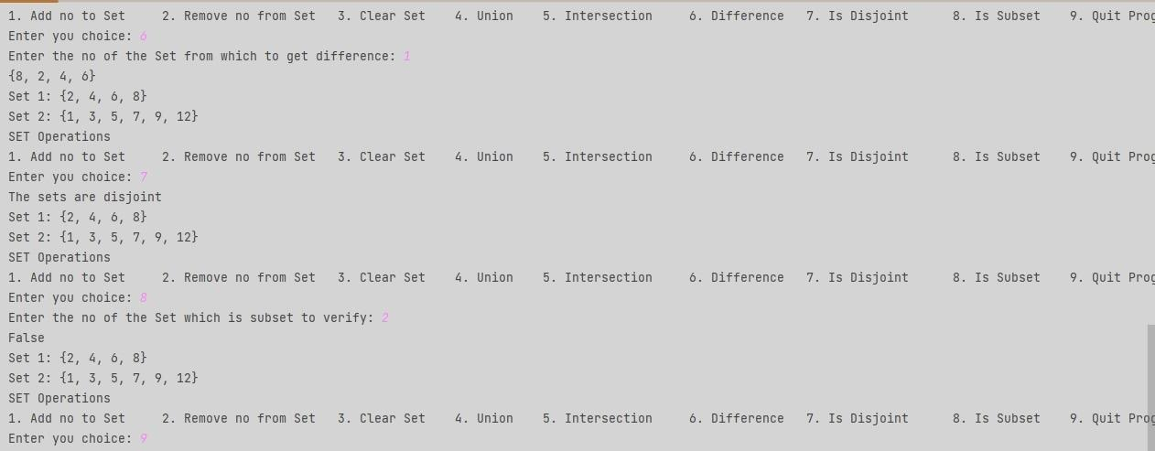

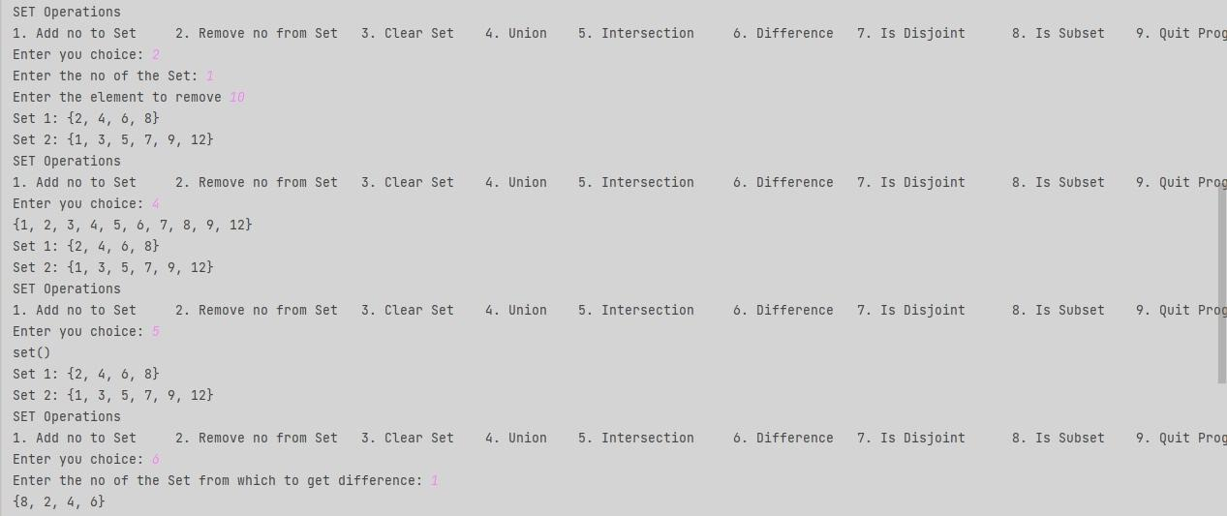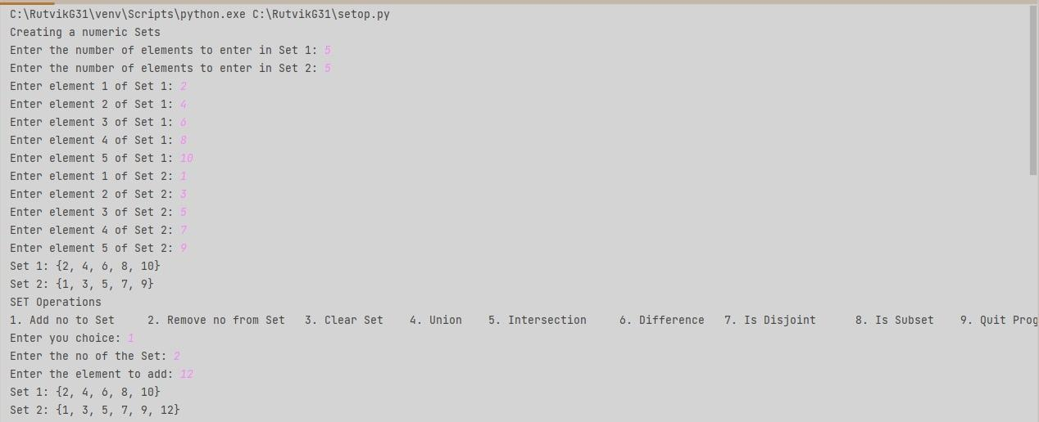

Program

STRING FUNCTIONS

myString = input("Enter a String: ")

print("Length of the given sting", len(myString))

print("Converting the given string to Uppercase", myString.upper())

print("Converting the given string to Lowercase", myString.lower())

print("Capitalizing the given string", myString.capitalize())

print("Converting the given string to Titlecase", myString.title())

print("Removing whitespaces", myString.strip())

subString = input("Enter a substring: ")

print("Finding the index of given substring in myString", myString.find(subString))

print("Returning the individual subStrings", myString.split(" "))

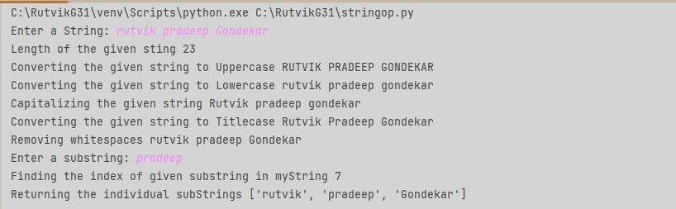

Conclusion: Different Set and String functions are executed successfully in Python