**﻿2011英语专业四级真题及答案**

**2011英语专业四级真题**

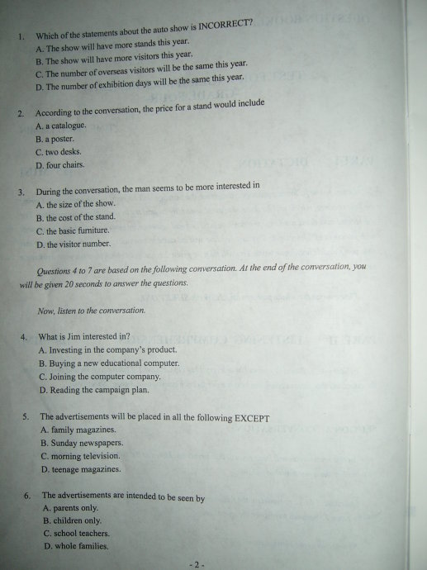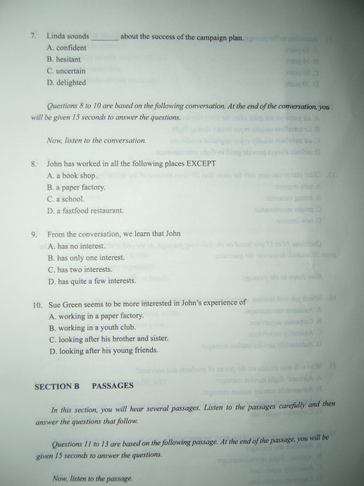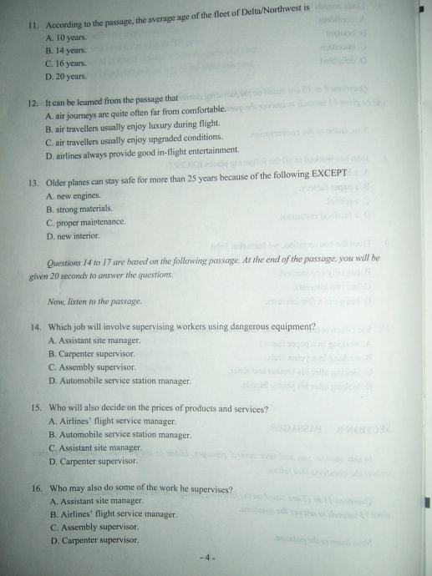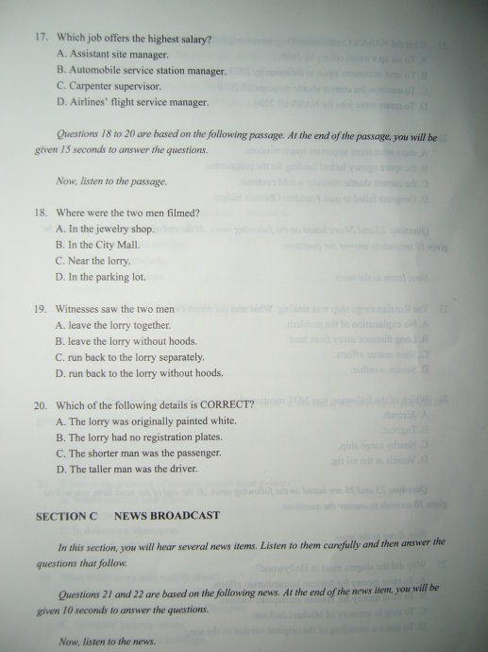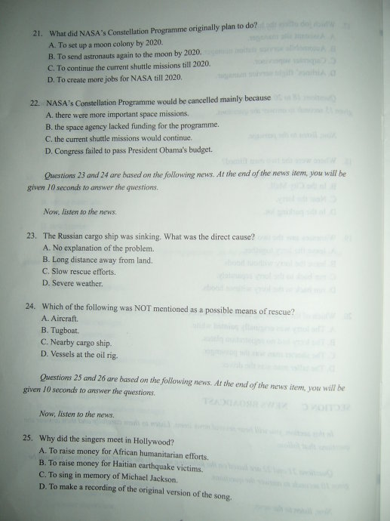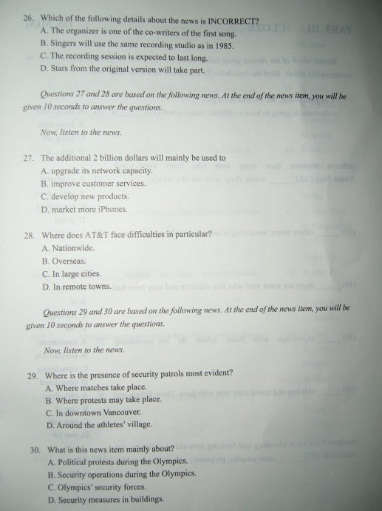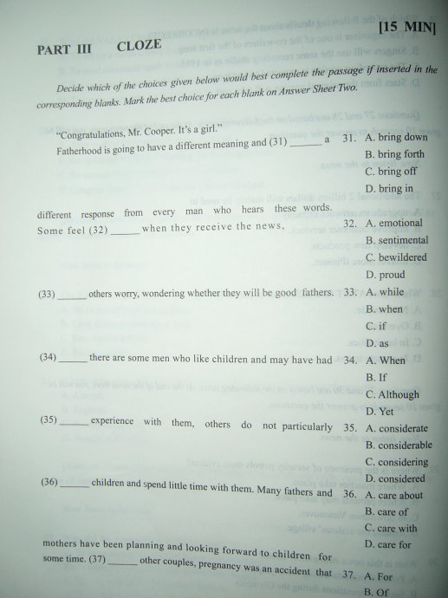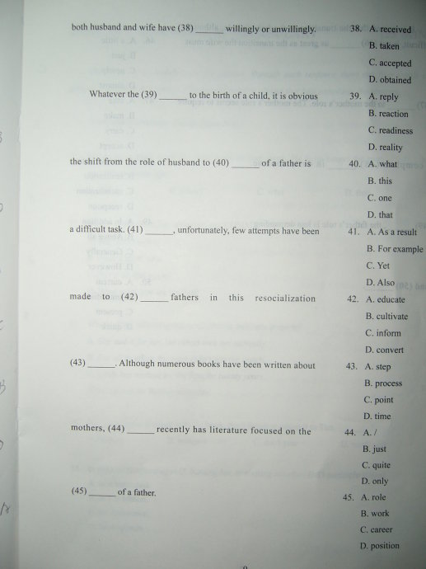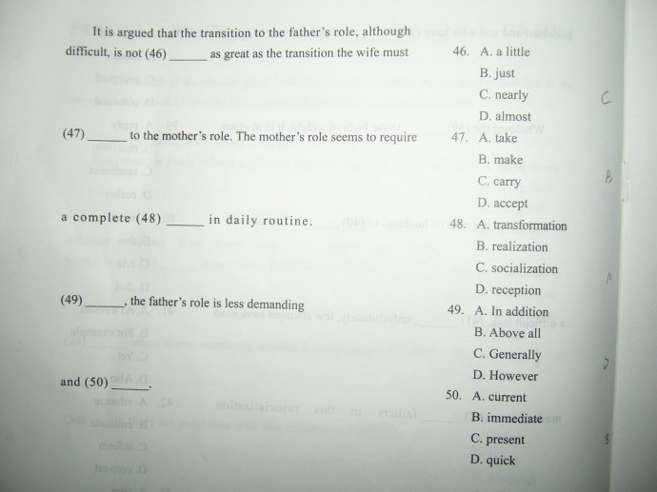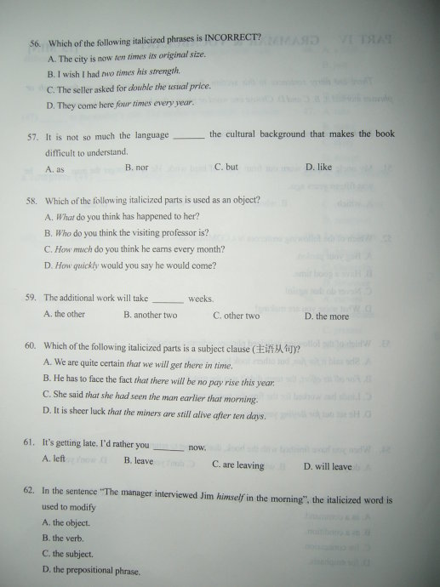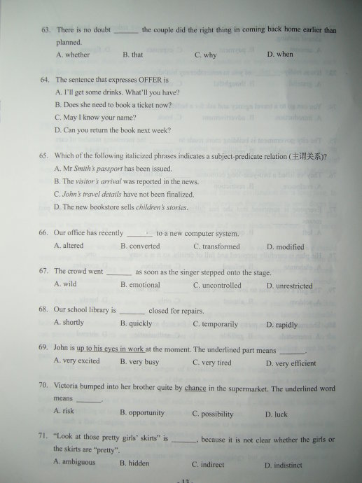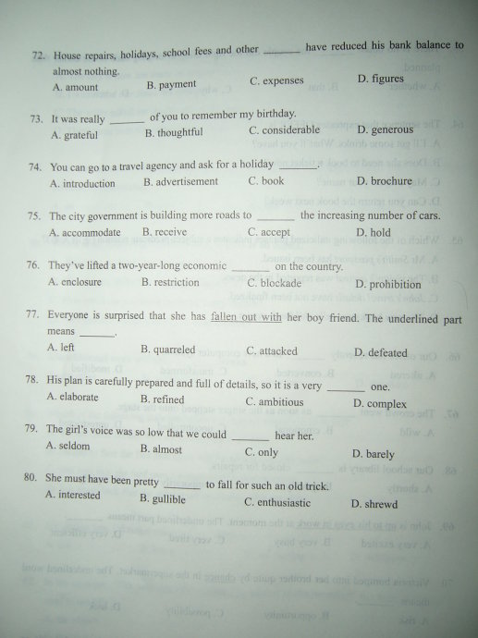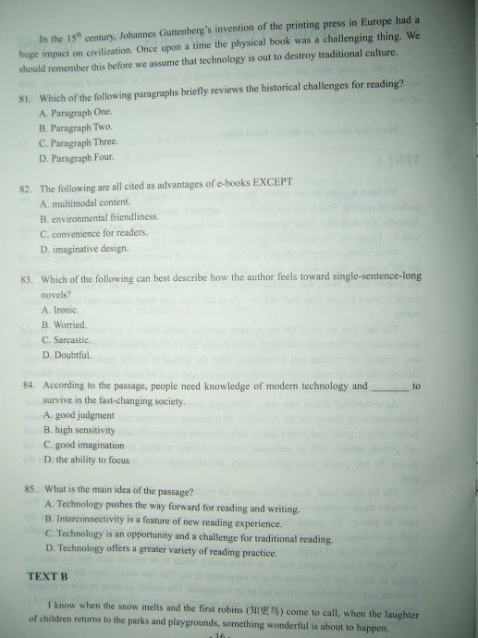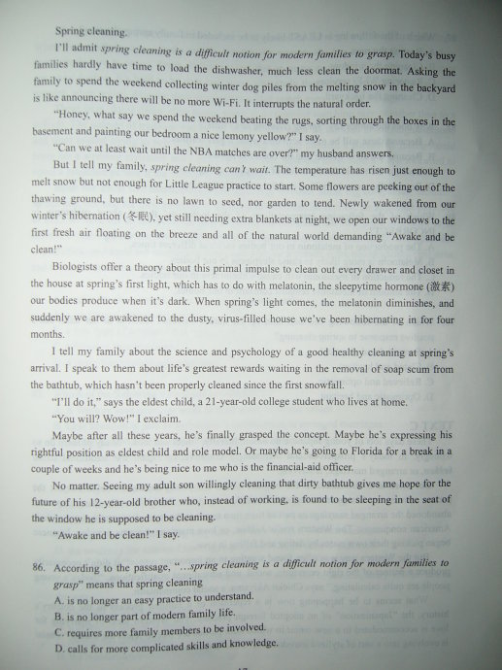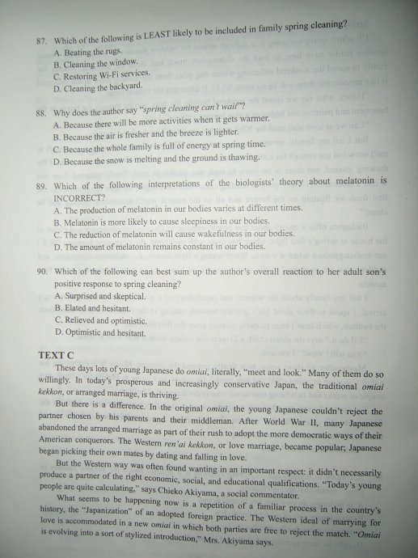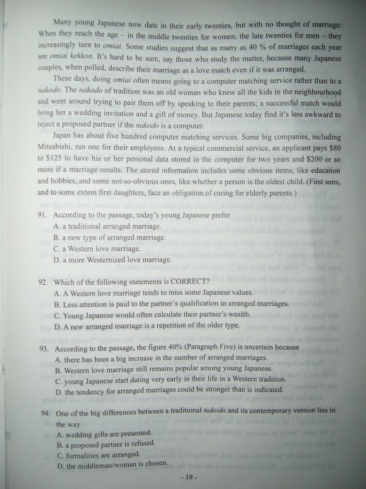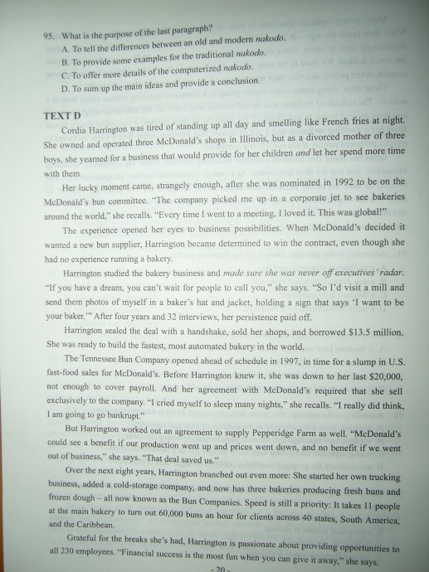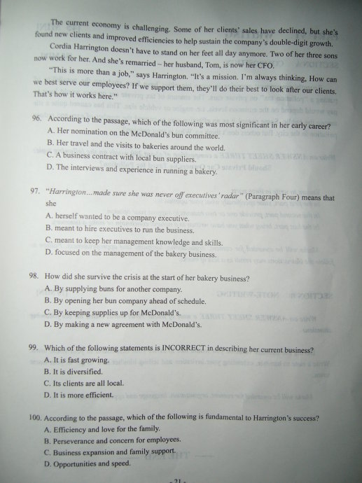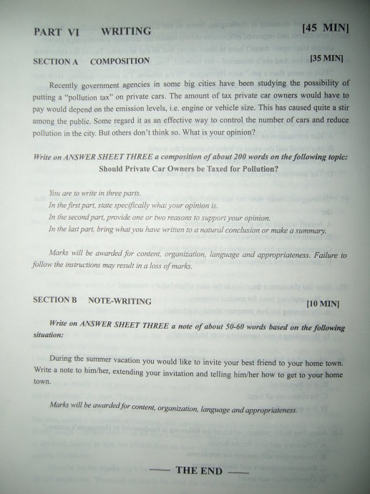

**2011专四答案**

**2011专四答案：听写部分**

　　British holidaying habits In the late 1970s, air travel became affordable for the average family in the UK, and more people started travelling abroad for their summer holidays. After all, the British weather wasn’t very good, even in summer, so a lot of people left the country for a vacation.

　　In the 1980s and 1990s, young people in the UK became wealthier on average. As a result, they started to go abroad in groups, to places such as Spain and Greece. Once they arrived at their destination, they met with other groups of young people and had one long party.

　　British holidaying habits have begun to change, however. Climate change means that the UK now has a hotter climate, so people do not need to go overseas to find good weather. Also, going abroad is more expensive. As a result, more British people are choosing to spend their summer holidays in the UK.

**2011专四答案：听力部分**

　　1-5 CDBAC 6-10 DACDB 11-15 CADCB

　　16-20 DACBB 21-25 BBACB 26-30 CACDB

**2011专四答案：完形填空部分**

　　31-35 BDACB 36-40 DACBD 41-45 CABDA 46-50 CBADB

**2011专四答案：语法词汇部分**

　　51-55 BCABD 56-60 BACBD 61-65 ACBAB 66-70 BACBD 71-75 ACBDA 76-80 CBADB

**2011专四答案：阅读部分**

　　81-85 BDBAC 85-90 ACADB

　　91-95 BADDC 96-100 BCACB

**2011年专四作文参考范文**

　　Should private car owners be taxed for pollution?私家车主是否应交污染税?

　　With the development of society, many people can afford a car. As the  number of the cars is rising, we are facing some problems. One big problem is the pollution caused by the use of cars. In order to solve this problem, government agencies in some big cities recently suggest that a “pollution tax” should be put on private cars in order to control the number of cars and reduce pollution in the city. For my part, I agree to this viewpoint, and my reasons are as follows:

　　To begin with, cars contribute to the environmental pollution. For example, a lot of big cities in China are now plagued by serious air pollution. Then it is the responsibility of these private car owners to pay for the pollution and they should be taxed. The purpose of collecting environmental pollution tax is to raise the fund, and then utilize the tax revenue lever to protect our environment.

　　Secondly, it is a good way to raise people’s environmental awareness by putting a pollution tax on private cars. If people suffer from the financial loss when making a decision, they will think more about their decision. Then they will consider more when deciding to buy a private car. Consequently, the increase rate of the number of the private cars can be controlled.

　　In a word, it is a very good and necessary attempt to use the means of taxation to treat the pollution. Of course, it must be kept in mind that all people, including the private car owners, should try their best to protect the environment.