**2013英语专八真题及答案**

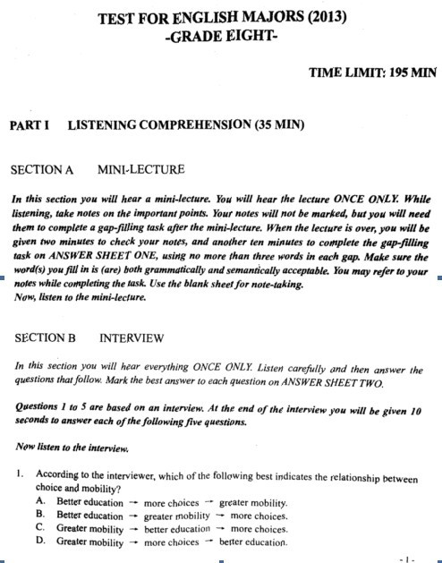

　　请点击下载：[**2013年专八真题.doc**](http://file.koolearn.com/20131107/13837966771343.doc)



**2013年专八真题答案**

**听力部分**

**Mini-- lecture**

　　1.checking their understanding 2. reflective on information 3.incomprehensible 4.what you read 5.organized 6.monitoring their understanding 7.differ 8.blame 9.performance 10.active learning

**听力选择题**

　　1. better education—greater mobility—more choices

　　2. shorter work hours was least chosen for being most important

　　3. the way in which the questions were designed

　　4. psychological reward is more important than material one

　　5. chances for advancement

　　6. passengers

　　7. renters can take a shower inside the box

　　8. police preventive measures for the carnival

　　9. the causes of death during the famine

　　10. in the 1950s

**阅读理解**

　　11.the appearance of advertisement in newspaper.

　　12.more people are involved in finding, discussing and distributing news

　　13.planning the return to coffee-house news.

　　14.optimistic and cautious

　　15.the participator nature of news.

　　16. regret

　　17.fasionable Parisian women return to Paris

　　18. can be happy if they want

　　19. its implications for life

　　20. thoughtfulness

　　21. Geographic location

　　22. the government’s determination

　　23. denmark’s energy-saving success offers the world a useful model

　　24. the country’s previous experience of oil shortage

　　25. energy saving cannot go together with economic growth.

　　26. shops try all kinds of means to please customers

　　27. over-friendly

　　28. customers have got a sense of superiority

　　29. keep asking for more discounts

　　30. the practice of frugality is of great importance

**人文知识**

　　31. the commonwealth of Austrilia

　　32. its heavy industries.

　　33. two-year programmes

　　34. 1997

　　35. safe and sound

　　36. George Bernard Shaw

　　37. novel

　　38 .goes

　　39. Onomatopoeia

　　40. directive

**改错部分**

　　1. production改成producing

　　2. 去掉language前面the

　　3. most of time 改为most of the time

　　4. looking改为look

　　5. we前面加that

　　6. influenced改为affected

　　7. their改成his

　　8. anyone改成 someone

　　9. evolved改成involved

　　10. were改成are

**汉译英.**

　　Life is like a cup of wine; people who love it discover inexhaustible wonders from it. Hold in the hand and gaze at it, the dark red color is reminiscent of the blood, which is the impress of life. Take a sip of it and appreciate the taste, the bittersweet flavor is exactly the same with life, which is complicated and blurred. Once the sip is swallowed, the lingering fragrance pleases the heart and refreshes the mind, leaving a person lifelong benefit. There is a remarkable resemblance between life and wine: the taste becomes more delicious as the wine mellows, just as life gets better as it becomes more abundant. When life comes to twilight years, it looks calm and tastes full of wisdom and generosity, just like a bottle of wine to be savored.

**英译汉**

　　联合国代表大会，中心政治论坛，由193个成员国组成，几乎包括世界上所有国家，其中三分之二的国家为发展中国家，占世界总人口的四分之三。通过决议非常困难，尤其是所有惯例决出的协议必须达成一致才能通过。结果就是，重要的协议总是被狭隘的特殊利益所挟持，并且大部分协议都只是用来使自己的利益最大化。但真正的问题是世界上主要国.是否愿意看到民主最大限度地开展。联合国安理会，负责和平和安全，处理最重要的政治问题。安理会只有15个成员国，所以能经常性地应付危机。它曾一度由于冷战对立而停摆，但已经重新获得了联合国宪章给予的权利。

**2013年专八写作范文：**

　　Is a sound social environment necessary for people to be good to others

　　Helping others has always been a virtue in traditional Chinese culture, but nowadays many people dare not offer help to those in need, for fear of getting into trouble. The issue has aroused public debate over the climate of morality and credibility, and many people sigh over the moral degeneration. In my opinion, while social environment is necessary for people to be good to others, each individual should try his or her best to do good deeds and be sympathetic with others, instead of waiting for the environment to improve.

　　There is no denying that some tragic events turn out to be traps by people with evil intentions, so people are becoming more risk-conscious and are more wary of traps and deceits. some people even wonder, ‘Is our society hostile to good people?’ The question may sound ridiculous but many people apparently think so. They believe that our current society provides a bad environment for good people doing good things, and good people pay a high price for being compassionate. In fact, such kind of things only accounts for a pretty small percentage, but massive media coverage makes the situation seem serious. Actually, most people around me are kind, warm-hearted and helpful, and I am quite delighted in their company. So I believe media should pay more attention to publicizing good people and exemplary deeds to enhance our confidence, rather than exposing disgusting behaviors.

　　At the same time, as John Donne puts it, “No man is an island, entire of itself. Every man is a piece of the continent, a part of the main.” Since everyone of us is a component of the society, it is each individual’s conducts that form social morality. Just imagine it is you who need help, what would you feel if everyone watches indifferently or suspiciously? So, put yourself in other’s position and be sympathetic. If we do nothing but wait for the environment to improve, nothing will happen. Only by removing the fence around our kind consciousness can we reverse the regress of social ethics, and make our world full of warmth and happiness. Therefore, if help is needed, never hesitate to lend a helping hand. It will make you happy and feel better about life.

　　In sum, I contend the idea that while social environment is necessary for people to be good to others, it is each individual’s responsibility to offer help to those in need, and together we build up a more harmonious society.