JAMM
Just Another MasterMind

Users Manual
Contents
1. Introduction 3
2. Mastermind in general 4
3. The game 5
3.1 The main window 5
3.1.1 Secret code 6
3.1.2 Guessing field 7
3.1.3 Color field 8
3.1.4 Chosen color 9
3.1.5 Info bar 9
3.1.6 Menu Bar 10
3.1.6.1 Game menu 10
3.1.6.2 Settings menu 11
3.1.6.3 Help menu 11
3.2 Mouse controls 12
3.3 Keyboard controls 12
3.4 Save a game 13
3.5 Load a game 14
4. Settings 15
5. Appendix 16
5.1 Important notes 16
5.2 Known bugs 16
5.3 License 16
5.4 Website 16

1. Introduction
This game was created in the context of the lecture „Programmierprojekt“ at university of applied sciences Aalen. The aim was to gain practical experience in programming as a team and to tighten and improve the programming skills of each team member.
The requirement was to create a simple Mastermind game which was easy to use, gives the user some options to vary the gameplay and to provide a form of an AI that solves games and/or gives the user hints and some support.

2. Mastermind in general
Mastermind is a code-breaking game originally designed for two players. One player has to choose a secret code which the other player has to guess. The one choosing the secret code is called „codemaker“, the one who tries to guess the code is called „codebreaker“. In this game you can choose whether you want to be the codemaker or the codebreaker. The computer will take the other role.
The codes consist of colored pins in a specified order. The length of the code (the number of pins) and the quantity of colors used can be specified before the game beginns. Also the allowance of using the same color several times can be specified.
At the beginning of the game the codemaker has to define a secret code. Then the codebreaker makes guesses either till he guesses the correct code or till the maximum number of tries has exceeded. Every guess of the codebreaker results in an response of black and white pins.
The white pins indicate the number of correct colors at wrong positions in the given guess. For example if the secret code is red green blue yellow and the guess was blue brown red orange the result contains two white pins because red and blue are in the secret code.
The black pins indicate the number of correct colors at the correct position in the given guess. For example if the secret code is red, green, blue, yellow and the guess was
red brown orange blue the result contains one black pin because red is used in the secret code and it is at the correct position. (There would also be a white pin because of blue.)

Response Pins | Meaning
white | number of guessed colors the secret code actually contains
black | number of guessed colors the secret code acutally contains AND which have the correct position

3. The game
This section covers the user interface of the game and how you control it.

3.1 The main window
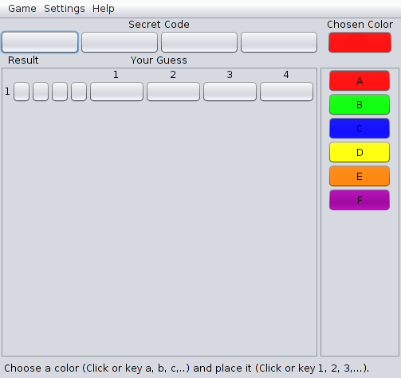The main window when you start a new game
When you start a new game this is how the game looks like. At this point the computer has already set a secret code and you are in the role of the codebreaker. The components of the main window are described in the following chapters.

3.1.1 Secret code
The secret code
This is the secret code field.
When you play as the codebreaker it looks like the picture above, showing only blank color fields. If you manage to solve the game or if the number of maximum tries exceeds it will show you what the secret code was.
When you play as the codemaker you will be able to set the secret code by choosing a color in the color field (see chapter 3.1.3) and clicking into the field in which you want to set the chosen color. You are also able to use the keyboard controls (see chapter 3.3) to set the code.

3.1.2 Guessing field
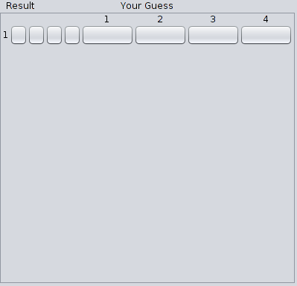The guessing field

The guessing field shows the guesses that were already tried and the correspondig results.
When you play as the codebreaker you can guess by placing colors into the bigger fields (labeled 1, 2, 3,...) and afterwards clicking on the result fields. When clicking the result fields, the game will evaluate your guess and show you the according result. Then a new line will show up for the next guess. (See chapters 3.2 and 3.3 for setting colors/controls.)
When you play as the codemaker it will show you the guesses (and corresponding results) the computer makes. Note: You don´t have to set the results by hand, the game will do it for you. Also the whole programm is locked while the computer solves the game.

3.1.3 Color field
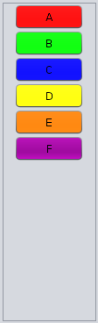The available colors of the running game
The color field contains all available colors of the running game. It allows you to choose the color you want to set either in the guessing field or in the secret code field depending on which game mode you have chosen. (See chapters 3.1.4 for chosen color, 5 for game mode.) The colors are labeled with the letters used for keyboard controls (see chapter 3.3).

3.1.4 Chosen color
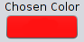The color that is chosen at the moment
The chosen color field shows you the color selected at the moment. Setting a color in the guessing or the secret code field will use this color..

3.1.5 Info bar
The info bar showing information about the running game
The info bar at the bottom of the main window shows you information about the game state and gives you instructions/tips on how to proceed with the game.

3.1.6 Menu Bar
There is a menu bar located on the top of the main window. It provides some functions described in this chapter.

3.1.6.1 Game menu
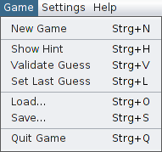The game menu
Entry | Shortcut | Action
New Game | Ctrl + N | Start a new game. The settings set in the settings dialogue (see chapter 4) will be used.
Show Hint | Ctrl + H | Let the game compute a next possible guess if you don´t know how to go on.  (See chapter 5.1 [1].)
Validate Guess | Ctrl + V | Checks if the guess you have in the guessing field at the moment is valid or makes no sense in context of previous guesses and results.
Set Last Guess | Ctrl + L | Set your last guess to the active row. (Handy if you want to change only a few colors in your next guess.)
Load... | Ctrl + O | Open the load dialogue. (See chapter 3.5.)
Save... | Ctrl + S | Open the save dialogue.  (See chapter 3.4.)
Quit Game | Ctrl + Q | Quit the game. (The running game will be lost if not saved before.)

3.1.6.2 Settings menu
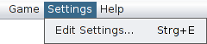The settings menu
The „Edit Settings...“ entry will open the settings dialogue. (See chapter 4.)
The equivalent shortcut is „Ctrl + E“.

3.1.6.3 Help menu
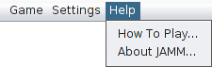The help menu
Entry | Action
How To Play... | Open the users manual. (This document.)
About JAMM... | Open a little info dialogue with information about the version, the license and the developers.

3.2 Mouse controls
The mouse controls are very intuitive: By clicking a color in the color field you choose this color to be used if you click a button in the guessing or secret code field. To see which color is chosen at the moment have a look at the chosen color field. (See 3.1.x for descriptions of the mentioned fields.)

3.3 Keyboard controls
You can play the game completely using your keyboard. The following table shows all buttons and shortcuts available in the game.
Key/Shortcut | Action
a,b,c,...,n,o | Choose the corresponding color from the color field.
1,2,3,4,5,6,7,8 | Setting the chosen color in the guessing or secret code field at the corresponding position.
Space | Make a guess and therewith request the according result.
Ctrl + H | Let the game compute a next possible guess if you don´t know how to go on.  (See chapter 5.1 [1].)
Ctrl + V | Checks if the guess you have in the guessing field at the moment is valid or makes no sense in context of previous guesses and results.
Ctrl + L | Set your last guess to the active row. (Handy if you want to change only a few colors in your next guess.)
Ctrl + S | Open a save dialogue that allows you to define a file in which the running game is saved.
Ctrl + O | Open a open dialogue that allows you to define a file from which a game is loaded.  (The file has to be a valid savegame created with the save dialogue.)
Ctrl + E | Open the settings dialogue
Ctrl + N | Initiates a new game. The running game will be lost if not saved before.
Ctrl + Q | Quit the game. The running game will be lost if not saved before.

3.4 Save a game
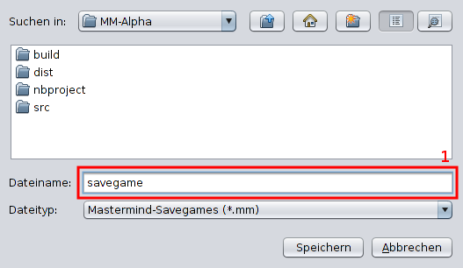The save dialogue
The save dialogue allows you to save the whole running game into a file. You can open the dialogue using the menu bar: Game → Save...
Alternatively you can use the keyboard shortcut „Ctrl + S“.
You can specify a filename typeing in field 1. You also can click an excisting file to choose its name and overwrite it.

3.5 Load a game
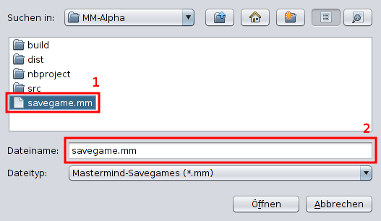The load dialogue
The open dialogue allows you to open a saved game from a file. You can open the dialogue using the menu bar: Game → Open...
Alternatively you can use the keyboard shortcut „Ctrl + O“.
You can specify the game/file you want to load by clicking its filename ( 1 ). Alternatively you can type a filename into 2.
Note: If you load a game, the game you play at the moment will be lost.

4. Settings
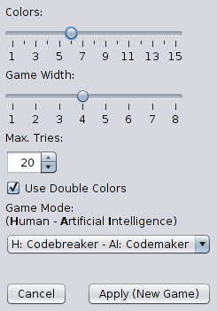The settings dialogue

The settings dialogue gives you the possibility to change some settings to add some variety to the game.
Setting | Meaning
Colors | Allows you to assign the number of different colors used in the game.
Game Width | This is the width of the codes. E.g. with a width of 5 the codes (secret code and guesses) consist of 5 pins.
Max. Tries | The maximum number of tries. If the codebreaker needs more guesses than speciefied here he loses the game.  Maximal value: 2147483674.
Use Double Colors | If this option is checked it is allowed to use a color several times in a code. If unchecked you can use every color just once in a code.
Game Mode | Game Mode lets you decide if you want to be the codemaker or the codebreaker. The computer will take the other role.  (See chapter 5.1 [1], [2].)

5. Appendix

5.1 Important notes
[1] This function uses the AI (artificial intelligence) of the game. Using it can take up to several minutes, especially if you have set a high width, many colors or when you run the game on a slow computer. This is not a bug, just a side effect of the complex algorithm the AI is using.
[2] While the AI is guessing, the GUI is locked. Please stand by until the AI broke the code or the maximum number of tries is reached.

5.2 Known bugs
Although we tried to create a solid and stable programm there are the following bugs we know about:
None. :-)

5.3 License
The whole programm is published under the conditions of GNU General Public License Version 3.


See http://www.gnu.org/licenses/gpl-3.0.html

5.4 Website
http://jamm.studio-vs.com/

