Ikasan Management Console
User Guide

0.9.4
EMAIL: info@ikasan.org
WEBSITE: www.ikasan.org

Table of Contents
1 Introduction 3
1.1 About 3
1.2 Audience 3
1.3 How to Use This Guide 3
1.4 Overview 3
2 Accessing the Ikasan Management Console 4
3 First Time Console Usage 5
4 Home 11
5 Modules 12
5.1 Module Summary 13
5.1.1 Flow Name 13
5.1.2 Type 13
5.1.3 Status 13
5.1.4 Start/Stop Operation 13
5.2 Flow Internals 14
5.2.1 Startup Type 14
5.2.2 Flow Element Components 14
5.2.2.1 Details - Component Configuration 16
5.2.2.2 Transitions 18
5.2.2.3 Before/After Element Triggers - Dynamic Event Capture 19
6 Events 23
7 Administration 25
7.1 Inspect the Scheduler 25
7.1.1 Pausing/Resuming the Scheduler 25
7.2 Inspect the System Event Log 26
7.3 Maintain Users 27
7.3.1 Creating Users 27
7.3.2 Permissions 28
7.3.2.1 Granting & Revoking Permissions 28
7.3.3 Disabling Users 29
7.3.4 Deleting Users 30
8 Document Info 31

Introduction

About
This document provides a quick start guide for user operations within the Ikasan Management Console (the blue console). This is part of the documentation suite for the Ikasan Enterprise Integration Platform.
This console is directly packaged with the application and part of the EAR (Enterprise Archive) deployed to the runtime container. This guide assumes packaging and deployment to runtime has been completed and focuses purely on the user operations of the console itself from initial first time usage through to administration and management.

Audience
This guide is targeted at users wishing to administer or configure Ikasan Enterprise Integration Platform applications through the Ikasan Management Console.

How to Use This Guide
This guide provides a reference that can be read front to back or dipped into as required for the operation of the Ikasan Management Console.

Overview
The Ikasan Management Console provides a web front end for the runtime administration of Ikasan Enterprise Integration Modules.
This guide covers the user operations within this console including,
- Module Runtime Administration and Management
- Event Searching and Tracking
- User Administration and Management

Accessing the Ikasan Management Console
The Ikasan Administration Console is bound to the root context of the runtime application – this is typically the same name as the module.
For example, to access the Ikasan Management Console for a module EAR called "bar" deployed to server “foo” (assuming default port 8080) you would open a web browser specifying the URL
http://foo:8080/bar
This would return the Ikasan Management Console login page below.
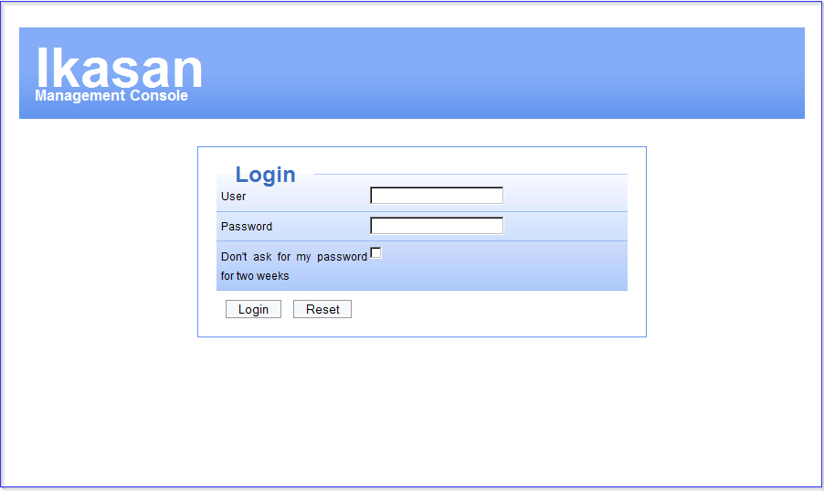
Use your Ikasan Management Console credentials to login.

First Time Console Usage
For any first time deployment of the Ikasan Management Console the only user configured will be the default administration user whose credentials are
username: admin
password: admin
These credentials can be used to login initially, however, it is strongly recommended that after this initial login, you add a new administration user account and disable the default admin user account. As a minimum you should change the password of this default admin account.
The following steps walk you through how to create a new administration account and disable the default admin.
Login as the default admin user
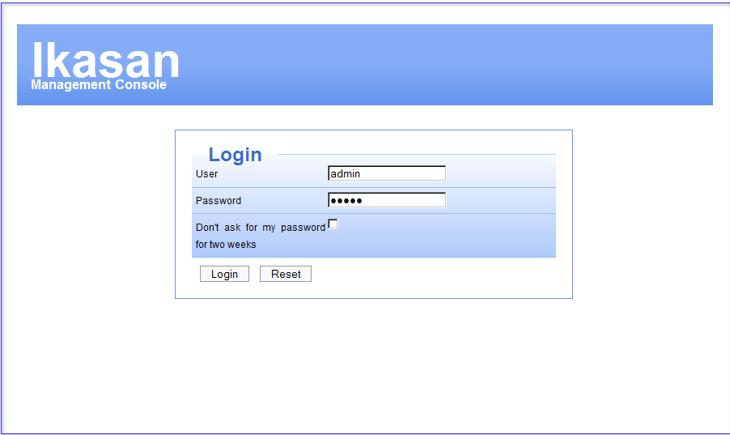
Once logged in you are presented with the default “Home” landing page, from here select the “Admin” menu item.
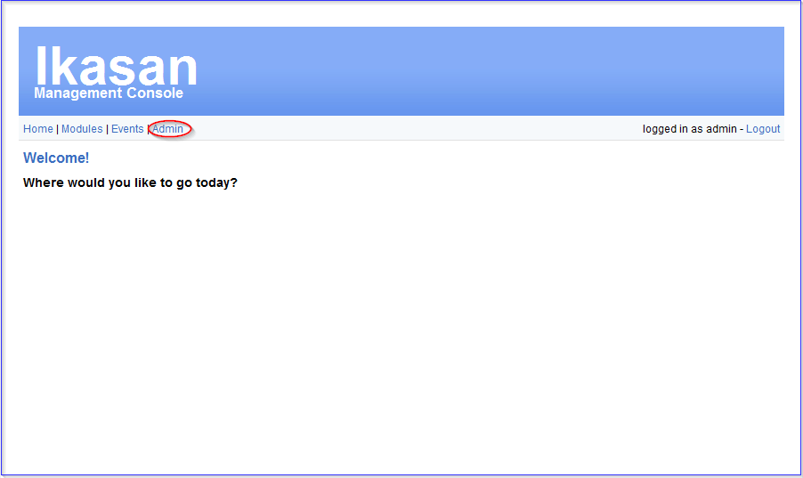
Select “Maintain Users”
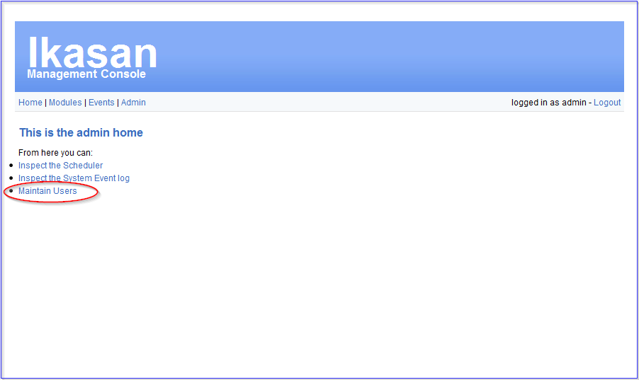
This takes you to the user maintenance page.
Firstly we will add the new administration user account. Note: This is a local account not LDAP.
Populate the new user fields below.
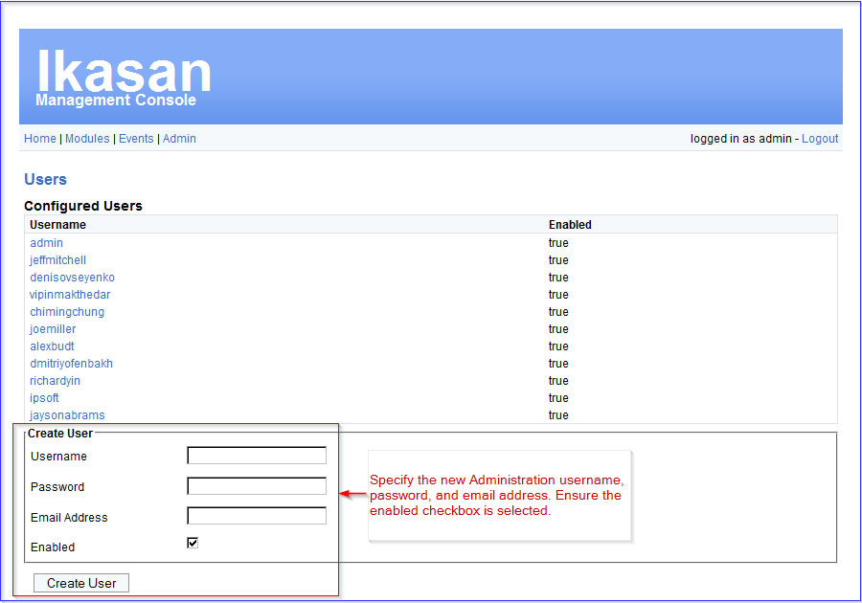

- Username - can be anything, you may want to have this conform to your user account format policies.
- Password – password for this local account
- Email Address – should be a valid email address as this is used for “forgot password” functionality
- Enabled – ensure this is checked otherwise the account will not be available for use

Select “Create User”.
Once created, select the username to grant permissions.
The new administration user must then be granted permission for “user” and “admin” roles by selecting “Grant” for ROLE_USER and ROLE_ADMIN.
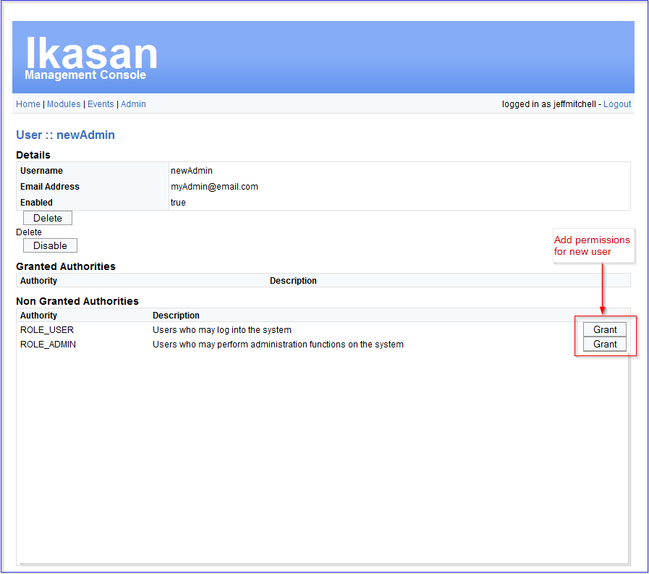
Once completed your new administration user should look like this.
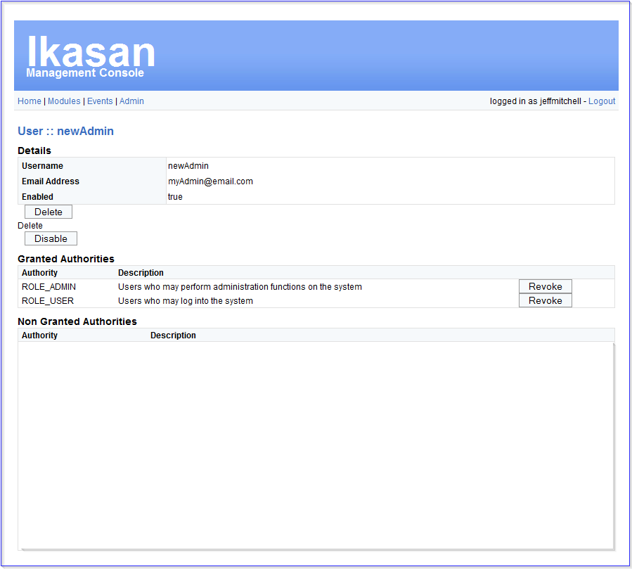
Congratulations, your new administration account is now created. Logout and login as the new administration account.
You should now disable the default “admin” user by selecting that user and invoking the “Disable” operation.
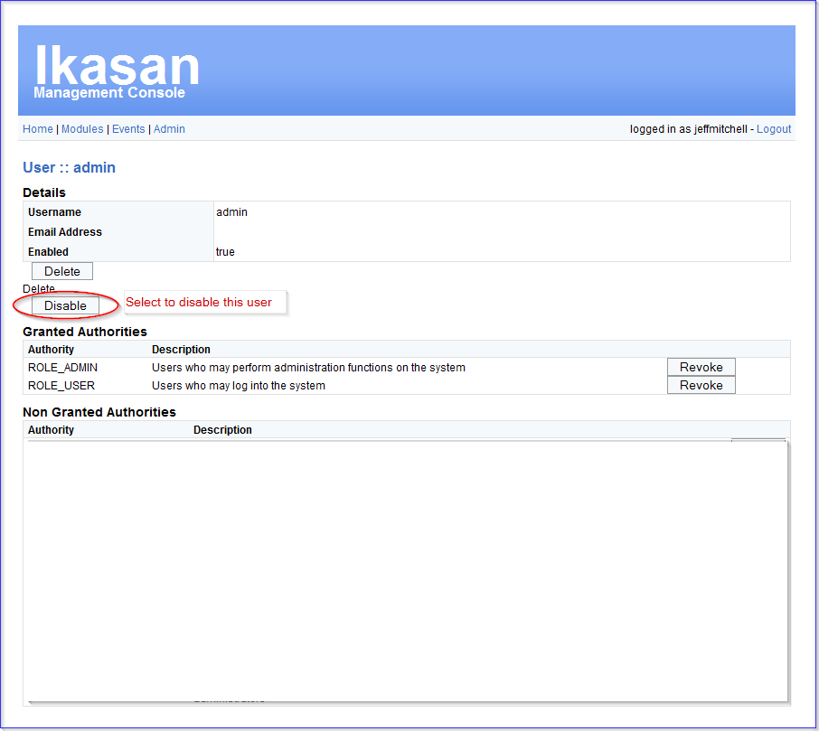

Home
Once successfully logged in (as shown on the top right of the page) you are presented with the default landing “Home” page. This “Home” page can be returned to from anywhere in the console by selecting the “Home” menu item at the top of the page.
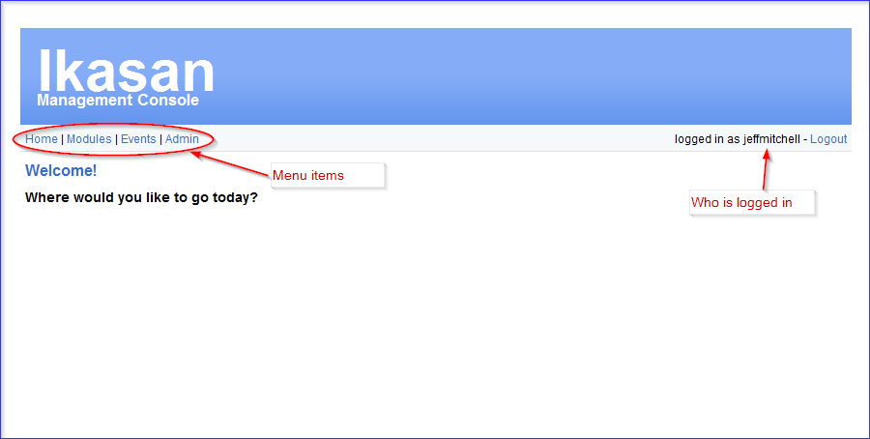

Modules
The “Modules” menu item (second menu item) provides access for all aspects of module management within the console.
There is always at least one module available for management via the Ikasan Management Console i.e. the module with which the console has been packaged and deployed.
If you do not see any modules then you are simply not permissioned correctly.
See the Maintain Users / Permissions section of this document to set the correct permissions for your user for this module.
Once you see the module you can select it.
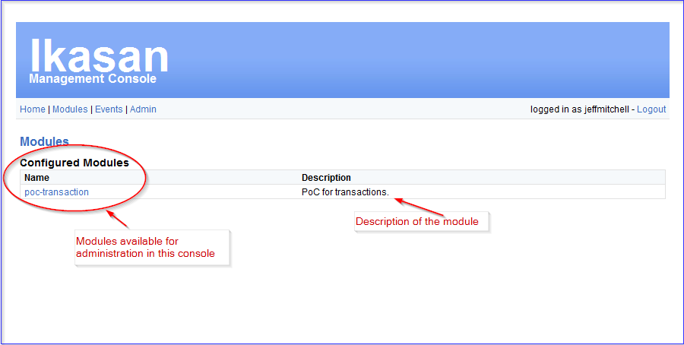
Selecting the module will show you the Module’s summary page.

Module Summary
The module summary page details all flows contained within that module
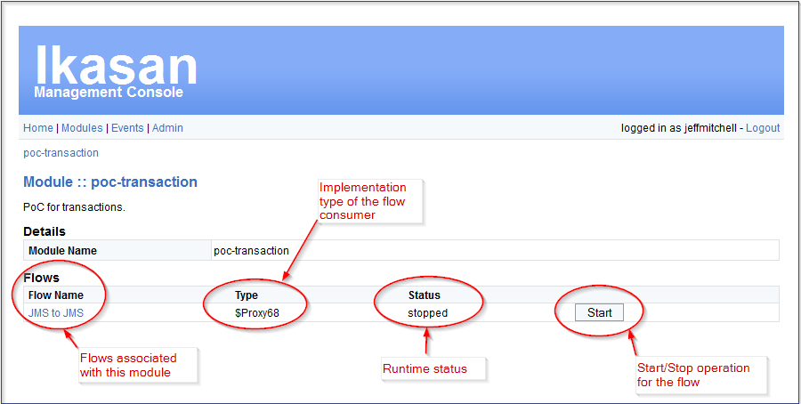
Each flow has the following properties.

Flow Name
The name of the flow. This is usually indicative of the operation the flow is undertaking.

Type
This is the implementation class type of this flow’s consumer component (head flow element component driving the flow). Where this type is shown as $ProxyXX this signifies that this component has a point cut for applying a transasction to the flow.

Status
Shows the current runtime status of this flow.
Any flow can exhibit one of four possible runtime states.
- Stopped – the flow is not currently running
- Running – the flow is currently running without issue
- Recovering – the flow is currently running, but encountered an issue from which it is configured to try to automatically recover
- StoppedInError – the flow is currently stopped due to encountering an unrecoverable error

Start/Stop Operation
Users may start or stop any flow through this operation. On invoking this operation the flow status is immediately updated and reflected on the Console. Sometimes the underlying technology the consumer is utlising can be slow to reflect their state - if you do not see the state change hit the module name directly under the menu items to refesh this screen and all flow states.

Flow Internals
The flow can be drilled into by selecting the flow name.
The flow internals page can be broadly split into the configured flow startup type configuration; and associated flow element components.
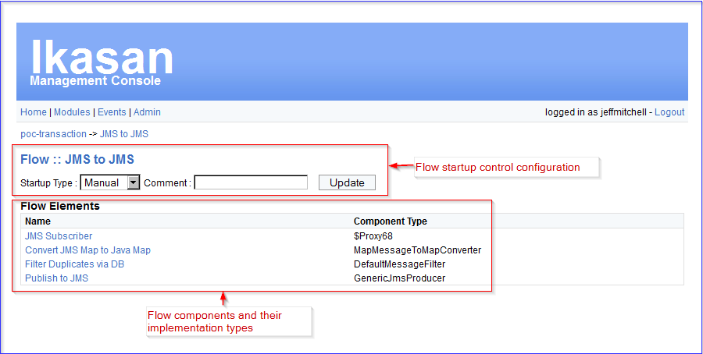

Startup Type
The startup type of a flow dictates how that flow will react on both deployment to its runtime container; and user start invocation throught the console.
All flows can be configured with one of three startup types
- Manual – flow requires user to specifically invoke start on the flow
- Automatic – flow will start on callback from the container, whether this be on deployment or failover
- Disabled – flow will never allow the container or user to start it. Disabled flows must be changed to manual or automatic before they can be started

Flow Element Components
The flow element components summarise the components that operate on the incoming event within the scope of this flow. This summary shows the component name and implementation class type.
Selecting a component name will drill down to the flow element component detail page.

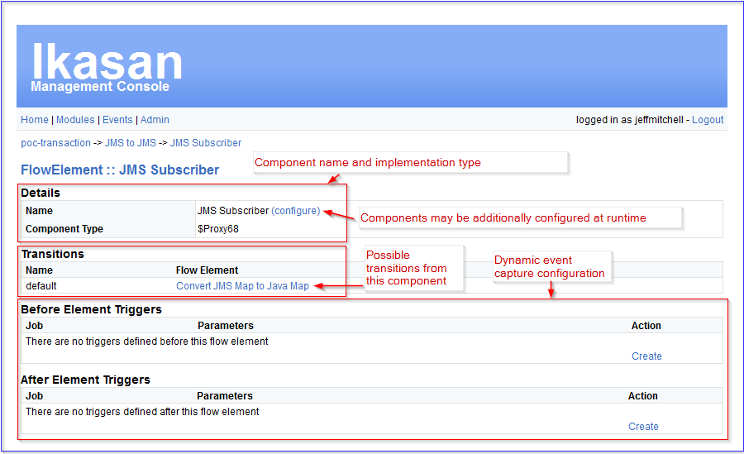
The flow element component detail page consist of
- Details - component name, implementation class type, and optional component configuration
- Transitions – the next potential flow element component to be invoked on exit from this component
- Before Element Triggers - dynamic event capture configuration before component is invoked
- After Element Triggers – dynamic event capture configuration after component is invoked

Details - Component Configuration
Any configurable component (marked at development time with the ConfiguredResource contract) can be configured at one of three levels,
- Hard-coded Configuration – all configuration properties are within a standard Java Bean exposed as getters/setters for the properties. These properties can be hard-coded with defaults by the developer.
- XML Configuration – configuration properties within the Java Bean can be overridden through the XML configuration packaged within the application by the developer. This configuration will override the hard-coded configuration
- Ikasan Management Console Configuration – configuration properties can be overridden by specification within the Ikasan Management Console on any configurable component. This configuration will override the XML Configuration

Configurable Components
On selecting the component “configure”, if none currently exists, you are prompted to create one.
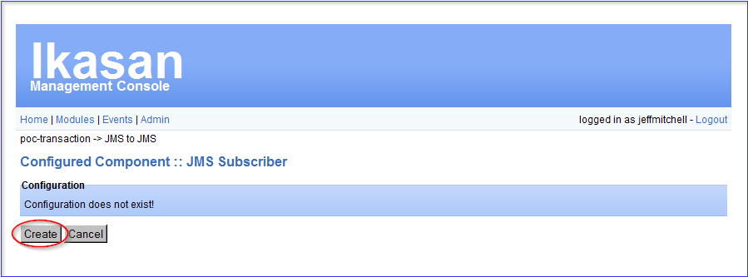
This will present the default configured Java Bean properties.
Below is an example of a component configuration page. These pages are generated from the JavaBean properties so always have a similar look and feel, but without presentation elegance.
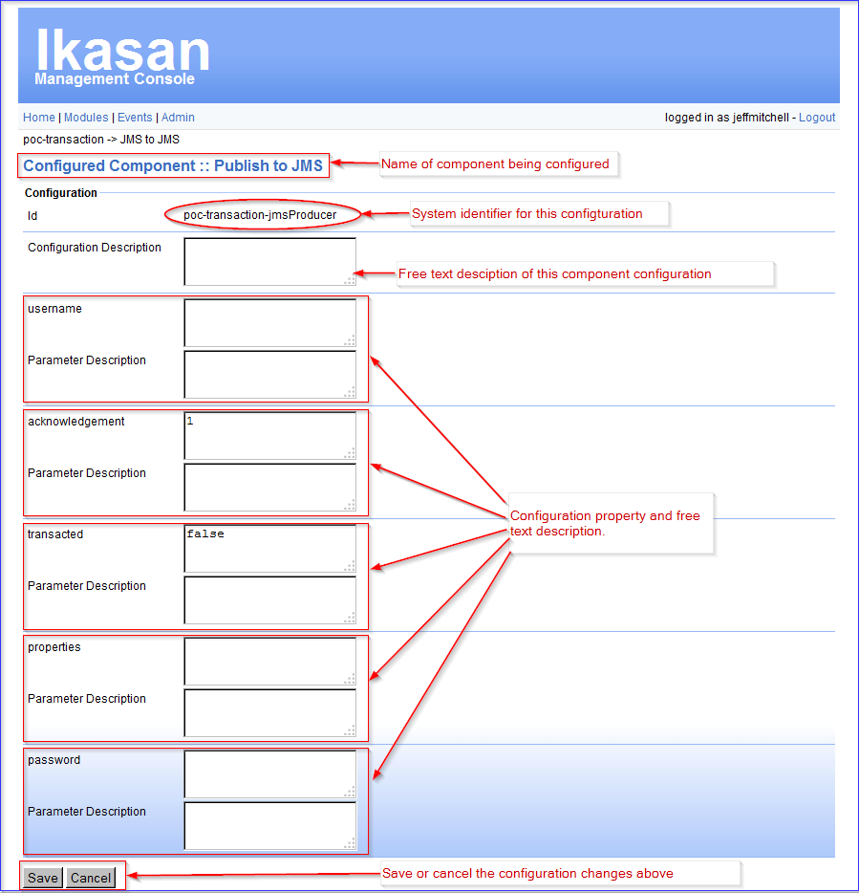
The component name is shown at the top along with the configuration id and free text configuration description – this description may be updated to provide additional detail about this configuration.
This configuration id is the identity of the configuration – not the component. This is important to understand as a configuration may be shared across multiple components by each component referring to the same configuration id. Where this is the case changing the configuration through one component effects the change across all components referring to that configuration id.
The configuration properties always consist of a value and description pair. The value is that which is used at runtime to set this particular property. For instance, in the above example username will be the username presented for authentication with the JMS provider. The description is just free text detail about this parameter value – it has no effect at runtime other than providing a description about this parameter.
The configuration changes can be saved – at which point they are persisted; or cancelled – they are dropped. To active any new or changed configuration the flow must be stopped and started.
Configuration changes will not take effect in runtime until the flow is (re)started.
Once an Ikasan Management Console configuration has been created it can be changed or deleted through the same page.

Non-Configurable Components
Not all components within a flow will be configurable. If the developer decides a specific component should not be configured then it will not have a configuration and will not be configurable within the Ikasan Management Console.
Any attempt to configure a non-configurable component will display the following,
“This component is not currently configurable. To allow configuration this component must implement the ConfiguredResource interface”
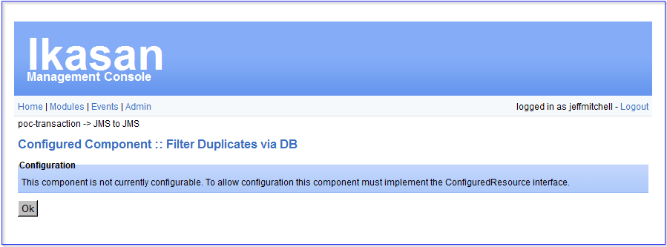

Transitions
This shows none (if this component is last in the flow), one (for a single default transition), or more (for multiple transitions from a component i.e. router) potential transitions from this component. The link to the next transitioned component will show that next component detail page. The complete flow can be navigated component by component by selecting each next transition.

Before/After Element Triggers - Dynamic Event Capture
Events in flight can be captured in realtime at any point in the flow.
This event capture can be configured by selecting “Create” from the Before/After Element Triggers Action operation then selecting the details of the capture.
Within the details of the capture you specify the Flow Element upon which the capture will occur; the relationship of the capture to the flow element i.e. before the flow element invocation or after the flow element invocation; and finally the type of capture.
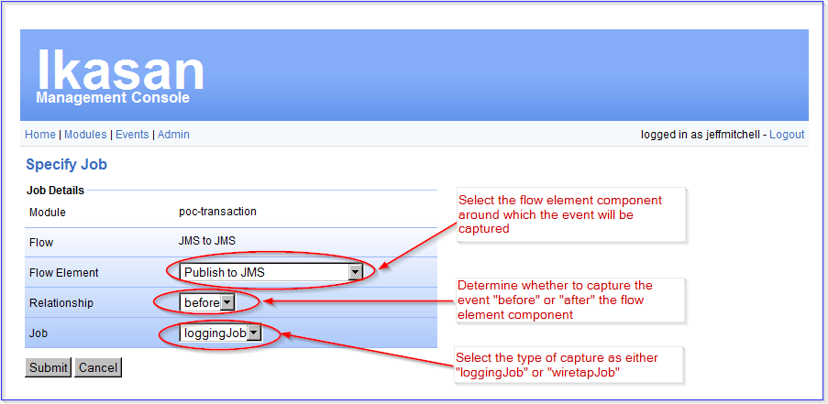
There are currently two types of capture, namely a loggingJob capture and a wiretapJob capture.

Logging job
Logging Job captures simply record the in-flight event, based on the criteria, to the application log. This type of capture is useful for viewing of in-flight event content where an event is causing the flow to rollback and stop in error (stoppedInError).
Select the “Create Trigger” operation to create this event capture.
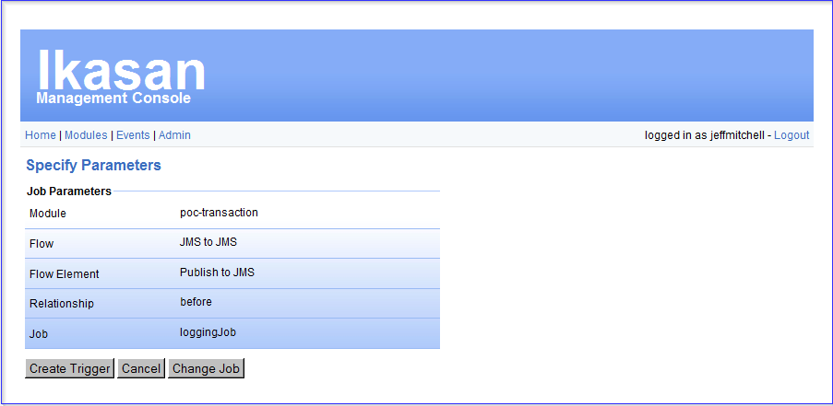
The event capture starts immediately the job trigger is created. There is no requierment to stop/start a flow.
Once created the capture trigger can be seen on the component detail page. This job capture can be removed at any time by selecting the “Delete” operation – this takes effect immediately without any stop/start of a flow.
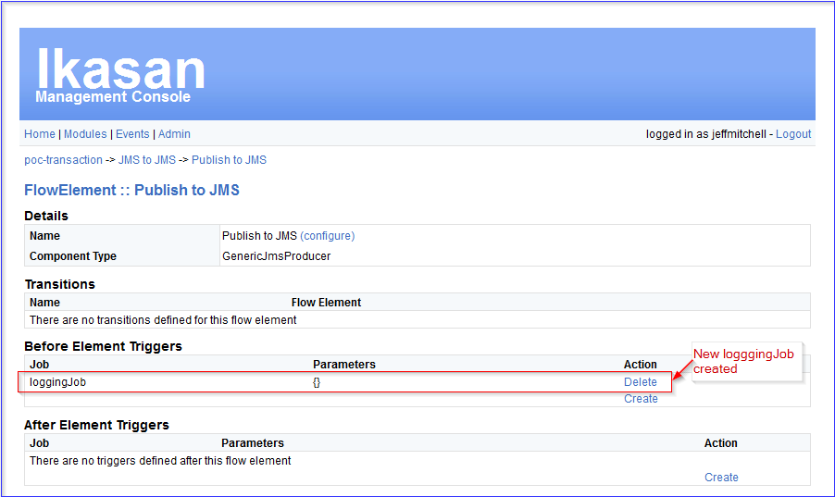

Wiretap Job
Wiretap Job captures record the in-flight event, based on the criteria, to a persistent store. Where transactions are configured on the flow this persistence is enrolled as part of the overall in-flight event’s transaction. As this is part of the transaction, support staff can gain a high degree of confidence that if a wiretap event exists then that business event was also successfully delivered to the flow destination.
NOTE: The participation of the wiretap job within the business event transaction is implemented to minimize the impact of this on the outcome of the business transaction. This can never be zero, but the advantage of having a wiretap job tends to outweigh their overall impact.
The criteria for creating a wiretap job are the same as the logging job criteria, but with the addition of a “time to live” property. This property provides the wiretap event with an expiry, set in minutes, from the time of wiretap capture. For instance, the wiretap job configuration below specifies 20,000 as the time to live. This means each event captured with this wiretap job will expire 20,000 minutes later. For instance, an event captured on 6th July 2010 at 16:50:00 will expire (and be house kept) 20,000 minutes later on 20th July 2010 at 14:10:00.
Select the “Create Trigger” operation to create this event capture.
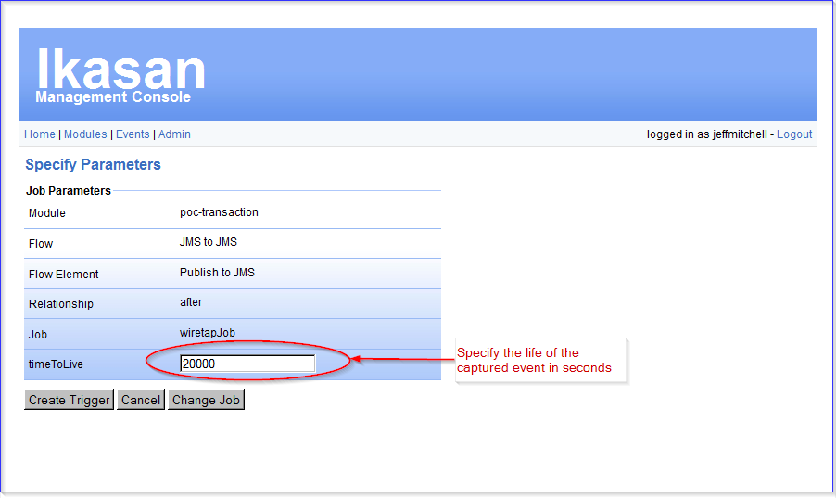

The event capture starts immediately the job trigger is created. There is no requierment to stop/start a flow.
Once created the capture trigger can be seen on the component detail page. This job capture can be removed at any time by selecting the “Delete” operation – this takes effect immediately without any stop/start of a flow. Importantly, the peristed wiretap events are not deleted when the trigger is deleted – wiretap events stay until they naturally expire and are housekept.
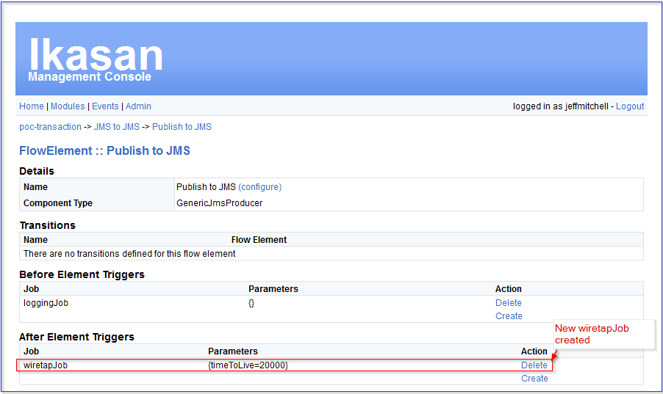

Events
NOTE: This feature is being deprecated in the Ikasan Management Console and a more flexible Events search option is available in the Ikasan User Console.
Events that have been dynamically captured using the “WiretapJob” are recorded to a persistent store. This allows these captured events to be searched and tracked for a given module.
The page below shows the filter criteria that can be applied when searching for events for a module.
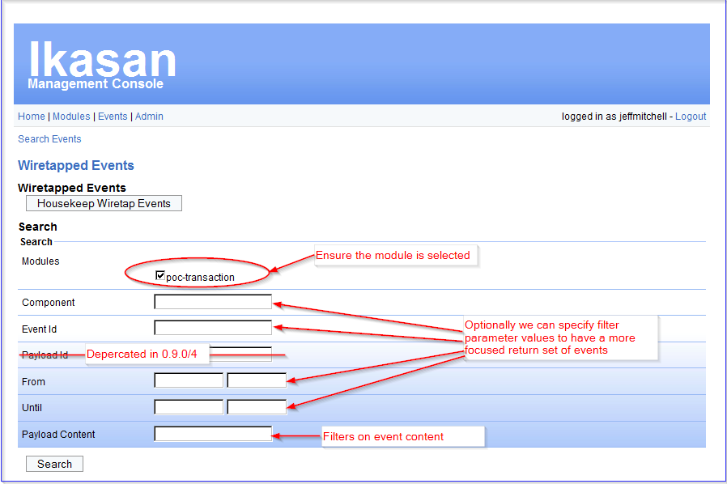
Ensure the module is selected.
The following filter criteria fields can be specified to reduce the results returned.
- Component – specified as “before <componentName>” or “after <componentName>”
- EventId – life identifier of the event
- From – date/time to scope the search from
- Until – date/time to scope the search until
These filter parameters are tuned to efficiently filter the result set.
- Payload Content – filters on the event content. This can be wildcarded with a ‘%’. For instance, to search content for the words “first” followed by “second” at some later point in the message ‘%first%second%’
The “Payload Content” is just the raw event content and not tuned, so any searches based on “Payload Content” are more resource intensive and will take longer.
It is recommended that “Payload Content” searches be combined with filter parameters to reduce the data the payload content filter is applied to.
The results returned from a search are summarised at the event level as follows,
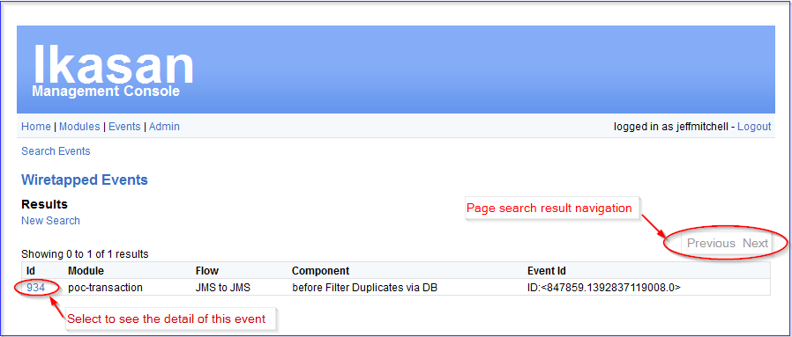
The search results are paginated when they exceed 20. Pages may be navigated using the Previous and Next operations.
Selecting an individual wiretap event id will show the wiretap event detail.
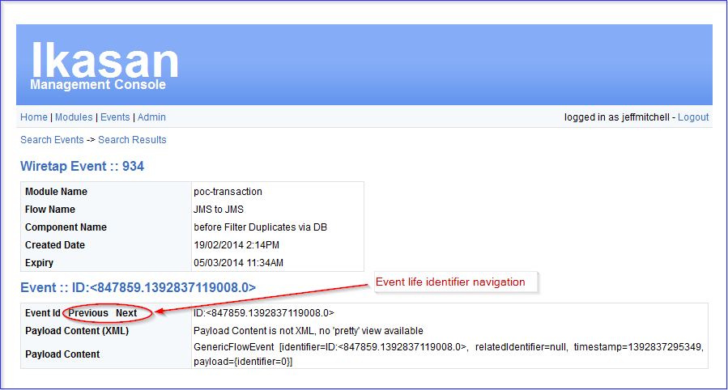
This detail shows the module, flow, and component name from where this wiretap event was captured; as well as the creation date/time and expiry date/time.
The Event Id is the business event identifier for this captured event. This is the identifier used to relate the same event across a number of different wiretap captures through out the life of that event. The Event Id “Previous” and “Next” navigate between the wiretapped instances of this same business event in its different guises.
Where possible the content of the business event is displayed as XML and as a string format. The string format is essentially the last resort for displaying the event as it is simply a toString() call on the in-flight event.

Administration

Inspect the Scheduler
Each application has an internal scheduler instance with which it submits job triggers and receives callbacks based on those job triggers.
It is possible to inspect the state of the application scheduler and see the triggers currently registered both in terms of when they were last invoked and when they will next be invoked.

Pausing/Resuming the Scheduler
From this page it is possible to pause and resume the application scheduler. This will stop all associated listed triggers.
Any pause/resume of the scheduler only impacts the scheduler for this application.
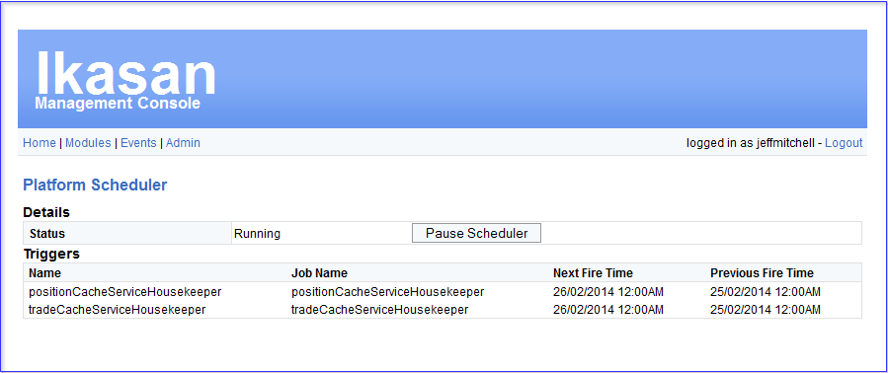

Inspect the System Event Log
The system event log provides an audit of all actions taken on any flows in this module. From this page you can see the following audited properties of any action on the flow.
- Subject – the module name and flow name against which the action was undertaken
- Action – the action taken i.e. stop or stop of a flow; configuration change on a flow
- Timestamp – when the action was invoked
- Actor – who invoked the action
These properties can be specifically used to filter any audit event searches on this page.
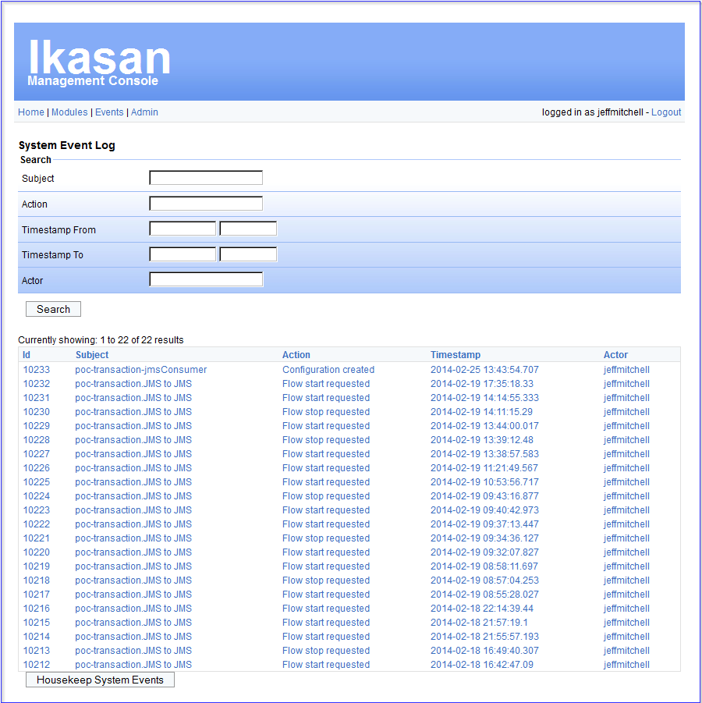
All system events are recorded with a “time to live” and are automatically housekept at runtime. Manual housekeeping of these events may also be undertaken be invoking the “Housekeep System Events” at the bottom of the page.

Maintain Users
Ikasan Management Console users can be either managed through LDAP or managed locally within the application. To be managed through LDAP the console must be configured and deployed with LDAP libraries.
Default deployment uses Ikasan Management Console local user administration.
Users of the Ikasan Management Console can be managed through this page.

Creating Users
New users of the console can be created through the “Create User” section at the bottom of the page.
It is important that the user email address is specified as this is used should they need to reset their password.

Permissions
Users are permissioned through role based access. Roles comprise of “user” actions and “admin” actions for each module.
By default the console has the following roles to allow users to be permissioned for the console itself.
- Role_User – users must be in this role to be able to login to the console.
- Role_Admin – users in this role have admin access over the console
Each module deployed in runtime will have equivalent roles for user and admin. For instance, for an integration module called “bar” the roles to which a user may be granted permission are
- User_bar – to view the module and flows and components and allow component configuration
- Admin_bar – to stop/start modules flows

Granting & Revoking Permissions
Permissions may be granted or revoked for a user by selecting that user then selecting the “Grant” or “Revoke” operation as appropriate against the required roles.
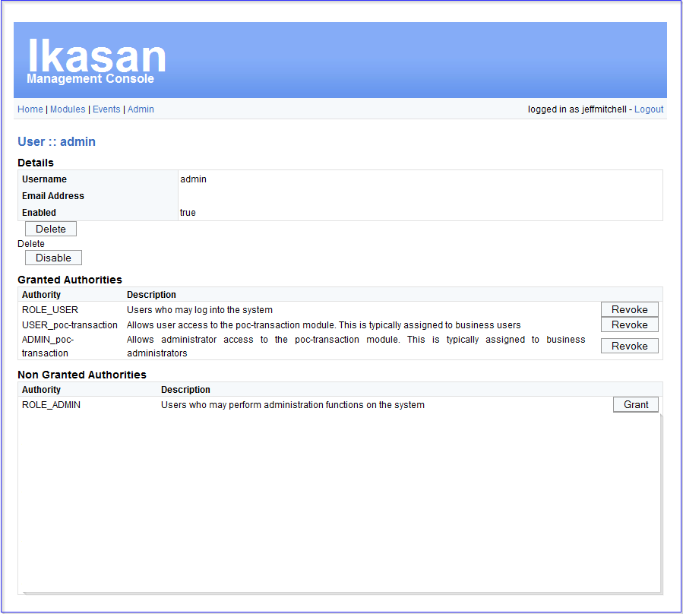

Disabling Users
Users can be disabled by selecting the user then selecting the “Disable” operation.
Disabled users will not be able to login to the console or perform any operation.
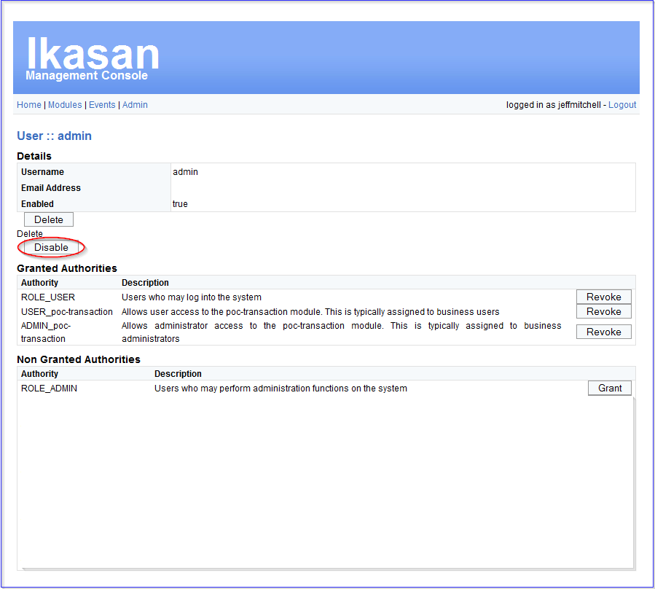

Deleting Users
Deleting users permanently removes the user and their associated permissions from the console.
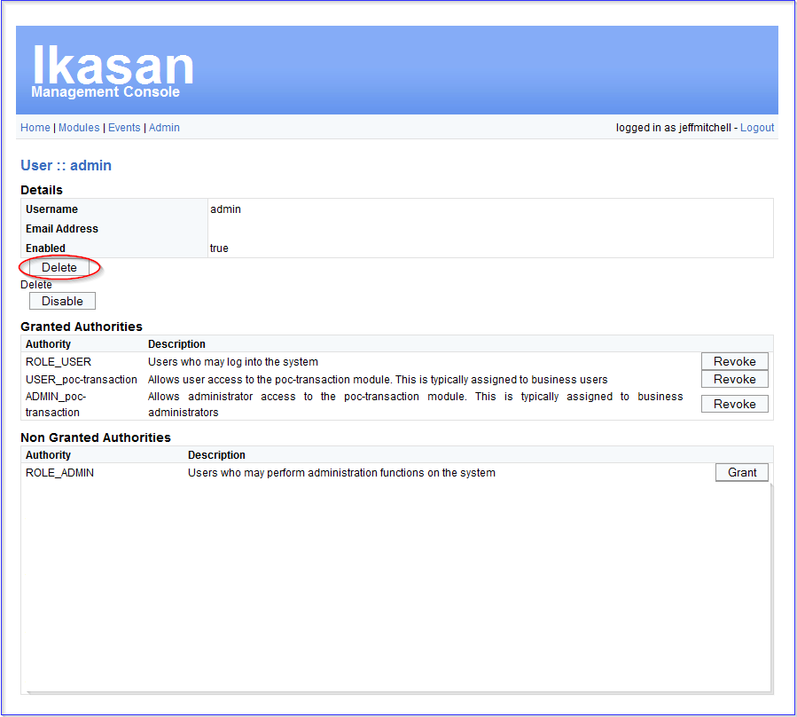

Document Info
Authors | Ikasan Development Team
Contributors | n/a
Version | 0.9.4
Date | 31st Jan 2014
Email | info@ikasan.org
WebSite | http://www.ikasan.org

