Ikasan User Console
Guide

0.9.4
EMAIL: info@ikasan.org
WEBSITE: www.ikasan.org

Table of Contents
1 Introduction 3
1.1 About 3
1.2 Audience 3
1.3 How to Use This Guide 3
1.4 Overview 3
2 Accessing the Ikasan User Console 4
3 First Time Console Usage 6
4 Home 11
5 Events 12
5.1 Search 13
5.1.1 Flows Search 13
5.1.2 Modules Search 14
5.2 Search Results 15
6 My Account 17
7 Administration 19
7.1 Maintain Users 19
7.1.1 User 20
7.1.2 Change Email Address 20
7.1.3 Change Password 20
7.1.4 Authorities 20
7.2 Creating Users 20
7.2.1 Permissions 22
7.2.1.1 Granting & Revoking Permissions 22
8 Support 23
9 Document Info 24

Introduction

About
This document provides a user guide for the Ikasan User Console (the orange console). This is part of the documentation suite for the Ikasan Enterprise Integration Platform.
This console is independently deployed as a self-contained WAR to the runtime container. This guide assumes packaging and deployment to runtime has been completed and focuses purely on the operations of the console itself from initial first time usage through to administration and management.

Audience
This guide is targeted at users wishing to track and view business events flowing over one or more Ikasan integration modules.

How to Use This Guide
This guide provides a reference that can be read front to back or dipped into as required for the operation of the Ikasan User Console.

Overview
The Ikasan User Console provides a web front end for searching and tracking events passing through Ikasan Integration Modules.
This guide covers the user operations within this console including,
- Event Searching and Tracking
- User Administration and Management
- Ikasan Support and Resources

Accessing the Ikasan User Console
The Ikasan User Console is bound to the root context of “console” at runtime.
So to access the Ikasan User Console deployed to server “foo” (assuming default port 8080) you would open a web browser specifying the URL
http://foo:8080/console
This would return the Ikasan User Console login page below.
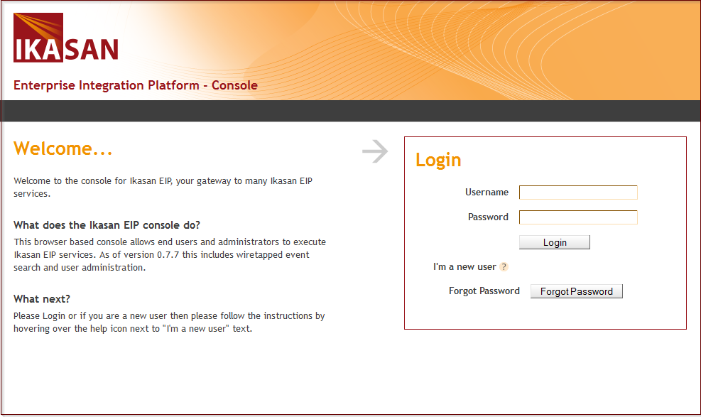
Use your Ikasan User Console credentials to login. If login is successful you are presented with the “Home” landing page.
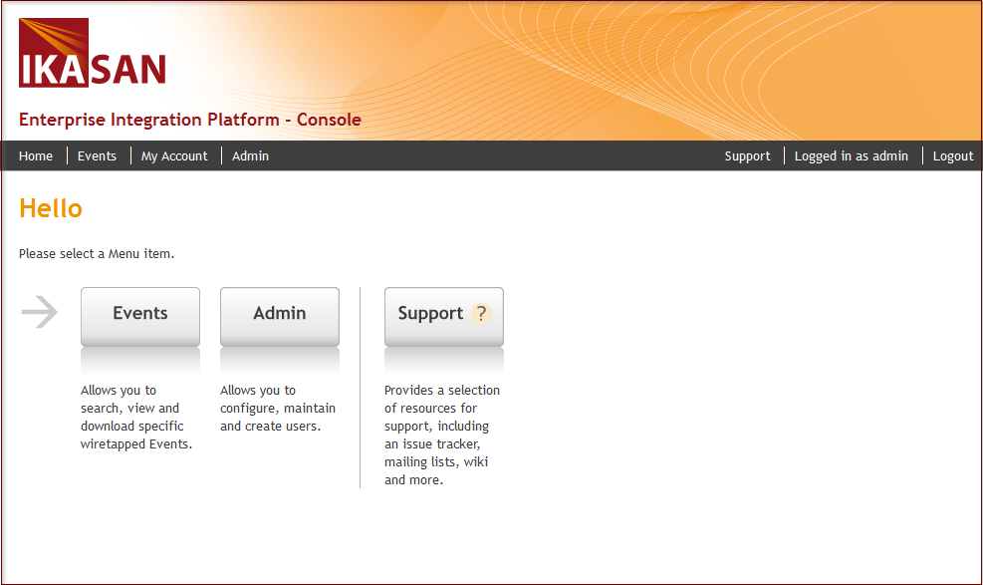
If unsuccessful, the failure and reason are shown at the bottom of the “Login” box.
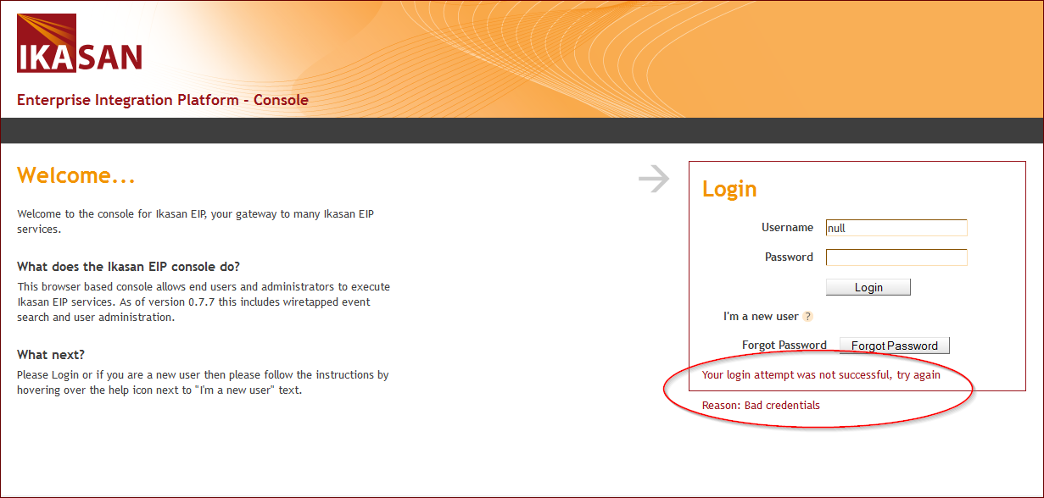
If you have forgotten your password you can select the “Forgot Password” operation from where you will be prompted for your username. Invoke the “Send New Password” operation and a new password is emailed to the email address associated with that account.
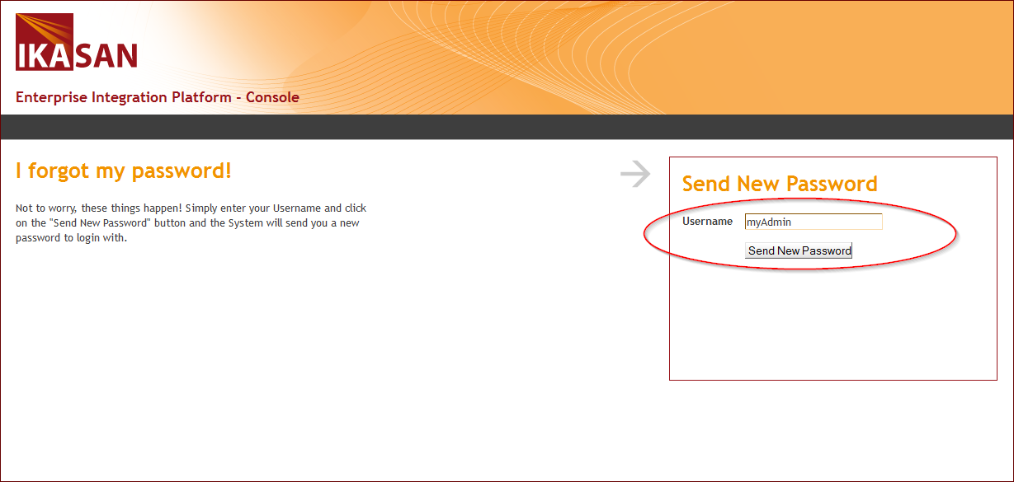
You are returned to the login page by default. You will now be able to login with your reset password received via email.

First Time Console Usage
For any first time deployment of the Ikasan User Console the only user configured will be the default administration user whose credentials are
username: admin
password: admin
These credentials can be used to login initially, however, it is strongly recommended that after this initial login, you add a new administration user account and disable the default admin user account. As a minimum you should change the password of this default admin account.
The following steps walk you through how to create a new administration account and disable the default admin.
Login as the default admin user.
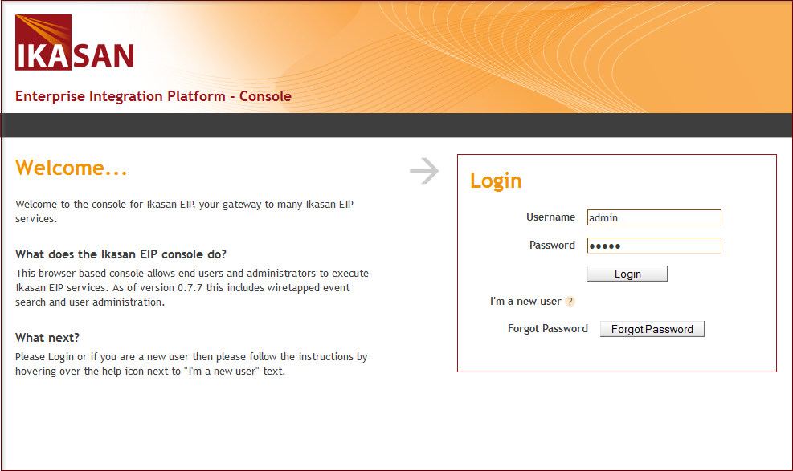
Once logged in you are presented with the default “Home” landing page, from here select “Admin”.
Select “Maintain Users”
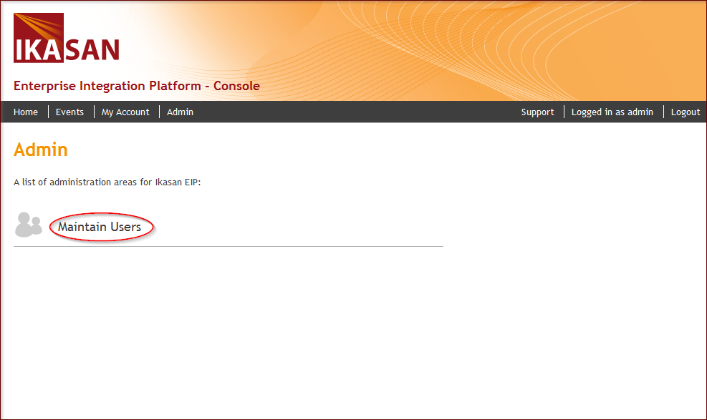
This takes you to the “Admin: Maintain Users” page showing just the default admin user.
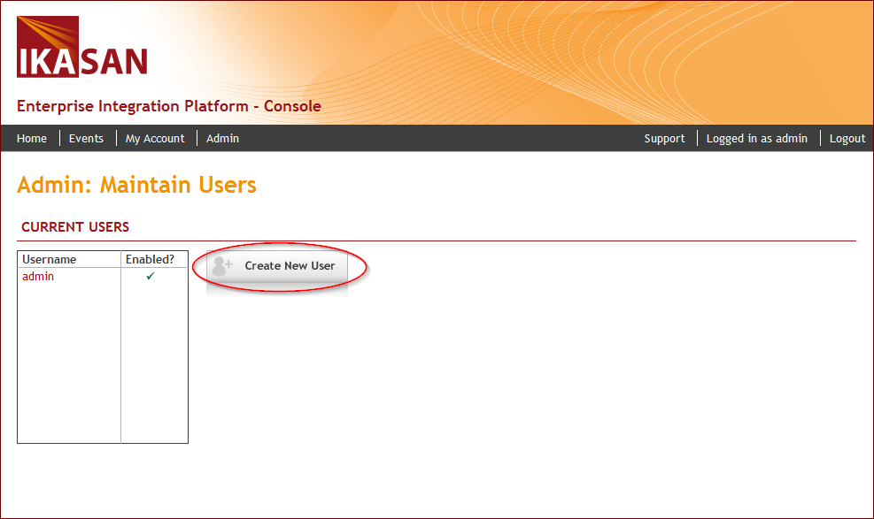
Firstly we will add the new administration user account. Note: This is a local account not LDAP.
Select “Create New User”.
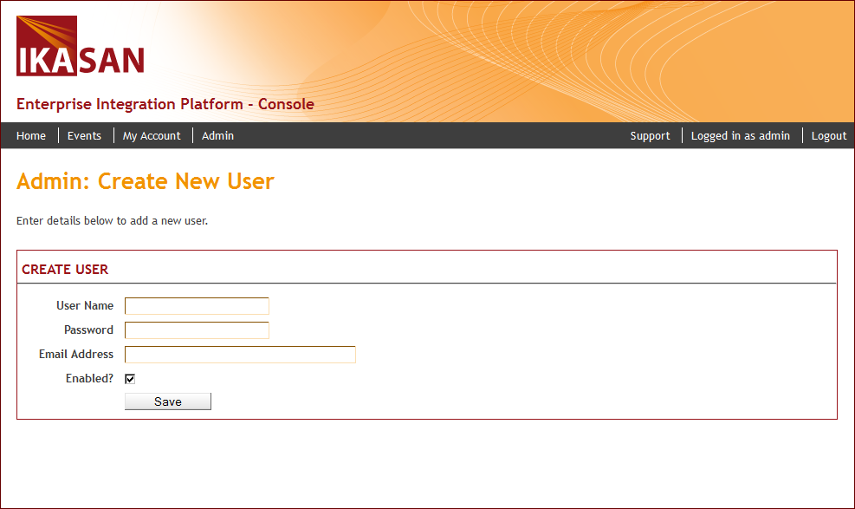
Populate the new user fields.
- Username - can be anything, you may want to have this conform to your user account format policies.
- Password – password for this local account.
- Email Address – should be a valid email address as this is used for “forgot password” functionality.
- Enabled – ensure this is checked otherwise the account will not be available for use.
Select “Save”.
Once completed your new administration account should look like this.
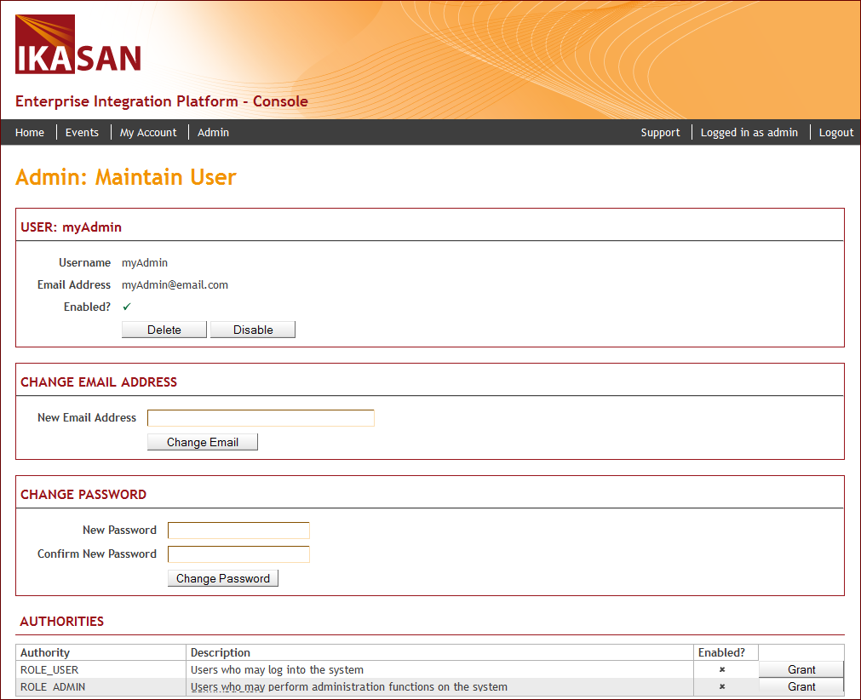
The new administration user must now be granted permission for “user” and “admin” roles by selecting “Grant” for ROLE_USER and ROLE_ADMIN.
Congratulations, your new administration account is now created.
You should then logout and log back in using your new administration user account to disable to default admin user.
Once logged in go back to the “Maintain Users” page (Admin/Maintain Users) and select the admin user.
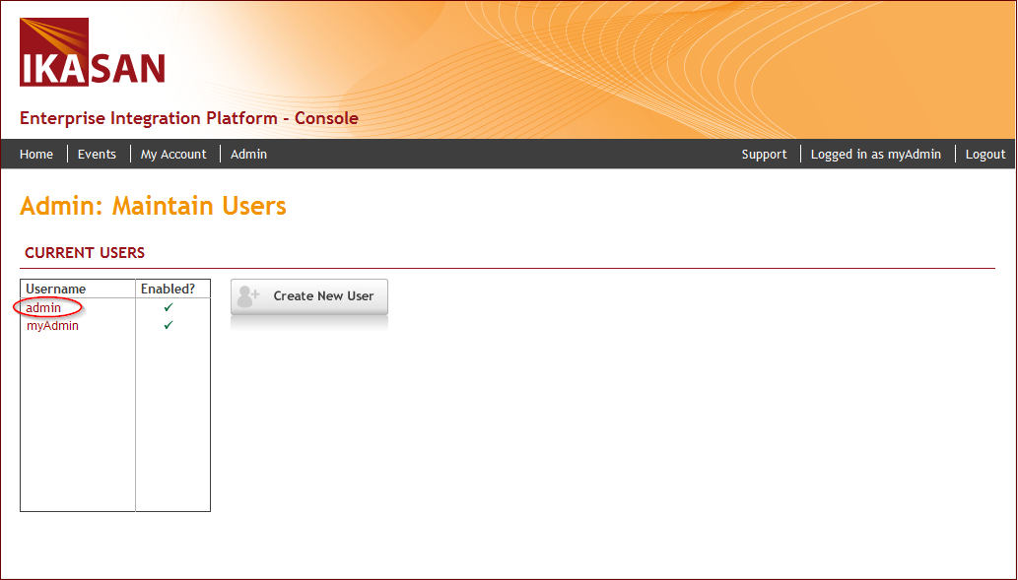
Select the “Disable” operation.
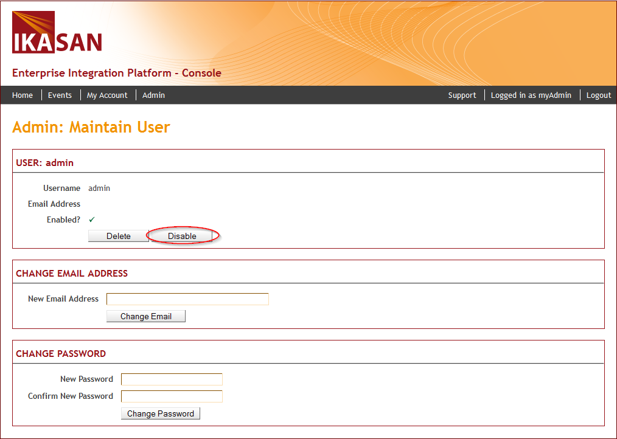

The default admin user is now disabled.

Home
Once successfully logged in (as shown on the top right of the page) you are presented with the default landing “Home” page. This “Home” page can be returned to from anywhere in the console by selecting the “Home” menu item at the top of the page.
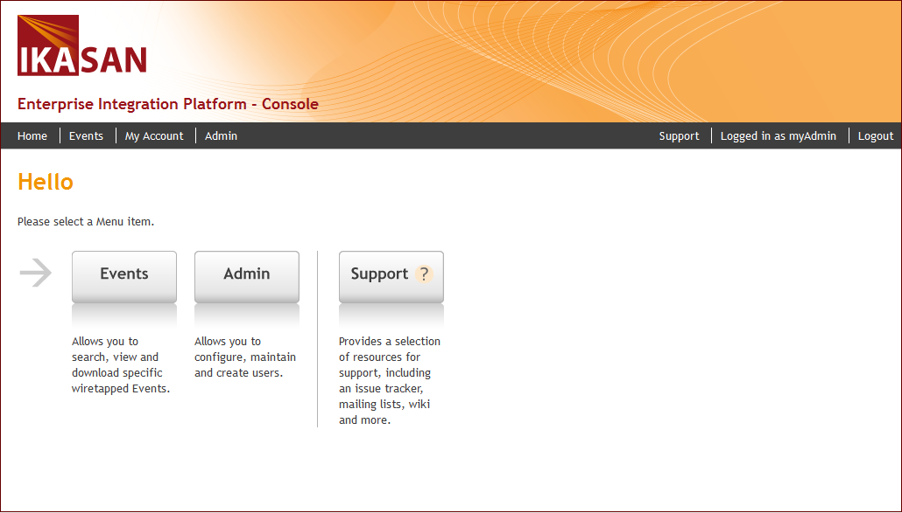
From this “Home” page we can navigate to the following,
- Events – for searching and tracking business events
- My Account – to reset your account’s password
- Admin – to perform administration across all users

Events
Events that have been dynamically captured using the “WiretapJob” (as configured via the Ikasan Management Console) are recorded to a persistent store. This allows these captured events to be searched and tracked within a specific module or across a group of modules.
The page below shows the “Events: Search” which is split into the search criteria on the top half of the page and the search results on the bottom half.
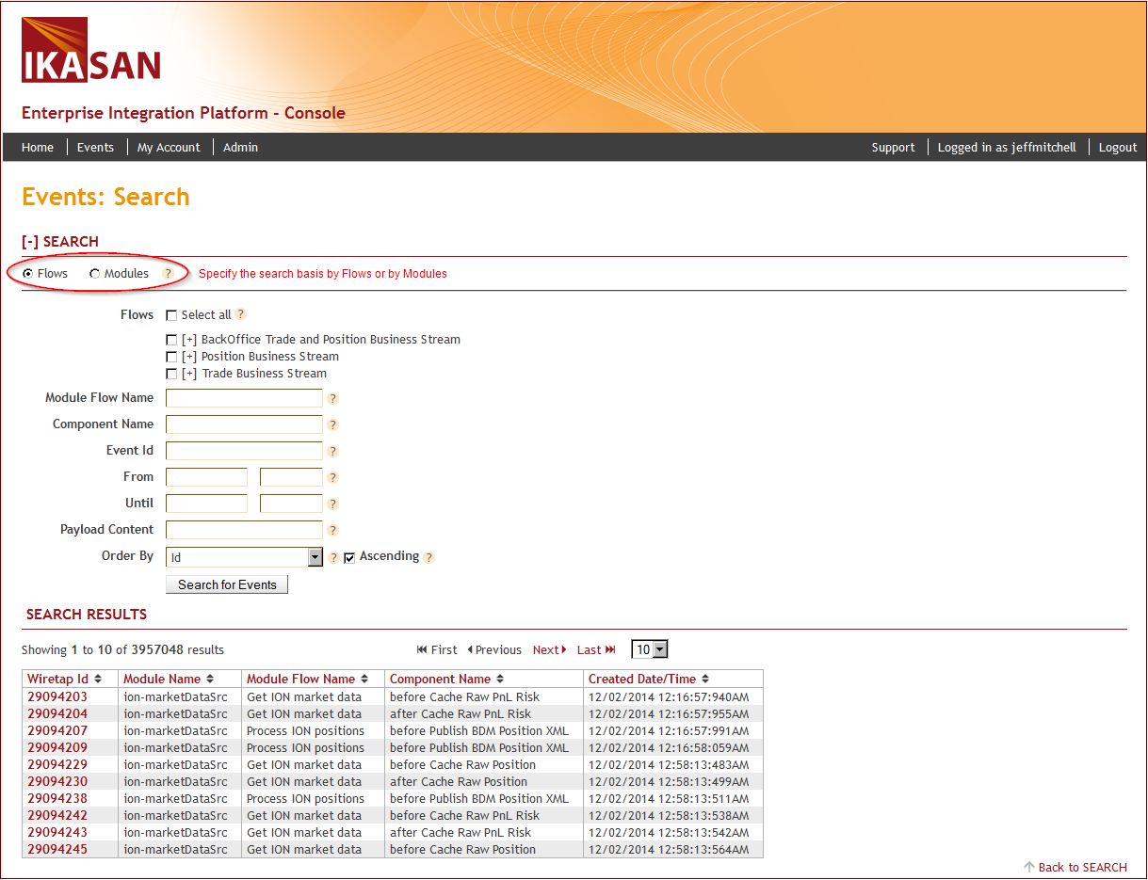

Search
The console allows searches to be specified as either “Flows” based or “Modules” based.

Flows Search
The Flows search supports searching within the context of business streams. Business streams are made up of logical groupings of modules modeling the actual business flow an event would undergo.
For example, the expanded business streams below show a business stream called “Positions Business Stream” which consists of events first passing through the ion-marketDataSrc module onto the position-arbitrator-module and finally into the coherence-module.
This allows the search of events within a scoped business stream.
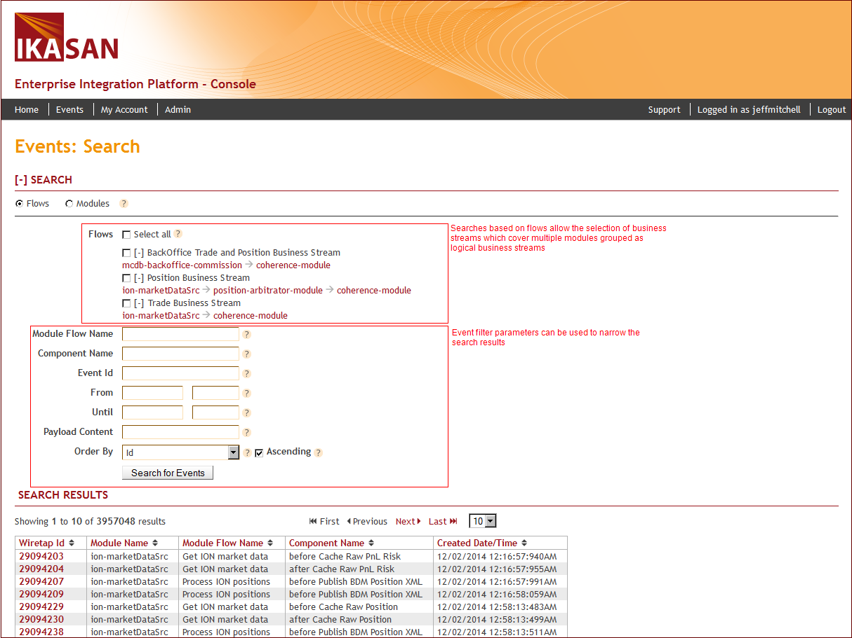
This is further focused by the filter criteria that can also be applied such as,
- Component Name – specified as “before <componentName>” or “after <componentName>”
- Event Id – life identifier of the event
- From – date/time to scope the search from
- Until – date/time to scope the search until
These filter parameters are tuned to efficiently filter the result set.
- Payload Content – filters on the event content. This can be wildcarded with a ‘%’. For instance, to search content for the words “first” followed by “second” at some later point in the message ‘%first%second%’
The results can have a tailored page order based on,
- Order By – which orders the results based on the drop down values
- Ascending – checkbox for ascending or descending Order By results

Modules Search
The Modules search supports searching directly within one or more modules. Any number of modules may be selected for inclusion in the search based on the checkbox list.
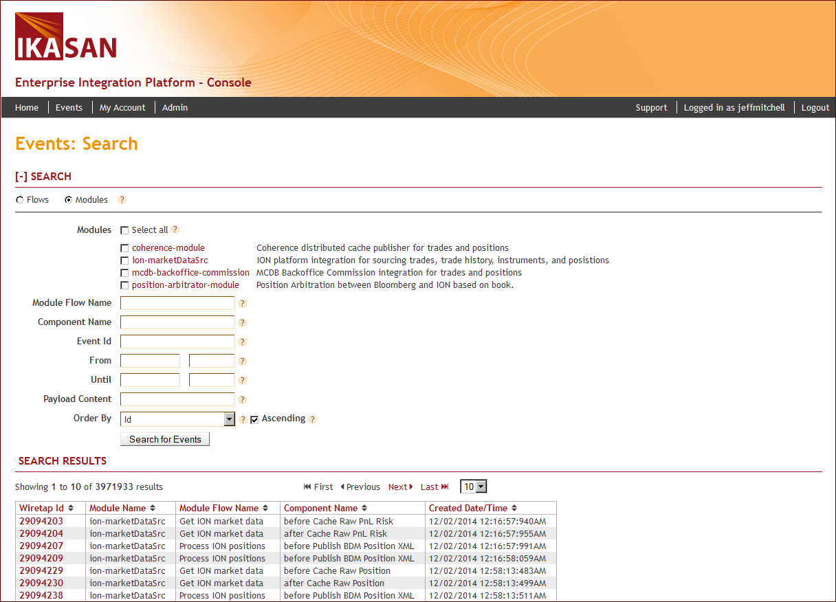
This is further focused by the filter criteria that can also be applied such as,
- Component Name – specified as “before <componentName>” or “after <componentName>”
- Event Id – life identifier of the event
- From – date/time to scope the search from
- Until – date/time to scope the search until
These filter parameters are tuned to efficiently filter the result set.
- Payload Content – filters on the event content. This can be wildcarded with a ‘%’. For instance, to search content for the words “first” followed by “second” at some later point in the message ‘%first%second%’
The results can have a tailored page order based on,
- Order By – which orders the results based on the drop down values
- Ascending – checkbox for ascending or descending Order By results

Search Results
The returned results from the search are summarized at the event level as follows,
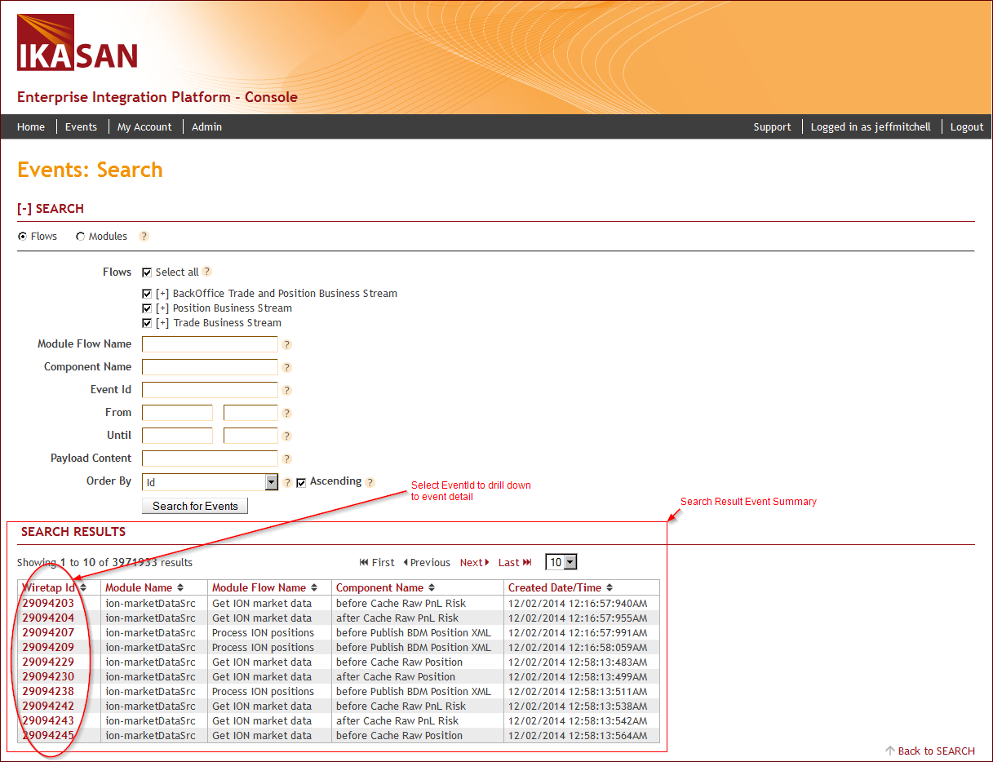
The returned search results are paginated based on the number of events per page drop down.
Each event line can be drilled into to see the event detail by selecting the wiretap Id for that event.
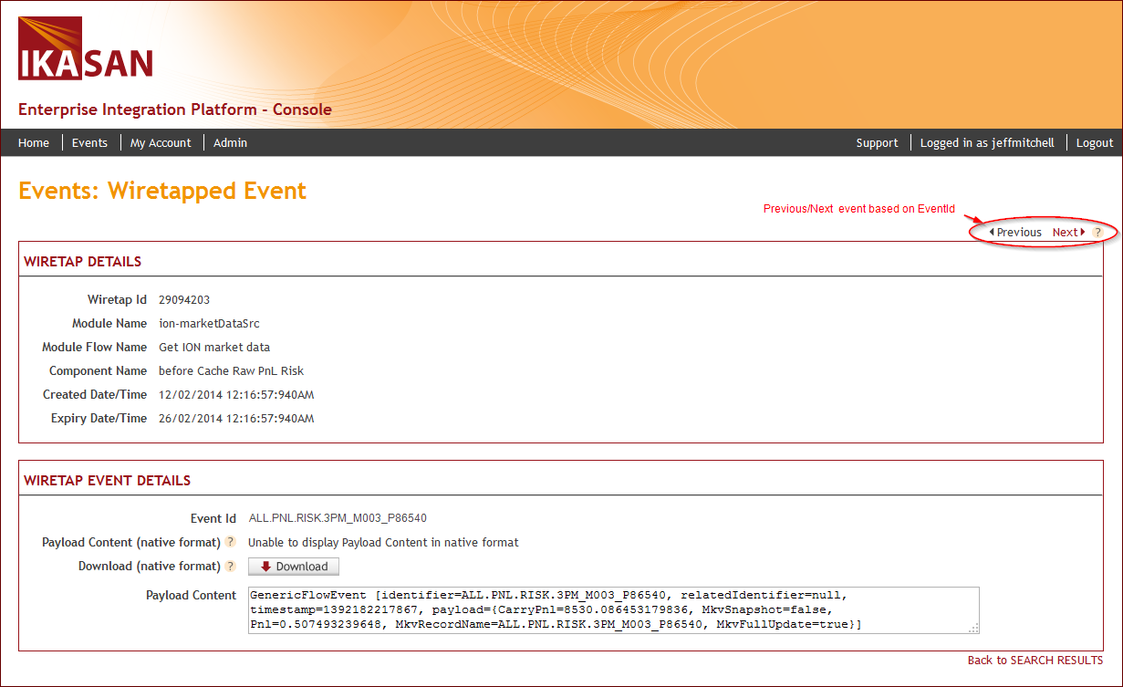
This detail shows the module name, flow name, and component name from where this wiretap event was captured; as well as the creation date/time and expiry date/time.
The Event Id is the business event identifier for this captured event. This is the identifier used to relate the same event across a number of different wiretap captures through out the life of that event. The Event Id “Previous” and “Next” navigate between the wiretapped instances of this same business event in its different guises.
Where possible the content of the business event payload is displayed as XML as well as the event’s native format. As a last resort the payload content is displayed by calling toString() on it.
It is also possible to download the content in its native form via the “Download” operation.

My Account
“My Account” provides the facility to change password for this account.
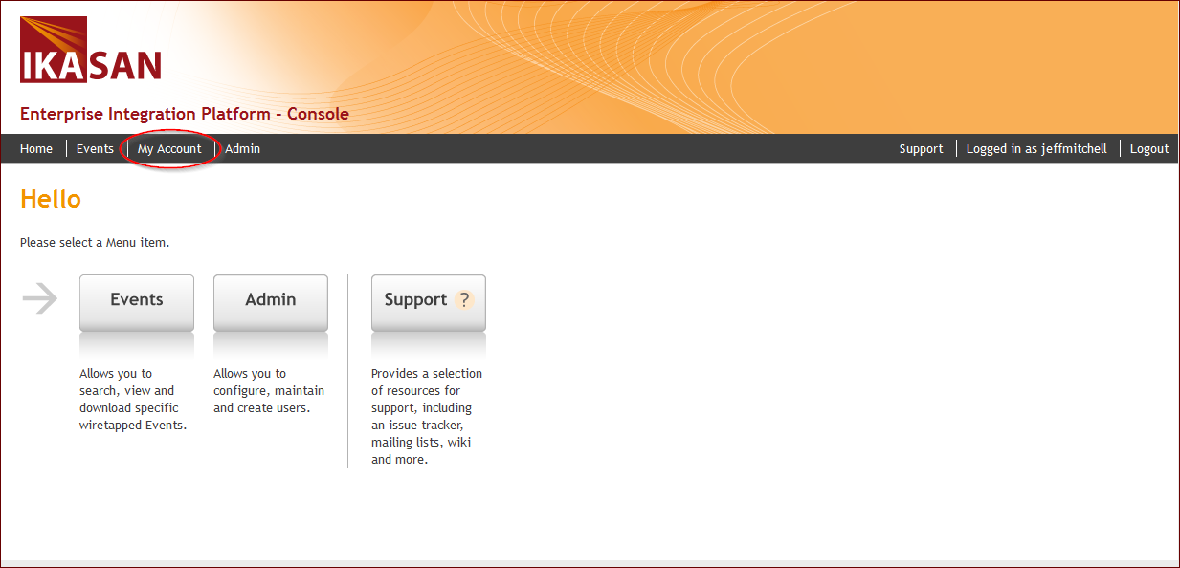
Select “Change Password”
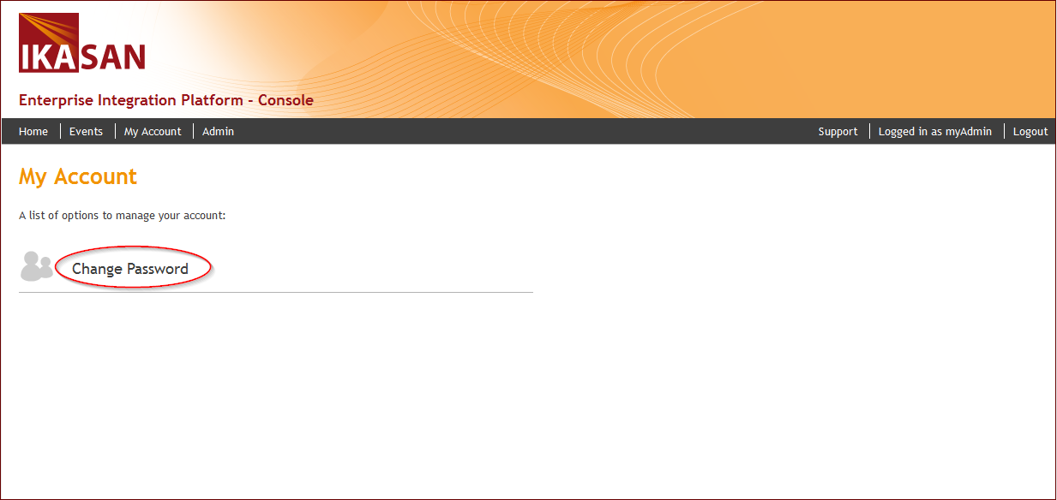
Enter your new password and select “Change Password”. All changes are immediate.
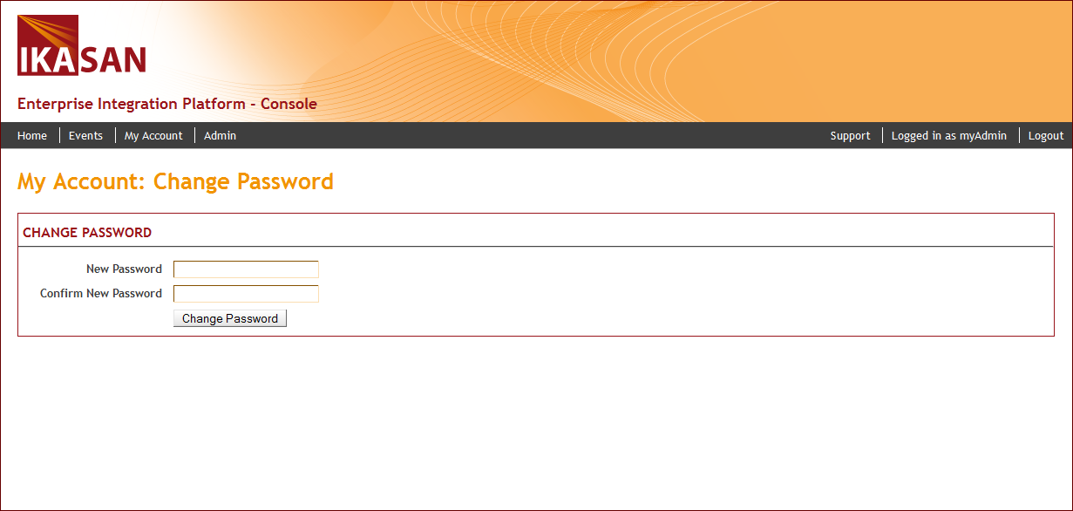

Administration

Maintain Users
Ikasan User Console users can be either managed through LDAP or managed locally within the application. To be managed through LDAP the console must be configured and deployed with LDAP libraries.
Default deployment uses Ikasan User Console local user administration.
Users of the Ikasan User Console can be managed by selecting “Admin” then “Maintain Users”.
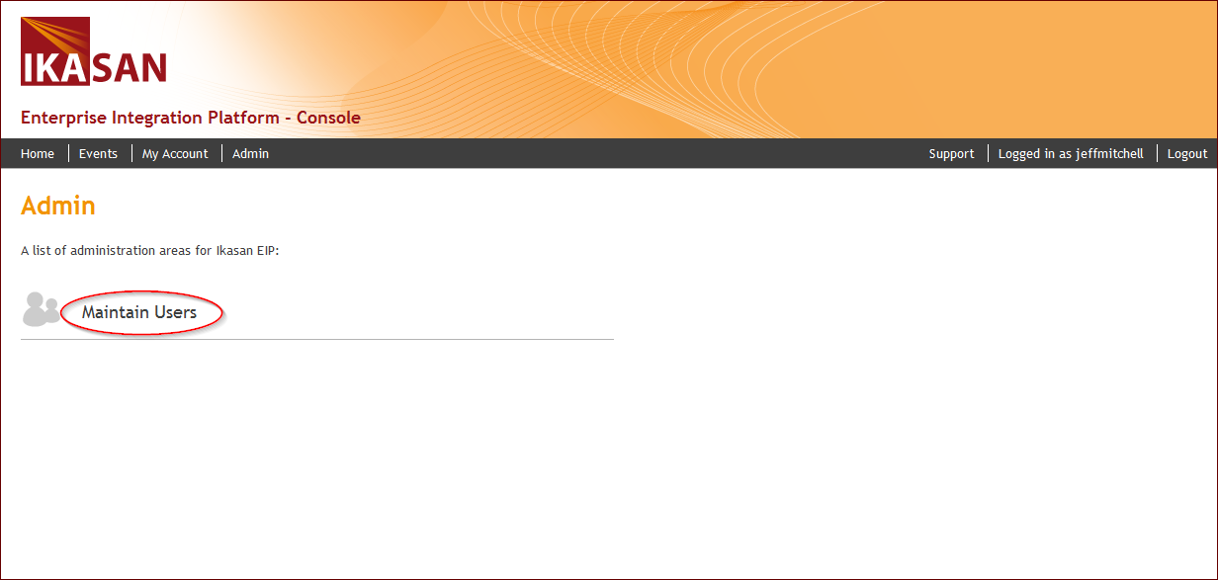
Select the user to be updated, for example myAdmin user.
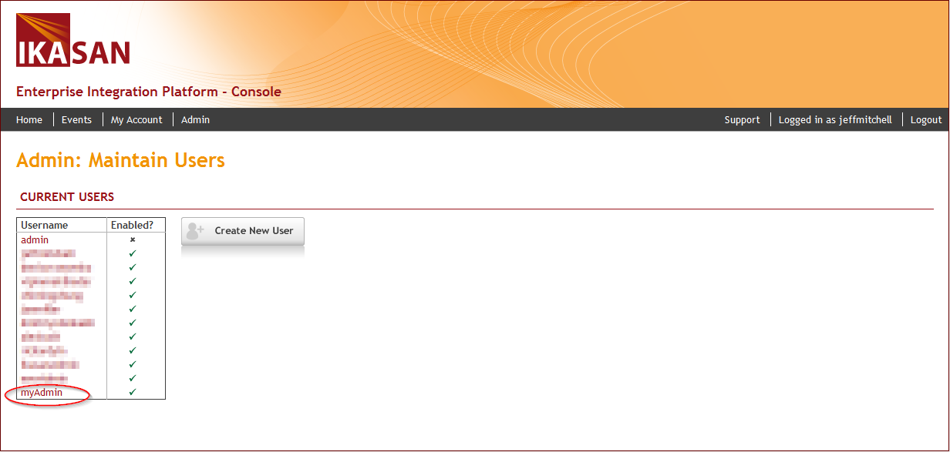
The following user details can be maintained from this page.
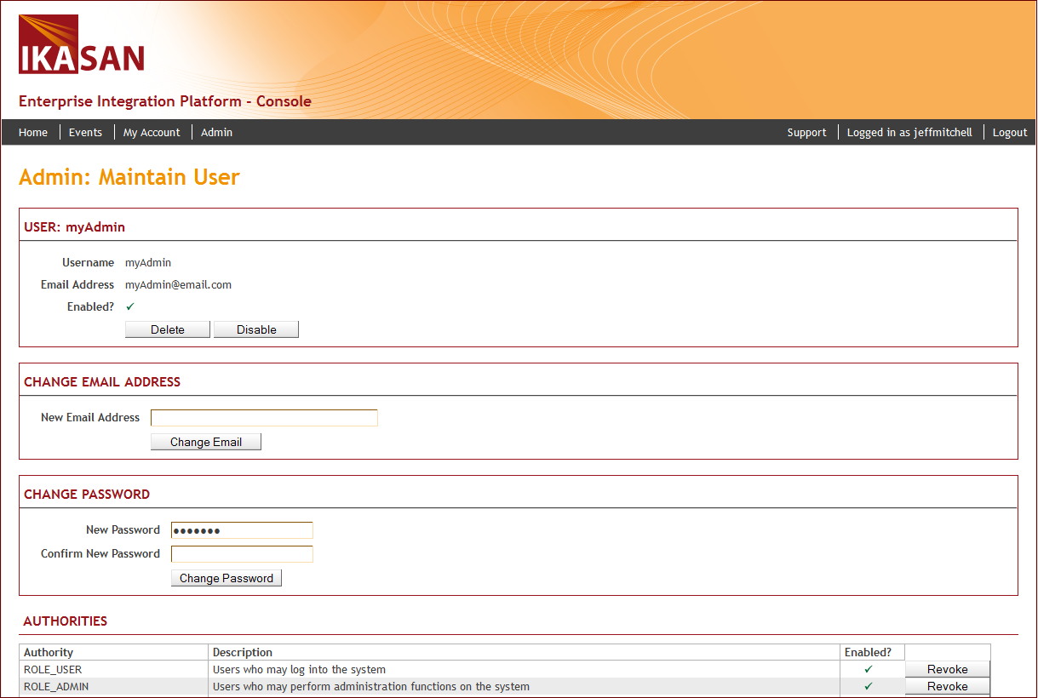

User
A user may be disabled or enabled. Disabling a user stops that user from logging into the console. Enabling the user restores the user login and all associated permissions the user had.
A user can be deleted. Any deletion of a user removes the user and their associated permissions.

Change Email Address
A user’s email address can be changed. This change takes immediate effect.

Change Password
A user’s password can be changed. This change takes immediate effect.

Authorities
The authorities this user has can be “Granted” or “Revoked” by selecting the appropriate operation against the listed authority. This change takes effect once the user logs out and back in.

Creating Users
New users of the console can be created via the “Admin: Maintain Users” page. Select the “Create New User”.
Populate the new user fields.
- Username - can be anything, you may want to have this conform to your user account format policies.
- Password – password for this local account.
- Email Address – should be a valid email address as this is used for “forgot password” functionality.
- Enabled – ensure this is checked otherwise the account will not be available for use.
Select “Save”. Once created, the user can be permissioned through the maintain users page.

Permissions
Users are permissioned through role based access. Roles comprise of “user” actions and “admin” actions for each module.
By default the console has the following roles to allow users to be permissioned for the console itself.
- Role_User – users must be in this role to be able to login to the console.
- Role_Admin – users in this role have admin access over the console
Each module deployed in runtime will have equivalent roles for user and admin. For instance, for an integration module called “bar” the roles to which a user may be granted permission are
- User_bar – to view the module and flows and components and allow component configuration
- Admin_bar – to administer modules flows

Where a user attempts to perform an operation they are not permissioned they are presented with the following error page.
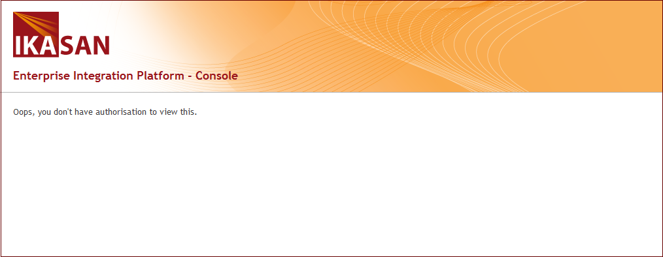

Granting & Revoking Permissions
Permissions may be granted or revoked for a user by selecting that user then selecting the “Grant” or “Revoke” operation as appropriate against the required roles.

Support
The Support page provides a list of resources for support with Ikasan Enterprise Integration Platform.
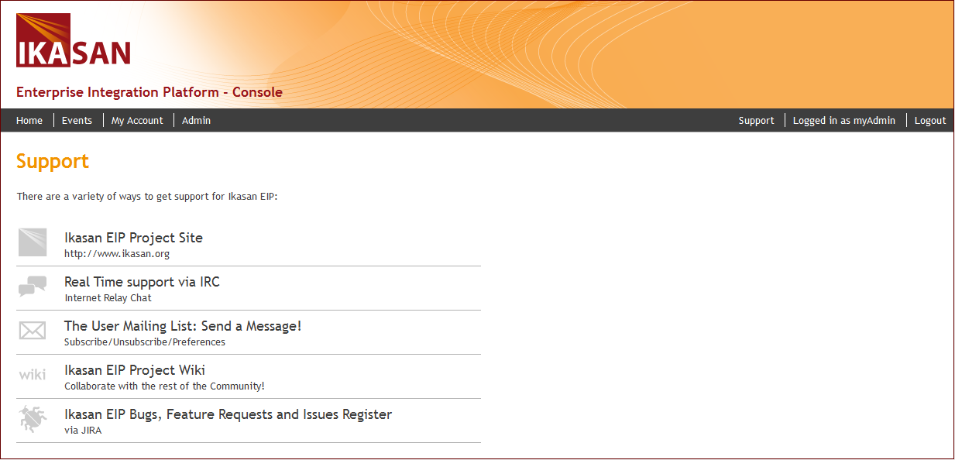
- Ikasan EIP Project Site – OSS project website
- Real Time support via IRC – displays the details you need to start an Internet Relay Chat session to raise questions, etc
- User Mailing List – for sending an email to the IkasanEIP maillist
- Ikasan EIP Project Wiki – directs you to the SourceForge Wiki for Ikasan
- Ikasan EIP Bugs, Feature Requests and Issues Register – Ikasan’s JIRA

Document Info

Authors | Ikasan Development Team
Contributors | n/a
Version | 0.9.4
Date | 31st Jan 2014
Email | info@ikasan.org
WebSite | http://www.ikasan.org

