RMBL Knowledge Commons Manual
Oct 27, 2026 · @Ian Breckheimer
The Knowledge Commons is RMBL's searchable library of publications, datasets, documents and news; this manual covers editing it in the admin (front end) and maintaining its data (back end).
Copies of this manual go out of date. The current Word version is always docs/RMBL-Knowledge-Commons-Manual.docx in the project repository; check the date above against it.

Quickstart: fix a record in five minutes
All manual edits happen in the admin at https://rmblknowledgecommons.org/admin, and they go live on the public site immediately.
- Get an account. An existing admin creates one under Users → Create New (email + password). There are no roles: every account can edit and delete every record, so give accounts only to people trusted with the whole catalog.
- Log in at /admin in a normal browser. The site runs bot protection, so you may see a brief check page first.
- Find the record. The left sidebar groups collections (Publications, Datasets, Documents, Stories, Authors, Projects, entities). Open one and use its search box, or paste the record's number from the public URL (/publications/1969 → Publication 1969).
- Edit and save. Change the fields, then Save. The sidebar's Curated fields list now includes what you changed, which protects it from being overwritten by the automated pipelines.
- Check the public page. Search results update at once, but a record's own page is cached for up to a week. Ask the maintainer to purge the cache (a redeploy) if a fix must show sooner.
To report a problem without an account, anyone can use the Report an issue link on a public record; reports appear in the admin under Curation → Flags.

Editing in the admin
Every save is recorded as a human decision that the automated pipelines will not overwrite, so edit freely but deliberately.
Sidebar group | Collections | Typical edits
Content | Publications, Datasets, Documents, Stories, Authors, Projects | Fix titles, years, DOIs, links; triage RMBL research; tag student authors; adjust project item lists
Entities | Species, Places, Protocols, Concepts, Eras | Fix names and descriptions (these are rebuilt by pipelines, so prefer reporting systematic problems)
Curation | Flags | Work through issues reported from the public site
— | Users | Create or remove admin accounts

Protected (curated) fields
- Saving a record adds each field you changed to its Curated fields list in the sidebar. Pipelines and syncs skip those fields from then on.
- To hand a field back to the pipelines, click its × in that list and save. Emptying a field also releases it.

RMBL research triage
- The RMBL Research select in a publication's sidebar decides whether a paper counts as RMBL research: Yes, No, or blank (not yet reviewed).
- Only Yes papers count in the annual metrics and appear on project pages, so newly discovered papers stay out until someone reviews them.
- The read-only RMBL research score beside it estimates how likely a paper is to be RMBL work; sort the review queue by it.

Student authors
- Each author in a publication's author list has a Student select: blank, Not a student, Student author (non-REU) or Student author (REU).
- Tags the pipelines detected are already filled in. Changing one saves your choice permanently; Not a student stops a wrong automatic tag from returning.
- Authors of student papers and theses show as non-REU students automatically and need no tagging.

Reported issues (Flags)
- Each report arrives as Open. Move it to In review while you work on it, then Resolved or Rejected; the resolution date is stamped automatically.
- A record's own edit page lists its open flags in the sidebar.

Deleting duplicates
- Delete is permanent. It records the deleted record's identifiers (DOI, title, year or URL) so the pipelines never re-import it, and its public page returns not found.
- Keep the copy with the most information and links; check both before deleting.
- There is no undo in the admin. Recovery needs a database restore, or the maintainer removing the tombstone so the pipeline can re-import it.

How it fits together
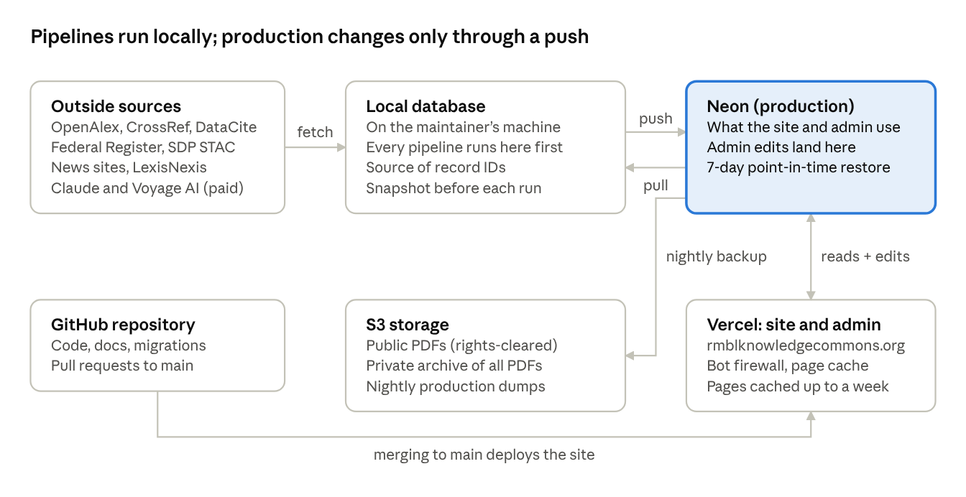
system overview · 6 parts
Pipelines write only the local database; production changes through an ordered push, and admin edits come back to local with a pull before the next run.

Where things are stored
Production data lives in Neon; everything else is either the maintainer's working copy, files in S3, or code in GitHub.
Store | What it holds | Written by
Neon PostgreSQL (production) | Every record the website and admin show | Admin edits; syncs from the local database
Local PostgreSQL rmbl_knowledge_hub (maintainer's machine) | Working copy where all pipelines run first; the source of record IDs | Pipeline scripts; pulls from Neon
Vercel project rmbl-knowledge-hub | The website and admin (rmblknowledgecommons.org), bot firewall, page cache | Deploys from GitHub main
GitHub ikb-rmbl/RMBL_knowledge_hub | Code, SQL migrations, these docs, small reference data | Pull requests
S3 rmbl-hub-pdfs/publications/ | Public PDFs served by the site (rights-cleared only) | migrate-pdf-links.ts, ingest-student-papers.ts
S3 rmbl-hub-pdfs-private/pdf-staging/ | Archive of every PDF, including restricted ones | PDF scripts
S3 rmbl-hub-backups | Daily production database dumps | GitHub Action, 03:00 Mountain
scripts/output/ (maintainer's machine, not in git) | Scraped caches, extraction results, local backups | Pipeline scripts
scripts/data/private/ (not in git) | Student rosters and REU lists — personal data | Maintainer only
Credentials live in the maintainer's .env file, in Vercel environment variables, and in GitHub Actions secrets — never in the repository.

Refreshing the data
A full refresh runs locally in the stages below, then goes to production in one push; budget about a week and roughly $100–150 in AI costs. Run each script with npx tsx scripts/<name>.ts, and use --dry-run first wherever it exists. Do not use npm run pipeline --phase=all: its authors phase rebuilds the whole author registry and reassigns every author ID.
- Prepare. Take backups (next sections), then npm run sync:pull so local has every admin edit.
- Discover new material. discover-publications (OpenAlex + CrossRef), discover-datasets, sync-sdp-stac, discover-fr-notices, and the news scrapers (scrape-news --refresh-urls, scrape-gunnison-times). LexisNexis stories arrive as PDF exports: parse with parse-lexis-fulltext --out=<file>, review relevance, then merge into the cache.
- Load. load-to-payload (needs npm run dev running) and load-stories, always followed by dedup-stories.
- Triage. score-rmbl-research --apply, then review new papers' RMBL Research field in the admin, highest score first.
- Extract entities (AI, paid). experiment-extraction --strategy=3 --ids-file=… for papers with PDFs; extract-longform-entities --ids-file=… for long or text-only papers; extract-document-entities, extract-dataset-entities, extract-story-entities, extract-dataset-variables-llm. Load results with load-extraction-results, load-document-extractions and load-story-extractions. Pilot two or three items before any full run.
- Link. resolve-candidates-additive, backfill-candidate-mentions --no-create --threshold=0.93 (0.94 for protocols), merge-plural-species, backfill-species-mentions, link-dataset-citations, crosslink-datasets, score-dataset-origin --apply, link-stories-publications --signals=title,researcher, and assign-projects (needs the dev server).
- Score and index. tag-student-authors, classify-funding-programs, generate-embeddings --collection=all.
- Push to production (next section), then redeploy so cached pages refresh.
Spot-check before every write: each linking script either has --dry-run or a review output, and this refresh caught wrong matches at almost every stage.

Pushing to production
Local is the source of record IDs, so production is updated by copying from local in a fixed order, matched by ID; record and link tables first, then the tables that point at them.
- Back up Neon (next section) and run npm run sync:pull.
- Records: sync-databases --direction=push --full-push --match-by-id --collection=<name> for authors, then publications, then datasets, documents, projects. Leave topics out until its case-variant duplicates are cleaned up.
- Author and keyword lists: sync-publication-children --target=neon.
- New stories: sync-stories-to-neon (never copies oral histories).
- Links between records: sync-rels-to-neon (adds only; reports links that exist only in production).
- Entities: sync-replace-entities.
- Mentions, citations, project assignments, dataset re-use: sync-bulk-to-neon --only=entity_mentions,references_cited,projects_rels,reuse.
- Production-side passes: load-story-extractions --target=neon, tag-student-authors --target=neon.
- Check and publish: compare counts (npm run sync:verify), redeploy production on Vercel so cached pages refresh, then open a few new records on the public site.
Run every step with --dry-run first where offered. Steps 4–7 run inside database transactions, so a failure leaves production as it was. Always use --match-by-id: without it the sync matches by title and DOI and has merged different papers that share a title.
As of this writing, sync-stories-to-neon, sync-rels-to-neon, --match-by-id and the transaction safeguards are on the fix/neon-push-tooling branch, pending merge.

Backups and recovery
Production is dumped to S3 automatically every night, and Neon can rewind to any point in the last 7 days; take your own snapshot before any bulk change anyway.
Backup | When | How
Nightly production dump → s3://rmbl-hub-backups (checksummed, encrypted) | Daily 03:00 Mountain, GitHub Action Database Backup | Automatic; npm run backup:verify checks the latest is recent
Neon point-in-time recovery | Continuous, last 7 days | Neon console → Branches → branch from a timestamp
On-demand production dump | Before any push or bulk edit | npm run backup:db, or a Neon branch from the console
Local database dump | Before any pipeline run | pg_dump -Fc rmbl_knowledge_hub -f scripts/output/backups/local-<date>.dump
PDF archive | After adding PDFs | npm run backup:pdfs
To restore, follow docs/RESTORE_RUNBOOK.md: stop all syncs first, then use Neon point-in-time recovery for problems under 7 days old, or npm run restore:list and npm run restore:db to restore a nightly dump. npm run backup:test-restore rehearses a restore without touching production.

Scripts not to run casually
These rebuild or truncate data that other things point at; each has a safer alternative, and the rebuilds belong in a planned full rebuild with fresh backups.
Command | What goes wrong | Use instead
pipeline.ts --phase=all, build-authors --load-payload | Rebuilds the author registry from old files, reassigning every author ID and losing manual repairs | Run pipeline phases individually
link-species-places.ts | Deletes every species and place and their links (refuses without a force flag) | resolve-candidates-additive.ts
cluster-concepts, cluster-protocols, cluster-stakeholders | Delete every link of that type and renumber the entities | backfill-candidate-mentions --no-create
detect-communities + load-neighborhoods | New neighborhood IDs, invalidating every primer and frontier link | Only as part of a full graph rebuild
load-frontiers.ts | Truncates the frontiers and, by cascade, the planning corpus | Grounded-frontier scripts
npm run sync:full | Truncates production and restores it from local | The ordered push above
npm run sync:schema | Re-runs every SQL file, including one-time data fixes | psql "$NEON_DIRECT_URL" < scripts/sql/<file>.sql for the one new migration
sync-databases --sync-entities | Clears production's link tables before copying | sync-replace-entities + sync-bulk-to-neon
Two standing rules: oral histories stay local until their release forms are confirmed, and student rosters in scripts/data/private/ never leave the maintainer's machine.

Further reading
No earlier document covered editing in the admin; these cover the rest in more depth, all in the project repository.
Document | For | Covers
README | Maintainers | Local setup, commands, deployment
CLAUDE.md | Maintainers | Every script, the curation design, known pitfalls
Disaster recovery runbook | Maintainers | Step-by-step restores
PDF acquisition protocol | Technicians, interns | Adding paywalled PDFs within copyright
Research community guide | Researchers | What the Commons offers and how to use it
Deep dive | Partners, funders | How it was built and is curated
Git workflow | Developers | Branches and pull requests
Roadmap | Everyone | Near-term priorities

