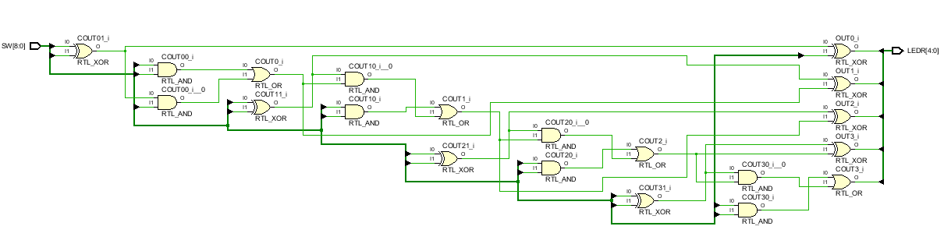For 2 different 4-bit input A, B and 1 bit carry in, four bit ripple carry adder circuit was designed. Depending on this design, the equalities of sums and carry outs for each bit were determined. As output, we had 4 bit sum and carry out. 5 bit output were observed with LEDs.

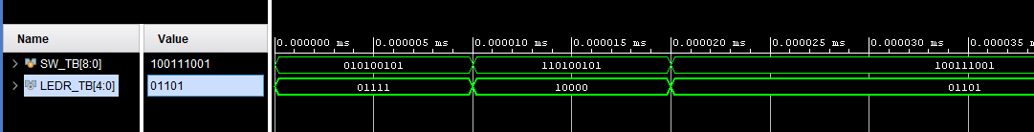 Figure-1 / Schematic of Part1

Figure-2 / Example of Simulation