Personal AI Assistant — Second Brain
Software Design Document
Use Cases · Domain Model · Sequence · Class · Package Diagrams
Author: İkbal Aktaş
Version 0.1 (iterative — living document)
September 18, 2026

Table of Contents

1. Introduction and Purpose
This document defines the software design of a proactive personal AI assistant — a “second brain” — built for a single user. The system captures the user’s ideas, bookmarks, journals, and tasks into an Obsidian vault (Markdown files), indexes them semantically, and — unlike a passive knowledge base — messages the user on its own initiative at appropriate times to deliver reminders and connection suggestions.
The distinguishing design goal is that the system is proactive: not an archive that only answers when asked, but an assistant that nudges at the right moment by taking into account the user’s productivity and mood patterns (metrics derived from journal entries, the class/exam calendar, and user-reported state flags).

1.1. Scope
- Included: chat-based capture, automatic Markdown filing, bookmark/link summarization, journaling and metric extraction, Google Calendar integration, semantic recall, and rule-based proactive reminders.
- Excluded (this version): multi-user support, mobile app development, a voice interface (optional future module), and machine-learned pattern “prediction” (descriptive statistics come first).

1.2. Actors and external systems
Actor | Type | Role
User (İkbal) | Primary | Interacts with the system over Telegram; enters content, queries, reports state.
Scheduler (Time) | Secondary (trigger) | Starts scheduled jobs: proactive reminders, journal analysis, calendar sync.
LLM Service (Claude) | Secondary (external) | Intent classification, summarization, text generation, and embeddings.
Google Calendar | Secondary (external) | Reads/writes events; determines the proactive scheduling window.
Web | Secondary (external) | Source of link content during bookmark capture.

2. Design Philosophy: Iterative Design, Feedback, Adaptation
This project is grounded end to end in the principle of iterative design, feedback, and adaptation. The principle operates on two planes:

2.1. At the development-process level
The system is not built all at once; it grows in small phases, each of which works and is usable on its own (see Section 8). At the end of each phase, real usage is observed, this document is updated, and the design of the next phase is adapted to that observation. This document is therefore a “living document”; its version number (v0.1) increments with each iteration.
This approach is also a defense against a well-known failure mode: such personal systems are typically set up over a weekend, used for two weeks, then abandoned. Small phases that are actually used are worth more than a system that is perfect on paper but never used.

2.2. At the product-behavior level
Iteration is not only the development method; it is at the heart of the product’s own behavior. At the system’s core is a feedback loop: journal entries → metric extraction → scheduling policy → proactive nudge → the user’s reaction → new journal entries. Instead of trying to guess the user’s state, the system reads from the data the user records and adapts its timing decisions accordingly.
This loop deliberately starts conservative: patterns are first reported descriptively (“over recent weeks your productivity tends to be lower during period X”), moving to prediction only after enough data accumulates — or not at all. The aim is to keep self-observation from turning into anxious self-optimization.

2.3. Interaction Principles — act, don’t chat
The assistant is an agent that does things, not a chatbot that answers. This shapes every user-facing message and is deliberately the opposite of ordinary chat-assistant behavior. It is enforced in the orchestrator’s system prompt.
- Act, don’t discuss. Treat an input as a task to carry out with tools, not a question to answer. Do the work, then report it.
- Receipts, not essays. After a tool runs, confirm in one short line what was done — no filler, no “anything else?” closers, no restating the request.
- Assume, don’t interrogate. On ambiguity, act on the most reasonable interpretation and state the assumption in a few words; ask a question only when genuinely blocked — a missing required value, or a destructive/irreversible action.
- Terse by default, with an escape hatch. Keep replies to a line or two; on a command like “detail” or “explain”, switch to a full explanation for that turn, then return to terse mode.
Example receipt:
✓ Saved → bookmarks · tags: gadget, wishlist · reminder Oct 2

3. Use Cases
The use case diagram below summarizes how the primary actor (the user) and the scheduler plus external services interact with the system. The proactive use cases (UC7–UC9) are triggered not by the user but by the Scheduler actor — this is how the system’s non-passive nature shows up in the diagram.
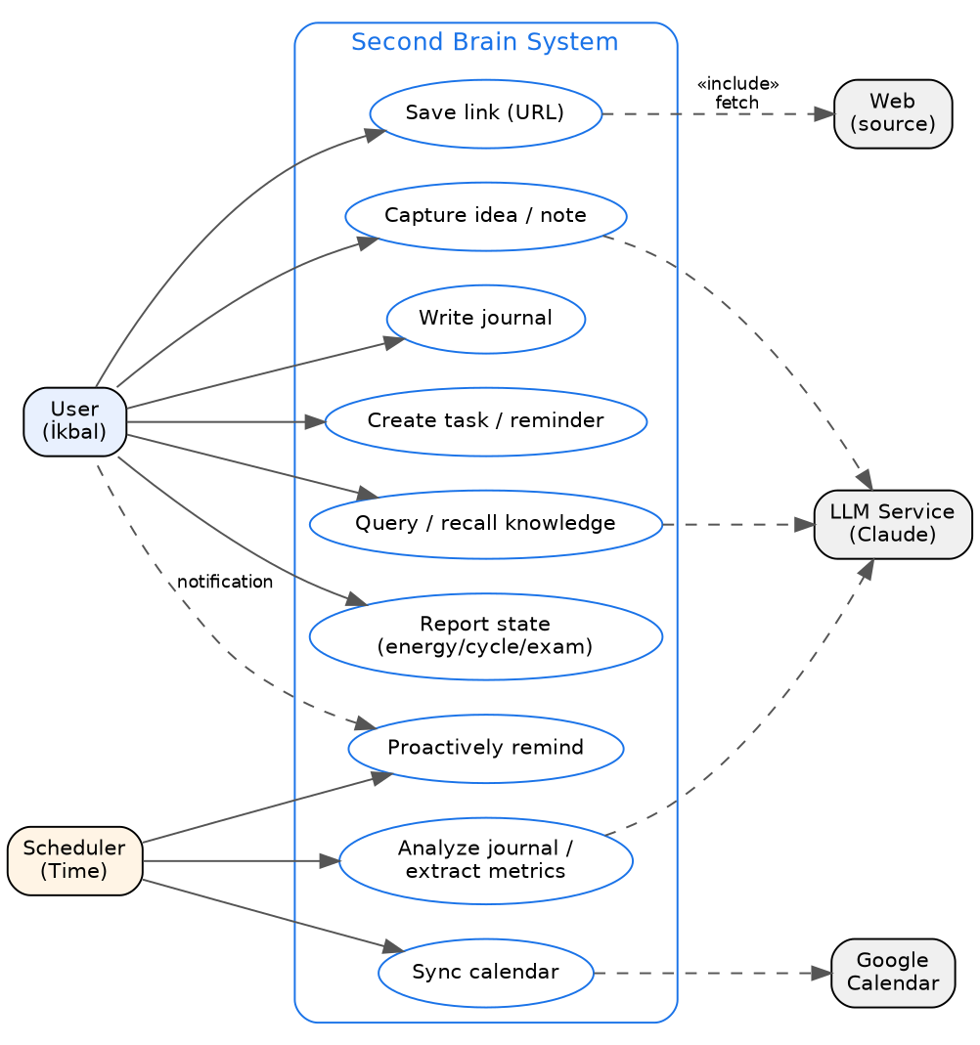
Figure 1 — Use case diagram

3.1. Detailed use cases
Two representative use cases are fully expanded; the others follow a similar structure.
UC2 — Save link (URL)
Field | Content
Actor | User (primary), Web and LLM (secondary)
Precondition | System running; user authenticated.
Trigger | User sends a URL with a short note (“look into this later”).
Main flow | 1. System receives the message and classifies intent (capture + remind).  2. Link content is fetched and summarized with the LLM.  3. A bookmark note is created in the vault with frontmatter and tags.  4. The note is added to the semantic index.  5. An optional reminder is set.  6. A confirmation message is sent to the user.
Alternative flow | 2a. If the link cannot be fetched: the note is still created, the raw link + the user’s note are stored instead of a summary, and the situation is reported to the user.
Postcondition | A searchable, tagged bookmark note exists in the vault.
UC7 — Proactively remind
Field | Content
Actor | Scheduler (trigger), User (recipient)
Precondition | A due reminder or a triggered context match exists.
Trigger | The scheduler loop (e.g., every 60 s) catches a condition.
Main flow | 1. The scheduler detects the due job.  2. The policy engine evaluates “is now appropriate?”: quiet hours, calendar busyness, state flags, rate limit.  3. If appropriate, the orchestrator composes the message (with semantic recall if needed).  4. The message is sent to the user.
Alternative flow | 2a. If not appropriate: the job is deferred to the next suitable window; the user is not disturbed.
Postcondition | The user receives a well-timed, relevant nudge, or is not disturbed at all.

4. Domain Model
The domain model shows the concepts and relationships in the problem space the system addresses (not the implementation classes — those are in Section 6). The central concept is the Note; Bookmark and Journal Entry are its specializations. A Journal Entry is associated with Day Metrics derived at end of day, and those metrics form the data source for proactive scheduling.
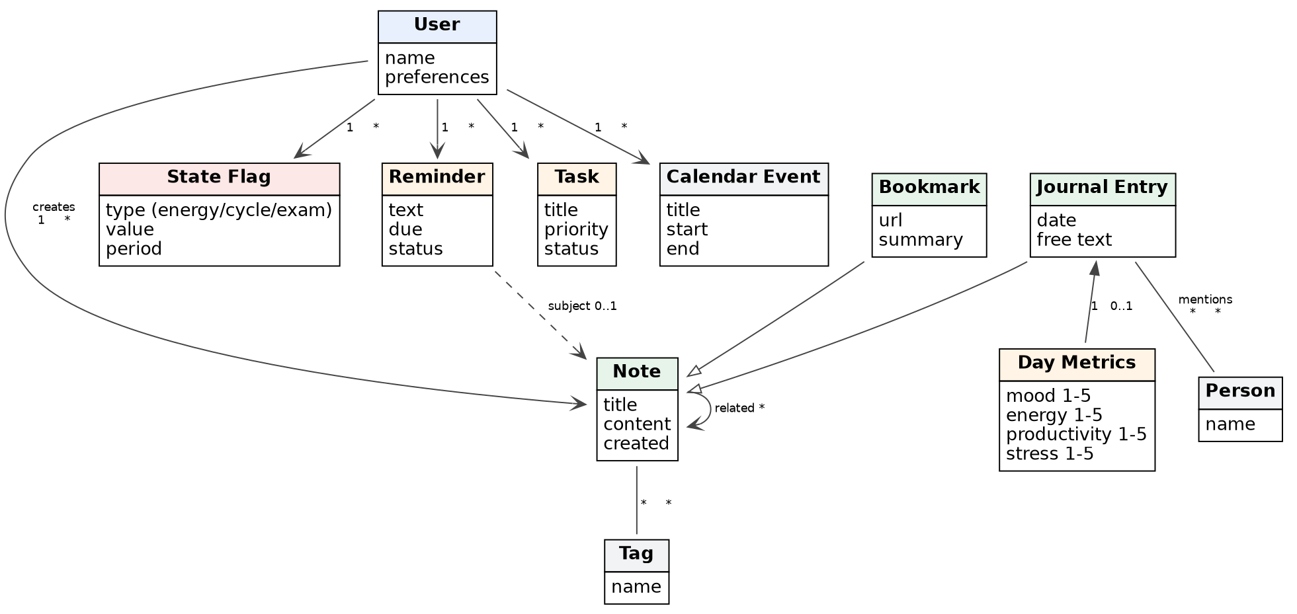
Figure 2 — Domain model

4.1. Concept glossary
Concept | Definition
Note | The abstract supertype of every Markdown file in the vault; carries title, content, tags. The source of truth.
Bookmark | An external source saved with a URL, an auto-summary, and tags (a Note specialization).
Journal Entry | Free text for a given day: what was done, feelings, events, people (a Note specialization).
Day Metrics | Fixed-scale indicators derived from the journal entry via the LLM (mood, energy, productivity, stress — 1–5). Stored in frontmatter; the user can correct them by hand.
State Flag | Contextual state reported by the user: energy level, cycle phase, exam week. Input to the policy engine.
Reminder / Task | A scheduled nudge; a prioritized to-do. Optionally linked to a Note.
Calendar Event | An event read from Google Calendar; constrains the proactive scheduling window.

5. Interaction / Sequence Diagrams
Three representative flows show the message order between objects. Solid arrows denote synchronous calls; dashed arrows denote returns.

5.1. Link capture
The flow from the user sending a URL with a “look later” note to a tagged bookmark being created in the vault and a reminder being set:
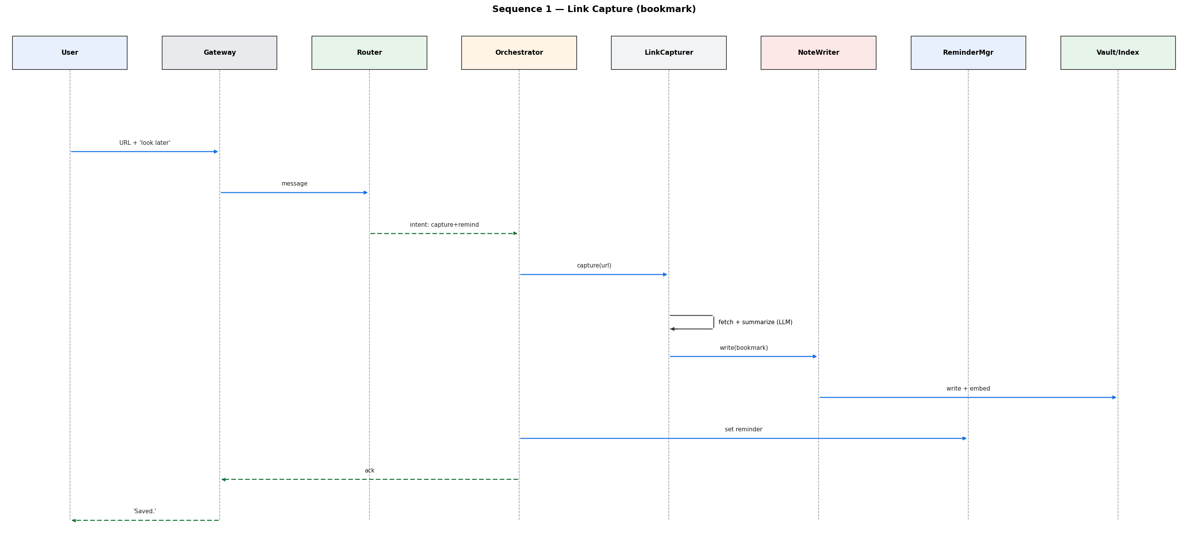
Figure 3 — Sequence: link capture

5.2. Proactive journal reminder and analysis
The scheduler detecting that today’s journal is empty, passing the policy check, then nudging the user; followed by metrics being extracted at end of day and written to the note’s frontmatter:
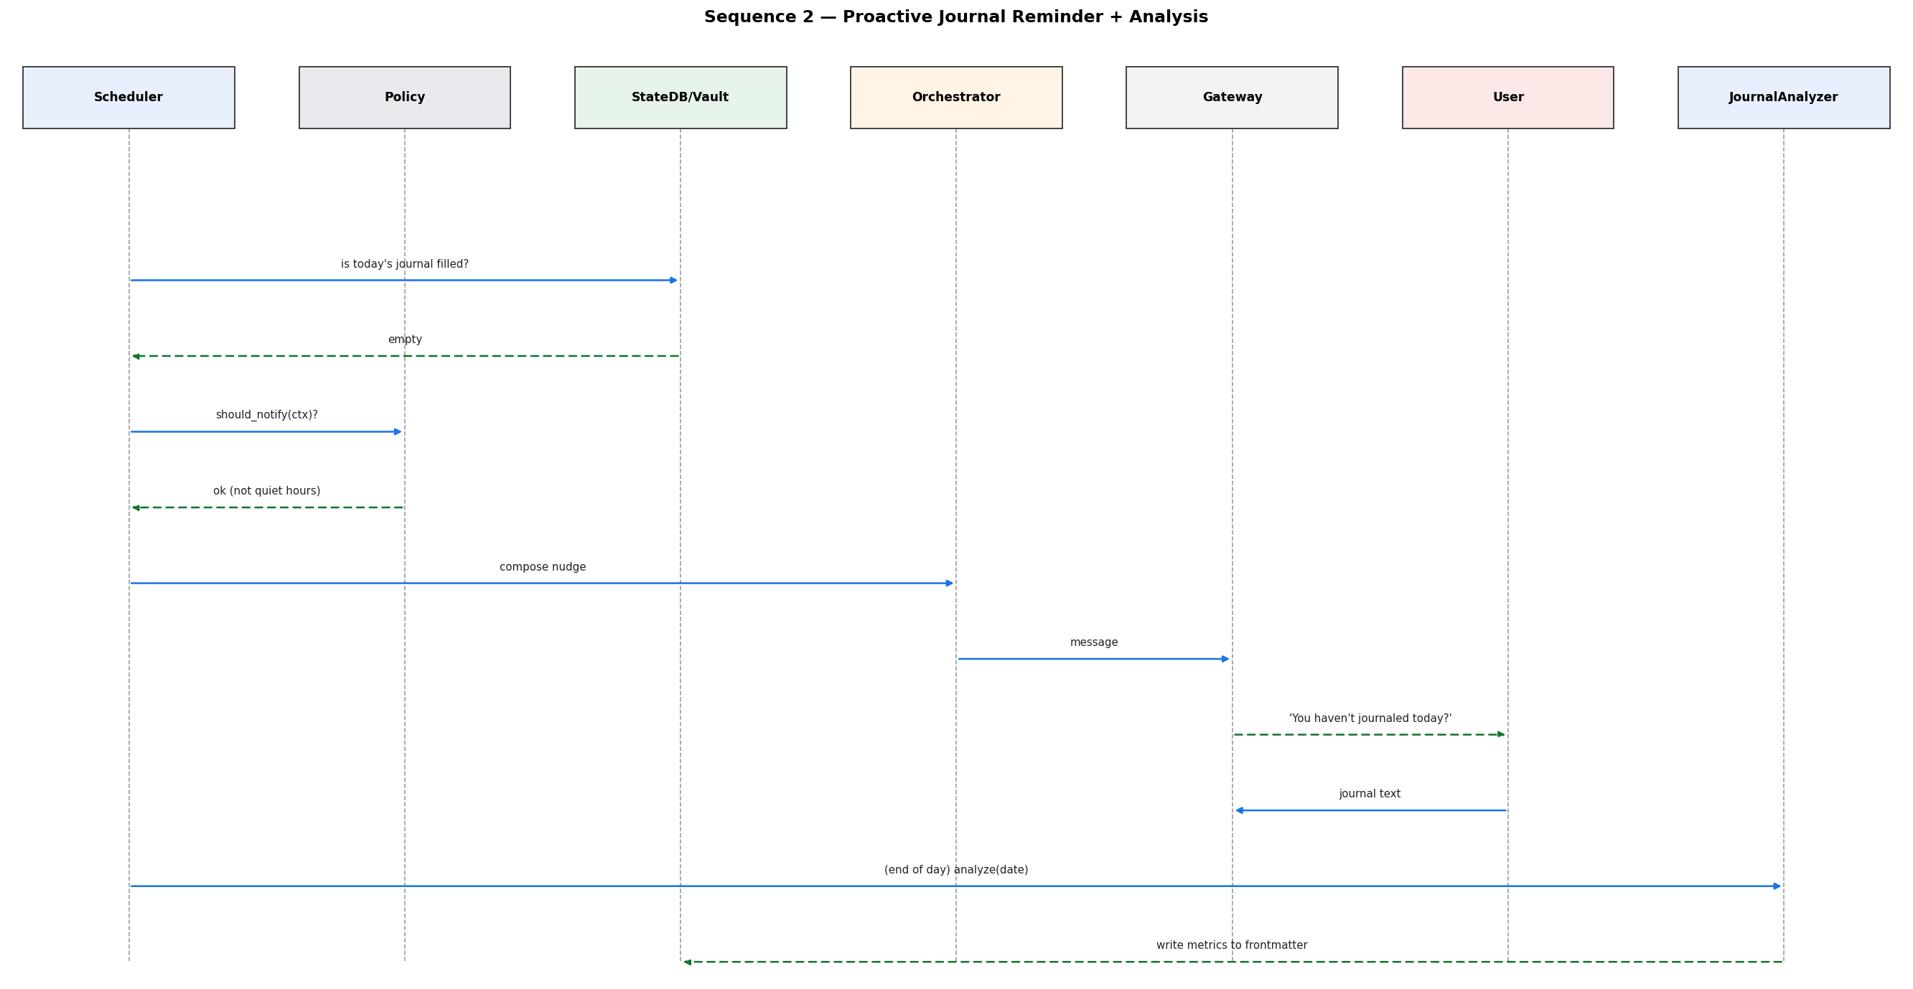
Figure 4 — Sequence: proactive reminder + analysis

5.3. Query and semantic recall
The flow from a user question to the system finding related notes saved weeks earlier in the semantic index and adding them as context to the answer:
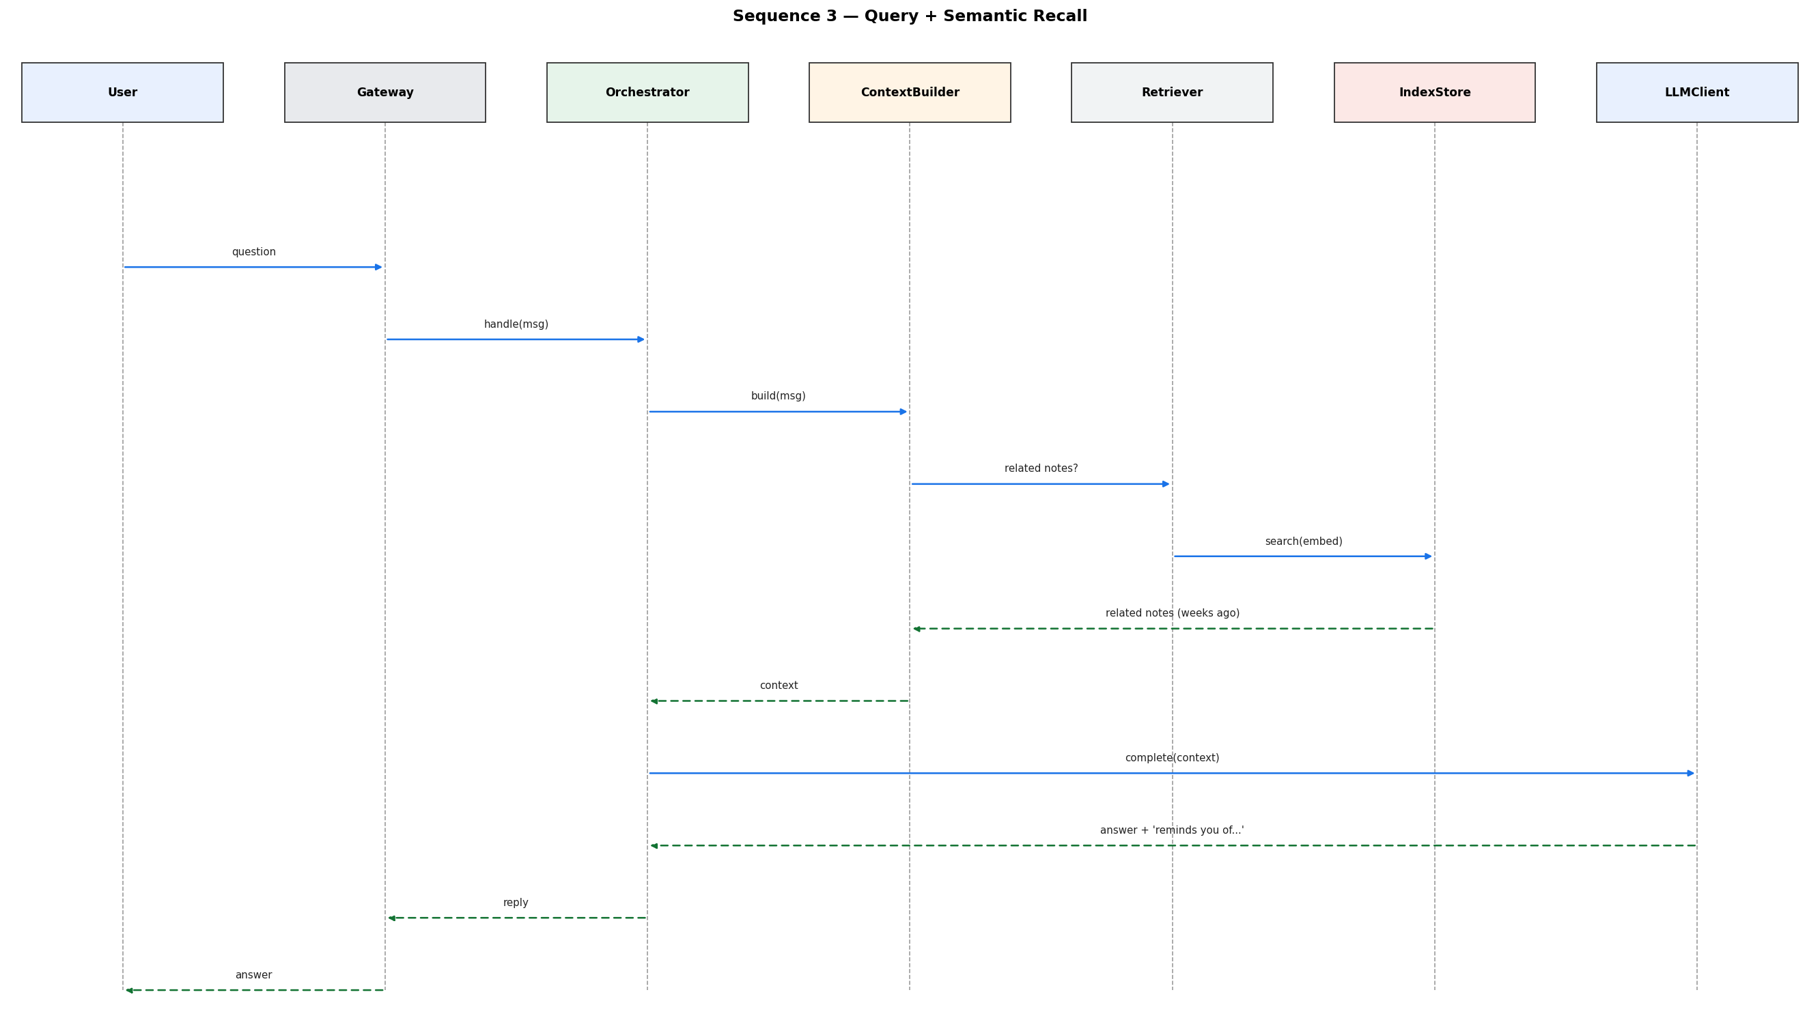
Figure 5 — Sequence: query + semantic recall

6. Design Class Diagram
The design class diagram shows the implementation-level classes, their responsibilities, and their dependencies. Tool is an interface; each tool (NoteWriter, LinkCapturer, Retriever, JournalWriter …) realizes it, and the Orchestrator invokes these tools via tool-calling. The storage classes (VaultRepository, IndexStore, StateDB) separate where data lives: Markdown is the source of truth, the index is derived, and StateDB holds only operational state.
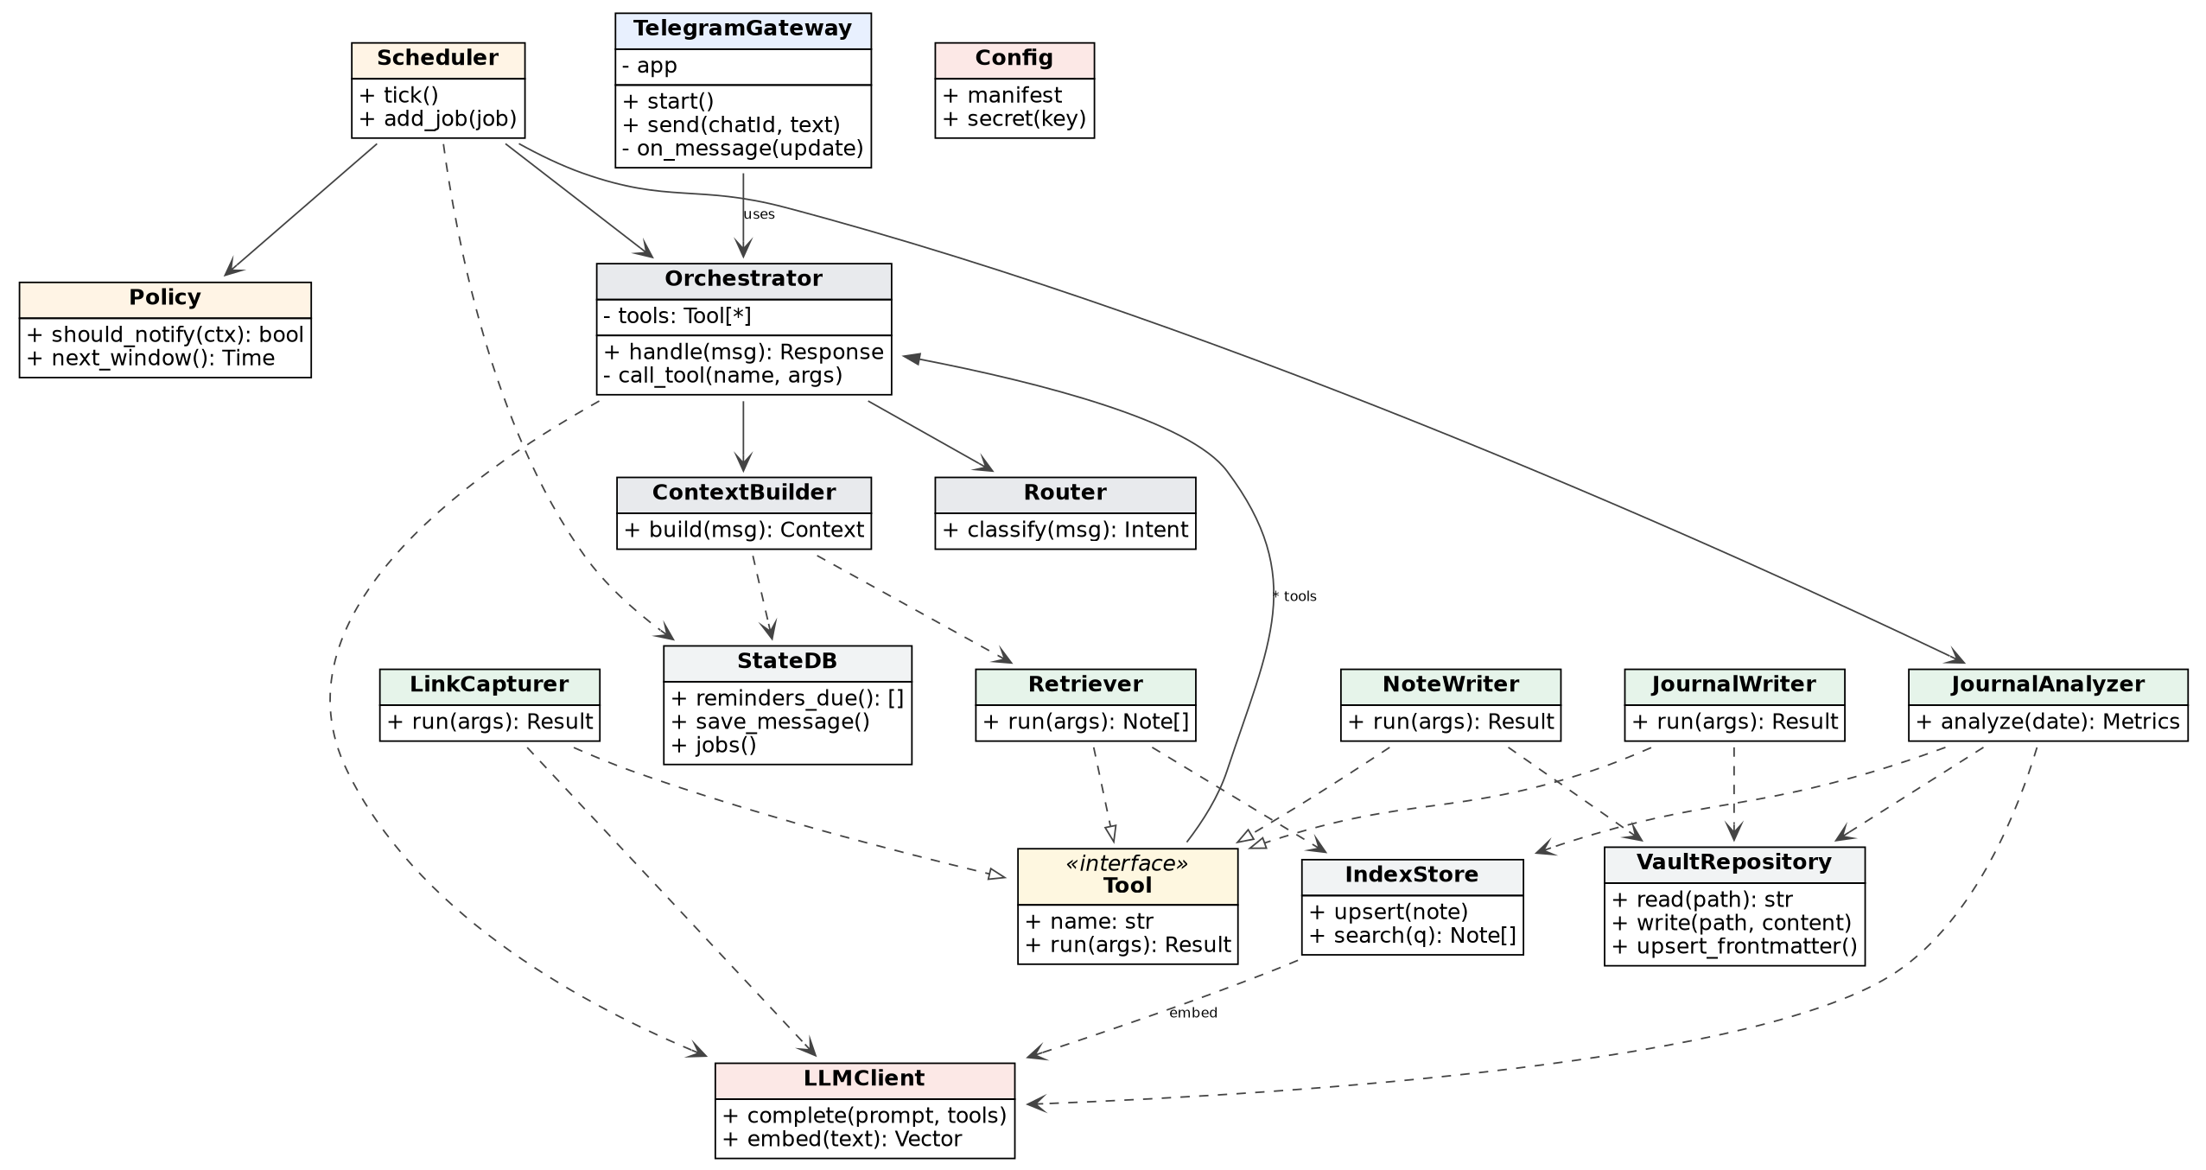
Figure 6 — Design class diagram

6.1. Class responsibilities
Class | Layer | Responsibility
TelegramGateway | interface | Receive and send messages; the single bidirectional channel (including proactive output).
Router | orchestration | Classifies the intent of the incoming message with a cheap model.
Orchestrator | orchestration | The core decision center; invokes tools via tool-calling.
ContextBuilder | orchestration | Builds the LLM context (history + related notes + state); manages token budget.
Tool «interface» + realizers | tools | Testable single capabilities: writing, capturing, retrieving, journaling.
JournalAnalyzer | tools | End-of-day metric extraction; fills the fixed schema, never invents new metrics.
Scheduler | proactive | Background loop; detects due jobs and starts the flow.
Policy | proactive | Applies the “whether/when to nudge” rules; rate limiting and quiet hours.
VaultRepository / IndexStore / StateDB | storage | Markdown (source) / embedding index (derived) / SQLite (operational state).
LLMClient / Config | cross-cutting | Model access; module manifest and secret management.

7. UML Package Diagram
The package diagram shows how the code is split into layers and the direction of dependencies. Dependencies are one-way and flow top to bottom: interface depends on orchestration, orchestration on tools, and the proactive layer on orchestration and storage. The storage and cross-cutting layers (config, llm_client, sync) depend on no upper layer — this keeps the layers independently testable and replaceable.
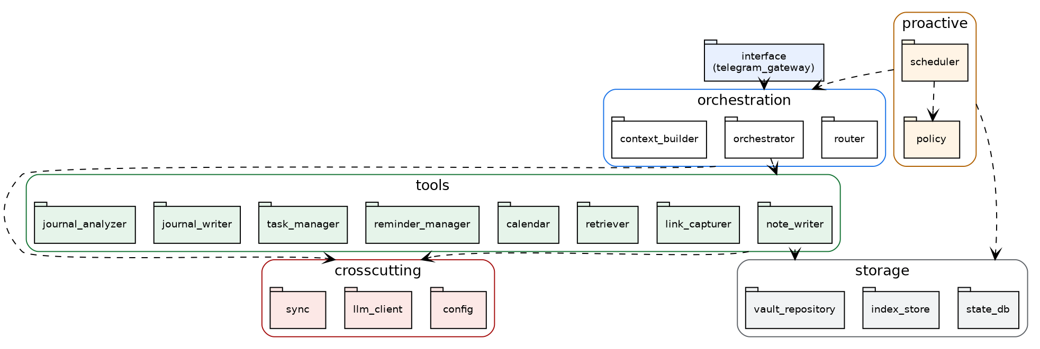
Figure 7 — UML package diagram

7.1. Dependency rules
- One direction: an upper layer depends on a lower one, never the reverse. Cyclic dependencies are forbidden.
- Storage isolation: only note_writer/journal_writer write to the vault; reads are free but writes go through a single door.
- Cross-cutting access: config and llm_client may be called from any layer; secrets only via config, never inside the vault.
- Fail-closed modules: when a module is turned off it disappears entirely from the tool list, commands, and sync — it is not merely hidden in a menu.

8. Iterative Roadmap
The system is built in phases, each usable on its own. At the end of each phase this document is updated based on observed real usage (Section 2).
Phase | Scope | Done / output
Phase 0 | Backbone (MVP) | Telegram + LLM + Python; message → reply → Markdown note in the vault. Runs on the laptop.
Phase 1 | Capture | Bookmark flow: URL → fetch → summarize → write with frontmatter + tags.
Phase 2 | Always-on + calendar | Service runs 24/7 on a VPS/Pi; Google Calendar read; scheduled jobs possible.
Phase 3 | Proactive (rules) | Reminders + calendar-aware nudges; the policy engine’s first rules.
Phase 4 | Recall | Embedding index over the vault; the “you saved this weeks ago” suggestion.
Phase 5 | Adaptive timing | Journal + metrics + state flags → descriptive patterns → shape the timing.

8.1. To be added to this document in the next iteration
- State machine diagram: the lifecycle of a Reminder (pending → deferred → sent → closed).
- Deployment diagram: the physical placement of the VPS/Pi, the sync agent, and external services.
- Locking the metric schema and a privacy note: keeping the most sensitive data (state flags) in plain text, under user control.

