ARCHITECTURE DECISION PROPOSAL
AFH AI Platform Architecture Proposal
MCP Gateway, service-owned AI tools, DevOps integration, security model, SDK strategy, and five-year growth path
Field | Value
Audience | Senior engineers, architects, platform owners, and service owners
Status | Proposed
Decision | Adopt a central MCP Gateway with service-owned tool providers, evolving toward workflow-specific services
Scope | Existing services under /services and shared SDKs under /sdk

Recommendation
Introduce an AFH MCP Gateway as the governed AI entry point. Keep business logic in the existing services, publish service-owned tool manifests, and add dedicated workflow services for DevOps and document intelligence when workflows become stateful or long-running.

1. Executive summary
AFH should introduce AI capabilities through a governed MCP Gateway rather than asking every AI client to connect to every microservice directly. The gateway should be treated as a protocol and policy boundary, not a new home for domain logic.
The current solution already has the right ingredients for this model: Azure Functions services, clear Contract/Application/Domain/Infrastructure/Function layering, existing HTTP APIs, OpenAPI/Scalar documentation, shared SDKs, gateway function apps, and service-specific persistence/integration boundaries.
- Use the MCP Gateway as the single AI entry point for Codex, GitHub Copilot, ChatGPT, Claude, and future internal agents.
- Let each service own the tools that map to its domain, such as booking.*, calendar.*, notification.*, location.*, adviser.*, identity.*, acs.*, client.*, devops.*, and sharepoint.*.
- Use shared SDKs for tool contracts, actor context, redaction, audit envelopes, MCP protocol helpers, and external client primitives.
- Move stateful or high-risk AI workflows into dedicated workflow services instead of growing the gateway into a God Service.

2. Current architecture
The solution is a set of Azure Functions-based services under /services, supported by cross-cutting SDKs under /sdk. Each major service largely follows a Clean Architecture shape: Contract, Domain, Application, Infrastructure, Function, and tests.
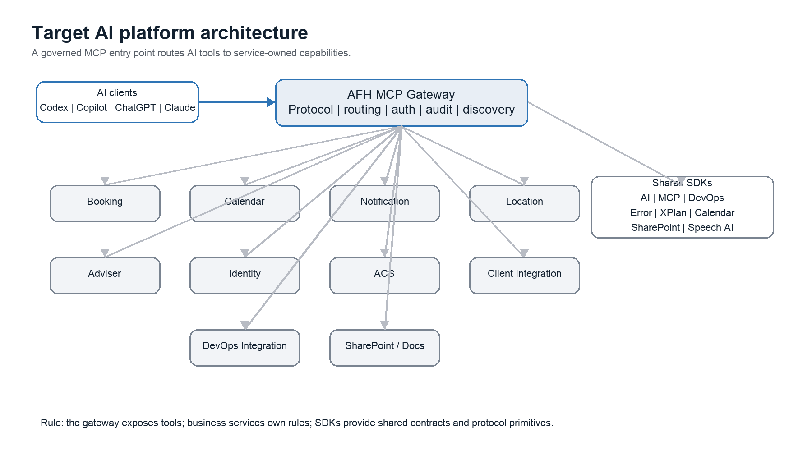
Service | Current responsibility | AI capability owner
afh-booking-function-app | Availability, holds, bookings, cancellations, rearrangements, approvals, lifecycle, reporting, config, duplicate clients, client lookup, projections. | booking.*
afh-calendar-function-app | Schedules, appointment create/update/cancel, Microsoft Graph subscriptions, webhook handling, projections. | calendar.*
afh-notification-function-app | Notification requests, templates, settings, retry policies, dispatch/message logs, bouncebacks. | notification.*
afh-location-function-app | Travel coverage, route time, location policy, organisation assignments, plus currently co-hosted adviser/identity surfaces. | location.*
afh-adviser-function-app | Adviser profiles, specialisms, coverage, availability rules, cache sync. | adviser.*
afh-identity-function-app | Users, partners, roles, permissions, access scopes, current user context. | identity.*
afh-acs-function-app | ACS meetings, join tokens, links, recordings, transcriptions. | acs.*
afh-client-integration-function-app | Prospects, client integration, XPlan, Snowflake transaction/status tracking. | client.*
afh-booking-admin-gateway-function-app | Admin gateway/proxy and admin health/sync APIs. | No domain tools; useful precedent for gateway operations.
afh-booking-consumer-gateway-function-app | Consumer gateway shell and downstream health registry. | No domain tools initially.

3. Current challenges
- AI clients should not need to understand every AFH microservice, endpoint, authentication rule, or deployment topology.
- Azure DevOps automation has no natural owner in the current service map.
- Security, audit, redaction, approval, and throttling would be duplicated if each AI client talked to services independently.
- Tool discovery will become difficult as more services are added.
- Several service boundaries are already porous, especially Booking to Location/Calendar/ACS/Notification/Identity, Location-Adviser-Identity co-hosting, and Booking carrying notification-facing projects.

4. Goals
Goal | Implication
Enable AI safely | AI access must be authenticated, authorized, auditable, rate-limited, and reversible where possible.
Preserve service boundaries | Services remain the source of truth for business rules and persistence.
Support multiple AI providers | Codex, Copilot, ChatGPT, Claude, and internal agents get one governed protocol entry point.
Avoid gateway sprawl | The gateway routes and enforces policy; workflow services own long-running orchestration.
Scale discovery | Services publish tool manifests; the gateway discovers and registers tools automatically.

5. Architecture options considered
Option | Description | Strengths | Weaknesses
A. Direct MCP providers | Every microservice exposes its own MCP server/tool provider directly to AI clients. | Strong service autonomy; no central runtime bottleneck. | Duplicates auth, audit, redaction, throttling, approvals, client onboarding, and discovery.
B. Central MCP Gateway | AI clients connect to one AFH MCP Gateway, which routes to service-owned tools. | Consistent governance; one AI entry point; natural fit with existing gateway services. | Can become a bottleneck if it starts owning business logic.
C. Gateway plus workflow services | The gateway routes tools and delegates complex workflows to services such as DevOps Integration or Document Intelligence. | Best long-term separation for stateful, high-risk, and long-running workflows. | More moving parts and requires stronger workflow contracts.

Decision rationale
Adopt Option B first and design it so Option C is easy. Option A is attractive for service autonomy, but it weakens platform governance and makes AI clients responsible for too much internal topology.

6. Recommended MCP Gateway architecture
The MCP Gateway should live under /services as a separate Azure Functions service named afh-ai-mcp-gateway-function-app. It should not reference existing service Application or Infrastructure projects directly. Instead, it should call downstream service APIs through HTTP by default and use asynchronous messaging for long-running workflows.
Gateway responsibility | Explanation
MCP protocol | Expose tools and resources to AI clients using MCP-compatible contracts.
Routing | Map tool names to owner service endpoints based on discovered manifests.
Policy enforcement | Check tool permissions, side-effect level, approval requirements, rate limits, and tenant/environment constraints before invocation.
Audit envelope | Record actor, AI agent, tool, correlation ID, request hash, redaction state, downstream target, outcome, and latency.
Thin aggregation | Aggregate read-only service responses where this improves the AI experience without embedding business rules.

7. Internal communication
Mechanism | Best use | Fit for current solution
HTTP | Synchronous tool calls and existing Azure Functions APIs. | Best default. The services already expose HTTP triggers, gateways, and OpenAPI/Scalar docs.
gRPC | High-throughput internal binary APIs. | Not a natural fit unless services move toward ASP.NET Core/container hosting.
Azure Service Bus | Asynchronous commands, long-running workflows, retries, and fan-out. | Strong fit for DevOps/document workflows and notification-style patterns, not simple request/response tools.
Direct project references | Local code reuse. | Not recommended for the gateway. It couples deployments and bypasses service-owned behavior.

8. AI orchestration boundaries
Belongs in MCP Gateway | Belongs in workflow-specific services
Tool discovery, registration, and schema validation. | Requirement document to Epic/Feature/User Story/Task generation.
Authentication, actor resolution, and policy checks. | SharePoint document analysis and classification.
Audit envelope and redacted request logging. | Sprint analysis, work item linking, and PR-link workflows.
Thin read-only aggregation. | Production incident investigation and remediation-plan workflows.
Human approval checks for high-risk tool invocations. | Potential PR generation, branch management, and review automation.

Practical rule
If a workflow needs durable state, retries, idempotency, approvals, scheduling, or domain-specific decisions, it should not live in the MCP Gateway.

9. DevOps integration recommendation
Azure DevOps automation should be implemented as a dedicated DevOps Integration Service under /services and exposed by the MCP Gateway as devops.* tools. This keeps Azure DevOps auth, work item templates, sprint reads, pull request linking, idempotency, and workflow audit in one owned service.
- The MCP Gateway should expose devops.* tools and enforce AI policy.
- AFH.DevOps.Integration.Application should own workflows such as create epic, create feature, create user story, create task, update work item, link pull request, read sprint, and generate implementation plan.
- AFH.DevOps.Integration.Infrastructure should contain Azure DevOps REST clients, auth, retries, and DTO mapping.
- A shared afh-common-devops SDK should contain reusable client primitives, not workflow business logic.

10. SDK strategy
The SDKs are part of the architecture. They should provide shared platform primitives while avoiding hidden business logic. Existing SDKs should remain focused, and new AI/MCP SDKs should define contracts, manifests, actor context, and protocol helpers.
SDK | Responsibility
afh-common-error | Shared error handling, Azure Functions support, EF persistence, Application Insights/email error sinks.
afh-common-calendar | Shared calendar and Microsoft Graph calendar utilities.
afh-common-sharepoint | Shared SharePoint access utilities.
afh-common-xplan | Shared XPlan integration utilities.
afh-common-speechai | Shared Speech AI utilities for transcription-oriented flows.
afh-common-ai | Tool manifest contracts, AI actor context, permission metadata, redaction helpers, audit event contracts.
afh-common-mcp | MCP envelope abstractions, discovery client, schema validation helpers.
afh-common-devops | Azure DevOps REST client primitives, work item DTOs, PR linking DTOs, retry and auth helpers.

SDK boundary
SDKs provide shared contracts and infrastructure primitives. They should not contain Booking, Calendar, Notification, Location, Adviser, Identity, ACS, Client, SharePoint, or DevOps workflow business logic.

11. Security model
AI actions should carry both the human principal and the AI principal. This allows AFH to answer who requested the work, which AI agent performed it, which service executed it, and which permission authorized it.
Security concern | Recommended approach
Authentication | Authenticate AI clients at the MCP Gateway using Entra ID where possible. Register AI agents as application identities.
Authorization | Use capability-based permissions such as booking.read, booking.rearrange, notification.requeue, devops.workitem.write, and sharepoint.requirements.read.
Identity propagation | Propagate actor user, actor email, AI agent ID, AI session ID, correlation ID, authorized permission, and approval ID to downstream services.
Downstream enforcement | Every business service must re-authorize operations. The gateway is an enforcing boundary, not the only enforcement point.
Audit | Log redacted input, request hash, tool name, side-effect level, actor, AI agent, target service, downstream operation, result, and latency.
High-risk tools | Require dry-run, approval, idempotency keys, and stronger audit for destructive or mutating operations.

12. Tool discovery
Each service should publish an internal AI tool manifest. The MCP Gateway should discover manifests from configured service providers, cache them, validate them, and register tools dynamically.
Manifest field | Purpose
Tool name | Stable name such as booking.search or devops.create_user_story.
Owner service | The service responsible for the capability and downstream endpoint.
Input/output schema | Validation and AI client discoverability.
Required permission | Capability-based authorization.
Side-effect level | Read, write, or destructive.
Approval requirement | Whether a human approval token is required before invocation.
Endpoint mapping | The downstream HTTP route or asynchronous command target.
Version/deprecation | Safe evolution as service APIs change.

13. Future evolution
At 30 or more services, the gateway must remain a routing and governance layer. Service-owned manifests, SDK contracts, and workflow services prevent it from becoming a bottleneck or God Service.
- Start with read-only tools and explicit manifests for Booking, Calendar, Notification, Location, Adviser, Identity, ACS, and Client Integration.
- Add mutating tools only after identity propagation, downstream authorization, audit logging, dry-run, and approval flows are in place.
- Create DevOps Integration as the first workflow-specific service.
- Add SharePoint or Document Intelligence as a separate service when requirement analysis grows beyond simple document retrieval.
- Split the gateway into separate business, DevOps, and operations MCP gateways only if isolation, scaling, or risk justifies it.

14. Proposed folder structure
/services
/afh-ai-mcp-gateway-function-app
/src
/AFH.Ai.McpGateway.Contract
/AFH.Ai.McpGateway.Application
/AFH.Ai.McpGateway.Infrastructure
/AFH.Ai.McpGateway.Function
/tests
/AFH.Ai.McpGateway.Tests
/afh-devops-integration-function-app
/src
/AFH.DevOps.Integration.Contract
/AFH.DevOps.Integration.Application
/AFH.DevOps.Integration.Domain
/AFH.DevOps.Integration.Infrastructure
/AFH.DevOps.Integration.Function
/tests
/AFH.DevOps.Integration.Tests
/sdk
/afh-common-ai
/afh-common-mcp
/afh-common-devops

15. Final decision statement
Decision
Proceed with a central AFH MCP Gateway that discovers service-owned tool providers. Add a DevOps Integration Service for Azure DevOps workflows. Use SDKs for shared AI/MCP/DevOps contracts and infrastructure primitives. Keep business rules in the owning services.

