BESTLINK COLLEGE OF THE PHILIPPINES BULACAN CAMPUS—HUMAN RESOURCE MANAGEMENT (EMPLOYEE ENGAGEMENT AND RELATIONS SYSTEM)

A Capstone
Presented to the Faculty of
The College of Computing Studies
Bestlink College of the Philippines

In Partial Fulfillment
of the Requirements for the Degree
Bachelor of Science in Information Technology

GEOFFREY C. BALANSAG
KARL ASHLEY MENDOZA
JOHN CARLO M. MIRABUENO
LANZ C. PLICERDA

OCTOBER 17, 2026

TABLE OF CONTENTS

TITLE PAGE i
TABLE OF CONTENTS viii
LIST OF TABLES xiii
LIST OF FIGURES xiv
LIST OF APPENDICES xv
CHAPTER 1 INTRODUCTION
1.1 Background of the Capstone Project 3
1.2 Context and Scope 21
1.3 Problem Statement 26
1.4 Objectives and Goals 29
1.5 Significance and Relevance 32
1.6 Structure of the Document 35
CHAPTER 2 RELATED LITERATURE, STUDIES, AND TECHNICAL BACKGROUND
2.1 Agile Scrum Methodology Overview 49
2.2 Enterprise Architecture Concepts 52
2.3 Monolithic Architecture 54
2.4 DevOps and CI/CD 56
2.5 Relevant Studies and Research 64
2.6 Integration of Information Systems in Enterprise Environments 72
CHAPTER 3 METHODOLOGY AND PROJECT MANAGEMENT
3.1 Agile Scrum Methodology in the Project 76
3.2 Roles and Responsibilities 80
3.3 Sprint Cycles 84
3.4 Scrum Artifacts 92
3.5 Integration Approach for Information Systems 100
3.6 Monolithic Architecture 103
3.7 Introduction to TOGAF and the Four Architectural Domains 108

CHAPTER 1

INTRODUCTION

Communication between employees and the Human Resource Department matters in every organization. Employees must be informed of key announcements, have channels to voice their feedback and concerns, and receive chances to take part and be acknowledged for what they contribute. Such activities help sustain solid employee engagement and healthy workplace relations.

At the Bulacan Campus of Bestlink College of the Philippines, the Human Resource Department manages various employee-related activities, including announcements, surveys, feedback, recognition, social interaction, and grievances. Keeping track of information from these activities can prove challenging when records and communication flow through multiple methods or channels. Managing information from different sources and reviewing previous records may also require additional time from the Human Resource Department.

To help tackle these issues, the researchers put forward the Human Resources Employee Engagement and Relations System for Bestlink College of the Philippines – Bulacan Campus. This system offers a centralized web-based platform for selected employee engagement and workplace relations activities. Through it, employees can view HR announcements, complete surveys, give feedback, join supported social features, see recognition-related information, and file grievances. Authorized Human Resource personnel and administrators are able to manage the associated records and examine the information available through the system.

This chapter covers the background, context and scope, problem statement, objectives and goals, significance and relevance, theoretical framework, conceptual framework, and structure of the capstone project.

Background of the Capstone Project

Human Resource Management is essential for helping employees and overseeing workplace tasks in an organization. In a school, the Human Resource Department handles communication, employee involvement, feedback, recognition, and workplace relations. These tasks require clear communication and proper record keeping so that employee-related information can be accessed, reviewed, and tracked when needed.

Bestlink College of the Philippines – Bulacan Campus depends on academic and administrative staff who carry out various duties that keep the institution running each day. The Human Resource Department helps these employees by giving official information, gathering feedback, running surveys, acknowledging employee contributions, encouraging employee involvement, and addressing grievances. These tasks matter for keeping communication open between employees and the Human Resource Department.

The proposed system focuses on selected employee engagement and relations activities, including announcements, surveys and feedback, recognition, social collaboration, and grievance management. It aims to provide a centralized platform for organizing related information and supporting the review of available records.
When related information is kept using different methods, the Human Resource Department may need additional time and effort to retrieve and review records. Past announcements can be hard to find, employee participation might need to be tracked separately, and recognition details might be kept in different records. Grievances also need correct documentation and follow-up so that authorized personnel can review their status and related information.

Employees also need access to Human Resource information and the available employee engagement and relations activities. These include answering surveys, giving feedback, joining supported social features, viewing recognition-related information, and filing grievances. Making these activities available in one system allows employees and the Human Resource Department to access and manage related information through a centralized platform. To meet these needs, the researchers propose the Human Resources Employee Engagement and Relations System for Bestlink College of the Philippines – Bulacan Campus. The Dashboard Overview gives authorized Human Resource personnel and administrators one central place to review the available Employee Engagement and Relations information. The system also includes Survey, Feedback, and Grievance Analytics, which provide descriptive summaries based on the available survey, feedback, and grievance records. Social-post information based on available keyword data may also be displayed through the Dashboard Overview to support monitoring of social interaction activities. The analytics are descriptive only and do not include predictive or advanced analytics. Reporting is limited to the available grievance-related records.

Through the system, employees can view available HR announcements, answer satisfaction and pulse surveys, give feedback, join supported social features such as posts, forums, groups, and projects, use comments and reactions, view recognition-related information, and file grievances. Only authorized Human Resource personnel and administrators are allowed to manage the records available to them and view information according to their assigned roles and permissions.

The Dashboard Overview gives approved users one central place to see the employee engagement and relations information that is available. The system also offers simple descriptive summaries drawn from the survey, feedback, grievance, and social-post information that is available. These summaries are meant for monitoring and administrative checking, and they are not predictive or advanced analytics. Reporting centers on the grievance-related records that are available.

The proposed system covers only a chosen set of employee engagement and relations activities. It does not take the place of other institutional or Human Resource systems that fall outside the project scope. The system does not calculate, create, or issue payroll, does not handle biometric attendance or timekeeping, and does not link to biometric devices. Payroll and attendance information can only be used as supporting details when it is relevant to looking into an employee concern or grievance. By bringing selected employee engagement and relations activities together on one web-based platform, the proposed system aims to support communication, feedback management, employee participation, recognition, grievance management, record management, and monitoring at Bestlink College of the Philippines – Bulacan Campus.

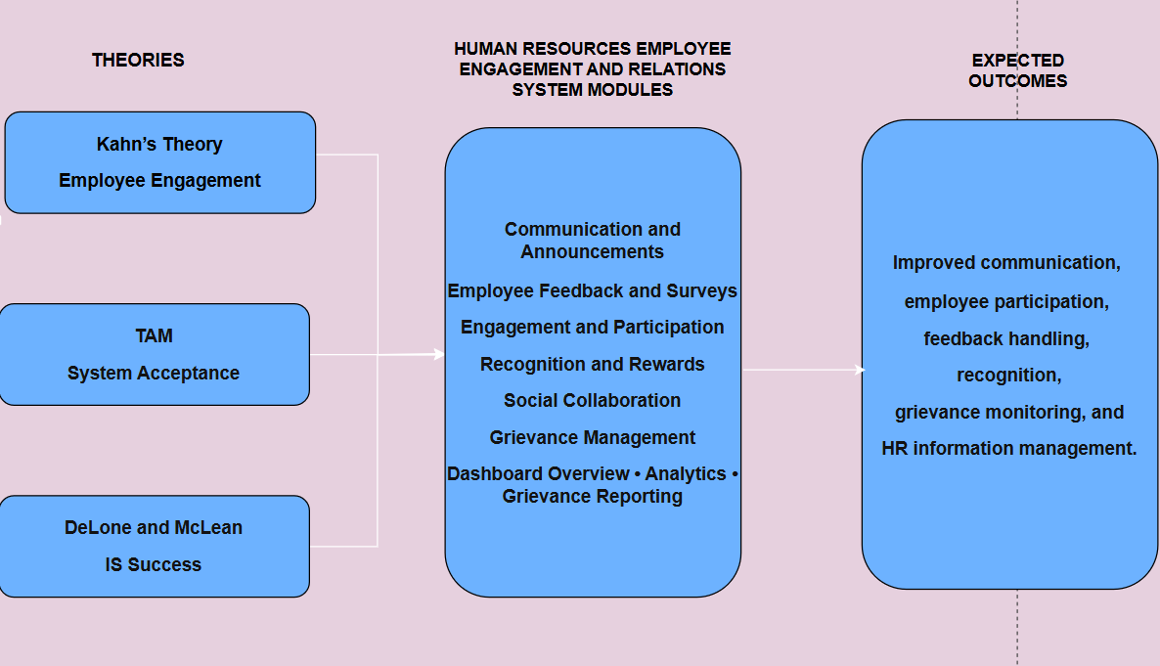
Figure no.6 Theoretical Framework

THEORETICAL FRAMEWORK

Three theories and models back the Human Resources Employee Engagement and Relations System for Bestlink College of the Philippines – Bulacan Campus. These include Kahn's Need-Satisfaction Theory of Personal Engagement, the Technology Acceptance Model (TAM), and the DeLone and McLean Information Systems Success Model. These theories were chosen because they offer varied yet connected viewpoints for the study. Kahn's theory centers on employee engagement and the mental conditions that encourage involvement at work. TAM centers on how users embrace and utilize technology depending on how useful and easy to use it is. The DeLone and McLean model offers a foundation for assessing the quality, use, satisfaction, and advantages of an information system.

Kahn's Need-Satisfaction Theory of Personal Engagement – William A. Kahn

Focus

Kahn's Need-Satisfaction Theory of Personal Engagement describes employee engagement using three psychological conditions: meaningfulness, safety, and availability. Meaningfulness is the degree to which people see value and purpose in what they do at work. Safety is a setting in which people can speak up and take part without worrying about bad outcomes. Availability is the physical, emotional, and psychological resources that let people involve themselves in their roles. Kahn (1990) suggested that these conditions shape how people personally invest themselves in their work.

Application to the Study

Kahn's theory applies to the proposed system because its features allow employees to communicate, provide feedback, answer surveys, participate in supported engagement activities, receive recognition, and raise workplace concerns or grievances. Through these functions, employees gain structured ways to take part in activities tied to their workplace experience.

In this study, Kahn's theory backs the employee-centered aim of the system, especially its emphasis on communication, participation, feedback, recognition, and grievance management. The theory helps clarify why it matters to give employees reachable chances to voice their views and join in employee-related activities.

Technology Acceptance Model (TAM) – Fred D. Davis
Focus

Fred D. Davis created the Technology Acceptance Model to describe the way users come to accept and adopt information technology. According to this model, perceived usefulness and perceived ease of use are key factors that shape whether people accept technology. Perceived usefulness is how much a person thinks a system will help them do tasks better, and perceived ease of use is how much a person thinks the system will take little effort to operate (Davis, 1989).

Application to the Study

TAM fits the proposed system since the intended users are both employees and authorized Human Resource personnel. Employees could use the system to read announcements, answer surveys, give feedback, join supported social features, check recognition information, and file grievances. Human Resource personnel and administrators could use the system to handle announcements, feedback, survey information, participation records, recognition records, grievances, dashboard information, and related analysis and reporting tasks.

For this study, TAM offers a way to find out whether the intended users see the proposed system as useful and easy to use. When a system helps with employee-related activities without causing needless trouble, users may be more willing to use its features the way they are meant to be used.

DeLone and McLean Information Systems Success Model – William H. DeLone and Ephraim R. McLean

Focus

The DeLone and McLean Information Systems Success Model offers a framework for judging whether an information system is successful. This model treats system quality, information quality, service quality, system use or intention to use, user satisfaction, and net benefits as key dimensions of information system success (DeLone &amp; McLean, 2003). These dimensions show that an information system should work well, but it should also give useful information, help its users, encourage proper use, and deliver real benefits.

Application to the Study

The DeLone and McLean model matters for the proposed system because how good the system is, and how good the information it gives, may affect how employees and Human Resource personnel use it. System quality can be judged by things like functionality, usability, reliability, and accessibility. Information quality can be judged by how accurate, organized, relevant, and accessible the announcements, survey responses, feedback records, recognition records, grievance records, dashboard information, and reports are.

The model also gives a way to look at system use, user satisfaction, and benefits. The planned system aims to offer well-organized processes and information that help with communication, feedback, participation, recognition, and handling of grievances. These areas can be checked to see if the system meets the needs of the people it is meant for and gives helpful support to the Human Resource Department.

The three theories and models give supporting foundations that work together for the creation and assessment of the Human Resources Employee Engagement and Relations System. Kahn’s theory gives the employee engagement view by describing the conditions that allow meaningful participation and self-expression. TAM gives the technology acceptance view by looking at whether users find the system useful and easy to use. The DeLone and McLean model gives the information system evaluation view by looking at system quality, information quality, use, user satisfaction, and benefits.

When put together, these views link the human, technological, and system evaluation parts of the study. Kahn’s theory backs the goal of giving employees organized ways to take part and communicate. TAM supports the need for a system that employees and Human Resource personnel can access and use according to their assigned functions. The DeLone and McLean model backs the checking of whether the finished system gives quality information and satisfactory system performance.

So, the three theories and models steer the study in building a system that supports chosen Employee Engagement and Relations activities, while also giving a basis for judging its usability, acceptance, information quality, system quality, and perceived benefits.
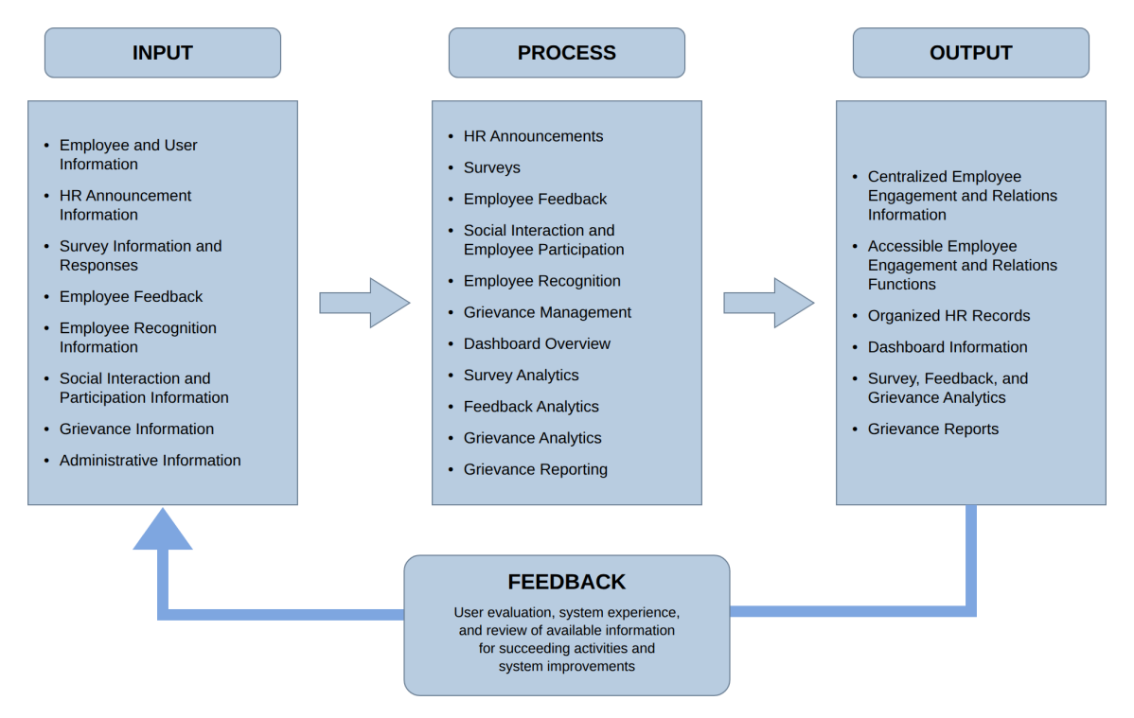FIgure no.7 Conceptual Framework
CONCEPTUAL FRAMEWORK

The conceptual framework portrays the flow of information within the Human Resources Employee Engagement and Relations System through the Input-Process-Output (IPO) Model, with a feedback mechanism. It provides the information input, the functions that process and manage the information, and the results provided to the employees, authorized Human Resource personnel, and administrators.

The conceptual framework is connected to the theories and models that were used in the research, where Kahn's Need-Satisfaction Theory of Personal Engagement provided the basis for incorporating the employee engagement component. The Technology Acceptance Model provided a basis for considering the perceived usefulness and perceived ease of use, and the DeLone and McLean Information Systems Success Model provided a basis for evaluating the system quality, information quality, system use, user satisfaction, and benefits provided by the system.

INPUT

The input represents the information required by the system to carry out the selected Employee Engagement and Relations functions.

Employee and User Information – Information related to user accounts, authentication, authorization, system access, and linking the appropriate records to the users.

Feedback and Survey Information – Employee feedback, suggestions, comments, survey information, and survey responses submitted through the system.

Human Resource Announcements and Information – Official Human Resource announcements, policy updates, notices, reminders, and other employee-related information.

Recognition and Reward Information – Information related to employee achievements, nominations, awards, badges, points, and available rewards maintained through the system.

Grievance Information – Employee grievances and related supporting information submitted for review, monitoring, status updates, remarks, resolutions, and other appropriate actions by authorized Human Resource personnel.

Participation and Social Collaboration Information – Information from employee participation through posts, forums, groups, projects, comments, and reactions that are supported by the system.

Administrative Information – Information used by authorized Human Resource personnel and administrators to manage, monitor, and review the available Employee Engagement and Relations functions based on their assigned roles and permissions.

PROCESS
The process represents how the system receives, manages, processes, and presents information through its selected functions.

Centralized HR Announcements – Authorized users create, manage, and publish official HR announcements, policy updates, notices, reminders, and other employee-related information. Employees can access the announcements that are available to them through the system.

Employee Feedback and Surveys – Employees submit feedback, suggestions, comments, and responses to the available surveys. Authorized users can manage the surveys and review the available response and feedback records.

Employee Participation and Social Collaboration – Employees participate through the supported posts, forums, groups, and projects, and can interact through comments and reactions.

Employee Recognition and Rewards – The system manages the information related to employee achievements, nominations, awards, badges, points, and available rewards.

Grievance Management – Employees submit grievances through the system, while authorized Human Resource personnel review the records, update their status, and document the appropriate remarks, resolutions, and related information.

Dashboard Overview – Authorized Human Resource personnel and administrators access a centralized view of the summarized information of the available Employee Engagement and Relations records.

Survey, Feedback, and Grievance Analytics – The system provides descriptive summaries based on the available survey, feedback, and grievance records. These summaries include survey response information, feedback information by category, and grievance information by status. The analytics support the review and monitoring of the records available in the system and do not include predictive or advanced analytics.

Grievance Reporting – The system organizes available grievance-related records for report generation to support the review and monitoring of the grievances.

OUTPUT
The output represents the information and results produced after the system processes employee and Human Resource information.

Centralized Employee Engagement and Relations Information – Stores and manages information related to HR announcements, feedback, surveys, employee participation and social collaboration, employee recognition and rewards, and grievances.

Accessible Employee Engagement and Relations Functions – Employees can use the system to access HR information, respond to surveys, provide feedback, participate in supported social features, view recognition-related information, and submit grievances.
Human Resource Records – Authorized Human Resource personnel and administrators can access and manage relevant employee engagement and workplace relations records according to their assigned roles and permissions

Dashboard Information – The Dashboard Overview provides the authorized users with selected summaries of the available Employee Engagement and Relations information.

Survey, Feedback, and Grievance Analytics – The system produces descriptive information based on the available survey, feedback, and grievance records to support review and monitoring by authorized Human Resource personnel and administrators.

Grievance Reports – The system generates reports from available grievance-related records to support Human Resource personnel in reviewing and monitoring grievances

FEEDBACK
The feedback mechanism establishes a continuing connection between the output of the system and the information that is used in succeeding Employee Engagement and Relations activities. The information obtained from employee feedback, survey responses, social participation, recognition records, and grievances can be reviewed by the authorized Human Resource personnel and administrators during the management of the appropriate functions of the system.

The user evaluation and experience with the system can also provide information about its perceived usefulness, perceived ease of use, system quality, information quality, system use, user satisfaction, and benefits. These aspects connect the feedback mechanism to the Technology Acceptance Model, and the DeLone and McLean Information Systems Success Model.

In this regard, the conceptual framework highlights that the system does not only receive and produce information through a one-way process. The available outputs and user feedback can be reviewed and considered in succeeding activities and system improvements. Thus, establishing a continuous flow between the information entered into the system, the functions that process it, the results produced, and the feedback obtained from its users.

1.2 Context and Scope
The Human Resources Employee Engagement and Relations System was created for the Human Resource Department of Bestlink College of the Philippines – Bulacan Campus. It supports selected employee engagement and workplace relations tasks, such as HR announcements, employee feedback, surveys, recognition, social interaction, and grievance management.

The system offers a web-based platform for employees, authorized Human Resource personnel, and administrators. Employees can view HR announcements, answer available surveys, provide feedback, use supported social features, access recognition-related information, and submit grievances. Authorized Human Resource personnel and administrators can manage announcements, surveys, feedback, recognition records, and grievance records. They can also review related dashboard information and reports.

The system arranges the records created by these activities and includes features for reviewing and monitoring the information available on the platform. Its Survey, Feedback, and Grievance Analytics provide descriptive summaries based on the available survey, feedback, and grievance records. These analytics do not include predictive or advanced analytics. The system supports selected Human Resource processes but does not replace other institutional systems or functions that are outside the project’s scope.

Scope

The Human Resources Employee Engagement and Relations System covers the following functions:

1. Centralized HR Announcements
Authorized users can create and publish announcements related to employees through the system. Announcements may contain details such as a title, category, priority, and intended audience. Employees can view the announcements made available to them through the system.

2. Employee Feedback and Surveys

The system includes an HR feedback feature that allows users to give feedback about selected employees, as well as employee satisfaction and pulse surveys. Authorized users can examine the available feedback and survey responses. While certain forms offer an anonymity option, the underlying records still contain an employee ID; consequently, the system should not be presented as guaranteeing anonymity.
3. Employee Participation and Social Collaboration
Through available surveys and social features, including posts, forums, groups, and projects, the system enables employee participation. Users can interact through comments and reactions. The system does not include a dedicated poll feature.

4. Employee Recognition and Rewards
The system includes features for recording and viewing employee recognition, achievements, nominations, awards, badges, points, and available rewards. It also offers recognition-related features, including leaderboards and Employee of the Month.

5. Grievance Management
Employees may submit grievances through the system. Authorized Human Resource personnel can update grievance statuses within the system only through the Engagement Grievance Management feature. This feature also enables them to review grievance records and document remarks, resolutions, and escalation information. The system can generate reports using available grievance records.

6. Dashboard Overview
The Dashboard Overview gives authorized Human Resource personnel and administrators access to summaries of available employee engagement and relations information. This information includes records concerning announcements, surveys, feedback, recognition, and grievances.

7. Survey, Feedback, and Grievance Analytics
The system provides descriptive summaries based on the available survey, feedback, and grievance records. These include survey response information, feedback information by category, and grievance information by status. The Dashboard Overview may also display social-post information based on available keyword data to support the monitoring of social interaction activities. The analytics are descriptive only and do not include predictive or advanced analytics.

8. Grievance Reporting
The system organizes available grievance-related records for report generation. These reports support authorized Human Resource personnel and administrators in reviewing and monitoring grievance information.

The system uses the user and employee details needed for authentication and for linking records to users. Management features are intended to be accessed only by authorized users, based on the functions assigned to their accounts.

1.3 Problem Statement
The Human Resource Department of Bestlink College of the Philippines – Bulacan Campus manages employee engagement and workplace relations activities, including announcements, feedback, surveys, employee participation, recognition, social interaction, and grievances. After gathering initial requirements, consulting relevant individuals, and making observations, the researchers identified the following challenges:

• HR Announcements and Information
Announcements, notices, and reminders related to employees may be distributed through various communication channels. Consequently, employees may have difficulty finding earlier information, and Human Resource personnel may have to keep announcement records in separate locations.

• Employee Feedback and Surveys
Feedback and survey answers may be gathered using different methods. Arranging these records and examining them later may take extra time and effort.

• Employee Engagement and Participation
Records of employee participation in surveys and other engagement activities must be kept and evaluated. If participation details are stored separately, authorized users may have more difficulty tracking how employees are involved.

• Employee Recognition and Rewards
Employee accomplishments, nominations, awards, and other recognition activities need to be recorded and managed within the system. When these records are kept separately, reviewing recognition details and tracking related activities may require more time and effort.

• Employee Communication and Social Interaction
Employees need convenient ways to share ideas, provide comments, and join workplace discussions. If these interactions occur across different channels, organizing the related information and participation may be more challenging.

• Employee Grievances
Grievances must be properly documented and followed up. If grievance details are managed using different methods, keeping records and tracking their status may be difficult.

• Monitoring and Reporting
Human Resource personnel and authorized administrators need well-organized information to track employee engagement, feedback, participation, recognition, and grievances. If relevant information is kept separately, reviewing records and creating grievance-related reports may take more effort.

These difficulties show the need for a system that brings the selected employee engagement and relations activities together on one platform. The proposed Human Resources Employee Engagement and Relations System meets this need by providing HR announcements, feedback and survey management, social and engagement features, recognition, grievance management, dashboard summaries, and grievance reporting.

1.4 Objectives and Goals
The main objective of this capstone project is to create, implement, and assess a Human Resources Employee Engagement and Relations System that facilitates communication, feedback management, employee involvement, recognition, and grievance handling at Bestlink College of the Philippines – Bulacan Campus.

Specific Objectives
More specifically, the project seeks to:

- Create a centralized feature for preparing and sharing HR announcements, notices, reminders, and other official information related to employees.
- Offer HR feedback, satisfaction, and pulse survey features, along with the ability to review the responses received.
- Encourage employee involvement and social interaction through the system’s features, including posts, forums, groups, projects, comments, and reactions.
- Offer recognition features for documenting employee achievements, nominations, awards, badges, points, and available rewards.
- Create a grievance management feature that enables employees to submit grievances and authorized Human Resource personnel to review and modify grievance records.
- Provide an administrative Dashboard Overview that presents selected summaries of available Employee Engagement and Relations information for authorized Human Resource personnel and administrators.
- Provide Survey, Feedback, and Grievance Analytics that present descriptive summaries based on the available survey, feedback, and grievance records.
- Provide reports based on the available grievance-related records.
- Assess the system based on the project’s stated requirements and evaluation standards.

Goals
The project is intended to provide the Human Resource Department with one centralized system for selected employee engagement and relations tasks, allowing authorized personnel to review and monitor related information through the system.

The system is also designed to help employees access HR information, answer surveys, share feedback, use supported social features, view recognition-related information, and submit grievances.

For authorized Human Resource personnel and administrators, the system provides access to employee engagement and relations records, dashboard summaries, and grievance reports for monitoring and administrative review.

1.5 Significance and Relevance

The Human Resources Employee Engagement and Relations System for Bestlink College of the Philippines – Bulacan Campus matters because it offers one central place for chosen activities involving employee engagement and workplace relations. The system aims to help employees, authorized Human Resource staff, administrators, and the institution handle and reach information that falls within the project's set scope.

Human Resource Department
This system can assist the Human Resource Department in keeping HR announcements, feedback, surveys, recognition records, social interactions, and grievances together on a single platform. The Dashboard Overview provides selected summaries of the available Employee Engagement and Relations information, while the Survey, Feedback, and Grievance Analytics support the review and monitoring of available survey, feedback, and grievance records. The Grievance Reporting feature also supports the review and monitoring of grievance-related records.

Employees
Through the system, employees can reach HR announcements, answer satisfaction and pulse surveys, give feedback, take part in the available posts, forums, groups, and projects, and engage using comments and reactions. They can likewise check recognition-related information and file grievances using the system. These features give employees orderly ways to communicate, take part, and raise workplace concerns.

Administrators
Authorized administrators can reach the features assigned to their accounts and go over the relevant employee engagement and relations information in the system. The Dashboard Overview can give them descriptive summaries that may help in monitoring the records found in the system.

Bestlink College of the Philippines – Bulacan Campus
The project can give the institution a centralized way to handle chosen employee engagement and workplace relations activities. By putting related records together on one platform, the system can help make access to employee-related information more orderly within the project's set scope
Future Researchers and Developers
This study can serve as a reference for future researchers and developers who intend to build systems tied to employee engagement, Human Resource information management, feedback and survey management, employee recognition, social interaction, or grievance management. The project can also offer a starting point for later improvements and connected studies.

1.6 STRUCTURE OF THE DOCUMENT
This capstone project is organized into three chapters. Each chapter presents a different part of the development and documentation of the Human Resources Employee Engagement and Relations System for Bestlink College of the Philippines – Bulacan Campus.

METHOD | DESCRIPTION
CHAPTER 1 INTRODUCTION | Introduces the Human Resources Employee Engagement and Relations System, including its background, context and scope, identified problems, objectives and goals, significance and relevance, structure of the document, theoretical framework, and conceptual framework.
1.1 Background of the Capstone Project | Describes the employee engagement and workplace relations activities handled by the Human Resource Department, the challenges in managing communication, feedback, participation, recognition, social interaction, and grievances, and the need for a centralized system.
1.2 Context and Scope | Describes the intended users, functions, activities, system boundaries, analytics, reporting, and other areas covered by the Human Resources Employee Engagement and Relations System.
1.3 Problem Statement | Identifies the problems related to HR announcements, employee feedback and surveys, participation, recognition, social interaction, grievance management, monitoring, and reporting that the proposed system aims to address.
1.4 Objectives and Goals | States the general and specific objectives of the project, including centralized HR announcements, feedback and surveys, employee participation and social interaction, recognition, grievance management, dashboard monitoring, analytics, grievance reporting, and system assessment.
1.5 Significance and Relevance | Explains the relevance of the proposed system to the Human Resource Department, employees, authorized administrators, Bestlink College of the Philippines – Bulacan Campus, and future researchers and developers.
1.6 Structure of the Document | Briefly presents the organization, contents, and purpose of each chapter of the capstone documentation.
Theoretical Framework | Presents Kahn’s Need-Satisfaction Theory of Personal Engagement, the Technology Acceptance Model, and the DeLone and McLean Information Systems Success Model as the theoretical bases of the study.
Conceptual Framework | Presents the Input-Process-Output model with a feedback mechanism, showing how employee and Human Resource information enters the system, is processed through its functions, and produces organized outputs.
CHAPTER 2 RELATED LITERATURE, STUDIES, AND TECHNICAL BACKGROUND | Presents the literature, studies, technical concepts, architecture references, and other related information that support the development of the Human Resources Employee Engagement and Relations System.
2.1 Agile Scrum Methodology Overview | Explains the Agile Scrum methodology and its concepts as a reference for the development approach used in the project.
2.2 Enterprise Architecture Concepts | Discusses Enterprise Architecture and the concepts of Business Architecture, Data Architecture, Application Architecture, and Technology Architecture in relation to information systems.
2.3 Monolithic Architecture | Discusses the characteristics of monolithic architecture and its relevance to the web-based architecture used by the proposed system.
2.4 DevOps and CI/CD | Presents the concepts of DevOps and Continuous Integration and Continuous Deployment and discusses their relevance to software development, testing, deployment, and maintenance.
2.5 Relevant Studies and Research | Presents previous studies related to Human Resource Information Systems, employee engagement, employee relations, digital HR technologies, feedback, recognition, and grievance management.
2.6 Integration of Information Systems in Enterprise Environments | Explains how information systems can support organizational processes and how the proposed system connects selected Employee Engagement and Relations activities within a centralized web-based environment.
CHAPTER 3 METHODOLOGY AND PROJECT MANAGEMENT | Explains how the project is planned, developed, managed, organized, integrated, and documented using the Agile Scrum approach and selected architecture concepts.
3.1 Agile Scrum Methodology in the Project | Explains how the Agile Scrum approach is applied during the development of the Human Resources Employee Engagement and Relations System.
3.2 Roles and Responsibilities | Identifies the roles and responsibilities assigned to the members of the development team during the project.
3.3 Sprint Cycles | Explains how system requirements and functions will be planned, developed, tested, reviewed, and improved during the project sprints.
3.4 Scrum Artifacts | Describes the Scrum artifacts and project management materials used to organize, track, and monitor system requirements and development activities.
3.5 Integration Approach for Information Systems | Explains how the selected system functions and related information are connected within the centralized web-based application.
3.6 Monolithic Architecture | Describes the monolithic architecture implemented in the proposed system, including its single application structure and centralized MySQL database.
3.7 Introduction to TOGAF and the Four Architecture Domains | Introduces TOGAF and discusses the Business, Data, Application, and Technology Architecture domains as references for describing the proposed system.
Table no.1 Structure of the Document

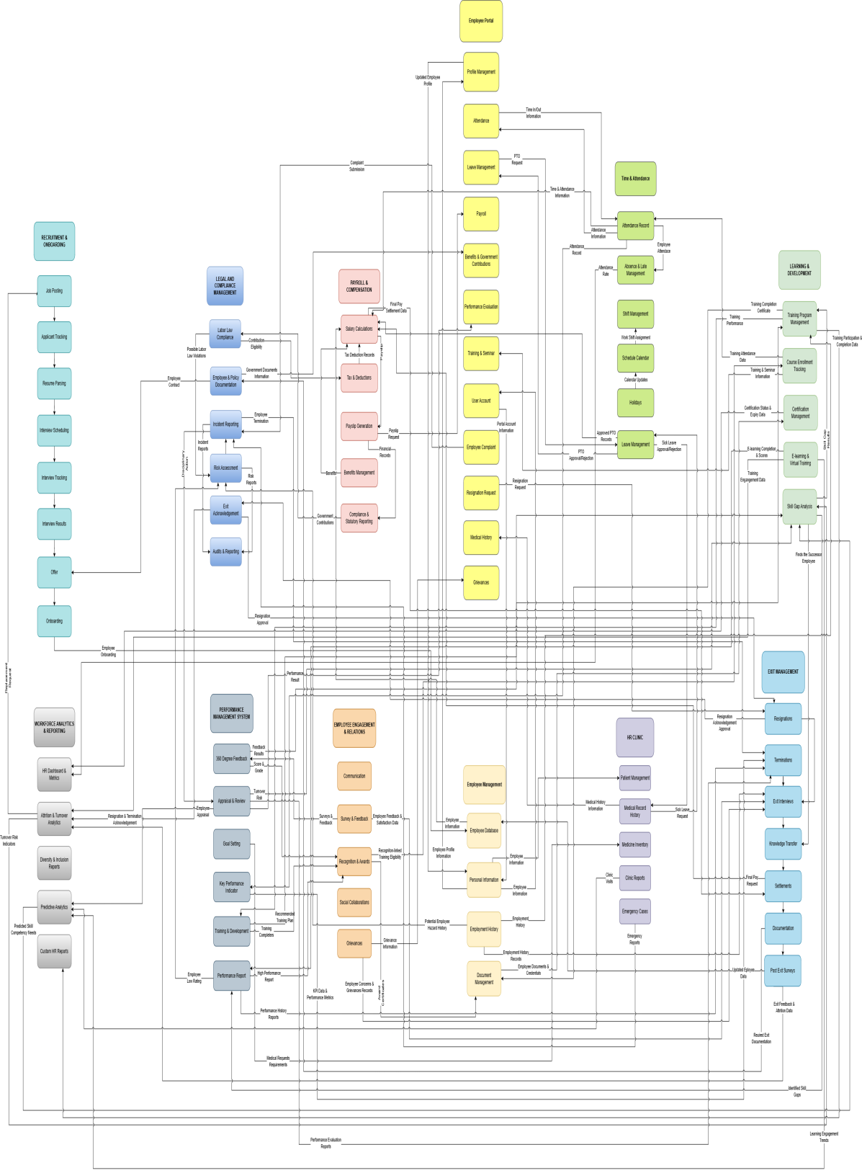
Figure no.1 BPA TOP LEVEL 1
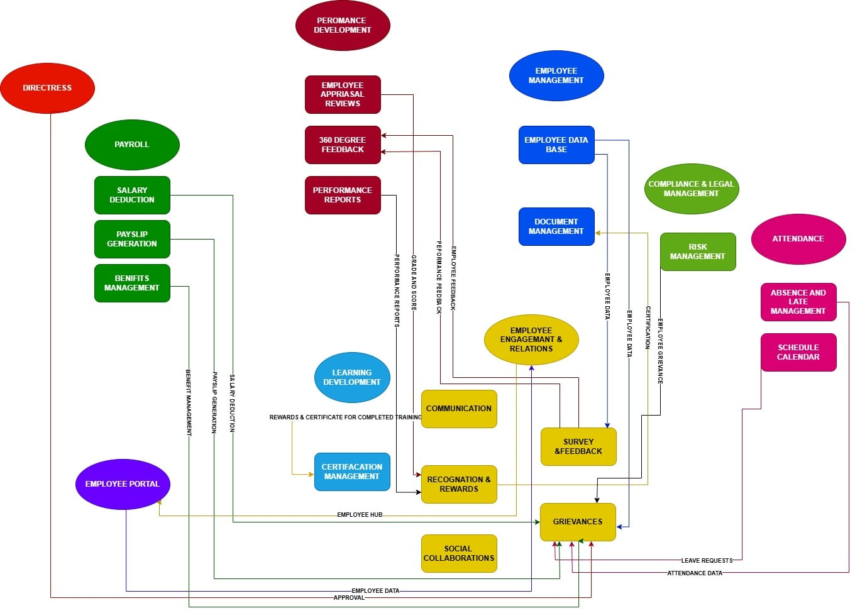Figure no.2 BPA TOP LEVEL 2
MODULE | DATA | CONNECTED MODULE
Communication | Announcements, HR notifications, employee messages | Employee Portal
Communication | Employee feedback and communication updates | Performance Development
Survey & Feedback | Survey forms and responses | Employee Management
Survey & Feedback | 360-degree feedback and performance feedback | Performance Development
Recognition & Rewards | Recognition records, points, badges, awards | Performance Development
Recognition & Rewards | Rewards and certificates for completed training | Learning & Development
Grievances | Grievance records, status and updates | Employee Management
Grievances | Related payroll information | Payroll
Grievances | Related attendance information | Time & Attendance
Grievances | Grievance investigation and compliance information | Compliance & Legal Management
Social Collaborations | Posts, comments, and reactions | Employee Management
Social Collaborations | Groups, members, and project spaces | Employee Portal
Figure no.3 BPA TOP LEVEL 3

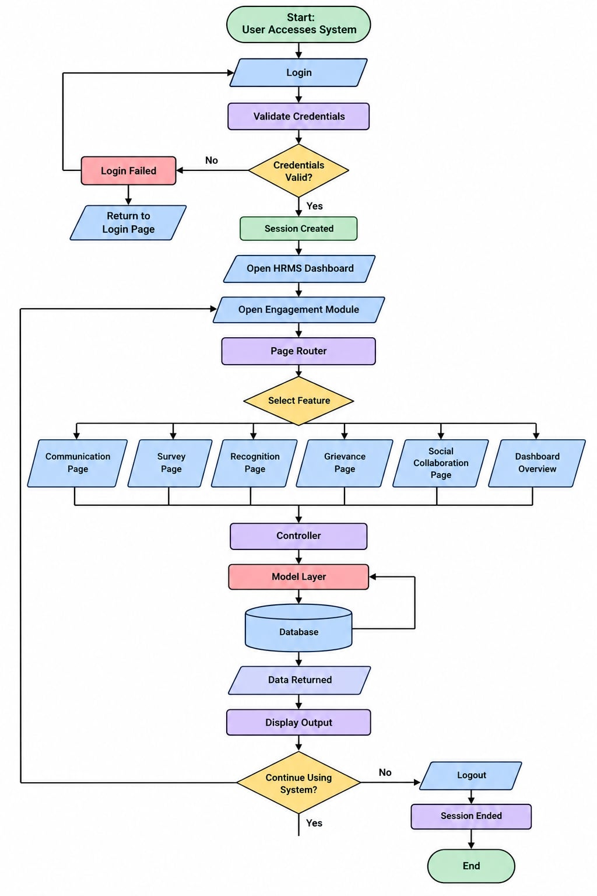
Figure no.4 System Flowchart
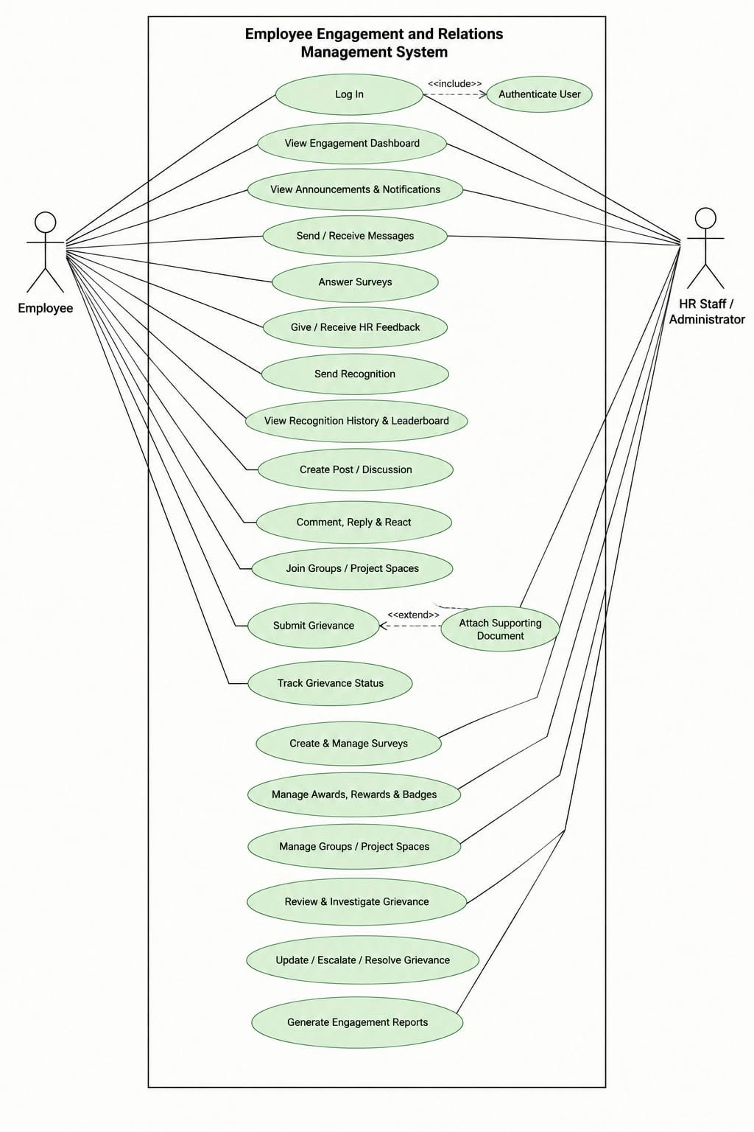
Figure no.5 Use Case Diagram

CHAPTER 2

RELATED LITERATURE, STUDIES, AND TECHNICAL BACKGROUND
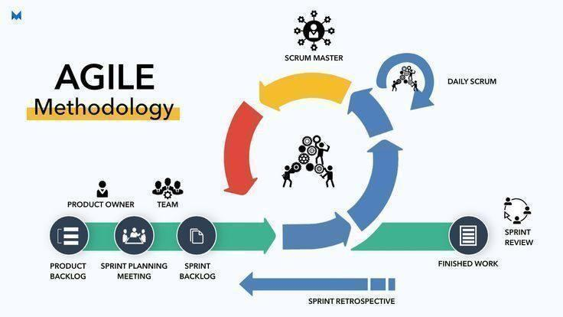
Figure no.8 Agile Scrum Methodology

2.1 AGILE SCRUM METHDOLOGY OVERVIEW
Agile Scrum is an iterative approach of building software that breaks development work down into smaller, more manageable cycles. Rather than building the whole system in one go, the development team focuses on chosen requirements for a set period, examines the outcomes, and refines them according to the needs that emerge. Thanks to this way of working, the team can modify the system as requirements grow clearer throughout development.

Scrum relies on an incremental approach, where system requirements are gathered into a Product Backlog and chosen items are built during a Sprint. A Sprint is a set timeframe during which the development team strives to finish a chosen set of requirements. Once a Sprint ends, the finished work can be examined and serve as the foundation for further refinements (Schwaber &amp; Sutherland, 2020).

Agile Scrum typically features three main roles: the Product Owner, the Scrum Master, and the Developers. The Product Owner's job is to maximize the product's value and to manage the Product Backlog. The Scrum Master upholds the Scrum process and assists the team in overcoming obstacles. Developers are tasked with producing the product increment and finishing the work needed during the Sprint (Schwaber &amp; Sutherland, 2020).

Scrum additionally relies on artifacts like the Product Backlog, Sprint Backlog, and Increment. The requirements and work the product needs are held in the Product Backlog. The work chosen for a given Sprint is held in the Sprint Backlog. The Increment stands for the usable outcome generated during the Sprint. Such artifacts assist the development team in arranging requirements and tracking progress.

When applied to the Human Resources Employee Engagement and Relations System, Agile Scrum offers a structured way to build the system in stages. The project can break the development work into smaller sets of requirements concerning HR announcements, feedback and surveys, employee participation and social interaction, recognition, grievance management, dashboard information, analytics, and grievance reporting. Every set of requirements can be planned, built, tested, and examined within the fitting development cycle.

Working iteratively also enables the development team to spot issues while development is underway and make the needed adjustments before moving on to the requirements that follow. Since the project brings together various user functions and information records that must interact inside one centralized application, this proves beneficial for the proposed system.

As a result, Agile Scrum acts as a methodological guide for structuring the development work of the proposed Human Resources Employee Engagement and Relations System. Through its iterative design, the process enables ongoing development, testing, review, and refinement, while giving the team the ability to handle system requirements in smaller, better-organized phases.
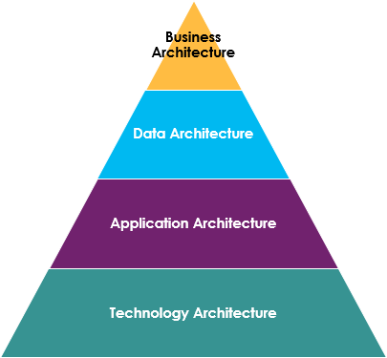

Figure no.9 Enterprise Architecture
2.2 ENTERPRISE ARCHITECTURE CONCEPTS

Enterprise Architecture provides the enterprise’s business process, information, application, and technology functions. It describes how the organization’s combined business capabilities, processes, and information technology to achieve strategic objectives. It is a model that characterizes the structure and relationships between the components of an information system to meet enterprise needs.

The Business Architecture defines business functions and processes that the system must support. The business functions for the proposed Human Resources Employee Engagement and Relations system include employee communication, feedback and surveys, participation, recognition, socialization, and grievance management processes.

The Data Architecture is about the company’s information needed to support its business processes and the data handled by the system. The data handled by the system are employee engagement records, announcements, survey results, feedback, participation records, recognition records, socialization records, and grievance records.

The Application Architecture defines the application functions and operations required to implement the system. It also entails the system users who will interact with the system. The system will offer application components or functions that address employee engagement-related matters. It will provide information services that support employees and other users in meeting organizational objectives. The application will offer two categories of functions: those that will be available to employees and those that will be accessible to Human Resource professionals and administrators. The functions will be availed through dashboards, analytics, and grievance reports. Employees will access the dashboards to participate in the feedback and survey processes, get engaged, recognized, and socialized. The Human Resource professionals and administrators will access the dashboards to monitor employee feedback, grievances, and concerns.

The Technology Architecture specifies the technologies and infrastructure involved in the system implementation. The technologies that will be used to develop and implement the system are PHP, HTML, CSS, JavaScript, MySQL, phpMyAdmin, and XAMPP.

The proposed system’s architecture model was developed using the four architecture domains to define the system’s organizational functions, data, application components, functions, and users, and technology infrastructure to support the intended business strategy and mission.

2.3 MONOLITHIC ARCHITECTURE
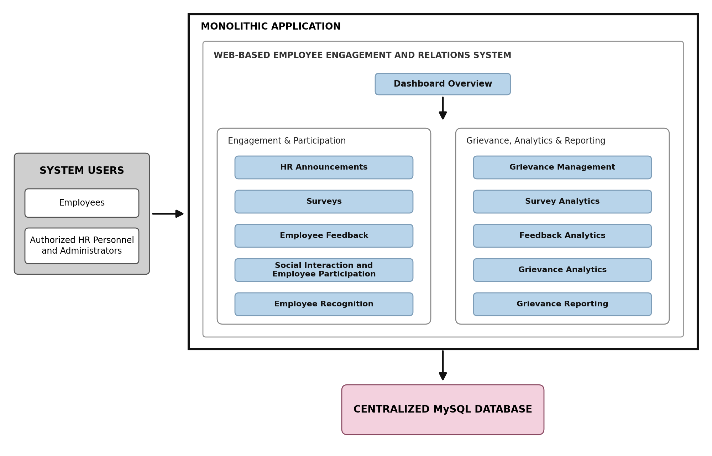

Figure no.10 Monolithic Architecture
A monolithic architecture refers to a software design in which an application's core functions are built and run as one unified system. Within a single application structure, the various components of the application operate together and typically rely on a shared database. Because it offers a more straightforward structure for building and maintaining an application, this approach is often chosen for web-based systems.

Within a monolithic system, features like user management, data processing, and other system capabilities all reside inside the same application. Updates or modifications can be applied inside the application itself, without needing to coordinate multiple separately deployed services. This tends to make the architecture simpler to comprehend and administer, particularly for systems that have a well-defined set of functions and a constrained development environment.

A key benefit of monolithic architecture lies in its more straightforward approach to development and deployment. Because the system runs as a single application, the development team is able to handle the source code, database connection, testing, and deployment all within one shared environment. As a system grows larger, though, maintaining and updating a single application can grow harder, since a change in one area may ripple into other areas of the system.

Monolithic architecture is applicable to the proposed Human Resources Employee Engagement and Relations System, since that system is built as a single web-based application backed by a centralized MySQL database. The chosen features — HR announcements, feedback and surveys, employee participation and social interaction, recognition, grievance management, dashboard information, analytics, and grievance reporting — all function inside the same application.

2.4 DevOPS and CI/CD
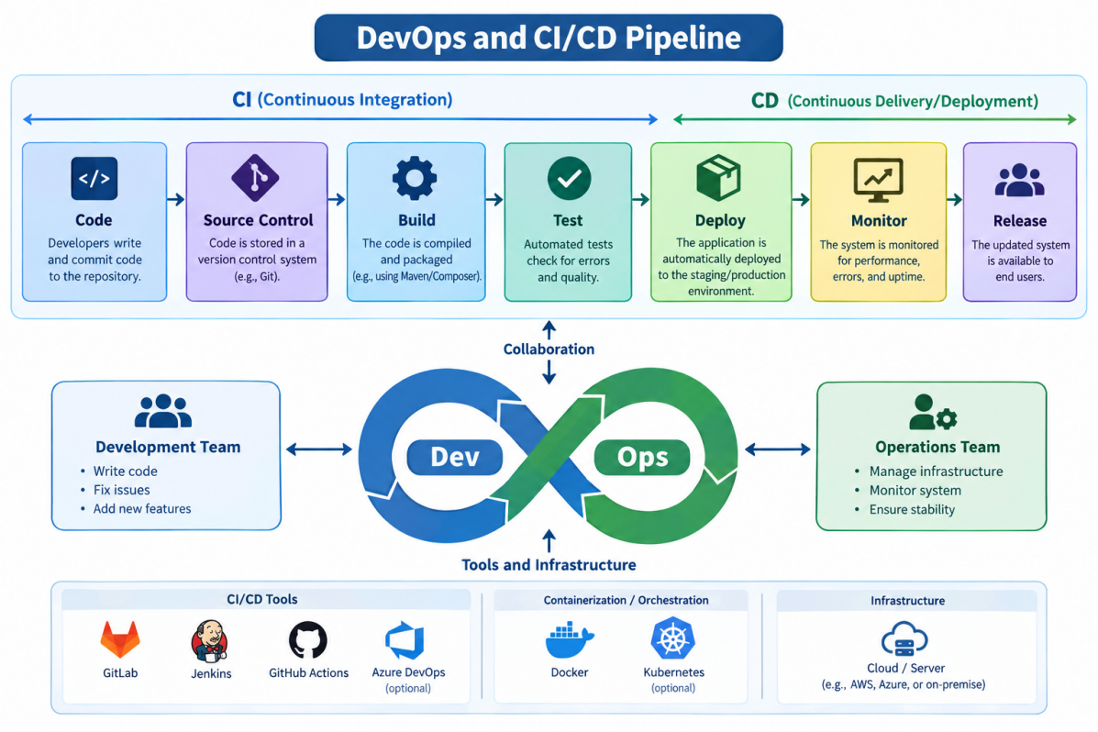Figure no.11 DevOps and CI/CD
DevOps is a way of building software that connects development work with operations work and promotes teamwork among everyone who creates and delivers software. Across the whole software life cycle, it combines tasks like development, testing, integration, deployment, and maintenance. Faustino et al. (2022) reported that the benefits of DevOps most often mentioned are stronger collaboration, quicker software delivery, better synergy, and automation. These results suggest that DevOps is a mix of practices that help develop and deliver software, not something that relies on a single tool or technology.

Two practices often tied to DevOps are Continuous Integration (CI) and Continuous Delivery or Continuous Deployment (CD). Continuous Integration means carrying out frequent tasks to integrate and validate changes made to a software project. Soares et al. (2022) looked at 101 empirical studies on Continuous Integration and discovered positive effects on development activities, software processes, quality assurance, integration, issues and defects, and build practices. The study also pointed out that CI can bring technical and process-related difficulties for development teams.

DevOps can also be viewed in connection with the various stages of the software life cycle. Amaro et al. (2025) studied how DevOps capabilities relate to software life-cycle processes. Their study presents DevOps as an approach that can enable faster and more dependable software development and delivery while stressing collaboration between development and operations. The study also covers the difficulties of aligning the technical, process, cultural, and measurement sides of adopting DevOps.

For the Human Resources Employee Engagement and Relations System, DevOps and CI/CD concepts serve as a guide for arranging development, testing, deployment, and maintenance work. This matters for the project since the system has many linked functions, such as HR announcements, employee feedback and surveys, employee participation and social collaboration, employee recognition and rewards, grievance management, dashboard information, analytics, and grievance reporting.

The DevOps and CI/CD ideas tied to the project can be explained through these activities:

Code Development

While developing code, the researchers build and enhance the various functions of the Human Resources Employee Engagement and Relations System according to the requirements set for the project. The work involves creating and improving functions for HR announcements, employee feedback and surveys, employee participation and social collaboration, employee recognition and rewards, grievance management, dashboard information, analytics, and grievance reporting.

The development process also includes verifying that new functions work correctly with the rest of the system. This matters because the system has connected functions that rely on data kept in the central database. Whenever updates happen, the researchers look at each function on its own and also at how it connects to other processes in the system.

Repository

A repository is where the source code and other project files are kept and organized. It gives a well-organized place to keep project files and to follow the changes made while the project is being developed.

Version control is one of the methods tied to DevOps and to managing the software life cycle. Amaro et al. (2025) studied DevOps capabilities alongside software life-cycle processes, and showed how development capabilities can be linked to the various stages of building and maintaining software.

In this project, the repository helps the development work by letting the researchers keep source code in order and handle the changes made to the system.

Integration and Testing
Testing is done to see whether the system works as it should and whether a change in one part of the system affects other connected functions. The researchers test the system's functions and look at how data moves between the different parts of the application and the central MySQL database.

The tests can cover employee feedback and survey submission, HR announcements, posts, comments and reactions, recognition records, grievance submission and status management, dashboard information, analytics, and grievance reporting. These tests help the researchers spot functional and integration issues while the system is being built.

Continuous Integration helps teams integrate and check software changes on a regular basis. Soares et al. (2022) discovered that CI brings good results in many parts of software development, such as development work, software processes, quality assurance, integration, and dealing with issues and defects. At the same time, the study pointed out technical and process problems that can come up when CI is used.

The project does not say that every CI activity runs through a completely automated CI pipeline. Rather, the implementation centers on how the development team integrates changes, tests system functions, finds errors, and fixes problems as development goes on.

Deployment

Once the system's features are built and checked, the application can be readied for release into the setting it was made for. While building the system, the researchers rely on XAMPP as a local setup to run the PHP application and the MySQL database. This makes it possible to build and test the system before readying it for the environment where it will run.

Deployment is one stage of the software life cycle, since software that has been built and tested must at some point be placed in an environment where it can work. Amaro et al. (2025) looked at DevOps capabilities alongside software life-cycle processes, such as those tied to software development and delivery.

In this project, deployment means readying and placing the finished and tested Human Resources Employee Engagement and Relations System into the environment where it is meant to run.

Production
The production environment is the setting in which the finished system is made available to the people it was built for. For the proposed system, these users are employees, authorized Human Resource personnel, and administrators.

Employees can use the system to read HR announcements, complete surveys, give feedback, use the supported social features, see recognition-related information, and file grievances. Authorized Human Resource personnel and administrators can handle related records and go over the available information based on the functions assigned to them.

Because the system's functions are linked, it only works properly when the information each function needs is processed correctly and is available. Testing before deployment helps the researchers spot issues that could get in the way of how the system runs.

Monitoring and Maintenance

Monitoring and maintenance matter once a system has been built and deployed, because it may still need to be checked, fixed, and improved. Amaro et al. (2025) looked at DevOps capabilities alongside software life-cycle processes and stressed how DevOps practices relate to software development and maintenance.

In the proposed system, monitoring and maintenance mean checking how the system runs and fixing issues found during testing or real use. The researchers can also look at how the database works and how related system functions interact with each other. These tasks help keep the system running and give a starting point for future upgrades.

DevOps and CI/CD provide a development approach that connects software development, testing, integration, deployment, operation, and maintenance. For the Human Resources Employee Engagement and Relations System, these ideas act as a guide for planning development and testing work, handling system changes, getting the application ready for deployment, and fixing problems during maintenance. The project does not claim to include every automated feature that modern CI/CD pipelines usually have. Rather, it uses relevant DevOps principles by developing, testing, integrating, deploying, and continuously improving the system.

2.5 RELEVANT STUDIES AND RESEARCH

LOCAL

“HRMS-Empowered Employee Engagement Decision Support System”
In 2025, Cabauatan, Isidro, Pereira, Valdez, Palapuz, Agravante, Boyang, and Lardizabal created the “HRMS-Empowered Employee Engagement Decision Support System” to help with certain Human Resource Management tasks. The study looked at tasks for hiring, managing employee profiles, training, judging performance, and handling leave, and it also checked the system's software quality in terms of functionality, performance efficiency, usability, reliability, security, maintainability, and portability. The study demonstrated how an information system can help organize and support Human Resource processes inside an institution. This matters to the proposed system because both projects rely on an information system to support Human Resource tasks that involve employees. Still, the proposed system zeroes in more on Employee Engagement and Relations, especially HR announcements, employee feedback and surveys, employee participation and social collaboration, employee recognition and rewards, and grievance management. So the study serves as a helpful guide for building a centralized system shaped by the specific Human Resource and employee engagement needs of Bestlink College of the Philippines – Bulacan Campus.

Reference:
Cabauatan, C. V., Isidro, J. N. J., Pereira, J., Valdez, M. E., Palapuz, J. J., Agravante, K. A., Boyang, N. C., &amp; Lardizabal, E. (2025). *HRMS-empowered employee engagement decision support system.* Asia-Pacific Journal of Advanced Research and Innovation, 1(1).https://www.ejournals.ph/article.php?id=30786

“Digital Technologies on Personnel Engagement and Retention in Human Resource Management 4.0”*

In 2025, Pinca, Dimaunahan, Simangan, and Lacerona studied how digital technologies affect personnel engagement and retention in Human Resource Management 4.0. The study looked at digital employee experience, digital communication and collaboration, and digital accessibility and how these relate to personnel engagement and retention among employees. The results highlighted how much digital technologies matter for supporting employee-related activities and engagement at work. This study matters to the proposed system because it backs the use of digital tools for communication, collaboration, and employee-related activities. The proposed system puts these ideas to work through centralized HR announcements, employee feedback and surveys, employee participation and social collaboration, employee recognition and rewards, and grievance management. The study backs the use of a web-based information system to organize selected employee engagement and relations activities in a specific organization like Bestlink College of the Philippines – Bulacan Campus.

Reference:
Pinca, J., Dimaunahan, L., Simangan, A. N., & Lacerona, R. (2025). Digital technologies on personnel engagement and retention in Human Resource Management 4.0. Psychology and Education: A Multidisciplinary Journal, 36(2), 215–227. https://www.ejournals.ph/article.php?id=30786

“Human Resource Information System with Digital Archiving”

In 2020, Argana, Sunico, and Francisco developed a Human Resource Information System with Digital Archiving to organize and manage employee-related information through an information system. The study examined the management of records such as leave credits, service records, training and development, employee performance and skills, and office resources. The researchers used the Rapid Application Development model and MySQL in developing the system, and the system was evaluated based on usability, functionality, maintainability, and efficiency. The study showed how Human Resource information can be organized and managed through a centralized computerized system. This is relevant to the proposed project because it also organizes employee-related information in one system instead of relying on separate methods. However, the proposed system has a smaller and more specific scope, focusing on Employee Engagement and Relations activities such as announcements, feedback and surveys, recognition, social interaction, and grievance management. The study therefore provides a useful reference for organizing employee-related records while the proposed system applies the concept specifically to engagement and workplace relations at Bestlink College of the Philippines – Bulacan Campus.

Reference:
Argana, E. S., Sunico, R. J. A., & Francisco, V. C. (2020). Human resource information system with digital archiving. International Journal of Computer (IJC), 39(1), 14–25.https://doi.org/10.53896/ijc.v39i1.1802

FOREIGN

“The Effect of HRIS Implementation Success on Job Involvement, Job Satisfaction and Work Engagement in SMEs”

In 2021, Maamari and Osta examined the relationship between successful Human Resource Information System implementation and job involvement, job satisfaction, and work engagement among employees in small and medium-sized enterprises. The study examined 1,082 responses from 163 SMEs to determine how HRIS implementation success was related to employee work-related outcomes. The findings showed that successful HRIS implementation had a strong effect on job satisfaction, while its effects on job involvement and work engagement were more limited. This study is relevant to the proposed system because it shows the importance of successful HRIS implementation in supporting employee-related experiences and outcomes. The proposed system applies this idea in a different setting by providing centralized functions for HR announcements, feedback and surveys, participation and social collaboration, recognition and rewards, and grievance management. The study therefore supports the importance of developing and implementing an information system that can properly support selected employee-related activities and workplace relations.

Reference:
Maamari, B. E., & Osta, A. (2021). The effect of HRIS implementation success on job involvement, job satisfaction and work engagement in SMEs. International Journal of Organizational Analysis, 29(5), 1269–1286. https://doi.org/10.1108/ijoa-07-2020-2298

“Adopting Human Resource Information System and Work-Related Outcomes in Emerging Market SMEs”

In 2024, Shahreki and Lee examined the adoption of Human Resource Information Systems and their relationship with work-related outcomes among HR employees in small and medium-sized enterprises in Malaysia. The study examined HRIS adoption and its relationship with work-related outcomes associated with creativity and engagement. The findings indicated that effective acceptance and adoption of HRIS can support positive work-related outcomes among HR employees and management. This study is relevant to the proposed system because it emphasizes the importance of users accepting and properly using an information system in the workplace. The proposed system applies this consideration by providing employees and authorized Human Resource personnel and administrators with functions for announcements, feedback and surveys, social collaboration, recognition, and grievance management. The study therefore provides a useful basis for considering user interaction and acceptance when developing an Employee Engagement and Relations system for Bestlink College of the Philippines – Bulacan Campus.

Reference:
Shahreki, J., & Lee, J. Y. (2024). Adopting human resource information system and work-related outcomes in emerging market SMEs: Unified theory of acceptance and use of technology. Cross Cultural & Strategic Management, 31(1), 116–142. https://doi.org/10.1108/ijoa-07-2020-2298

“The Effects of High Performance Work Systems and Leader-Member Exchange Quality on Employee Engagement”

In 2015, Oliveira and da Silva examined the effects of high-performance work systems and leader-member exchange quality on employee engagement in a Brazilian non-profit organization. The study examined how workplace systems and the quality of relationships between employees and leaders were related to employee engagement, and the findings showed that both high-performance work systems and leader-member exchange quality had positive effects on employee engagement. This study is relevant to the proposed system because it highlights the importance of workplace practices and employee relationships in supporting engagement. The proposed system addresses related areas through employee communication, feedback, participation, recognition, social collaboration, and grievance management, which provide employees with ways to interact, share concerns, and participate in selected engagement activities. Although the study focuses on organizational practices and workplace relationships rather than an information system, it provides a useful foundation for understanding the employee engagement and workplace relations areas that the proposed system is designed to support.

Reference:
Oliveira, L. B., & da Silva, F. F. R. A. (2015). The effects of high performance work systems and leader-member exchange quality on employee engagement: Evidence from a Brazilian non-profit organization. Procedia Computer Science, 55, 1023–1030. https://doi.org/10.1108/ccsm-09-2022-0144

2.6 Integration of Information System in Enterprise Environment

Organizations rely on information systems to carry out various activities, processes, and information needs. Since organizations rely on more information systems, they must ensure these systems, along with information and processes, can properly work together. Enterprise Information Systems can assist in bringing together various functional areas of an organization and in supporting organizational and management processes (Annisa et al., 2018).

Information system integration means linking systems, applications, information, and processes so that they work together to support what an organization does. A literature review by Aguirre et al. (2018) describes enterprise information systems integration through technical, business, and socio-organizational integration. This indicates that integration is not just about linking technologies; it also covers the business processes and the people within an organization.

Interoperability also plays a key role in information system integration. Vernadat (2007) states that interoperability lets systems or processes draw on information or functionality from another system or process while adhering to suitable standards. Within an enterprise setting, integration may cover business processes, applications, and information stores. This makes it possible to connect related information and processes rather than treating them as entirely separate activities.

Information system integration can additionally enable better access to information within an organization. Vernadat (2007) states that an integrated enterprise environment can link administrative and business processes, information stores, and systems, giving users a more consistent view. Integration can thus enable access to the information needed, along with reporting and monitoring tasks.

Another key point to consider is how well organizational requirements, business processes, and software systems line up with one another. A systematic literature review by Habba et al. (2019) looked at ways to narrow the gap between business requirements, business processes, and software systems. The study stresses how important it is to keep information systems in line with organizational objectives and processes.

Enterprise Architecture also offers a means of organizing how organizational processes relate to information systems. The TOGAF approach looks at information systems architecture through areas like Data Architecture and Application Architecture, which show how information and applications support the Business Architecture. This link matters when designing an information system, since the functions it performs and the information it handles should back the processes the organization needs to carry out.

For the Human Resources Employee Engagement and Relations System, information system integration falls within the scope of the chosen Employee Engagement and Relations activities. The system puts several connected functions into a single web-based application, including HR announcements, employee feedback and surveys, employee participation and social collaboration, employee recognition and rewards, and grievance management. These functions rely on related employee and Human Resource information that the system keeps and updates.

The integration approach also links the system's dashboard, analytics, and grievance reporting functions to the information that the supported activities generate. For instance, survey responses can be viewed in survey-related summaries, feedback records can be viewed in feedback-related information, and grievance records can be tracked and used for grievance-related reports. This means the information produced by the different functions can be arranged and reviewed inside one system.

The proposed system is not meant to integrate or take the place of all institutional information systems. It covers only the chosen Employee Engagement and Relations activities that fall within the project scope. Payroll, biometric attendance processing, payroll computation, payroll disbursement, and other Human Resource functions beyond the project are not connected as system functions.

CHAPTER 3: METHODOLOGY

3.1 AGILE SCRUM METHODOLOGY IN THE PROJECT

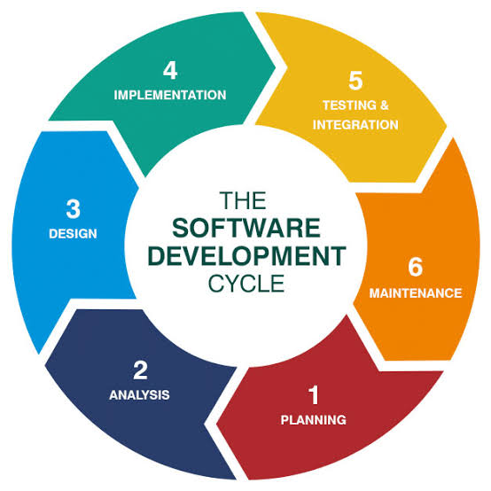
Figure no.12 Agile Scrum Methodology

Agile is a software development approach that emphasizes flexibility, collaboration, improvement, and the gradual development of system functions. Scrum is a framework that falls under Agile and involves organizing a development into short and manageable cycles known as Sprints. Instead of developing the whole system at once, the researchers split the work into smaller tasks and functions that can be developed, tested, reviewed, and improved step by step.
The researchers adapted the approach and adjusted it based on the development requirements of the proposed Human Resources Employee Engagement and Relations System for Bestlink College of the Philippines – Bulacan Campus. They split the development into six major phases that included Analysis, Design, Implementation, Testing, Deployment, and Maintenance. The following are the activities that were done in each phase considering Scrum practices such as Product Backlog preparation, Sprint Planning, discussing and reviewing progress, monitoring, Sprint Review, and Sprint Retrospective:
Analysis Phase – The researchers studied the processes, problems, and requirements related to the project. The researchers gathered and reviewed the related information and processes including how the company currently handles HR announcements, employee feedback and surveys, participation and social interaction, recognition, and grievances. The identified requirements were considered the basis for the functions and tasks included in the development.
Design Phase – The researchers designed the proposed system based on the requirements identified in the previous phase. They developed the necessary system architecture, database structure, user interface, navigation, and process flow. The system functions were also identified, including HR announcements, employee feedback and surveys, employee participation and social collaboration, recognition and rewards, grievance management, Dashboard Overview, Survey, Feedback, and Grievance Analytics, and Grievance Reporting.
Implementation Phase – The researchers implemented the system based on the project requirements. The system was developed using PHP, HTML, CSS, JavaScript, and MySQL. The system functions were developed one after another and connected to the database as the researcher worked on them.
Testing Phase – The researchers tested the implemented functions to identify if they met the requirements. The functions were tested one after another to detect possible errors and problems. The testing was done by exercising the system functions, checking database operations, testing the user inputs and outputs, navigating through the system, checking access permissions, and exercising the interrelated functions. The detected errors and problems were corrected and retested to ensure that they were resolved.
Deployment Phase – The researchers prepared the application and database for the target environment. The application connections and functions were also reviewed and tested to ensure that everything works fine. The target users were also invited to access the application and submit their feedback and suggestions.
Maintenance Phase – The researchers monitored the application for possible errors, usability concerns, and user feedback. The detected errors and concerns were resolved and re-monitored to ensure that everything works fine. The changes and updates considered necessary based on user feedback and system performance were also reviewed and approved. If the changes and updates require further analysis, they were considered during the appropriate activities.
The adapted Agile Scrum approach allowed the researchers to develop the proposed system in manageable steps and make necessary improvements. It also allowed the implementation team to organize and monitor the development considering the requirements to create an application the Human Resource Department and users expect.

3.2 ROLES AND RESPONSIBILITIES
The researchers created roles and responsibilities of each of their members to organize the process of planning, analyzing, developing, testing, documenting, and managing the Human Resources Employee Engagement and Relations System. In turn, each member took their part and the roles helped them plan the process, monitor and control it, solve the problems, and complete the different parts of developing the software.
Role | Team Member | Responsibilities
Scrum Master | Mendoza, Karl Ashley  karlmendoza098@gmail.com  09942159807 | Guides the team during development, facilitates Scrum meetings, tracks progress on tasks, resolves development-related issues, and reviews planned activities and sprint progress.
Programmer | Balansag, Geoffrey C.  balansaggeoffrey05@gmail.com  09817127679 | Develops the system according to the approved requirements and design, writes program code, develops system functions, connects the application to the MySQL database, tests the system, and eliminates detected defects.
System Analyst | Plicerda, Lanz C.  lanzplicerda4@gmail.com  09472957607 | Studies the existing processes, determines users’ needs and problems, collects and analyzes requirements, prepares specifications, studies the system flow, and helps develop the system design.
Document Specialist |  | Prepares and organizes project documentation, maintains project records, updates tables and diagrams, records meetings and decisions, and organizes documents produced during development.
Business Specialist | Mirabueno, John Carlo M.  carlomirabueno8@gmail.com  09911186173 | Studies organizational and user needs, identifies relevant Human Resource processes, helps analyze requirements, and assists in translating identified needs into system requirements.
Table no.2 Roles and Responsibilities

3.3 SPRINT CYCLES
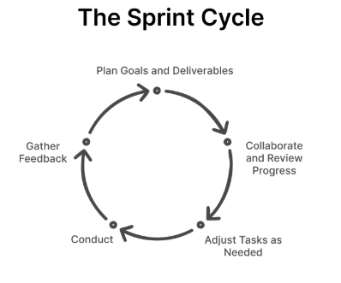
Figure no.13 Sprint Cycles
To build the system in smaller, more manageable parts, the researchers will use Sprint Cycles. Each sprint will focus on a specific set of system features. The team will plan tasks, develop the features, test completed work, review the outcomes, and refine the system based on issues or feedback.
SPRINT | FEATURES | TASK / DEVELOPMENT | DURATION
Sprint 1 | Dashboard Overview | Create dashboard interface, design the layout for Employee Engagement and Relations information, and add summary displays. | 7 days
Sprint 2 | Centralized HR Announcements | Create the announcement interface and develop functions for posting and viewing announcements, notices, and updates. | 11 days
Sprint 3 | Employee Feedback and Surveys | Create survey forms, develop survey response functions, and add feedback and suggestion submission. | 12 days
Sprint 4 | Employee Communication and Social Interaction | Develop supported social interaction and participation features such as posts, forums, groups, projects, comments, and reactions, including the recording and monitoring of participation information. | 13 days
Sprint 5 | Employee Recognition and Rewards | Create recognition forms and develop records for achievements, nominations, awards, and appreciation. | 8 days
Sprint 6 | Grievance Management | Create grievance submission forms and develop grievance monitoring, status updates, and concern management. | 6 days
Sprint 7 | Survey, Feedback, and Grievance Analytics | Develop descriptive analytics for survey, feedback, and grievance records and provide relevant summaries for authorized users. | 10 days
Sprint 8 | Grievance Reporting | Develop managed reports based on available grievance-related records for authorized Human Resource personnel and administrators. | 12 days
Daily Standups
TEAM MEMBER / ROLE | ACCOMPLISHMENT | TASKS | IMPEDIMENTS / CHALLENGES
Scrum Master – Mendoza, Karl Ashley | Coordinated team activities and monitored the progress of the Employee Engagement and Relations System. | Organize team meetings, monitor sprint tasks, coordinate activities, and help resolve project concerns. | Difficulty coordinating team members' schedules and monitoring task progress.
Programmer – Balansag, Geoffrey C. | Developed system functions and worked on connecting the application to the database. | Write code, develop system features, connect the application to MySQL, test functions, and fix errors. | Coding errors, database connection issues, and difficulties integrating system functions.
System Analyst – Plicerda, Lanz C. | Analyzed system requirements and prepared the system flow and specifications. | Gather and review requirements, prepare system flow and use cases, and coordinate technical requirements with the team. | Changes in requirements and the need to clarify system functions.
Business Specialist – Mirabueno, John Carlo M. | Reviewed employee and HR needs to help ensure that the system supports the required engagement and relations activities. | Identify user needs, review business requirements, and check whether system functions align with HR processes. | Limited information about some HR processes and the need to clarify user requirements.
Document Specialist – | Organized and updated project documentation based on the team's development progress. | Prepare and update chapters, tables, diagrams, meeting records, and other project documents. | Delays in receiving updates and outputs from other team members.
Table no.4 Daily Standups
PRODUCT BACKLOG
Features | Name & Role | Duration
Dashboard Overview | Balansag, Geoffrey C. – Programmer | 7 days
Centralized HR Announcements | Balansag, Geoffrey C. – Programmer | 11 days
Employee Feedback and Surveys | Balansag, Geoffrey C. – Programmer | 12 days
 | Balansag, Geoffrey C. – Programmer | 13 days
  Employee Participation and Social Collaboration
 | Balansag, Geoffrey C. – Programmer | 8 days
  Employee Recognition and Rewards
Grievance Management | Balansag, Geoffrey C. – Programmer | 6 days
Survey, Feedback, and Grievance Analytics | Balansag, Geoffrey C. – Programmer | 10 days
Grievance Reporting | Balansag, Geoffrey C. – Programmer | 12 days
System Integration and Database Connection | Balansag, Geoffrey C. – Programmer | Ongoing
System Testing and Error Fixing | Balansag, Geoffrey C. – Programmer | Ongoing
System Improvement and Maintenance |  | Ongoing

3.4 SCRUM ARTIFACTS

The researchers will use Scrum artifacts and activities to manage the requirements, tasks, progress, and outcomes of the project. These artifacts will provide the team with a framework to plan work for each sprint, track development progress, review completed functions, and document improvements for subsequent development activities.
SCRUM ARTIFACT / ACTIVITY | TOOLS USED | PURPOSE
Product Backlog | Google Sheets, Notes | Lists and prioritizes system requirements, features, tasks, and improvements.
Sprint Backlog | Google Docs | Records and tracks the tasks selected for each sprint.
Sprint Planning | Google Meet, Google Sheets | Used to discuss sprint goals, select tasks, and plan the work for the sprint.
Daily Scrum | Messenger | Used to share progress, current tasks, and development problems among team members.
Sprint Review | Google Meet | Used to present completed work and gather feedback from the team or stakeholders.
Sprint Retrospective | Notes | Used to record problems encountered, lessons learned, and improvements for the next sprint.
Information Gathering | Google Forms | Used to collect user needs, feedback, and system requirements.
Sprint Documentation | Google Drive | Used to store project documents, meeting notes, decisions, and sprint records.
Increment | Completed system files | Represents the working system output produced during a sprint.
System Design | Draw.io, Microsoft Word | Used to create system diagrams, process designs, and other design documentation.
Table no.5 Scrum Artifact

TOOLSTACK
Tool | Purpose
Google Meet | Used for online meetings, consultations, Scrum discussions, and information-gathering sessions.
Discord | Used for team communication, updates, task discussions, and coordination.
Trello | Used to organize and monitor development tasks, backlog items, and pending work.
Google Calendar | Used to schedule meetings, consultations, deadlines, and project activities.
Google Docs | Used to write, edit, review, and update project documents.
Google Drive | Used to store and organize documents, diagrams, system files, and project materials.
Draw.io | Used to create flowcharts, system diagrams, and process diagrams.
Canva | Used to prepare presentation slides and visual materials for the defense.
Git | Used to track changes to the source code during system development.
GitHub | Used to store and manage the system source code and project repository.
Visual Studio Code | Used to write and edit PHP, HTML, CSS, and JavaScript files.
PHP | Used to develop the main system functions and processes.
HTML | Used to structure the content and pages of the system.
CSS | Used to design the layout and appearance of the system interface.
JavaScript | Used to add interactive functions and improve user interaction.
MySQL | Used to store, retrieve, organize, and manage system data.
phpMyAdmin | Used to create and manage the MySQL database, tables, fields, and records.
XAMPP | Used to run the PHP system and MySQL database during development and testing.
Web Browser | Used to access, test, and review system pages and functions.
Table no.7 Toolstack

3.5 INTEGRATION APPROACH FOR INFORMATION SYSTEMS
The Human Resources Employee Engagement and Relations System is focused to support specific employee engagement and workplace relations initiatives at Bestlink College of the Philippines – Bulacan Campus. The purpose of this system is to consolidate particular employee engagement and relations functions within a single centralized platform, instead of maintaining separate procedures for each distinct activity. Consequently, the Human Resources Employee Engagement and Relations System furnishes the Human Resource Department with a more systematic means of administering and overseeing employee-related activities and information.

The system includes Centralized HR Announcements, Employee Feedback and Surveys, Employee Participation and Social Collaboration, Employee Recognition and Rewards, along with Grievance Management. Through the system, employees are able to view HR announcements, take part in surveys, offer feedback and suggestions, engage in posts, forums, groups, and projects, and communicate via comments and reactions. Furthermore, employees are able to access recognition-related information and submit grievances. Designated Human Resource staff and administrators are capable of overseeing the activities and examining the information supplied, in accordance with the access rights assigned to them.

The system's various functions are interconnected according to their objectives and the information they encompass. For instance, an announcement might convey details regarding an upcoming survey, which employees will then use to submit their responses. Conversely, designated Human Resource staff are able to examine the survey responses and feedback. Recognition activities are capable of documenting employee achievements, nominations, awards, badges, points, and available rewards, while grievance management may be employed to submit, review, update, and track grievances.

The system incorporates a Dashboard Overview that allows authorized users to examine summarized information drawn from the available system records. Furthermore, the Analytics function serves to deliver descriptive information derived from survey responses, feedback records, grievance records, and social-post information based on available keyword data. The Grievance Reporting function is designed to arrange the available grievance records in preparation for report generation. Accordingly, the system's functions may be employed to examine and track information pertaining to employee engagement and workplace relations activities.

By combining various functions tied to employee engagement and relations activities, a more systematic means of managing employee engagement and relations is delivered. Rather than coordinating announcements, feedback, recognition, social media interaction, and grievances through separate channels, the system offers a single centralized platform where authorized users can administer and examine the activities falling within the project's scope. Additionally, the system's functions furnish a more accessible and systematic way for pertinent employee information to be viewed and examined as needed.

The range of functions encompassed by the system is directed toward specific employee engagement and relations activities. Other Human Resource systems and functions remain unintegrated, such as payroll computation, payroll generation and disbursement, biometric attendance processing, timekeeping, and biometric device integration. Data pertaining to attendance and payroll shall be employed solely as supplementary evidence when examining a matter or complaint raised by an employee.

By adopting an integration strategy, the Human Resources Employee Engagement and Relations System makes it possible to merge disparate functions tied to employee engagement and relations activities into a single, centralized application. Consequently, this integration strategy the system provides the Human Resource Department with a structured framework for administering the employee engagement and workplace relations activities that fall within the project's scope.

3.6 Monolithic Architecture
A monolithic architecture is a software design in which an application's core functions are built and run as a single application. Rather than breaking the functions apart into services that are deployed independently, the various components of the system reside within one and the same application structure. This architecture offers a more straightforward structure for building, testing, deploying, and maintaining a system whose functions are clearly defined.

The Human Resources Employee Engagement and Relations System is built on a monolithic architecture. All of the system's functions reside in a single web-based application and operate alongside a centralized MySQL database. This indicates that the researchers built the system as a single application instead of splitting its functions into services that are deployed independently.
The system comprises Centralized HR Announcements, Employee Feedback and Surveys, Employee Participation and Social Collaboration, Employee Recognition and Rewards, Grievance Management, Dashboard Overview, Survey Analytics, Feedback Analytics, Grievance Analytics, and Grievance Reporting. Every function serves a distinct purpose, yet they all reside in the same application and collaborate to support the employee engagement and workplace relations activities covered by the project.

The centralized database holds the information that the various system functions create and manage. For instance, feedback and survey responses can be stored and reviewed, recognition records can be handled, social interaction records can be kept, and grievance records can be tracked and used for grievance reporting. These records can also be linked to the right users through employee information. Storing the information in the same application and database offers a unified structure for handling related records.

PHP, HTML, CSS, JavaScript, and MySQL were the technologies used to develop the system. XAMPP served as the local development environment, Visual Studio Code was used to write the source code, and phpMyAdmin was used to administer the MySQL database. These technologies enable the system to be developed and operated within a centralized application environment.

The system that was built relies on a monolithic architecture instead of a microservice architecture. In the technical background of the study, microservice architecture was examined as a related software architecture concept, but it was never applied to the actual system. The researchers chose not to split the system into services that are deployed independently. Rather, the functions that were implemented stay inside a single web-based application and rely on the centralized MySQL database.
Adopting a monolithic architecture gives the researchers a more straightforward structure for developing and managing the system. Because all of the system's functions reside in a single application, the researchers are able to manage, test, and update the system as one project. This approach fits the defined scope of the Human Resources Employee Engagement and Relations System along with the requirements identified for the Human Resource Department.

The monolithic architecture also accommodates the integration approach covered in the preceding section. Because the system's functions are housed in a single application that relies on a centralized database, the appropriate functions can access related information. For instance, the Dashboard Overview and Survey Analytics, Feedback Analytics, Grievance Analytics can draw on records available from the relevant system functions, whereas Grievance Reporting can use the grievance records that the system keeps.

As a result, the Human Resources Employee Engagement and Relations System is actually built as a PHP-based monolithic web application with a centralized MySQL database. The system is not built with microservices or services that are deployed independently. With this architecture, the researchers can keep the chosen employee engagement and workplace relations functions inside one centralized application.

3.7 INTRODUCTION TO TOGAF AND THE FOUR ARCHITECTURE
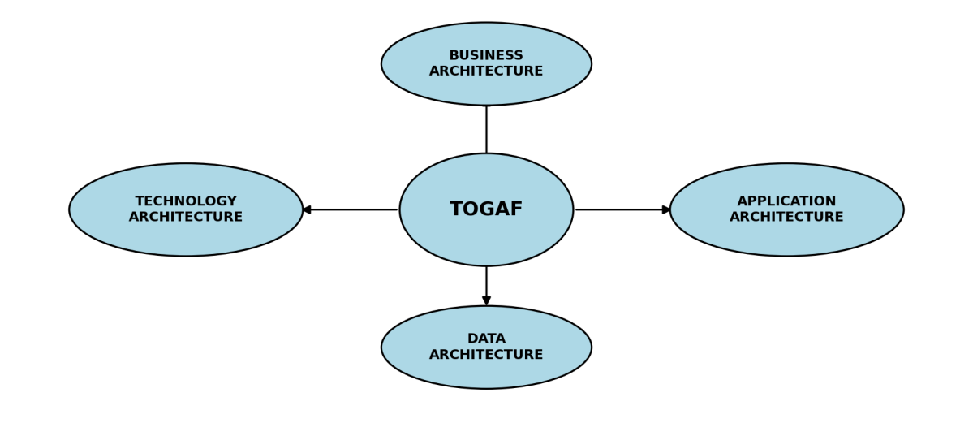
Figure no.14 TOGAF and Four Architecture Domains
The Open Group Architecture Framework (TOGAF) is an Enterprise Architecture framework that presents an managed approach to describing the different parts of an organization's information system. The researchers of this project utilized the four architecture domains of the TOGAF as a guide in presenting the relationship between the Human Resource processes, the information required by the system, the application and its users, and the technologies utilized to support the system.
The four architecture domains include Business Architecture, Data Architecture, Application Architecture, and Technology Architecture. The architecture domains provide different views of the Human Resources Employee Engagement and Relations System and help explain the manner through which the system supports the selected employee engagement and workplace relations activities of Bestlink College of the Philippines – Bulacan Campus.
Figure no.15 Business Architecture
Business Architecture
The Business Architecture describes the processes and activities that the system is intended to support. For the Human Resources Employee Engagement and Relations System, it focuses on the selected activities handled by the Human Resource Department and the interactions between employees and authorized Human Resource personnel and administrators.

The business processes supported by the system include Centralized HR Announcements, Employee Feedback and Surveys, Employee Participation and Social Collaboration, Employee Recognition and Rewards, and Grievance Management. The system, in turn, supports the monitoring of available information through the use of the Dashboard Overview and Analytics, while Grievance Reporting is for available grievance-related records.

By virtue of the processes, employees can access HR information, provide feedback, respond to surveys, participate through supported social features, view recognition-related information, and submit grievances. On the other hand, authorized Human Resource personnel and administrators can manage the appropriate functions and review the available records according to their assigned roles and permissions.
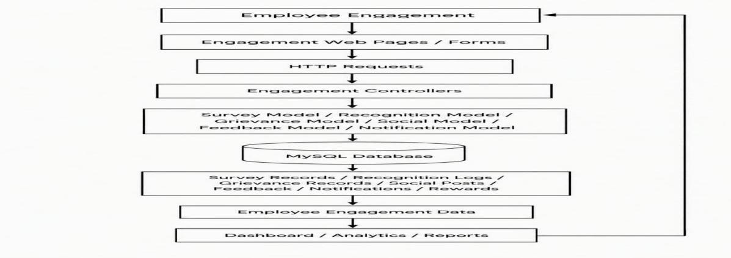
Figure no.16 Data Architecture
Data Architecture
The Data Architecture describes the information required and managed by the system. The Human Resources Employee Engagement and Relations System utilizes the centralized MySQL database in storing the information required by its different functions.
The information maintained by the system includes employee and user information, HR announcement records, survey information and responses, employee feedback and suggestions, social interaction and participation records, recognition and reward information, and grievance records. The system utilizes available records in providing dashboard summaries, descriptive analytics, and grievance-related reports.
Employee and user information is used for authentication and for linking the system records to the appropriate users. Access to information is dependent on the assigned roles and permissions of the users. Maintaining the information in a centralized database allows the different functions of the application to access related records from the same data source.
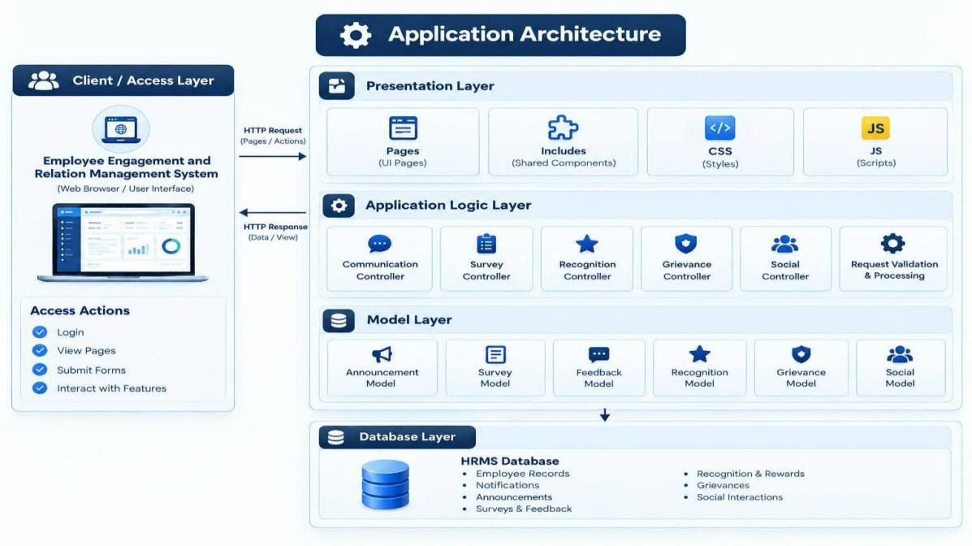
Figure no.17 Application Architecture
Application Architecture
The Application Architecture describes the system functions and the users that interact with them. The Human Resources Employee Engagement and Relations System is developed as one web-based application to provide different functions according to the responsibilities and access permissions of its users.
The main application functions include Centralized HR Announcements, Employee Feedback and Surveys, Employee Participation and Social Collaboration, Employee Recognition and Rewards, Grievance Management, Dashboard Overview, Analytics, and Grievance Reporting.
The system users include employees, authorized Human Resource personnel, and administrators. Employees utilize the functions available to them for viewing announcements, responding to surveys, providing feedback, participating in social features, accessing recognition-related information, and submitting grievances. Authorized Human Resource personnel and administrators, in turn, utilize the appropriate management functions to create or manage records, review employee responses, monitor grievances, access dashboard information, review analytics, and generate grievance-related reports according to their assigned permissions.
The application follows the monolithic architecture discussed in the previous section. The different functions are contained within the same web-based application and are utilized together with the centralized MySQL database.
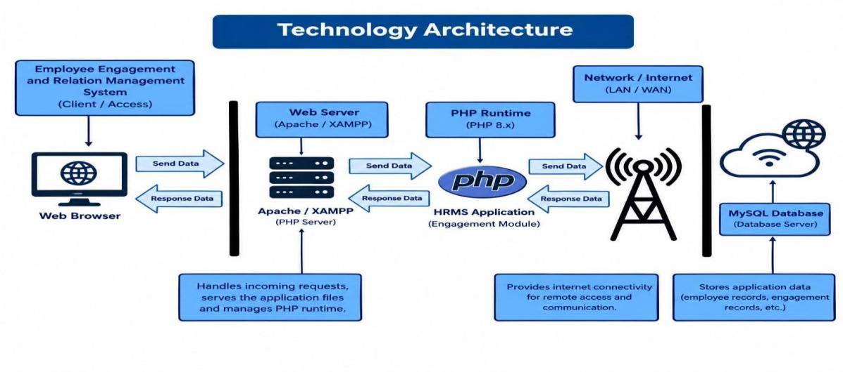Figure no.18 Technology Architecture
Technology Architecture
The Technology Architecture describes the technologies and development environment used to support the application. The Human Resources Employee Engagement and Relations System was developed using PHP, HTML, CSS, JavaScript, and MySQL.
PHP is used for the server-side functions of the application, while HTML and CSS are used to structure and present the web pages. JavaScript supports interactive functions on the user interface, while MySQL is used for storing and managing the system's data.
The researchers have utilized Visual Studio Code for source code development, XAMPP as the local development environment, and phpMyAdmin for managing the MySQL database. The technologies provide the development environment needed to build, test, and operate the web-based system.
The four architecture domains provide an organized view of the Human Resources Employee Engagement and Relations System. The Business Architecture identifies the processes supported by the system, the Data Architecture identifies the information required and managed by the system, the Application Architecture identifies the system functions and users, and the Technology Architecture identifies the technologies used to develop and operate the application. Altogether, the domains show the manner through which the processes, information, users, application functions, and technologies are connected within the proposed system.

