BESTLINK COLLEGE OF THE PHILIPPINES – BULACAN CAMPUS
HUMAN RESOURCE MANAGEMENT: EMPLOYEE ENGAGEMENT AND RELATIONS SYSTEM
A Capstone
Presented to the Faculty of
The College of Computing Studies
Bestlink College of the Philippines
In Partial Fulfilment
of the Requirements for the Degree
Bachelor of Science in Information Systems
DAVID G. JAURIGUE
BY
GEOFFREY BALANSAG
KARL ASHLEY MENDOZA
JOHN CARLO M. MIRABUENO
LANZ C. PLICERDA

2026-2027

TABLE OF CONTENTS
Page
TITLE PAGE i
APPROVAL SHEET ii
ACKNOWLEDGMENT iii
DEDICATION v
ABSTRACT vi
TABLE OF CONTENTS viii
LIST OF TABLES xiii
LIST OF FIGURES xiv
LIST OF APPENDICES xv

APPROVAL SHEET

This project entitled BESTLINK COLLEGE OF THE PHILIPPINES BULACAN CAMPUS- HR MANAGEMENT (EMPLOYEE ENGAGEMENT AND RELATION), prepared and submitted by Geoffrey Balansag, Karl Ashley Mendoza, John Carlo M. Mirabueno, and Lanz C. Plicerda, in partial fulfillment of the requirements for the degree of Bachelor of Science in Information Systems, has been examined and is recommended for acceptance and approval for the Oral Defense.

DAVID JAURIGUE
Adviser
____________________________________________
THESIS REVIEW PANEL
Approved by the committee on Oral Examination with the grade of __

ACKNOWLEDGEMENT
The researchers would like to express their sincere gratitude and deepest appreciation to all the individuals whose guidance, support, and encouragement made the successful completion of this research possible.
First and foremost, the researchers extend their heartfelt gratitude to Dr. Maria M. Vicente, President and Chief Executive Officer of Bestlink College of the Philippines, for her unwavering commitment to providing affordable and quality education and for fostering an environment that promotes academic excellence, productivity, and responsible citizenship.
The researchers are also deeply grateful to Ms. Edith M. Vicente, Vice President for Academic Affairs, for her invaluable encouragement and steadfast support throughout this research journey. Her strong belief in the importance of student research inspired the researchers to persevere and strive for excellence.
Sincere appreciation is extended to Dr. Charlie I. Cariño, Head of Academic Affairs, for his significant contributions to academic development through his leadership in curriculum initiatives, faculty management, and the supervision of academic programs, all of which helped create a conducive learning environment for this study.
The researchers are likewise thankful to Eng. Diosdado T. Lleno, Vice President for Administration and Finance, for granting the necessary permission to conduct this research and for his valuable administrative support.
Special thanks are extended to Dr. Milagros O. Luang, School Dean and Principal, for her unwavering support, encouragement, and inspiring leadership throughout the completion of this study.
The researchers would also like to express their profound gratitude to Mr. Phillip Arevalo, Research Coordinator, for his invaluable advice, expertise, and guidance in research methodologies and academic writing. His dedication and commitment greatly contributed to the successful completion and proper presentation of this research.
The researchers are especially indebted to Mr. David Jaurigue, Research Adviser, whose exceptional guidance, constructive feedback, patience, and unwavering support were instrumental throughout every stage of this research. His expertise, encouragement, and insightful recommendations significantly enhanced the quality and credibility of this study.
The researchers also extend their sincere appreciation to the Panel of Examiners for their constructive comments, insightful suggestions, and professional recommendations. Their expertise and critical evaluation greatly contributed to refining this research and ensuring its academic rigor and overall quality.
The researchers likewise express their gratitude to the clients for their trust, cooperation, and active participation throughout the conduct of this study. Their collaboration and support were essential to the successful completion of this research and the achievement of its objectives.
Heartfelt appreciation is also extended to the researchers' families, friends, and loved ones for their unwavering moral, financial, emotional, and spiritual support. Their constant encouragement, patience, understanding, and belief in the researchers' abilities provided the strength and motivation needed to overcome every challenge encountered during this academic journey.
Above all, the researchers offer their highest praise and deepest gratitude to the Almighty God for His boundless love, grace, wisdom, strength, and guidance. His divine blessings, protection, and unfailing presence made it possible for the researchers to overcome obstacles and successfully accomplish this research. To Him be all the glory and honor.
The Researchers
Balansag, Geoffrey
Mendoza, Karl Ashley
Mirabueno, John Carlo M.
Plicerda, Lanz C.

DEDICATION

This study is wholeheartedly dedicated to the researchers themselves, whose unwavering commitment, perseverance, resilience, and countless sacrifices made the successful completion of this research possible.
The researchers lovingly dedicate this work to their beloved parents, whose unconditional love, moral, spiritual, emotional, and financial support served as a constant source of strength, inspiration, and motivation throughout this academic journey. Their guidance, encouragement, and steadfast belief in the researchers' abilities made every challenge more bearable and every achievement more meaningful.
This study is also dedicated to the researchers' siblings and friends, whose encouragement, understanding, and unwavering support provided comfort and inspiration during the most demanding moments of this endeavor.
The researchers likewise dedicate this work to their research adviser and professors, whose knowledge, expertise, guidance, and mentorship played a vital role in shaping this study. Their invaluable insights, constructive feedback, and dedication to academic excellence significantly contributed to the successful completion of this research.

THE RESEARCHERS

ABSTRACT

Title: BESTLINK COLLEGE OF THE PHILIPPINES BULACAN CAMPUS- HR MANAGEMENT (EMPLOYEE ENGAGEMENT AND RELATION.
Authors: Geoffrey Balansag, Karl Ashley Mendoza, John Carlo M. Mirabueno, and Lanz C. Plicerda
Degree: Bachelor of Science in Information System
Date of Completion:

INTRODUCTION
Human Resource Management plays an important role in maintaining effective communication, employee participation, recognition, feedback, and positive workplace relationships within an organization. Employee engagement and employee relations involve activities such as communicating organizational information, collecting employee feedback, recognizing employee contributions, supporting participation, and managing workplace concerns. When these activities are handled through manual records and separate communication channels, organizing employee-related information and monitoring employee participation may become difficult. This study proposes the development of a Human Resources Employee Engagement and Relations System for Bestlink College of the Philippines – Bulacan Campus. The proposed system provides a centralized platform for managing employee engagement and relations activities, including Human Resource announcements, feedback and surveys, recognition and rewards, grievance management, employee participation, administrative monitoring, and analytics and reports. Employees may use the system to access official information, participate in surveys and engagement activities, provide feedback and suggestions, and communicate workplace concerns. Authorized Human Resource personnel may use the system to manage employee-related information, announcements, feedback, recognition records, grievances, and engagement-related activities. The system is developed to reduce dependence on scattered communication methods and manual processes by providing a centralized platform for employee engagement and relations activities. The proposed system also provides administrative monitoring and reporting functions that may assist Human Resource personnel and authorized administrators in organizing employee-related information and supporting Human Resource decision-making. The study utilizes an adapted Agile Scrum approach for system development and uses appropriate system evaluation procedures to determine whether the developed system meets the identified requirements of its intended users. The study aims to provide Bestlink College of the Philippines – Bulacan Campus with an organized and accessible information system that supports employee communication, feedback, participation, recognition, grievance management, and workplace relations.

CHAPTER 1
INTRODUCTION
1.1. PROJECT BACKGROUND AND MOTIVATION
In this chapter, the researchers present the background and motivation of the proposed Human Resources Employee Engagement and Relations System for Bestlink College of the Philippines – Bulacan Campus. This section discusses the importance of employee engagement and workplace relations, the challenges in managing employee-related activities, and the reason for developing a centralized system to support Human Resource processes.
Human Resource Management plays an important role in supporting employees and organizational operations. In an educational institution, academic and administrative employees contribute to the delivery of education and other institutional services. Maintaining effective communication, employee participation, recognition, feedback, and positive relationships between employees and management is therefore important in supporting an organized and productive workplace.
Employee engagement refers to employees' participation and involvement in organizational activities, including providing feedback, participating in surveys and activities, receiving recognition, and communicating their experiences and suggestions. Employee relations, on the other hand, involve the communication and interaction between employees and the organization, including the management of workplace concerns, complaints, grievances, and other employee-related matters. These areas are closely related because effective communication and appropriate management of employee concerns can influence employee participation and their relationship with the organization.
At Bestlink College of the Philippines – Bulacan Campus, employee engagement and relations activities require communication, documentation, coordination, and monitoring. These activities may include the dissemination of Human Resource announcements and policy updates, collection of employee feedback, participation in surveys and engagement activities, recognition of employee achievements, and management of workplace concerns and grievances.
When these activities are handled through different communication channels and manual processes, organizing employee-related information and monitoring employee participation may become more difficult. Human Resource personnel may need to gather information from different sources, maintain records manually, monitor employee responses, and follow up on workplace concerns. Employees may also experience difficulties in accessing official information, providing feedback, participating in engagement activities, and communicating workplace concerns through an organized process.
These concerns provide a basis for developing a centralized Human Resource system that focuses specifically on employee engagement and employee relations. A centralized platform can organize employee-related information and provide authorized users with a common location for managing announcements, feedback, surveys, recognition, grievances, participation, and reports.
In response to these concerns, the researchers propose the development of a Human Resources Employee Engagement and Relations System for Bestlink College of the Philippines – Bulacan Campus. The proposed system will provide functions for Human Resource announcements, feedback and surveys, recognition and rewards, grievance management, employee participation, administrative monitoring, and analytics and reports. Employees will be provided with accessible channels for receiving official information, participating in engagement activities, providing feedback, and communicating workplace concerns. Authorized Human Resource personnel and administrators will be provided with tools for managing employee-related information, monitoring engagement activities, handling grievances, managing recognition records, and generating reports.
The proposed system is intended to reduce dependence on scattered communication methods and manual processes by bringing selected employee engagement and relations activities into a centralized platform. Through this approach, the system may help organize employee-related information, improve communication, encourage participation, support recognition, facilitate grievance management, and provide Human Resource personnel with information that can assist monitoring and decision-making.
Therefore, this study focuses on the design, development, and evaluation of a Human Resources Employee Engagement and Relations System for Bestlink College of the Philippines – Bulacan Campus. The proposed system is intended to support the Human Resource Department and employees by providing an organized, accessible, and centralized platform for managing selected employee engagement and workplace relations activities.

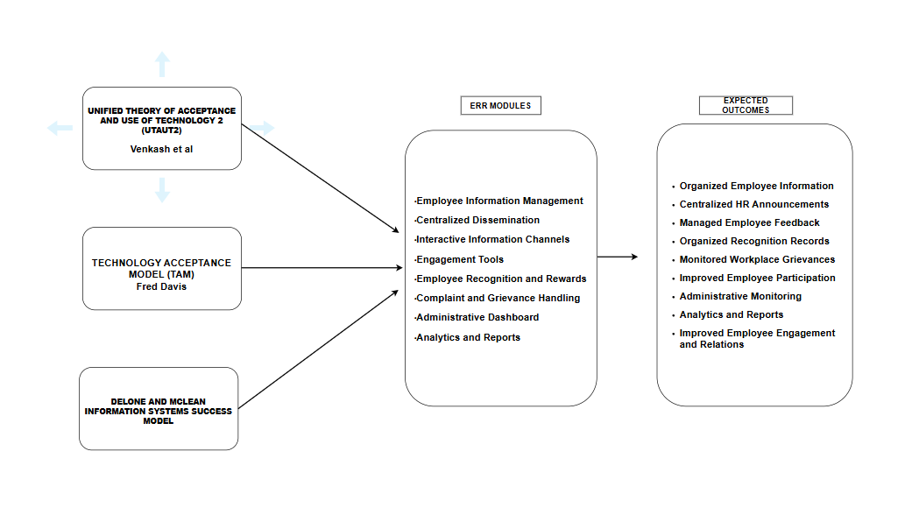
Figure no.1 Theoretical Framework
The development of the Human Resources Employee Engagement and Relations System for Bestlink College of the Philippines – Bulacan Campus is anchored on three theories that guide the design, development, implementation, and evaluation of the proposed system. These theories are the Unified Theory of Acceptance and Use of Technology 2 (UTAUT2), Technology Acceptance Model (TAM), and DeLone and McLean Information Systems Success Model.
The Unified Theory of Acceptance and Use of Technology 2 (UTAUT2) helps explain the factors that influence employees' and Human Resource personnel's acceptance and continued use of the proposed system. The Technology Acceptance Model (TAM) focuses on perceived usefulness and perceived ease of use, which are important in determining whether users will accept and use the system. The DeLone and McLean Information Systems Success Model provides a basis for evaluating the quality, use, satisfaction, and benefits of the proposed system.
Based on these theories, the proposed Human Resources Employee Engagement and Relations System provides centralized dissemination, interactive information channels, engagement tools, employee recognition and rewards, complaint and grievance handling, employee information management, administrative dashboard, and analytics and reports. These functions are intended to improve communication, employee participation, feedback management, recognition, grievance handling, monitoring, and Human Resource decision-making. The selected theories therefore provide the foundation for understanding user acceptance and evaluating the effectiveness of the proposed Employee Engagement and Relations System.
Unified Theory of Acceptance and Use of Technology 2 (UTAUT2) – Venkatesh et al.
Focus: The Unified Theory of Acceptance and Use of Technology 2 (UTAUT2) explains the factors that influence users' acceptance and continued use of technology. It considers factors such as performance expectancy, effort expectancy, social influence, facilitating conditions, and other user-related factors that may affect technology adoption.
Application to the Study: This theory is relevant to the proposed Employee Engagement and Relations System because employees and authorized Human Resource personnel need to accept and continuously use the system in their engagement and relations activities. Employees are more likely to use the system when they perceive that it can make communication easier, provide convenient access to announcements and surveys, simplify feedback submission, support recognition activities, and provide an organized method for raising workplace concerns. Human Resource personnel are also expected to use the system when it can reduce manual work, organize employee-related information, monitor engagement activities, manage grievances, and generate reports. Proper system support and user guidance may further encourage effective and continuous system use.
Technology Acceptance Model (TAM) – Fred Davis
Focus: The Technology Acceptance Model (TAM) explains that technology acceptance is primarily influenced by perceived usefulness and perceived ease of use. Users are more likely to accept a system when they believe that it can improve their work and can be used without unnecessary difficulty.
Application to the Study: TAM is relevant to the proposed Employee Engagement and Relations System because the system should provide useful and easy-to-use functions for both employees and Human Resource personnel. Employees should be able to easily access announcements, participate in surveys, provide feedback, submit grievances, and interact through available engagement features. Human Resource personnel should be able to manage employee information, recognition records, feedback, grievances, announcements, and engagement activities without relying heavily on manual processes. A simple and user-friendly interface may encourage users to adopt the proposed digital process and participate more actively in employee engagement and relations activities.
DeLone and McLean Information Systems Success Model – DeLone and McLean
Focus: The DeLone and McLean Information Systems Success Model evaluates information system success through system quality, information quality, service quality, system use, user satisfaction, and net benefits.
Application to the Study: This model is relevant to the proposed Employee Engagement and Relations System because its success depends on the quality, reliability, usability, accuracy, and accessibility of the system and the information it provides. The system should provide organized employee information, reliable feedback and survey records, accurate recognition and grievance records, accessible announcements, and useful reports and analytics. These qualities are expected to encourage system use and user satisfaction while providing benefits such as improved communication, organized employee engagement activities, easier monitoring of workplace concerns, improved Human Resource processes, and better support for management decision-making.
The three theories complement one another in the development and evaluation of the proposed system. UTAUT2 explains the factors that may influence users' acceptance and continued use of the system, TAM emphasizes usefulness and ease of use, while the DeLone and McLean model provides criteria for evaluating system quality, user satisfaction, use, and benefits. Together, these theories provide a theoretical basis for developing a centralized Employee Engagement and Relations System that responds to the needs of employees, Human Resource personnel, and authorized administrators.

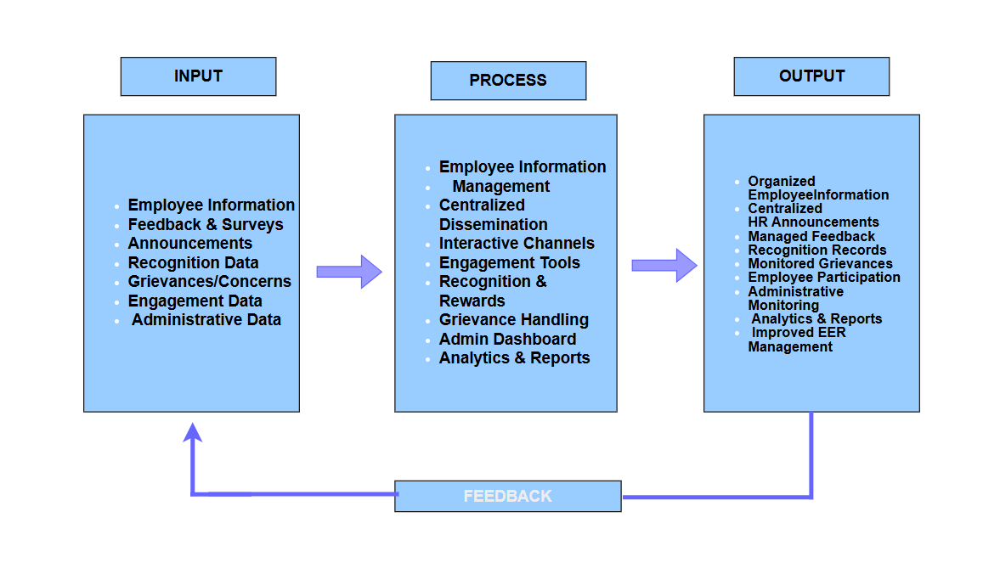
Figure no.2 Conceptual Framework
The conceptual framework of the study illustrates the flow of information within the proposed Human Resources Employee Engagement and Relations System using the Input-Process-Output (IPO) Model with a feedback mechanism. The framework demonstrates how employee-related information, feedback, requests, and engagement data are entered into the system, processed through its different functions, and transformed into organized information, reports, and services that support employee engagement and Human Resource relations.
INPUT
The input component consists of the data, information, requests, feedback, and records required by the system to perform employee engagement and relations functions. These inputs serve as the foundation of the proposed system and are processed to provide organized and accessible information for employees, Human Resource personnel, and authorized administrators.
Employee Information – Refers to the personal and employment-related information required for the operation of the Employee Engagement and Relations System. This information is maintained by authorized users according to assigned roles and permissions.
Feedback and Survey Information – Refers to employee opinions, suggestions, comments, responses, and survey submissions concerning workplace experiences, organizational activities, and employee-related concerns.
Announcement and Policy Information – Refers to official announcements, policy updates, notices, and other employee-related information prepared and published by authorized Human Resource personnel.
Recognition Information – Refers to employee achievements, nominations, recognition records, awards, and related information submitted or managed through the recognition feature.
Complaint and Grievance Information – Refers to workplace complaints, concerns, descriptions, supporting information, and other details submitted by employees for Human Resource review and management.
Engagement Information – Refers to employee participation and responses collected through surveys, suggestion-based feedback forms, social engagement features, and other available engagement activities.
Administrative and Monitoring Information – Refers to information required by Human Resource personnel and administrators to monitor employee participation, feedback, grievances, recognition activities, and other engagement-related records.
PROCESS
The process component describes how the proposed Employee Engagement and Relations System transforms the collected employee-related information into organized and meaningful outputs through centralized data management. It covers the procedures involved in managing employee information, disseminating announcements, collecting feedback, conducting surveys, managing recognition, handling grievances, monitoring engagement, and generating reports.
Employee Information Management – Authorized Human Resource personnel can record, update, and manage employee information in a centralized database. Access to employee information is controlled according to user roles and permissions.
Centralized Dissemination – Authorized Human Resource personnel and administrators can create, manage, and publish announcements, policy updates, notices, and other official employee-related information through one centralized platform.
Interactive Information Channels – The system provides available interaction features that allow employees to communicate, provide feedback, and participate in discussions or social engagement activities.
Engagement Tools – The system manages surveys and suggestion-based feedback forms that allow employees to provide opinions, suggestions, and insights regarding workplace experiences and organizational activities.
Employee Recognition and Rewards – The system records employee achievements, nominations, recognition activities, and awards. It provides an organized method for managing employee contributions and recognition records.
Complaint and Grievance Handling – Employees can submit workplace complaints and concerns through a structured process. Authorized Human Resource personnel can record, monitor, review, and manage submitted grievances.
Administrative Dashboard – The system consolidates employee engagement information into a centralized dashboard where authorized Human Resource personnel and administrators can monitor participation, feedback, grievances, recognition activities, and other relevant records.
Analytics and Reports – The system processes collected information and generates organized reports and engagement analytics that can help Human Resource personnel and management identify workplace trends and support decision-making.
OUTPUT
The output component represents the organized information, services, records, and reports produced after the system processes the employee engagement and relations inputs.
Organized Employee Information – Provides authorized Human Resource personnel with accessible and organized employee-related information needed for employee engagement and relations activities.
Centralized HR Announcements – Provides employees with easier access to official announcements, policy updates, notices, and other organizational information.
Managed Employee Feedback – Provides organized feedback and survey records that allow Human Resource personnel to review employee opinions, suggestions, and responses.
Organized Recognition Records – Provides records of employee achievements, nominations, recognition activities, and awards that can support employee motivation and morale.
Monitored Workplace Grievances – Provides structured records of complaints and workplace concerns, including their status and actions taken by authorized Human Resource personnel.
Improved Employee Participation – Provides employees with accessible opportunities to participate in surveys, provide suggestions, interact through available engagement features, and communicate workplace concerns.
Administrative Monitoring – Provides Human Resource personnel and administrators with a centralized view of employee participation, feedback, grievances, recognition activities, and engagement information.
Analytics and Reports – Provides organized reports and engagement analytics that can assist Human Resource personnel and management in evaluating workplace trends and supporting informed decision-making.
Improved Employee Engagement and Relations Management – Supports a more organized, accessible, and efficient approach to managing employee communication, feedback, participation, recognition, grievances, and workplace relations.
FEEDBACK
Feedback allows the Human Resources Employee Engagement and Relations System to continuously improve its accuracy, usability, efficiency, and responsiveness to the needs of employees and Human Resource personnel. Feedback may be obtained from employees, Human Resource personnel, administrators, system evaluations, and observations of system outputs.
The feedback gathered from users can help identify functions that require improvement, correction, modification, or additional features. The results of system use and evaluation may also help identify issues related to communication, feedback collection, recognition, grievance handling, employee participation, and reporting.
This continuous feedback cycle allows the proposed system to remain responsive to the needs of Bestlink College of the Philippines – Bulacan Campus. It also supports continuous improvement of the system's functions, usability, information management, and employee engagement processes.

1.2 PROBLEM STATEMENT
The Human Resource Department of Bestlink College of the Philippines – Bulacan Campus plays an important role in supporting employee communication, participation, recognition, feedback, and workplace relations. Employee engagement and relations activities involve the dissemination of Human Resource announcements and policy updates, collection of employee feedback, participation in surveys and engagement activities, recognition of employee achievements, and management of workplace concerns and grievances.
However, the use of different communication channels and manual processes may make it difficult to organize these activities and maintain accessible and consistent employee-related information. Human Resource personnel may need additional time and effort to gather information from different sources, monitor employee participation, maintain recognition records, review feedback, and manage workplace concerns. Employees may also experience difficulties in accessing official information, providing feedback, participating in engagement activities, and communicating workplace concerns through an organized process.
The lack of a centralized platform may also make it more difficult for Human Resource personnel and authorized administrators to obtain consolidated information about employee participation, feedback, recognition activities, and grievances. This may limit the availability of organized information that can support Human Resource monitoring and decision-making.
To address these concerns, this study proposes the development of a Human Resources Employee Engagement and Relations System for Bestlink College of the Philippines – Bulacan Campus.
- How can Human Resource announcements, policy updates, notices, and other official employee-related information be centralized to provide employees with organized and accessible information?
- How can employee achievements, nominations, recognition activities, and awards be organized and managed through a centralized recognition and rewards function?
- How can employee feedback, survey responses, participation, suggestions, complaints, and grievances be collected, monitored, and managed through a centralized system?
- How can the proposed system provide Human Resource personnel and authorized administrators with centralized monitoring, analytics, and reports to support the management of employee engagement and workplace relations?

1.3. PROJECT VISION AND SCOPE
The proposed Human Resources Employee Engagement and Relations System is designed to provide Bestlink College of the Philippines – Bulacan Campus with a centralized and organized platform for managing selected employee engagement and employee relations activities. The system aims to support the Human Resource Department in organizing employee communication, feedback, participation, recognition, workplace concerns, and related information while providing employees with accessible channels for communication and participation.
The proposed system will provide employees with access to Human Resource announcements, policy updates, notices, surveys, feedback forms, and other available engagement activities through a centralized platform. Selected interactive features may allow employees to communicate, provide feedback, and participate in discussions or other engagement activities supported by the system.
The system will include an Employee Recognition and Rewards function for recording employee achievements, nominations, recognition activities, and awards. This function is intended to provide an organized method for managing employee contributions and recognition records.
The system will also include a Complaint and Grievance Handling function that allows employees to submit workplace complaints and concerns through a structured process. Authorized Human Resource personnel will be able to record, review, monitor, and manage submitted grievances. When necessary, relevant employee information such as attendance or payroll records may be reviewed as supporting information for assessing employee concerns. Such information will not constitute separate primary payroll or attendance functions of the proposed system.
An Administrative Dashboard will provide authorized Human Resource personnel and administrators with a centralized view of employee participation, feedback, grievances, recognition activities, and other relevant employee engagement and relations information. The system will also generate Analytics and Reports based on available system information to assist Human Resource personnel and management in monitoring employee-related activities and supporting decision-making.
The scope of the proposed system covers selected employee engagement and relations activities of Bestlink College of the Philippines – Bulacan Campus. The intended users are employees, Human Resource personnel, and authorized administrators.
The system includes the following major functions:
- Centralized Dissemination – Provides authorized Human Resource personnel and administrators with a centralized platform for publishing announcements, policy updates, notices, and other employee-related information.
- Interactive Information Channels – Provides available communication and interaction features that allow employees to provide feedback and participate in discussions or selected engagement activities.
- Engagement Tools – Provides surveys and suggestion-based feedback forms that allow employees to provide opinions, suggestions, and insights regarding workplace experiences and organizational activities.
- Employee Recognition and Rewards – Provides a structured function for managing employee achievements, nominations, recognition activities, and awards.
- Complaint and Grievance Handling – Provides employees with a structured method for submitting workplace complaints and concerns while allowing authorized Human Resource personnel to record, monitor, review, and manage submitted grievances.
- Administrative Dashboard – Provides authorized Human Resource personnel and administrators with an organized view of employee participation, feedback, grievances, recognition activities, and other relevant employee engagement and relations information.
- Analytics and Reports – Generates organized reports and engagement-related analytics based on information collected through the system to support Human Resource monitoring and decision-making.
- Employee Information Management – Maintains the employee information necessary for the operation of the employee engagement and relations functions, with access controlled according to assigned roles and permissions.
The proposed system is limited to employee engagement and employee relations functions. It is not intended to replace a complete Human Resource Information System and does not primarily perform payroll processing, attendance management, recruitment, compensation, benefits administration, or comprehensive performance management. Attendance and payroll information may only be used as supporting records when necessary for the assessment or verification of workplace concerns.
Through the integration of these functions, the proposed system aims to provide a more organized and accessible approach to managing employee engagement and workplace relations at Bestlink College of the Philippines – Bulacan Campus.

1.4 OBJECTIVES AND GOALS
The general objective of this study is to design, develop, and evaluate a Human Resources Employee Engagement and Relations System for Bestlink College of the Philippines – Bulacan Campus that supports centralized communication, employee feedback, participation, recognition, grievance management, administrative monitoring, and reporting.
Specifically, the study aims to:
- Develop a centralized dissemination function that allows authorized Human Resource personnel and administrators to publish announcements, policy updates, notices, and other official employee-related information.
- Develop an employee recognition and rewards function for recording employee achievements, nominations, recognition activities, and awards.
- Develop employee engagement and relations functions that allow employees to participate in surveys, submit feedback and suggestions, communicate workplace concerns, and support the structured management of complaints and grievances.
- Develop administrative monitoring, analytics, and reporting functions that provide authorized Human Resource personnel and administrators with organized information regarding employee participation, feedback, recognition activities, and grievances.

GOALS
The primary goal of this study is to design, develop, and implement an Employee Engagement and Relations System that strengthens communication, enhances employee participation, and fosters positive relationships between employees and management through a centralized digital platform.
The proposed system aims to:
- Improve the organization of employee-related communication by providing a centralized platform for Human Resource announcements, policy updates, notices, and other official information.
- Provide accessible channels for employee feedback and participation through surveys, feedback forms, suggestions, and available engagement activities.
- Improve the organization of employee recognition records by providing a structured function for recording achievements, nominations, recognition activities, and awards.
- Support systematic grievance management by providing employees with a structured method for submitting workplace concerns and authorized Human Resource personnel with tools for recording, reviewing, monitoring, and managing grievances.
- Reduce dependence on scattered manual processes by centralizing selected employee engagement and relations information within one system.
- Provide organized monitoring and reporting through an administrative dashboard, analytics, and reports that can assist Human Resource personnel and administrators in reviewing employee-related information.
- Provide an accessible and user-friendly platform that supports the intended activities of employees, Human Resource personnel, and authorized administrators.

1.5 SIGNIFICANCE AND RELEVANCE
The proposed Human Resources Employee Engagement and Relations System is intended to provide a centralized platform for selected employee engagement and employee relations activities. The study may benefit the following:
Employees
The proposed system may provide employees with a centralized and accessible platform for receiving Human Resource announcements and policy updates, participating in surveys and engagement activities, providing feedback and suggestions, viewing recognition-related information, and communicating workplace concerns.
Human Resource Department
The system may assist Human Resource personnel in organizing employee-related information and managing announcements, feedback, surveys, recognition records, employee participation, and workplace grievances. The centralized platform may also reduce dependence on scattered manual processes and make employee-related information easier to monitor and manage.
Management and Authorized Administrators
The proposed system may provide authorized administrators and management with centralized dashboards, analytics, and reports concerning employee participation, feedback, recognition activities, grievances, and other employee engagement and relations information. These outputs may provide organized information that can support Human Resource monitoring and decision-making.
Bestlink College of the Philippines – Bulacan Campus
The institution may benefit from a more organized approach to managing selected employee engagement and relations processes. The proposed system may support the institution's efforts to improve communication, information organization, employee participation, and workplace concern management through the use of an information system.
Future Researchers
The study may serve as a reference for future researchers and system developers who intend to conduct studies or develop information systems related to Human Resource Management, employee engagement, employee relations, employee feedback, recognition and rewards, grievance management, or related organizational processes.

1.6 DEFINITION OF TERMS
For clarity and proper understanding of the study, the following terms are operationally defined based on their use in the proposed Human Resources Employee Engagement and Relations System for Bestlink College of the Philippines – Bulacan Campus:
Administrator – Refers to an authorized user responsible for managing administrative functions of the system, including employee information, announcements, engagement-related information, grievances, recognition records, and other authorized system functions.
Centralized Platform – Refers to the single digital system where selected employee engagement and employee relations activities, records, and information are organized and managed.
Employee Engagement – Refers to employee participation and involvement in organizational activities supported by the proposed system, including participation in surveys, submission of feedback and suggestions, recognition activities, and other available engagement activities.
Employee Relations – Refers to the communication and interaction between employees and the organization, including the submission and management of workplace concerns, complaints, grievances, and other employee-related matters supported by the proposed system.
Employee Engagement and Relations – Refers collectively to the employee participation, communication, feedback, recognition, workplace concern management, grievance handling, and organizational interaction supported by the proposed system.
Employee Information – Refers to the personal and employment-related information required for the operation of the Employee Engagement and Relations System and managed by authorized users according to assigned roles and permissions.
Feedback and Surveys – Refers to the system functions that allow employees to provide opinions, suggestions, comments, and responses concerning workplace experiences, organizational activities, and employee-related concerns.
Recognition and Rewards – Refers to the system function used to record and manage employee achievements, nominations, recognition activities, and rewards provided by the institution.
Grievance Management – Refers to the process of receiving, recording, reviewing, monitoring, and managing employee complaints and workplace concerns through the proposed system.
Announcements – Refers to official notices, policy updates, reminders, and other organizational information published by authorized Human Resource personnel through the system.
Employee Engagement Activities – Refers to activities supported by the system that encourage employee participation and interaction, including surveys, feedback activities, and other available organizational engagement activities.
Social Collaboration – Refers to available system functions that allow employees to communicate, share ideas, participate in discussions, and interact with other employees.
Human Resource Department – Refers to the department responsible for managing employee-related information, programs, activities, concerns, and workplace relations within the institution.
Human Resource Personnel – Refers to authorized staff members responsible for managing employee information, announcements, feedback, surveys, grievances, recognition, and other employee engagement and relations activities through the system.
Administrative Dashboard – Refers to the centralized interface that provides authorized Human Resource personnel and administrators with an organized view of employee engagement and relations information, including participation, feedback, grievances, recognition activities, and related records.
Analytics and Reports – Refers to organized information generated from available system data to support Human Resource monitoring and decision-making.
User Authentication – Refers to the process of verifying the identity of a user before allowing access to the system and its authorized functions.
User Acceptance Testing (UAT) – Refers to the testing process in which intended users evaluate the developed system to determine whether its functions meet identified requirements and expected operations.

1.6 STRUCTURE OF THE DOCUMENT
Chapter | Title | Description
Chapter 1 | Introduction | This chapter presents the background and motivation of the study, the statement of the problem, the project vision and scope, the objectives and goals, the significance and relevance of the study, the theoretical framework, the conceptual framework, the definition of terms, and the structure of the document. It establishes the context of the proposed Human Resources Employee Engagement and Relations System and identifies the employee engagement and relations concerns that the study intends to address.
Chapter 2 | Related Literature, Studies, and Technical Background | This chapter presents literature and studies related to Human Resource Management, employee engagement, employee relations, employee communication, feedback and surveys, recognition and rewards, grievance management, employee participation, collaboration, Human Resource Information Systems, and related information-system concepts. It also presents related local and foreign studies and identifies the research gap addressed by the proposed system. The chapter further discusses the software development methodology and only those technologies, standards, and architectural concepts that are relevant to the actual development of the proposed system.
Chapter 3 | Methodology and Project Management | This chapter presents the methodology used in developing the proposed system. It discusses the adapted Agile Scrum Framework, development team roles, Scrum activities, requirements gathering, system analysis and design, development procedures, testing procedures, tools and technologies, and other project-management activities. The chapter also describes the procedures used to evaluate the developed system based on the identified requirements and intended users.
Chapter 4 | System Design, Development, Results, and Evaluation | This chapter presents the requirements, design, development, implementation, testing, and evaluation of the proposed system. It discusses the major system functions, system architecture, business processes, data architecture, technology implementation, testing results, User Acceptance Testing, and validation of the system against the objectives of the study.
Chapter 5 | Summary, Conclusions, and Recommendations | This chapter summarizes the development and major findings of the study. It presents conclusions based on the results and determines whether the proposed system addressed the identified problems and achieved its objectives. It also provides recommendations for future system enhancements, implementation, and future research.
Table 1 Structure of the Document

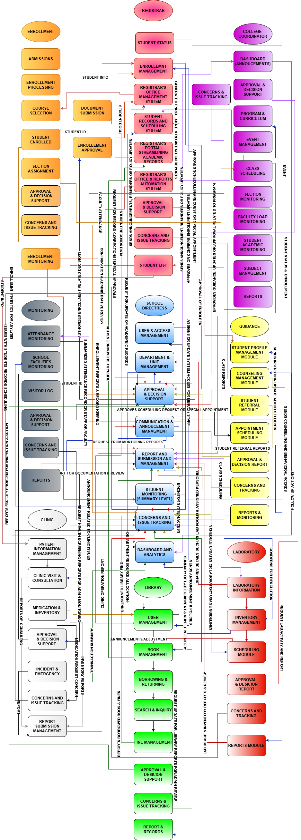
Figure 3 BPA Level 1
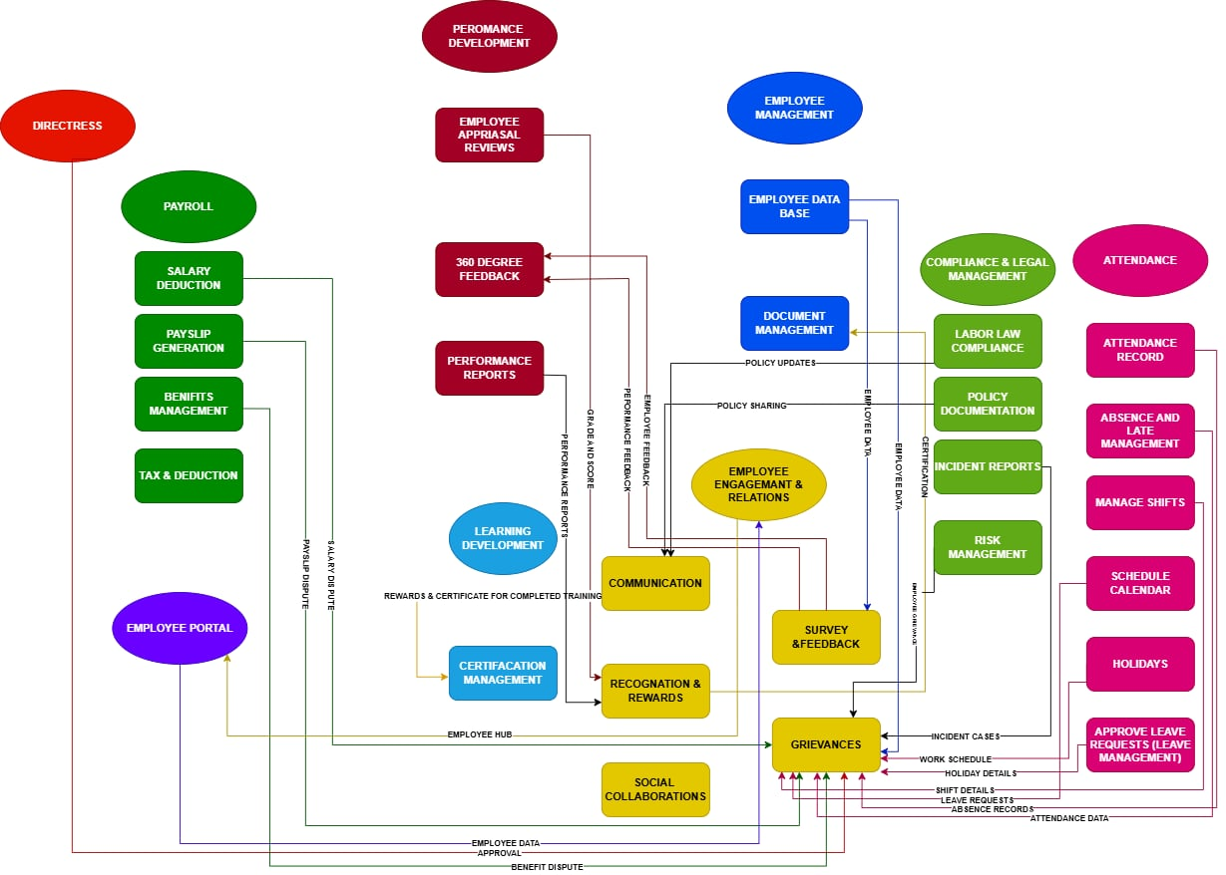
Figure 4 BPA Level 2
CHAPTER 2
RELATED LITERATURE, STUDIES, AND TECHNICAL BACKGROUND
Human Resource Management (HRM) refers to the management of employees and employee-related activities within an organization. It involves processes that support employees throughout their relationship with the organization, including communication, participation, recognition, feedback, and the management of workplace concerns. Effective Human Resource Management requires organized information and processes to support communication between employees and management.
In the context of the present study, Human Resource Management provides the organizational foundation for the proposed Human Resources Employee Engagement and Relations System. The system focuses on selected HR activities that are directly related to employee engagement and employee relations, particularly the dissemination of announcements, collection of feedback and survey responses, recognition of employee achievements, participation in engagement activities, and management of complaints and grievances.
The proposed system does not intend to replace all Human Resource functions. Instead, it focuses on providing a centralized platform for selected employee engagement and relations activities. This scope allows the study to address specific communication, participation, feedback, recognition, and workplace concern-management processes identified in the research.

2.1 Review of Related Literature
Local Studies #1
“HRMS-Empowered Employee Engagement Decision Support System”
The study is relevant to the present research because it provides a basis for understanding employee-related practices and their relationship to Human Resource Management. The concepts presented in the study support the importance of organized processes that consider employee participation, communication, and workplace experiences. However, the present study differs in its focus on the development of an information system specifically designed to support employee engagement and employee relations activities at Bestlink College of the Philippines – Bulacan Campus. The proposed system translates selected employee-related processes into centralized system functions, including announcements, feedback and surveys, recognition and rewards, grievance management, employee participation, monitoring, and reporting.
Cabauatan, C. V., Isidro, J. N. J., Pereira, J., Valdez, M. E., Palapuz, J. J., Agravante, K. A., Boyang, N. C., & Lardizabal, E. (2025). HRMs-Empowered Employee Engagement Decision Support System.
https://www.ejournals.ph/article.php?id=30786

Local Studies #2
“Digital Technologies on Personnel Engagement and Retention in Human Resource Management 4.0”

The study is relevant to the present research because it provides additional evidence regarding Human Resource practices and employee-related processes. Its discussion supports the importance of considering employee experiences and organizational practices when addressing employee engagement and workplace relations. The present research builds on these concepts by developing a centralized information system that allows selected employee engagement and relations processes to be managed through a single platform. These processes include employee communication, feedback, recognition, grievance management, participation, and administrative monitoring.
Pinca, J., Lacerona, R., Dimaunahan, L., & Simangan, A. N. (2025). Digital Technologies on Personnel Engagement and Retention in Human Resource Management 4.0. https://ejournals.ph/article.php?id=32429

Local Studies #3
“Human Resource Information System with Digital Archiving”

The study is relevant to the present research because it demonstrates the importance of Human Resource practices and employee-related processes within an organizational setting. It provides a basis for considering employee experiences and organizational support when designing solutions for employee-related concerns. The present study extends this perspective by applying information technology to selected employee engagement and employee relations processes. The proposed system provides centralized functions for communication, feedback and surveys, recognition and rewards, grievance management, participation, monitoring, and reporting.
Argana, E. S., Sunico, R. J. A., & Francisco, V. C. (2020). Human Resource Information System with Digital Archiving. © 2012-2019 International Journal of Computer (IJC). https://doi.org/10.53896/ijc.v39i1.1802

Foreign Studies#1
“The Effect of HRIS Implementation Success on Job Involvement, Job Satisfaction and Work Engagement in SMEs”

The study is relevant to the present research because it provides a perspective on employee engagement and factors associated with employees' relationships and experiences within an organization. These concepts support the present study's focus on providing opportunities for employee communication, participation, feedback, and engagement. However, the present study differs because it focuses on the design and development of a centralized information system that operationalizes selected employee engagement and employee relations processes within the context of Bestlink College of the Philippines – Bulacan Campus.
Maamari, B. E., & Osta, A. (2021). The effect of HRIS implementation success on job involvement, job satisfaction and work engagement in SMEs. International Journal of Organizational Analysis, 29(5), 1269–1286. https://doi.org/10.1108/ijoa-07-2020-2298

Foreign Studies#2
“Adopting Human Resource Information System and Work-Related Outcomes in Emerging Market SMEs”

The study is relevant to the present research because it provides a technological perspective on the adoption and use of Human Resource information systems. It supports the idea that technology can be applied to Human Resource processes to organize information and support HR activities. The present study applies this perspective specifically to employee engagement and employee relations by developing a centralized platform for announcements, feedback and surveys, recognition and rewards, grievance management, employee participation, administrative monitoring, and reporting.
Shahreki, J., & Lee, J. Y. (2024). Adopting human resource information system and work-related outcomes in emerging market SMEs: unified theory of acceptance and use of technology. Cross Cultural & Strategic Management, 31(1), 116–142. https://doi.org/10.1108/ccsm-09-2022-0144

Foreign Studies#3
“The Effects of High Performance Work Systems and Leader Member Exchange Quality on Employee Engagement”

The study is relevant to the present research because it provides a perspective on employee engagement and organizational factors that may affect employee experiences. Its findings support the importance of considering employee engagement when developing organizational practices and interventions. The present study builds on this perspective by developing an information system that provides centralized functions for employee participation, feedback, communication, recognition, and workplace concern management.
Oliveira, L. B., & da Silva, F. F. R. A. (2015). The effects of high performance work systems and leader-member exchange quality on employee engagement: Evidence from a Brazilian non-profit organization. Procedia Computer Science, 55, 1023–1030. https://doi.org/10.1016/j.procs.2015.07.092

2.2 Analysis of Related Studies and Existing Systems
The table presents a comparative synthesis of selected local and foreign studies related to the proposed Employee Engagement and Relations System. The reviewed studies highlight the importance of digital tools in managing employee information, communication, feedback, engagement, HR processes, employee relations, and administrative records.
Local studies mainly emphasize the use of digital systems for employee information management, HR processes, communication, engagement, and record keeping, while foreign studies provide broader perspectives on HRIS, technology adoption, employee participation, work outcomes, and employee-management relationships.
However, the reviewed studies do not present a single system that combines all these functions in one centralized platform. This gap supports the development of the proposed system, which aims to integrate communication, feedback and surveys, recognition and rewards, grievance management, employee participation, engagement monitoring, and administrative reporting into one digital platform for Bestlink College of the Philippines – Bulacan Campus.

FEATURES | L1 | L2 | L3 | F1 | F2 | F3 | YOUR SYSTEM
Employee information management | ✓ |  | ✓ | ✓ | ✓ |  | ✓
Employee communication | ✓ | ✓ |  |  |  | ✓ | ✓
Feedback and surveys | ✓ | ✓ |  |  |  | ✓ | ✓
Employee engagement activities | ✓ | ✓ |  | ✓ | ✓ | ✓ | ✓
Employee participation | ✓ | ✓ |  |  |  | ✓ | ✓
Recognition and rewards |  | ✓ |  |  |  | ✓ | ✓
Grievance / concern management |  | ✓ |  |  |  | ✓ | ✓
HR process management | ✓ | ✓ | ✓ | ✓ | ✓ | ✓ | ✓
Centralized employee platform | ✓ | ✓ | ✓ | ✓ | ✓ |  | ✓
Engagement monitoring | ✓ | ✓ |  | ✓ | ✓ | ✓ | ✓
Digital record management | ✓ |  | ✓ | ✓ | ✓ |  | ✓
Administrative monitoring and reporting | ✓ | ✓ | ✓ | ✓ | ✓ | ✓ | ✓
User-friendly digital access | ✓ | ✓ | ✓ | ✓ | ✓ |  | ✓

2.3 AGILE SCRUM METHODOLOGY
The development of the Human Resources Employee Engagement and Relations System (EERS) requires a development approach that is flexible, organized, and responsive to the needs of its intended users. The proposed system includes several functions such as employee information management, HR announcements, feedback and surveys, recognition and rewards, grievance management, employee engagement activities, and social collaboration. Because these functions may require changes and improvements during development, the researchers selected the Agile Scrum Framework as the methodology for developing the system.
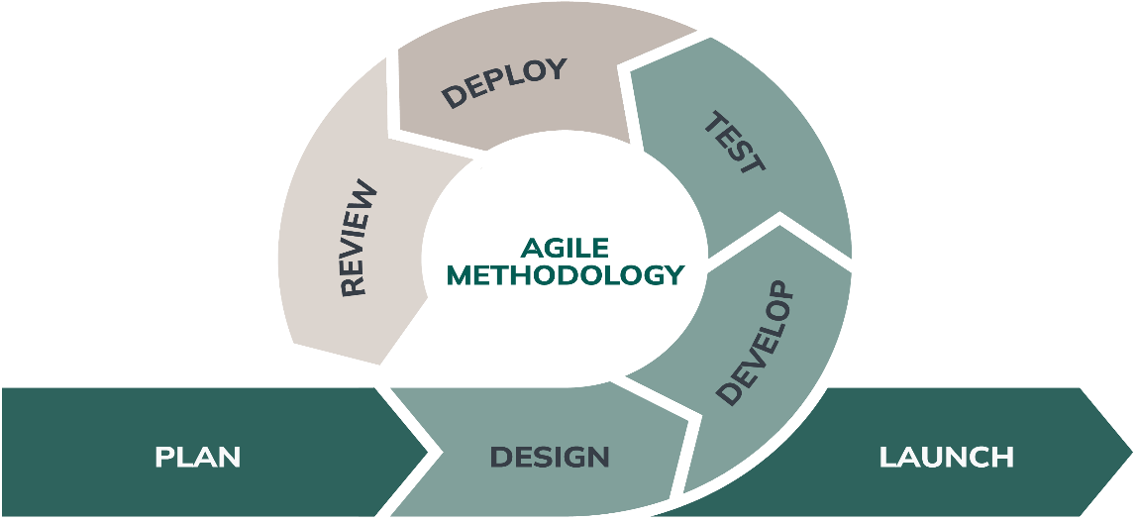
Figure 6 Agile Scrum Methodology Overview

Agile is a software development approach that focuses on flexibility, collaboration, continuous improvement, and the gradual development of system features. Scrum is a framework under Agile that organizes the development process into short and manageable cycles called Sprints. In each Sprint, a selected set of requirements is planned, developed, tested, and reviewed. This allows the researchers to work on the system step by step rather than developing all of its functions at the same time.
The development process begins with gathering and analyzing the requirements of the Human Resource Department and the intended users of the system. The identified requirements are placed in the Product Backlog, which contains the features and tasks that need to be developed. The researchers then prioritize these requirements and select the tasks to be completed during Sprint Planning. These tasks may include employee information, announcements, feedback and surveys, recognition and rewards, grievance handling, engagement activities, and social collaboration.
During each Sprint, the selected functions are designed, developed, and tested. Testing is conducted to determine whether the features are working according to the identified requirements. Errors and problems found during testing are documented and corrected by the researchers. The completed features are then reviewed to determine whether they are suitable for the intended users. Feedback and observations gathered during the review are considered when planning the succeeding Sprint.
The Scrum approach also encourages cooperation among the members of the development team. The Scrum Master helps organize the Scrum activities and monitors the progress of the team. The System Analyst gathers and analyzes the system requirements, while the Programmer develops and maintains the system features. The Business Analyst helps ensure that the system functions are consistent with the needs of the organization, while the Document Specialist prepares and maintains the necessary project documentation.
The use of Agile Scrum allows the researchers to identify and address problems while the system is still being developed. Instead of waiting until the final stage of development to make corrections, the researchers can apply changes and improvements within succeeding Sprints. Regular discussions, testing, reviews, and feedback also help the team monitor the progress of the project and determine which areas require further improvement.
Through the continuous process of planning, development, testing, review, and improvement, the researchers can gradually develop the proposed Human Resources Employee Engagement and Relations System based on the requirements of Bestlink College of the Philippines – Bulacan Campus. The Agile Scrum Framework therefore provides the researchers with a practical and systematic way of managing the development of the system while allowing necessary changes to be considered throughout the project.

2.4 Emerging Technologies, Intelligent
Systems, and Standards in Modern
Information Systems 20
2.4.1 Microservices Architecture
Microservices Architecture is a software design approach in which an application is divided into smaller and more manageable services. Each service is responsible for a specific function and can operate independently while communicating with other services when necessary. Unlike a monolithic architecture, where the major functions of an application are closely combined into a single application, microservices allow individual components to be developed, modified, and maintained separately. This approach can make the system easier to manage and improve because changes to one service do not necessarily require changes to the entire application.
For the proposed Employee Engagement and Relations System, the microservices approach can be used to organize the major HR functions into separate services. Each service focuses on a particular responsibility while remaining connected to the rest of the system. For example, the system may contain services for User Authentication, Employee Information, Communication and Announcements, Surveys and Feedback, Recognition and Rewards, Grievance Management, Engagement Activities, Notifications, and Reports and Analytics.
The User Authentication Service manages user accounts, login processes, and access permissions to ensure that system functions and employee-related information are available only to authorized users. The Employee Information Service manages the employee records required by the system. The Communication Service supports the distribution of HR announcements, policy updates, and other organizational information. The Survey and Feedback Service manages surveys, polls, and employee responses used to gather information about employee engagement.
The Recognition and Rewards Service manages employee recognition records and related activities. The Grievance Management Service provides a structured method for submitting, recording, monitoring, and managing workplace concerns. The Engagement Service supports activities intended to encourage employee participation, while the Reports and Analytics Service processes available system information to produce reports that can assist HR personnel in monitoring participation, feedback, recognition, and grievances.
Communication between the different services can be handled through application programming interfaces (APIs). When a user performs an action, the system directs the request to the appropriate service, which processes the request and returns the required result. This separation allows individual services to be updated or improved without having to redesign the entire system. It also provides flexibility when additional functions are needed in the future.
The use of Microservices Architecture can support the proposed system by providing a more organized structure for its different modules. It allows the researchers to separate major HR functions according to their responsibilities while maintaining communication between related services. This can contribute to easier maintenance, modular development, and future expansion of the system.
For the proposed Employee Engagement and Relations System, Microservices Architecture is therefore considered as an approach for organizing the system's functional components. By separating the major services while maintaining their necessary connections, the architecture supports the development of a system that can be improved incrementally based on user feedback and changing organizational requirements.

2.4.2 Artificial Intelligence (AI) 24
2.4.3 Internet of Things (IoT) 26
2.4.4 Data Analytics and Business
Intelligence 28
2.4.5 Polyglot Persistence 30
2.4.6 Cybersecurity 32
2.4.7 Data Privacy 34
2.4.8 Software Quality Standards 36
2.4.9 Cloud Computing 38
2.4.10 Edge Computing 40
2.5 DevOps Culture and CI/CD Practices 42
2.6 Enterprise Architecture & System Integration
2.2 Enterprise Architecture Concepts
Enterprise Architecture (EA) is a structured approach used to organize the relationship between an organization's business processes, information, applications, and technology resources. It provides a framework for understanding how different parts of an organization work together to support its objectives. Through Enterprise Architecture, organizations can identify how their processes and technologies can be improved, integrated, and managed more effectively. The commonly used domains of EA include Business Architecture, Data Architecture, Application Architecture, and Technology Architecture, which provide different perspectives of an organization's operations and information systems.
For the proposed Employee Engagement and Relations System, Enterprise Architecture provides a structured basis for integrating different HR-related activities into one centralized platform. The system is intended to support employee communication, feedback and engagement activities, recognition and rewards, grievance handling, and the monitoring and reporting of employee-related information. By bringing these functions together, the system can help reduce the use of disconnected records and communication channels while providing authorized users with easier access to organized and updated information.
The Business Architecture represents the HR processes and activities supported by the proposed system. It includes the dissemination of announcements, collection of employee feedback, administration of surveys and polls, recognition of employees, submission and monitoring of grievances, and management of engagement activities. These processes serve as the foundation for identifying the functions that the system needs to provide.
The Data Architecture focuses on how employee-related information is organized, stored, and managed within the system. This may include employee profiles, announcements, feedback responses, survey results, recognition records, grievance records, engagement activities, and system reports. Proper organization of these data helps prevent unnecessary duplication and allows authorized HR personnel to retrieve relevant information more efficiently.
The Application Architecture describes the software components and modules that support the identified HR processes. The proposed system includes modules for employee information, communication and announcements, surveys and feedback, recognition and rewards, grievance handling, engagement activities, dashboard monitoring, and reports. These application components work together to provide a centralized environment for managing employee engagement and relations activities.
The Technology Architecture covers the technical resources required to operate the system. It includes the programming environment, database management system, web server, computers or other supported devices, and network resources used by the system. These components provide the foundation for implementing and accessing the proposed system while supporting its reliability, security, and maintainability.

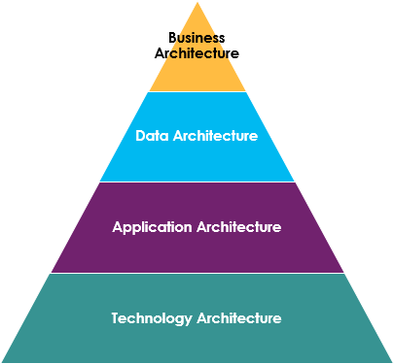
The four domains of Enterprise Architecture—Business, Data, Application, and Technology—work together to provide a clear view of how the proposed system supports the HR department's processes. Their integration allows the researchers to align the system's functions with the needs of its intended users. It also provides a basis for improving information management, reducing unnecessary manual processes, supporting better monitoring of employee engagement, and making the system easier to maintain and improve as requirements change.
In the proposed Employee Engagement and Relations System, Enterprise Architecture therefore serves as a guide for organizing the different components of the system and establishing their relationships. It helps ensure that the business processes, data, applications, and technologies are properly connected and support the intended purpose of the system. Through this approach, the researchers can develop a system that is organized, adaptable, and responsive to the communication and engagement needs of the organization.

CHAPTER 3
METHODOLOGY AND PROJECT MANAGEMENT

3.1 The Adapted Agile Scrum Framework
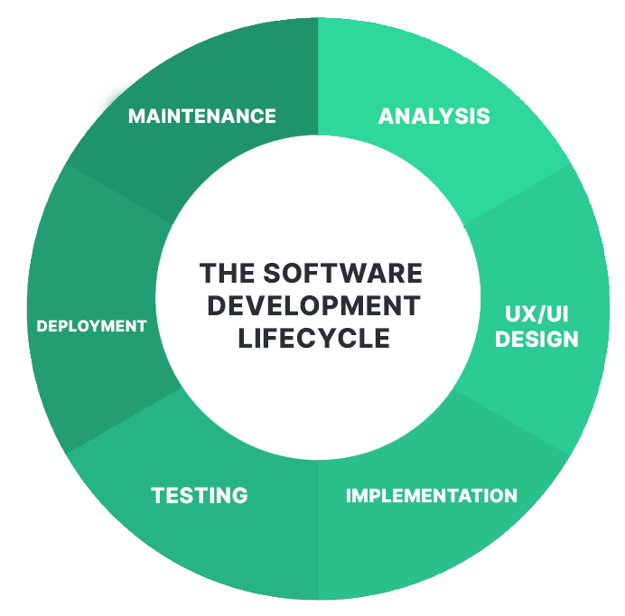
Analysis Phase
The analysis phase, the researchers identify and assess the needs, concerns, and requirements of the intended users of the Employee Engagement and Relations System. The researchers gather information through interviews, observations, and document review to understand the existing HR processes and the difficulties encountered in handling employee communication, feedback, recognition, engagement activities, and workplace concerns. The information gathered during this phase is used to determine the system requirements and prioritize the functions that will be included in the development.
Design Phase
The design phase focuses on converting the identified requirements into a practical system structure. The researchers develop the system architecture, database design, interface layouts, navigation, and workflow based on the results of the analysis. Attention is given to making the system organized, understandable, and easy to use for both HR personnel and employees. The design is also reviewed by the researchers to ensure that the proposed components are appropriate for the identified requirements.
Implementation Phase
The implementation phase involves the actual development of the proposed system. The programmers write the necessary source code and develop the system modules based on the approved requirements and designs. The database is created and connected to the system, while the user interfaces and required functions are implemented. The modules are developed incrementally, allowing the researchers to check the progress of each component and make necessary adjustments before integrating it with the other parts of the system.
Testing Phase
In the testing phase, the researchers evaluate the developed system to determine whether its functions operate according to the identified requirements. The team tests the different modules, database operations, inputs and outputs, navigation, and interactions between system components. Errors and unexpected results encountered during testing are recorded and corrected. The affected functions are then tested again to verify that the necessary improvements have been properly implemented.
Deployment Stage
The deployment stage involves preparing the tested system for actual use by the intended users. The researchers configure the system in its intended operating environment and make the necessary preparations for its initial implementation. During this stage, the users are given an opportunity to interact with the system and provide feedback regarding its functionality and usability. Any concerns identified during the initial use are documented for possible revision.

Maintenance Phase
The maintenance phase focuses on monitoring and improving the system after its initial deployment. The researchers address reported errors, usability concerns, and other issues that may arise during actual use. User feedback is also considered in identifying possible enhancements to the system. When new requirements or improvements are identified, these are brought back to the Analysis Phase for further assessment. This allows the researchers to repeat the development cycle and continuously improve the Employee Engagement and Relations System based on actual user needs.

3.1.1 Team Roles and Responsibilities

The researchers assigned specific roles and responsibilities to each member of the development team to ensure that the development of the Human Resources Employee Engagement and Relations System was properly organized. Each role contributes to a specific part of the project, from planning and analyzing system requirements to programming, testing, and documentation. The responsibilities of each team member are presented
ROLES | NAME AND CONTACT INFORMATION | RESPOSIBILITIES
Scrum Master | Mendoza,Karl Ashley  Karlmendoza098@gmail.com  09942159807 | Coordinates the development team and ensures that the adapted Scrum process is properly followed. Monitors the progress of each Sprint, facilitates team meetings, helps identify and resolve development issues, and ensures that project activities remain aligned with the planned schedule and objectives.
Programmer | Balansag, Geoffrey  balansaggeoffrey05@gmail.com  09817127679 | Develops and implements the system based on the approved requirements and design. Responsible for coding system functions, integrating system components, managing database connections, correcting errors, conducting technical testing, and improving system functionality and performance.
System Analysis | Mirabueno, John Carlo M. | Analyzes the existing Registrar’s Office processes and identifies the problems and system requirements. Prepares system specifications, analyzes user requirements, helps design system processes, and ensures that the developed functions correspond to the identified needs of the institution.
Document Specialist | Plicerda, Lanz C. | Responsible for preparing, organizing, and maintaining the project's technical and research documentation. Records development activities, system requirements, meeting discussions, testing results, system revisions, and other necessary documents to ensure that project information is properly maintained and presented.
Business Specialist | Hipol, Adrian I. | A Business Specialist is the team member who focuses on the organizational and operational requirements related to employee engagement and relations. The Business Specialist identifies the needs of employees, Human Resources personnel, and other intended users, evaluates existing employee engagement and relations processes, gathers relevant system requirements, and helps ensure that the proposed system provides appropriate solutions to identified problems. The role also assists in translating organizational needs into system functions that support communication, feedback, recognition, grievance management, and employee engagement activities.

The assignment of these roles provides the researchers with a clear division of responsibilities throughout the development process. Although team members may assist one another when necessary, each role has specific responsibilities that contribute to the successful planning, development, testing, and documentation of the proposed system.
3.1.2 Scrum Events

3.1.3 Scrum Artifacts

3.1.4 TOOLSTACK
The researchers used a combination of software development tools and technologies to design, develop, test, and manage the proposed Human Resources Employee Engagement and Relations System. The selected tools were used according to their respective functions throughout the development process.
Tool | Purpose and Application
Visual Studio Code | Used as the primary code editor for writing, organizing, and modifying the source code of the system.
PHP | Used as the server-side programming language for implementing system processes, handling user requests, processing information, and connecting the application to the database.
HTML | Used to create and structure the content and elements of the system's web pages.
CSS | Used to design and format the system interface, including page layouts, forms, navigation elements, and other visual components.
JavaScript | Used to provide interactive functions and dynamic behavior within the system interface.
MySQL | Used as the relational database management system for storing and managing employee information, feedback, survey responses, recognition records, grievance records, announcements, and collaboration-related information.
phpMyAdmin | Used to create, configure, manage, and maintain the MySQL database during system development and testing.
XAMPP | Used as the local development environment for running the Apache web server, PHP application, and MySQL database during development and testing.
Git | Used for version control and for monitoring changes made to the system source code during development.
GitHub | Used as a remote repository for storing and managing project source code and facilitating collaboration among members of the development team.
Web Browser | Used to access, test, and evaluate the functionality and interface of the developed web-based system.
Draw.io | Used to create selected system diagrams and visual representations used in the system analysis and design process.

3.2 Architectural Design Decisions 56
3.2.1 Why Microservices? Justify the choice over Monolithic architecture.
3.2.2 Core Architectural Patterns Used
3.3 Development, Operations, and Quality Assurance (QA) Methodology 60
3.3.1 DevOps Toolchain
3.3.2 CI/CD Pipeline Design
3.3.3 Testing Strategy
3.4 Innovation Framework 62

CHAPTER 4
SYSTEM DESIGN, DEVELOPMENT, AND
4.1 Requirements Engineering 64
4.1.1 Stakeholder Analysis
4.1.2 Elicitation Techniques
4.1.3 Functional Requirements
4.1.4 Non-Functional Requirements
4.1.5 User Stories, Acceptance Criteria, and Use Cases
4.2 High-Level System Design 70
4.2.1 System Context Diagram
4.2.2 Overview of the Integrated System
4.3 Business Process Architecture (BPMN 2.0) 76
4.3.1 As-Is Process Model
4.3.2 To-Be Process Model
4.3.3 Analysis of Improvements
4.4 Application Architecture 80
4.4.1 Component Diagram
4.4.2 Detailed UML Diagrams for Key Services
4.5 Data Architecture and Design 86
4.5.1 Logical Data Model
4.5.2 Physical Data Model
4.5.3 Data Dictionary
4.5.4 Data Flow Diagrams (Level 0, Level 1)
4.6 Technology Architecture & Infrastructure 92
4.6.1 Technology Stack Justification
4.6.2 Deployment Architecture
4.6.3 Network and Security Design
4.6.4 Cloud Infrastructure
4.7 Development Journey 95
4.7.1 Sprint Summaries
4.7.2 Key Technical Challenges and Solutions
4.8 Implementation Strategy 98
4.8.1 Deployment Plan
4.8.2 Migration Plan
4.8.3 User Training and Change Management
4.9 Testing and Quality Assurance Report 100
4.9.1 Test Plan
4.9.2 Summary of Test Results
4.9.3 Performance Test Report
4.9.4 Security Audit Findings
4.10 Results and Evaluation 104
4.10.1 User Acceptance Testing (UAT) Protocol and Results 106
4.10.2 Validation Against Objectives 108
4.10.3 Project Retrospective 110

CHAPTER
5 CONCLUSION 5.1 Summary of the Project 112
5.2 Conclusion 114
5.3 Project Contributions 116
5.4 Recommendations 118
5.4.1 For Future Enhancement
5.4.2 For Implementation
5.4.3 For Future Researchers

REFERENCES 120
APPENDICES 124
CURRICULUM VITAE 140

LIST OF TABLES
Table Page
- Roles and Responsibilities 27
- Sprint Cycle 33
- Product Backlog (User Stories) 37
- Product Backlog for EIS Information Security 47
- Product Backlog for EIS Standards 49
- Product Backlog for EIS Integration 51
- Product Backlog for Analytics 56
- Product Backlog for EIS Analytics 58
- Sprint Backlog (User Stories) 60
- Scrum Board 73

LIST OF FIGURES
Figure Page
- Agile Scrum Framework 26
- Burndown Chart 76
- Microservices Diagram 79
- Communication Pattern 80
- Data Flow Diagram 81
- CI/CD Pipeline 85
- Infrastructure as a Code (IaC) 85
- Monitoring and Alerting 86
- Integration Diagram 88
- API Gateway 88
- Data Flow Diagram 89
- Use Case Diagram 92
- Sequence Diagram 93
- Flowchart 93

LIST OF APPENDICES
Appendix A DETAILED TECHNICAL DOCUMENTATION
A.1 System Architecture
A.2 Information Systems Integration
A.3 Application Design and Development
A.4 Database Schema and Data Management
A.5 Network Configuration
A.6 Deployment and Infrastructure
A.7 Security Measures
A.8 Testing and Quality Assurance
A.9 System Monitoring and Maintenance
A.10 APIs and Integration Points
A.11 User Documentation
A.12 Known Issues and Troubleshooting
A.13 Version Control and Source Code Repository
A.14 DevOps and CI/CD
A.15 Licensing and Open Source Libraries
A.16 Performance Metrics and Monitoring
Appendix B: Project Management Artifacts
B.1 Project Charter / Proposal
B.2 Sprint Backlogs and Burndown Charts
B.3 Meeting Minutes (Key decisions should be documented)
B.4 Gantt Chart or Project Timeline
Appendix C: Research and Requirements Artefacts
C.1 Approved Adviser Acceptance Form
C.2 Company Endorsement / Memorandum of Agreement
C.3 Survey Questionnaires and Raw Data
C.4 Interview Transcripts and Guides (Anonymized)
C.5 UAT Forms and Signed Off Sheets
C.6 Certificate of Originality
Appendix D: Certificate of Technical Adviser and Grammarian
Appendix F: Defense and Validation
F.1 Panel Evaluation Sheets (Signed)
F.2 Photos from Defense and Pilot Testing
F.3 Certificates of Copyright / Patent Application (If any)
Appendix G: Access Links (All valid for 3 years)
G.1 Live System URL
G.2 Source Code Repository (e.g., GitHub)
G.3 Comprehensive Online Documentation (e.g., ReadTheDocs, GitBook)
G.4 System Demo Video (YouTube/Vimeo)
G.5 CI/CD Pipeline Dashboard (if publicly accessible)
Appendix H: Technical Adviser Curriculum Vitae
Appendix I: Research Adviser Curriculum Vitae
Appendix J: Researcher’s Curriculum Vitae

