BESTLINK COLLEGE OF THE PHILIPPINES BULACAN
CAMPUS – HUMAN RESOURCE MANAGEMENT
(LEGAL AND COMPLIANCE SYSTEM)

A Capstone
Presented to the Faculty of
The College of Computer Studies
Bestlink College of the Philippines

In Partial Fulfillment
of the Requirements for the Degree
Bachelor of Science in Information Technology

PHIL VINCENT LOPE
MARIA CHESKA JALOTJOT
MARYCRIS ELIAGA
JOHNA MHAE AZUCENA

February 2026
TABLE OF CONTENTS
Page
TITLE PAGE i
APPROVAL SHEET ii
ACKNOWLEDGMENT iii
DEDICATION v
ABSTRACT vi
TABLE OF CONTENTS viii
LIST OF TABLES xiii
LIST OF FIGURES xiv
LIST OF APPENDICES xv
CHAPTER
1 INTRODUCTION 7
1.1. Background of the Capstone Project 8
1.2. Context and Scope 23
1.3. Problem Statement 28
1.4. Objectives and Goals 30
1.5. Significance and Relevance of the Study 33
1.6. Structure Of Documents 36

CHAPTER
- RELATED STUDIES AND
LITERATURE REVIEW 49
2.1 Agile Scrum Methodology Overview 51
2.2 Enterprise Architecture Concepts 52
2.3 Monolithic Architecture 55
2.4 DevOps and Continuous Integration
and Continuous Deployment (CI/CD) 58
2.4.1 Relevant Studies and Research 62
2.4.2 Integration of Information Systems
in Enterprise Environments 70
CHAPTER
3 METHODOLOGY AND PROJECT MANAGEMENT 75
3.1 Agile Scrum Methodology in the Project 79
3.1.1 Team Roles and Responsibilities 81
3.1.2 Sprint Cycle 83
3.1.3 Scrum Artifacts 90
3.2 Integration Approach for Information System 98
3.3 Introduction to TOGAF and the Four Architecture Domains 106

LIST OF TABLES
Table Page
- Structure of the Document 46
- Roles and Responsibilities 89
- Sprint Cycle 93
- Daily Standups 97
- Scrum Artifacts 97
- Product Backlog 104
- Sprint Backlog 104

LIST OF FIGURES
Figure Page
- Theoretical Framework 10
- Conceptual Framework 15
- Business Process Architecture Level 1 45
- Business Process Architecture Level 2 46
- Business Process Architecture Level 3 50
- System Flowchart 51
- Use Case Diagram 52
- Agile Scrum Methodology 55
- Enterprise Architecture 56
- Architecture Framework 58
- Monolithic Architecture 59
- DevOps and CI/CD 62
- SDLC 79
- Agile Scrum Methodology 83
- Sprint Cycle 87
- Monolithic Architecture 105
- TOGAF Architecture Framework 110
- Business Architecture 111
- Data Architecture 112
- Application Architecture 113
- Technology Architecture 114

LIST OF APPENDICES
Appendix A DETAILED TECHNICAL DOCUMENTATION
A.1 System Architecture
A.2 Information Systems Integration
A.3 Application Design and Development
A.4 Database Schema and Data Management
A.5 Network Configuration
A.6 Deployment and Infrastructure
A.7 Security Measures
A.8 Testing and Quality Assurance
A.9 System Monitoring and Maintenance
A.10 APIs and Integration Points
A.11 User Documentation
A.12 Known Issues and Troubleshooting
A.13 Version Control and Source Code Repository
A.14 DevOps and CI/CD
A.15 Licensing and Open Source Libraries
A.16 Performance Metrics and Monitoring
Appendix B: Project Management Artifacts
B.1 Project Charter / Proposal
B.2 Sprint Backlogs and Burndown Charts
B.3 Meeting Minutes (Key decisions should be documented)
B.4 Gantt Chart or Project Timeline
Appendix C: Research and Requirements Artefacts
C.1 Approved Adviser Acceptance Form
C.2 Company Endorsement / Memorandum of Agreement
C.3 Survey Questionnaires and Raw Data
C.4 Interview Transcripts and Guides (Anonymized)
C.5 UAT Forms and Signed Off Sheets
C.6 Certificate of Originality
Appendix D: Certificate of Technical Adviser and Grammarian
Appendix F: Defense and Validation
F.1 Panel Evaluation Sheets (Signed)
F.2 Photos from Defense and Pilot Testing
F.3 Certificates of Copyright / Patent Application (If any)
Appendix G: Access Links (All valid for 3 years)
G.1 Live System URL
G.2 Source Code Repository (e.g., GitHub)
G.3 Comprehensive Online Documentation (e.g., ReadTheDocs, GitBook)
G.4 System Demo Video (YouTube/Vimeo)
G.5 CI/CD Pipeline Dashboard (if publicly accessible)
Appendix H: Technical Adviser Curriculum Vitae
Appendix I: Research Adviser Curriculum Vitae
Appendix J: Researcher’s Curriculum Vitae

CHAPTER 1

INTRODUCTION
Human Resource (HR) management involves more than hiring and assisting employees. It also includes managing employee records, following government requirements and labor laws, implementing institutional policies, handling employee concerns, and preparing reports. These activities require HR personnel to keep records accurate, updated, and easy to access.
As HR records and compliance activities increase, managing them through separate files and manual processes can become difficult and time-consuming. HR personnel may face challenges in monitoring government compliance, managing employee documents, tracking policy acknowledgments, handling incidents and complaints, monitoring risks, and preparing reports. It may also take time to find reliable labor law information and communicate important compliance matters to employees.
To address these concerns, this capstone project proposes an HR Legal and Compliance Management Module for Bestlink College of the Philippines – Bulacan Campus. The module will be integrated into the existing Human Resource Management System (HRMS) to provide a centralized platform for managing HR legal and compliance activities. It will help authorized HR personnel organize records, monitor requirements, manage documents, communicate with employees, and access relevant legal and compliance information in one system.
The proposed module will include government compliance monitoring, salary compliance, labor law references, employee document management, document services, policy management and acknowledgment, incident and complaint management, risk assessment, exit acknowledgment, compliance monitoring, notifications and alerts, email communication, and report generation.
The Labor Law References function will contain relevant labor laws, rules, regulations, and other official references issued by appropriate government agencies. It will also include Lala AI (Labor Law Assistant), which helps authorized HR personnel find relevant references based on their questions or HR-related situations. Lala AI will provide information based on the official references available in the system and will not replace professional legal advice, government interpretation, or official legal guidance.
The module will also include an email communication feature that allows authorized HR personnel to send emails directly to employees. This can be used for compliance reminders, document requests, policy acknowledgments, notifications, and other HR-related concerns, helping improve communication and follow-up.
Through these features, the project aims to provide a more organized and centralized way of managing HR legal and compliance activities. It seeks to help HR personnel monitor requirements, manage records, access government-issued labor law references, communicate with employees, and prepare reports more efficiently while supporting the existing HRMS of the institution.

  - Background of the Capstone Project
The Human Resources Department handles different employee records and compliance activities, such as government requirements, employee documents, policies, complaints, incidents, risks, salary information, and employee exit records. Managing these records properly is important to support daily HR operations and ensure that important information is organized and available when needed.
When these activities are managed through separate files and manual processes, HR personnel may have difficulty finding information, monitoring document expiration, tracking compliance requirements, following up on employee concerns, and preparing reports. These processes may also take more time and may result in incomplete, outdated, or difficult-to-monitor records. Finding applicable labor laws and government requirements may also require HR personnel to search through different sources. Communicating compliance-related reminders and requirements to employees may also require separate email processes.
At Bestlink College of the Philippines – Bulacan Campus, the Human Resources Department manages faculty and non-teaching personnel and handles various employee-related records and compliance activities. Based on the researchers’ preliminary assessment, these activities are not centralized in a dedicated Legal and Compliance Management platform. This may make it more difficult to monitor compliance activities, organize related records, communicate with employees, and access applicable labor law references when needed.
The proposed Human Resource Management System (HRMS) with a Legal and Compliance Management Module aims to address these concerns through a centralized platform. The module will support government compliance monitoring, salary compliance, labor law references, employee document management, document services, policy management and acknowledgment, incident and complaint management, risk assessment, employee exit acknowledgment, compliance monitoring, notifications and alerts, email communication, and report generation.
The Labor Law References feature will contain applicable labor laws, rules, regulations, and other official references issued by appropriate government agencies. It will also include Lala AI (Labor Law Assistant) to help authorized HR personnel find relevant references based on their labor law questions or HR-related situations. Lala AI will provide information based on the official references available in the system and will serve as an information-support tool. It will not replace professional legal advice, government interpretation, or official legal guidance.
The Email Communication feature will allow authorized HR personnel to compose and send emails directly to employees using their recorded email addresses. It can be used for compliance reminders, document requests, policy acknowledgments, notifications, and other HR-related matters. The system can also maintain records of sent emails and related communication activities to support monitoring and follow-up.
The system is designed to support, rather than replace, the responsibilities of HR personnel. By providing centralized records, compliance monitoring, government-issued labor law references, Lala AI assistance, document management, direct email communication, and reporting tools, the system aims to help HR personnel manage legal and compliance activities in a more organized, accessible, and efficient manner.
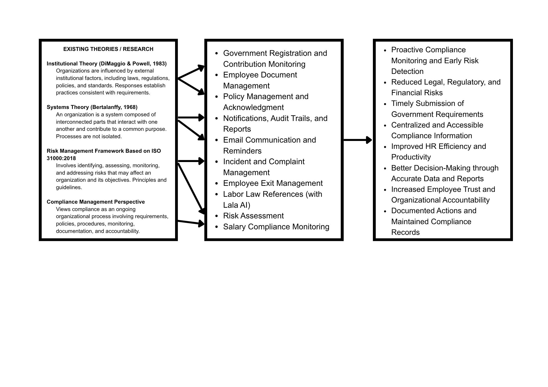
Figure 1. Theoretical Framework
This study is guided by four theoretical and conceptual perspectives that provide a foundation for the development of the proposed Human Resource Management System (HRMS) with a Legal and Compliance Management Module. Institutional Theory provides a basis for understanding how organizations are influenced by laws, regulations, policies, standards, and institutional requirements. Systems Theory supports the view that related HR processes and information should be connected as parts of one system. Risk Management provides a basis for identifying, assessing, monitoring, and addressing risks. A Compliance Management Perspective emphasizes continuous monitoring, documentation, accountability, and organized compliance activities.
Together, these perspectives guide the development of a centralized system that supports the Human Resources Department in managing government compliance, salary compliance, employee documents, policies and acknowledgments, incidents and complaints, risks, employee exit records, labor law references, notifications, email communication, compliance monitoring, and reports. The framework also supports Lala AI (Labor Law Assistant) within the Labor Law References feature, which helps authorized HR personnel access relevant government-issued labor laws, rules, regulations, and other official references available in the system.

Institutional Theory (DiMaggio and Powell, 1983)
Focus: Institutional Theory explains how organizations are influenced by external factors such as laws, regulations, policies, standards, and institutional expectations. Organizations develop practices and processes in response to these requirements.
Application to the Capstone Project: This perspective is relevant because HR activities are affected by government requirements, labor laws, and institutional policies. It supports system functions for monitoring government registration and contributions, salary compliance, employee documents, policies, incidents, complaints, and other compliance activities.
It also supports the Labor Law References feature, which provides access to government-issued labor laws, rules, regulations, and other official references. Lala AI is included within this feature to help authorized users locate and understand relevant references based on their questions or HR-related situations. It serves as an information-support tool and does not replace professional legal advice or official government interpretation.

Systems Theory (Bertalanffy, 1968)
Focus: Systems Theory views an organization as a system made up of connected parts that work together toward a common purpose. Activities in one part may affect other parts of the system.
Application to the Capstone Project: This perspective supports the development of a centralized Legal and Compliance Management Module because HR compliance activities are connected. Employee information may be related to documents, policies, incidents, complaints, risks, government compliance, salary records, and employee exit records.
The proposed system connects these functions through one centralized platform. Notifications, email communication, compliance monitoring, and reports also use information from different system functions. This allows related records and activities to be managed as connected parts of the overall HR legal and compliance process.

Risk Management Framework Based on ISO 31000:2018
Focus: Risk management involves identifying, analyzing, evaluating, monitoring, and addressing risks that may affect an organization and its objectives. ISO 31000:2018 provides principles and guidelines for establishing and improving risk management processes.
Application to the Capstone Project: This perspective provides a basis for the Risk Assessment function. The system supports authorized HR personnel in recording risks, assessing their levels, monitoring their status, and documenting related actions.
Other system records, such as incidents, complaints, document status, policy acknowledgments, and compliance activities, may also provide information that can help identify areas of concern. Notifications, email communication, and reports can support follow-up and monitoring of these concerns.

Compliance Management Perspective
Focus: Compliance management is an ongoing process that involves requirements, policies, procedures, monitoring, documentation, accountability, and corrective actions. It requires organizations to regularly monitor requirements, maintain records, and address identified concerns.
Application to the Capstone Project: This perspective provides a broad foundation for the Legal and Compliance Management Module. It supports government compliance monitoring, salary compliance, employee document management, policy management and acknowledgment, incident and complaint management, risk assessment, employee exit acknowledgment, labor law references, notifications, email communication, compliance monitoring, and report generation.
The perspective emphasizes that compliance is not limited to checking whether a requirement has been met. It also involves maintaining supporting records, monitoring deadlines and statuses, documenting actions, and communicating important requirements. The proposed system supports these activities through centralized records and monitoring tools.
The Labor Law References feature also supports access to government-issued labor laws, rules, regulations, and other official references. Lala AI, as part of this feature, helps users find relevant references based on the information available in the system. It is intended to support information access and understanding and does not replace professional legal advice or official interpretation.

Integration of the Theoretical Perspectives
The four perspectives provide complementary foundations for the proposed Human Resource Management System (HRMS) with a Legal and Compliance Management Module. Institutional Theory explains the influence of legal, regulatory, and organizational requirements on HR activities. Systems Theory supports the connection of different HR legal and compliance processes within one centralized system. Risk Management provides a basis for identifying and monitoring potential risks, while the Compliance Management Perspective emphasizes continuous monitoring, documentation, accountability, and organized compliance activities.
Together, these perspectives support the major functions of the proposed system. Government compliance and salary compliance address regulatory and compensation requirements; document and policy management support proper records and organizational procedures; incident and complaint management support the recording and monitoring of workplace concerns; risk assessment supports risk monitoring; employee exit acknowledgment supports separation-related requirements; and Labor Law References provide access to relevant government-issued legal information.
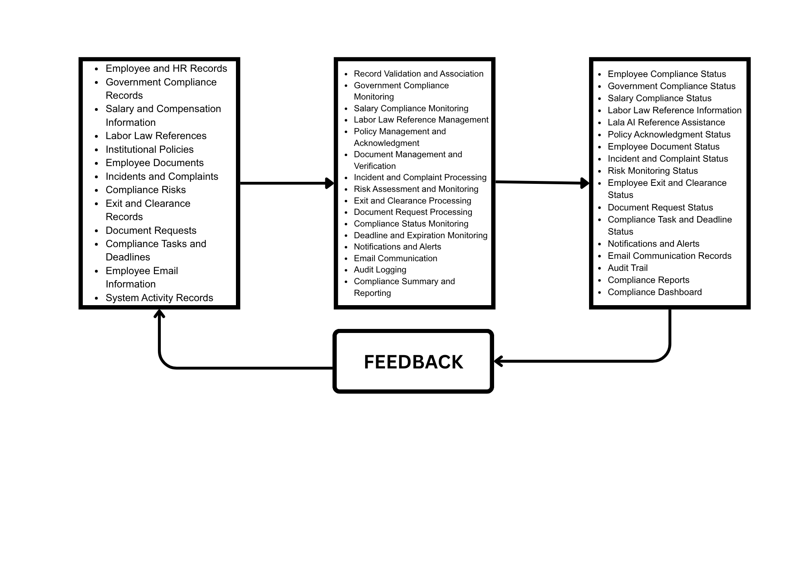
The framework also supports notifications, email communication, compliance monitoring, and reporting as tools for improving follow-up, communication, documentation, and management review. Lala AI, as part of the Labor Law References feature, further assists authorized HR personnel in accessing relevant legal information available in the system while remaining an information-support tool rather than a legal decision-making system.
Figure 2. Conceptual Framework

INPUT
• Employee and HR Records – Employee profiles, employment status, positions, departments, salary information, employment dates, and other HR records relevant to legal and compliance activities.
• Government Compliance Records – Government registration and contribution information for SSS, PhilHealth, Pag-IBIG, and BIR used for compliance monitoring.
• Salary and Compensation Information – Employee salary information, applicable minimum wage or standard rate references, and other compensation-related data used for salary compliance monitoring.
• Labor Law References – Labor laws, rules, regulations, memoranda, and other official references issued by appropriate government agencies. These references also support Lala AI (Labor Law Assistant) within the Labor Law References feature.
• Institutional Policies – Existing institutional policies, guidelines, rules, procedures, policy categories, and related acknowledgment information.
• Employee Documents – Identification documents, certificates, clearances, government documents, licenses, certifications, and other required employee files.
• Incidents and Complaints – Records of employee complaints, workplace incidents, case details, supporting documents, decisions, and related information.
• Compliance Risks – Identified compliance risks, policy concerns, document issues, workplace concerns, and other areas requiring assessment and monitoring.
• Exit and Clearance Records – Employee separation information, clearance requirements, accountabilities, acknowledgments, and related exit records.
• Document Requests – Requests for certificates, clearances, employment documents, and other HR-related documents.
• Compliance Tasks and Deadlines – Compliance activities, document expiration dates, scheduled activities, review dates, and other time-sensitive requirements.
• Employee Email Information – Employee email addresses and other communication details used for sending HR and compliance-related messages.
• System Activity Records – Records of relevant user activities and system transactions, including record creation, updates, uploads, acknowledgments, and other applicable actions.

PROCESS
• Record Validation and Association – The system organizes and associates employee, document, policy, incident, risk, and compliance records with their corresponding requirements.
• Government Compliance Monitoring – The system records and monitors government registration and contribution information, including SSS, PhilHealth, Pag-IBIG, and BIR records.
• Salary Compliance Monitoring – The system monitors employee salaries against applicable standard rates and allows authorized users to review and rectify salary records that do not match the applicable rate.
• Labor Law Reference Management – The system organizes government-issued labor laws, rules, regulations, and other official references by category. It also includes Lala AI, which helps users find relevant references based on labor law questions or HR-related situations. Lala AI provides information support and does not replace professional legal advice or official interpretation.
• Policy Management and Acknowledgment – The system manages existing institutional policies, assigns applicable policies to employees or groups, records acknowledgments, and monitors acknowledgment status.
• Document Management and Verification – The system records, organizes, and verifies employee documents and monitors their status, validity, and expiration.
• Incident and Complaint Processing – The system records and manages employee complaints and workplace incidents, including related case information and supporting records.
• Risk Assessment and Monitoring – The system records identified risks, assesses their applicable risk levels, and monitors their status and related actions.
• Exit and Clearance Processing – The system records employee exit requirements and monitors clearance activities, documents, accountabilities, and completion status.
• Document Request Processing – The system records and tracks HR-related document requests through their applicable processing stages.
• Compliance Status Monitoring – The system consolidates compliance information and monitors requirements, pending activities, expired records, and items requiring attention.
• Deadline and Expiration Monitoring – The system monitors compliance deadlines, document expiration dates, scheduled activities, and other time-sensitive requirements.
• Notifications and Alerts – The system provides reminders and alerts for deadlines, document expiration, pending acknowledgments, compliance activities, and other items requiring attention.
• Email Communication – The system allows authorized HR personnel to compose and send emails directly to employees regarding compliance reminders, document requests, policy acknowledgments, notifications, and other HR-related matters.
• Audit Logging – The system records relevant user activities, actions performed, dates, and applicable changes to support accountability and traceability.
• Compliance Summary and Reporting – The system organizes compliance information and generates summaries and reports for HR personnel and management review.

OUTPUT
• Employee Compliance Status – Displays applicable employee compliance information, including complete, missing, incomplete, expired, or other recorded conditions.
• Government Compliance Status – Provides summarized SSS, PhilHealth, Pag-IBIG, and BIR compliance information.
• Salary Compliance Status – Displays salary records, applicable standard rates, and records requiring review or correction.
• Labor Law Reference Information – Provides organized government-issued labor laws, rules, regulations, memoranda, and other official references.
• Lala AI Reference Assistance – Provides AI-assisted responses to labor law-related questions or HR situations based on the references available in the system.
• Policy Acknowledgment Status – Displays the acknowledgment status of assigned institutional policies.
• Employee Document Status – Displays employee document status, including valid, missing, incomplete, expired, or records requiring verification.
• Incident and Complaint Status – Displays the current status and relevant information of recorded incidents and complaints.
• Risk Monitoring Status – Displays identified risks, their assessed levels, current status, and related actions.
• Employee Exit and Clearance Status – Displays the status of employee exit and clearance requirements.
• Document Request Status – Displays the status and progress of HR-related document requests.
• Compliance Task and Deadline Status – Displays upcoming, pending, completed, and overdue compliance activities and other time-sensitive requirements.
• Notifications and Alerts – Provides reminders and alerts for deadlines, document expiration, pending acknowledgments, and other compliance activities.
• Email Communication Records – Provides records of emails sent to employees for HR and compliance-related communication and follow-up.
• Audit Trail – Provides records of relevant system activities, including users, actions, affected records where applicable, and date and time information.
• Compliance Reports – Provides organized reports containing compliance information, outstanding requirements, risks, incidents, and other relevant records.
• Compliance Dashboard – Provides a consolidated view of compliance information, including government requirements, salary compliance, documents, policies, incidents, complaints, risks, pending activities, notifications, and other applicable records.

FEEDBACK
The proposed Human Resource Management System (HRMS) with a Legal and Compliance Management Module provides authorized HR personnel with a centralized way to manage and monitor employee-related legal and compliance activities. By bringing together employee records, government compliance information, salary records, government-issued labor law references, policies, documents, incidents, complaints, risks, exit records, document requests, and communication records, the system supports more organized compliance management.
The resulting compliance statuses, document and policy records, incident and complaint information, risk assessments, exit and clearance status, tasks, notifications, email records, audit trails, and reports can help HR personnel identify items requiring attention, monitor pending activities, communicate with employees, and prepare information for management review.
The Labor Law References feature, including Lala AI, provides organized government-issued legal references and AI-assisted support for labor law-related questions or HR situations. Lala AI helps users locate and understand relevant information available in the system but does not make legal decisions or provide official legal interpretations.

1.2 Context and Scope
The Legal and Compliance Management Module is developed as part of the Human Resource Management System (HRMS) to support the Human Resources Department of BESTLINK College of the Philippines – Bulacan Campus in managing and monitoring employee-related legal and compliance requirements. The module provides a centralized platform for recording, monitoring, reviewing, and reporting information related to government registration and contribution records, salary compliance, labor laws and references, employee documents, institutional policies, workplace incidents, complaints, compliance risks, employee exit activities, document requests, and audit-related information.
The module is connected to employee and HR information within the existing HRMS, allowing authorized personnel to access and manage related legal and compliance information through a centralized system. It also provides monitoring tools, notifications, reports, and an AI-assisted labor law reference function to support HR personnel in reviewing compliance-related information.
• Dashboard Overview – The Dashboard Overview serves as the main monitoring page of the Legal and Compliance Management Module. It provides summarized information, indicators, trends, and status information related to government compliance, salary compliance, employee documents, policies, incidents, complaints, risks, pending activities, and other compliance-related records. The dashboard helps authorized HR personnel identify items that may require attention and provides a consolidated view of the current compliance situation without requiring users to review individual records separately.
• Labor Law Compliance – The Labor Law Compliance section focuses on monitoring government and employment-related legal and compliance requirements. It includes the following functions:
• Government Registration – Manages employee government identification and registration information used for HR and compliance monitoring. It provides HR personnel with a centralized location for recording and reviewing government registration details and related information.
• SSS Compliance – Monitors employee SSS contribution records and assists HR personnel in reviewing recorded employee and employer contribution information based on the applicable rules implemented in the system.
• PhilHealth Compliance – Monitors employee PhilHealth contribution records and assists HR personnel in reviewing recorded contribution information based on the applicable rules implemented in the system.
• Pag-IBIG Compliance – Monitors employee Pag-IBIG contribution records and assists HR personnel in reviewing employee and employer contribution information based on the applicable rules implemented in the system.
• BIR Compliance – Manages and monitors BIR-related employee information, particularly compensation and applicable withholding-tax information recorded in the system.
• Salary Compliance – Assists HR personnel in reviewing employee salary information against the salary and compliance rules implemented in the system. It helps identify salary records that may require further review.
• Labor Law References – Provides HR personnel with access to relevant Philippine labor laws, regulations, government issuances, memoranda, and other legal references. These resources support the review of employee-related concerns and applicable labor requirements.
• Lala AI (Labor Law Assistant) – Lala AI is an AI-assisted function integrated within the Labor Law References feature. It allows authorized users to enter labor law-related questions or describe HR-related situations and receive information based on the labor law references available within the system. It is intended to assist users in locating and understanding relevant legal references and does not replace professional legal advice or the official interpretation of applicable laws and regulations.
• Document Services – Handles employee requests for HR and legal documents. It provides available document templates and supports the preparation, generation, and processing of institutional documents requested through the system.
• Document Management – Allows authorized HR personnel to manage employee-related documents stored in the system. It supports document organization, verification, status monitoring, and identification of incomplete, missing, expired, or soon-to-expire documents.
• Policy Management – Manages existing organizational policies and their related employee acknowledgment records. It allows HR personnel to assign applicable policies, monitor acknowledgment status, and send reminders for pending acknowledgments. The function focuses on managing and monitoring existing institutional policies rather than independently creating or establishing new institutional policies.
• Incident Management – Records and manages workplace incidents involving employees. Records may include incident information, individuals involved, classification, date and time, location, status, actions taken, outcomes, and other information required for HR review and monitoring. This provides HR personnel with an organized record of workplace incidents and their current status.
• Complaint Management – Records and manages employee complaints and related case information. It allows HR personnel to document complaints, monitor their status, maintain investigation and decision records, and organize relevant information throughout the applicable case process.
• Risk Assessment – The Risk Assessment function maintains a centralized risk register containing identified compliance and organizational risks. HR personnel can record relevant risk information, assess applicable likelihood and impact factors, determine the corresponding risk level, monitor risk status, and document actions taken to address identified risks. The system can also provide notifications to concerned personnel or departments when a risk requires attention.
• Exit Acknowledgement – The Exit Acknowledgement function manages employee separation-related records and documentation. It provides HR personnel with a centralized location for monitoring exit requirements, clearance activities, acknowledgments, and related accountabilities. The function supports the documentation of employee separation and may notify the concerned workforce or HR team regarding the employee's separation and related staffing requirements.
• Compliance Monitoring – The system consolidates information from different legal and compliance functions to help authorized HR personnel monitor employee compliance, government requirements, document status, policy acknowledgment, incidents, complaints, risks, pending activities, and other requirements.
• Notifications and Alerts – The system provides applicable reminders and alerts for compliance deadlines, document expiration, pending policy acknowledgments, outstanding document requests, scheduled activities, and other items requiring attention. Notifications help authorized personnel identify time-sensitive compliance activities.
• Reporting – The Reporting function allows authorized HR personnel to generate and review compliance-related reports for management and administrative purposes. Reports may include employee compliance, government compliance, salary compliance, employee documents, policy acknowledgment, incidents, complaints, risks, violations, document requests, and employee exit activities.
The system also supports scheduled reports, allowing HR personnel to establish reporting schedules based on required reporting frequencies. These reports provide organized compliance information that can assist authorized personnel and management in reviewing records, monitoring trends and outstanding requirements, and supporting informed administrative decision-making.

1.3 Problem Statement
Based on the researchers’ preliminary assessment, the Human Resources Department of BESTLINK College of the Philippines – Bulacan Campus handles different employee-related legal and compliance activities. These include government requirements, employee records, documents, policies, incidents, complaints, risks, employee exit records, and compliance reports. However, without a centralized Legal and Compliance Management system, the following problems may occur:
• Separate Legal and Compliance Records – Government records, employee documents, policies, incidents, complaints, risks, exit records, document requests, and reports may be kept in different files or processes. This can make it harder for HR personnel to find, organize, and review information.
• Difficulty in Monitoring Government and Labor Compliance – SSS, PhilHealth, Pag-IBIG, BIR, salary compliance, and other labor requirements may need to be checked separately. This can make it harder for HR personnel to monitor these requirements and identify records that need attention.
• Difficulty in Accessing Labor Law Information – HR personnel may need to search through different sources to find labor laws, regulations, government issuances, and other legal references. This may take additional time when handling employee concerns or compliance-related questions.
• Challenges in Managing Employee Documents – Checking whether employee documents are complete, valid, verified, or expired may require manual checking. Document requests and document preparation may also be handled through separate processes, making them harder to track.
• Difficulty in Monitoring Policy Acknowledgment – HR personnel may need to manually check which employees have received and acknowledged assigned policies and which employees still have pending acknowledgments.
• Difficulty in Monitoring Incidents and Complaints – Workplace incidents and employee complaints require proper records, status updates, investigation information, decisions, and supporting documents. Without centralized records, it may be harder to monitor the progress of each case.
• Difficulty in Monitoring Compliance Risks – Identified risks need information about their likelihood, possible impact, risk level, assigned actions, and current status. Managing these details separately may make it harder to monitor risks and follow up on needed actions.
• Separate Employee Exit Records – Employee separation may involve clearance requirements, accountabilities, acknowledgments, documents, and notifications. Managing these through different records may make it harder to track completed and pending requirements.
• Difficulty in Monitoring Compliance Tasks and Deadlines – Compliance requirements, document expiration dates, policy acknowledgments, scheduled activities, and document requests need regular monitoring. Without centralized tracking, upcoming, pending, or overdue tasks may be missed or difficult to identify.
• Time-Consuming Compliance Reporting – HR personnel may need to collect information from different records when preparing reports or reviewing previous compliance activities. This can take additional time and make it harder to review compliance information.
• Lack of a Centralized Compliance View – Without a single system that shows employee compliance, government requirements, documents, policies, incidents, complaints, risks, deadlines, and other compliance activities, HR personnel and management may have difficulty seeing the overall compliance status and identifying areas that need attention.

1.4 Objectives and Goals
The study aims to develop a Legal and Compliance Management Module that helps the Human Resource Department organize, monitor, and manage employee-related legal and compliance information within the existing HRMS.
Specifically, the study aims to:
• Centralize legal and compliance information by organizing government compliance records, employee documents, policies, incidents, complaints, risks, employee exit records, document requests, and compliance reports in one system.
• Support government and labor compliance monitoring by maintaining records related to SSS, PhilHealth, Pag-IBIG, BIR, salary compliance, government registration, and labor law references.
• Provide access to labor law references by organizing applicable labor laws, regulations, and related information. The module also includes Lala AI, an AI-assisted tool under Labor Law References that can help users find and understand information based on the labor law references available in the system.
• Support employee document management by recording document status, completeness, verification, validity, and expiration dates, as well as supporting applicable document requests and document services.
• Support policy management and acknowledgment monitoring by recording existing institutional policies, assigned policies, employee acknowledgment status, pending acknowledgments, and related reminders or notifications.
• Support incident and complaint management by providing authorized HR personnel with organized case records, case status, supporting documents, investigation information, and related actions.
• Support compliance risk management by recording identified risks, assessing their likelihood and impact, assigning actions, and monitoring the status of risk responses.
• Support employee exit and clearance processes by organizing separation requirements, clearance information, acknowledgments, accountabilities, and related notifications.
• Monitor compliance activities and deadlines by tracking pending tasks, document expiration, policy acknowledgments, document requests, and other time-sensitive compliance requirements.
• Provide notifications and alerts by informing authorized users about pending tasks, upcoming deadlines, document expiration, and other compliance activities that require attention.
• Provide compliance reports and activity records by consolidating relevant information to support HR monitoring, management review, documentation, and accountability.
• Provide a centralized compliance dashboard that presents important compliance information, status summaries, trends, pending activities, and other monitoring information in an organized and easy-to-understand format.
• Evaluate the developed system using the criteria and evaluation tools defined in the study to determine its effectiveness, limitations, and possible areas for improvement.

Goals
The study aims to:
• Improve the organization of legal and compliance activities by providing one centralized system for managing government compliance, employee documents, policies, incidents, complaints, risks, employee exit records, and other compliance information.
• Improve compliance monitoring by making requirements, records, statuses, deadlines, document expiration, pending tasks, and follow-up actions easier for authorized HR personnel to track and review.
• Provide an organized and consistent process for recording, retrieving, updating, and reviewing legal and compliance information within the existing HRMS.
• Make labor law information easier to access and understand by providing organized labor law references and an interactive Lala AI feature under Labor Law References. Lala AI allows users to ask labor law-related questions and receive AI-assisted responses based on the labor law references available in the system. It is intended to support information and reference needs and does not replace professional legal advice or official legal interpretation.
• Support better administrative decisions by providing organized, updated, and traceable compliance information, summaries, dashboards, and reports for HR personnel and management review.
• Improve accountability and traceability by keeping records of compliance activities, document requests, policy acknowledgments, incident and complaint cases, risk actions, employee exit requirements, and other relevant system activities.
• Support proactive compliance monitoring by helping authorized HR personnel identify pending, incomplete, expired, overdue, or other records that require attention.
• Improve communication and follow-up by providing notifications and alerts for important compliance tasks, deadlines, document expiration, pending acknowledgments, and other activities that require action.
• Provide a maintainable and secure Legal and Compliance Management Module that works with the existing HRMS and applies appropriate data management, user access, authentication, and security practices.

1.5 Significance and Relevance of the Study
The proposed Legal and Compliance Management Module is expected to help the organization better organize, monitor, and manage employee-related legal and compliance information. By integrating these functions into the existing HRMS, the module can provide authorized users with easier access to records, compliance statuses, documents, policies, incidents, complaints, risks, employee exit information, notifications, and reports. The interactive Lala AI feature may also help users access and understand labor law information based on the references available in the system.
The following are the expected beneficiaries of the study:
• Human Resource Department – The Human Resource Department may benefit from having a centralized system for managing and monitoring employee-related legal and compliance information. The module can help HR personnel review government compliance records, salary compliance, employee documents, policy acknowledgments, incidents, complaints, risks, exit requirements, document requests, deadlines, and reports. The interactive Lala AI feature may also help authorized users ask labor law-related questions and access AI-assisted information based on the labor law references available in the system. These functions may help HR personnel organize information and identify matters that need attention.
• Directress – The Directress may benefit from organized compliance information, dashboards, and reports that can support administrative review and decision-making. The system can provide information about employee compliance, documents, incidents, complaints, risks, pending requirements, and other compliance activities. The information provided by the system is intended to support administrative review and does not make legal decisions or provide legal advice. Final decisions remain with the appropriate management personnel and should consider applicable laws, institutional policies, and professional advice when necessary.
• Administrators – Administrators may benefit from centralized compliance records and reports that can help them monitor relevant institutional requirements and activities. The system can make important compliance information easier to access, review, and track, depending on their assigned access and responsibilities.
• Employees – Employees may benefit from more organized processes for employee-related compliance activities. These may include document requests, employee documents, policy acknowledgments, workplace incidents, complaints, and exit-related requirements, depending on the functions applicable to them. A centralized system may help provide a more organized and consistent way of managing employee-related compliance information.
• Bestlink College of the Philippines – Bulacan Campus – The institution may benefit from a more organized way of managing HR legal and compliance information. By bringing related records and monitoring functions into one module, the system can support the HR Department and authorized personnel in reviewing compliance activities, tracking important requirements, and preparing reports for administrative purposes.
• Future Researchers – This study may serve as a reference for future researchers who plan to develop or improve HRMS applications with legal and compliance functions. It may provide useful information about organizing government compliance records, salary compliance, labor law references, interactive AI-assisted reference tools, employee documents, policy acknowledgments, incidents, complaints, risk assessment, employee exit processes, notifications, and reporting. Future researchers may use the study as a reference for further research and possible system improvements.

1.6 Structure Of Documents

DOCUMENT PART | DESCRIPTION
1.1 Background of the Capstone Project | Presents the background of the project and discusses the importance of legal and compliance management within the Human Resource Department. It explains the need for a centralized system to organize, monitor, and manage employee-related legal and compliance information at BESTLINK College of the Philippines – Bulacan Campus.
1.2 Context and Scope | Describes the organizational context of the project and defines the scope of the Legal and Compliance Module. It identifies the legal and compliance processes, records, documents, policies, incidents, complaints, risks, employee exit information, and compliance reports covered by the system, including the limitations of the project.
1.3 Problem Statement | Identifies the existing problems and challenges encountered in managing legal and compliance information within the Human Resource Department. It discusses concerns related to manual processes, scattered records, compliance monitoring, document management, incident and complaint handling, risk assessment, and reporting.
1.4 Objectives and Goals | Presents the objectives and goals of the capstone project. It describes the intended outcomes of developing the Legal and Compliance Management Module, including centralizing information, improving compliance monitoring, supporting labor law reference access through the interactive Lala AI feature, managing documents and policies, monitoring incidents and risks, supporting employee exit processes, providing notifications, and generating compliance reports.
1.5 Significance and Relevance of the Study | Explains the importance of the project to the Human Resource Department, employees, administrators, and the institution. It discusses how the Legal and Compliance Module can support more organized documentation, efficient monitoring, controlled access to information, and improved compliance management.
1.6 Structure of the Document | Provides an overview of the organization and contents of the capstone document. It explains how the succeeding chapters present the related literature, development methodology, project management, system architecture, implementation, testing, evaluation, and other supporting information.
CHAPTER 2 — RELATED STUDIES AND LITERATURE REVIEW | Presents the theoretical, methodological, technological, and research foundations of the project. This chapter discusses concepts and existing studies relevant to software development, enterprise architecture, system integration, and the development of a Legal and Compliance Module.
2.1 Agile Scrum Methodology | Discusses Agile Scrum as an iterative and collaborative software development methodology. It explains concepts such as sprint planning, iterative development, continuous feedback, team collaboration, testing, review, and improvement, which provide a foundation for the project's development approach.
2.2 Enterprise Architecture Concepts | Discusses enterprise architecture and its role in aligning organizational processes, information, applications, and technologies. It provides the conceptual foundation for analyzing how the Legal and Compliance Module can support the requirements and processes of the Human Resource Department.
2.3 Monolithic Architecture | Discusses the principles and characteristics of monolithic architecture and its application in information system development. It explains how an integrated application structure can support the implementation of the Legal and Compliance Module within the existing HRMS environment.
2.4 DevOps and Continuous Integration and Continuous Deployment (CI/CD) | Discusses DevOps practices and CI/CD processes used to support software development, integration, testing, deployment, and maintenance. It explains how these practices can improve development workflow, system reliability, and the delivery of updates to the Legal and Compliance Module.
2.4.2 Integration of Information Systems in Enterprise Environments | Discusses the importance of integrating information systems within an organization. It explains how systems and modules can interact with existing applications, databases, processes, and organizational information to support efficient and coordinated operations within an enterprise environment.
CHAPTER 3 — METHODOLOGY AND PROJECT MANAGEMENT | Describes the methods, procedures, project management practices, and architectural approach used in planning, developing, integrating, testing, and evaluating the Legal and Compliance Module. It explains how the project was managed through Agile Scrum and how enterprise architecture principles were applied.
3.1 Agile Scrum Methodology in the Project | Explains how Agile Scrum was specifically applied during the development of the Legal and Compliance Module. It describes the iterative development process, sprint planning, requirement prioritization, development activities, testing, review, feedback, and continuous improvement performed throughout the project.
3.2 Roles and Responsibilities | Identifies the roles and responsibilities of the researchers, developers, stakeholders, Human Resource representatives, and other project participants. It explains how responsibilities were distributed to support requirements gathering, system development, testing, evaluation, documentation, and project management.
3.1.2 Sprint Cycle | Describes the activities performed during each sprint cycle, including planning, requirements analysis, system design, development, testing, review, feedback, and refinement. It explains how each sprint contributed to the incremental development of the Legal and Compliance Module.
3.1.3 Scrum Artifacts | Presents the Scrum artifacts used to organize and monitor the project, including the Product Backlog, Sprint Backlog, user stories, tasks, and increments. These artifacts provide a structured means of documenting requirements, tracking progress, and managing development activities.
3.5 Information System Integration Approach | Describes the approach used to integrate the Legal and Compliance Module with the existing Human Resource Management System. It explains the relationship between the module, employee information, databases, existing HRMS functions, and other system components required to support integrated HR operations.
3.3 Introduction to TOGAF and the Four Architecture Domains | Introduces The Open Group Architecture Framework (TOGAF) and explains its relevance to the project. It presents the four major architecture domains: Business Architecture, Data Architecture, Application Architecture, and Technology Architecture, which provide a structured framework for describing the system architecture.
Table 1. Structure of the Document

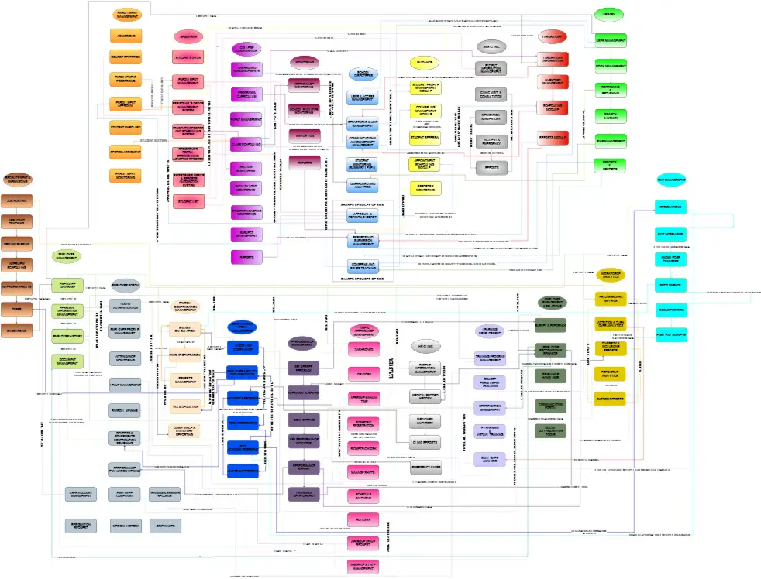
Figure 3. Business Process Architecture Level 1

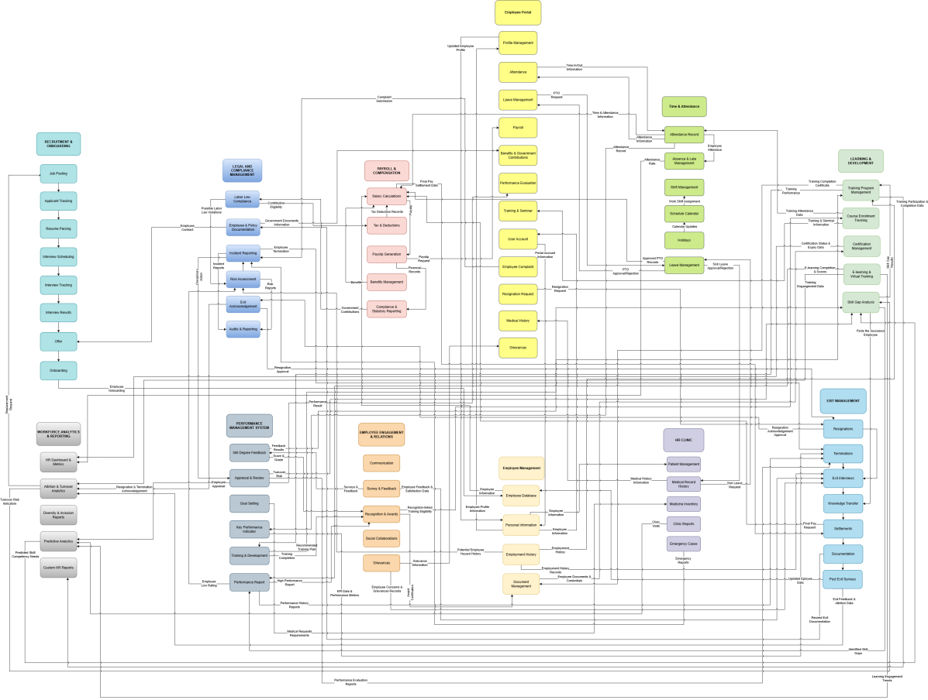
Figure 5. Business Process Architecture Level 2

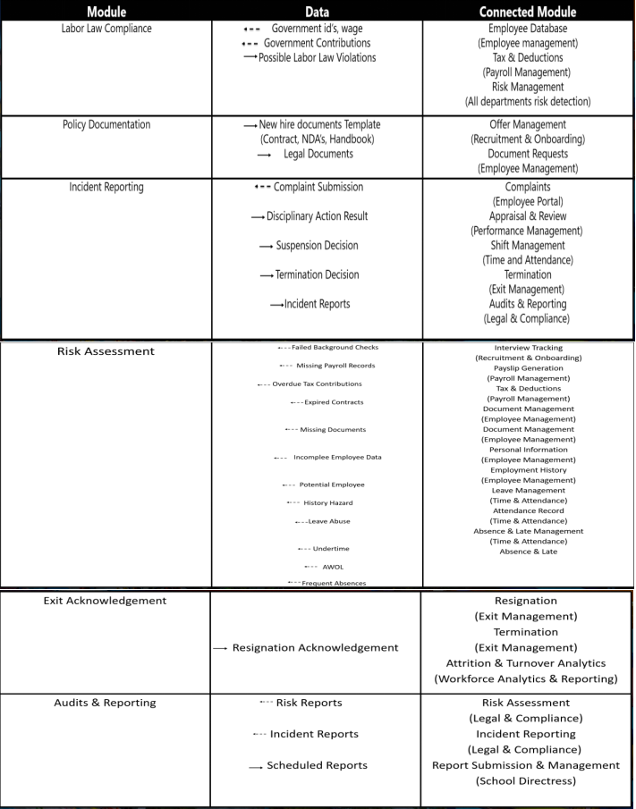
Figure 4. Business Process Architecture Level 3
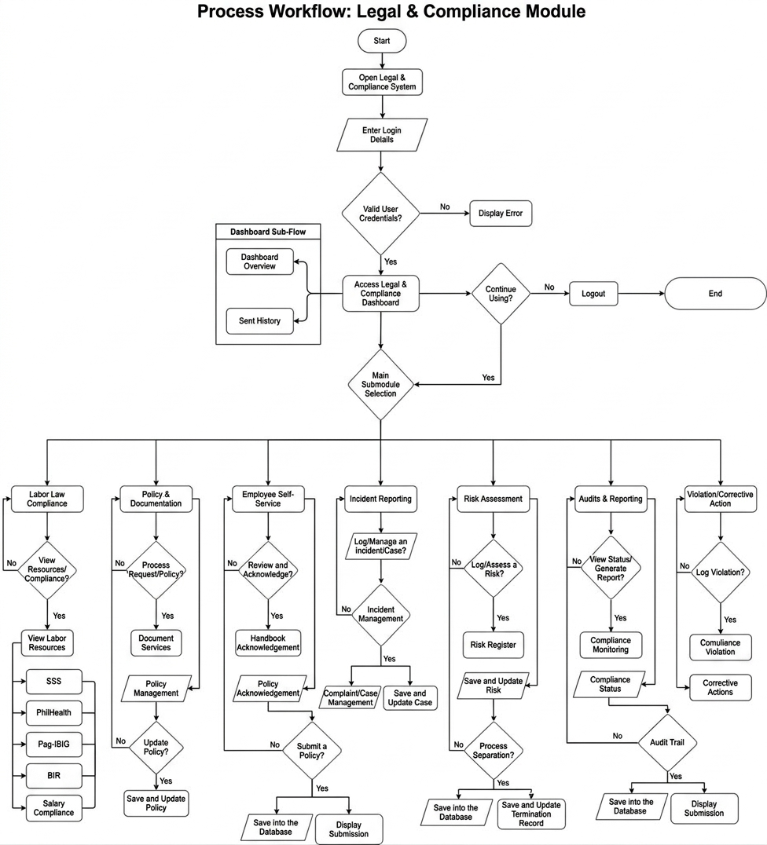Figure 6. System Flowchart
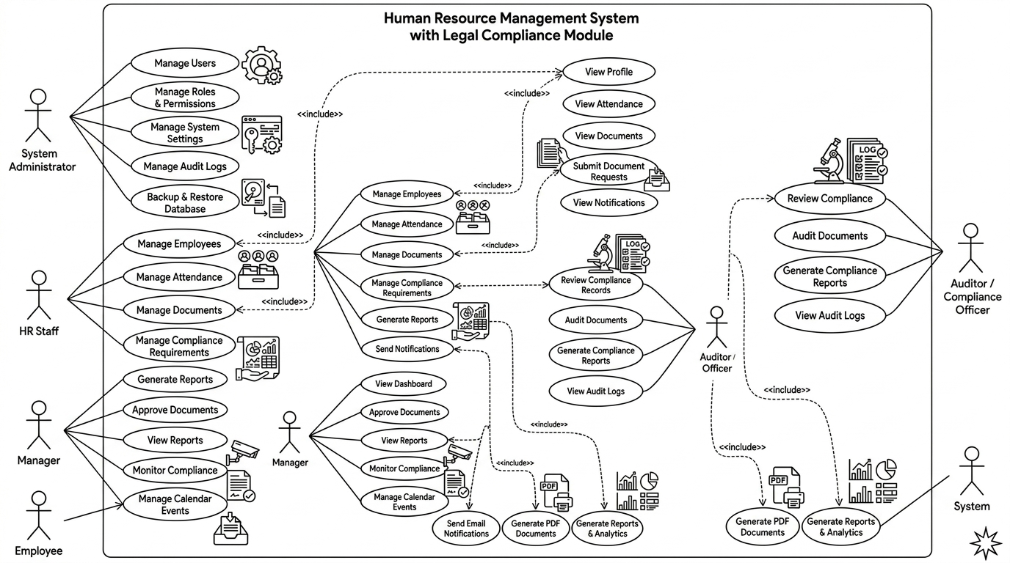
Figure 6. Use Case Diagram

CHAPTER 2

RELATED STUDIES AND LITERATURE REVIEW
The development of the Human Resource Management System (HRMS) with a Legal and Compliance Management Module focuses on supporting the Human Resource Department in managing employee-related legal and compliance activities. These activities include government requirements, salary compliance, labor law references, employee documents, policies, workplace incidents, complaints, risks, employee exit requirements, notifications, and compliance reports. For BESTLINK College of the Philippines – Bulacan Campus, the module provides a centralized system for organizing, monitoring, and reviewing compliance-related information.
The Legal and Compliance Management Module includes Government Registration, SSS Compliance, PhilHealth Compliance, Pag-IBIG Compliance, BIR Compliance, Salary Compliance, and Labor Law References under Labor Law Compliance. The Labor Law References section also includes Lala AI, an interactive AI-assisted tool that allows users to ask labor law-related questions and receive information based on the references available in the system. The module also includes Document Services, Document Management, Policy Management, Incident Management, Complaint Management, Risk Assessment, Exit Acknowledgement, Compliance Monitoring, Notifications and Alerts, and Reporting. These functions are intended to support authorized HR personnel in organizing and monitoring compliance activities. The system does not replace legal professionals, official government sources, or professional legal advice.
The related studies and literature cover topics that support the development of the module. These include Human Resource Management Systems, legal and labor compliance, government compliance monitoring, salary and employee benefits compliance, labor law references, document management, policy management, incident and complaint management, risk assessment, employee exit acknowledgement, compliance monitoring, notifications, reporting, information system integration, artificial intelligence as an information-support tool, Agile Scrum, enterprise architecture, monolithic architecture, and DevOps practices.
Recent studies and sources, particularly those published from 2021 to 2026, are prioritized to provide current information about technologies, practices, and related systems. Older sources may also be included when they provide established theories, models, frameworks, or concepts that remain relevant to the study.
The reviewed literature provides the academic and practical foundation for the development of the Legal and Compliance Management Module. The researchers examine and compare related studies, existing systems, technologies, and approaches with the needs of the Human Resource Department. Through this review, the researchers identify useful concepts, existing practices, limitations, and research or system gaps that can be addressed within the scope of the project.
The literature review also helps establish how the proposed module can support the HR Department through centralized information management, compliance monitoring, document and policy tracking, incident and complaint management, risk monitoring, employee exit documentation, labor law reference access, interactive AI-assisted information support, notifications, and compliance reporting. These findings serve as a basis for the design and development of the system while keeping its functions within the defined scope of the study.

2.1 Agile Scrum Methodology Overview
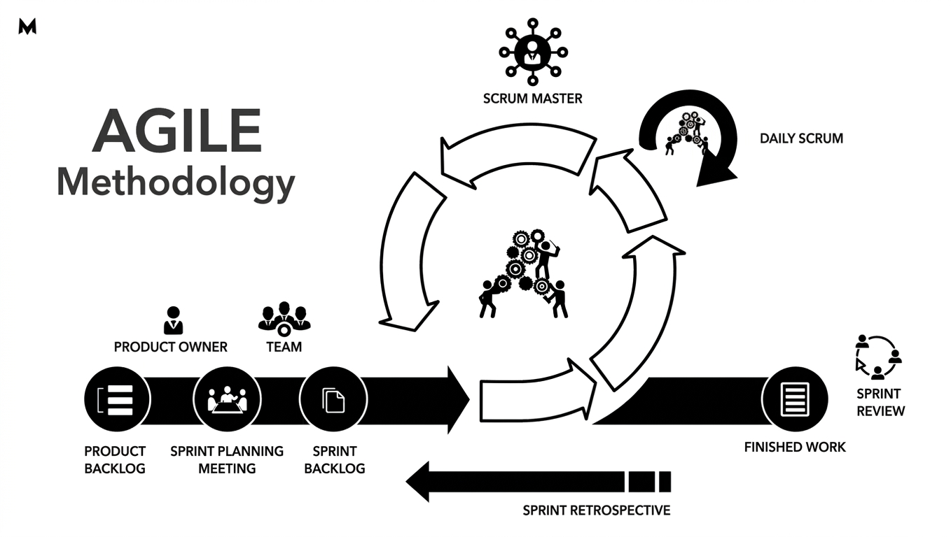
Figure 8. Agile Methodology
Agile Scrum is a software development methodology that focuses on step-by-step development, teamwork, regular feedback, testing, and continuous improvement. Instead of developing the entire system at once, the project is divided into smaller parts called sprints. During each sprint, selected system functions are planned, developed, tested, reviewed, and improved. This approach allows the researchers to identify problems early and make changes throughout the development process.
Agile Scrum was selected for the development of the Legal and Compliance Management Module because the system has several connected functions that can be developed and improved step by step. These include Government Registration, SSS Compliance, PhilHealth Compliance, Pag-IBIG Compliance, BIR Compliance, Salary Compliance, Labor Law References with the interactive Lala AI feature, Document Services, Document Management, Policy Management, Incident Management, Complaint Management, Risk Assessment, Exit Acknowledgement, Compliance Monitoring, Notifications and Alerts, and Reporting.
Through Scrum, the researchers organized the development process through planning, requirements analysis, design, development, testing, review, feedback, and refinement. Each sprint focused on selected system requirements while considering how the functions would work with the existing HRMS. Feedback from the project stakeholders was used to identify needed changes and improve the system.
The iterative approach also allowed the researchers to gradually integrate the different functions into one Legal and Compliance Management Module. This helped the team improve system workflows, address identified issues, test individual functions, and make necessary adjustments before continuing with the next development activities.

2.2 Enterprise Architecture Concepts
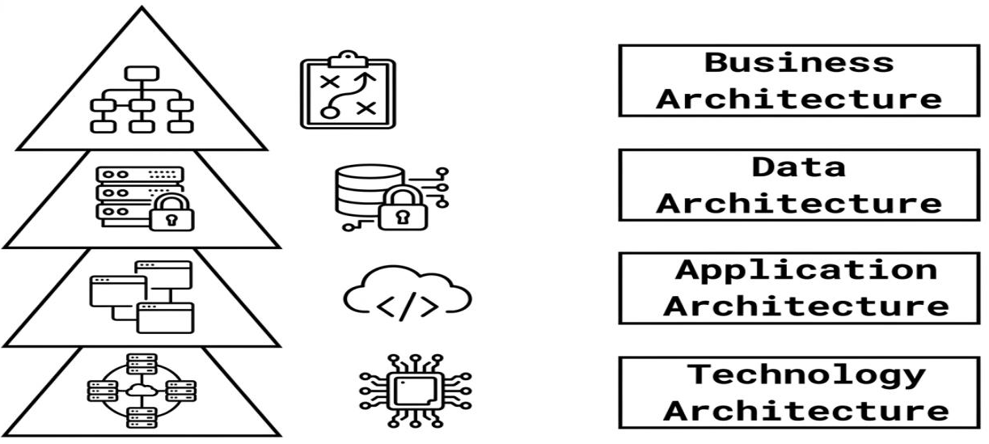
Figure 9. Enterprise Architecture
Enterprise Architecture (EA) is a structured approach used to organize and connect an organization’s business processes, information, applications, and technologies. It provides a clear view of how these parts work together to support the organization’s goals. One commonly used framework is The Open Group Architecture Framework (TOGAF), which includes four main architecture domains: Business Architecture, Data Architecture, Application Architecture, and Technology Architecture (The Open Group, 2018).
For the HRMS with a Legal and Compliance Management Module, Enterprise Architecture provides a framework for understanding how the module fits within the existing HRMS. It helps organize the business processes, data, system functions, and technologies needed to support the Human Resource Department’s legal and compliance activities.
The module covers Government Registration, SSS Compliance, PhilHealth Compliance, Pag-IBIG Compliance, BIR Compliance, Salary Compliance, and Labor Law References. The Labor Law References section also includes Lala AI, an interactive AI-assisted feature that allows users to ask labor law-related questions and receive information based on the references available in the system. Other functions include Document Services, Document Management, Policy Management, Incident Management, Complaint Management, Risk Assessment, Exit Acknowledgement, Compliance Monitoring, Notifications and Alerts, and Reporting.
Using an Enterprise Architecture approach helps show how these functions, the information they use, the existing HRMS, and the supporting technologies are connected. This supports a more organized and integrated system design while keeping the Legal and Compliance Management Module within the existing HRMS environment. The system is intended to support HR operations and compliance monitoring and does not replace legal professionals or official regulatory authorities.
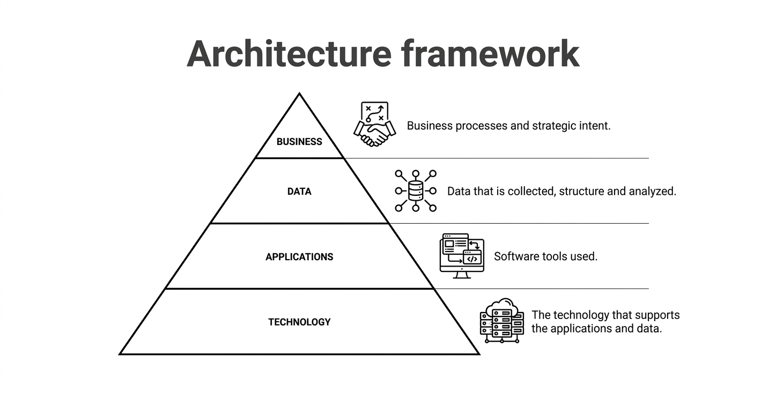
Figure 10. Architecture Framework

2.2.1 Business, Data, Application, and Technology (BDAT) Architecture
The Business, Data, Application, and Technology (BDAT) Architecture provides a structured way to describe the major parts of the Legal and Compliance Management Module and how they work together within the existing HRMS.
Business Architecture focuses on the HR processes supported by the module. These include government registration and compliance, SSS, PhilHealth, Pag-IBIG, BIR, salary compliance, labor law references, employee document management, document services, policy management and acknowledgment, incident and complaint management, risk assessment, exit acknowledgement, compliance monitoring, notifications, and reporting. The Labor Law References section also includes Lala AI, which provides interactive AI-assisted support for labor law-related questions using the references available in the system.
Data Architecture focuses on the information used and managed by the module. This includes employee records, government compliance and contribution records, salary information, labor law references, employee documents, policies and acknowledgments, incidents, complaints, risk records, exit and clearance information, document requests, compliance tasks, notifications, and reports. These records provide the information needed for monitoring and managing different compliance activities.
Application Architecture focuses on the system functions that allow authorized users to record, manage, monitor, search, review, and report compliance information. These functions include the different government compliance pages, Salary Compliance, Labor Law References, interactive Lala AI, Document Services, Document Management, Policy Management, Incident Management, Complaint Management, Risk Assessment, Exit Acknowledgement, Compliance Monitoring, Notifications and Alerts, and Reporting.
Technology Architecture focuses on the technologies and components that support the system. This includes the existing HRMS, PHP-based application, MySQL database, web interface, authentication and access-control mechanisms, server environment, and other supporting software components used by the module.
The BDAT approach helps organize the relationship between HR processes, data, system functions, and technology. TOGAF concepts provide a reference for organizing these architectural areas, while Agile Scrum provides the development approach used by the researchers. Together, these approaches support the structured development and integration of the Legal and Compliance Management Module based on the requirements of the Human Resource Department.

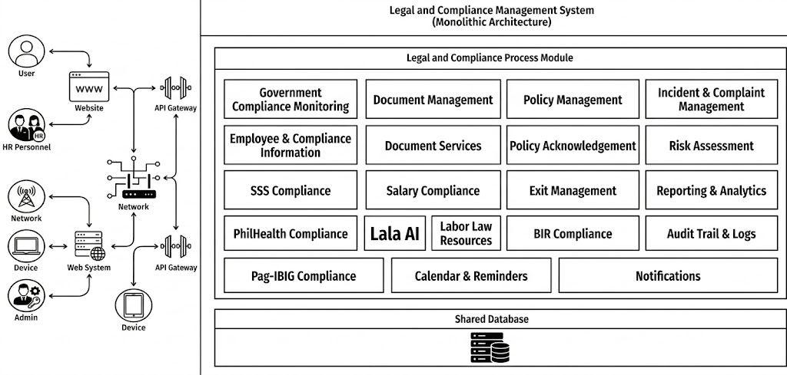
2.3 Monolithic Architecture
Figure 11. Monolithic Architecture
Monolithic architecture is a software architecture approach where the main functions of an application are developed and deployed as one integrated application. In this project, the Legal and Compliance Management Module is integrated into the existing Human Resource Management System (HRMS) instead of being developed as separate applications or independently deployed services. This allows the different HR and compliance functions to work within the same application environment and use shared system resources and data.

The monolithic architecture used in the project has the following characteristics:
• Integrated Application Structure – The different HR and compliance functions are organized as parts of one HRMS application. These include government compliance, salary compliance, labor law references, document management, policy management, incident and complaint management, risk assessment, exit acknowledgement, compliance monitoring, notifications, and reporting.
• Centralized Data Management – Employee, HR, and compliance information is managed within the system's centralized database. This allows related functions to access the information needed for their operations.
• Shared Database Resources – The different module functions can use shared employee and compliance records through the HRMS database. This supports connections between employee information, documents, policies, incidents, complaints, risks, exit records, and reports.
• Integration of Internal Components – The functions operate within the same application instead of communicating through separate independently deployed services. For example, employee information can be used by compliance monitoring, document management, policy management, incident management, risk assessment, and reporting.
• Centralized System Management and Deployment – The HRMS and its integrated Legal and Compliance Management Module can be managed, maintained, and deployed as one application.
The use of monolithic architecture provides several benefits for the developed system. It supports centralized data access, simpler system integration, and easier management of related functions. It also reduces the need for communication between separate services and provides a straightforward structure for deploying the system. These characteristics are suitable for the project because the Legal and Compliance Management Module needs to work closely with existing HRMS employee information and functions.
The architecture also has limitations. Since the functions are part of one application, changes in one area may affect other parts of the system if they are closely connected. Individual functions may also be more difficult to scale separately. A major problem in the application may affect multiple functions, and maintaining a larger integrated codebase may become more difficult as the system grows. Updates may also require deployment of the application as an integrated unit.
In the developed HRMS, the monolithic approach allows the Legal and Compliance Management Module to use related employee and HR information within the same system. For example, employee records may be used in government compliance monitoring, Salary Compliance, employee document management, policy acknowledgment, incident and complaint management, risk assessment, Exit Acknowledgement, notifications, and reporting. Labor Law References and the interactive Lala AI feature are also included within the same application and can use the labor law reference information available in the system.
The monolithic architecture was selected because it matches the existing structure of the HRMS and the scope of the Legal and Compliance Management Module. It provides an integrated structure for developing, connecting, deploying, and maintaining the required HR legal and compliance functions within one system.

2.4 DevOps and CI/CD

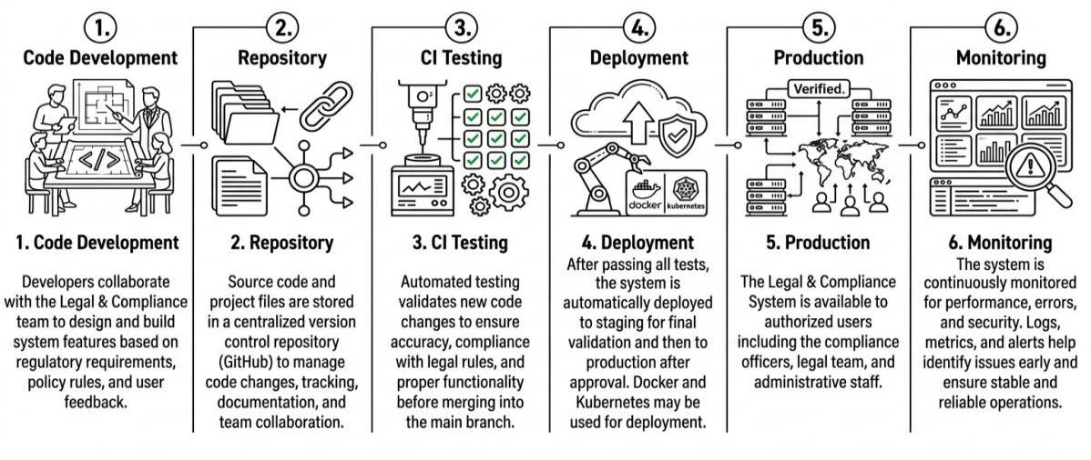
Figure 12. DevOps and CI/CD
DevOps is a software development approach that encourages cooperation between development, testing, deployment, and system maintenance. In the proposed Human Resource Management System (HRMS) with a Legal and Compliance Management Module for Bestlink College of the Philippines – Bulacan Campus, DevOps practices support the continuous development, testing, deployment, and monitoring of the system. This approach helps the development team manage system updates while keeping the Legal and Compliance Management Module connected to the existing HRMS.
The module contains several connected functions, including Dashboard Overview, Government Registration, SSS Compliance, PhilHealth Compliance, Pag-IBIG Compliance, BIR Compliance, Salary Compliance, Labor Law References, Employee Document Management, Document Services, Policy Management and Acknowledgment, Incident Management, Complaint Management, Risk Assessment, Exit Acknowledgement, Compliance Monitoring, Notifications and Alerts, Compliance Calendar, and Reporting. The Lala AI feature is included under Labor Law References and provides AI-assisted information based on the labor law references available in the system. It is an information-support feature and does not replace legal professionals, official government information, or legal advice.
The DevOps and Continuous Integration and Continuous Deployment (CI/CD) approach can be applied through the following activities:
1. Code Development – During development, programmers work with the identified system requirements and feedback from authorized users. The source code is developed and improved based on the required functions of the Legal and Compliance Management Module. Development includes functions for recording and monitoring government compliance information, managing employee documents, monitoring policy acknowledgments, handling incidents and complaints, assessing compliance risks, managing exit requirements, providing notifications, and generating reports. Updates are reviewed to ensure that new changes work properly with the existing HRMS.
2. Repository – The source code and related project files are maintained in a centralized version control repository such as GitHub. The repository stores the application files, database scripts, configuration files, documentation, and revision history. Version control allows developers to use branches, commits, merges, and other version tracking activities when developing or updating the Legal and Compliance Management Module. It also provides a record of previous changes that can be reviewed when troubleshooting or restoring an earlier version.
3. Continuous Integration (CI) Testing – Continuous Integration involves testing newly developed or modified code before it is integrated into the main application. Testing may include functional, integration, and regression testing to identify errors at an early stage. For the Legal and Compliance Management Module, testing covers functions such as government compliance records, contribution monitoring, salary compliance, labor law references, document management, policy acknowledgments, incident and complaint records, risk assessment, exit requirements, notifications, and report generation. Testing also checks whether updates continue to work correctly with the existing HRMS authentication, employee records, database, and access control functions.
4. Deployment – After the required testing is completed, the system is prepared for deployment to the Indevfinite Server. Deployment includes uploading and updating the PHP application files, updating database tables or scripts when needed, applying the required configuration settings, and connecting the Legal and Compliance Management Module to the existing HRMS. The module must remain connected to the existing authentication, access control, navigation, and database structure. After deployment, the system is checked to make sure that the main functions work properly in the server environment. Proper deployment helps reduce errors and system interruptions when new features or updates are added.
5. Production – The production environment contains the live HRMS and its Legal and Compliance Management Module used by authorized personnel. Through the production system, authorized users can manage government compliance records, employee documents, policies and acknowledgments, incidents, complaints, risks, exit requirements, labor law references, notifications, and compliance reports. The production environment should be properly secured because the system may contain sensitive employee and institutional information. Access should therefore be limited according to the user's assigned role and responsibilities.
6. Monitoring and Maintenance – After deployment, the system is continuously monitored and maintained to identify technical issues, data problems, expired requirements, pending activities, and other items that require attention. Monitoring may include reviewing system logs, checking application errors, verifying record updates, monitoring document expiration dates, checking policy acknowledgment status, reviewing pending document requests, and tracking compliance-related tasks and notifications. Identified issues can then be addressed through future development and deployment cycles.
Through DevOps and CI/CD practices, the Legal and Compliance Management Module can be continuously improved while remaining integrated with the existing HRMS. The approach supports regular testing, controlled updates, system monitoring, and maintenance. This helps the development team maintain the reliability of the module while responding to changes in user requirements, institutional processes, and applicable legal or regulatory references.

2.4.1 Relevant Studies and Research
Several studies have examined the use of Human Resource Information Systems (HRIS), digital information systems, compliance management, employee document management, and risk management in organizations. These studies provide a foundation for the proposed Legal and Compliance Management Module by showing how centralized information, digital records, monitoring tools, and risk assessment can support HR operations and compliance-related activities.
The studies reviewed are related to the proposed system in different ways. Some focus on HRIS and administrative efficiency, while others focus on employee records, information security risks, regulatory compliance, and HRMS implementation. Together, they provide useful concepts for developing a centralized Legal and Compliance Management Module for the Human Resource Management System of Bestlink College of the Philippines – Bulacan Campus.

Local Study
“Digital Governance in the Philippines Education Sector: Assessing the Impact of HRIS on Administrative Efficiency and School Performance”
Author: Zamora (2026)
Reference: Zamora, R. R. (2026). Digital governance in the Philippines education sector: Assessing the impact of HRIS on administrative efficiency and school performance. International Journal of Social Science and Human Research, 9(7), 5940–5942. https://doi.org/10.47191/ijsshr/v9-i7-18
Zamora (2026) examined the use of Human Resource Information Systems (HRIS) as a digital governance tool in the Philippine education sector. The study focused on how digital HR processes can affect administrative efficiency and institutional operations. It also discussed challenges related to technology and infrastructure that may affect the implementation and integration of HRIS.
This study is relevant to the proposed system because both are concerned with the use of digital HR systems in an educational institution. The proposed Legal and Compliance Management Module builds on the use of centralized HR information by adding functions for government compliance monitoring, salary compliance, labor law references, employee document management, policy acknowledgments, incident and complaint management, risk assessment, exit acknowledgment, notifications, and compliance reporting. The study therefore provides a local context for using an integrated digital HR system to support administrative processes.

Foreign Studies
“Human Resource Information Systems in Health Care: A Systematic Evidence Review”
Authors: Tursunbayeva et al. (2017)
Reference: Tursunbayeva, A., Bunduchi, R., Franco, M., & Pagliari, C. (2017). Human resource information systems in health care: A systematic evidence review. Journal of the American Medical Informatics Association, 24(3), 633–654. https://doi.org/10.1093/jamia/ocw141
Tursunbayeva, Bunduchi, Franco, and Pagliari (2017) conducted a systematic review of Human Resource Information Systems (HRIS) used in healthcare organizations. The study examined the development, implementation, and use of HRIS and identified their effects on organizational processes. The review discussed how HRIS can support areas such as information management, administrative processes, decision-making, and organizational operations.
The study is relevant to the proposed system because it demonstrates the value of using a centralized HR information system to organize employee-related information. The proposed Legal and Compliance Management Module applies a similar concept by providing a centralized environment for government compliance records, employee documents, policies, incidents, complaints, risks, exit requirements, notifications, and reports.
“The Relationship between Human Resource Information System Functions and Human Resource Management Functionalities”
Author: Obeidat (2012)
Reference: Obeidat, B. Y. (2012). The relationship between human resource information system (HRIS) functions and human resource management (HRM) functionalities. Journal of Management Research, 4(4), 192–211. https://doi.org/10.5296/jmr.v4i4.2262
Obeidat (2012) examined the relationship between HRIS functions and HR management functionalities in organizations within the Jordanian banking sector. The study explored how different HRIS functions can support HR activities, including the management of employee information and records.
This study supports the proposed system because employee information is an important part of HR compliance management. The proposed module connects employee-related information with government compliance records, employee documents, policies and acknowledgments, incidents, complaints, risks, and exit requirements. This approach allows authorized HR personnel to access related information within the existing HRMS instead of managing compliance information through separate systems or records.
“The Design of Information Security Risk Management: A Case Study Human Resources Information System at XYZ University”
Authors: Anang, Gandhi, and Sucahyo (2021)
Reference: Anang, A., Gandhi, A., & Sucahyo, Y. G. (2021). The design of information security risk management: A case study human resources information system at XYZ University. In Proceedings of the 2021 4th International Conference on Computer and Informatics Engineering (IC2IE) (pp. 198–203). IEEE. https://doi.org/10.1109/IC2IE53219.2021.9649035
Anang, Gandhi, and Sucahyo (2021) examined information security risk management in an HRIS used by a university. The study identified information security risks and discussed the use of risk management standards in addressing these risks. It highlights the importance of identifying, assessing, and managing risks related to HR information systems.
This study is relevant to the proposed system because the Legal and Compliance Management Module includes a Risk Assessment function. The proposed system allows authorized personnel to record and assess compliance-related risks, monitor their status, and record actions for addressing identified risks. The study provides a basis for considering systematic risk management when handling HR and compliance information.
“Challenges and Technology Trends in Implementing a Human Resource Management System: A Systematic Literature Review”
Authors: Destriani et al. (2024)
Reference: Destriani, R., Adhitama, R. Y., Sensuse, D. I., Hidayat, D. S., & Purwaningsih, E. H. (2024). Challenges and technology trends in implementing a human resource management system: A systematic literature review. Journal of Information Systems Engineering and Business Intelligence, 10(3), 355–367. https://doi.org/10.20473/jisebi.10.3.355-367
Destriani et al. (2024) conducted a systematic literature review on the challenges and technology trends involved in implementing Human Resource Management Systems (HRMS). The review identified different factors that organizations need to consider when implementing HRMS, including system integration, data management, privacy, security, and changes in organizational or regulatory requirements.
This study is relevant to the proposed system because the Legal and Compliance Management Module is integrated into an existing HRMS rather than developed as a completely separate application. The proposed module connects compliance activities with employee information, government requirements, documents, policies, incidents, complaints, risks, exit processes, notifications, and reports. The study supports the importance of considering integration, information management, security, and changing requirements when developing an HRMS.
“Compliance and Efficiency in Human Resource Information System Implementation: A Study of Factors Addressing Employee Documentation in the Hospitality Sector”
Author: Menaria (2026)
Reference: Menaria, J. (2026). Compliance and efficiency in human resource information system implementation: A study of factors addressing employee documentation in the hospitality sector. International Journal of Research Publication and Reviews, 7(6), 5666–5671. https://ijrpr.com/uploads/V7ISSUE6/IJRPR67212.pdf
Menaria (2026) examined factors affecting compliance and efficiency in HRIS implementation, with particular attention to employee documentation in the hospitality sector. The study discussed challenges related to employee files and the importance of organized digital processes for managing employee documentation.
This study is relevant to the proposed system because Employee Document Management and Document Services are important functions of the Legal and Compliance Management Module. The proposed system supports the recording and monitoring of employee documents, document requests, document status, verification, expiration, and related document services. These functions provide a centralized way of managing employee documentation and can help reduce difficulties associated with scattered or manually maintained records.

Synthesis of the Related Studies
The reviewed studies show that HR information systems can support organizations by centralizing information, improving administrative processes, managing employee records, and supporting risk and compliance-related activities. The local study provides a Philippine educational-sector context, while the foreign studies provide additional perspectives on HRIS implementation, employee information management, information security risk management, and HRMS integration.
The proposed Legal and Compliance Management Module applies these concepts within the context of Bestlink College of the Philippines – Bulacan Campus. Unlike studies that focus mainly on general HRIS functions, employee documentation, or information security, the proposed system brings several compliance-related activities together in one module. These include government compliance monitoring, salary compliance, labor law references, employee document management, document services, policy management and acknowledgment, incident and complaint management, risk assessment, exit acknowledgment, notifications, compliance monitoring, and reporting.
The proposed module also includes Lala AI under Labor Law References as an interactive AI-assisted information-support feature. Users can ask labor law-related questions and receive responses based on the labor law references available in the system. This feature is intended to make relevant information easier to access and understand and does not replace legal professionals, official government sources, or legal advice.

2.4.2 Integration of Information Systems in Enterprise Environments
Information system integration refers to the connection of information, processes, and functions within an organization so that related systems can share and use information appropriately. In an enterprise environment, integration allows different functional areas to work with related information while maintaining their respective responsibilities. Information systems can be integrated through shared data, application functions, interfaces, and process-based connections. This allows information from one area to support activities performed in another area and can improve coordination and access to relevant information (Weber, 2025). Information systems also support organizations by providing information that can be used across different business functions for operational activities and decision-making (Laudon & Laudon, 2024).
In the proposed Human Resource Management System (HRMS) with a Legal and Compliance Management Module, integration allows the Legal and Compliance Management Module to operate as part of the existing HRMS. Instead of maintaining a completely separate application, the module uses relevant employee and HR information available within the HRMS while maintaining its own compliance-related functions. This approach supports centralized information management and allows authorized personnel to access related information when performing compliance activities.
The Employee Management function serves as an important source of information for the Legal and Compliance Management Module. Employee information such as employee identification, department, position, and employment status can be used when recording and monitoring compliance-related records. This information provides a common reference for government compliance, employee documents, policies, incidents, complaints, risks, and exit-related activities.
The Government Registration and Contribution Compliance functions use employee-related information when managing records associated with government requirements. The module includes monitoring functions for SSS, PhilHealth, Pag-IBIG, and BIR, allowing authorized personnel to maintain and review relevant contribution and compliance records. These functions demonstrate how employee information can be connected with government-related compliance records within the HRMS.
Salary Compliance uses employee and compensation-related information to support the monitoring of salary requirements maintained in the system. The module can also use relevant employee and organizational information when reviewing compliance conditions and identifying items that may require attention. The system serves as a monitoring and record-management tool and does not independently determine an organization's legal compliance.
Employee Document Management and Document Services use employee information to organize documents and document requests. The Legal and Compliance Management Module supports the recording, monitoring, verification, and status tracking of employee-related documents. Document requests and related services can also be associated with the appropriate employee record, allowing authorized personnel to monitor pending, completed, or time-sensitive requests.
Policy Management connects employee information with institutional policies and policy acknowledgments. Existing policies can be assigned to appropriate employees, while acknowledgment records can be monitored through the system. This provides HR personnel with a centralized way to review which assigned policies have been acknowledged and which may still require action.
Incident Management and Complaint Management use employee and workplace-related information to record incidents and complaints. Authorized users can maintain case information, status, workflow records, decisions, and related actions. Connecting these records with employee information helps organize case records while supporting controlled access to sensitive information.
Risk Assessment uses information from different compliance-related areas to identify and monitor potential risks. Risk records may be associated with government requirements, employee documentation, incidents, complaints, policies, or other HR and compliance activities. The module allows authorized personnel to record identified risks, assess their relevant conditions, monitor their status, and document actions taken to address them.
Exit Acknowledgement uses employee information to support activities related to employee separation. The module can maintain exit-related acknowledgments, clearance information, accountabilities, and other required records associated with the separation process. This allows relevant exit requirements to be monitored within the same HRMS environment.
The module also provides Labor Law References, which serves as a centralized source of labor law-related information available within the system. The Lala AI feature is included under Labor Law References as an interactive AI-assisted information tool. Users can ask labor law-related questions and receive responses based on the labor law references available in the system. It is intended to support access to information and does not replace legal professionals, official government interpretations, or legal advice.
Notifications and Alerts further support integration by providing reminders and notifications related to compliance activities, document requirements, policy acknowledgments, deadlines, and other items requiring attention. These notifications can use information recorded in the different compliance functions to help authorized personnel identify pending or time-sensitive activities.
Finally, the Reporting function brings together relevant information from the Legal and Compliance Management Module to produce summaries and reports. Information from government compliance records, employee documents, policies, incidents, complaints, risks, exit records, and other compliance activities can be used to support reporting and monitoring. The Dashboard Overview provides a centralized view of selected compliance information, allowing authorized users to review summaries, trends, pending activities, and items requiring attention.
The integration of these functions demonstrates how the Legal and Compliance Management Module operates as a component of the broader HRMS. Its integration is primarily based on shared employee information, centralized database access, related application functions, and the connection of compliance records with existing HR information. This approach allows authorized personnel to manage and review related information within one HRMS environment while keeping compliance activities organized according to their specific functions. The system supports HR personnel in managing information and monitoring activities but does not replace the responsibilities of HR personnel, management, legal professionals, or government authorities.

CHAPTER 3
METHODOLOGY
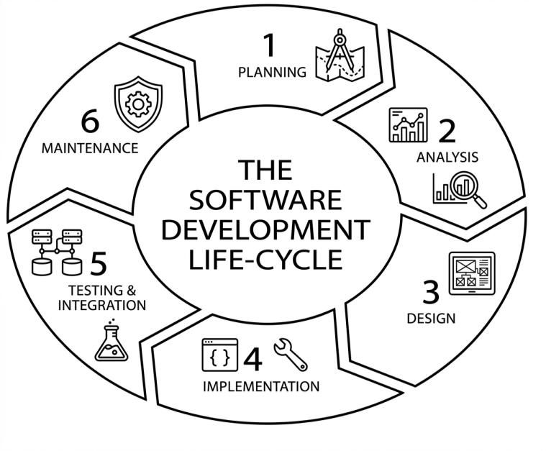

Figure 21. SDLC
The Systems Development Life Cycle (SDLC) is a structured process used to plan, analyze, design, develop, test, deploy, and maintain an information system. It provides a step-by-step approach for developing a system based on identified user requirements and organizational needs. SDLC helps ensure that the system is properly planned, developed, tested, and maintained throughout its development and use.
For the proposed Human Resource Management System (HRMS) with a Legal and Compliance Management Module for Bestlink College of the Philippines – Bulacan Campus, SDLC provides a framework for developing and improving the system in an organized manner. It guides the researchers from identifying the requirements of the Human Resource Department to designing and implementing the system, testing its functions, deploying the completed module, and maintaining it after deployment.
The SDLC used in the project consists of the following phases: Analysis, Design, Implementation, Testing, Deployment, and Maintenance. These phases provide a structured development process while allowing the researchers to review and improve the system based on testing results, user feedback, and identified requirements.
- Analysis Phase – During the analysis phase, the researchers gathered and examined information about the existing HR, legal, and compliance-related processes of Bestlink College of the Philippines – Bulacan Campus. The researchers identified the requirements related to government registration, SSS, PhilHealth, Pag-IBIG, BIR, salary compliance, labor law references, employee documents, document services, policy management and acknowledgment, incident management, complaint management, risk assessment, exit acknowledgment, notifications, and reporting. Existing processes, records, user needs, and information requirements were reviewed to determine how the Legal and Compliance Management Module could support the Human Resource Department. The findings from this phase were used to define the system requirements, functions, and priorities for development.
- Design Phase – During the design phase, the requirements identified during analysis were translated into the structure and design of the Legal and Compliance Management Module. The researchers designed the database structure, system architecture, application components, data flow, navigation, and user interfaces. The design covered the major functions of the module, including Dashboard Overview, Government Registration, SSS Compliance, PhilHealth Compliance, Pag-IBIG Compliance, BIR Compliance, Salary Compliance, Labor Law References, Document Services, Document Management, Policy Management, Incident Management, Complaint Management, Risk Assessment, Exit Acknowledgement, Notifications and Alerts, Compliance Monitoring, and Reporting. The design also considered the existing HRMS authentication, access control, employee information, database structure, and navigation to support proper integration with the main system. The Lala AI feature was designed as part of Labor Law References to provide interactive AI-assisted access to labor law information available in the system.
- Implementation Phase – During the implementation phase, the researchers developed the Legal and Compliance Management Module based on the approved requirements and system design. The programmers developed the necessary PHP source code, database tables, forms, interfaces, and application functions. The implementation included government compliance monitoring, salary compliance, labor law references, employee document management, document services, policy management and acknowledgment, incident and complaint management, risk assessment, exit acknowledgment, notifications, compliance monitoring, and reporting. The module was integrated with the existing HRMS components where relevant, particularly employee information, authentication, access control, database resources, and system navigation. Development was performed incrementally so that individual functions could be developed, tested, reviewed, and improved before being integrated with other related functions.
- Testing Phase – During the testing phase, the researchers evaluated the developed functions to identify errors and determine whether the system operated according to the defined requirements. Testing covered data entry, record creation, updating, searching, document management, government compliance records, salary compliance, policy acknowledgment, incident and complaint records, risk assessment, exit acknowledgment, notifications, dashboard information, and report generation. Integration testing was also performed to check the interaction between the Legal and Compliance Management Module and relevant HRMS components. The researchers examined system inputs, processes, and outputs to determine whether the expected results were produced. Identified errors, inconsistencies, and usability issues were corrected and tested again to improve the reliability and functionality of the module.
- Deployment Phase – After development and testing, the Legal and Compliance Management Module was prepared for deployment within the intended HRMS environment. The deployment process involved transferring the required application files, configuring the database and system settings, and making the module accessible through the existing HRMS navigation. The researchers verified database connectivity, authentication, access control, page navigation, and the operation of major compliance-related functions after deployment. The deployed module was then made available to its intended authorized users for system use and evaluation.
- Maintenance Phase – The maintenance phase focuses on correcting, updating, and improving the Legal and Compliance Management Module after deployment. Issues identified during system use, evaluation, testing, or monitoring may be reviewed and addressed through future updates. Maintenance may include correcting software errors, improving existing functions, updating system configurations, and addressing changes in organizational processes. Because the module contains labor law references and government compliance-related information, relevant references and system rules may also require review and updating when applicable requirements or institutional policies change. Maintenance provides a continuous basis for improving the system and keeping the module useful, secure, and aligned with the operational needs of the Human Resource Department.

3.1 Agile Scrum Methodology in the Project
Figure 14. Agile Scrum Methodology

This study adopted the Agile Scrum Methodology in developing the Legal and Compliance Management Module for the Human Resource Management System (HRMS) of Bestlink College of the Philippines – Bulacan Campus. Agile Scrum is an iterative software development approach that divides development into short and manageable cycles called sprints. It was selected because it allows the researchers to develop the system gradually, review completed functions, respond to user feedback, and make improvements throughout the development process.
The development process began with gathering and analyzing the requirements of the Human Resource Department and identifying the functions needed for the Legal and Compliance Management Module. The requirements were organized into a Product Backlog, which contained the planned system functions and development tasks. These included Dashboard Overview, Government Registration, SSS Compliance, PhilHealth Compliance, Pag-IBIG Compliance, BIR Compliance, Salary Compliance, Labor Law References, Document Services, Document Management, Policy Management, Incident Management, Complaint Management, Risk Assessment, Exit Acknowledgement, Compliance Monitoring, Notifications and Alerts, and Reporting. The Lala AI feature was included under Labor Law References as an interactive AI-assisted tool for accessing labor law information available in the system.
The development tasks were divided into sprints and prioritized according to system requirements, function dependencies, and development needs. Each sprint involved activities such as sprint planning, requirements review, interface design, coding, database development, testing, and refinement. The researchers and developers reviewed the progress of the work and addressed technical or functional issues identified during development. Related functions were also checked to ensure that they could work properly with the existing HRMS.
At the end of each sprint, the completed functions were reviewed and tested. Feedback and identified issues were used as inputs for the next sprint. Functions that required changes or improvements were refined and tested again before being considered ready for integration. This iterative process allowed the researchers to progressively improve the Legal and Compliance Management Module while maintaining its connection with the existing HRMS.
Through Agile Scrum, the development team was able to manage the project in smaller and more manageable stages. The methodology supported continuous testing, feedback, refinement, and integration of the module's functions. This allowed the developed system to address the identified requirements of the Human Resource Department while providing flexibility for improvements during the development process.

3.1.1 Team Roles and Responsibilities
ROLES | NAME AND CONTACT | RESPONSIBILITIES
Scrum Master | PHIL VINCENT LOPE  lope.philvince1105@gmail.com | Facilitates team coordination, monitors sprint progress, and serves as a bridge between stakeholders and the development team.
Programmer | MARIA CHESKA JALOTJOT  jalotjot.cheska@icloud.com | Develops and maintains the Legal and Compliance Management Module, implements system functionalities, and performs coding, testing, and debugging.
Document Specialist | MARYCRIS ELIAGA  eliagamarycris@gmail.com | Analyzes system requirements, evaluates existing HR legal and compliance processes, and ensures that the system design supports organizational needs.
Business  Analyst | JOHNA MHAE AZUCENA  johnaazucena@gmail.com | Identifies business requirements, coordinates with stakeholders, and ensures that the module aligns with the Human Resource Department’s legal and compliance management needs.
Table 2. Roles and Responsibilities

3.1.2 Sprint Cycles
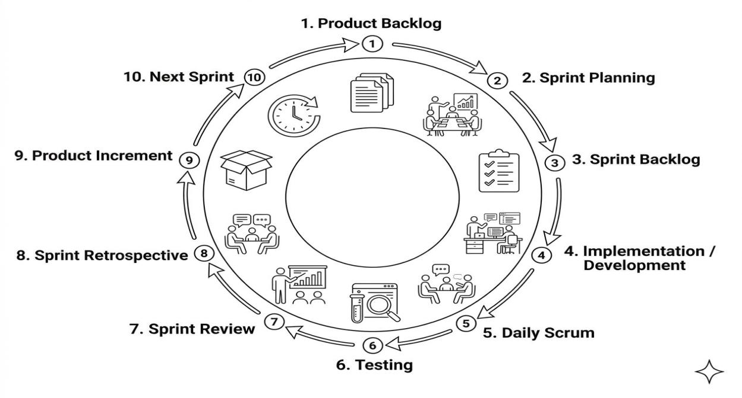Figure 15. Sprint Cycle

The Scrum Development Cycle for the Legal and Compliance Management Module of the Human Resource Management System (HRMS) of Bestlink College of the Philippines – Bulacan Campus follows a continuous and iterative process. The cycle begins with identifying and organizing the requirements of the Human Resource Department in the Product Backlog. The team then prioritizes the requirements during Sprint Planning and selects the tasks to be developed in the Sprint Backlog.
During each sprint, the team performs requirements review, interface design, coding, database development, testing, and refinement. The selected functions may include Government Registration, SSS Compliance, PhilHealth Compliance, Pag-IBIG Compliance, BIR Compliance, Salary Compliance, Labor Law References, Document Services, Document Management, Policy Management, Incident Management, Complaint Management, Risk Assessment, Exit Acknowledgement, Compliance Monitoring, Notifications and Alerts, and Reporting. The Lala AI feature is developed as part of Labor Law References to provide interactive AI-assisted access to labor law information available in the system.
Throughout the sprint, the team conducts Daily Scrum meetings to discuss progress, identify problems, and coordinate development tasks. Completed functions are tested to identify errors and ensure that they work according to the defined requirements. Issues found during development and testing are addressed through refinement before the functions are included in the completed increment.
At the end of each sprint, the developed and tested functions are presented during the Sprint Review. The team reviews the completed work and considers feedback from the intended users and relevant stakeholders. The team then conducts a Sprint Retrospective to discuss what worked well, what problems were encountered, and what improvements can be made in the next sprint.
The completed and tested functions form the Product Increment, which represents an improved version of the Legal and Compliance Management Module. The results of the Sprint Review and Sprint Retrospective are then used to update and prioritize the Product Backlog. The team proceeds to the next sprint and repeats the cycle until the required system functions have been developed, tested, integrated, and refined.
This continuous Scrum cycle allows the researchers to develop the Legal and Compliance Management Module in manageable stages while providing opportunities for regular testing, feedback, correction, and improvement throughout the project.
SPRINT | FEATURES | TASK/DEVELOPED | DURATION
Sprint 1 | Dashboard Overview & Compliance Monitoring | Developed the Dashboard Overview, compliance summaries, status indicators, monitoring information, pending activities, and items requiring attention. | 15 days
Sprint 2 | Labor Law References | Developed the Labor Law References section for organizing and accessing labor law-related information. Integrated Lala AI as an interactive AI-assisted tool for asking labor law-related questions based on the references available in the system. | 15 days
Sprint 3 | Government Registration & Compliance | Developed Government Registration and the basic structure for monitoring government-related compliance requirements. | 15 days
Sprint 4 | SSS, PhilHealth, Pag-IBIG & BIR Compliance | Developed monitoring functions and records for SSS, PhilHealth, Pag-IBIG, and BIR compliance and contribution-related information. | 15 days
Sprint 5 | Salary Compliance | Developed salary compliance monitoring, salary-related records, and functions for reviewing applicable salary requirements maintained in the system. | 15 days
Sprint 6 | Employee Documents & Document Services | Developed Employee Document Management and Document Services, including document records, document requests, status monitoring, verification, and expiration-related monitoring. | 15 days
Sprint 7 | Policy Management & Acknowledgment | Developed the Risk Assessment function, including risk records, risk evaluation, risk status monitoring, and recording actions related to identified compliance risks. | 15 days
Sprint 8 | Incident Management | Developed Incident Management functions for recording incidents, maintaining incident information, monitoring case status, and managing related workflow records. | 15 days
Sprint 9 | Complaint Management | Developed Complaint Management and complaint workflow functions for recording employee complaints and workplace concerns, monitoring case status, and maintaining related decision records. | 15 days
Sprint 10 | Risk Assessment | Developed the Risk Assessment function, including risk records, risk evaluation, risk status monitoring, and recording actions related to identified compliance risks. | 15 days
Sprint 11 | Exit Acknowledgement | Developed Exit Acknowledgement functions for managing employee separation-related acknowledgments, clearance information, accountabilities, and related exit records. | 15 days
Sprint 12 | Notifications & Alerts | Developed Notifications and Alerts for compliance-related reminders, pending activities, document requirements, policy acknowledgments, and other items requiring attention. | 15 days
Sprint 13 | Reporting & Generated Reports | Developed reporting functions for generating and reviewing compliance-related reports and summaries based on available system records and activities. | 15 days
Sprint 14 | System Integration, Testing & Refinement | Integrated the developed functions with the existing HRMS, verified database connections, authentication, access control, navigation, and module interactions. Conducted final testing, error correction, validation, and refinement. | 15 days
Table 3. Sprint Cycle

Daily Standups
TEAM MEMBER | ACCOMPLISHMENTS | TASKS | IMPLEMENTED CHALLENGES
Scrum master | Facilitated team progress and coordinated the development of the Legal and Compliance module | Support ongoing tasks, monitor team progress, coordinate activities, and ensure timely completion of assigned work | None
Programmer | Developed and implemented all pages and functionalities of the Legal and Compliance module | Develop, implement, integrate, and test all module pages and features, including the dashboard, legal references, compliance monitoring, document management, compliance calendar, notifications, audit trail, privacy compliance, and reports | Managed the integration of multiple interconnected pages and compliance-related functionalities while maintaining consistent system design and workflow
Document Specialist | Updated and maintained the Legal and Compliance documentation | Organize, update, and maintain module documentation, requirements, workflows, and supporting legal references | None
Business Specialist | Provided business insights and validated module requirements | Review module progress, provide business requirements, validate workflows, and ensure that implemented features support the intended HR processes | Ensured that system functionalities matched the required business processes and compliance requirements
Table 4. Daily Standups

3.1.3 Scrum Artifacts
Application | Used
Trello | Used to manage and track the team’s tasks, monitor progress, and organize development activities using task boards.
Messenger | Used for daily communication, quick updates, discussions, and coordination among team members regarding project tasks and concerns.
Google Drive | Used to store, organize, share, and collaborate on project documents, files, and other development materials.
Facebook | Used as an additional communication and coordination platform for team announcements, updates, and group discussions.
Discord | Used for team communication, project discussions, file sharing, and coordination during development activities.
Microsoft Word | Used to create, edit, and format project documentation, reports, requirements, and other written materials.
GitHub | Used to manage source code, track changes, collaborate on development tasks, and maintain version control throughout the project.
Table 5. Scrum Artifacts

Product Backlog
USER STORY NO. | USER STORIES | USER STORIES PRIORITIES | REVISED PRIORITY | STATUS
1 | As an Authorized Personnel, I want to view the Legal and Compliance Dashboard so that I can monitor compliance information, pending activities, and items requiring attention in one place. | 1 | 1 | Done
2 | As a Compliance Personnel, I want to monitor government registration requirements so that I can review and maintain the organization's government compliance records. | 1 | 1 | Done
3 | As a Compliance Personnel, I want to manage SSS compliance records so that I can monitor SSS-related contribution and compliance information. | 1 | 1 | Done
4 | As a Compliance Personnel, I want to manage PhilHealth compliance records so that I can monitor PhilHealth-related contribution and compliance information. | 1 | 1 | Done
5 | As a Compliance Personnel, I want to manage BIR compliance records so that I can monitor BIR-related contribution and compliance information. | 2 | 2 | Done
6 | As a Legal or Compliance Personnel, I want to access labor law references so that I can easily find relevant labor law information available in the system. | 2 | 2 | Done
7 | As a Legal or Compliance Personnel, I want to ask labor law-related questions through Lala AI so that I can receive AI-assisted information based on the labor law references available in the system. | 2 | 2 | Done
8 | As an Authorized Personnel, I want to manage employee documents so that employee compliance documents can be recorded, reviewed, verified, and monitored. | 1 | 1 | Done
9 | As an Authorized Personnel, I want to manage document requests and document services so that employee document requests can be recorded and monitored until completion.. | 2 | 2 | Done
10 | As a Compliance Personnel, I want to manage existing institutional policies so that policies can be organized, assigned, and monitored within the system. | 2 | 2 | Done
11 | As a Compliance Personnel, I want to monitor policy acknowledgments so that I can identify employees who have acknowledged or still need to acknowledge assigned policies. | 2 | 2 | Done
12 | As a Compliance Personnel, I want to record and manage incidents so that workplace incidents can be properly documented and monitored. | 2 | 2 | Done
13 | As a Compliance Personnel, I want to record and manage complaints so that employee complaints and workplace concerns can be properly documented and monitored. | 2 | 2 | Done
14 | As a Compliance Personnel, I want to manage complaint workflows and decisions so that the progress and actions related to complaints can be properly recorded. | 3 | 3 | Done
15 | As a Compliance Personnel, I want to record compliance-related risks so that identified risks can be documented and monitored. | 2 | 2 | Done
16 | As a Compliance Personnel, I want to assess and monitor identified risks so that I can review their status and record actions related to risk management. | 2 | 2 | Done
17 | As an Authorized Personnel, I want to manage exit acknowledgments and clearance-related records so that employee separation requirements can be properly documented and monitored. | 2 | 2 | Done
18 | As an Authorized Personnel, I want to receive compliance notifications and alerts so that I can be informed about pending, upcoming, or time-sensitive activities. | 2 | 2 | Done
19 | As a Compliance Personnel, I want to generate compliance reports so that authorized management and HR personnel can review compliance-related information and activities. | 2 | 2 | Done
20 | As an Authorized Personnel, I want to view compliance summaries and trends on the dashboard so that I can quickly identify areas that require monitoring or follow-up. | 2 | 2 | Done
21 | As an Administrator, I want the Legal and Compliance Management Module to work with the existing HRMS authentication and access control so that only authorized users can access appropriate compliance functions and information. | 1 | 1 | Done
22 | As an Administrator, I want the Legal and Compliance Management Module to use the existing HRMS employee information and database structure where applicable so that related employee and compliance records can be properly connected. | 1 | 1 | Done
23 | As an Authorized Personnel, I want compliance records and activities to be organized in one module so that I can access related legal and compliance information without relying on separate records or systems. | 1 | 1 | Done
Table 6. Product Backlog
Sprint Backlog
FEATURES | NAME & ROLE | DURATION
Dashboard Overview & Compliance Monitoring | Maria Cheska Jalotjot  Programmer | 15 days
Labor Law References | Maria Cheska Jalotjot  Programmer | 15 days
Government Registration & Compliance | Maria Cheska Jalotjot  Programmer | 15 days
SSS, PhilHealth, Pag-IBIG & BIR Compliance | Maria Cheska Jalotjot  Programmer | 15 days
Salary Compliance | Maria Cheska Jalotjot  Programmer | 15 days
Employee Documents & Document Services | Maria Cheska Jalotjot  Programmer | 15 days
Policy Management & Acknowledgment | Maria Cheska Jalotjot  Programmer | 15 days
Incident Management | Maria Cheska Jalotjot  Programmer | 15 days
Complaint Management | Maria Cheska Jalotjot  Programmer | 15 days
Risk Assessment | Maria Cheska Jalotjot  Programmer | 15 days
Exit Acknowledgement | Maria Cheska Jalotjot  Programmer | 15 days
Notifications & Alerts | Maria Cheska Jalotjot  Programmer | 15 days
Reporting & Generated Reports | Maria Cheska Jalotjot  Programmer | 15 days
System Integration, Testing & Refinement |  | 15 days
Table 7. Sprint Backlog

3.2 Integration Approach for Information Systems
The Human Resource Management System (HRMS) with a Legal and Compliance Management Module combines different HR, legal, and compliance functions into one system. The system uses a centralized application and relational database where employee information, government compliance records, legal references, documents, policies, incidents, complaints, risks, exit records, notifications, and reports can be stored and managed. Authorized personnel can access these functions based on their assigned roles and permissions.
The existing HRMS employee information is used by different functions of the Legal and Compliance Management Module. Government Registration supports the management and monitoring of government registration records. SSS, PhilHealth, Pag-IBIG, and BIR Compliance support the monitoring of employee contribution and related compliance records. Salary Compliance supports the review of employee salary information based on the salary requirements and reference information used by the system. Using the existing employee information helps reduce repeated data entry and keeps related records connected.
The Labor Law References function provides organized labor law information that authorized personnel can access when reviewing legal and compliance concerns. It also includes Lala AI, an AI-assisted tool that allows users to ask labor law-related questions and receive responses based on the labor law references available in the system. Lala AI is only an information-support tool and does not replace legal professionals, official government information, or legal advice.
The Employee Documents and Document Services functions support the management of employee documents and document requests. Authorized personnel can monitor document information, status, verification, validity, expiration, and requests. The Policy Management and Acknowledgment functions support the management of existing institutional policies, assigning policies to employees, and monitoring whether employees have acknowledged the policies. These functions use employee information to keep document and policy records organized.
The Incident Management and Complaint Management functions allow authorized personnel to record and manage incidents and complaints related to HR and compliance. Records may include details, status, supporting documents, workflow information, and decision history. These records can also be used for monitoring and reporting.
The Risk Assessment function supports the recording and monitoring of compliance-related risks. Authorized personnel can record risks, assess their likelihood and impact, record actions taken, and monitor their status. This allows risk information to be connected with other compliance records in the system.
The Exit Acknowledgement function supports the management of employee separation and clearance-related records. It allows authorized personnel to monitor exit requirements, acknowledgments, accountabilities, clearance information, and other related separation records.
Other supporting functions are connected to the different parts of the module. Notifications and Alerts provide reminders about pending activities, document expiration, policy acknowledgments, deadlines, and other activities that may require attention. The Compliance Calendar provides a view of scheduled compliance activities and important dates. The Dashboard Overview displays summaries, status information, trends, pending activities, and items that may need attention. The Reporting function allows authorized personnel to generate and review reports using available system records.
The integration is supported by a centralized relational database that stores the information used by the different functions. These records include employee information, government registration and contribution records, salary compliance information, labor law references, employee documents, document requests, policies and acknowledgments, incidents, complaints, risks, exit records, notifications, calendar entries, and reports. The system also uses the existing HRMS authentication, session management, access control, and employee information where applicable.
The integrated HRMS and Legal and Compliance Management Module are deployed on the Indevfinite Server. The server provides the environment where the web-based application operates and allows authorized users to access the system through a web browser. The application connects to the centralized database to store and retrieve the information needed by the different system functions.
Through this integration approach, the Legal and Compliance Management Module provides one place for managing related HR, legal, and compliance information. Instead of keeping separate records for each compliance activity, related information can be connected through the existing HRMS, centralized database, and Indevfinite Server. This helps improve the organization, monitoring, access, and reporting of compliance information while allowing HR personnel to continue following the institution's procedures and applicable requirements.
3.6 Monolithic Architecture
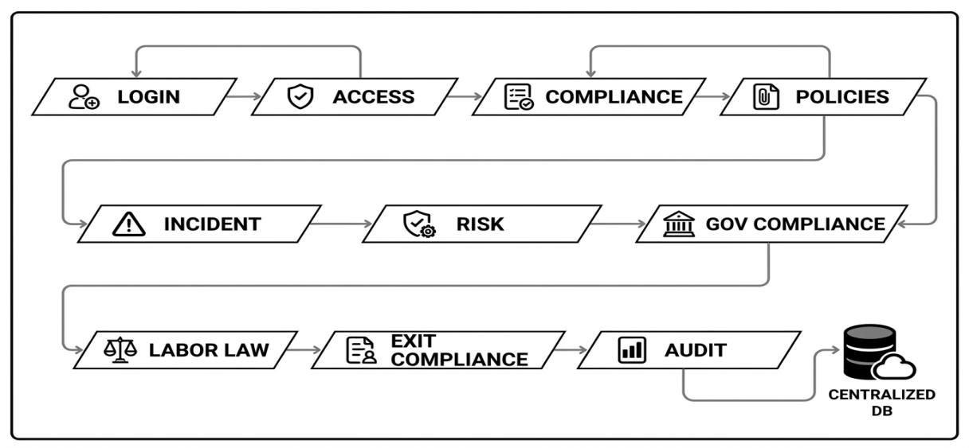
Figure 16. Monolithic Architecture
• Authentication and Access Control – This supporting function works with the existing HRMS authentication and session structure to control access to the Legal and Compliance Management Module. It uses authenticated user and role information to protect compliance-related functions and employee records and to ensure that only authorized personnel can access the appropriate system functions.
• Dashboard Overview – The Dashboard Overview provides a centralized view of legal and compliance information within the system. It presents summaries, compliance status, trends, pending activities, items requiring attention, notifications, risks, incidents, documents, government compliance records, and other monitoring information available to authorized personnel.
• Government Registration – The Government Registration function supports the management and monitoring of government registration records related to HR and compliance requirements. It provides authorized personnel with access to registration information and status records for monitoring and administrative purposes.
• SSS Compliance – The SSS Compliance function supports the management and monitoring of employee SSS contribution records. It allows authorized personnel to review contribution information and related statuses maintained in the system.
• PhilHealth Compliance – The PhilHealth Compliance function supports the management and monitoring of employee PhilHealth contribution records. It provides access to contribution information and related status records for administrative monitoring.
• Pag-IBIG Compliance – The Pag-IBIG Compliance function supports the management and monitoring of employee Pag-IBIG contribution records. It allows authorized personnel to review contribution information and related records maintained in the system.
• BIR Compliance – The BIR Compliance function supports the management and monitoring of BIR-related employee and contribution records maintained in the system. It provides authorized personnel with information needed for compliance monitoring and administrative review.
• Salary Compliance – The Salary Compliance function supports the review of employee salary records against applicable salary and minimum-wage reference information maintained in the system. It helps authorized personnel identify records that may require review based on the reference values used by the system.
• Labor Law References – The Labor Law References function provides an organized collection of labor law references available in the system. It allows authorized personnel to search and review information related to labor laws and compliance matters.
• Lala AI – Lala AI is an AI-assisted feature included under Labor Law References. It allows authorized users to enter labor law-related questions and receive responses based on the labor law references available in the system. It serves as an information-support tool and does not replace legal professionals, official government interpretations, or legal advice.
• Employee Document Management – The Employee Document Management function provides a centralized way to manage employee-related compliance documents. It supports the recording, verification, status monitoring, completeness checking, and expiration monitoring of applicable employee documents.
• Document Services – The Document Services function supports the processing and monitoring of HR-related document requests. It allows authorized personnel to manage request information, document types, request status, priority, verification, and other related document-processing records.
• Policy Management and Acknowledgment – The Policy Management and Acknowledgment function supports the management of existing institutional policies within the system. It allows authorized personnel to organize and update policy records, assign applicable policies to employees, and monitor employee acknowledgment status and related records.
• Incident Management – The Incident Management function supports the recording and management of compliance-related incidents. It allows authorized personnel to record incident information, supporting records, status, workflow information, and other details required for monitoring and processing incidents.
• Complaint Management – The Complaint Management function supports the recording and management of employee complaints and other compliance-related concerns. It allows authorized personnel to monitor complaint information, status, supporting records, workflow activities, and decision-related information.
• Complaint Workflow and Decision History – Complaint workflow functions support the processing of complaint records through applicable review and decision stages. The system can maintain workflow status and decision history to provide a record of actions and changes made during complaint processing.
• Risk Assessment – The Risk Assessment function supports the identification, evaluation, and monitoring of compliance-related risks. It allows authorized personnel to record identified risks, assess their likelihood and impact, document actions or mitigation measures, and monitor risk status.
• Exit Acknowledgement – The Exit Acknowledgement function supports the management of employee separation and clearance-related records. It allows authorized personnel to monitor exit requirements, acknowledgments, accountabilities, clearance-related information, and other applicable separation records.
• Notifications and Compliance Alerts – The Notifications and Compliance Alerts function provides information about pending activities, document expiration, policy acknowledgments, requests, deadlines, and other time-sensitive compliance activities. It helps authorized personnel identify records and activities that may require attention.
• Compliance Calendar – The Compliance Calendar provides a calendar-based view of scheduled compliance activities and important dates recorded in the system. These may include deadlines, document expiration dates, government compliance dates, and other scheduled activities.
• Compliance Monitoring – The Compliance Monitoring function supports the tracking of compliance-related activities, statuses, pending requirements, expirations, acknowledgments, requests, and other records that require regular review. It provides information that can be used by authorized personnel for follow-up and monitoring.
• Reporting and Generated Reports – The Reporting function supports the generation and review of compliance-related reports based on available system records. Reports may cover government compliance, salary compliance, documents, policies, incidents, complaints, risks, exit records, and other implemented areas of the module.
• Database Management – The database serves as the centralized data-storage component of the Legal and Compliance Management Module. It stores and organizes records related to government registration, SSS, PhilHealth, Pag-IBIG, BIR, salary compliance, labor law references, employee documents, document requests, policies, acknowledgments, incidents, complaints, risks, exit records, notifications, calendar entries, reports, and other information required by the implemented system functions.
3.3 Introduction to TOGAF and the Four Architectural Domains
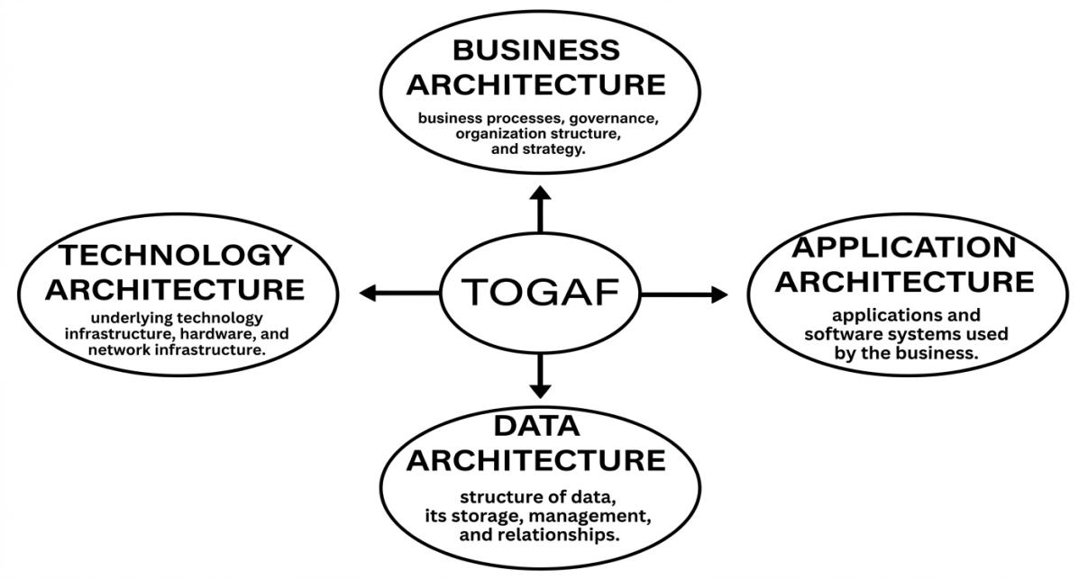Figure 17. TOGAF Architecture Framework
The Open Group Architecture Framework (TOGAF) is an enterprise architecture framework that provides a structured way to organize and connect an organization’s business processes, information, applications, and technology. It helps explain how these areas work together to support the organization’s needs.
In this study, TOGAF is used as a guide for describing the architecture of the proposed Human Resource Management System (HRMS) with a Legal and Compliance Management Module for Bestlink College of the Philippines. It helps the researchers explain how HR processes, employee information, compliance records, system functions, and supporting technologies are connected within the existing HRMS.
TOGAF uses four major architecture domains. Business Architecture describes the HR and legal and compliance activities supported by the system. Data Architecture describes the employee, legal, and compliance information stored and managed by the system. Application Architecture describes the HRMS and Legal and Compliance Management functions used to manage and process information. Technology Architecture describes the software, database, server, and other technologies that support the system, including the Indevfinite Server used for deployment.
Through these four domains, TOGAF provides a clear way to explain how the Legal and Compliance Management Module fits into the existing HRMS and how its different functions, data, applications, and technologies work together to support HR, legal, and compliance-related activities.

Business Architecture
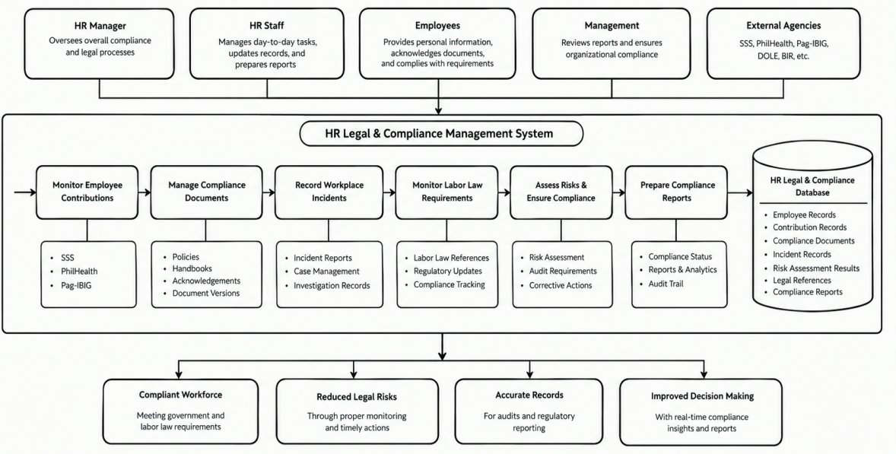
Figure 18. Business Architecture
The Business Architecture describes how the Legal and Compliance Management Module supports the activities and processes of the Human Resource Department related to legal and compliance management. It identifies the authorized users, their responsibilities, and the HR processes supported by the system.
The module supports activities such as monitoring government registration and employee contributions for SSS, PhilHealth, Pag-IBIG, and BIR; reviewing salary compliance; accessing labor law references; managing employee documents and document requests; managing existing institutional policies and policy acknowledgments; recording incidents and complaints; assessing compliance-related risks; managing employee exit acknowledgments; monitoring compliance activities; and preparing compliance reports.
The Business Architecture also includes supporting activities such as notifications and compliance alerts, the compliance calendar, dashboard monitoring, and reporting. Lala AI, which is included under Labor Law References, provides AI-assisted information support for labor law-related questions based on the references available in the system.
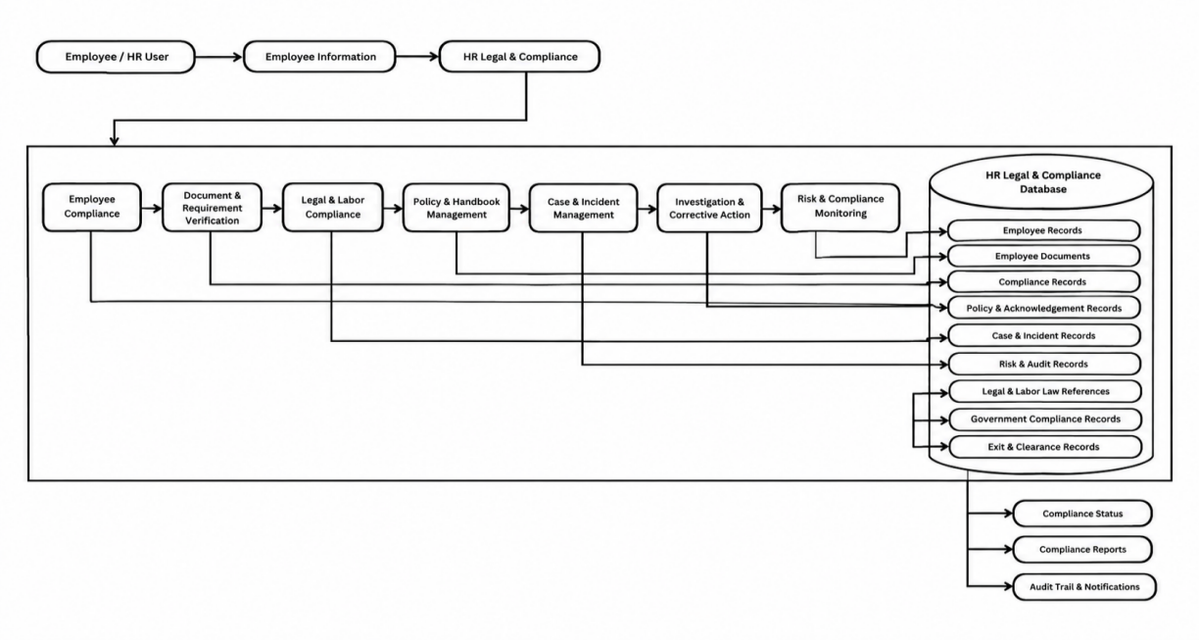
Data Architecture
Figure 19. Data Architecture
The Data Architecture describes how information used by the Legal and Compliance Management Module is organized, stored, processed, and maintained within the existing HRMS. It defines the types of data required by the different system functions and how related information is managed through the centralized relational database.
The data managed by the module includes employee-related information, government registration records, SSS, PhilHealth, Pag-IBIG, and BIR compliance records, salary compliance information, labor law references, employee documents, document requests, institutional policies, policy assignments and acknowledgments, incidents, complaints, complaint workflow and decision records, compliance-related risks, exit and acknowledgment records, notifications, calendar activities, and generated reports.
The Data Architecture also supports the relationship between employee information and related legal and compliance records. For example, employee records can be associated with government contribution records, documents, policy acknowledgments, incidents, complaints, risks, and exit-related information. This allows related records to be managed within the same centralized database instead of being maintained separately.
The system uses database access controls and the existing HRMS authentication and authorization mechanisms to restrict access to protected information. Proper organization of the data supports accurate record management, easier information retrieval, compliance monitoring, and reporting by authorized personnel.
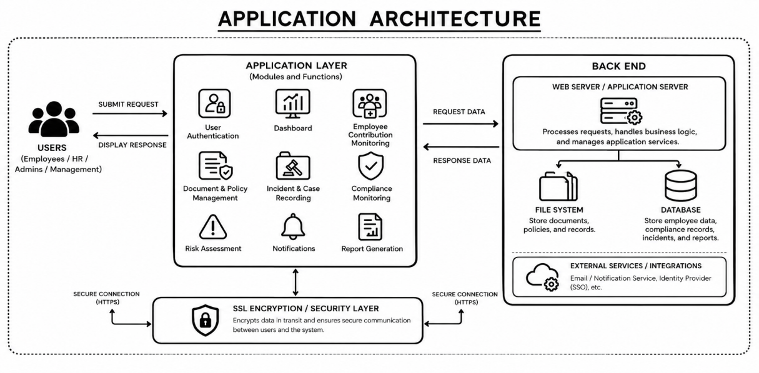
Application Architecture
Figure 20. Application Architecture
The Application Architecture describes the applications, modules, and system functions that support the Legal and Compliance Management Module within the existing HRMS. It explains how the different functions work together to manage, monitor, and provide access to HR legal and compliance information through a centralized system.
The module includes Authentication and Access Control, Dashboard Overview, Government Registration, SSS Compliance, PhilHealth Compliance, Pag-IBIG Compliance, BIR Compliance, Salary Compliance, and Labor Law References. The Labor Law References section also includes Lala AI, an AI-assisted tool that provides information based on the labor law references available in the system.
The application also provides Employee Document Management, Document Services, Policy Management and Acknowledgment, Incident Management, Complaint Management, Risk Assessment, and Exit Acknowledgement. These functions allow authorized personnel to manage related employee, legal, and compliance records within the same application.
Supporting functions include Compliance Monitoring, Notifications and Compliance Alerts, Compliance Calendar, Dashboard Monitoring, and Reporting and Generated Reports. These functions help authorized personnel monitor pending activities, important dates, document expiration, acknowledgments, compliance-related records, and other information requiring attention.
The Application Architecture is integrated with the existing HRMS authentication, employee information, database, and system navigation where applicable. Through this integration, the different application functions can work together within one system environment, providing authorized personnel with a centralized platform for managing and monitoring legal and compliance-related activities.

Technology Architecture
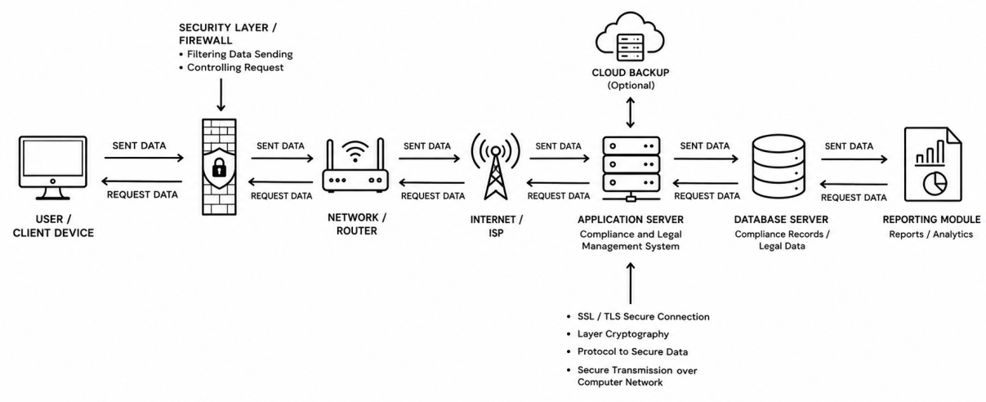
Figure 21. Technology Architecture
The Technology Architecture describes the technologies and technical infrastructure that support the operation of the Human Resource Management System (HRMS) with the Legal and Compliance Management Module. It provides the technical foundation needed to run the system, store and process information, and allow authorized users to access the different HR, legal, and compliance functions.
The system uses PHP for application development and MySQL as the relational database for storing employee, legal, and compliance-related information. The module operates within the existing HRMS environment and uses its web-based interface, authentication, session management, and access control mechanisms. Users can access the system through a web browser using the deployed HRMS environment.
For system deployment and hosting, the application is hosted on the Indevfinite Server, which provides the server environment needed to make the HRMS and Legal and Compliance Management Module accessible through the web. The server environment supports the application files, database connection, and other technical requirements needed for system operation.
The technology environment supports the different functions of the module, including government compliance monitoring, salary compliance, labor law references, employee document management, policy management, incident and complaint management, risk assessment, exit acknowledgment, notifications, dashboard monitoring, and reporting. It also supports Lala AI under Labor Law References as an AI-assisted information-support feature.
Security-related technologies and controls are used to help protect employee and compliance information. Authentication and role-based access control restrict access to functions and records based on user permissions, while database controls help maintain the organization and integrity of stored information. The deployed server environment also supports secure web access to the system.

