**SUMMARY OF KEY FINDINGS WITH VISUALS**

**1. Trends in Smart Device Usage**

The weakly negative correlation between total steps taken and the number of sedentary minutes suggests that users who take more steps might be less likely to engage in sedentary activities.

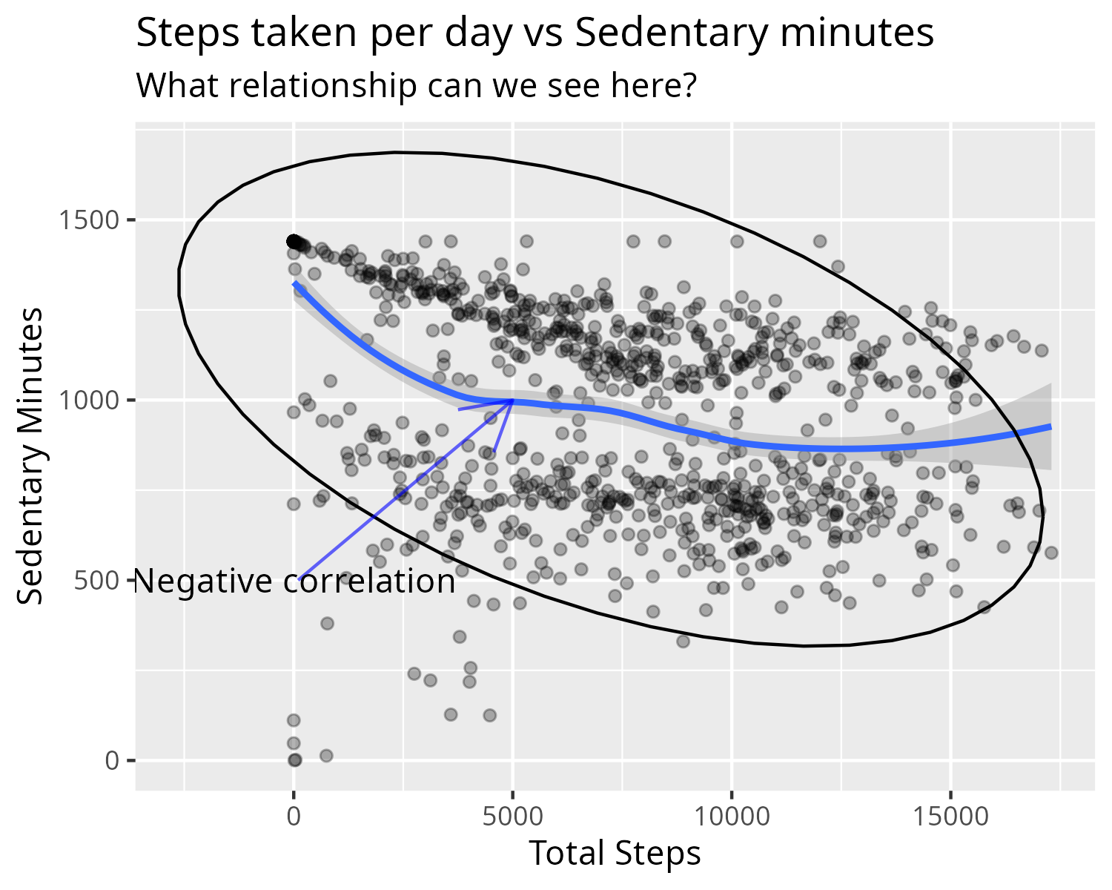

*Figure 1: Scatterplot of number of steps per day vs number of sedentary minutes*

The strong positive correlation between the total number of minutes asleep and the total number of minutes spent in bed indicates that users who sleep longer might spend more time in bed.

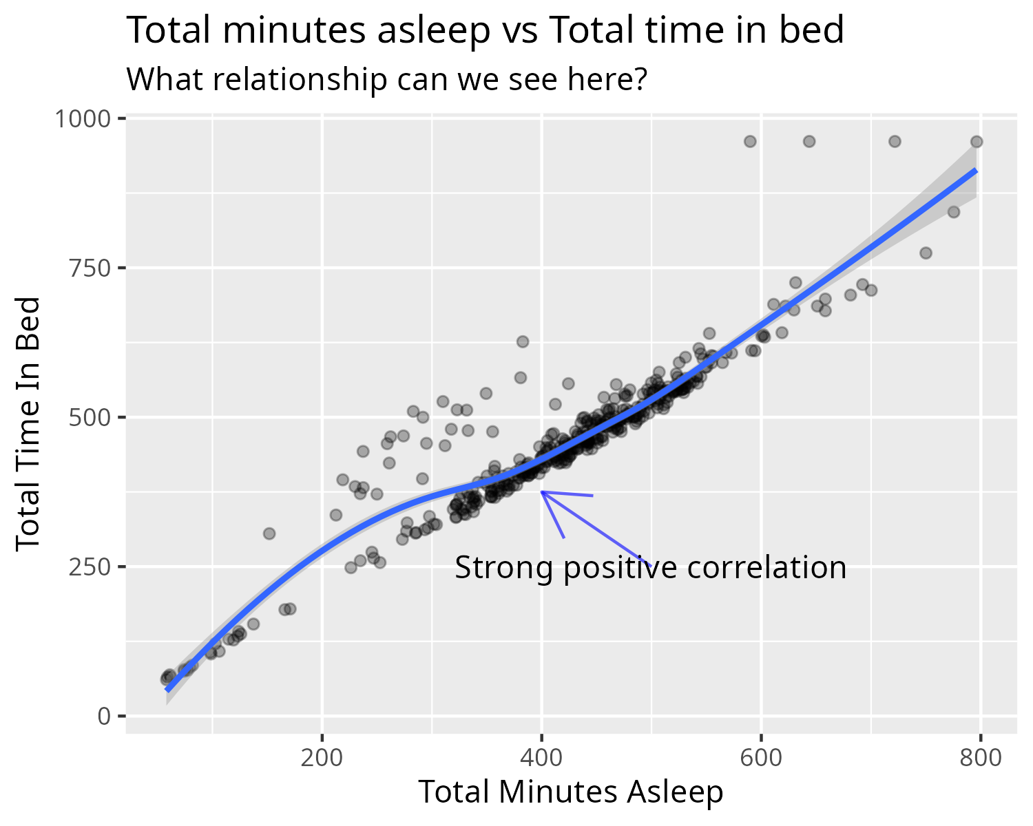

*Figure 2: Scatterplot showing total time asleep vs total minutes in bed*

However, the lack of correlation between total number of minutes of sleep and the total steps taken per day suggests that the smart device's features are somewhat independent of each other, which could be a strength in its design.

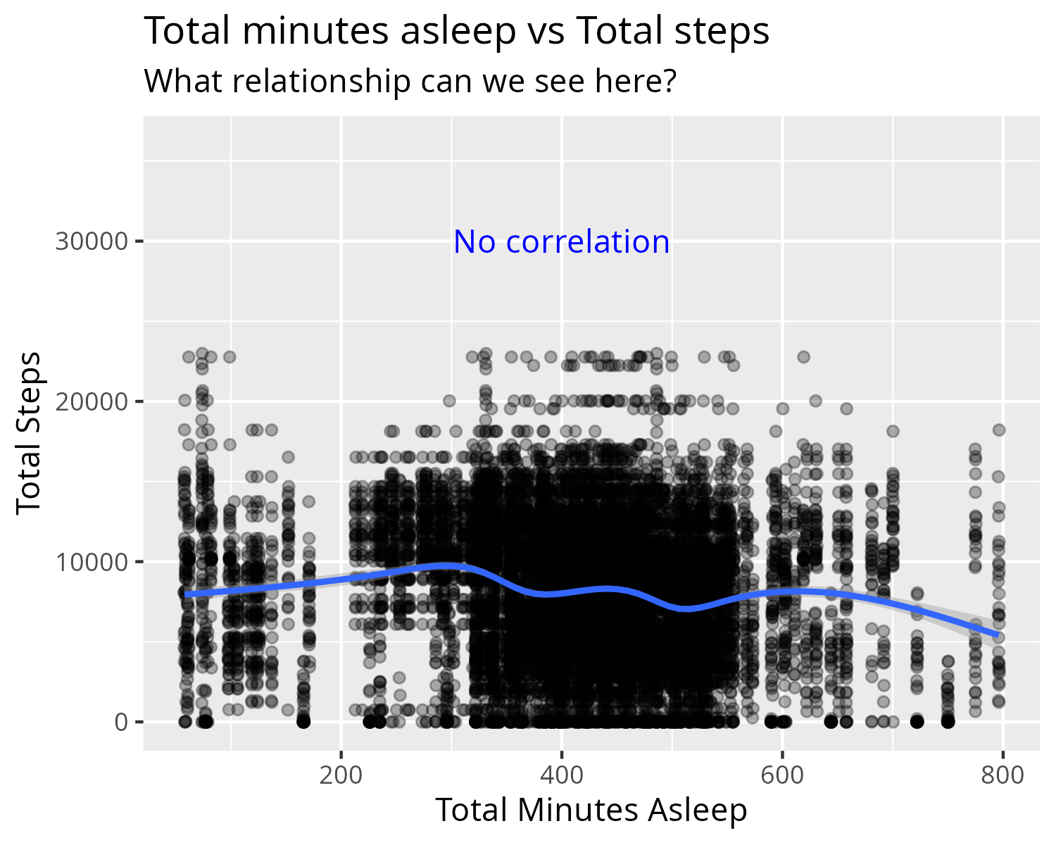

*Figure 3: Scatterplot showing total time asleep vs daily total steps*

Furthermore, there is little variation in the number of steps with being normal weight or overweight suggesting that the smart device's activity tracking feature might not be as effective at promoting weight loss as initially thought.

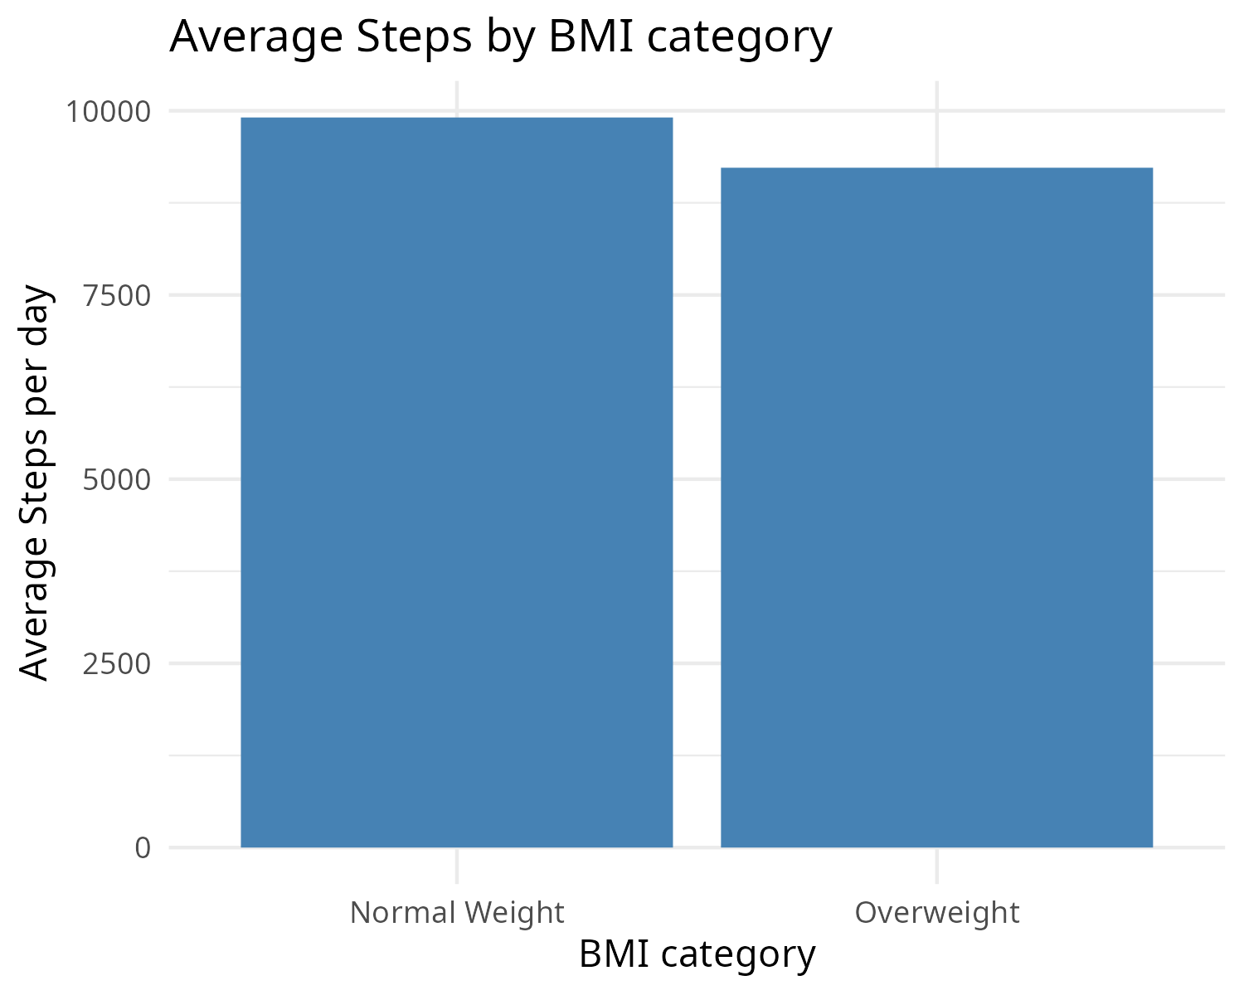

*Figure 4: Bar Graph showing BMI category and daily average number of steps*

**2. Application to Bellabeat Customers**

The features of the smart device could be particularly appealing to users who are conscious of their sedentary behavior, given the weakly negative correlation between steps taken and sedentary minutes.

The sleep tracking feature could be valuable to users who value accurate sleep data, given the strong positive correlation between sleep duration and time in bed.

Also, due to the little variation in the number of steps with being normal weight or overweight, the smart device's activity tracking feature might not be as effective at promoting weight loss as initially thought. This could be something to consider when using the smart device to promote healthy lifestyle habits.

**3. Influence on Bellabeat Marketing Strategy**

These trends can help shape Bellabeat's marketing strategy. Emphasizing the benefits of physical activity could appeal to users who are conscious of their sedentary behavior. Highlighting the accuracy of the sleep tracking feature could attract users who value precise sleep data.

The little variation in the number of steps with being normal weight or overweight could limit the effectiveness of marketing messages that emphasize the benefits of weight loss through increased physical activity. Instead, Bellabeat could focus on promoting the smart device as a tool for overall wellness, rather than specifically for weight loss.