Clone my GitHub repository “[COMP804-ASSIGNMENT-1](https://github.com/ikechukwujachi/COMP804-ASSIGNMENT-1)” on my local computer

* git clone

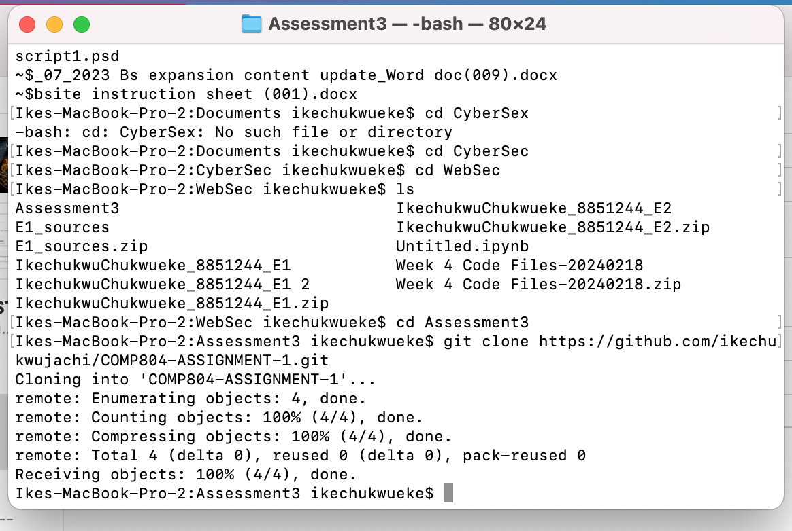

Check status of repository

* git status

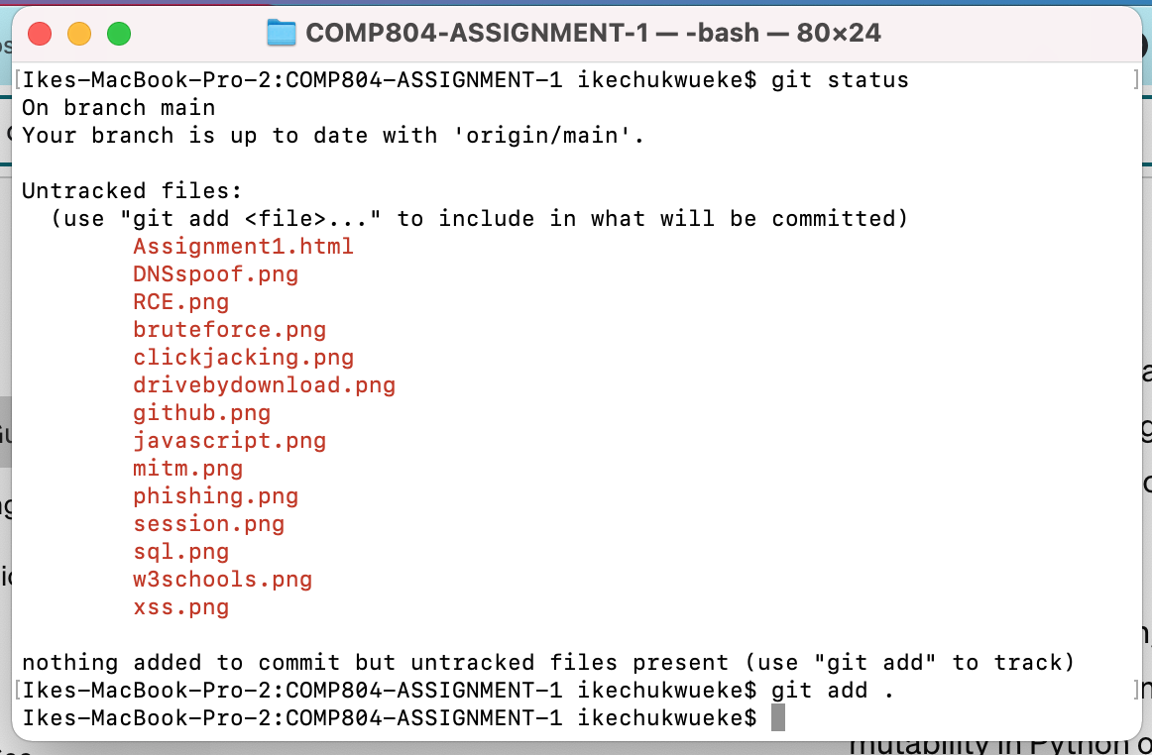

Add all files in repository - we want to add all files and directories in the project

* git add .

and we also want to check the status after adding

* git status

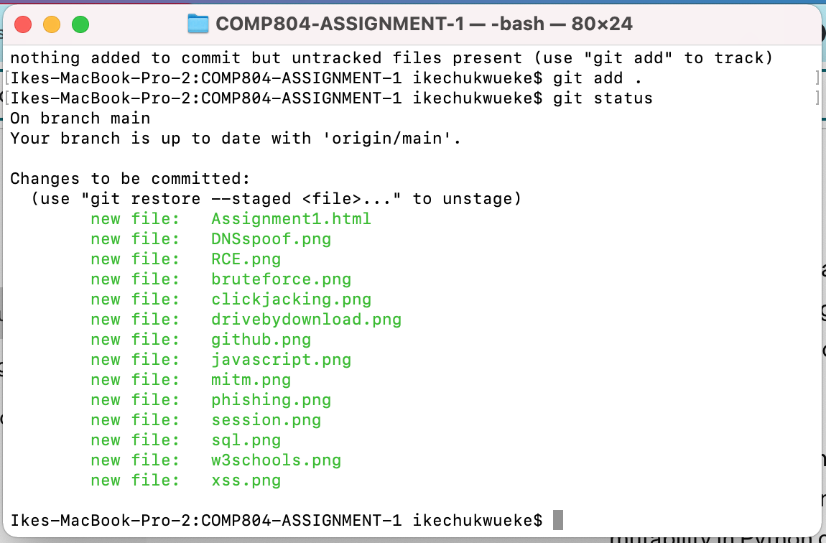



We then need commit the work, the commit message tells us what was changed and why it was changed.

* 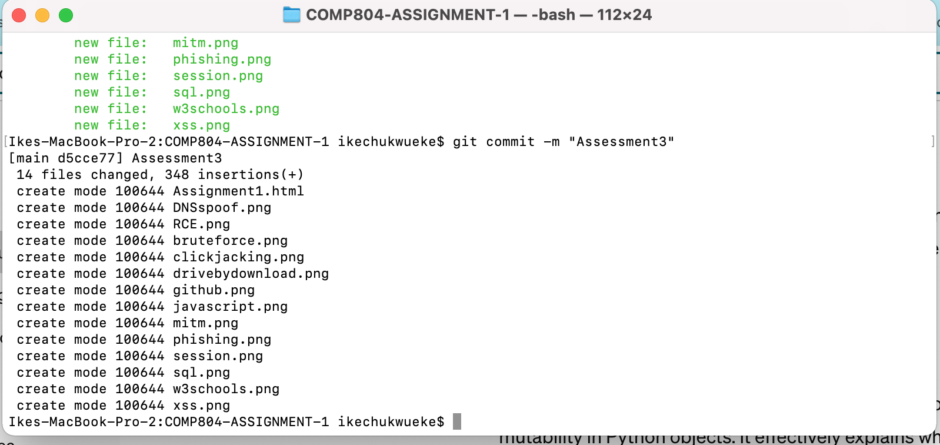git commit -m “Assessment3”

The result shows that how many file changes and how many insertions.

* 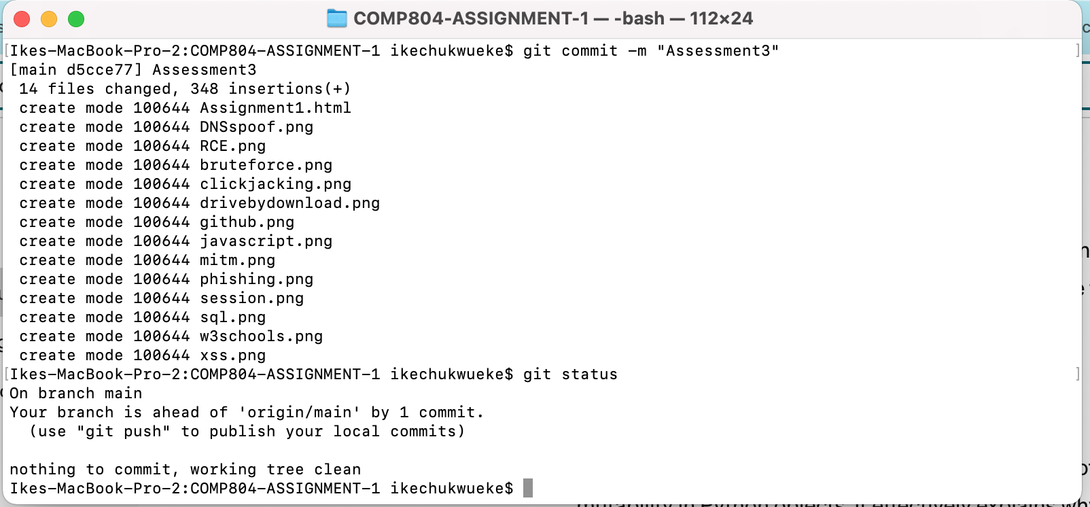git status

We then need to push the files and enter username and PAT

* git push

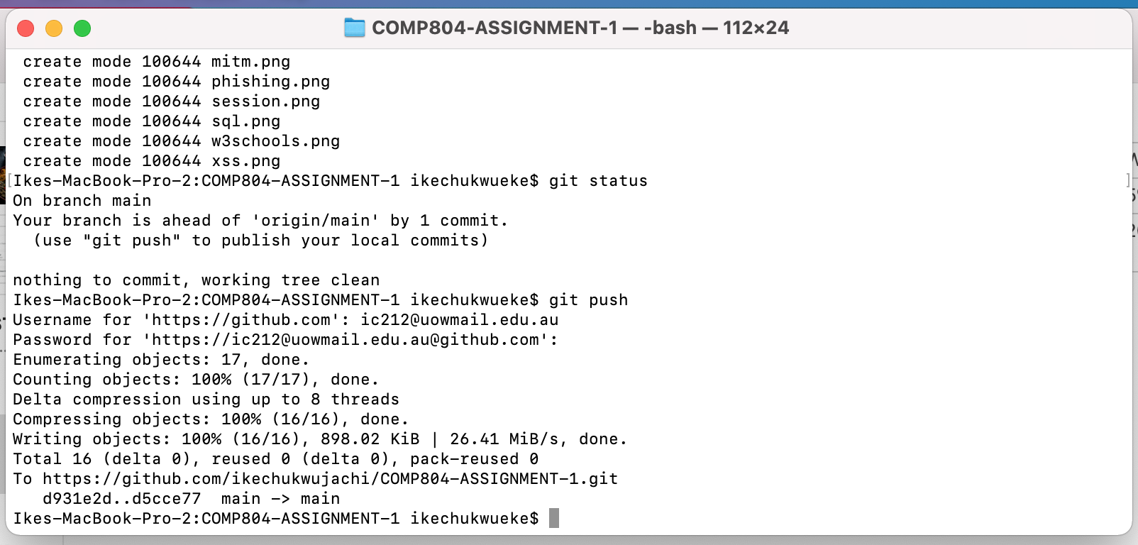

Lastly double check if repo has been updated online

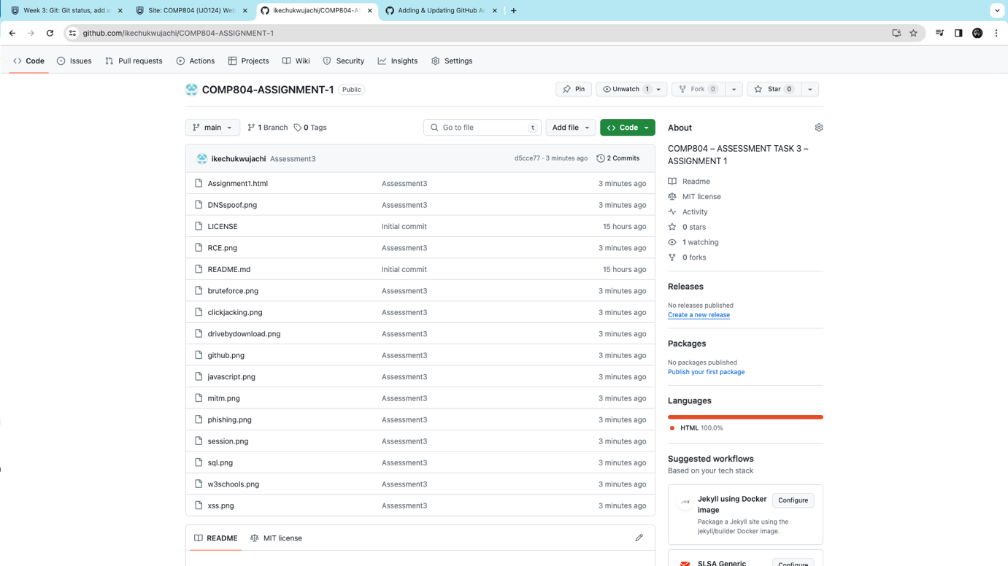

Link to my repository below;

<https://github.com/ikechukwujachi/COMP804-ASSIGNMENT-1.git>