Simple_linear_regression_.R

Emmanuel_Ikehi

Wed Sep 20 23:21:19 2017

#Simple Linear Regression to find the relationship between Job Experience and Salary  
  
# Importing the dataset  
dataset = read.csv('Salary_Data.csv')  
  
# Splitting the dataset into the Training set and Test set  
# install.packages('caTools')  
library(caTools)  
set.seed(123)  
split = sample.split(dataset$Salary, SplitRatio = 2/3)  
training_set = subset(dataset, split == TRUE)  
test_set = subset(dataset, split == FALSE)  
  
#Fitting simple linear regression model  
regressor = lm(formula = Salary ~ YearsExperience,  
 data = training_set)  
  
#Predicting the Test set results  
y_pred = predict(regressor, newdata = test_set)  
  
#Visualising the training data set  
#install.packages('ggplot2')  
library(ggplot2)  
ggplot() +  
 geom_point(aes(x = training_set$YearsExperience, y = training_set$Salary),  
 colour = 'red') +  
 geom_line(aes(x = training_set$YearsExperience, y = predict(regressor, newdata = training_set)),  
 colour = 'blue') +   
 ggtitle('Salary vs Experience (Training Set)') +  
 xlab('Salary') +  
 ylab('Experience')

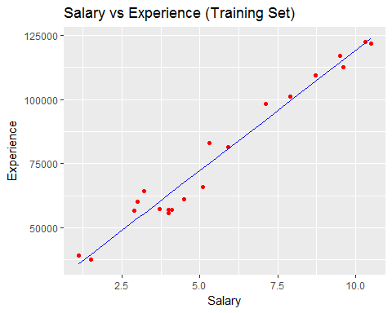

#Visualising the test data set  
#install.packages('ggplot2')  
library(ggplot2)  
ggplot() +  
 geom_point(aes(x = test_set$YearsExperience, y = test_set$Salary),  
 colour = 'red') +  
 geom_line(aes(x = training_set$YearsExperience, y = predict(regressor, newdata = training_set)),  
 colour = 'blue') +   
 ggtitle('Salary vs Experience (Test Set)') +  
 xlab('Salary') +  
 ylab('Experience')

