

§

Project Report.
Social Media Data Visualization and Analysis.

Okpala Ikenna N. Jr.
u0959353

22nd September 2010

Supervisor: Dr. Nigel Kermode

IN PARTIAL FULFILMENT OF THE REQUIREMENT FOR THE AWARD
OF BACHELOR OF SCIENCE IN BUSINESS INFORMATION SYSTEMS FROM
THE UNIVERSITY OF EAST LONDON
Table of Contents

Chapter One 3
INTRODUCTION 3
BACKGROUND 3
1.2 RATIONALE 4
1.3 OBJECTIVES 5
1.4 HYPOTHESIS 5
1.4.1 Influence 5
1.4.2 Volume 6
Chapter Two 6
2.0 LITERATURE REVIEW 6
2.1 Web 2.0 6
2.2 SOCIAL MEDIA AND INTERACTION 7
2.3 SOCIAL MEDIA ANALYSIS 9
2.4 BUILDING SOCIAL AND WEB 2.0 APPLICATIONS 9
2.5 Non-MVC FRAMEWORK FOR THE SOCIAL WEB 9
Chapter Three 10
3.0 RESEARCH METHODS 10
3.1 SYSTEM ANALYSIS AND DESIGN 11
3.1.1 DEVELOPMENT TOOLS. 11
3.1.1.1 SCALA 11
LIFT 12
Specifications and Requirements Analysis 12
Design/Model: 12
Architecture: Client/Server 13
Functional Requirements 13
Non-Functional Requirements 13
Use Case Diagram 13
Class Diagram 14
REFERENCE: 15
BIBLIOGRAPHY: 15
Appendix 17
Activity Log 17
Use excel to pick track of time? 17
Error Log 17
Progress Log (what I have learnt during this exciting project) 19
Appendix 20
Code 20
Screenshot 41

Chapter One

INTRODUCTION

BACKGROUND
Since the inception of computing, our planet has witnessed waves of innovations and technology sweeps. In the 1970s, mainframe computers were used to compute and interpret data for decision-making within organizations. The 1980s, made way for personal computing, this was the beginning of automating manual tasks.
The 1990s, it was Internet computing, this became the first to indigenously facilitate groups and conversation asynchronously. And presently in this decade it is social computing that is permeating across the Internet via social graphs to connect people.
Businesses and brands have over the years heavily relied on print / digital media, telecommunications services and the Internet to reach out to their target audience. The print / digital media provides a one to many pattern while the telecommunications services provides a one to one pattern. The Internet gives a many to many pattern. The Internet has built-in structure for conveying telecommunication services via VOIP and print / digital media via TCP/IP concurrently. This lead to the migration of phone calls, music, movies and newspapers etc to the Internet (Shirky C., 2009).
Social computing combines the Internet, networking and communication technologies to facilitate participation, social interaction and human innovation. Social interaction denotes the mutual influence a person has on the other’s behaviour.
With emergence of social media networks, the way people communicate, collaborate and share data has changed. Groups that see, read or hear about things of interest to them, can share information easily and gather around via social networks to talk to each other. This has transformed the members of the former target audience from content consumers to content producers. These producers produce unfettered contents, which largely reflects the true complexion of the dialogue.
It appears that in the present scenery, media is global, social, ubiquitous and cheap (Shirky C., 2009). The aggregation of these user-generated opinions is revolutionary for businesses and brands. This will drive innovation within them and help them make informed decisions (Surowiecki, J. 2004).
This proposed project is focused on the design and development of a web-based analytical tool for social media data interpretation.

1.2 RATIONALE
Computers and mobile devices have become ubiquitous in today’s gadgetry. The technologies between mobile applications, web browsers and networking standards (e.g. 802.11n and 3G) etc have provided the state of being for social networks to provide informal communities where users generate and share content, interact and respond in an unfettered manner to stimulus especially from product and/or service providers.

Data from social media networks has facilitated fundamental changes to business and societal practices. In a 2006 Forrester research, it was observed that societal changes were emanating from social mechanisms like instant messaging, blogs and social networks, where individuals took cues from themselves rather than relying on traditional sources of news, purchasing, and social interaction (Vannoy S. A. and Palvia P., 2010).

Social data is revolutionary for businesses and brands, as they are sure to obtain honest feedback from their customers. Social media drives innovation from both ends; customer opinions are value insight to evolving trends. Businesses require this in order to make effective decisions and adapt to their customers requirements

1.3 OBJECTIVES
The proposed system will sample data from twitter.com. Twitter is a social network and micro blogging service. Users of this service send and read other user messages known as tweets. These tweets are text content of 140 characters generated by the authors. This may be publicly viewed by default, or the author may choose to restrict message delivery to their friends list. Twitter users can subscribe to other author tweets, this is called as following and subscribers are called followers. The objectives of this project is to achieve the following:
- Develop an analytical tool for social media data interpretation
- Capture, quantify and evaluate volume and social influence on twitter data streams where these streams are made up of the following: -
  - followers count
  - retweet count
  - @reply count
  - lists
  - hashtags
- To seek for weaknesses and strengths of the system by critics (colleagues and lecturers)

1.4 HYPOTHESIS

1.4.1 Influence
  - Which of my streams (hashtags, my followers, my lists, who I follow, lists I follow) is the most influential?

1.4.2 Volume
  - Which of my followers produces the most volume?
  - How much volume do I produce with regard to streams I belong to?
  - Which stream produces the most volume?

Chapter Two

2.0 LITERATURE REVIEW

2.1 Web 2.0
2001 is marked as the beginning of technology sweeps on the web. It appeared at the time that the web was being publicized excessively and the resulting changes and buzzwords appeared to be a common highlight of these technological innovations.
Today Internet users in their alarming numbers are utilizing web technologies especially social web sites to connect with their friends, make new friends, and share the contents they discover or have, like social bookmarks, status message or monologues, news, photos, videos, and articles.
There are so many social web sites out there; at the moment the most popular ones are facebook, myspace, linkedin and twitter. These social networks claim to have user population larger than some countries in the world. Their features have been evolving quite rapidly. These features are heavily based on concepts of Web 2.0.
The name Web 2.0 was given after a brainstorming session at a conference organized by O’Reilly and Media Live International, to the new innovations that had evolved on the web.
“You can visualize Web 2.0 as a set of principles and practices that tie together a veritable solar system of sites that demonstrate some or all of those principles, at a varying distance from that core.” O’Reilly T. (2005).
Social media mechanisms (which include instant messaging, blogs and social networks) are established on ideology and fundamental mechanics of Web 2.0, they are mostly a set of Internet based applications facilitating the creation and sharing of contents generated by its users (Kaplan A. and Haenlein M., 2010).

2.2 SOCIAL MEDIA AND INTERACTION
Social media are communication mediums on the Internet for social interaction, exploiting web based publishing methods to broadcast and transform the monologues from individuals to social dialogues in an unfettered manner.
Social interaction underscores mutual influence we have on each other. Social interactions are the behaviours, gestures and/or actions of two or more persons cooperatively oriented towards each other’s subjective intentions, sometimes in a symbiotic manner.
According to Kaplan A. and Haenlein M., (2010) Social media can be classified into six varying forms: Virtual game worlds, virtual social worlds, collaborative projects, blogs and microblogs, content communities and finally the social networking sites. These social services are commonly integrated via social network aggregation platforms. This allows for users to socially interact via blogs (i.e. web logs), vlogs (i.e. video logs), picture sharing, wall postings, email, instant messaging, video sharing, music sharing, crowd sourcing, and voice over IP (e.g. skype) etc.
In November 2008, the North Americans had a presidential election and there some fears in some parts of the country of voter suppressions. A plan came up to video the voting exercise. The idea was that individual citizens with mobile phones capable of taking photos and/or creating video, would be on the look out to document proceedings of any forms of voter suppression techniques at their local polling station and multimedia file are then uploaded this to the repository of videothevote.org and this served as operate as a form of citizen observation that will help maintain the sanctity of the voting exercise. This is a pattern that assumes that we are all in this together (Shirky C., 2009).
What matters here is not the technical capital but the social capital; because now that media is becoming increasingly social, innovation can happen anyway at any time. Thanks to social media collaboration and communication innovation is happening everywhere, moving from one spot to the other.
The Sichuan province of China in May 2008, suffered massive destruction in a wide area to an earthquake. The earthquake was reported as it was happening, people were tweeting on twitter, taking and uploading video and photo footage of buildings shaking to social media web site. And because of the social connection people around the world were able to get information about the quake. The BBC received hint of the Sichuan earthquake via twitter, ahead of the American geological survey. The earthquake china had prior to this one, it took them three months to admit that anything had happened. This wind of the quake attracted global interest and it was not quite long that donations and aid started pouring from all corners of the globe.
The media ecosystem has transformed as a whole, not just a particular instance. These case studies show how social media facilitates information dissemination to influence social behaviour and interaction, this does not only concern users generating and sharing data, but also affect organizations that want to reach out to their target audience. Most organizations that are trying to send messages to a distributed collection of the audience can use social media to talk to the audience and the audience can now talk back.
It appears that the part of the media landscape which is primarily made up of the print/digital media and have professionals broadcasting messages to “us”, is now gradually slipping away. In a world where media is becoming global, social, ubiquitous and cheap, in a world where the former audience (“us”) are now increasingly full participators. In this world, it is now no longer about crafting a single message to be consumed by individuals (Shirky C., 2009).

2.3 SOCIAL MEDIA ANALYSIS
Social media mechanisms have continued to turn up across the Internet in the form of p2p networks, discussion forums, instant messaging, blogs and social networks. These mechanisms host users on their databases. Everyone on a social network is a potential consumer of products and/or services. With social media at the disposal of product consumers they have in their possession a soapbox of unprecedented reach for information dissemination. The data they produce on social media networks is huge and provide valuable insight to the evolving trends brand experiences, and opinions (be it positive or negative).
The opinions of consumers on these social networks are capable of influencing on other consumers and also their brand advocacy, buying decisions and brand loyalty. An example of this is a satisfied and loyal customer of tesco using the tesco logo as her profile picture on a social network. This often occurs and only tells of how satisfied and happy this customer is with the company.
Businesses require an interface to help them filter the social web of enormous data of content producers. This will give them valuable insights into what their consumers feel about their products.
Social media analysis integrates analyzing, monitoring and measuring data generated on social media networks. These Social networks usually provide Application-programming interfaces that provide set of methods that can be invoked remotely to return required information.
This is most required by marketing and communications/PR teams of organization. This helps them to plan their marketing campaign and choose what channel of communication to use.
Social analytics is very important as it allows companies to capitalize on consumer generated content, which is honest, unfettered and innovative.

2.4 BUILDING SOCIAL AND WEB 2.0 APPLICATIONS
This section is in progress as the required materials have just been ordered and will be shipped shortly.

2.5 Non-MVC FRAMEWORK FOR THE SOCIAL WEB
This section is in progress as the required materials have just been ordered and will be shipped shortly. http://www.tomcatexpert.com/blog/2010/08/23/non-mvc-frameworks-social-and-web-20

Chapter Three

3.0 RESEARCH METHODS
In any software development project, the analysis, design, implementation, tools and techniques used in the development process have a significant impact on the accuracy of the final results. <This should be put in specific figures of time preferably hours> Considerable amount of time has been spent in researching the methods in which an analytics tool for social media data maybe built. Below are the proposed tools and techniques to be used.

3.1 SYSTEM ANALYSIS AND DESIGN

3.1.1 DEVELOPMENT TOOLS.

3.1.1.1 SCALA
Scala is an acronym that stands for Scalable Language. It is a statically typed functional and object oriented programming language that runs on the Java Virtual machine (JVM) and the .NET common language runtime (CLR). It has this feel of a truly dynamically typed language but really it is not dynamically typed.
Scala on its functional side is a branch of the ML languages (example Haskell), they are known to be strongly typed unlike their homoiconic and dynamically typed functional language counterpart like LISP or Dylan.
The main principle of Scala is that functional programming complements object oriented programming, despite the surface contradictions. Functional programming places her emphasis on immutable values and side effect free functions as opposed to object oriented programming which is all about state that is mutated in objects and methods that can modify state that are out of their scope. But combining these two paradigms in Scala has proven to be worthwhile. Scala makes it possible to create immutable objects and also apply object-oriented goodness. In Scala, every value is an object and every function an object (Wampler. D, 2008).
The core reasons of choosing Scala for this project are:
- Scala is functional which helps to write lesser and more concise code making it easier to test and maintain.
- Because Scala is functional in nature it embraces a lot of mathematical concepts, which emphasize correctness from a logical point of view, which is very important and can help reduce bugs in the software system.
- Scala introduces better ways of doing object oriented programming, in terms of composability (using mixins and traits) and scalable design.
- Scala provides a better model and much more principled approached for dealing with concurrency issues. Scala provides an Actors library that is similar to the one in Erlang. Actors are nothing more than concurrent process actions that communicate by exchanging messages. Actors can also view as active objects, based on this a method call corresponds to sending a message. The Scala Actors can also do asynchronous and synchronous messaging.

LIFT
Lift is a non-mvc web framework based on the Scala programming language, which in my opinion provides the best from other web frameworks before it. This gives the conciseness and kind of the developer productivity of the Ruby on Rails world. Lift runs on the JVM and using the Scala Actors library to provide scalability of the Java Virtual machine.
Lift‘s approach to web development, is coined “view first“. With this approach a component of web page is an instance of a Scala object, these are called snippets in Lift. Snippets basically are methods that could contain some business logic and transform input XML to output XML. They could be easily mistaken to be controllers, but they are not.
So far it appears that Lift is elegant and has a productive sensation. I appreciate the fact that it does a lot of the plumbing for me, especially with regards to form rendering and security etc.
This is a web framework that I feel possesses elements of rhythm, tempo, melody, harmony, timbre, articulation, and dynamics. It leverages the power of Scala‘s xml. Scala
And because Lift is based on Scala, it is possible to play with legacy java code seamlessly and combine both functional and OO features like pattern matching, closures and high order functions etc.

Specifications and Requirements Analysis
The specification of requirements is the bedrock of software development projects. The requirements for this project, here will refer to the Skills, Techniques and Tools needed to develop the system.

Design/Model:
A model represents the domain objects of the system in context. UML provides the semantics and guidelines that are implemented to develop well-formed models.
System modelling carried out in order:
- To provide a clearer picture of the system to be built,
- To identify and mitigate risks
- To provide visible and understandable mode of the design.
- To communicate the intent and design philosophy of the designer of the system

Architecture: Client/Server
The client/server architecture favoured here is 3-tiers web-enabled.
3-tier client/server is scalable, interoperable; comparatively lower longer-term costs of maintenance and management.

Functional Requirements
- Login with Twitter Account Details Via OAuth.
- Search for keywords or Hashtags
- View Followers Count, Retweets and Replys.
- Volume Analysis information.
- View influence Chart and Report.

Non-Functional Requirements
SCALABILITY: The system will be able to handle requests during peak time in the future.
RELIABILITY: The system will be able to perform satisfactorily over a period of time under specified operating conditions.
SUPPORTABILITY: Will provide support 24/7.
SERVICEABILITY: The software will be easier to understand in order to perform effective root cause analysis.

Use Case Diagram
Unified Modelling language is used to develop a diagram that describes what the system will do and how it is implemented.
A use case describes an interaction between a user and a system. A use case diagram displays the relationship among actors and use cases. The two main components of a use case diagram are use cases and actors. It shows a skeletal view of the system and how it functions. An actor represents the user, in this case of the system is the customer, which uses the system.
The Use Case diagram below explains the interaction between the use case(s) and the actors. Also the relationship between the various use cases. It actually identifies the functionality of the system in terms of behaviour of the system. (Bruegge and Dutoit, 2004)
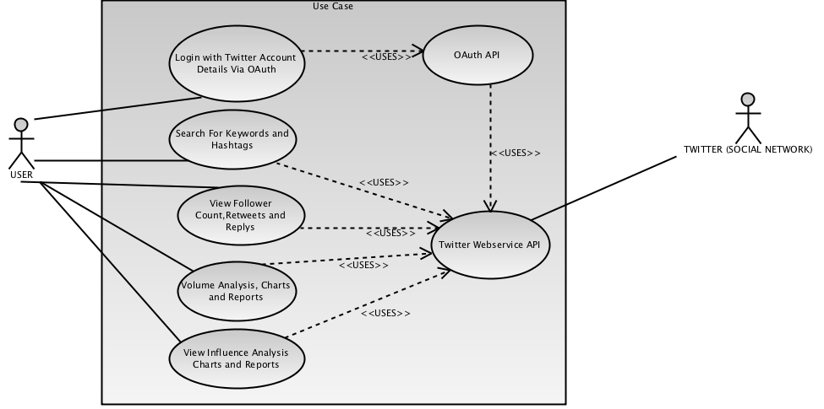

Class Diagram
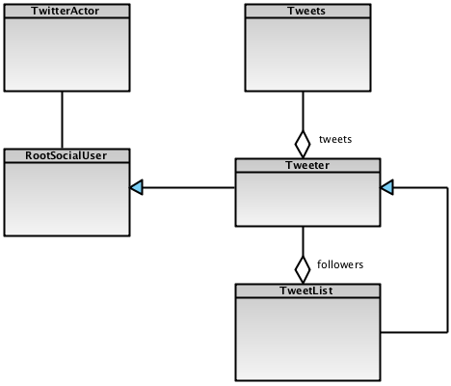

REFERENCE:
Bruegge B, Dutoit H. (2004), Object-Oriented Software Engineering using UML, Patterns and Java, Second Edition. Inc: Pearson Education Publishing, NJ
Shirky, C. (2009): How social media can make history,
Available at: http://www.ted.com/talks/clay_shirky_how_cellphones_twitter_facebook_can_make_history.html [Accessed 9th June 2010]
Kaplan A. M. and Haenlein M., (2010), Users of the world, unite! The challenges and opportunities of social media, Business Horizons, Vol. 53, Issue 1, p. 59-68.
Odersky, M. et al, 2008. Programming in Scala First Edition, Artima.
Surowiecki, J. (2004). The Wisdom of Crowds, Doubleday Anchor Books
Sommerville I. (2007) Software Engineering, Eight Edition Inc: Pearson Education Printing press.
O’Reilly T. (2005) What Is Web 2.0, Available at: http://oreilly.com/web2/archive/what-is-web-20.html [Accessed 18th June 2010]
Wampler, D. 2008. http://blog.objectmentor.com/articles/2008/08/03/the-seductions-of-scala-part-i

BIBLIOGRAPHY:
Ghosh D. and Vinoski S., “Scala and Lift — Functional Recipes for the Web,” IEEE Internet Computing, vol. 13, no. 3, 2009, pp. 88–92.
Meeyoung C. et al (2010), Measuring User Influence in Twitter: The Million Follower Fallacy, Max Planck Institute for Software Systems (MPI-SWS), Germany.
On Twitter, Followers Don't Equal Influence Available at: http://blogs.hbr.org/research/2010/05/influence-and-twitter.html [Accessed 12th May 2010]

Appendix

Activity Log

Use excel to pick track of time?
activity | ACT TYPE | ACT START | ACT STOP | DURATION | ACHIEVED | PROBLEMS ENCOUNTERED

Error Log

Progress Log (what I have learnt during this exciting project)
SNo. | Description | Date Logged | Impact | Fixed? | Date Fixed | Time Taken | Nature of Fix
P 1 | ERROR - Actor threw an exception (NoSuchElementException) | September 10 2010 | Actor exception on OAuthResponse(verifier) | No | ---------------------- | ----------------- | ----------------------
P2 | Redirecting to twitter user’s page | September 11, 2010 | Display friendly and bookmark able URL | Yes | September 12, 2010 | 1 Day | S.redirectTo(“/”+username)
P3 | [warn] dispatch failed!  [warn] EXCEPTION  java.lang.OutOfMemoryError: unable to create new native thread | August 17, 2010 : 1:37 AM | Jetty server | Yes | August 17, 2010 : 1:43 AM | 1 Day | Advise from stack over flow
P4 | OAuth request token not rebndering | August 20, 2010 : 12:31 AM | User cannot use twitter OAuth for authetication. | Yes | August 20, 2010 : 12:31 AM | 1 Day | Advise from the twitter support staff.
P5 | found : collection.immutable.::[B]  [error] required: net.liftweb.common.Box[Any]  [error] case x :: rest => val TwtInfoList = tprofile.asInstanceOf[List[TwitterUserVO] | September 25, 2010 : 1:43 AM | Type Mismatch | Yes | September 25, 2010 : 3:13 AM | 1 Day | Box[T] Monad
P6 | ERROR - Actor threw an exception  dispatch.StatusCode: Exceptional response code: 500  {"status":500,"users":null}  at dispatch.HttpExecutor$$anonfun$when$1.apply(Http.scala:101)  at dispatch.HttpExecutor$$anonfun$when$1.apply(Http.scala:99)

- Creating a website in Lift
- URL rewriting with Lift
- Logout with Lift
- Using the Lift’s Actors Library (Basics: Beginner Level)
- Whittling Twitters API and OAuth (Basics: Beginner Level)
- Using SBT for Scala development (Basics: Beginner Level)
- Functional Programming in Scala (Basics: Beginner Level)
- Overcoming Java/Scala integration issues (Basics: Beginner Level)
- Rendering Form components with scala’s lift framework (Basics: Beginner Level)
- Parsing JSON data with Scala dispatch.json library (Basics: Beginner Level)

Appendix

Code
SharedSnippet.scala // entry snippet
package schoolprojectnov2010.snippet

/**
* Created by IntelliJ IDEA.
* User: ikennaokpala
* Date: Sep 8, 2010
* Time: 1:47:55 PM
* To change this template use File | Settings | File Templates.
*/

import _root_.net.liftweb.util._
import Helpers._
import xml.NodeSeq
import net.liftweb._
import http.js._
import http._

object Influencer extends SessionVar[Any]() // influencer singleton object
object searchObj extends RequestVar[String]("") // search singletion object

class SharedSnippet extends ApplicationUser { // SharedSnippet extends ApplicationUser Class
var search = "" // search variable
import SHtml._ // Library imports into local class scope
import JsCmds._
import JE._
import JsCmds.Alert
def render(xhtml: NodeSeq): NodeSeq = { // render method definition

bind("ss", xhtml, // bind helper
"search" -> text(searchObj.is, searchObj(_), "id" -> "search"), // search text field
"submit" -> submit(S.?("Search"), () => doSearch(searchObj.is), "id" -> "btn", "onclick" ->
JsIf(JsEq(ValById("search"), ""), Alert("You are expected to provide a topic or keyword") & JsReturn(false)))) // submit button with javascript validation
}

def smallSearchBox(xhtml: NodeSeq): NodeSeq = { // render method definition
bind("ss", xhtml,
"search" -> text(search, search = _, "id" -> "smallbox"), // search text field
"submit" -> submit(S.?("Go"), () => S.redirectTo("/" + search), "id" -> "smallboxbtn", "onclick" ->
JsIf(JsEq(ValById("smallbox"), ""),
Alert("You are expected to provide a twitter user name") & JsReturn(false)))) // submit button with javascript validation
}

def doSearch(searchInput: String) = { // topic search operation method
val influencerList = user.topicInfluencersSearch(searchInput) // method call to topicInfluencersSearch which returns List of Any
Influencer set (influencerList) // setting the Influencer session object with InfluencerList
S.redirectTo("/search/index") // redirecting to search index page which automatically invokes the render method for Search snippet

}

}

SearchSnippet.scala
package schoolprojectnov2010.snippet

import scala._
import math._

import net.liftweb.util.Helpers._
import net.liftweb.http.js.JsCmds._
import net.liftweb.http.js._
import net.liftweb.widgets.flot._
import net.liftweb.common._
import JE._

import schoolprojectnov2010.model.KloutUserVO
import xml.NodeSeq

/**
* Created by IntelliJ IDEA.
* User: ikennaokpala
* Date: Oct 5, 2010
* Time: 12:39:54 AM
* To change this template use File | Settings | File Templates.
*/

class SearchSnippet { // class SearchSnippet
private lazy val influencerList = Influencer.is.asInstanceOf[List[KloutUserVO]]// casting List of Any to List of KloutUserVO lazily evaluated
private lazy val sortedInfluencerList = influencerList sortWith (_.score > _.score) //Sorting the list of Klout Users lazily evaluated
private lazy val topic = sortedInfluencerList(0).topic + "." // retriving topic from Klout user object lazily evaluated
private lazy val data = influencerList map {_.score} // creating new List of klout user score lazily evaluated
private lazy val bar_labels = influencerList map {_.user_name} // creating new List of klout user name lazily evaluated
// title lazily evaluated
private lazy val title = <b>According to
<a href="http://www.klout.com">Klout</a>
the following are the top 50 influencers on topic:</b>

def render(xhtml: NodeSeq): NodeSeq = { // default page load method
Influencer.is match {
case x :: rest =>
val influencerDetails = sortedInfluencerList map { // creating new list of topic influencer with thier detail embedded in XML
x => <li>
<a href={"/" + x.user_name.trim /*triming username for any white spaces*/} class="badge">
<div class="thumb">
<img
src={x.picture/*twitter picture*/}/>
</div>
<div class="username">
{x.user_name /*twitter user name*/}
</div>
<div class="score">
<img src="/classpath/images/klout_mini.png"/>{round(x.score.doubleValue)/* Rounding to the nearest whole number*/}
</div>
</a>
</li>
}

bind("sn", xhtml, // bind helper
"title" -> title, // title
"graphTitle" -> "Graphical representation of the top influencers on topic: ", // message string
"topic" -> topic, // topic
"instruction" -> "To view volume and/or Influence rating.login with your twitter account.", // message string
"influencerDetails" ->
<ul>
{influencerDetails}
</ul>,
"graphArea" -> <div id="graph_area" style="width:920px;height:400px;"></div>,
"graph" -> flot _,// calling flot graph method
"errorMsg" -> "") // error message string

case _ => bind("sn", xhtml, // bind helper
"title" -> "", // returning Empty string
"graphTitle" -> "", // returning Empty string
"topic" -> "", // returning Empty string
"instruction" -> "", // returning Empty string
"influencerDetails" -> "",// returning Empty string
"graphArea" ->"", // returning Empty string
"graph" -> "", // returning Empty string
"errorMsg" -> <h1>Oops ! Error >>> Topic Not Found...</h1>) // error message string

}

}

def flot(xhtml: NodeSeq) = { // flot graphing metho definition

val data_to_plot = for ((y, x) <- data zipWithIndex) yield new FlotSerie() { // One FlotSerie for each bar zipped with list index
override val data: List[(Double, Double)] = (x.toDouble, y.toDouble) :: Nil // creating new list for graph data
override val label = Full(bar_labels(x)) // Bar label
}

val options: FlotOptions = new FlotOptions() { // Options for rendering graph
override val series = Full(Map("bars" -> JsObj("show" -> true, "barWidth" -> 1.0))) // bar graph selected to be rendered

override val xaxis = Full(new FlotAxisOptions() { // x axis flot options
override def min = Some(0d) // minimum value

override def max = Some(data.length * 1d) // maximum value
// override val mode = Full("time")
})
override val legend = Full(new FlotLegendOptions() {// legend flot options
override val container = Full("legend_area") // kengend container flot options
})

}

Flot.render("graph_area", data_to_plot, options, Flot.script(xhtml)) // rendering the flot graph
}

}
AppUser.scala
package schoolprojectnov2010.model

/**
* Created by IntelliJ IDEA.
* User: ikennaokpala
* Date: Sep 12, 2010
* Time: 2:10:18 AM
* To change this template use File | Settings | File Templates.
*/

class AppUser extends Tweeter { // class AppUser
val appActor = new ApplicationActor // new instance of ApplicationActor class
var authorized: Boolean = false // authorized set tpo false by default

def appAuthURL = // appAuthURL method making calls to appActor
appActor !? AuthURL // sending message and receiving reponse to / from AuthURL case class in message handler

def appVerifyAuth(verifier: String) = // appVerifyAuth method making calls to appActor
appActor !? OAuthResponse(verifier) // sending message and receiving reponse to / from OAuthResponse case class in message handler

def userDataForName(screenName: String) = // userDataForName method making calls to appActor
appActor !? TwitteruserInfo(screenName) // sending message and receiving reponse to / from TwitteruserInfo case class in message handler

def topicInfluencersSearch(search: String) = // topicInfluencersSearch method making calls to appActor
appActor !? InfluencersSearch(search) // sending message and receiving reponse to / from InfluencersSearch case class in message handler
}

TwitterOAuth.scala
package schoolprojectnov2010.snippet

/**
* Created by IntelliJ IDEA.
* User: ikennaokpala
* Date: Sep 8, 2010
* Time: 12:14:01 PM
* To change this template use File | Settings | File Templates.
*/

import net.liftweb.http._

class TwitterOAuth extends ApplicationUser {
import scala.xml.NodeSeq // library import into local class scope
import SHtml._
import js._
import JsCmds.{Noop, RedirectTo}

def render(xhtml: NodeSeq) = { //defualt page load method
user.authorized match {
case true => userLoggedIn // if user is already logged in, dont show OAuth button
case false =>

(for{ // for comprehension
tkn <- S.param("oauth_token") // retrieves the oauth token for the current authentication session
vrfr <- S.param("oauth_verifier") // retrieves the oauth verifier for the current authentication session
} yield useTokens(tkn, vrfr)) getOrElse <li class="btnimg">
{a(() => twitterAuthURL, // if user isnt logged in, create an anchor tag around a the twitter sign in imagge button which will do an AJAX call and invoke the OAuth URL request and Authentication function
<img src="/classpath/images/twitter/twitter_button_3_lo.gif" alt="Twitter OAuth Button"/>)}
</li>
}
}

def twitterAuthURL: JsCmd = { // generate URL for Twitter Auth requests

user.appAuthURL match {

case (Some(url: String)) =>
// println("I HAVE BEEN CALLED: " + url)
RedirectTo(url) // generate javascript command redirect URL for Twitter Auth requests

case _ =>

Noop // return nothing or no url
}
}

def useTokens(token: String, verifier: String): NodeSeq = {

user.appVerifyAuth(verifier) match {

case Some(username: String) => // if URL has tokens, then complete OAuth process

user.authorized = true
user.screenName = username
// S.redirectTo("/" + username)
S.redirectTo("/") // redirect to home page
userLoggedIn // return node sequence for logged in user

case _ => <b>something aint right</b> // return error notification node sequence
}
}
// return node sequence for logged in user
def userLoggedIn = <span>
<li>
<a href={"/" + user.screenName}>
{user.screenName}
</a>
</li>
<li>
<a href="/logout" class="last">Log Out</a>
</li>
</span>
}

Tprofile.scala
package schoolprojectnov2010.snippet

/**
* Created by IntelliJ IDEA.
* User: ikennaokpala
* Date: Sep 23, 2010
* Time: 5:23:45 PM
* To change this template use File | Settings | File Templates.
*/

import _root_.net.liftweb._
import http.S
import util._
import Helpers._
import scala.math._
import scala.xml.NodeSeq
import schoolprojectnov2010.model.TwitterUserVO

class TProfile extends ApplicationUser { // TProfile class definition
val screenName = S.param("screenName") // retrieving twitter screen name from URL
val width = 300 // graph width
val height = 225 // graph height

def render(xhtml: NodeSeq): NodeSeq = // render method definition
user.authorized match {
case true => val tprofile = (for{
screenName <- S.param("screenName") // retrieving twitter screen name from URL
} yield userStream(screenName)) getOrElse noTweets // yield making call to userStream for a particular twitter data if it returns null render the notweets method
tprofile match {
case x :: rest => val TwtInfoList = tprofile.asInstanceOf[List[TwitterUserVO]] // casting List of Any to List of TwitterUserVO
// println("THE TWITTER INFORMATION FOR"+screenName+" IS :"+TwtInfoList)
val TwtUserInfo = TwtInfoList(0) // retrieving the first object index in list of TwitterUserVO
val text = TwtInfoList map (n => <li>
{n.text}
</li>) // creating a new list of the twitter user tweets
val influencerOfDetails = <li>
<em>Oops !! This information is not available at the moment..</em>
</li> // errors messagge for influencerOfDetails not conclusive yet
val influencedByDetails = {
TwtUserInfo.influencedBy match {
case x :: rest => TwtUserInfo.influencedBy map {// creating a new list of the twitter user influenced By
x => // println("This is the influencedByDetails " + x)
<li>
<img src="/classpath/images/klout_mini.png"/>{round(x._2.doubleValue)}<a href={"/" + x._1}>
{"| @" + x._1}
</a>

</li>
}
case _ => <li>
<em>Oops !! This information is not available at the moment..</em>
</li> // errors messagge for influenced By not conclusive yet
}
}
bind("p", xhtml, // bind helper returns a NodeSeq
"error" -> "", // error mesage
"name" -> TwtUserInfo.name.toString, // twitter user name
"description" -> TwtUserInfo.description, // twitter user bio description
"screen_name" -> TwtUserInfo.screenName, // twitter user screen name
"screen_name_anchor" -> <a>@
{TwtUserInfo.screenName}
</a>, // twitter user screen name with anchor
"influencedBy" -> influencedByDetails, // list of influenced .by details
"influencerOf" -> influencerOfDetails, // list of influenced .of details
"favourites_count" -> TwtUserInfo.favourites_count.toString,// twitter user favoritte count
"listed_count" -> TwtUserInfo.listed_count.toString, // twitter user's listed count
"text" -> text, // twitter user tweets
"location" -> TwtUserInfo.location.toString, // twitter user's location details
"statuses_count" -> TwtUserInfo.statuses_count.toString, // twitter user's status count
"followers_count" -> TwtUserInfo.followers_count.toString, // twitter user's follwer count
"profile_picture" -> <img src={TwtUserInfo.profile_image_url.toString} width=' ' height=' '/>, // twitter user's image
"friends_count" -> TwtUserInfo.friends_count.toString, // twitter user's friends count
"score" -> round(TwtUserInfo.score.doubleValue).toString, // twitter user's klout score
"percentile" -> TwtUserInfo.percentile.toString, // twitter user's percentile score
"kclass" -> TwtUserInfo.kclass, // twitter user's kclass score
"klout_description" -> TwtUserInfo.klout_description, // twitter user's kclass description
"truereach" -> round(TwtUserInfo.true_reach.doubleValue).toString, // twitter user's true reach
"amplification" -> round(TwtUserInfo.amplification_score.doubleValue).toString, // twitter user's amplification score
"network" -> round(TwtUserInfo.network_score.doubleValue).toString, // twitter user's networki score
"scoregraph" -> <img src={googleVizBarChartURL(List(round(TwtUserInfo.score.doubleValue)), List(TwtUserInfo.screenName))} width={width.toString} height={height.toString} alt="graph"/>, // Klout Score bar graph
"truereachgraph" -> "", //<img src={googleVizBarChartURL(List(round(TwtUserInfo.true_reach.doubleValue)), List(TwtUserInfo.screenName))} width={width.toString} height={height.toString} alt="graph"/>, // Klout true reach bar graph
"ampgraph" -> <img src={googleVizBarChartURL(List(round(TwtUserInfo.amplification_score.doubleValue)), List(TwtUserInfo.screenName))} width={width.toString} height={height.toString} alt="graph"/>, // Klout amplification score bar graph
"networkgraph" -> <img src={googleVizBarChartURL(List(round(TwtUserInfo.network_score.doubleValue)), List(TwtUserInfo.screenName))} width={width.toString} height={height.toString} alt="graph"/>,// Klout network score bar graph
"qrcodegraph" -> <img src={googleVizQrCodeChartURL(TwtUserInfo.screenName,round(TwtUserInfo.score.doubleValue))} alt="graph"/>) // Klout qrcode score bar graph

case _ => val tprofileTuple = tprofile.asInstanceOf[Tuple2[Option[String], String]] // casting List of Any toTuple2 of Option of string and string
bind("p", xhtml, // bind helper returns xml node sequence
"error" -> (tprofileTuple._2 + " is not a valid twitter user !!"), // returns twitter user screen name appedded to a message string
"name" -> "", // returns an Empty String
"description" -> "", // returns an Empty String
"screen_name" -> "", // returns an Empty String
"screen_name_anchor" -> "", // returns an Empty String
"influencedBy" -> "", // returns an Empty String
"influencerOf" -> "", // returns an Empty String
"favourites_count" -> "", // returns an Empty String
"listed_count" -> "", // returns an Empty String
"text" -> "", // returns an Empty String
"location" -> "", // returns an Empty String
"statuses_count" -> "", // returns an Empty String
"followers_count" -> "", // returns an Empty String
"profile_picture" -> "", // returns an Empty String
"friends_count" -> "", // returns an Empty String
"score" -> "", // returns an Empty String
"percentile" -> "", // returns an Empty String
"truereach" -> "", // returns an Empty String
"amplification" -> "", // returns an Empty String
"network" -> "", // returns an Empty String
"scoregraph" -> "", // returns an Empty String
"truereachgraph" -> "", // returns an Empty String
"ampgraph" -> "", // returns an Empty String
"networkgraph" -> "", // returns an Empty String
"qrcodegraph" -> "") // returns an Empty String

}
case false => notAuthorised // returns Node Sequence of div with You need to login
}

def userStream(screen_name: String) = { // userStream method definition
val userInfoList = user.userDataForName(screen_name) // method call to userDataForName which returns List of Any
userInfoList
}
// returns Node Sequence of div with Notweets
def noTweets: NodeSeq = <div>
no tweets here
</div>

// returns Node Sequence of div with You need to login
def notAuthorised: NodeSeq = <center>
<h2>
You need to login to used this application
</h2>
</center>

def googleVizBarChartURL(data: List[Double], bar_label: List[String]) = "http://chart.apis.google.com/chart?" + List(
"chxt=x,y",
"chbh=41,0,240",
"chxl=0:|" + bar_label.mkString("|"),
"chs=%dx%d".format(width, height),
"cht=bvg",
"chco=A2C180",
"chd=t:" + data.mkString(",")).mkString("&") // returns Google vizualisation chart bar graph
//"chtt=%d+%d+%d".format(src, gtype, bar_label(0))).mkString("&")

def googleVizQrCodeChartURL(user: String, kscore: Double) = "http://chart.apis.google.com/chart?" + List(
"chf=a,s,000000",
"chs=100x100",
"cht=qr",
"chld=|0",
"chl=Twitter Username: @%s+Klout Score: %f".format(user, kscore)).mkString("&") // returns Google vizualisation chart QR Code bar code image
//"chl=Twitter Username: @%d+Klout Score: %d+TrueReach: %d+Amplification: %d+ Network:%d").format(user, kscore, truereach, amp, net)).mkString("&")
}

ApplicationActor.scala
package schoolprojectnov2010.model

/**
* Created by IntelliJ IDEA.
* User: ikennaokpala
* Date: Sep 8, 2010
* Time: 1:21:51 PM
* To change this template use File | Settings | File Templates.
*/

import net.liftweb.actor._
import dispatch._
import json._
import JsHttp._
import oauth.{Consumer, Token}
import twitter._
import net.liftweb.http.S

trait ExtUserProps extends UserProps with Js { // ExtUserProps extending UserProps and Js ofrom the databinder dispatch library
val id = 'id ! num // SymOp extractor for twitter user id `
val listed_count = 'listed_count ! num // SymOp extractor for twitter user list count
val favourites_count = 'favourites_count ! num // SymOp extractor for twitter user favourites count
val url = 'url ! str // SymOp extractor for twitter user url ( notes this may throw a runtime extractor exception)
val friends_count = 'friends_count ! num // SymOp extractor for twitter user friends count
val profile_image_url = 'profile_image_url ! str // SymOp extractor for twitter user image url
val name = 'name ! str // SymOp extractor for twitter user screen name
val description = 'description ! str // SymOp extractor for twitter user bio description
val location = 'location ! str // SymOp extractor for twitter user location
val statuses_count = 'statuses_count ! num // SymOp extractor for twitter user statuses count
}
object ExtUser extends ExtUserProps with Js // ExtUser inherits SymOp extractor for twitter user from ExtUserProps and Js

object TwitterCredentials { // twitter api credentials singleton object
lazy val consumerKey = "ZbjvoQtqD56WzVGsJYYqzw" // OAuth application consumer key, top-secret lazily evaluated
lazy val consumerSecret = "plgoNIGZOic9keO4BEHZ3aHRdRC6N0JJMGJPOpg" // OAuth application consumer Secret lazily evaluated
lazy val consumer = Consumer(consumerKey, consumerSecret) // composing Oauth application consumer key, top-secret lazily evaluated
}

object KloutCredentials { // klout api credentials singleton object
lazy val key = "n6aahpgj7geqespvdvsbuk7u" // Klout Application key
lazy val req = :/("api.klout.com") / "1" // Klout request uri
}
object TwitterCounterCredentials { // TwitterCounter api credentials singleton object
lazy val key = "77e1b81ea83c1c5d0c5d894fd3d5d66e"
lazy val req = :/("api.twittercounter.com")
}

case object AuthURL // case object to obtain OAuth-thentication URL
case class OAuthResponse(verifier: String) // OAuth-thentication Responce case class
case class TwitteruserInfo(screenName: String) // twitter users information
case class InfluencersSearch(searchInput: String) // topic or key word search case class
case class KloutUserVO(user_name: String, score: BigDecimal, picture: String, topic: String) // Klout User Data Transfer Object
case class TwitterUserVO(id: BigDecimal, name: String, screenName: String,
description: String, text: String, statuses_count: BigDecimal,
friends_count: BigDecimal, followers_count: BigDecimal,
listed_count: BigDecimal, favourites_count: BigDecimal,
location: String, profile_image_url: String,
score: BigDecimal, true_reach: BigDecimal, kclass: String,
klout_description: String, amplification_score: BigDecimal, network_score: BigDecimal,
influencedBy: List[(String, BigDecimal)], percentile: BigDecimal) // Twitter and Klout user Data Transfer Object

class ApplicationActor extends LiftActor { // Aplication actor inherit capabilities from Lift'sActor library
private lazy val http = new Http // databinder dispatch Http instance lazily evaluated
private var request_token: Option[Token] = None // request token Option type
private var access_token: Option[Token] = None // access token Option type
private val httpHost = S.hostAndPath // this get the current Host url

def messageHandler = { // Lift Actors message handler
case AuthURL =>
try {
val tok = http(Auth.request_token(TwitterCredentials.consumer, httpHost)) // request token for the application, as opposed to the user consider using Future this could throw a 503

request_token = Some(tok)
val url = Auth.authenticate_url(tok).to_uri.toString // generate the url the user needs to go to, to grant us access authorize_url(tok).to_uri
reply(Some(url))

} catch {
case ex => reply((None, None))
}

case OAuthResponse(vrfr) =>

val accessToken = http(Auth.access_token(TwitterCredentials.consumer, // this could throw a NoSuchElementException
request_token.get, vrfr))

reply(Some(accessToken._3))

case TwitteruserInfo(screenName) =>

try {
lazy val reqScore = KloutCredentials.req / "users" / "show.json" <<? Map("key" -> KloutCredentials.key, "users" -> screenName) // Klout User request end point Url
lazy val reqInfluencedBy = KloutCredentials.req / "soi" / "influenced_by.json" <<? Map("key" -> KloutCredentials.key, "users" -> screenName) // Klout User influencedBy end point Url
lazy val reqInfluencerOf = KloutCredentials.req / "soi" / "influenced_of.json" <<? Map("key" -> KloutCredentials.key, "users" -> screenName) // Klout User influencedOf end point Url
lazy val reqTwitterUserId = User(screenName).show // Twitter user end point Url and Json parser handler
val twitterUserDTO = { // twitter data transfer object
val kjson = http(reqScore ># {'users ! list}) map {'score ! obj} // handling the reqScore as JSON, taking what i want
val score = ('kscore ! num)(kjson(0)) // Extracting Klout score with the SymOp kscore
val true_reach = ('true_reach ! num)(kjson(0)) // Extracting truereach with the SymOp true_reach
val amplification_score = ('amplification_score ! num)(kjson(0)) // Extracting amplification score with the SymOp amplification_score
val network_score = ('network_score ! num)(kjson(0)) // Extracting network score with the SymOp network_score
val kclass = ('kclass ! str)(kjson(0)) // Extracting klout class with the SymOp kclass
val klout_description = ('description ! str)(kjson(0)) // Extracting klout class description with the SymOp description
val percentile = ('percentile ! num)(kjson(0)) // Extracting klout user percentile with the SymOp percentile
val twitterUser = http(reqTwitterUserId) // handling the reqTwitterUserId as JSON, taking what i want
val twitterUserId = ('id ! num)(twitterUserObj) // Extracting twitterUserId with the SymOp kscore
lazy val reqTc = TwitterCounterCredentials.req <<? Map("apikey" -> TwitterCounterCredentials.key, "twitter_id" -> twitterUserId)// Twitter Counter User request end point Url
val followersPerDate = http(reqTc ># {'followersperdate ! obj}) // handling the reqTc as JSON, taking followersperdate as an obj
val g = followersPerDate
lazy val influencedBy = { // influencedBy variable lazily evaluated
try { // exception
val influencer = for{ // for conmprehension
influencerList <- http(reqInfluencedBy ># {'users ! list}) flatten {'influencers ! list} // handling the reqTwitterUserId as JSON, taking what i want
screen_name = ('twitter_screen_name ! str)(influencerList) // Extracting screen_name with the SymOp twitter_screen_name
kscore = ('kscore ! num)(influencerList) // Extracting screen_name with the SymOp kscore
} yield (screen_name, kscore) // yield creates a new list of tuple2 string and BigDecimal
// println("I am looking for you "+influencer)
influencer
} catch { // exception trap
case _ => List() // return an empty list
}
}

/*val influencerOf = {
val influencer = for{
influencerList <- http(reqInfluencerOf ># {'users ! list}) flatten {'influencers ! list}
screen_name = ('influencer ! str)(influencerList)
kscore = ('kscore ! num)(influencerList)
} yield (screen_name, kscore)
influencer
}*/

val twitterUserObj = for{// for comprehension
twtJsonList <- http(Status(screenName).timeline) // handling the Status reponse as JSON, taking what i want
Status.user.screen_name(screen_name) = twtJsonList // handling the Status reponse as JSON, taking what i want
Status.text(text) = twtJsonList // handling the Status reponse as JSON, taking what i want
Status.user.followers_count(followers_count) = twtJsonList // handling the Status reponse as JSON, taking what i want
Status.user(user) = twtJsonList // handling the Status reponse as JSON, taking what i want
id = ExtUser.id(user) // handling the Status reponse as JSON, taking what i want
statuses_count = ExtUser.statuses_count(user) // handling the Status reponse as JSON, taking what i want
friends_count = ExtUser.friends_count(user) // handling the Status reponse as JSON, taking what i want
listed_count = ExtUser.listed_count(user) // handling the Status reponse as JSON, taking what i want
favourites_count = ExtUser.favourites_count(user) // handling the Status reponse as JSON, taking what i want
profile_image_url = ExtUser.profile_image_url(user) // handling the Status reponse as JSON, taking what i want
name = ExtUser.name(user) // handling the Status reponse as JSON, taking what i want
location = ExtUser.location(user) // handling the Status reponse as JSON, taking what i want
description = ExtUser.description(user) // handling the Status reponse as JSON, taking what i want
} yield TwitterUserVO(id, name, screenName,
description, text, statuses_count, friends_count,
followers_count, listed_count, favourites_count,
location, profile_image_url, score, true_reach, kclass, klout_description,
amplification_score, network_score, influencedBy, percentile)
println("this is my id: " + twitterUserObj(0).id) // yield creates a new list of TwitterUserVO
twitterUserObj

}
reply(twitterUserDTO) // replying back to caller the twitterUserDTO
} catch {

case ex => println(ex); reply((None, screenName)) // replying back to caller tuple2 of Option and String
}

case InfluencersSearch(searchInput) =>

try {

val searchresult = { // searchresult variable
val req = KloutCredentials.req / "topics" / "search.json" <<? Map("key" -> KloutCredentials.key, "topic" -> searchInput) // Klout Topic request end point Url
val kuser = for{ // for comprehension
json <- http(req ># {
'users ! list

}) // processing topic request
user_name = ('user_name ! str)(json) // Extracting twitter user name via Klout with the SymOp user_name
score = ('skore ! num)(json) // Extracting Klout user score with the SymOp skore
picture = ('pic_url ! str)(json) // Extracting twitter image via Klout with the SymOp pic_url
} yield KloutUserVO(user_name, score, picture, searchInput) // yield creates a new list of KloutUserVO
kuser
}

reply(searchresult) // replying back to caller the searchresult
} catch {
case ex => reply((None, None)) // replying back to caller tuple2 of Option and Option
}

case _ => println("unkown message") // printing to console some unknown message

}

}

// println("THE TWITTER INFORMATION FOR "+screenName+" FROM APPLICATION IS : "+twt1)

Screenshot
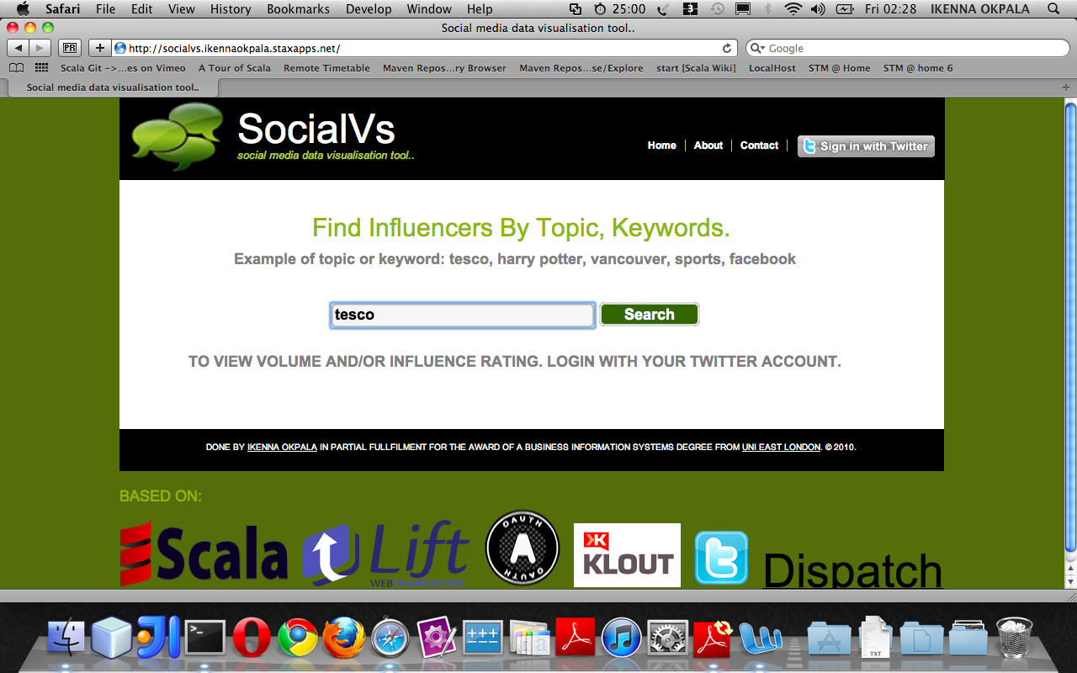
HOME SCREEN

TWITTER PAGE FOR AUTHENTICATION
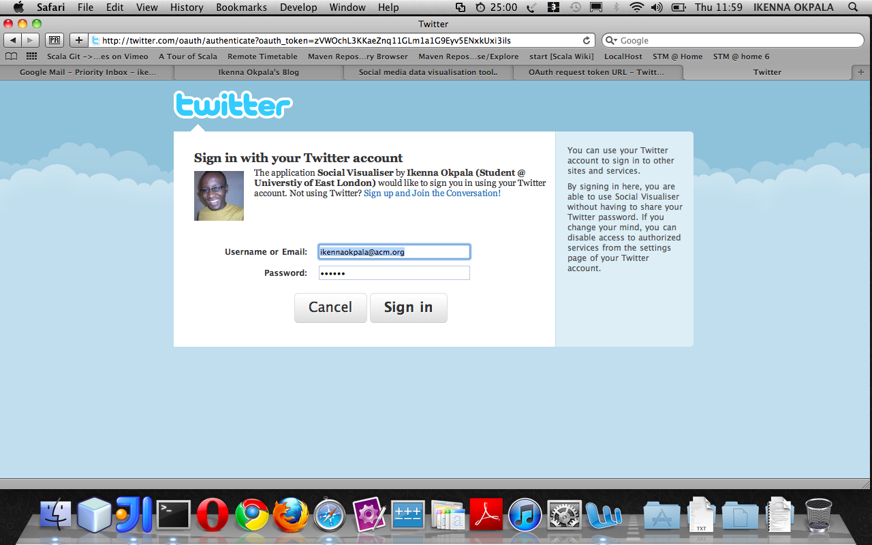

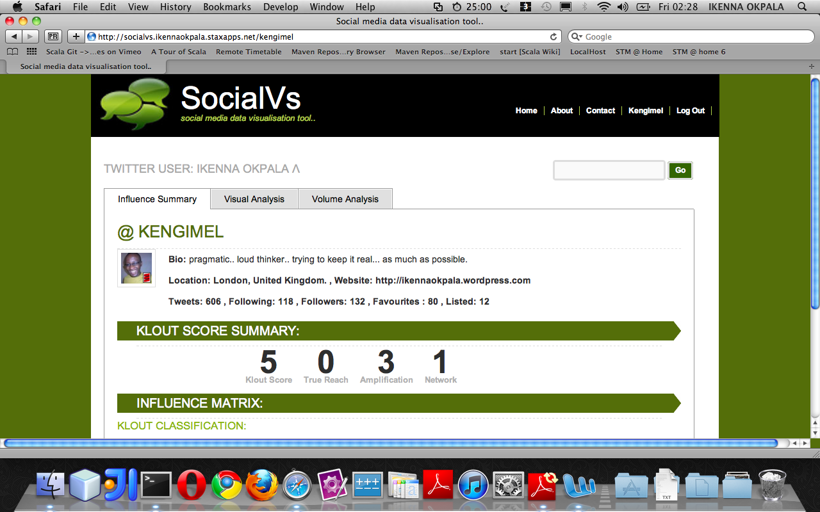
PROFILE SCREEN AFTER USER HAS LOGGED IN VIA OAUTH FROM TWITTER

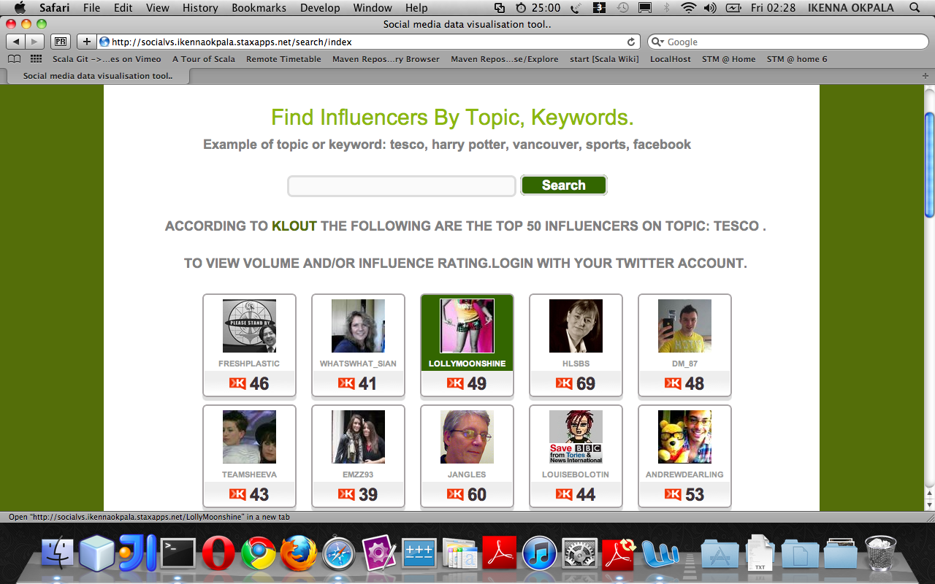
PAGES OF INFLUENCERS:

