My Wealth Solutions
Fee Report Import — Change Specification
Adviser-aware totals + Commitment fee as its own category
For: the Replit fee-report import tool. Report format: “All Transactions” export — key columns: Client Name, Full Name (adviser), Status, Total Amount, Transaction Time, Recurring Payment: Recurring Payments Name.

1. What Changes (Summary)
- Adviser-aware tiles: every summary tile recomputes when the adviser filter changes, with a visible scope chip. “All advisers” shows whole-report figures; a selected adviser shows only their clients’ figures.
- Three fee categories instead of two: COMMITMENT, UPFRONT/ONE-OFF and ONGOING. Commitment is currently buried inside ongoing because it is entered as a one-off “ongoing” transaction.
- New “Commitment (FY)” column in the client table (between Payments and Upfront), a new Commitment tile, and a distinctive badge on commitment amounts.
- Configurable commitment amounts — default 554, 914, 1214 — shown as an editable setting above the tiles.

2. What a Commitment Fee Looks Like in the Data
A commitment fee is charged once, as the client’s FIRST ever payment, before regular ongoing fees start. It is entered in the payment system as an ongoing-type transaction (it usually HAS a recurring payment ID), so recurring-ID logic cannot identify it — only the amount and its position can.
Real examples from the attached report: Madeline T… — $554.00 (commitment, first payment), then $2,500.00 (upfront), then $139.67 recurring (ongoing). Lucas Saun… — $914.00 (commitment), $2,830.00 (upfront), then $162.50 recurring (ongoing).
Verified against the full report (8,700 rows): 237 client groups contain a commitment-amount payment; for 234 of them (99%) it is the first-ever payment; 222 have exactly one; 163 of the 237 carry a recurring payment ID — so a recurring ID must NOT disqualify a payment from being a commitment fee.

3. Classification Algorithm (Implement Exactly)
Run classification over the WHOLE report (all dates, approved payments only), per client group, BEFORE any financial-year or adviser filtering. Then bucket the classified payments into FY and adviser views.
COMMITMENT_AMOUNTS = [554.00, 914.00, 1214.00] // editable setting, match to the cent

for each clientGroup:
txns = approved payments for the group, sorted by Transaction Time (whole report)
// 1. COMMITMENT — at most ONE per client group, ever
first = txns[0]
if first.amount in COMMITMENT_AMOUNTS (±0.01):
first.category = COMMITMENT
// NOTE: do NOT require a missing recurring ID — 69% of real
// commitment fees carry one. Amount + first-position is the test.
// 2. UPFRONT / ONE-OFF — over the remaining payments
base = mode (most common value) of remaining payments
for tx in remaining:
if tx has no recurring ID OR tx.amount >= 3 × base:
tx.category = UPFRONT
// 3. ONGOING — everything else
remaining uncategorised => ONGOING
Guards: only the first-ever payment can be a commitment fee (if a later payment happens to equal $554 etc., it classifies through the normal upfront/ongoing rules); a client group never has more than one commitment fee; declined/voided payments are excluded before everything.

4. Adviser-Aware Tiles
- Compute all tiles from a single filtered transaction set: filteredTxns = classified payments → adviser filter → FY filter. When the adviser dropdown changes, recompute every tile from filteredTxns (not just the table).
- Tiles, left to right: Total in FY (scoped) · Commitment fees (FY) · Upfront/one-off (FY) · Ongoing fees (FY) · Client groups with FY payments · Median per client group. The first four must satisfy: Total = Commitment + Upfront + Ongoing (assert this in code).
- Add a scope chip above the tiles: “Scope: All advisers (16)” or “Scope: Ben Budge”, so it is always obvious what the figures cover.
- Rename the old “Report total (all dates)” tile out of the tile row or drop it — every visible figure should respect the adviser scope to avoid mixed-scope confusion.

5. Client Table
- Insert a “Commitment (FY)” column between Payments and “Upfront / one-off (FY)”. Show the amount in a teal badge; an em-dash when none.
- “Upfront / one-off (FY)” EXCLUDES the commitment fee. “Total for FY” = Commitment + Upfront + Ongoing for that group.
- Keep the existing flags (⚠ on single payments ≥ $5,000, and the more-than-12-recurring-payments flag) — a commitment fee never triggers either.
- Draft invoice prefill: Upfront/Retainer amount = Commitment + Upfront for the FY (shown as two figures in the prefill note so the adviser can split or exclude); Ongoing amount = Ongoing for the FY.

6. Mock-ups

State A — “All advisers” selected
All tiles show whole-report figures. Note the editable commitment-amounts setting, the commitment tile, and the badge in the new column.
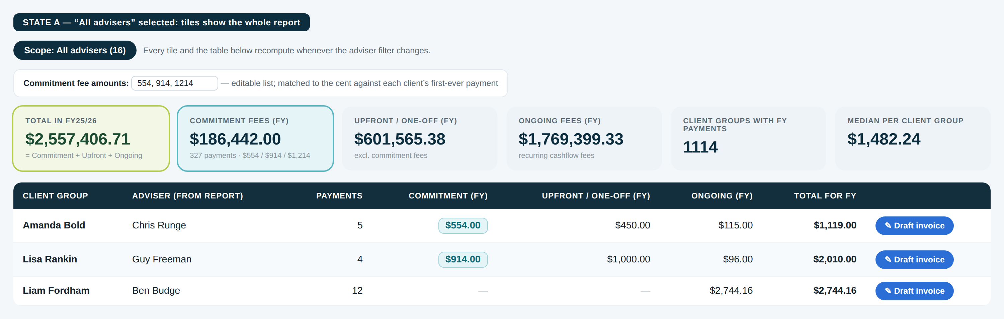

State B — a single adviser selected
Identical layout — every figure recomputed for the selected adviser only, with the scope chip making that explicit.
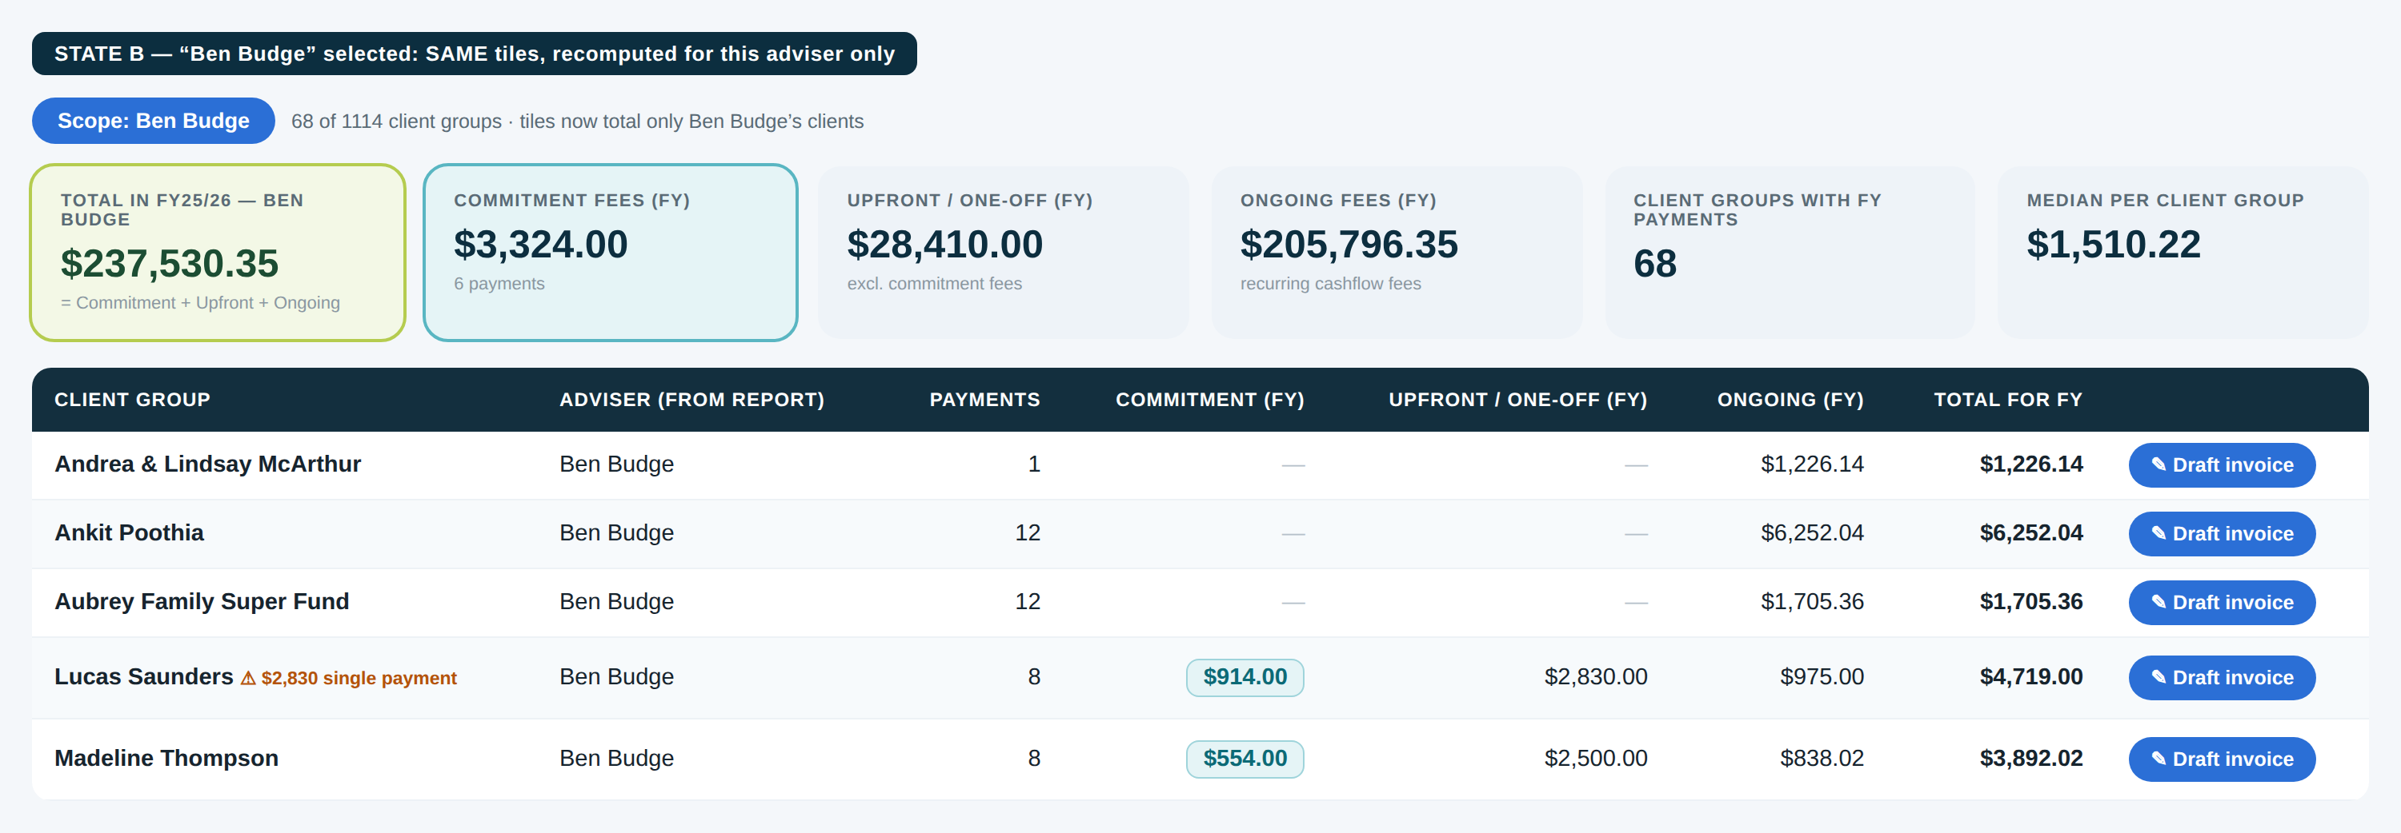

7. Acceptance Tests (run against the attached report)
- Madeline T… (ending in 271): Commitment $554.00, Upfront $2,500.00, Ongoing = the $139.67 recurring payments. The $554 must NOT appear in ongoing.
- Lucas Saun… (ending in 042): Commitment $914.00, Upfront $2,830.00; the $162.50 recurring payments belong to the separate “Lucas & Re… (ending in 827)” payment method — group by Client Name, not payment method.
- Dataset totals: the report contains 136 payments of $554, 73 of $914 and 47 of $1,214; ~237 client groups should show a commitment fee, and ~99% of those are the group’s first-ever payment.
- Toggle the adviser filter between “All advisers” and any single adviser: every tile must change; Commitment + Upfront + Ongoing must equal the Total tile in both states.
- A client whose first payment carries a recurring ID AND equals $554/$914/$1,214 must still classify as commitment.
- A $554 payment that is NOT the client’s first-ever payment must NOT classify as commitment.
Internal specification for MWS. Amounts shown in the mock-ups are illustrative.

