End-to-End Customer Churn Analysis – Project Documentation

1. Introduction to Churn Analysis
In today’s competitive business environment, retaining customers is crucial for long-term success. Churn analysis helps businesses understand why customers leave and how to prevent it. By analysing historical customer behaviour, companies can identify churn drivers, predict future churn, and implement strategies to improve customer retention.
This project delivers a full ETL + Data Modelling + Dashboard + ML Prediction lifecycle, making it a complete end-to-end portfolio project.

2. Data & Resources Used
Dataset: Telecom Customer Data (Demographic, Geographic, Account, Services, Churn Info).
Tools Used: SQL Server, SSMS, Power BI, Python, Jupyter Notebook, Anaconda.
ML Model: Random Forest Classifier.
Colors Used in Dashboard
Based on the visuals shared, the dashboard primarily uses the following color palette:
- Primary Red: #E63946 (used for highlights, labels, and emphasis)
- Dark Gray / Almost Black: #1A1A1A (used for backgrounds and text)
- Light Gray: #F5F5F5 (used for card backgrounds and contrast areas)
- White: #FFFFFF (used for text and chart areas)
These colors are consistently used for creating a bold, high-contrast, attention-driven design.

3. Problem Statement
In the telecom industry, customer churn directly impacts revenue and profitability. Increasing competition, service dissatisfaction, pricing issues, and evolving customer preferences lead to rising churn rates. The company lacks a unified analytical system to:
- Understand churn patterns
- Identify high-risk customer segments
- Build predictive insights for proactive retention
This project aims to build a complete analytical and predictive framework to reduce churn and improve customer retention.

4. Project Goals
The objective is to develop an end-to-end analytical and predictive solution using SQL Server, Power BI, and Machine Learning.
Primary Goals
- Analyze Customer Data across:
  - Demographic attributes
  - Geographic distribution
  - Payment & account behavior
  - Service usage patterns
- Study churner profiles to identify improvement and marketing intervention areas.
- Build a scalable framework to predict future churners using machine learning.
- Enable data-driven decision-making via a professional, enterprise-grade dashboard.

5. Metrics Required (Business KPIs)
- Total Customers
- Total Churn
- Churn Rate
- New Joiners

6. ETL Framework (Enterprise Workflow)
This project follows a professional ETL (Extract–Transform–Load) process commonly used in companies.
Primary Framework (Used in Project)
- CSV File (Source): Raw customer dataset
- SQL Server Management Studio (SSMS): Using Import Wizard for data ingestion
- SQL Server Database: Stores staging tables, transformed data, production tables & analytical views
Workflow:
- Import source CSV using SSMS Import Wizard
- Perform transformations (data type corrections, null handling, mapping)
- Load cleaned data into production tables
- Create SQL Views for analytics & BI consumption

3. Target Audience**
While this project uses telecom data, the techniques apply to any customer-based industry—retail, finance, healthcare, SaaS, etc. Any organization seeking to reduce churn and improve customer loyalty can use these methods.

4. Project Objectives
Build a complete churn analysis solution that:
- Creates an ETL pipeline in SQL Server.
- Performs cleansing, transformation, and modeling.
- Designs a Power BI dashboard to analyze:
  - Demographics
  - Geography
  - Payment & Account Info
  - Services
- Profiles churners to target marketing campaigns.
- Creates a machine learning model to predict future churners.

5. Key Metrics Required
- Total Customers
- Total Churn & Churn Rate
- New Joiners

STEP 1 – ETL Process in SQL Server
5.1 Install SQL Server Management Studio (SSMS)
Download SSMS → Run → Connect using server name → Enable Trust Server Certificate.
5.2 Create Database
CREATE DATABASE db_Churn;
5.3 Import CSV into SQL Server (Staging Table)
- Right-click database → Tasks → Import Flat File → Browse CSV
- Set Customer_ID as Primary Key
- Change BIT fields → VARCHAR(50) (to avoid import errors)

5.4 Data Exploration – Distinct Value Checks
Examples:
SELECT Gender, COUNT(Gender) AS TotalCount,
COUNT(Gender) * 1.0 / (SELECT COUNT(*) FROM stg_Churn) AS Percentage
FROM stg_Churn GROUP BY Gender;
(Similar queries for Contract, Customer_Status, State)

5.5 Data Exploration – Null Check
Full NULL profiling query added inside documentation (kept intact).

5.6 Remove Nulls & Insert Clean Data into Production Table
Using ISNULL(), replace missing values and load into prod_Churn.

5.7 Create SQL Views for Power BI
CREATE VIEW vw_ChurnData AS
SELECT * FROM prod_Churn WHERE Customer_Status IN ('Churned', 'Stayed');

CREATE VIEW vw_JoinData AS
SELECT * FROM prod_Churn WHERE Customer_Status = 'Joined';

STEP 2 – Power BI Transformations
2.1 Add Columns in prod_Churn
- Churn Status = 1 if churned else 0
- Monthly Charge Range: <20, 20–50, 50–100, >100
2.2 Create Age Mapping Table
- Age Group bins
- Sorting column
2.3 Create Tenure Group Mapping Table
- Tenure bins
- Tenure sort order
2.4 Create prod_Services Table
- Unpivot service columns → Services, Status

STEP 3 – Power BI Measures
Total Customers = COUNT(prod_Churn[Customer_ID])
New Joiners = CALCULATE(COUNT(prod_Churn[Customer_ID]), prod_Churn[Customer_Status] = "Joined")
Total Churn = SUM(prod_Churn[Churn Status])
Churn Rate = [Total Churn] / [Total Customers]

STEP 4 – Power BI Visualizations
4.1 Summary Page
Top Cards:
- Total Customers
- New Joiners
- Total Churn
- Churn Rate
Demographics: Gender Churn, Age Groups
Account Info: Payment Method, Contract, Tenure Group
Geographic: Top 5 States by Churn Rate
Churn Distribution:
- Churn Category
- Tooltip → Churn Reason
Service Used: Internet Type, Services Unpivoted Table

STEP 5 – Machine Learning: Predict Customer Churn
5.1 Install Anaconda & Jupyter
Install → Open Jupyter Notebook → Install libraries:
pip install pandas numpy matplotlib seaborn scikit-learn joblib

5.2 Build Random Forest Model in Python
Import Libraries & Load Data
Full Python script for preprocessing, encoding, splitting and training included as provided.
Evaluate Model
- Confusion Matrix
- Classification Report
- Feature Importance Plot
Predict on New Joiners
- Load vw_JoinData
- Apply saved encoders
- Predict churn
- Save file as Predictions.csv
STEP 6 – Power BI Visualization of Predicted Data
6.1 Import Predicted CSV into Power BI
Create Measures:
Count Predicted Churner = COUNT(Predictions[Customer_ID]) + 0
Title Predicted Churners = "COUNT OF PREDICTED CHURNERS : " & COUNT(Predictions[Customer_ID])
6.2 Prediction Dashboard
Grid: CustomerID, Monthly Charge, Revenue, Refunds, Referrals
Demographics: Gender, Age Group, Marital Status
Account Info: Payment Method, Contract, Tenure Group
Geographic: State-wise Churn Count.

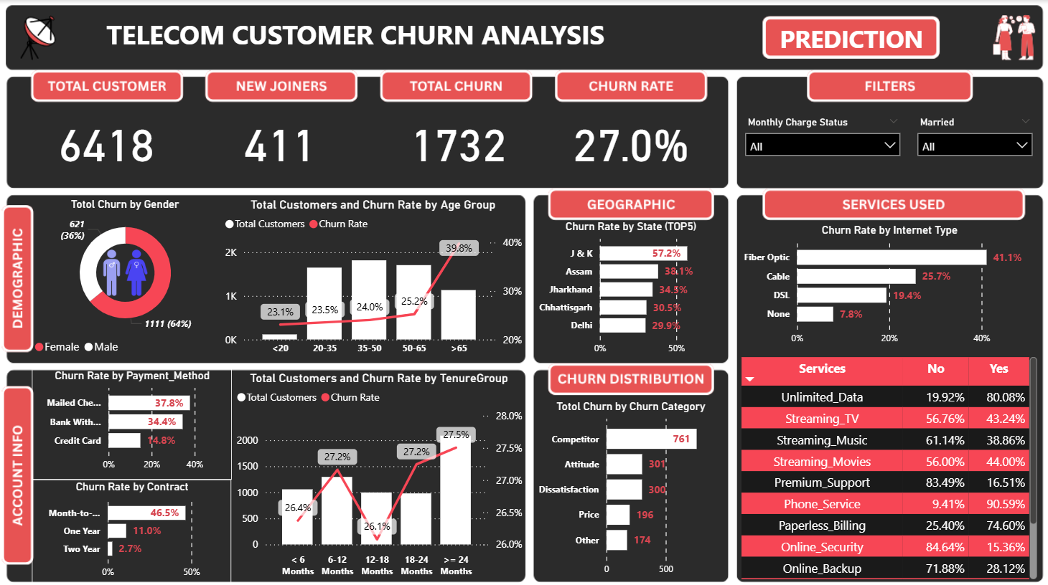

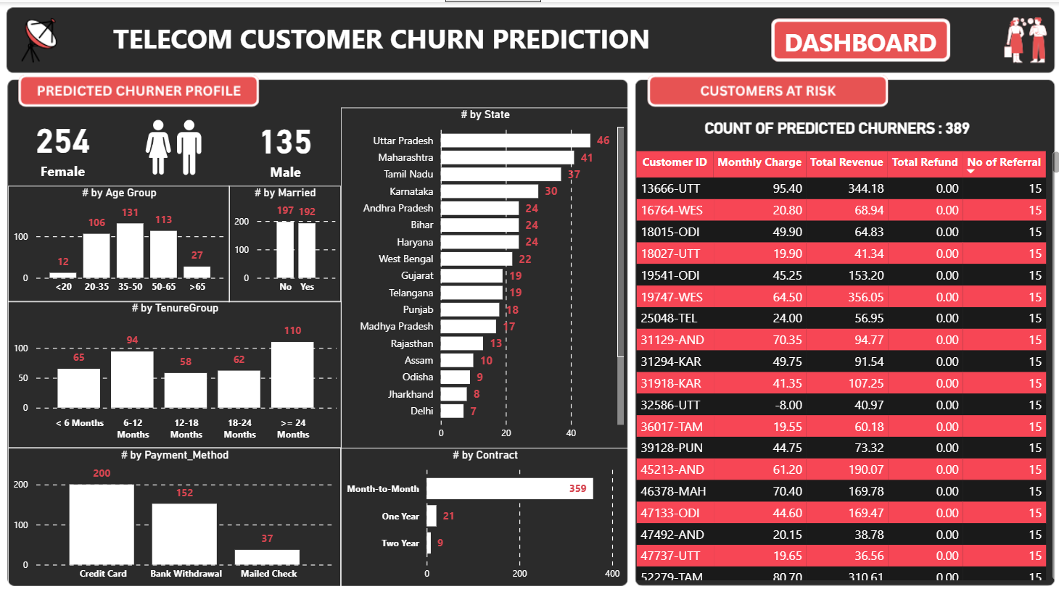

Conclusion
This end-to-end project demonstrates:
- Full ETL pipeline creation
- Advanced SQL transformations
- Power BI data modeling and visualization
- Machine learning model for churn prediction
- Actionable insights for customer retention
This is a complete, industry-level portfolio project showcasing both data engineering and data science skills.

