INDEX

|  |  |
| --- | --- |
| S.NO | Description |
| 1 | Database Structure |
| 2 | USER CATEGORY AND RESPONSIBILITIES |
| 3 | ADMIN PANEL |
| 3.A | MANAGE BLOGS |
| 3.B | MANAGE CATEGORIES |
| 3.C | MANAGE TAGS |
| 3.D | EDITOR’S CHOICE |
| 3.E | DASHBOARD |
| 4 | FILTERS |
| 4.A | FILTER-CATEGORY |
| 4.B | FILTER-SEARCH TITLE |

1. DATABASE STRUCTURE

* DATABASE CREATED:
* BLOG
* FIXED TABLE LIST:
* USER
* BLOG_INFO
* BLOG_CATEGORIES
* BLOG_TAGS
* DYNAMIC TABLE LIST:
* It will be created when new blog has been added into BLOG_INFO table with the name of BLOG_TITLE.
* QUERY FOR CREATING FIXED TABLE LIST:
* USER:

CREATE TABLE USER

(

ID INT AUTO_INCREMENT PRIMARY KEY,

USERNAME VARCHAR(255) NOT NULL,

EMAIL VARCHAR(255) NOT NULL,

MOBILENUMBER INT(10) NOT NULL,

PASS VARCHAR(255) NOT NULL

);

* BLOG_INFO:

CREATE TABLE BLOG_INFO

(

ID INT NOT NULL AUTO_INCREMENT PRIMARY KEY,

BLOG_TITLE VARCHAR(100) NOT NULL,

BLOG_COMMENT_TABLE_NAME INT NOT NULL,

BLOG_CATEGORY VARCHAR(20) NOT NULL,

BLOG_TAGS VARCHAR(20) NOT NULL,

BLOG_CONTENT LONGTEXT NOT NULL,

BLOG_DATE_TIME DATETIME,

BLOG_PHOTOS_PATH VARCHAR(40) NOT NULL,

BLOG_AUTHOR VARCHAR(20) NOT NULL,

BLOG_STATUS VARCHAR(10) NOT NULL,

BLOG_ADMIN_COMMENTS LONGTEXT NOT NULL

);

* BLOG_CATEGORIES:

CREATE TABLE BLOG_CATEGORY

(

ID INT NOT NULL AUTO_INCREMENT PRIMARY KEY,

BLOG_CATEGORY VARCHAR(20) NOT NULL

);

* BLOG_TAGS:

CREATE TABLE BLOG_TAGS

(

ID INT NOT NULL AUTO_INCREMENT PRIMARY KEY,

BLOG_TAGS VARCHAR(20) NOT NULL

);

DB SCREEN-SHOT:

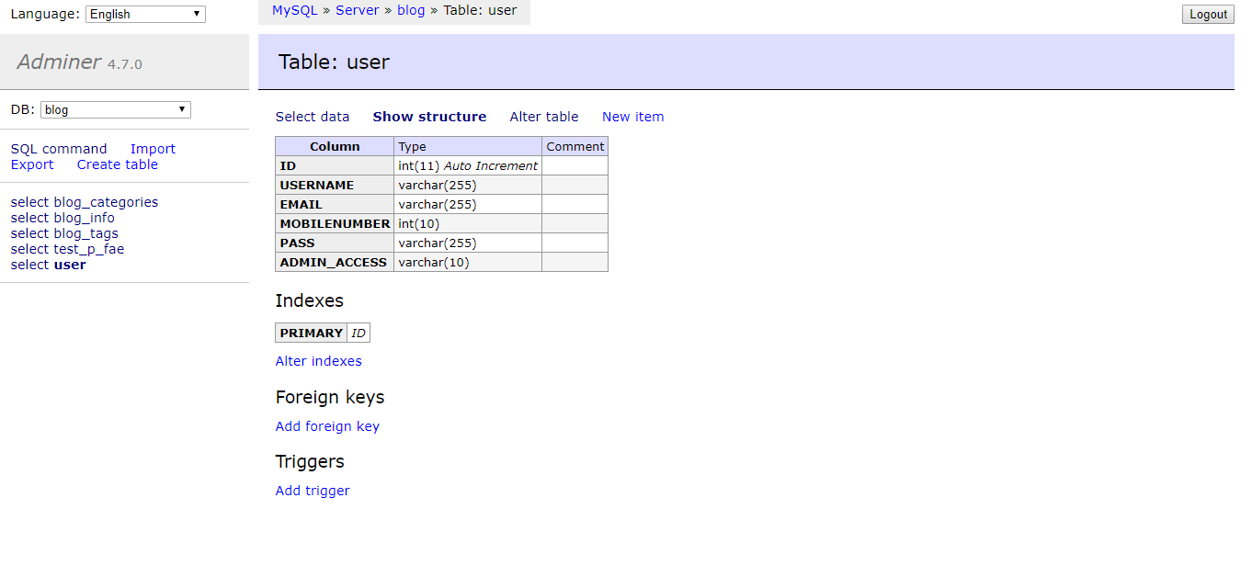

1. USER CATEGORY AND RESPONSIBILITIES

* CREATE AN ACCOUNT:
* CLICK SIGNUP FROM THE MENU BAR

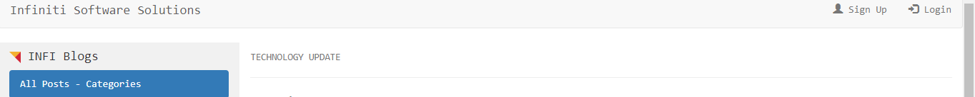

* BELOW SIGNUP PAGE WILL GET OPEN

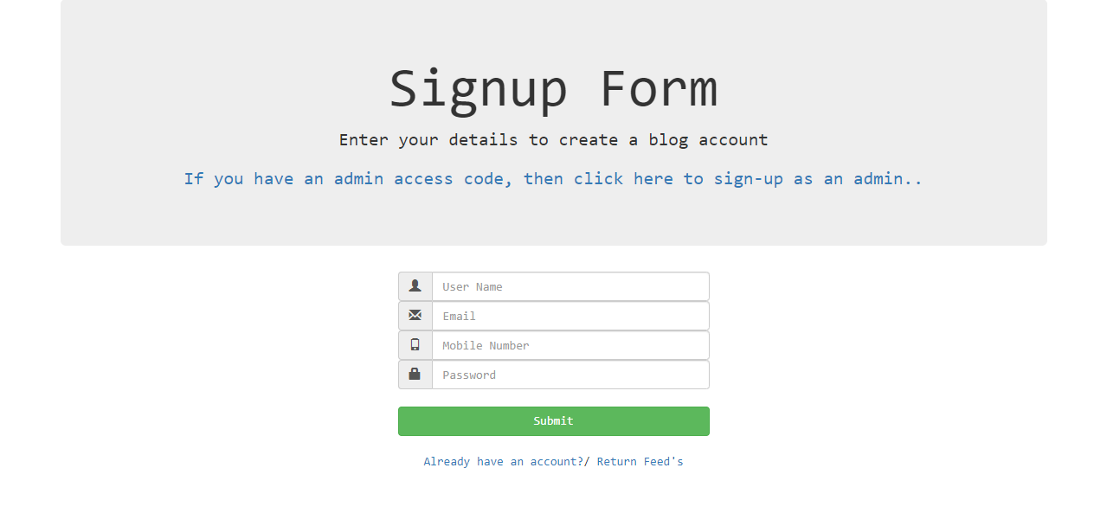

* FILL THE FORM TO CREATE AN ACCOUNT AS A GENERAL USER
* IF YOU HAVE THE ADMIN CODE, THEN CREATE AN ACCOUNT BY SELECTING THE ABOVE HIGHLIGHTED ANCHOR.



* AFTER SELECTING THIS ADMIN SIGNUP LINK

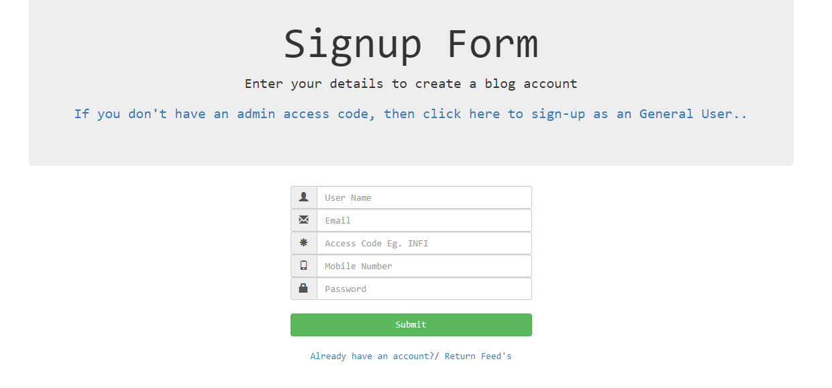

* SIGNUP FORM WILL OPEN WITH ADMIN CODE, IF WE ENTERED CORRECT ADMIN CODE THEN ACCOUNT WILL BE OPENED AS AN ADMIN. FOR TEMPORARY PURPOSE THE ADMIN CODE IS ‘INFI’
* USER CATEGORY:
* NORMAL USER
* GENERAL USER
* ADMIN USER
* NORMAL USER:
* CAN VIEW THE BLOGS AND COMMENTS
* THEY CAN’T PROVIDE ANY COMMENTS
* PUBLISHED ARTICLES ONLY VISIBLE UNDER THIS FEED

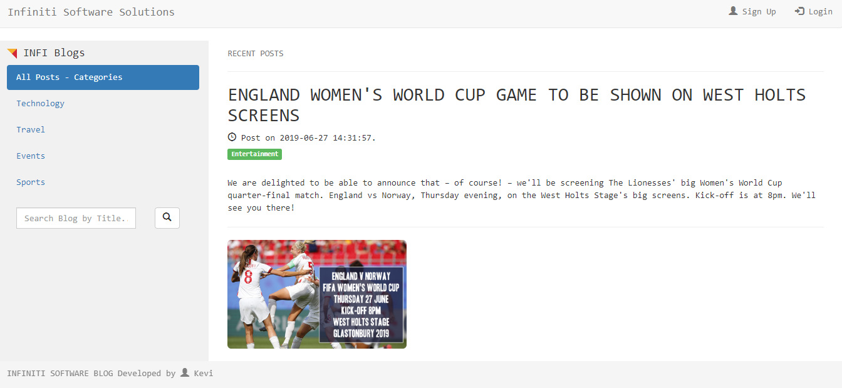

* GENERAL USER:
* CAN ADD COMMENTS ALSO CAN SHARE ARTICLES TO SOCIAL MEDIA PLATFORM.

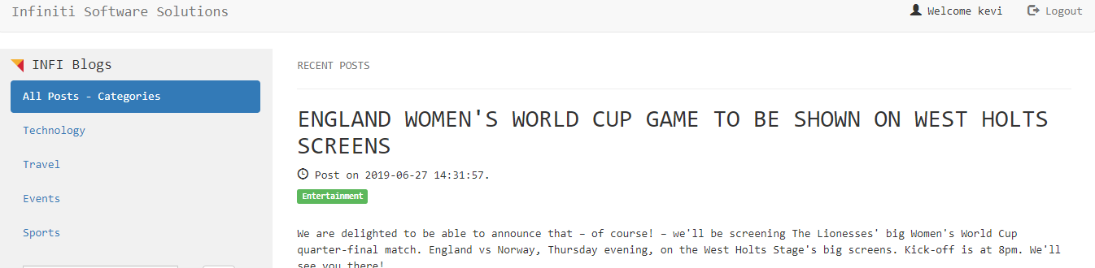

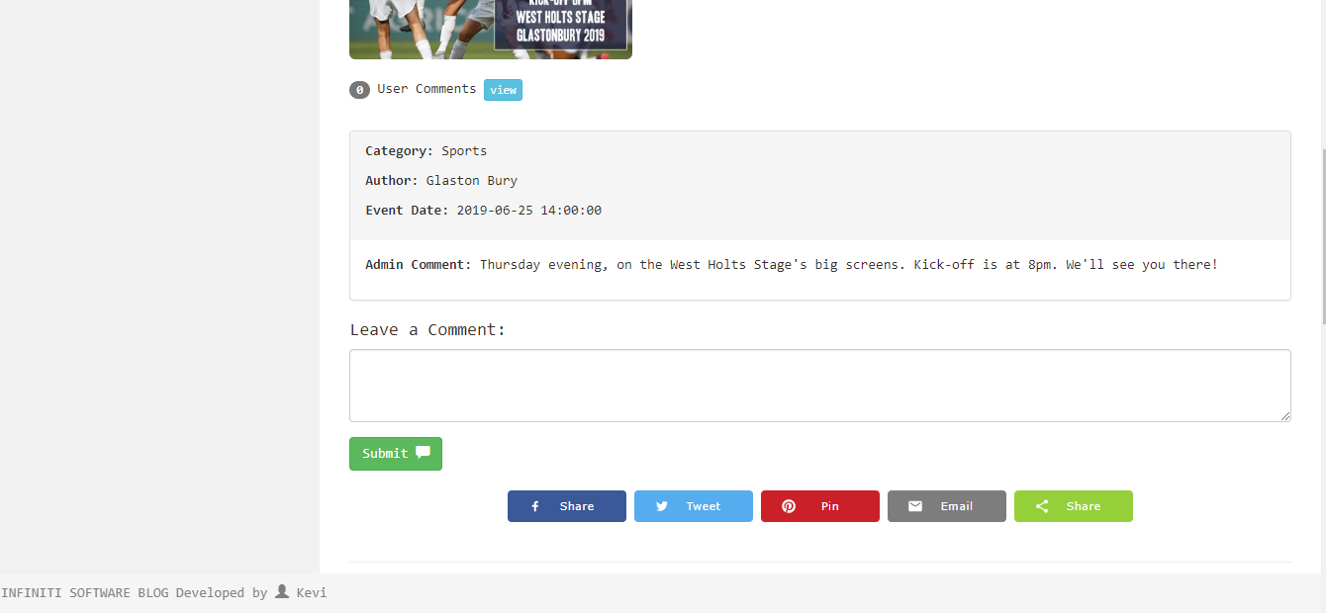

* ADMIN USER:
* HAS THE COMPLETE CONTROL.
* CAN ADD/VIEW/DELETE/UPDATE BLOGS.
* CAN MANAGE CATEGORIES
* CAN MANAGE TAGS
* CAN SET THE EDITOR’S CHOICE ARTICLES
* CAN SEE THE DASHBOARD
* ADMIN PANEL VISIBLE

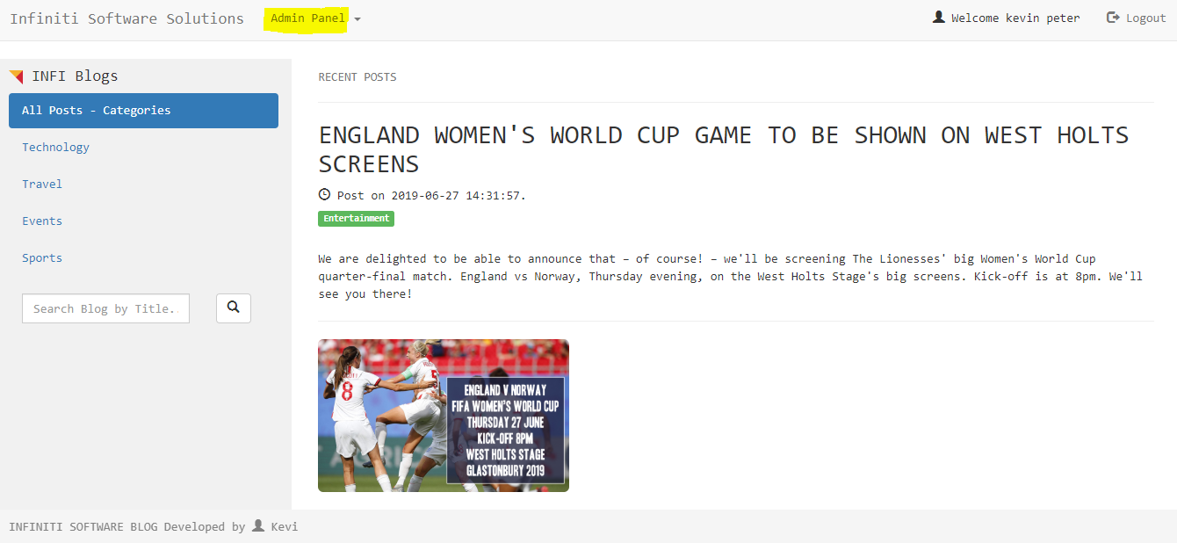

* View user comment list:

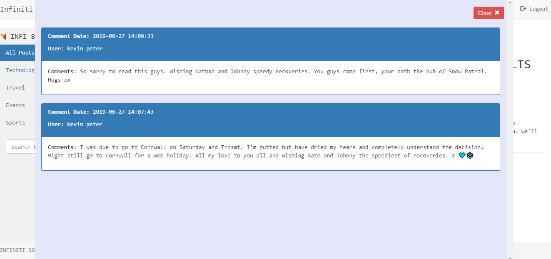

1. ADMIN PANEL

* ADMIN PANEL HAS 5 DROPDOWN OPTIONS:
* ONLY ADMIN CAN SEE THIS ADMIN PANEL
* MANAGE BLOGS
* MANAGE CATEGORIES
* MANAGE TAGS
* EDITOR’S CHOICE
* DASHBOARD

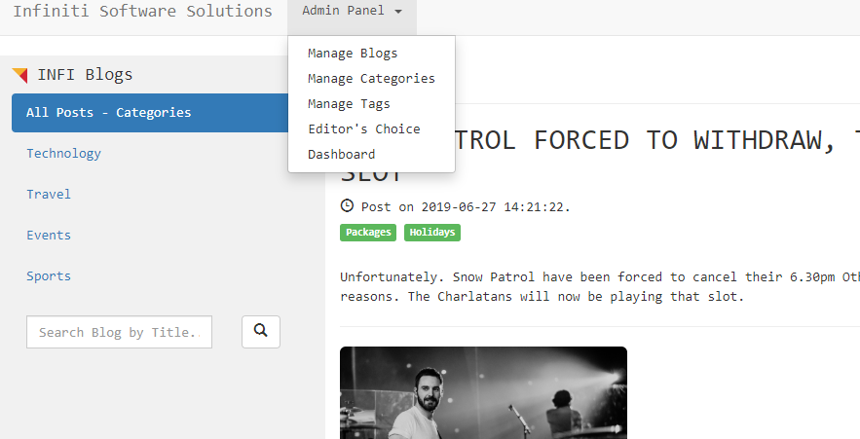

1. A. MANAGE BLOGS

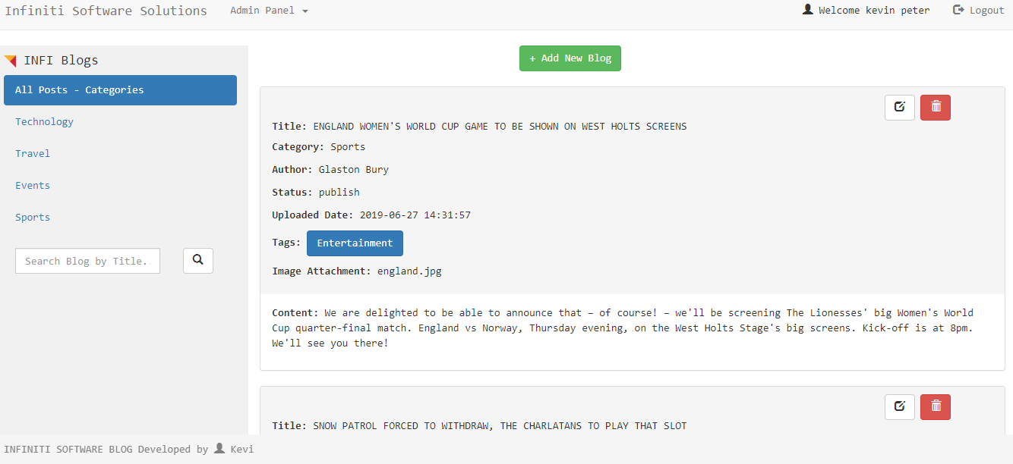

* HERE ADMIN CAN VIEW/EDIT/DELETE AND ADD BLOGS

ADD NEW BLOG SECTION:

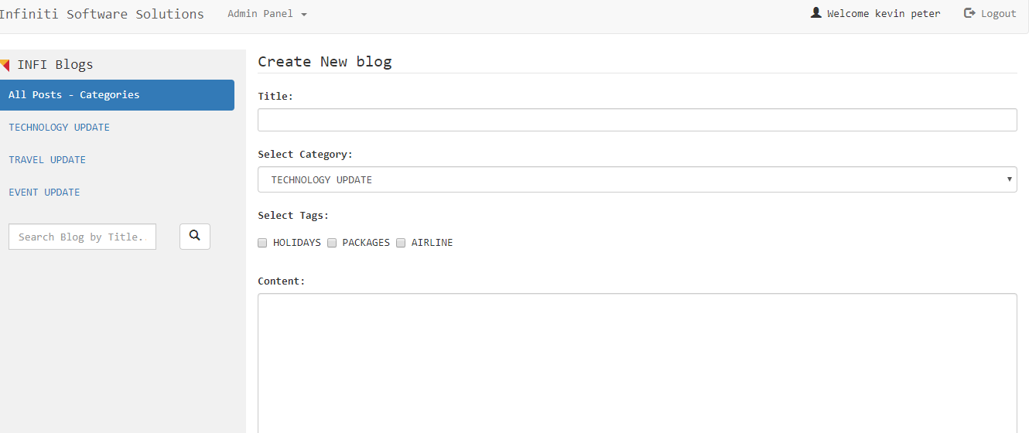 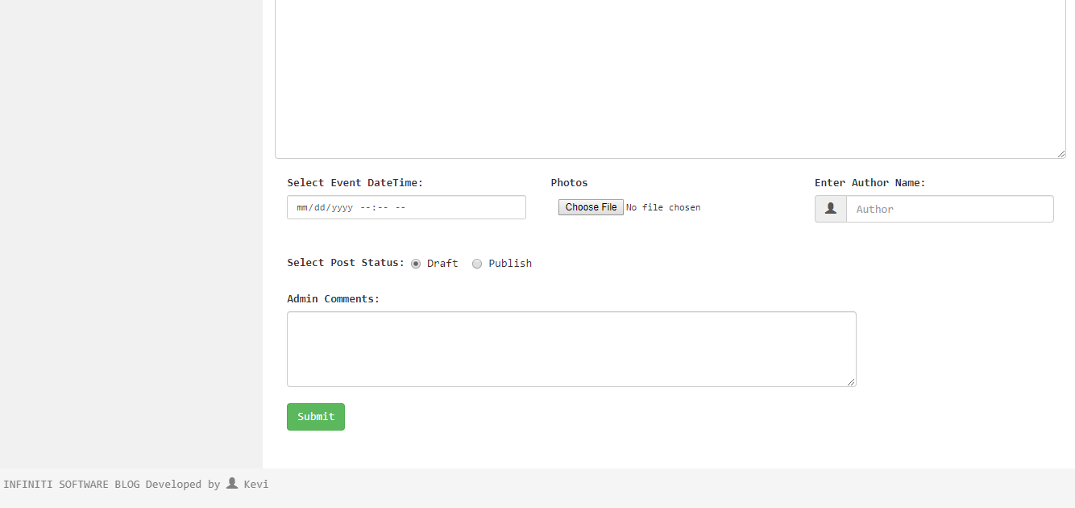

EDIT BLOG SECTION:

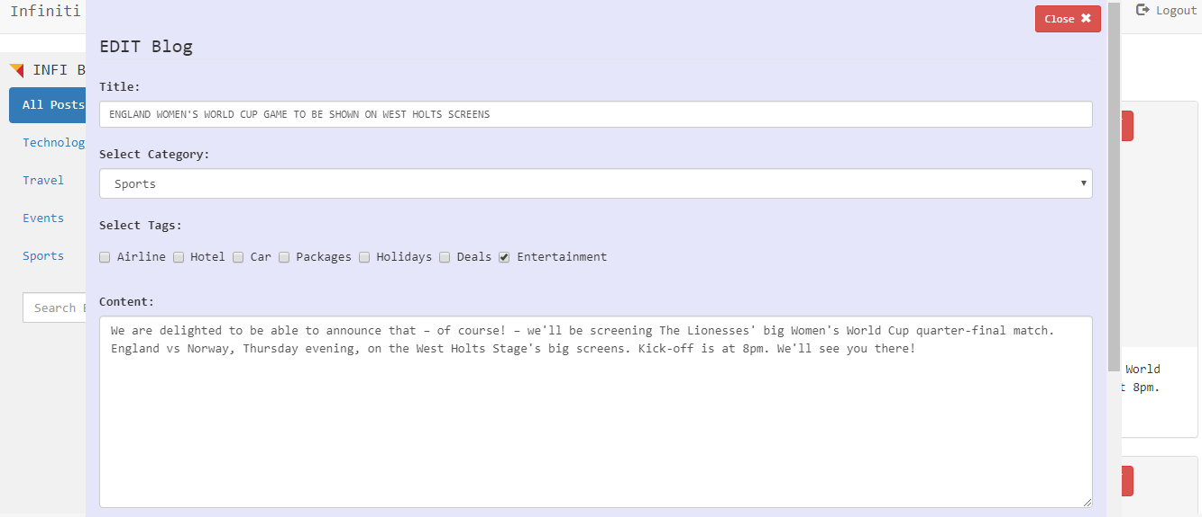 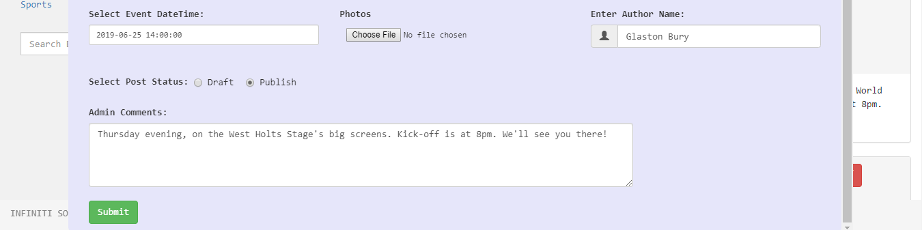

3. B MANAGE CATEGORIES

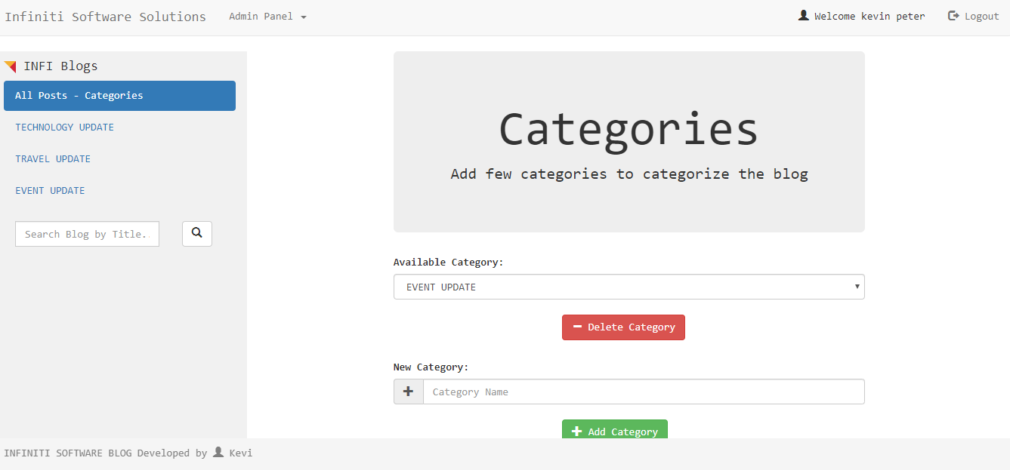

* HERE ADMIN CAN ADD THE CATEGORIES
* ADMIN CAN SEE THE CATEGOREIS AVAILABLE
* ADMIN CAN DELETE THE OLD CATEGORIES

3. C MANAGE TAGS

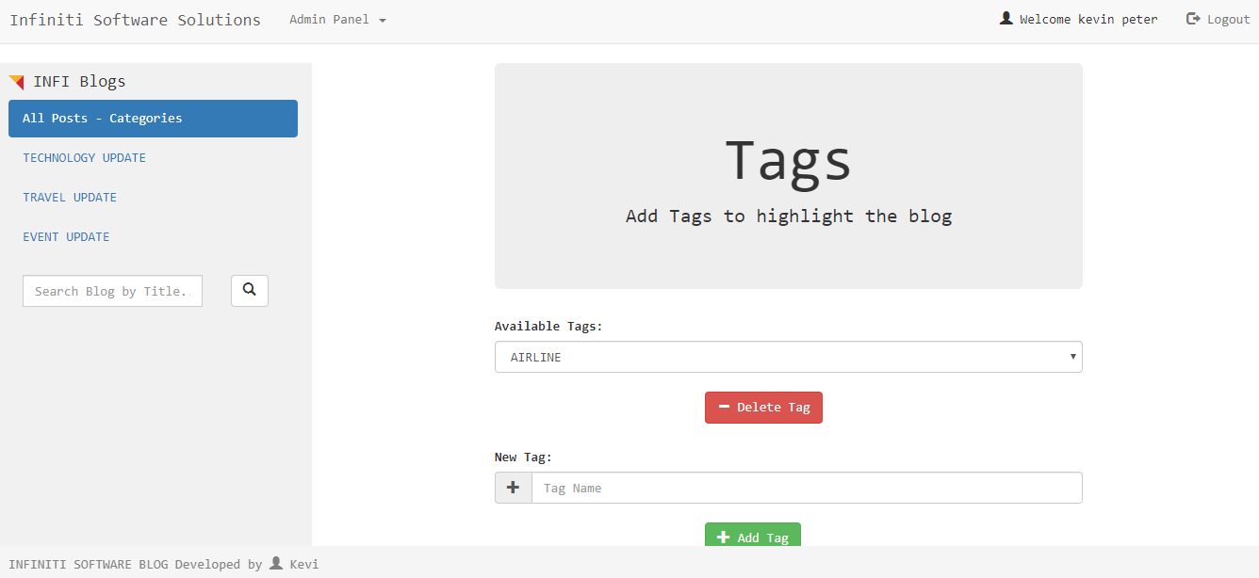

* HERE ADMIN CAN ADD TAGS
* ADMIN CAN SEE THE TAGS AVAILABLE
* ADMIN CAN DELETE THE OLD TAGS

3. D EDITOR’S CHOICE

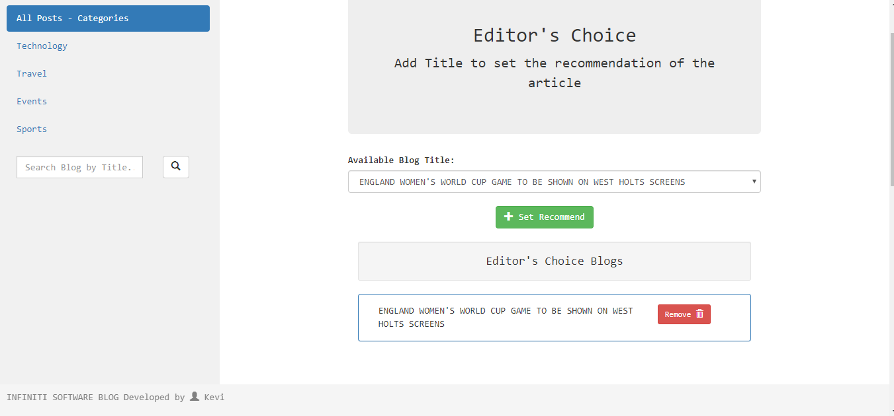

* HERE ADMIN CAN SET THE BLOG AS EDITORS CHOICE
* CAN REMOVE FROM THE EDITOR CHOICE LIST
* CAN VIEW THE LIST OF EDITOR CHOICE BLOGS

3. E DASHBOARD

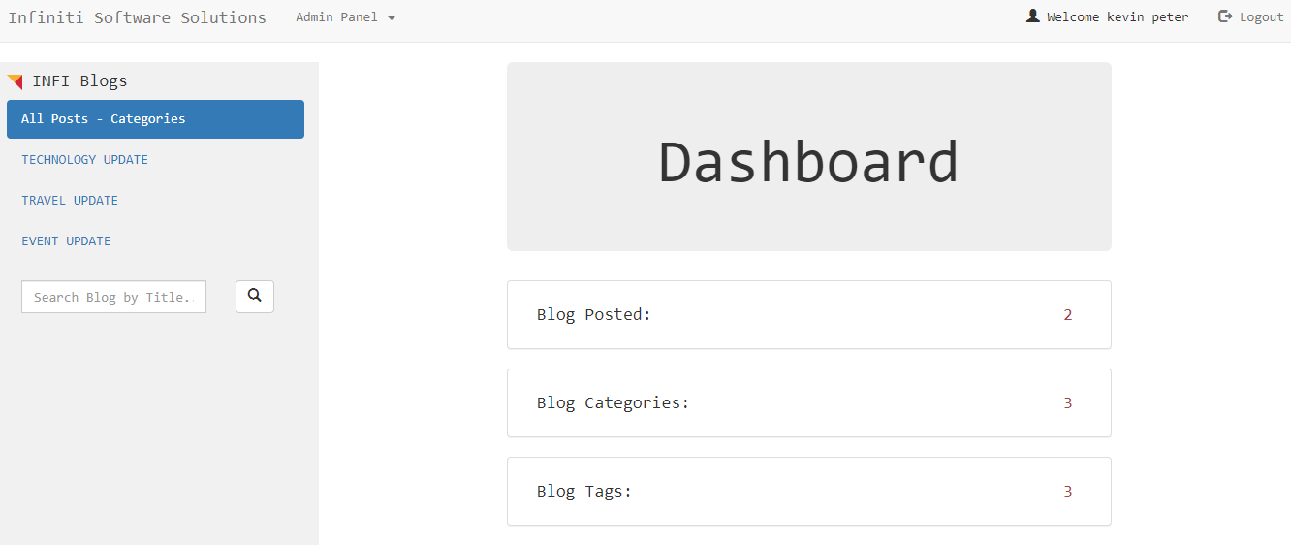

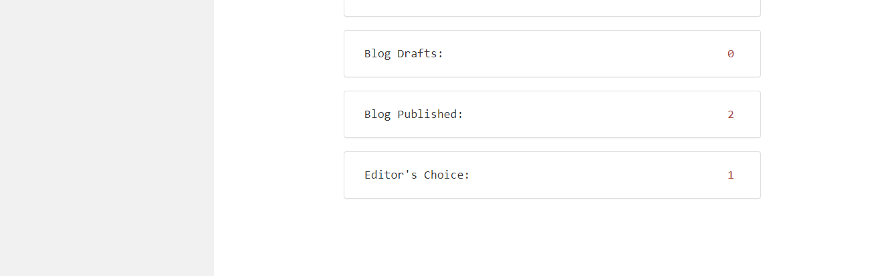

* HERE ADMIN CAN SEE THE LIST OF POST THAT HE/SHE PUBLISHED/DRAFTED
* NUMBER OF TAGS AND CATEGORIES HE/SHE HAS
* COMPLETE STATUS ADMIN CAN SEE FROM THIS DASHBOARD

1. FILTERS

* TO ACCESS THE PAGE EASY, HERE WE HAVE TWO FILTER
* CATEGORY FILTER
* SEARCH TITLE FILTER
* THIS FILTER CAN BE USED BY ALL THE USER CATEGORIES

4. A FILTER-CATEGORY

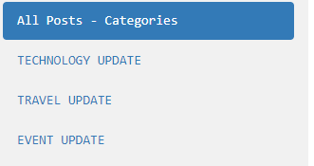

* BASED ON THE CATEGORIES WE HAVE, WE CAN SORT THE PUBLISHED ARTICLE BY CATEGORIES.

4. B FILTER-SEARCH TITLE

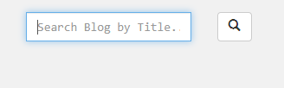

* USING THIS FILTER WE CAN SORT THE BLOG ARTICLES BY TITLE NAME.