# **Project Title** : Insights of Wildfires in the United States

**Team Members**:

1-Areej Edaibat

2-isaac

3-Justin Dooley

4-Sandra Regan

**GitHub Repo**: <https://github.com/ikevina/Project-2>

**Introduction:**

The increase in forest fires has caused an increase in insurance costs and building costs across the United States and especially in California. Due to the destructive nature of these disasters, it would be helpful to track trends. The increase in wildfires has been theorized to be linked to Global Climate Change.

* Type of Project: Dashboard Visualizations
* JS Library We Intend to Use: TBD

**Data:**

Data for this study is obtained from Kaggle.com. This database is a spectacular collection of data on wildfires in the United States from 1992 to 2015 created to support the US Fire Program Analysis. It has data on nearly 2 million wildfires over this time period

* Link: <https://www.kaggle.com/rtatman/188-million-us-wildfires>
  + FPA_FOD_20170508.sqlite
  + A SQLite database containing information on US wildfires.
* Screenshot of Meta Data:

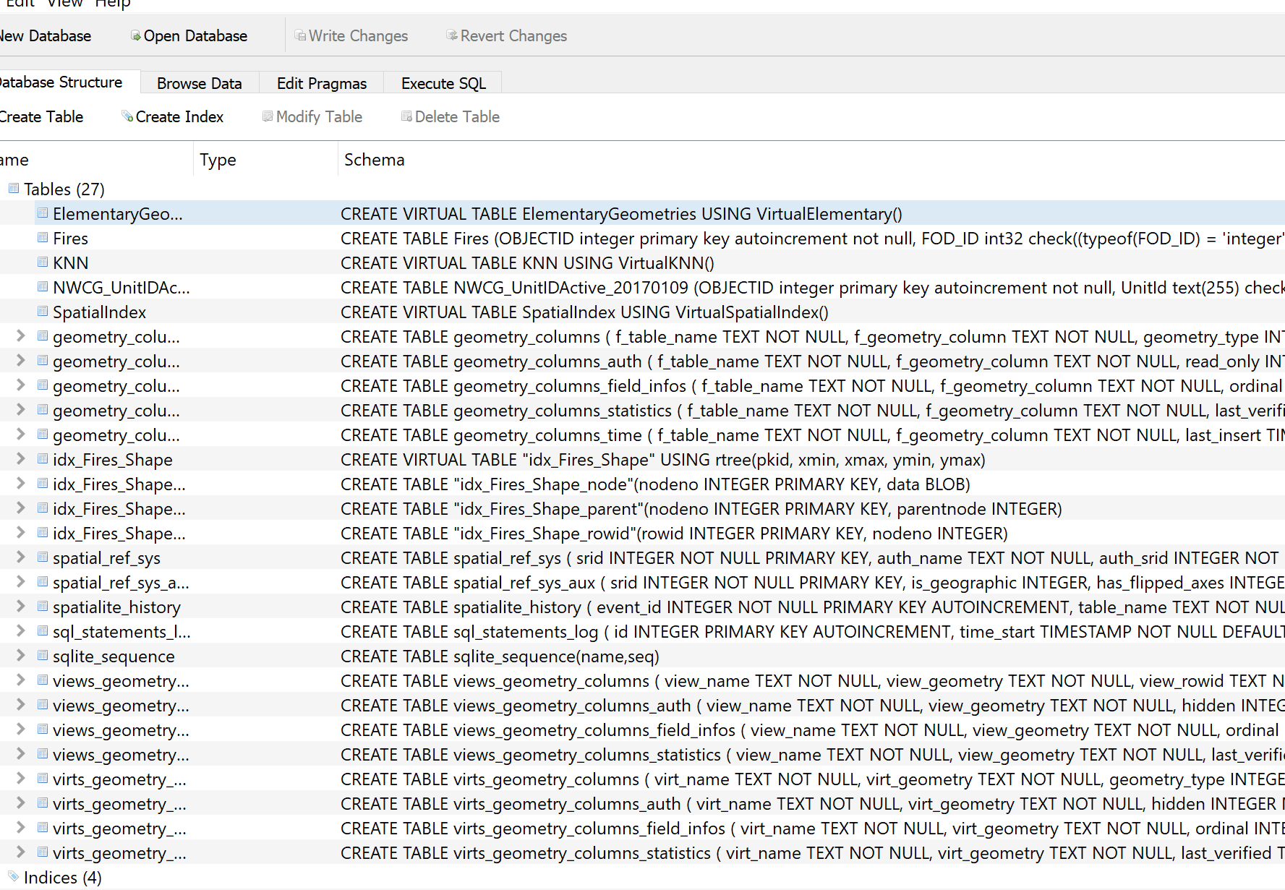

**Research Questions:**

1. Are wildfires on the rise in the United States?
2. Effects of the climate changes in the spread of the wildfires all over the Unites States.
3. Wildfires damage and the impact on the economy.

**Breakdown of Tasks** :

1-Clean up Data - Use Python to clean data

2- Data Analysis - Use Python to analyze data and produce values for visualizations

3- Prepare data to be served - Send data to a database

4- Fetch data from Database - Use Python Flask API

5- Load for Plotting and Visualizations - Send data from flask to JavaScript

6- Visualize with Plotly or D3

7- Bind visualizations form D3 to HTML with flask

4-Create an interactive Dashboard in JavaScript

**Expected Dashboard Output:**

Graph 1 Number of wildfires in each state- dropdown to select state

Graph 2 Causes of wildfires in each state

Graph 3- geo json heat map showing number of fires

Graph 4 – fires size per state

Graph 5 – Trend chart fires per years