**Virtual Machine: A VM is a completely self-contained computer that is running within a host operating system.**

**Virtualization: Used some physical resources and made some virtual machines.**

**Emulation: pretend to have hardware we don’t have the real. We need CPU that support for Virtualization**

1. **How do you image PC from the cloud? Are you experienced with Windows Autopilot?**
   * "You can image PCs from the cloud using cloud-based imaging solutions such as Microsoft Endpoint Configuration Manager in the cloud.
     + **Windows Autopilot:** Windows Autopilot is a collection of technologies that simplify the deployment and management of Windows devices. It allows you to easily set up and configure new devices, including imaging, without the need for traditional on-premises infrastructure."
2. **How do you manage Windows Updates?**
   * "Windows Updates can be managed through:
     + **Windows Update settings:** Use the Windows Update settings in Windows to configure automatic updates, schedule updates, and choose which updates to install.
     + **Group Policy:** Use Group Policy to centrally manage Windows Updates for computers within an Active Directory domain.

**Third-party update management tools:** Utilize third-party tools to automate and streamline the Windows Update process.

1. **What is the difference between virus, malware, spyware, and ransomware?**
   * + **Virus:** A malicious software program that replicates itself and spreads to other computers.
     + **Malware:** A broad term that encompasses all types of malicious software, including viruses, worms, trojans, spyware, and ransomware.
     + **Spyware:** Malware that secretly monitors user activity and collects personal information.
     + **Ransomware:** Malware that encrypts a user's files and demands a ransom payment for their release.
2. **You’ve received a trouble ticket that the monitor is not working; what is the first thing you should do?**
   * "The first thing I would do is perform basic checks:
     + **Check power connections:** Ensure the monitor is properly connected to the power source and turned on.
     + **Check video cable connections:** Ensure the video cable (e.g., VGA, DVI, HDMI) is securely connected to both the computer and the monitor.
     + **Check input source:** Make sure the monitor is set to the correct input source (e.g., VGA, HDMI).
     + **Check for loose connections:** Reseat the video cable at both ends.

**Try a different monitor:** If possible, connect the computer to a different monitor to see if the issue is with the monitor or the computer's video output

1. **What is an NTP server?**
   * "NTP (Network Time Protocol) is a protocol used to synchronize the time on computers across a network. An NTP server is a time server that provides accurate time information to other computers on the network."
2. **How do you manage BYOD Mobile devices? Are you familiar with Intune or Microsoft Endpoint Manager? How can you register an employee's personal device to company applications?**
   * "BYOD (Bring Your Own Device) management involves managing and securing employee-owned devices that are used for work purposes.
     + **Intune (now part of Microsoft Endpoint Manager)** is a cloud-based service that provides a unified platform for managing and securing corporate devices, including mobile devices.
     + **Registering personal devices:**
       - **Company Portal App:** Employees can install the Company Portal app on their devices and use it to enroll their devices for access to company resources.
       - **Device Enrollment Programs:** Intune supports various enrollment programs, such as Azure AD Join, which allows users to join their devices to Azure AD for access to company resources."

**If a user Outlook shows mailbox is full, what would you do?**

* + "If a user's Outlook mailbox is full:
    - **Identify the cause:** Determine what is consuming the mailbox space (e.g., large attachments, duplicate emails, old emails).
    - **Delete unnecessary files:** Encourage the user to delete unnecessary emails, attachments, and other files from their mailbox.
    - **Archive old emails:** Archive old emails to an archive mailbox or to local storage.
    - **Increase mailbox quota:** If necessary, request an increase in the mailbox quota from the email administrator.

1. **How do you solve OneDrive Sync issue?**
   * "To troubleshoot OneDrive Sync issues:
     + **Check network connectivity:** Ensure a stable internet connection.
     + **Restart OneDrive:** Close and restart the OneDrive application.
     + **Check for conflicts:** Resolve any file conflicts that may be preventing synchronization.
     + **Clear OneDrive cache:** Clear the OneDrive cache and allow it to resync.
     + **Check for storage space:** Ensure sufficient storage space is available on the local device.
     + **Troubleshoot antivirus/firewall:** Temporarily disable antivirus or firewall software to see if they are interfering with OneDrive.
     + **Contact OneDrive support:** If the issue persists, contact OneDrive support for further assistance.
2. **What is SharePoint, why company uses SharePoint?**
   * "SharePoint is a web-based platform for creating and sharing documents, websites, and portals.
     + **Reasons companies use SharePoint:**
       - **Document collaboration:** Enables teams to easily create, share, and collaborate on documents.
       - **Intranet portal:** Provides a central hub for company information, news, and communication.
       - **Team sites:** Allows teams to create dedicated workspaces for projects and collaboration.
       - **Document management:** Provides features for version control, document libraries, and metadata management."
3. **What is RBAC?**
   * "RBAC (Role-Based Access Control) is a security model that grants or denies access to system resources based on a user's assigned roles and responsibilities. It simplifies access control management by defining and managing user permissions based on their job functions."
4. **What is Virtualization? What virtualization technology are you familiar with?**
   * "Virtualization is the process of creating a virtual version of something, such as a server, operating system, or storage device.
     + I am familiar with virtualization technologies such as:
       - **Hyper-V:** Microsoft's virtualization platform.
       - **VMware vSphere:** A popular virtualization platform from VMware.
       - **Azure Virtual Machines:** Virtual machines hosted on the Microsoft Azure cloud platform."
5. **What kind of backup solution are you experienced with? What is incremental backup means?**
   * "I have experience with various backup solutions, including:
     + **Veeam**
     + **Symantec Backup Exec**
     + **Microsoft Azure Backup**
     + **Incremental backup:** An incremental backup backs up only the data that has changed since the last full or incremental backup. This significantly reduces backup time and storage space compared to full backups."
6. **I see you have Azure in your resume, what have you done so far in Azure?**
   * "In my experience with Azure, I have:
     + **Supported Azure Virtual Machines:** Assisted with the deployment, configuration, and troubleshooting of Azure Virtual Machines.
     + **Assisted with Azure Active Directory:** Provided basic support for Azure AD users, including password resets and account unlocks.
     + **Gained familiarity with Azure services:** Explored other Azure services such as Azure Storage, Azure SQL Database, and Azure Monitor."
7. **What is the difference between a resource mailbox and a user mailbox in Exchange?**
   * + **User Mailbox:** A mailbox assigned to an individual user for their personal email and communication needs.
     + **Resource Mailbox:** A mailbox associated with a shared resource, such as a conference room, equipment, or a shared calendar. It allows users to book and manage these resources.
8. **What is MFA? How do you fix MFA related user authentication issue?**
   * "MFA (Multi-Factor Authentication) adds an extra layer of security by requiring users to provide two or more forms of identification to access resources.
     + **Troubleshooting MFA issues:**
       - **Verify user credentials:** Ensure the user is entering their credentials correctly.
       - **Check MFA method:** Verify that the user's MFA method is configured correctly and functioning properly.
       - **Check for device issues:** Ensure the user's device is properly configured and connected to the network.

**Troubleshoot authentication app:** If the user is using an authentication app, ensure it is properly installed and configured

1. **What is SSO? How can you use SSO with Office365?**
   * "SSO (Single Sign-On) allows users to access multiple applications with a single set of credentials.
     + **SSO with Office365:**
       - **Azure Active Directory (Azure AD):** Azure AD can be used as an identity provider for Office 365, enabling users to sign in to Office 365 applications with their corporate credentials.
       - **Federation:** Organizations can federate their on-premises Active Directory with Azure AD, allowing users to use their existing credentials to access both on-premises and cloud-based applications.
2. **What is ADFS? Why does an organization need ADFS setup?**
   * "ADFS (Active Directory Federation Services) is a service that enables single sign-on (SSO) across multiple applications and devices.
     + **Reasons for using ADFS:**
       - **Enhanced security:** Provides strong authentication and authorization for access to applications.
       - **Improved user experience:** Enables users to access multiple applications with a single set of credentials.
       - **Simplified identity management:** Centralizes identity management for both on-premises and cloud-based applications.

**Outlook issue:**

If a user is experiencing Outlook connectivity issues, I start by checking if they are connected to the internet or VPN, as network issues are often the root cause. Next, I ensure Outlook is not in Offline Mode and switch it back to Online if necessary. Sometimes, simply restarting the PC resolves the problem. If the issue persists, I navigate to the OST file in the C: drive, delete it, and restart Outlook to allow it to rebuild the file, as a corrupted OST file can often cause connectivity problems. I also check if the mailbox is full and, if needed, archive older emails to free up space and restore functionality. Additionally, I verify the user’s Outlook credentials, check the email server settings (e.g., incoming/outgoing server details), and recreate the profile if required. This step-by-step approach helps me effectively troubleshoot and resolve Outlook connectivity issues

**Internet connectivity issue:**

To troubleshoot network connectivity issues, I first check if the router is properly connected with all cables securely in place. I then restart the PC, as this can sometimes resolve temporary network glitches. If the issue persists, I ask the user to open Command Prompt and type ipconfig /all to check the IP configuration. If the IP address starts with 169, which indicates an APIPA address, it suggests the device isn’t receiving an IP from the DHCP server, so I verify the DHCP settings. If the status shows Media Disconnected, I inspect the physical connections or suggest restarting the Wi-Fi, as it may be a wireless connectivity issue.

Next, I check DNS functionality by pinging the DNS server (e.g., ping google.com) and test raw IP connectivity by pinging 8.8.8.8. If I receive replies, it confirms that the network connection is active, and any remaining issue may be DNS-related. If there’s no reply, I continue troubleshooting the network path, including checking gateway settings and router status. This systematic approach helps me identify and resolve network problems efficiently.

**Printer not working:**

To troubleshoot a printer issue, I start by checking if the power cables are securely connected and if the printer is properly connected to the network, especially for network printers. I verify if there are any error messages on the printer display, ensure there’s sufficient paper, ink, or toner, and check for paper jams that could be causing the problem. Next, I confirm that the correct printer is set as the default to avoid misdirected print jobs. I also check the print queue and delete any pending or stuck print jobs that might be causing a backlog.

If the issue persists, I restart both the printer and the PC to refresh the connection. If that doesn’t resolve the problem, I restart the Print Spooler service, as it manages print jobs. If the problem continues, I navigate to C:\Windows\System32\spool\PRINTERS, delete any leftover .TMP, .SHD, or .SPL files that may be causing spooler conflicts, and restart the spooler again. As a final step, I go to Device Manager, right-click the printer driver, and update it online to ensure compatibility and stability.

**Can you tell us more details about your day-to-day task?**

Every day, I start by checking my tickets and going through the priorities based on urgency, severity, or impact. I handle tasks such as network outages, server issues, printer problems, email, or Outlook-related issues—primarily Level 1 and Level 2 tasks. I don’t go a lot deeper into Level 3 issues as I don’t have access at that level. Once I’ve reviewed the tickets, I reach out to users to confirm if it’s a good time to assist them and work with them to resolve their issues as quickly as possible. I also document my work, update ticket notes, and communicate with the team to ensure smooth operations

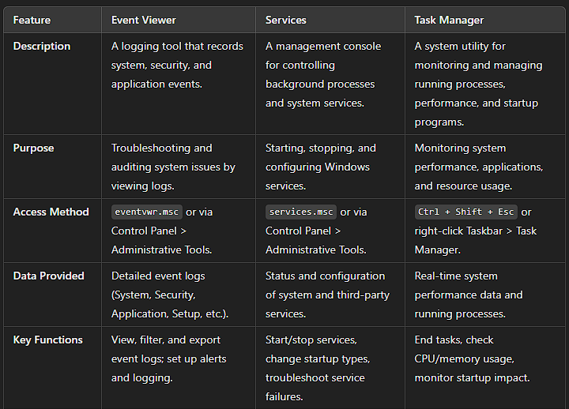

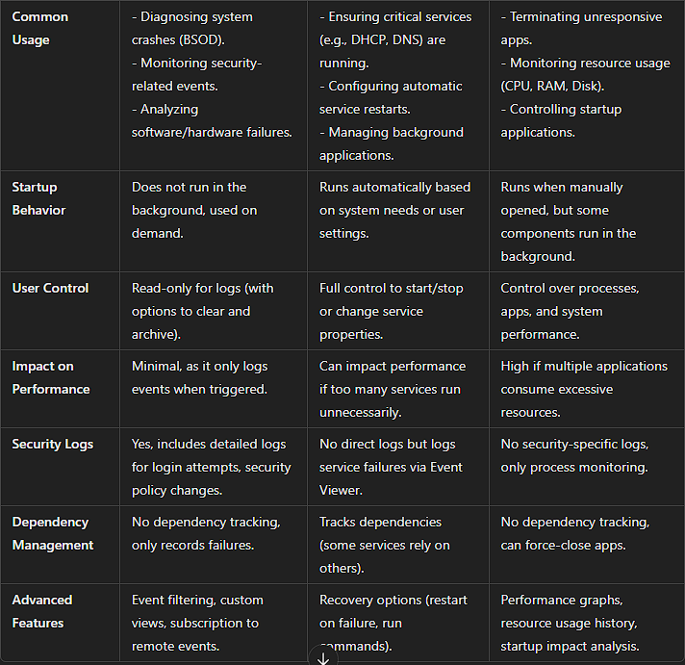

**Task manager**

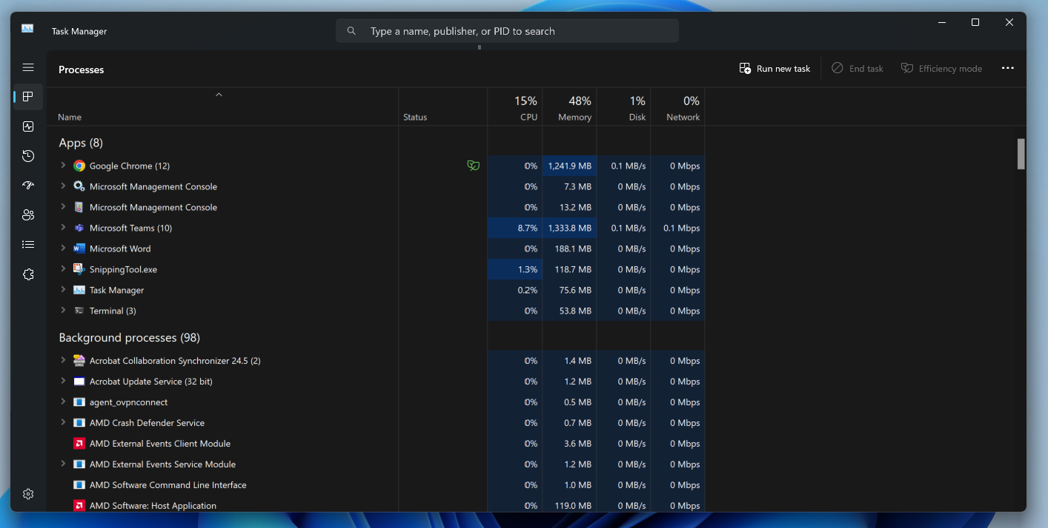

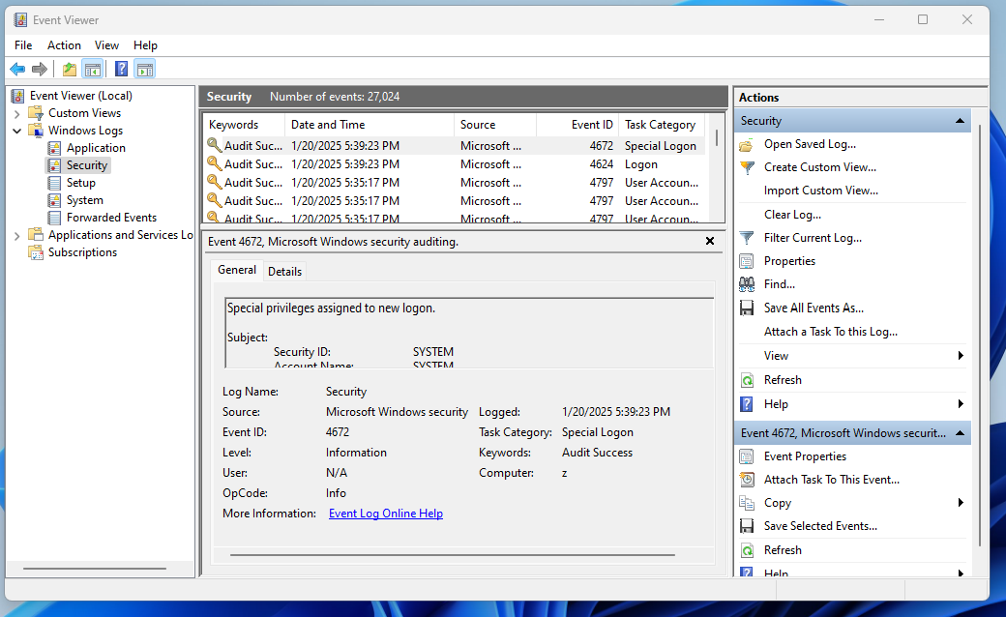**Event viewer**

**Services**

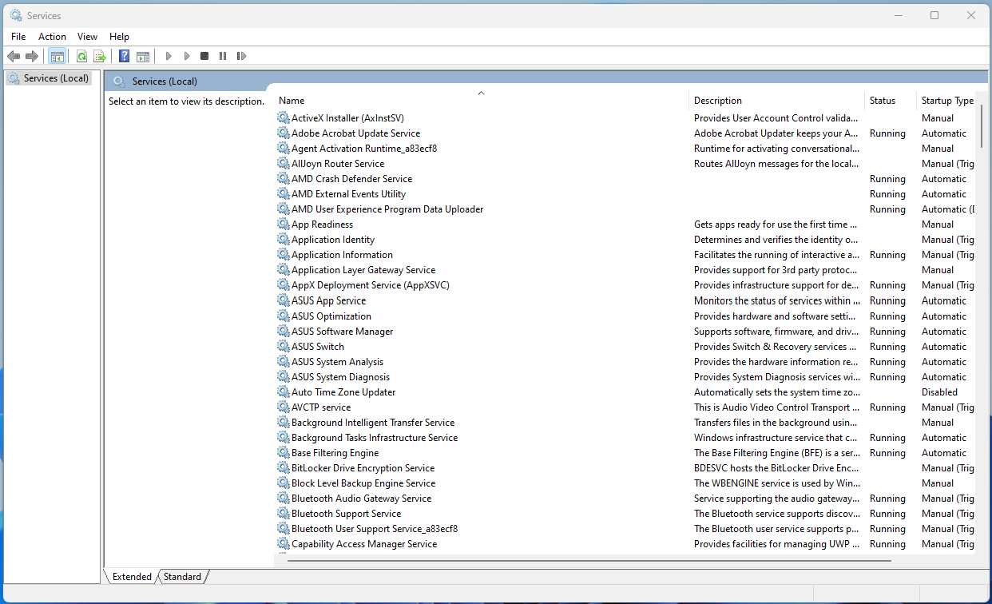

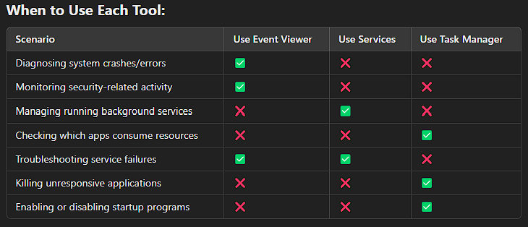

**. Why do you want to work in the IT Support field?**

**Answer:**

I want to work in IT Support because I have a deep passion for technology. I truly enjoy solving both simple and complex technical issues while helping others.

This role allows me to combine my problem-solving skills with excellent customer service, ensuring that users can work smoothly and efficiently.

Additionally, this field offers many opportunities for growth, and I’m excited to learn new technologies and find solutions that positively impact the organization.  
I’ve always enjoyed helping people resolve technical challenges. Working at an MSP taught me how vital IT is to business operations, and I love ensuring everything runs smoothly so users can focus on their work.

**2. What’s your strength?**

**Answer:**

My strengths include a combination of experience and problem-solving ability. With over four years of experience in this field, I’ve developed a strong ability to break down complex technical issues and find practical solutions. This helps me tackle challenges and contribute to my team and organization.

Another key strength is my communication skills. I’m able to explain technical concepts clearly to non-technical users. This is especially important in customer service, where clear communication is key to providing excellent support.

I am also highly adaptable, which allows me to quickly learn new technologies and processes. This helps me stay up-to-date and bring relevant skills to the organization.

Additionally, I take feedback positively, which helps me keep improving in my role.

Overall, I’m focused on delivering good results, working well with others, staying organized, and providing great customer service. These strengths help me contribute to the success of the organization in any situation.

I stay calm under pressure and communicate complex ideas in simple terms. My certifications (Network+, AZ-900, MS-900) also give me a strong technical backbone to solve varied issues quickly.

**3. What is your weakness?**

**Answer:**

**One of my weaknesses is that I sometimes take on too many tasks because I like to help others and make sure everything is done well. However, this can sometimes make me feel stressed. Additionally, I sometimes hesitate to ask for help. I have realized that this is not always the most effective approach.**

**To improve, I take time to review my workload and capacity before committing to a new task. I am also working on asking for help when needed and learning to priorities tasks more effectively. and asking for help whenever needed and learning to set up the priorities. By staying organized and using task management tools, I can better track and balance my workload. This approach has helped me manage tasks more efficiently and maintain high-quality support for end users**

I can be a perfectionist, sometimes double-checking too much. I’ve learned to balance thoroughness with efficiency so I don’t get stuck on minor details.

**4. How would you handle angry and frustrated users?**

**Answer:**

I would stay calm and professional.

First, I would listen carefully and let the user explain their concerns without interrupting, making sure they feel heard and respected.

Second, I would acknowledge their feelings with empathy by letting them know I understand their concerns and that I am here to help.

Next, I would ask clear and specific questions to fully understand the issue and then offer a practical solution.

Finally, I would keep them updated throughout the process and make sure the problem is fully resolved. My goal is to remain calm and focused on finding a solution.

I would listen calmly, empathize with their frustration, then propose clear steps to fix the issue. Frequent updates and a calm tone help de-escalate the situation.

**5. How do you prioritize your tasks?**

**Answer:**

I prioritize my tasks by identifying what is most urgent and what aligns with Service Level Agreements (SLAs). I mainly focus on tasks with approaching deadlines or those that have a significant impact on critical operations.

To stay organized, I used to-do lists or task management tools. By addressing SLA-related tasks first and breaking larger tasks into smaller steps, I ensure I meet the deadlines and maintain overall efficiency.

I consider urgency, business impact, and SLAs. High-severity tickets or those with looming deadlines get immediate attention, while routine issues queue behind.

**6. Suppose your supervisor gives you instructions you don’t agree with. What would you do?**

**Answer:**

If I disagree with my supervisor's instructions, I will handle the situation respectfully and professionally. First, I would follow their guidance to fully understand their approach while considering other possible solutions. Then, I would request a meeting to discuss my ideas and clearly explain my reasoning, using specific examples. During the conversation, I would listen to their perspective and remain open to feedback.

Ultimately, my goal is to ensure the assignment is completed effectively. Whether we follow their approach or find a better solution together, I am committed to the team's success.

I’d follow their instructions while respectfully asking for a private discussion to offer an alternative solution if I believe it’s more efficient. Ultimately, I respect the final decision.

**7. Share a time when you were unable to resolve a technical issue immediately.**

**Answer:**

There was a situation where a user could not connect to the company VPN. I tried troubleshooting the issue; however, I could not resolve it immediately because it required input from a specialized team.

I communicated with the user, explained the steps I had taken so far, and informed him that I would escalate the matter to the senior team. I also provided a clear timeline for the updates, so he knew what to expect.

~~The senior team discovered that the recent changes in the VPN configurations had affected some users' access~~.

Throughout the process, I kept the user updated and followed up regularly. By communicating the situation and steps, I was able to maintain trust and make sure the issue was resolved smoothly.

I once encountered a complex network outage requiring vendor escalation. I explained the delay to the client, offered a temporary workaround, escalated to the vendor, and provided regular status updates until resolved.

**8. Why do you want to leave your current job?**

**Answer:**

I’ve had a wonderful experience at my current company, where I have developed valuable skills and grown both personally and professionally. However, I’m now ready for a new challenge that aligns with my long-term career goals. I’m excited to take on greater responsibilities, contribute to a dynamic team, and continue expanding my skill set. I believe the environment will give me the chance to make a meaningful impact in a company that values progress, growth, and recognizes the contributions of its employees. And also my current company is about to downsize and I don’t see the room to grow.

I’m grateful for my MSP experience but want to tackle larger-scale or more complex environments for greater professional growth.

**9. How do you keep up with changing technologies, or how do you plan to learn new tech?**

**Answer:**

I believe staying updated with the latest technologies is crucial in the fast-paced tech industry. I plan to continue self-training through online courses from different platforms. I plan to set up my own lab where I can experiment with new tools and technologies. I also want to attend industry conferences and webinars to stay updated on the latest trends and best practices in IT management.

This way, I can keep improving my skills and stay updated and adapt to new technologies effectively.

I read tech blogs, attend webinars, maintain a home lab, and pursue relevant certifications—like I did with Network+, AZ-900, and MS-900—to remain current.

**10. What would you do if you didn’t know how to resolve an issue?**

**Answer:**

If I encountered an issue I could not immediately resolve, I would approach it systematically.

First, I would check our internal knowledge base or documentation to see if there is a known solution or troubleshooting guide. If that did not work, I would try to replicate the issue in a controlled lab environment. This would allow me to experiment with different approaches without impacting our live systems.

If I still could not resolve it, I would reach out to a more experienced colleague. I believe in the power of collaboration, and discussing the issue with someone who has more expertise could provide a fresh perspective.

Finally, if the issue remained unresolved, I would escalate it to the appropriate team.

My priority would always be to resolve the issue as quickly as possible and minimize disruption. With this approach, I am confident in my ability to address even the most challenging IT problems effectively.

I’d try to replicate it in a lab if possible, check documentation or knowledge bases, consult colleagues, and escalate if needed—documenting every step for clarity.

**11. What would you do if someone provides constructive feedback?**

**Answer:**

If someone provides constructive feedback, I listen carefully and thank them for their input. I see it as an opportunity to grow and improve my skills. For instance, a client once mentioned that I speak too fast during our conversations. I took that feedback positively, worked on slowing down my pace, and noticed significant improvement in how I communicate. I’m still mindful of this and continue to refine my communication skills. Feedback like this helps me deliver better results and grow both personally and professionally  
I’d thank them, ask clarifying questions, and then apply their suggestions to refine my approach. Feedback is always an opportunity to improve.

**12. What are three qualities your colleagues say about you?**

**Answer:** My colleagues consider me as:

### **Reliable**: They know I’m always available to help resolve issues and can be trusted to follow through on tasks.

### **Punctual**: I complete 95% of task within the given deadline

1. **Team-Oriented**: They value my willingness to collaborate, share insights, and support the team in achieving our goals.

### Myself consideration: Team oriented, highly adaptable, and good communicator

### Good Communicator:

"There was a time when an employee was having trouble with their email setup in Outlook, and they were frustrated because they couldn't access important documents. I took the time to carefully listen to their concerns, asked questions to understand the root of the problem, and walked them through the steps to resolve the issue. I made sure to explain each step clearly and checked in with them after each part to ensure they understood what we were doing. Once the issue was resolved, I followed up with a brief summary email outlining what had been done and providing instructions in case they encountered similar issues in the future."

### Problem-Solver:

"A user reported that they couldn’t access shared files on the network drive, which was impacting their work. I started by gathering details and checking if others were having the same issue. After confirming the network connection was fine, I checked the file permissions and discovered their access had been removed after a system update. I quickly updated their permissions, and they regained access to the files. To prevent this from happening again, I set up a monitoring system for permission changes and made sure the user knew who to contact in the future."

**Adaptable:**

"I'm a quick learner and adaptable to new technologies. For example, in my current role at the MSP, I’m actively helping clients transition from an on-premises environment to Microsoft 365. I quickly adapted to the new cloud-based services, leveraging Microsoft 365 Learning Paths to familiarize myself with the platform and its features. This proactive approach allowed me to effectively support my team and clients during the transition, ensuring a smooth migration while becoming proficient in troubleshooting and resolving any issues that arise within the new cloud environment."

They often mention my reliability, ability to explain things clearly, and willingness to help. MSP work requires solid teamwork and trust.

**13. Describe a time when you went above and beyond to help a customer.**

Recently, near the end of my working hours, I received a call from an executive at one of our client companies. He mentioned that his computer had been frequently crashing and becoming increasingly unstable. I guided him through basic troubleshooting steps over the phone, like checking the power cables and monitor connections, closing unnecessary apps, and restarting the PC, but nothing seemed to work. The executive was frustrated because he had an important meeting the next day. Understanding the urgency, I offered to visit his office, which was about 25-30 miles away. Upon arrival, I suspected a potential RAM issue. After confirming that he had spare RAM available, I replaced the existing RAM. To my relief, the computer stopped crashing and returned to stable operation. The executive was extremely relieved and grateful for your prompt support.

**Answer:**  
A client’s server crashed late at night. I stayed beyond normal hours, restored backups, verified data, and had them ready by the next business day.

**14. What was your most challenging task in your current job?**

**Answer:**

One of the most challenging tasks I faced was adding multiple users to Active Directory. Typing the information manually was time-consuming and prone to errors. To address this, I decided to use PowerShell scripts, although I wasn’t very skilled in PowerShell at the time. However, with the help of my senior colleagues and some automation tools like ChatGPT, Copilot, and Cursor, I was able to create a script that efficiently added multiple users to Active Directory. This experience taught me the importance of automation and scripting, and I’m eager to continue learning and gaining hands-on experience in this area.

Migrating a client’s entire on-prem environment to a hybrid Azure setup without interrupting daily operations required intense planning, after-hours work, and thorough testing.

**15. ~~How do you handle constructive criticism?~~**

**~~Answer:~~** ~~I see it as a valuable chance to grow. I make sure I understand the feedback, then adjust my approach accordingly.~~

**16. Tell me about a time you worked through a challenging situation.**

**Answer:**

Our MSP onboarded a new client, a law firm, with outdated systems, including unsupported servers and a slow, unreliable network. I conducted a comprehensive audit, identified critical risks, and proposed a phased upgrade plan to modernize their hardware, software, and migrate their operations to Microsoft 365 apps for better performance and collaboration. Throughout the process, I ensured clear communication, scheduled upgrades during off-hours to minimize disruption, and proactively addressed issues. Within two months, the firm experienced significantly improved system performance, enhanced operational efficiency, and strengthened security, with a modern IT environment designed to meet their business and compliance needs.

Our MSP had a critical firewall failure across multiple sites. I coordinated with different vendors, documented each step, and kept stakeholders informed until we had everything stable again.

**17. Give an example of how you’ve improved processes at work.**

**Answer:**

**Developed PowerShell script for fully automated system.**

I implemented automated CPU-usage alerts for our clients’ servers, enabling us to address performance issues proactively before they impacted end users

Also mentioned that I implemented the SSA so that password rests troubleshooting was reduce significantly

I implemented automated CPU-usage alerts for our clients’ servers, letting us address performance issues proactively before they affected end users.

**18. Describe a time you made a mistake at work.**

**Answer:**

# I once forgot to schedule a backup before making configuration changes to a server. While the changes were minor and no data was lost, I realized the importance of ensuring backups are always performed before any changes. I quickly ran a manual backup and set up automated reminders to prevent this from happening again. This experience taught me the value of automating critical tasks to ensure data protection.

In this case, I was configuring new network settings on the server to optimize its connection to remote clients. I updated the DNS settings and adjusted the firewall rules to allow specific inbound and outbound traffic. While making these changes, I forgot to schedule the backup, which would have ensured data protection in case of any issues during the configuration. Although no data was lost, I immediately ran a manual backup afterward and set up automated reminders to ensure backups were always performed before making such changes  
I once deployed a Group Policy update too quickly, causing printer mapping issues. I immediately rolled back, tested thoroughly, and redeployed correctly. I also documented it as a lesson learned.

**19. Tell me about a time you had to adapt to a significant change at work.**

**Answer:**  
We switched ticketing systems at the MSP. I volunteered to learn it first, created a quick-reference guide, and trained colleagues, ensuring a smooth transition.

**20. Why did you leave your previous job?**

**Answer:**  
The contract ended (or) I sought a new environment with more complex challenges and growth opportunities.

**21. What would you do if you were given a task you’ve never done before?**

**Answer:**  
I’d research best practices, possibly set up a test environment, and consult with senior team members if necessary. Then I’d implement carefully in production.

**22. How do you handle working in a fast-paced environment?**

**Answer:**

**Working in an MSP has helped me handle the fast-paced environment. The best approach is to stay organized and prioritize tasks effectively. I remain calm under pressure, ensuring clear communication with my team and clients. I also break down complex technical issues into smaller steps to find solutions. These strategies help me thrive in a fast-paced environment**   
My MSP experience taught me to juggle high-priority tickets efficiently. I rely on good documentation, clear priorities, and strong communication to stay on top of tasks.

**23. Why should we hire you?**

**Try to answer using your strengths answer with slide modification**

**Answer:**  
I bring diverse MSP experience, proven certifications, and a user-focused approach that emphasizes quick, thorough solutions and clear communication.

**24. Where do you see yourself in the next 3 to 5 years? How do you plan to be there?**

**Answer:**

In the next 3 to 5 years, I see myself advancing into a senior role with more responsibility, such as a System Administrator or Systems Engineer.

I’m passionate about growing my technical skills and taking on greater responsibility in managing IT infrastructure and systems.

To reach this goal, I plan to continue self-training and earn certifications in this field.

I also plan to set up my own lab where I can simulate real-world network setups and test new technologies. This hands-on experience will help me enhance my knowledge and apply it in real-world situations. Additionally, I’m eager to attend industry conferences and webinars to stay updated on the latest trends and best practices in IT management.

I’d like to move into a System Administrator or Cloud Engineer role. My plan includes pursuing advanced Azure certifications, building on my Azure-900, and taking on complex migration or infrastructure projects.

**25. What do you think will be the challenge for you in this role?**

**Answer:**

**Adapting to new internal processes and systems is always a challenge for me, however , my MSP background helps me to adapt quicky.**   
Adapting to new internal processes and systems is always a challenge initially, but I’m confident my MSP background helps me learn environments quickly.

**26. Why do you want to work for this company?**

**Answer:**

**My skills and experience in network troubleshooting, system configuration and end-user support perfectly align with the requirements of this role. Also, I want to take on new challenges that will help me to grow professionally. In addition,** I admire the company’s innovation and commitment to employee development.

Your environment aligns with my desire to keep learning and contributing to advanced projects.

**27. Do you have any questions for me?**

**Answer:**

a. Could you elaborate on day-to-day responsibilities for this role?

b. What are the key challenges someone in this position might face?

c. How is success measured for someone in this role?

d. What type of clients or industries does the company primarily server?

e. Are there any opportunities for training or certification to further develop skills in this role?

f. What are the next steps in the hiring process?

g. Is there anything else I can provide you with to further strengthen my application?  
*(Typical question back to the interviewer—ask about the team structure, growth opportunities, or upcoming projects.)*

**28. Can you tell me about yourself?**

**Answer:**

**From here go on**   
I’m an IT Support Specialist at an MSP, handling around five key clients. I hold Network+, AZ-900, and MS-900 certifications, and I enjoy tackling a wide range of technical challenges daily.

**29. What is the largest project you have done so far, and what was it?**

**Answer:**  
Migrating a 200-user client’s on-prem Exchange to a hybrid Azure/Office 365 setup. It required careful planning, minimal downtime, and thorough user communication.

**30. How do you plan to reach your next career goal?**

**Answer:**  
By focusing on hands-on cloud projects, expanding my Azure skills, maintaining a home lab, and pursuing advanced certifications like the Azure Administrator Associate.

**31. Describe a situation where you had to agree to another viewpoint even though you believed you were right.**

**Answer:**  
A teammate proposed a solution to fix recurring network drops. Though I initially disagreed, I saw the merit in their approach and supported it. We solved the issue faster than if we had stuck to my original plan.

**32. Describe a situation where you were asked to do something technical, evyou’d never attempted before.**

**Answer:**  
I needed to configure Azure Conditional Access for the first time. I studied Microsoft documentation, tested in a lab, and successfully deployed it for the client environment.

**33. If we called two of your past employers, how would they describe your attendance, punctuality, organization, and ability to work on a team?**

**Answer:**  
They’d say I’m dependable, always on time, very organized with tickets, and a team player who communicates clearly.

**34. Give an example of how you set priorities and made the best use of your time.**

**Answer:**  
When multiple tickets come in, I rank them by severity. For instance, a server-down scenario takes precedence over minor software queries. I then handle lower-priority items once critical ones are under control.

**35. Describe three ways you ensure proper customer service over the phone.**

**Answer:**

1. I actively listen and restate their issue in my own words.
2. I use plain language, not jargon.
3. I confirm resolution and follow up to ensure everything is working.

**36. Describe a time when customer feedback led you to change how you work.**

**Answer:**  
A user felt I was rushing on calls. Now, I slow down, verify each step with the user, and confirm their comfort level before moving on. It improved customer satisfaction.

**37. Give a specific example of a customer request that couldn’t be accommodated.**

**Answer:**  
A user wanted full admin privileges on all domain machines. It violated company policies, so I explained the security risks and provided limited privileges that still met their primary needs.

**38. Can you tell me why you are looking for a job right now?**

**Answer:**  
I’m ready to take on more advanced projects and continue growing in cloud technologies, which my current role isn’t offering at the scale I’d like.

**39. Are you willing to travel?**

**Answer:**  
Yes, I already do some onsite visits for our MSP clients, and I’m open to more travel with mileage reimbursement.

**40. What were you doing prior to your current IT career?**

Back in my home country, I worked as a computer lab technician in a lab dedicated to high school students. My role involved ensuring the smooth operation of the computers, replacing hardware when necessary, updating software, and configuring educational and programming apps to support the students' learning. When I moved to the United States, I decided to pursue a career in the IT field, building on my experience in managing and maintaining computer systems

**Answer:**  
I ran a small IT support business in Nepal, handling hardware fixes and basic networking. This experience motivated me to pursue formal MSP roles in the U.S.

**41. How many tickets did you typically solve in a day?**

**Answer:**  
Usually around 12–15, though it varies depending on the complexity. Some are quick fixes; others may take several hours.

**42. How do you manage your work time?**

**Answer:**  
I track tasks in our ticketing system, prioritize by severity, and allocate blocks of time for larger projects while remaining responsive to urgent tickets.

**43. Why is technical skill required for a help desk technician?**

**Answer:**  
So we can diagnose and fix issues effectively without guesswork, minimizing downtime and improving user confidence.

**44. For you, dowhaes quality or quantity matter more?**

**Answer:**  
Quality is paramount; I’d rather fix the root cause thoroughly than rush, only to see the issue repeat.

**45. Is customer service or technical knowledge more important?**

**Answer:**  
They’re equally important. Even a brilliant technical fix fails if the user doesn’t feel supported or understand what was done.

**46. When can you start (or can you start next week)?**

**Answer:**  
I’d need to give two weeks’ notice to my current employer, but I’m open to discussion if a quicker transition is needed.

**47. What is your pay in your current company?**

**Answer:**  
I’m in the mid-$20s hourly range, though I focus more on growth and the overall opportunity.

**48. I have a job but it’s only $23 per hour. What do you think?**

**Answer:**  
I’d consider the overall package—benefits, growth potential, work environment—before deciding, as pay is just one factor.

**49. Why did you leave your last job?**

**Answer:**  
Either the contract ended or I needed a role offering more advanced challenges. (Adjust to match your situation.)

**50. What is your role at your current company?**

**Answer:**  
I’m an IT Support Specialist responsible for resolving tickets, troubleshooting hardware/software, handling Office 365 admin tasks, and assisting with network issues.

**51. Are you looking for full-time or part-time?**

**Answer:**  
Ideally full-time, but if a part-time or contract position offers strong potential for advancement, I’d be open to it.

**TECHNICAL Q&A**

*(Total: 104 items, numbered 1–104 in ascending order)*

**1.Q:** *What is your troubleshooting process?*  
**A:** My troubleshooting process is methodical and user focused. For example, when a client reported a slow PC, I started by asking questions like, ‘When did the slowness start?’ and ‘Are specific applications lagging?’ I confirmed it was an isolated workstation issue by checking our RMM dashboard. I then formed theories, such as high CPU usage, insufficient RAM, or malware. Using Task Manager, I found a background process consuming 90% of CPU resources. I resolved the issue by terminating the process, updating the app, and disabling unnecessary startup programs. I verified the fix by having the user test the PC’s performance and monitored it remotely to ensure the issue didn’t return. Finally, I documented the steps in our ticketing system and created a knowledge base article for Tier 1 to handle similar cases.This approach not only resolved the issue quickly but also reduced resolution time by 40%, improving the client’s productivity

I gather details (logs, user reports), form a hypothesis, systematically test, apply a fix, verify with the user, and document the resolution.  
1. **Identify the Problem** (INTENTIFY)

2. **Define the Scope**

3. **Establish a Theory of Probable Cause** (CREATE THEORY)

4. **Test the Theory**

5. **Create and Implement a Solution** (CREATE & IMPLEMENT)

6. **Verify the Solution** (VRIFY)

7. **Document Findings and Prevent Future Issues** (DOCUMENT)

8. **Escalate if Necessary** (ESCALATE)

**2.Q:** *What is Blue Screen of Death (BSOD)?*  
**A:** The Blue Screen of Death (BSOD) is a critical Windows error screen that appears when the system encounters a critical failure, often due to hardware issues (like faulty RAM), driver conflicts, or corrupted system files. It forces a shutdown to prevent further damage and displays an error code (e.g., IRQL_NOT_LESS_OR_EQUAL) for diagnosis. Troubleshooting typically involves checking recent changes, updating drivers, running diagnostics (e.g., chkdsk), or restoring the system.

A critical Windows stop error caused by hardware or driver failures. It forces a system halt to prevent damage, often providing an error code for diagnostics.

**3.Q:** *What is Safe Mode in Windows, how do you get to it, and what is it used for?*  
**A:** Safe Mode in Windows is a diagnostic startup mode that loads only essential drivers and services to troubleshoot system issues. To access it, restart the computer and press F8 (or Shift + F8 for newer versions) during boot, or use the recovery options in Settings. It’s used for diagnosing problems like driver conflicts, malware infections, or software errors by allowing you to isolate issues without unnecessary processes running

* Restart your computer and press **F8** (or **Shift + F8**) before Windows starts.
* Alternatively, go to **Settings > Update & Security > Recovery > Advanced startup > Restart now** and select **Troubleshoot > Advanced options > Startup Settings > Restart**.
* Safe Mode boots Windows with minimal drivers. On Windows 10/11, access it via Shift + Restart → Troubleshoot → Advanced Options → Startup Settings. It’s for isolating software/driver conflicts.

**4.Q:** *How do you upgrade Windows OS version (e.g., from 10 to 11)?*  
**A: To upgrade Windows OS from version 10 to 11:**

**1. Check Compatibility: Ensure your device meets the system requirements for Windows 11.**

**2. Backup Data: Backup your important files to avoid data loss.**

**3. Download the Upgrade: Go to the Microsoft website and download the Windows 11 Installation Assistant.**

**4. Run the Installer: Open the Installation Assistant and follow the on-screen instructions to complete the upgrade.**

Check hardware compatibility, back up data, then use Windows Update or official installation media. I often test on a single machine before organization-wide deployment.

**5.Q:** *What is PC imaging? How do you boot from the network to install PC imaging?*

**A:** PC Imaging is the process of creating a standardized image of a computer's operating system, applications, and settings, and then deploying that image to multiple computers. This ensures consistency and saves time when setting up new machines or restoring systems.

How to Boot from the Network to Install PC Imaging

1. Prepare the Network Boot Environment:
   * Set up a server with network boot services (e.g., Windows Deployment Services or a PXE server).
   * Ensure the image file is available on the server.
2. Configure the Client Computer:
   * Access the BIOS/UEFI settings on the client computer.
   * Enable network boot (PXE boot) and set it as the first boot option.
3. Boot from the Network:
   * Restart the client computer.
   * It will attempt to boot from the network and connect to the server.
   * Follow the on-screen instructions to select and deploy the desired image.

This process allows you to efficiently install or restore the operating system and applications on multiple computers over the network.

Imaging involves deploying a standardized OS image. Network-boot (PXE) is enabled in BIOS/UEFI; the device connects to a WDS or MDT (microsoft deployment toolkit) server to pull down the image.

**6.Q:** *You receive a trouble ticket that states: “My printer is not working properly. It prints out weird pattern on paper. Please assist.” How do you fix it?*  
**A:** Check if the correct driver is installed, verify toner/ink isn’t faulty, try cleaning/firmware update. If the test page or different PC produces the same error, it might be hardware/firmware related.

**7.**

**Q:** *You’ve received a trouble ticket that monitor is not working; what is the first thing you should do?*  
**A:** Verify the physical connections (power, video cable). Then test the monitor on another PC or use another monitor on this PC to isolate if it’s the monitor or the video card/system.

**8.**

**Q:** *If you have a fresh new PC and need to join it to the domain, what do you do?*  
**A:** First ensure network connectivity and verify that the DNS settings are correctly pointing to the domain controller. Then, go to System Properties by right-clicking on "This PC" and selecting Properties or using sysdm.cpl in the Run dialog. Navigate to the Computer Name( to make it unique in the domain) tab, click Change, select Domain, enter the domain name, and provide domain administrator credentials when prompted. Finally, restart the PC to complete the process and apply the changes.

**9.**

**Q:** *How do you upgrade Outlook version to new version?*  
**A:** If using Microsoft 365, it updates automatically. For standalone versions, install the new version via Office installer or Windows Update. Confirm add-in compatibility beforehand.

**10.Q:** *How do you manage Windows Updates?*  
**A:** Via WSUS or an RMM (Remote Monitoring and Management) platform. We stage updates, test critical patches on pilot machines, then approve them for all to reduce disruption.

**11.Q:** *If someone says his/her sound is not working on PC, what would you do?*  
**A:** Check volume settings, ensure the correct playback device, verify drivers are up to date, and confirm no physical cable issues.

**12.Q:** *What is a docking station? Why is it important?*  
**A:** A docking station allows a laptop to connect quickly to multiple peripherals (monitors, keyboard, mouse, Ethernet). It’s crucial for productivity, turning a laptop into a full desktop setup.

**13.Q:** *User has 2 monitors, but both show the same content. How do you change settings, so each monitor is separate?*  
**A:** In Display Settings, select “Extend these displays” instead of “Duplicate.” Adjust resolution or arrangement if needed.

**14.Q:** *What do you understand by Cache memory? What is the advantage of a processor having more cache memory?*  
**A:** Cache is high-speed CPU memory storing frequently used data. More cache reduces latency and improves overall performance.

**15.Q:** *What do you do if you identify a user’s PC is infected with Ransomware?*  
**A:** Isolate it from the network immediately, notify security teams, then follow incident response protocols—often restoring from a secure backup.

**16.Q:** *If a user’s PC hard drive is full and you can’t delete files, what do you do?*  
**A:** Move large files to OneDrive or a shared network drive or upgrade the disk if absolutely necessary.

**17.Q:** *As soon as you power on the computer, you hear a beep. What does that beep mean?*  
**A:** A POST code (Power-On Self-Test code) is a diagnostic code output by a computer's BIOS or UEFI firmware during the initial boot process. When a computer is powered on, it performs a series of hardware checks to ensure that all essential components (such as RAM, CPU, GPU, and storage) are functioning correctly. These tests are collectively known as the Power-On Self-Test (POST).  
It’s the POST (Power-On Self-Test code) beep code. A single short beep often signals everything is OK. Multiple or patterned beeps indicate specific hardware errors (e.g., RAM issue).

**18.Q:** *What are repeated problems faced by the customer or your users?*  
**A:** Commonly slow PCs, Outlook sync issues, password resets, connectivity/slow internet problems, and printer errors.

**19.Q:** *What is OST file?*  
**A:** OST (Offline Storage Table) is a local copy of Exchange data for Outlook, allowing offline access and syncing changes when reconnected.

**20. Q:** *What is a .PST file?*  
**A:** PST (Personal Storage Table) is an Outlook data file used for local storage of email, contacts, and calendar items, separate from an Exchange server. PST files are commonly used to back up or archive Outlook data and can be transferred from one user to another by copying the file to a different computer and importing it into Outlook through the File > Open & Export > Import/Export option. This allows users to access their emails and other Outlook data on a new system.

**21.Q:** *How will you know if an OST file is corrupted? What happens if you delete OST file?*  
**A:** Outlook may show sync errors or crash frequently. Deleting the OST file forces Outlook to recreate it from the server upon next launch, usually resolving corruption unless the server data is also corrupted**22.Q:** *Where is it (OST file) located? What would you do if an employee leaves the company or terminates?*  
**A:** Typically at C:\Users\<Username>\AppData\Local\Microsoft\Outlook. When employees leave, we usually archive/export their mailbox and disable their account.

**23.Q:** *If someone says their PC is running slow, what would you do?*  
**A:** Check Task Manager for CPU/memory usage, run malware scans, clear temp files, and ensure OS/drivers are updated. Also consider hardware upgrades if needed.

**24.Q:** *What is VDI?*  
**A:** Virtual Desktop Infrastructure, where desktops are hosted on centralized servers and delivered to end-users over a network.

**25.Q:** *What is Cloud PC?*  
**A:** A Windows desktop hosted in the cloud (e.g., Windows 365/Azure Virtual Desktop), allowing remote access to a persistent virtual environment from anywhere.

**26.Q:** *How do you image PC from cloud? Are you experienced with Windows autopilot?*  
**A:** Windows Autopilot allows devices to pull their configuration/image from the cloud on first boot. I’ve tested it for streamlined provisioning and management.

**27.Q:** *What would you do if a PC CPU is 100% used all the time?*  
**A:** Open Task Manager to identify resource-heavy processes, update or remove the offending software, and check for malware or hardware issues.

**28.Q:** *What would you do if the user says his/her files are missing?*  
**A:** Check Recycle Bin, OneDrive backups, or server backups. If needed, use file-recovery tools if the data isn’t retrievable from backups.

**29.Q:** *How do you test SMTP port whether it’s working or not?*  
**A:** Often using telnet or PuTTY to connect to port 25 (or relevant SMTP port). If I get a successful handshake, the port is open.

Open cmd prompt

* Nslookup
* server outside of my network 8.8.8.8
* set Q=mx domain.com (this will output the mx record for the exchange server)
* set q=a (mx record) the output from the previous command (this will provide the exchange server ip address)
* take this ip addres and open telnet

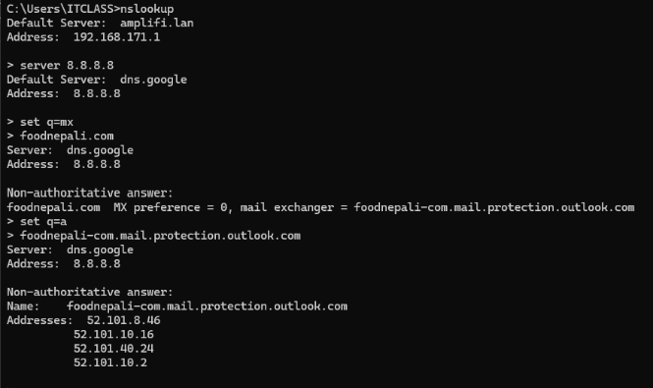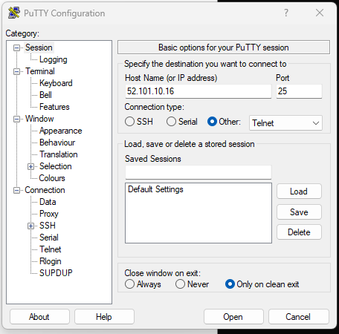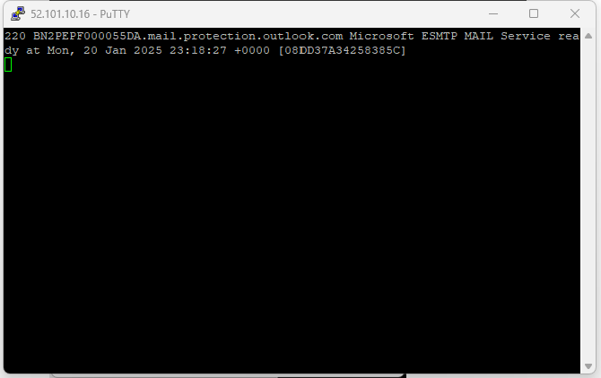

* Use that ip and set the port to 25 and select other /telnet
* It should show the 220 message that means the port 25 is healthy and working

**30.vvvvvvvv important please ratantam**

**Q:** *A domain is what? A forest is what?*  
**A:** A domain is a network of objects (users, computers) sharing a security database. A forest is the top-level container in Active Directory holding one or more domains with a shared schema and global catalog.

**31.Q:** *VDI is what, and how does virtualization help?*  
**A:** VDI is Virtual Desktop Infrastructure. Virtualization allows multiple OS or apps to run on one physical machine, saving space, cost, and resources.

**32.Q:** *How do you prioritize your tasks (technical context)?*  
**A:** I follow SLA guidelines—critical system outages come first, followed by issues with large user impact, then routine tasks. I document everything in the ticketing system for clarity.

**33. Q:** *What is bandwidth? Jitter? Latency? Packet loss?*  
**A: Bandwidth:** Data transfer rate over a network in a given time. (Megabits per second)

* **Jitter:** Variation in packet arrival times. (millisecond
* **Latency:** The time a packet takes to travel from source to destination. (millisecond)
* 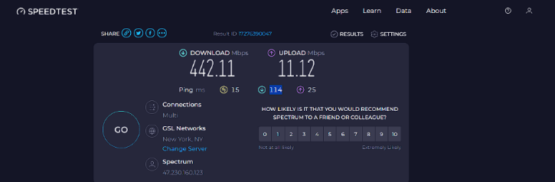**Packet loss:** Data packets failing to reach their destination.
* To test bandwidth /jitter/latency
* Go to speedtest.net
* Bandwidth (bandwidth download 441.11, bandwidth upload 11.12) Megabits per second
* Latency is 15 MS millisecond (ping)
* Jitter (download jitter is 114millisecond, upload jitter is 25millisecond)
* Packet loss

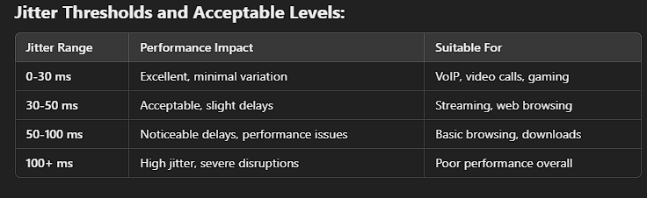One way is pathping this will show the packet loss at each hop.

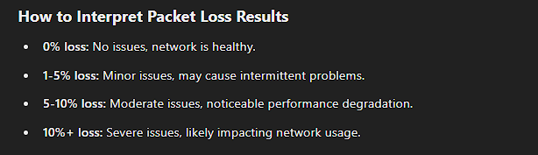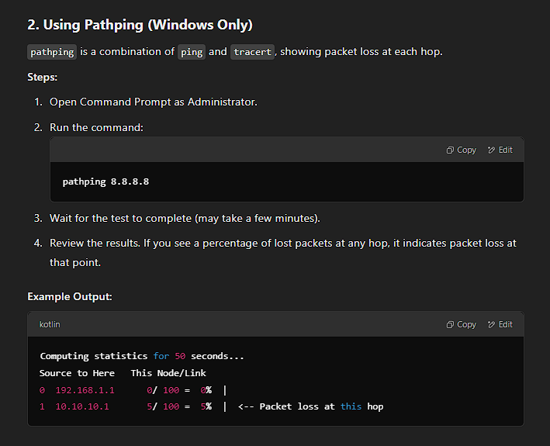

* Other way to determine packet loss is ping
* By default, it will ping 4 times but we can extend the time length to determine packet loss over an extended period of time
* Ping -n 10 8.8.8.8 (the number 10 before the ip is the amount of time it will ping )
* 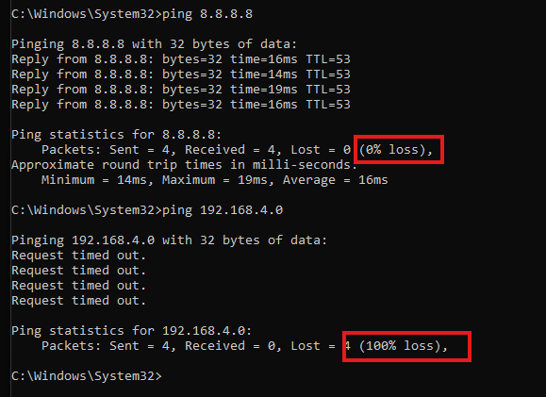At the end of the search we can see the % of loss

**34. Q:** *What is NAT (Network Address Translation)?*  
**A:** NAT translates private (internal) IP addresses to a public IP address for internet communication and vice versa.

**35.Q:** *If you get tickets from top customers and the CEO at the same time, which do you prioritize? (technical aspect for triage)*  
**A:** I evaluate the severity/impact. If both are mission critical, I might delegate one to a teammate or handle the quickest fix first while keeping both informed.

**36.Q:** *What do you need for internet at home?*  
**A:** ISP subscription, a modem, a router, proper cables, and a device (e.g., computer, phone) to access it.

* **37.Q:** *Hub vs Switch vs Router—differences?*  
  **A: Hub:** Layer 1, broadcasts data to all ports.
* **Switch:** Layer 2, sends data only to destination MAC.
* **Router:** Layer 3, routes data between different IP networks.

**38.Q:** *What is Active Directory?*  
**A:** Active Directory (AD) is a directory service developed by Microsoft that provides centralized authentication, authorization, and resource management in a Windows domain network. It allows administrators to manage users, computers, groups, security policies, and other resources within an organization efficiently.

**39. Q:** *What is a Default Gateway?*  
**A:** The router that sends traffic from a local network to other networks (often the internet).

**40. Q:** *What is a Domain?*  
**A:** A logical grouping in Active Directory containing users, computers, and resources under a common security database and policies.

**41. Q:** *How do you explain Active Directory for a non-technical person?*  
**A:** "It’s like an airport check-in system."

When you check in, the system verifies your ticket, identity, and baggage before letting you onto the plane. Active Directory checks your login, assigns permissions, and ensures you access only what you're allowed to.  
  
It’s like a security office that checks who you are and what you can access whenever you log into your work computer.

**42.Q:** *How do you differentiate DHCP and DNS?*  
**A:** **DHCP**: Assigns IP addresses automatically. **DNS**: Resolves domain names to IP addresses so you don’t have to memorize numbers.

**43.Q:** *What is a Group Policy?*  
**A:** A Windows feature that enforces specific settings or security configurations across users/computers in a domain environment.

**44.Q:** *What is VPN?*  
**A:** A Virtual Private Network that encrypts data and tunnels traffic securely over a public network, allowing remote access to internal resources.

**45.Q:** *What was your most challenging task faced by you in your previous job? (Technical version)*  
**A:** Implementing a multi-site VPN or zero-downtime server migration. Required coordinated downtime windows, thorough planning, and multiple vendor interactions.

**46.Q:** *How would you change folder permissions?*  
**A:** Right-click folder → Properties → Security tab → Edit. Then set the rights (Read, Write, Modify, etc.) for the appropriate user/group.

**47.Q:** *Which ticketing system do you use?*  
**A:** Currently Freshdesk. I also experimented with ServiceNow in a pilot project.

**48. Q:** *If you get ticket from top customer and CEO at the same time, what will you do? (technical perspective)*  
**A:** Evaluate severity. If one is truly business-critical, do that first. If both are urgent, escalate or coordinate with a teammate to handle them in parallel.

**49.Q:** *What are the things required to get an internet connection at home?*  
**A:** (Duplicate in technical context) ISP subscription, modem, router, cables, and a device that connects.

**50.Q:** *Are technical skills or customer service more important for a help desk? (Technical viewpoint)*

**A:** Both. You need technical proficiency to fix issues and strong communication to guide users effectively.

**51.Q:** *Are you aware of the latest Computer Processors?*  
**A:** The major and popular CPU manufacturers currently are INTEL (14 gen processors i5,i7,i9 etc), AMD (AMD Ryzen series ) and APPLE (m1,m2,m3,m4) on the consumer side on the SERVER / AI side the major player is NVIDIA (***Grace CPU***/ Blackwell)

**52.Q:** *What is an IP Address and how to find it?*  
**A:** A unique identifier for a device on a network. On Windows, run ipconfig in Command Prompt to see it.

**53.Q:** *Differentiate between MAC address and IP address.*  
**A:** MAC is hardware-level (Layer 2), unique to each network card. IP is logical (Layer 3), assigned by DHCP or statically for routing.

**54.Q:** *What are some commonly used LAN Cables?*  
**A:** Cat5e (1 Gbps), Cat6 (up to 10 Gbps for short runs), Cat6a, and Cat7 with better shielding.

**55.Q:** *How would you recover data from Virus infected computer?*

Recovering data from a virus-infected computer can be a delicate process. Here are some steps you can follow:

1. **Disconnect from the Internet**: This prevents the virus from spreading or communicating with other systems.
2. **Run Antivirus Software**: Use a reputable antivirus program to scan and remove the virus. Ensure your antivirus software is up-to-date.
3. **Boot in Safe Mode**: Restart your computer in Safe Mode to prevent the virus from running. This can make it easier to remove the virus and recover data.
4. **Use Data Recovery Software**: After removing the virus, use data recovery software like Disk Drill, Recuva, or Wondershare Recoverit to recover lost or deleted files[[1]](https://www.cleverfiles.com/howto/recover-virus-infected-files.html)[[2]](https://www.handyrecovery.com/recover-files-deleted-by-virus/).
5. **Check Backups**: If you have backups, restore your data from them. This is often the safest and most reliable method.
6. **Seek Professional Help**: If the infection is severe and you cannot recover the data yourself, consider consulting a professional data recovery service.  
   **A:** Isolate from network, run antivirus or rescue disk, back up important data if safe, and potentially reformat or re-image if necessary.

**56.Q:** *What is ping?*  
**A:** A command to test connectivity and measure round-trip time (RTT) between two devices, checking if the remote host is reachable.

**57.Q:** *How does DHCP server work?*  
**A:** It follows DORA: Discovery, Offer, Request, Acknowledge. Clients broadcast requests, the server offers an IP, client requests it, server confirms.

**58.Q:** *(Repeated) What is Blue Screen of Death (BSOD)?*  
**A:** A Windows stop error triggered by critical system or driver faults, halting the OS to prevent damage.

**59.Q:** *How many tickets did you solve in a day?*  
**A:** Typically 12–15, but some are quick, while others are multi-hour or multi-day investigations.

**60.Q:** *How do you manage your work time? (Technical tasks approach)*  
**A:** I keep a prioritized list in our ticketing system, tackle the most severe or SLA-urgent tasks first, and schedule maintenance or less critical tasks accordingly.

**61.Q:** *What is OST file?*  
**A:** (Duplicate in purely technical context) Offline Storage Table for Outlook, storing mailbox data locally for offline work.

**62.Q:** *What is a PST file?*  
**A:** A personal Outlook data file storing emails, contacts, etc. locally, not necessarily tied to Exchange.

**63.Q:** *How will you know if OST file is corrupted?*  
**A:** Outlook may give sync errors or crash frequently. ***The scanpst.exe*** tool can detect/fix corruption.  
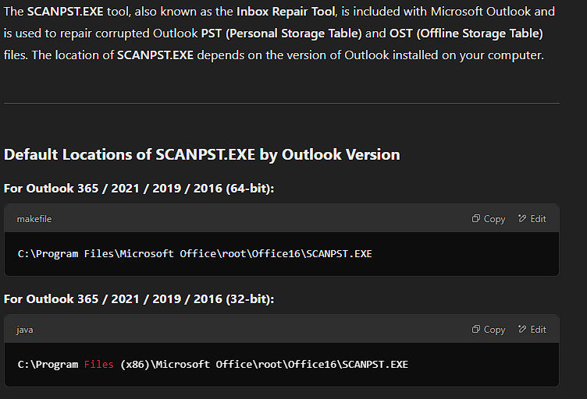

**64.Q:** *Where is the OST file located?*  
**A:** Usually C:\Users\<username>\AppData\Local\Microsoft\Outlook. For a departing employee, we might archive or export the mailbox data.

**65.Q:** *What is Safe Mode in Windows means, how do you get to it, and what is it used for? (Duplicate purely technical)*  
**A:** Safe Mode starts with minimal drivers. Access by Shift+Restart → Troubleshoot → Advanced Options → Startup Settings. Used to diagnose driver or software conflicts.

**66.Q:** *What is your troubleshooting process?*  
**A:** (Duplicate purely technical) Gather info, isolate possible causes, implement a solution, verify, and document. If stuck, escalate or consult logs and colleagues.

**67.Q:** *How do you difference HUB, Switch, and Router?*  
**A:** (Duplicate purely technical) Hub = Layer 1 broadcast, Switch = Layer 2 MAC-based forwarding, Router = Layer 3 IP-based routing.

**68.Q:** *What do you understand by Cache memory? What is the advantage of a processor having more cache memory?*  
**A:** (Duplicate purely technical) Cache is a small, fast memory. More cache improves CPU performance by reducing data fetch times from RAM.

**69.Q:** *Which ticketing system do you use?*  
**A:** (Duplicate question) Freshdesk, with some ServiceNow pilot experience.

**70.Q:** *You receive a trouble ticket that states: “My printer is not working properly. It prints out weird patterns...”*  
**A:** (Duplicate) Typically a driver or hardware problem. Reinstall drivers, update firmware, or test a new cartridge/toner.

**71.Q:** *If you get ticket from top customer and CEO at the same time, what will you do? (purely technical triage)*  
**A:** (Duplicate) Assess severity or business impact. If both are equally critical, escalate one or split tasks so both are handled promptly.

**72.Q:** *Are you aware of the latest Computer Processors?*  
**A:** (Duplicate purely technical) Yes. Intel’s 13th/14th Gen and AMD Ryzen 7000 series, focusing on improved IPC and efficiency cores.

**73.Q:** *What is an IP Address, and how to find it?*  
**A:** (Duplicate purely technical) A unique network identifier. On Windows, run ipconfig in CMD to see your IP.

**74.Q:** *Differentiate between MAC address and IP address (purely technical).*  
**A:** MAC = physical (Layer 2) identifier. IP = logical (Layer 3) address assigned by DHCP or static configuration for routing.

**75.Q:** *What are some commonly used LAN cables? (purely technical)*  
**A:** (Duplicate) Cat5e (1 Gbps), Cat6 (10 Gbps short distances), Cat6a, Cat7 for higher performance and shielding.

**76.Q:** *How would you recover data from a virus-infected computer?*  
**A:** (Duplicate purely technical) Isolate it, run anti-malware scans, back up data if verified clean, then reformat or re-image as needed.

**77.Q:** ***What is ping command and its use?*  
A: Sends ICMP echo requests to check connectivity and measure latency. Helps identify if a host is reachable or if there’s packet loss**.

**78.Q:** *How does DHCP server work?*  
**A:** (Duplicate) Via DORA: client broadcasts a Discovery, server Offers an address, client Requests, server Acknowledges.

**79.Q:** *Is customer service important in a technical role?*  
**A:** Yes. Even brilliant technical solutions require user-friendly communication and empathy to foster trust.

**80.Q:** *How many tickets did you solve in a day? (purely technical metrics)*  
**A:** (Duplicate) Around 12–15 on average, depending on complexity.

**81.Q:** *What is the Blue Screen of Death (BSOD)?*  
**A:** (Triplicate question) Critical error halting Windows due to driver or hardware failures.

**82.Q:** *How do you manage your work time? (Technical tasks)*  
**A:** (Duplicate) Ticket queue, SLA-based priorities, and clear logging of escalations or next steps.

**83.Q:** *Basic problems faced by the customer? (Technical angle)*  
**A:** Slow PCs, password resets, network drops, Outlook errors, printer issues—common IT headaches.

**84.Q:** *How will you know if OST file is corrupted? (purely technical)*  
**A:** Frequent sync errors, Outlook crashes, or data mismatch. The Inbox Repair Tool can diagnose it.

**85.Q:** *Where is the OST file located? (purely technical)*  
**A:** C:\Users\<Username>\AppData\Local\Microsoft\Outlook by default. We often export mail if an employee departs.

**86.Q*: (Wrap-up) If you didn’t know how to resolve an issue, what would you do from a technical standpoint?  
A: Attempt to replicate in a lab, consult official documentation, ask senior engineers, or escalate to the vendor if needed.***

Technical Questions and Answers

**. What is your troubleshooting process?**

**Answer:**  
I gather info (error messages, user descriptions), form hypotheses, test systematically, apply a fix, verify with the user, then document the solution.

**2. What is Blue Screen of Death (BSOD)?**

**Answer:**  
A Windows stop error caused by critical driver or hardware failures. The system halts to prevent damage and displays an error code for troubleshooting.

**3. What is Safe Mode in Windows, how do you get to it, and what is it used for?**

**Answer:**  
Safe Mode boots with minimal drivers/services. In Windows 10/11, you can access it by Shift+Restart → Troubleshoot → Advanced Options → Startup Settings. It’s used to diagnose driver/software conflicts.

**4. How do you upgrade Windows OS version (e.g., from 10 to 11)?**

**Answer:**  
Check compatibility, back up data, then proceed via Windows Update or official installation media. I often test on a pilot machine before broad rollout.

**5. What is PC imaging? How do you boot from the network to install PC imaging?**

**Answer:**  
PC imaging deploys a standardized OS image across multiple machines. To network-boot (PXE), enable it in the BIOS, then connect to a deployment server (e.g., WDS or MDT) to apply the image.

**6. If a printer prints out weird patterns, how do you fix it?**

**Answer:**  
Check ink/toner levels, reinstall or update drivers, run printer self-tests, and ensure you’re using the correct driver. Firmware issues or hardware faults may also cause pattern errors.

**7. If a monitor is not working, what is the first thing you should do?**

**Answer:**  
Verify power and cable connections, then test the monitor on another PC or vice versa to rule out hardware vs. software issues.

**8. If you have a fresh new PC and need to join it to the domain, what do you do?**

**Answer:**  
Ensure network connectivity, then go to System Properties → Computer Name → Change → enter domain credentials.

**9. How do you upgrade Outlook to a new version?**

**Answer:**  
If you have a Microsoft 365 subscription, it updates automatically. Otherwise, run the standalone installer or use Windows Update. Confirm add-in compatibility beforehand.

**10. How do you manage Windows Updates?**

**Answer:**  
Using WSUS or an RMM tool at the MSP level. We schedule and test patches for high-impact scenarios, then approve updates in stages to minimize disruption.

**11. If someone’s sound is not working, what do you do?**

**Answer:**  
Check volume levels, ensure correct playback device, verify cables or headphones, update drivers, and scan for any OS-level audio conflicts.

**12. What is a docking station, and why is it important?**

**Answer:**  
It’s a hub allowing a laptop to connect quickly to monitors, LAN, peripherals. It improves productivity for employees moving between desks and mobile use.

**13. How do you enable two monitors to show separate content instead of duplicating?**

**Answer:**  
In Display Settings, select “Extend these displays.” Arrange orientation if needed and apply.

**14. What is cache memory, and what is the advantage of a processor having more of it?**

**Answer:**  
Cache is high-speed memory in the CPU storing frequently used instructions. More cache reduces fetch times and speeds up performance.

**15. What do you do if you identify a user’s PC is infected with ransomware?**

**Answer:**  
Immediately isolate it from the network, alert the security team, and follow incident-response protocols (restore from known good backups, etc.).

**16. If a user’s PC hard drive is full and you can’t delete files, what do you do?**

**Answer:**  
Offload data to OneDrive or a network share, archive older data, or upgrade the storage if necessary.

**17. What does the POST beep code mean on boot-up?**

**Answer:**  
It indicates Power-On Self-Test results. A single beep often means normal startup; multiple beeps can signal hardware errors (RAM, GPU, etc.).

**18. What are the repeated problems your customers face?**

**Answer:**  
Common issues include PC slowness, password resets, Outlook sync errors, printer malfunctions, and basic connectivity problems.

**19. What is an OST file?**

**Answer:**  
Offline Storage Table for Outlook with Exchange accounts. It lets users work offline and sync changes once reconnected.

**20. What is a PST file?**

**Answer:**  
Personal Storage Table used by Outlook to store emails, contacts, calendar items locally, independent of an Exchange server.

**21. How do you know if an OST file is corrupted?**

**Answer:**  
Outlook may fail to open, stop syncing, or show repeated error messages. Running scanpst.exe can detect and fix some corruption.

**22. Where is the OST file located, and what do you do if an employee leaves?**

**Answer:**  
Typically at C:\Users\<username>\AppData\Local\Microsoft\Outlook. If they leave, I archive or export their mailbox before disabling the account.

**23. If a PC is running slow, what do you do?**

**Answer:**  
Check Task Manager for high CPU/RAM usage, scan for malware, clear temp files, and ensure OS and drivers are updated.

**24. What is VDI?**

**Answer:**  
Virtual Desktop Infrastructure: user desktops are hosted on virtual machines in a central data center, accessible remotely.

**25. What is Cloud PC?**

**Answer:**  
A Windows desktop hosted entirely in the cloud (e.g., Azure Virtual Desktop or Windows 365), allowing remote access from almost anywhere.

**26. How do you image a PC from the cloud? Are you experienced with Windows Autopilot?**

**Answer:**  
With Windows Autopilot or similar MDM solutions, the PC contacts the cloud service on first boot to pull down a custom image or configuration. Yes, I’ve tested Autopilot to streamline provisioning.

**27. What if a PC’s CPU is at 100% usage all the time?**

**Answer:**  
Open Task Manager to see which process is hogging resources, update or remove that software if necessary, and scan for malware.

**28. What if a user says their files are missing?**

**Answer:**  
Check the Recycle Bin, backups, or OneDrive version history. If needed, use file recovery tools or restore from server backups.

**29. What’s the first step if a trouble ticket says the printer is printing weird patterns?**

**Answer:**  
Check driver correctness and possibly reinstall it. Then verify cartridge/toner status, run any internal printer diagnostic, and confirm correct print settings.

**30. If you get tickets from a top customer and the CEO at the same time, what do you do?**

**Answer:**  
Assess urgency and impact. If both are critical, I’d escalate one to a colleague. Otherwise, handle the most business-critical first while keeping both parties informed.

**31. What do you need to get an internet connection at home?**

**Answer:**  
An ISP subscription, modem, router, proper cables, and a device (PC, laptop, etc.) to connect.

**32. How do you differentiate a Hub, Switch, and Router?**

**Answer:**

* **Hub:** Layer 1 device, broadcasts data to all ports.
* **Switch:** Layer 2 device, forwards data to the specific MAC address.
* **Router:** Layer 3 device, routes data between different networks using IP addresses.

**33. What is Active Directory?**

**Answer:**  
Microsoft’s directory service that manages domain users, groups, and resources, providing centralized authentication and policy enforcement.

**34. What is a Default Gateway?**

**Answer:**  
A router that connects the local network to external networks, typically the internet.

**35. What is a Domain?**

**Answer:**  
A collection of networked objects (users, computers, etc.) under centralized administration (e.g., via Active Directory).

**36. How do you explain Active Directory to a non-technical person?**

**Answer:**  
It’s like a digital security office controlling who can log into company computers and what resources they can access.

**37. How do you differentiate DHCP and DNS?**

**Answer:**

* **DHCP** automatically assigns IP addresses to devices.
* **DNS** translates domain names into IP addresses so browsers can find the right server.

**38. What is Group Policy?**

**Answer:**  
A Windows feature for centrally managing user and computer settings in a domain (e.g., password policies, desktop restrictions).

**39. What is a VPN?**

**Answer:**  
A Virtual Private Network creates a secure, encrypted tunnel over the internet for remote access to a private network.

**40. How do you change folder permissions?**

**Answer:**  
Right-click the folder → Properties → Security tab → Edit. Then add or remove users and assign the desired permissions (e.g., Read, Write, Full Control).

**41. Which ticketing system do you use?**

**Answer:**  
I primarily use Freshdesk at my MSP, and I’ve had some exposure to ServiceNow in a pilot phase.

**42. Are you aware of the latest computer processors?**

**Answer:**  
Yes, I keep track of Intel’s 13th/14th Gen and AMD’s Ryzen series for performance gains, core counts, and power efficiency.

**43. What is an IP address, and how do you find it?**

**Answer:**  
An IP address uniquely identifies a device on a network. On Windows, type ipconfig in Command Prompt to see your IP.

**44. What’s the difference between a MAC address and an IP address?**

**Answer:**  
A MAC is a hardware-level (Layer 2) identifier unique to each network adapter. An IP is a logical (Layer 3) address assigned by the network (DHCP or static) for routing.

**45. What are some commonly used LAN cables?**

**Answer:**  
Cat5e (up to 1 Gbps), Cat6 (up to 10 Gbps for short distances), Cat6a, and Cat7 (better shielding and performance).

**46. How do you recover data from a virus-infected computer?**

**Answer:**  
Isolate the machine from the network, run antivirus scans or rescue disks, and back up crucial data if clean. Reinstall or restore from backups if necessary.

**47. What is ping (or the ping command), and its use?**

**Answer:**  
Ping checks connectivity between two devices by sending ICMP echo requests, measuring round-trip time, and detecting packet loss.

**48. How does a DHCP server work?**

**Answer:**  
It follows the DORA process (Discovery, Offer, Request, Acknowledge) to automatically assign IP addresses and network settings to clients.

**49. Is customer service important in a technical role?**

**Answer:**  
Absolutely. Even if you have all the right technical solutions, users need clear communication and empathy to feel confident in the support they receive.

**50. How many tickets did you solve in a day?**

**Answer:**  
Typically 12–15 on average, though complexity can vary. Some issues might take minutes; others can be multi-hour investigations.

**51. What are the basic problems faced by customers?**

**Answer:**  
Common ones include password resets, slow PCs, printer malfunctions, email or Outlook issues, and basic network connectivity errors.

**52. (Repeated) What is the Blue Screen of Death (BSOD)?**

**Answer:**  
(It’s the same as #2 in this list.) A critical Windows stop error caused by driver or hardware issues, requiring a reboot and further investigation.

**53. How do you manage your work time from a technical perspective?**

**Answer:**  
I use a ticketing system with clear SLAs, prioritize high-severity issues first, and keep tabs on escalations or unresolved tickets to ensure nothing slips.

**54. If you get ticket requests from both a top customer and the CEO at once, how do you handle it?**

**Answer:**  
Similar to #30. I assess urgency/impact. If equally critical, I escalate one to a colleague; if not, I tackle the most pressing and keep both updated.

**55. When can you start imaging or reformatting a machine?**

**Answer:**  
Only after confirming data backups. Then I apply the standard image (via PXE or Autopilot) or reformat, ensuring user data is safe.

**Technical - Network related**

Here are the answers to each of the questions:

1. **Private vs Public IP Addresses**:
   * **Public IP addresses** are globally unique and can be accessed over the internet.
   * **Private IP addresses** are used within local networks and are not routed over the internet.

**A-> 1.0.0.0 – 127.255.255.255 used for large network**

**B-> 128.0.0.0 – 191.255.255.255 used for medium size networks**

**C-> 192.0.0.0 – 223.255.255.255 used for small network and support up to 254 host**

1. **Ping Command**:
   * The ping command is used to check the connectivity between two network devices by sending ICMP (Internet Control Message Protocol) Echo Request packets and receiving Echo Reply packets.
2. **Netstat Command**:
   * netstat is used to display network connections, routing tables, interface statistics, and other network-related information.
3. **HUB, Switch, and Router**:
   * **Hub**: A basic networking device that broadcasts data to all connected devices.
   * **Switch**: A smarter device that forwards data to the correct device by learning the MAC addresses of connected devices.
   * **Router**: A device that routes data between different networks (e.g., between LAN and the internet).
4. **Default Gateway**:
   * A **Default Gateway** is the ip address of the router that provides the path to the internet.
5. **Domain**:
   * A **Domain** is a group of devices, like computers and servers that share the same network name and are managed by a central system, like Active Directory.
6. **Wireless Router vs WAP**:
   * **Wireless Router**: A device that routes traffic between networks and provides Wi-Fi capabilities.
   * **WAP (Wireless Access Point)**: A device that provides wireless network access to clients but doesn’t route traffic between networks.
   * **Wireless Router:** Combines the functions of a router and a wireless access point. It routes data between networks and provides wireless connectivity.
   * **Wireless Access Point (WAP):** Extends the wireless coverage of an existing network without routing capabilities. It connects to a router or switch to provide wireless access
7. **DNS (Domain Name System)**:
   * DNS is a system that translates human-readable domain names (like www.example.com) into IP addresses that computers can understand.
8. **NAT (Network Address Translation)**:
   * NAT is a process where a router or firewall translates private IP addresses into a single public IP address for accessing the internet.
9. **DMZ (Demilitarized Zone)**:
   * It is a small, isolated network segment within a large network. It often hosts public-facing services like web servers. It adds an additional layer of security to the local area network (LAN) by isolating external services from the internal network.
10. **IP Address in OSI Model**:
    * The **IP Address** operates at the **Network Layer (Layer 3)** of the OSI model.
11. **IP Addresses with Subnet Mask 255.255.255.240**:
    * A subnet mask of 255.255.255.240 (or /28) provides 16 IP addresses, of which 14 are usable.
12. **Broadcast IP Address**:
    * A **Broadcast IP address** is an address used to send data to all devices on a network, usually represented as the last IP in a subnet.
13. **VPN**:
    * A **VPN (Virtual Private Network)** is a secure connection over the internet that allows remote users to access a private network. It should be used when secure remote access is needed.
    * You should use VPN for secure data transmission, privacy, and protection of sensitive information. Depending on your company, you might use **IPsec**, **SSL**, or **PPTP** VPNs.

**VPN (Virtual Private Network):**

* Creates a secure, encrypted connection over a public network (like the internet).
* Allows users to access private network resources remotely.
* **When to use VPN:**
  + Accessing work resources from home or while traveling
  + Browsing the internet privately and securely
  + Bypassing censorship or geo-restrictions
* **Type of VPN in your current company:** (This depends on your specific company's setup)
  + **Site-to-Site VPN:** Connects two or more office locations over the internet.
  + **Point-to-Site VPN:** Allows individual employees to connect to the company network remotely.
  + **SSL/TLS VPN:** A common type of remote access VPN that uses SSL/TLS encryption.
* A **VPN (Virtual Private Network)** creates a secure, encrypted connection over a less secure network, such as the internet. It is used to protect data, maintain privacy, and access resources remotely. VPNs are commonly used for secure remote work, accessing region-restricted content, and protecting sensitive information. There are different types of VPNs, such as **site-to-site VPNs** for connecting entire networks and **point-to-site VPNs** for connecting individual devices to a network. The specific type of VPN used in a company can vary based on its needs and infrastructure.

1. **Things Required for Internet Connection at Home**:
   * **Modem**, **Router**, **ISP Service**, and **Cabling** (Ethernet or Wi-Fi setup).
2. **IP Address and How to Find It**:
   * An **IP address** is a unique identifier for a device on a network. To find it, you can use the ipconfig (Windows) or ifconfig (Linux/macOS) command.
3. **Firewall**:
   * A **Firewall** is a network security system that monitors and controls incoming and outgoing network traffic based on predetermined security rules.
4. **Point-to-Site vs Site-to-Site VPN**:
   * **Point-to-Site VPN** allows individual users to connect securely to a remote network.
   * **Site-to-Site VPN** connects two entire networks securely over the internet.
5. **Port Numbers**:
   * **DNS (Port 53)**, **LDAP (Port 389)**, **RDP (Port 3389)**, **HTTPS (Port 443)**.
6. **MAC Address vs IP Address**:
   * A **MAC address** is a hardware address that uniquely identifies a device on a local network, while an **IP address** identifies the device on a network layer (Layer 3) for routing.
7. **VLAN (Virtual LAN)**:
   * A **VLAN** is a logically segmented network within a physical network, used to improve security and performance by isolating traffic.
8. **QoS (Quality of Service)**:
   * QoS is a technique that prioritizes certain types of network traffic to ensure performance for critical applications (e.g., VoIP).

VoIP: Technology that allows voice communication and multimedia sessions over the internet instead of traditional phone lines. It converts voice signal into digital data packets and transmits them over an IP network

1. **Proxy Server**:
   * A **Proxy Server** acts as an intermediary between a client and the internet, used to filter content, improve performance, or enhance security.
2. **Split Tunnel**:
   * **Split Tunnel** allows you to route some traffic through the VPN and other traffic directly to the internet, increasing performance.
3. **Blocking Facebook or TikTok**:
   * To block access, you can use **firewall rules**, **web filtering software**, or modify the **DNS settings** to block these sites.
4. **Cisco Phone Setup**:
   * To set up a new Cisco phone, connect it to the network, power it on, and configure it with the user’s extension via the Cisco Unified Communications Manager or similar software.
5. **Troubleshooting Internet Issues**:
   * Start with **physical checks** (cables, lights on the modem), then **check IP configuration**, **ping internal and external addresses**, and examine **DNS settings**.
6. **Test SMTP Port (Windows Command)**:
   * You can use telnet <mailserver> 25 to check if the SMTP port (25) is open.
7. **DHCP and DORA Process**:
   * **DORA** stands for **Discover**, **Offer**, **Request**, and **Acknowledge**—the process by which a device obtains an IP address from a DHCP server.
8. **DHCP Server Down**:
   * If the DHCP server is down, devices will not be able to receive IP addresses, and they may use an APIPA address (169.254.x.x).
9. **DHCP Static**:
   * **DHCP Static** is when a DHCP server is configured to always assign the same IP address to a specific device based on its MAC address.
10. **Jitter vs Packet Loss**:
    * **Jitter** is the variation in packet delay, while **Packet Loss** refers to packets that are lost during transmission.
11. **Accessing Cisco Router Remotely**:
    * You can access a Cisco router remotely via **SSH** or **Telnet** using a terminal or network management tool.
12. **Review Cisco Router Configurations**:
    * You can use the command show running-config to review the current configuration on a Cisco router.
13. **Backup Cisco Router Config File**:
    * To backup a Cisco router config, use the command copy running-config tftp://<tftp-server-ip>/filename.

Let me know if you'd like any further clarification on any topic!

• **What is PC Imaging? Have you done it? Can you explain the process?**

* "PC Imaging is the process of creating a standardized image of a computer's operating system, applications, and settings. This image can then be quickly deployed to multiple devices, ensuring consistency and reducing manual configuration time. Yes, I have extensive experience with PC imaging. The process typically involves capturing an image of a clean and configured system, deploying that image to target devices using tools like Microsoft Deployment Toolkit (MDT) or System Center Configuration Manager (SCCM), and then performing any necessary post-imaging customizations."

• **What PC makes and models are you supporting?**

* "I have experience supporting a wide range of PC makes and models, including Dell, HP, Lenovo, and Apple. I am comfortable working with various hardware and software configurations."